190905514 MOHAMMAD TOFIK C SECTION

LAB 1 :

1. To count the number of lines and characters in a file.
pgm1.c

#include <stdio.h>
#include <stdlib.h>
#include <unistd.h>
#include <string.h>
int main()
{
printf("All the file in the computer\n");
system("ls -l");
FILE *fp;
char fileName[1000];
char ch;
int countLine = 0;
int countCharacter = 0;
int countWord = 0;
printf("Enter the filename from the given list of file : ");
scanf("%s", fileName);
fp = fopen(fileName, "r");
if (fp == NULL)
{
printf("File does not exist\n");
return 0;
}
while ((ch = fgetc(fp)) != EOF)
{
printf("%c", ch);
countCharacter = countCharacter + 1;
if (ch == '\n')
{
countLine++;
}

}
printf("\n");
printf("The Line number is = %d\n", countLine);
printf("All the character in the file are : %d \n", countCharacter);
printf("\n");
return 0;
}

OUTPUT :
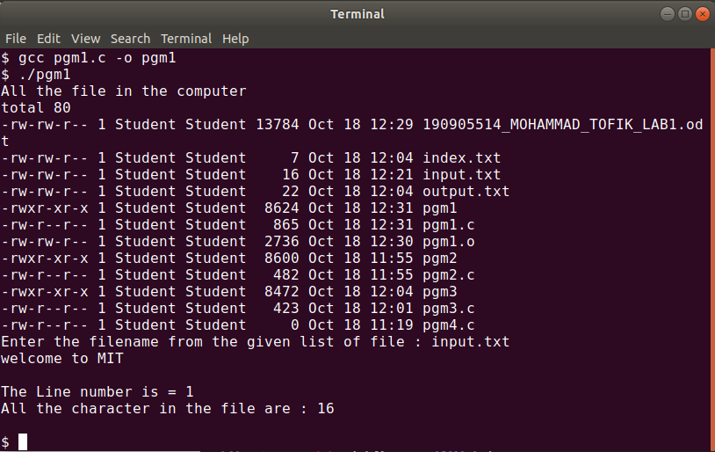
pgm2.c To reverse the file contents and store in another file. Also display the size of file
using file handling function.

#include<stdio.h>
#include<string.h>
#include<unistd.h>
int main(){
FILE *fp1;
FILE *fp2;
int ch;
int i=0;
fp1=fopen("input.txt","r");
if(fp1==NULL){
printf("File does not exist\n");
return 0;
}
fseek(fp1,0,SEEK_END);
ch=ftell(fp1);
while(i<ch){
i++;
fseek(fp1,-i,SEEK_END);
printf("%c",fgetc(fp1));
}
printf("\n");
fp2=fopen("output.txt","w");
fseek(fp1,0,SEEK_CUR);
ch=ftell(fp1);
while(i<ch){
i++;
fseek(fp1,-i,SEEK_CUR);
fputc(ch,fp2);
}

fclose(fp1);
fclose(fp2);
return 0;
}

OUTPUT:

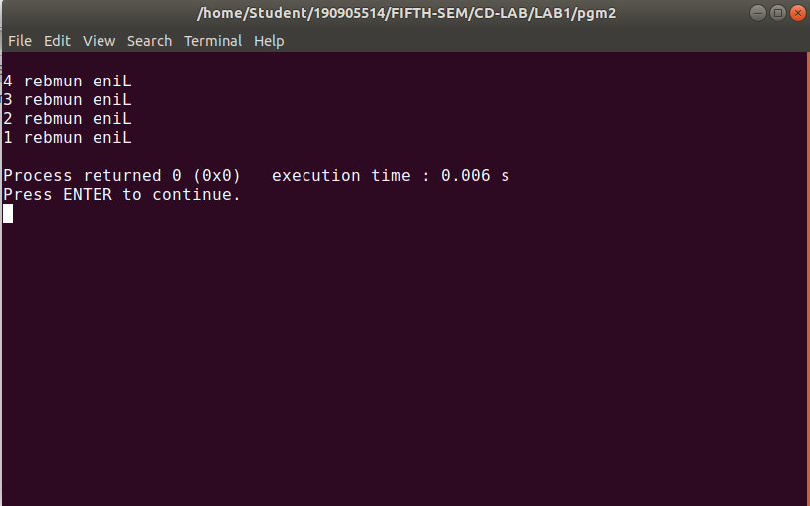
pgm3.c That merges lines alternatively from 2 files and stores it in a resultant file.

#include<stdio.h>
#include<string.h>
#include<stdlib.h>
int main(){
FILE *fp1;
FILE *fp2;
FILE *fp3;
char ch;
fp1=fopen("input.txt","r");
fp2=fopen("index.txt","r");
fp3=fopen("output.txt","w");
if(fp1==NULL || fp2==NULL || fp3==NULL){
printf("File does not exist\n");
return 0;
}
while((ch=fgetc(fp1))!=EOF){
fputc(ch,fp3);
}
while((ch=fgetc(fp2))!=EOF){
fputc(ch,fp3);
}
printf("\n");
return 0;

}

OUTPUT :

input.txt

Line number 1
Line number 2
Line number 3
Line number 4

index.txt
Line number 5
Line number 6
Line number 7

output.txt
Line number 1
Line number 2
Line number 3
Line number 4
Line number 5
Line number 6
Line number 7

