190905514 MOHAMMAD TOFIK BATCH : C2
ROLLNO : 62 SECTION : C SEM : 6th

-: DS-LAB-WEEK-2 :-

import pandas as pd
import numpy as np

print("Creating a DataFrame Using Dictionary : \n")
s = pd.Series([3, 9, -2, 10, 5])
print(s.sum())
print(s.min())
print(s.max())

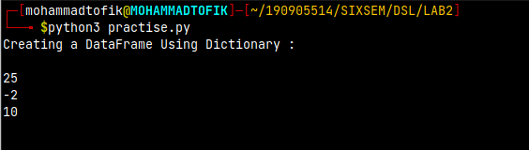

print("\n")
print("Creating a Data Frame : ")
data = [['Dinesh', 10], ['Nithya', 12], ['Raji', 13]]
df = pd.DataFrame(data, columns=['Name', 'Age'])

print("Indexed Data Frame : ")
data = {'Name': ['Kavitha', 'Sudha', 'Raju',
'Vignesh'], 'Age': [28, 34, 29, 42]}
df = pd.DataFrame(data, index=['rank1', 'rank2', 'rank3', 'rank4'])

print(df.shape)
print(df.dtypes)
print(df.head())
print(df.tail())
df1 = pd.DataFrame({'A': pd.Timestamp('20130102'), 'B': np.array([3]*4, dtype='int32'),
'C': pd.Categorical(['Male', 'Female', 'Male', 'Female'])})

print(df1.shape)
print(df1.dtypes)
print(df1.head())
print(df1.tail())

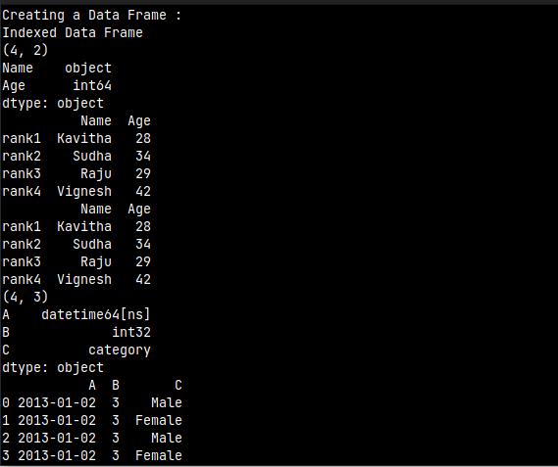
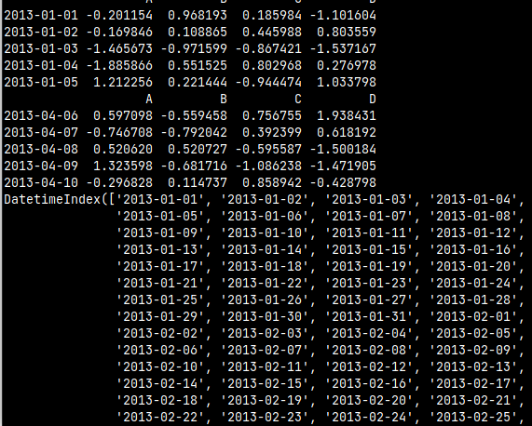

print("\n")
dates = pd.date_range('20130101', periods=100)
df = pd.DataFrame(np.random.randn(100, 4), index=dates, columns=list('ABCD'))

print(df.head())
print(df.tail())
print(df.index)
print(df.columns)
print("\n")
df.sort_index(axis=1, ascending=False)
print(df.head())
print("\n")
df.sort_values(by='B')
print(df.head())

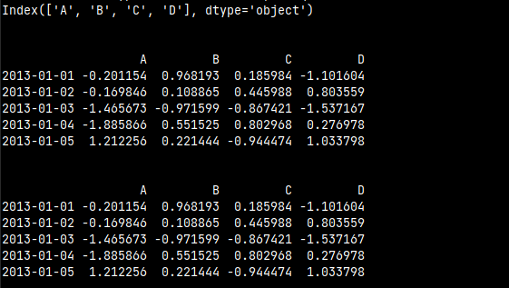

print("\nslicing")
print(df['20130105':'20130110'])

print("\n")
print(df.iloc[0])
print("\n")
print(df.iloc[0, :2])
print("\n")
print(df['A'])
dates = pd.date_range('20130101', periods=100)
df = pd.DataFrame(np.random.randn(100, 4), index=dates, columns=list('ABCD'))
df1 = pd.DataFrame({'A': pd.Timestamp('20130102'), 'B': np.array([3]*4, dtype='int32'),
'C': pd.Categorical(['Male', 'Female', 'Male', 'Female'])})
df2 = pd.DataFrame({'A': pd.Timestamp('20130102'), 'B': np.array([3]*4, dtype='int32'),
'C': pd.Categorical(['Male', 'Female', 'Male', 'Female'])})

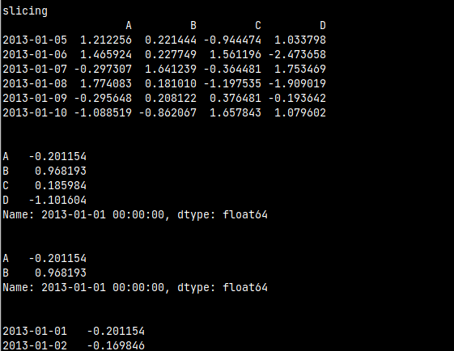

print("\nboolean indexing : ")
print(df[df.A > 0])

print("\n")
df.loc[:, 'D'] = np.array([5]*len(df))

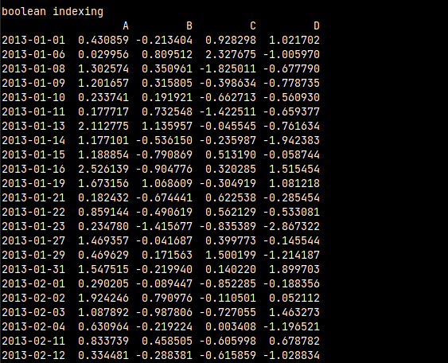

print("\ndeleting column : ")
df.drop('A', axis=1, inplace=True)

s=pd.Series([3,9,-2,10,5])
print(s.sum())
print(s.min())
print(s.max())

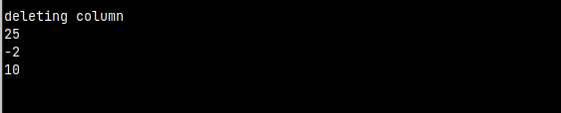

print("\n")
print("Creating a Data Frame : ")
data = [['Dinesh',10],['Nithya',12],['Raji',13]]
df = pd.DataFrame(data,columns=['Name','Age'])

print("Indexed Data Frame")
data = {'Name':['Kavitha', 'Sudha', 'Raju','Vignesh'],'Age':[28,34,29,42]}
df = pd.DataFrame(data, index=['rank1','rank2','rank3','rank4'])

print(df.shape)
print(df.dtypes)
print(df.head())
print(df.tail())

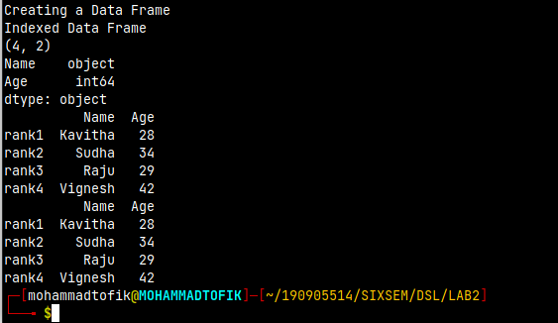

import pandas as pd
import numpy as numpy
import matplotlib.pyplot as plot
print("I/O Operations with external file : \n")
df = pd.read_csv('xyz.csv', header = None)
print(df.head())
print(df.tail())
df.columns = ['preg', 'glu', 'bp', 'sft', 'ins', 'bmi', 'dpf', 'age', 'class']
plot.scatter(df['bmi'], df['glu'])
plot.xlabel('bmi')
plot.ylabel('Glucose')
plot.show()
df['age'].hist()
plot.show()
f.plot(kind ='bar')
plot.show()
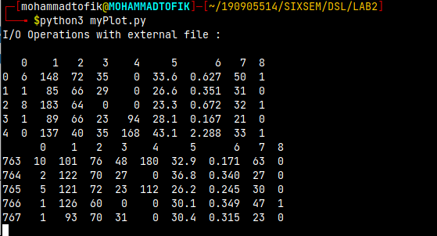
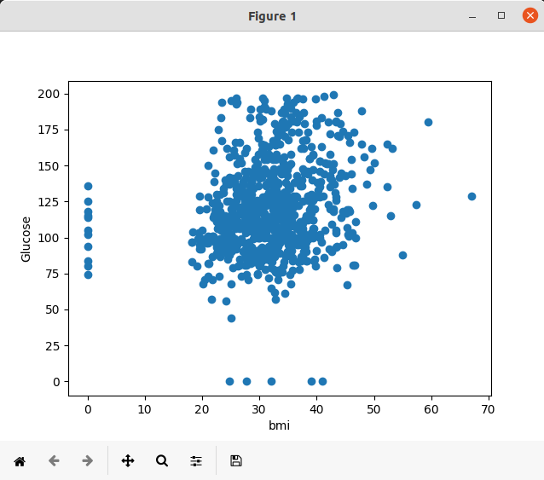

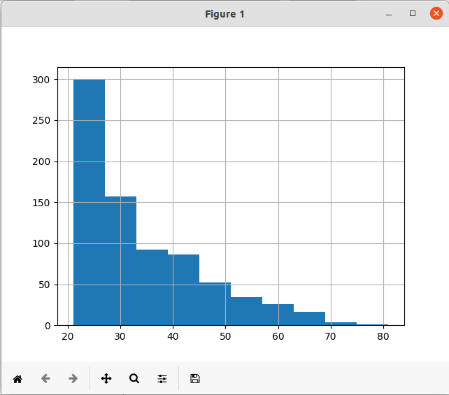

import pandas as pd
import numpy as numpy
import matplotlib.pyplot as plot

df = pd.read_table("myTxtFile.txt")
print(df.head())
f = df["Department"].value_counts()
print(f)
f.plot(kind = 'bar')
plot.show()
f.plot(kind = 'pie')
plot.show()
foo = pd.crosstab(df['Gender'], df['Attrition'])
foo.plot(kind ='bar')
plot.show();

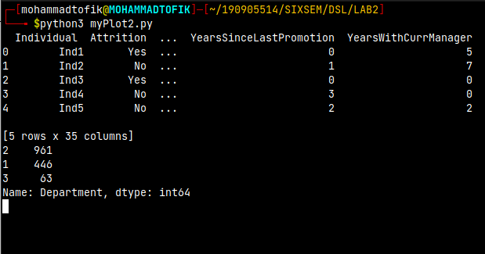
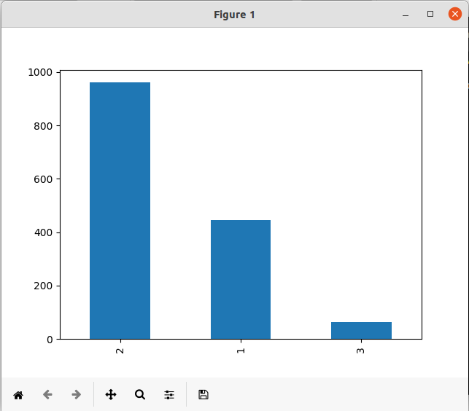

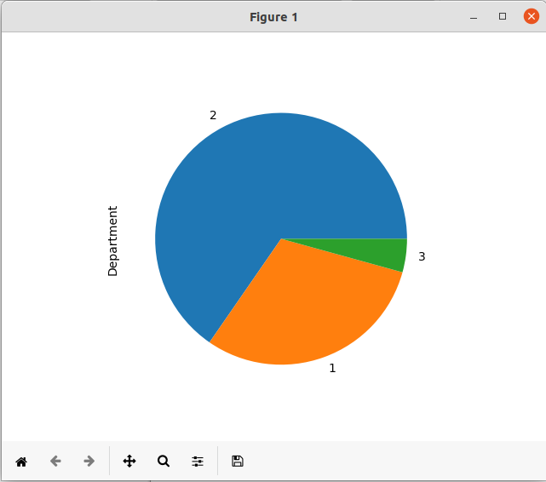

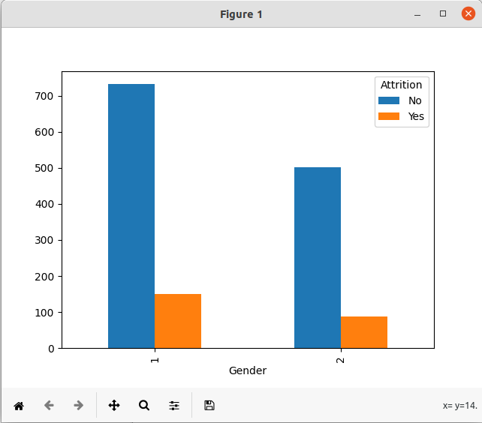

EXCERCISE QUESTIONS :

1.write a program to find the area of reatangle.Take input from the user
import numpy as np

print('OUTPUT : 1\n')
a = int(input('Enter Number: '))
b = int(input('Enter Number: '))
print('Area of rectangle')
print(a*b)

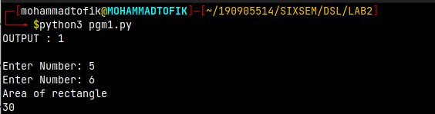
2.write a program to swap the value of two variable

print("OUTPUT : 2\n")
num1 = int(input("Enter the first number : "))
num2 = int(input("Enter the second number : "))
print("Before swapping : ")
print("Nuber1 : ",num1,"Number 2 : ", num2)
temp = num1
num1 = num2
num2 = temp
print("After swapping : ")
print("Nuber1 : ",num1,"Number 2 : ", num2)

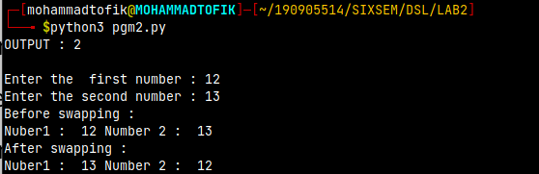

3.write a program to find whether the given number is odd or even

print("OUTPUT : 3\n")
num1 = int(input("Enter the number : "))
if num1 %2 == 0:
print("It is Even number : ")
else:
print("It is odd number : ")

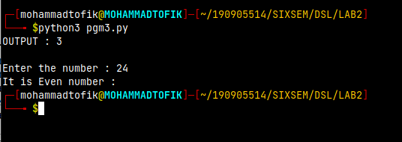

4.WAP to check largest number among three number

print("OUTPUT : 4\n")
num1 = int(input("Enter the first number : "))
num2 = int(input("Enter the second number : "))
num3 = int(input("Enter the third number : "))
if num1 > num2 and num1 > num3:
print("The greatest number is : ", num1)
elif num2 > num3:
print("The greatest number is : ", num2)
else:
print("The greatest number is : ", num3)

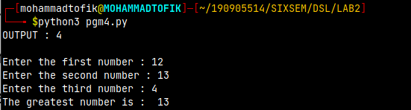
4.WAP to demonstrate while loop with else

print("OUTPUT : 5\n")
num1 = int(input("Enter any number : "))
while num1 > 10:
print("I am Mohammad")
break
else:
print("I am not Mohammad")

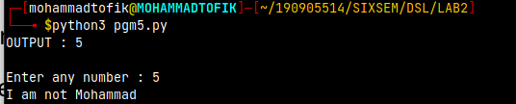
6.WAP to demonstrate the list functions and operations

print("OUTPUT : 6\n")
print("List Operations : \n")
a = [7,8,9,7,5,4]
print('list ',a)
print('list count',len(a))
a.reverse()
print('list reverse',a)

print('delete element',a.pop())
a.sort()
print('sorted list',a)

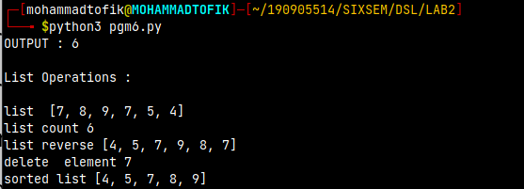
7.consider the tuple(1,3,5,7,9,2,4,6,8,10).WAP to print the half its values in one line and the other half in the next line

print('OUTPUT : 7\n')

tuple1 = (1,3,5,7,9,2,4,6,8,10)
c=0
n=len(tuple1)

for i in tuple1:
c=c+1
if c==int(n/2)+1:
print()
print(i,end=" ")
print("\n\n")

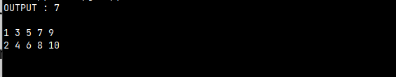
8.consider the tuple(12,7,38,56,78).WAP to print another tuple whose values are even number in the given tuple

print("OUTPUT 8")
tup1 = []
tup =(12, 7, 38, 56, 78)

for num in tup:

if num %2==0:
tup1.append(num)
tup1=tuple(tup1)
print(tup1)

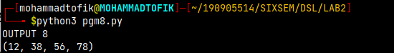
9.WAP to print negative number in a list using for loop Eg.[11,-21,0,45,66,-93]

print("OUTPUT : 9\n")
list= [11, -21, 0, 45, 66, -93]
for i in list:
if i<0:
print(i)
print("\n\n")

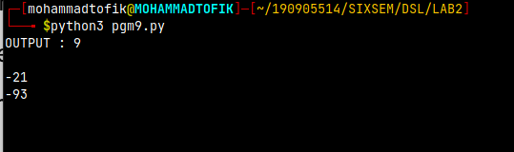
10.WAP to print negative number in a list using while loop

print("OUPUT : 11\n")
list1 = [11, -21, 0, 45, 66, -93]
n=len(list1)
i=0;
while(i<n):

if list1[i] < 0:
print(list1[i], end = " ")
i=i+1
print("\n")

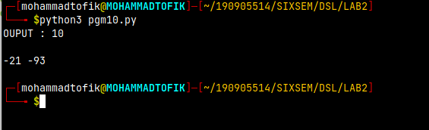

11.WAP to to count positive and negative number in a list

print("OUTPUT : 11 \n")
list1 = [11, 21, 0, 45, 66, 93]
e=0
o=0;
for num in list1:

if num %2 == 0:
e=e+1;
o=o+1;
print("Number of Even Numbers: ",e)
print("Number of Odd Numbers: ",o)
print("\n\n")

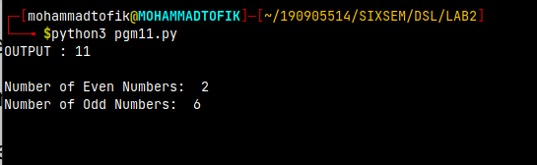
12.WAP to remove all even elements from the list

print("OUTPUT : 12\n")
list = [11, 22, 33, 44, 55]

print (list)

for i in list:
if(i%2 == 0):
list.remove(i)
print ("list after removing even numbers:")
print (list)
print("\n\n")

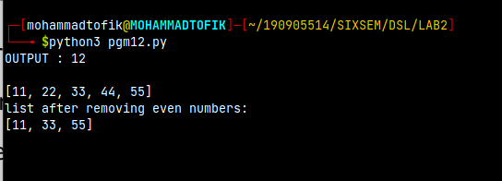
13.Define a dictionary containing Student data {Name, Height, Qualification}
(a)Convert the dictionary into data frame
(b)Declare a list that is to be converted into new column(Address)
(c)Using address as the column name and equate it to the list and display the result.

import pandas as pd
print("OUTPUT : 13\n")
dict={"Name":["Ram","Shyam","Mohan"],"Height":[150,120,170],"Qualification":["UG","PG","PhD"]}
df=pd.DataFrame(dict)
print(df)
address=["Delhi","Mumbai","Hyderabad"]
print("\nAppending address:- ")
df['Address']=address
print(df)
print("\n\n")

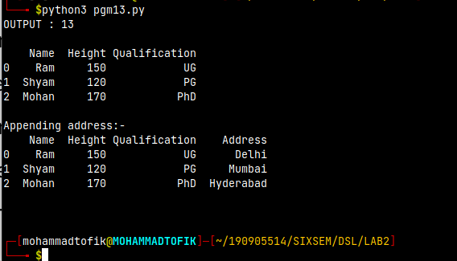
14.Define a dictionary containign student data{Name, Height, Qualification}
(a)Convert the dictionary into DataFrame
(b)Use DataFrame.insert() to add a column and display the result

import pandas as pd
print("OUTPUT : 14 \n")
dict={"Name":["Ram","Shyam","Mohan"],"Height":[150,120,170],"Qualification":["UG","PG","PhD"]}
df=pd.DataFrame(dict)
print(df)
print("\nAppending column using insert()")
gpa=[10,9,8]
df.insert(3, "GPA", gpa, allow_duplicates = False)
print(df)
print("\n")

