190905514 MOHAMMAD TOFIK BATCH : C2
SECTION : C SEM : 6th ROLLNO : 62

WEEK1-DS-LAB
LAB EXCERCISE :

(1).Assign to Variable

from typing import Counter
counter = 100
miles = 1000
name = "Mohammad Tofik"
print(counter)
print(miles)
print(name)

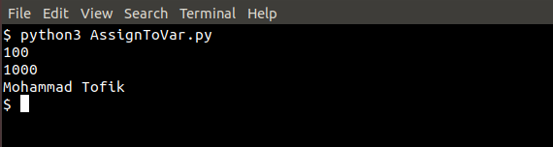

(2).Multiple Assignment
a = b = c = 1
a, b, c = 1, 2, "john"
print(a)

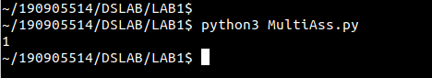

(3).Numbers

a = 5
b = 4.56
print(5 * a)
print(a / 2)
print(a ** 2)

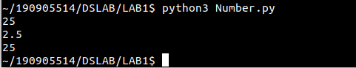

(4).Python Strings:

str = 'Hello Wolrd'
print(str)
print(str[0])
print(str[2:5])
print(str[2:])
print(str * 2)
print(str + "TEST")

var1 = 'Hello Wolrd'
print('Updated String is :',var1[:6] + 'Python')

print("My name is = %s and weight is = %d !" %('Anitha', 55))

str = "this is string example"
print(str.capitalize())
print(str.count('s'))

print(str.find('example'))

print(str.replace("is","was"))

str = "this is string example ... wow!!!"
print(str.swapcase())

str = "this is string example...wow"
print(str.title())

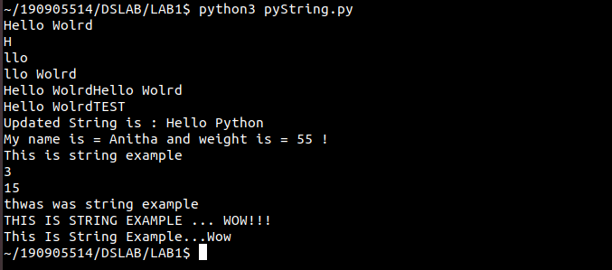

(5).Python Lists :

list = ['abcd', 786, 2.23, 'john', 70.2]
tinyList = [123, 'john']
print(list)
print(list[0])
print(list[1:3])
print(list[2:])
print(tinyList * 2)
print(list + tinyList)

list =['physics','chemistry',1997,2000]
print(list)
list.append('maths')
print(list)
print(list.count('physics'))

list = ['physics', 'chemistry', 1997, 2000]
list.pop()
print(list)

list = ['physics','chemistry',1997,2000]
list.insert(2,'maths')
print(list)

list = ['physics','chemistry',1997,2000]
list.remove('chemistry')
print(list)

list = ['physics','chemistry',1997,2000]
list.reverse()
print(list)

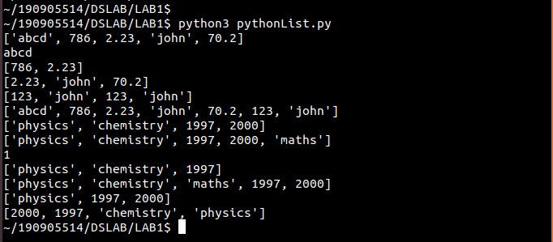
(6).Python tuples:
tuple = ('abcd', 786, 2.23, 'jhon', 70.2)
list = [ 'abcd', 768, 2.23, 'john', 70.2]
list[2] = 1000
print(list)
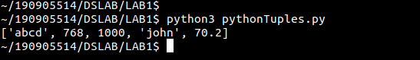

(7)
num = float(input('Enter a number : '))
if num > 0 :
print("Pos number ")
elif num == 0:
print('Zero')
else:
print('Negative Number')

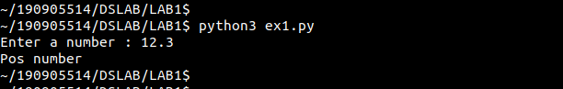
(8)
x = float(input('Enter a number'))
if x < 0:
print("smaller")
if x > 20:
print('Bigger')
print('Finished')

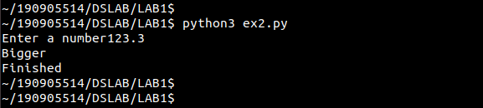

(9)
x = 5
print('Before 5')
if x == 5:
print('This is 5')
print('Stil 5')
print('After 5')
print('Before 6')
if x == 6:
print('This is 6')
print('After 6')

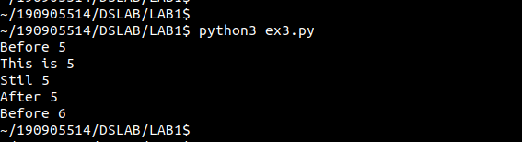

(10)
x = float(input('Enter a number'))
if x < 20:
print('Below 20')
elif x < 10:
print('Below 10')
else:
print('Something else')
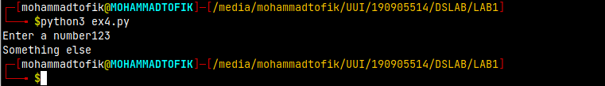

(11)
x = 42
if x > 1:
print('Above one')
if x < 100:
print('Less than 100')
print('All done')

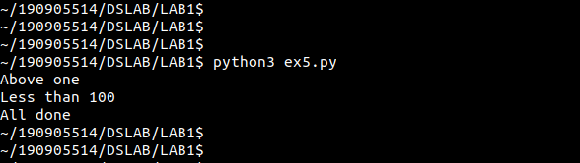

(12)
age = 15
b = ('kid' if age < 18 else 'adult')
print(b)

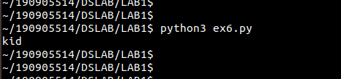

(13)
for val in [5, 4, 3, 2, 1]:
print(val)
print('Done')

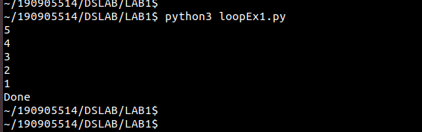

(14)
stud = ['Ram','Rahul', 'Anu','Ramesh','Suja']
for k in stud:
print("Hello:",k)
print('Done')

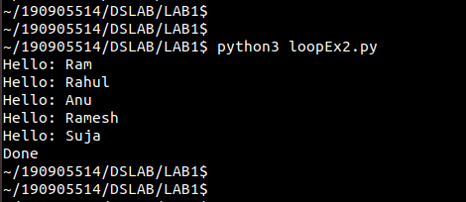

(15)
for i in range(5):
print(i)
if i > 2:
print("Bigger than 2")
print("Done with i", i)

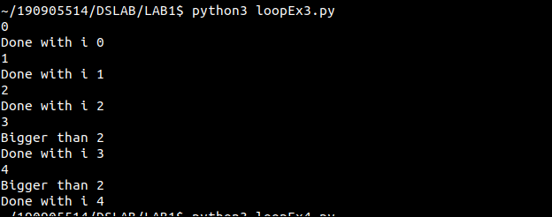
(16)
x = int(input('Enter a number :'))
for i in range(1,x+1):
if x%i ==0:
print(i)

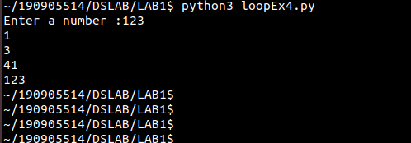

(17)
from math import *
x = [9, 41, 12, 3, 74, 15]
Largest = - inf
for i in x:
if i > Largest:
Largest =i
print(Largest)

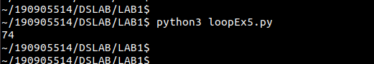
(18)
from math import *
x= [9, 41, 12, 3, 74, 15]
smallest = inf
for i in x:
if i<smallest:
smallest=i
print(smallest)

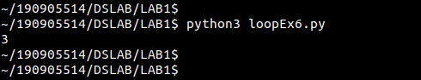

(19)
x = [9, 41, 12, 3, 74, 15]
count = sum = avg = 0
for i in x:
count=count+1
sum=sum+1
avg = sum / count
print(count)
print(sum)
print(avg)

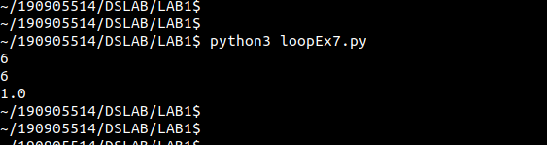
(20)
x = [9, 41, 12, 3, 74, 15]
for i in x:
if i>20:
print (i)

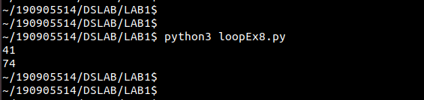

(21)
x = [9, 41, 12, 3, 74, 15]
res = [100]
for i in x:
if i>20:
res.append(i)
print(i)

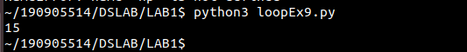

(22)
import numpy as np
x = [9, 41, 12, 3, 74, 74, 15]
y = np.zeros(len(x ))
for i in range(len(x)):
if x[i] > 20:
y[i]=x[i]
print(y)

