Mobile Maquette

Homepage :

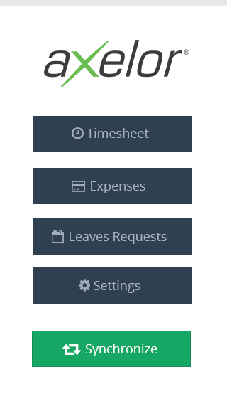

Design :
Font : Open sans, regular;
Background-color : #fff;
line top color : #e7e7e7;

Timesheet, Expenses & Settings button :
background-color : #2f4050;
color : #a7b1c2;
(no border)

Synchronize button :
background-color : #16a765;
border : 1px solid #139057;

Timesheet Menu

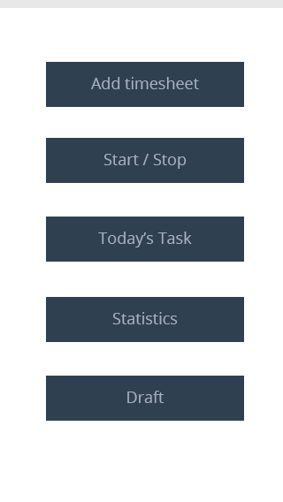

Design :
Background-color : #fff;
line top color : #e7e7e7;

Buttons :
background-color : #2f4050;
color : #a7b1c2;

Add Timesheet :
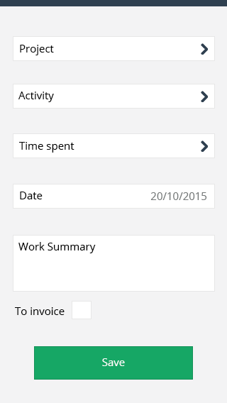

Design :
Background-color : #f3f3f4;
line top color : #2f4050;

Input :
background-color : #fff;
border: 1px solid #e7e7e7;
input label color : #000;
input color text : #757979;

Save button :
background-color : #16a765;
border-color : #139057;

Checkbox “To Invoice” :
background-color : #fff;
border: 1px solid #e7e7e7;

On hover :

border : 1px solid : #139057;

When checked :

background-color : 1px solid #139057;
color : #fff;

Add this icon when user can only select answer (he can’t write) :
 color : #2f4050;

On click on this icon (and input) , this type of list of selection appears :

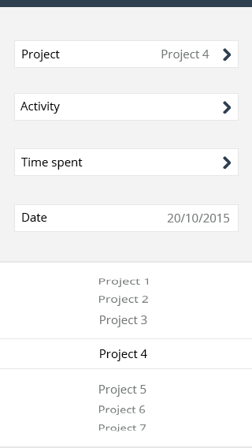
 | Project will be synchronized from ERP (will be the same for every input with selection).

Border : 2px solid #e7e7e7;
background-color : #fff;
Color text : #757979

Selectioned :
Color text : #000;
border : 1px solid #e7e7e7;



It will be the same for Activity, Time spent (from 01 to 24 hours, and from 00 to 59 minutes).
? Activity will be synchronized from ERP ?

Input date : today’s date by default. On click on date’s input :

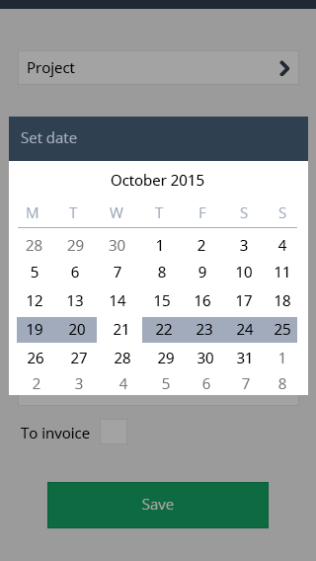

background-color : #000 with opacity

Header :
Background-color : #2f4050:
Color : #a1abbc;

Background-color : #fff;
Color : #000 (actuel month’s days), #757979 (last month and next month), #a1abbc title (monday, tuesday …)
background-color line day selected : #a1abbc;

Time sheet start :

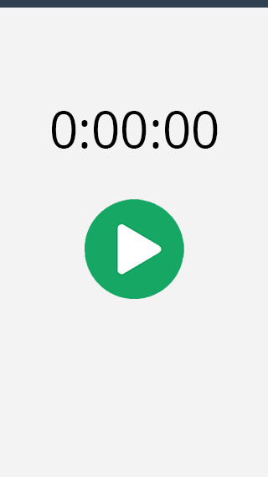

Timesheet stop :

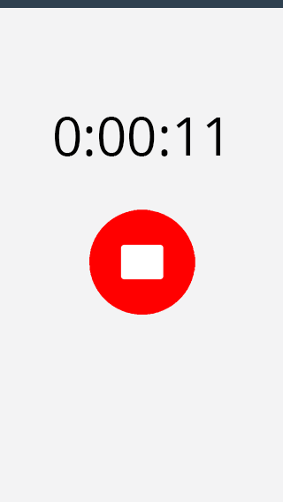

When user quit his application (and if he has started this timer), the timer will continue to run.
If he opens his application, he will directly be on this page.

When user ckick on this button “stop”, he will automatically be redirected to the “Add timesheet” page, and it will automatically add on the input “Time spent” his time spent :

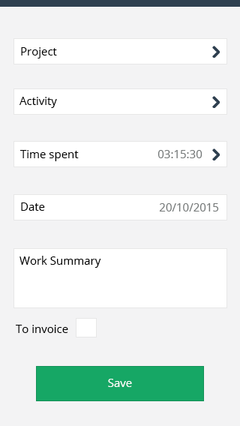

My planned tasks :

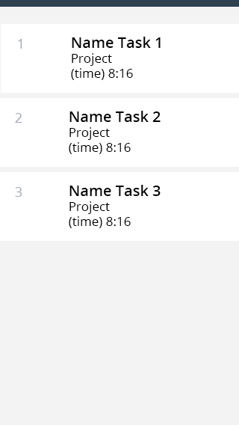

Color task’s number : #a1abbc;
Color text : #000;
? We agreed to not have tasks. I think the tasks should be replaced by activities. ?

Timesheet Statistics :

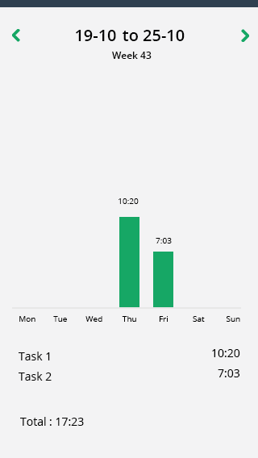

It shows how many hours user worked (by week).
Green color : #16a765;
? The app will statistics timesheet only upon local data or all data via WS ?

Timesheet Draft :

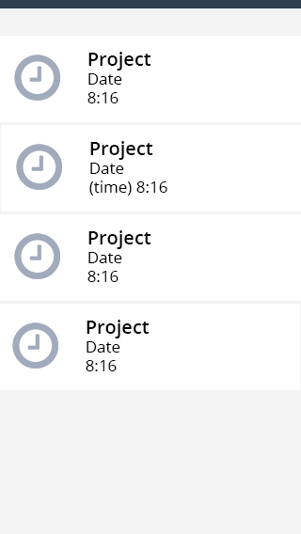

List of Timesheet created.
 | When user synchronize (principal menu) with ERP, every timesheet created will be imported in ERP, and will disappear from his mobile application since he won’t have the possibily to change timesheet.  ? Synchronzied timesheet will be disappeared only from draft page or other pages as well such as “Today’s task”? Because it’s wired if the synchronized timesheet will disappear from the app definetely.

Expense menu :

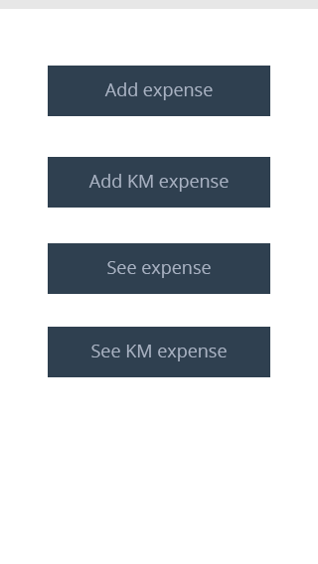

Add Expense :

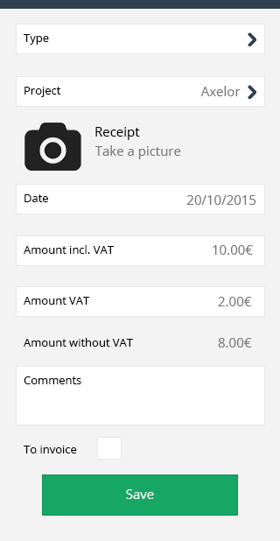

Amount without VAT is not editable, it is automatically calculate.
Date automatically add on today.
? VAT is always 20% ?

Add KM expense :
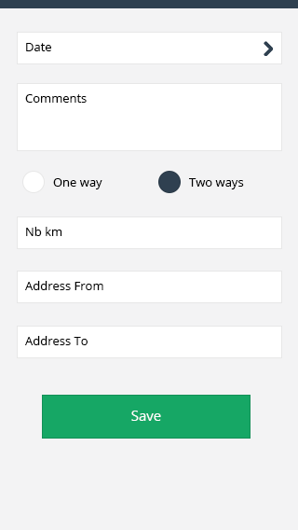

Radio button :
Color when selected : #2f4050;

See expenses :

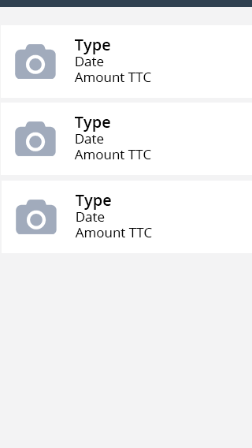

icon’s color : #a1abbc;

? if expense item is clicked, then detail page will appear or not? need to create edit form as well ?

See KM expense :

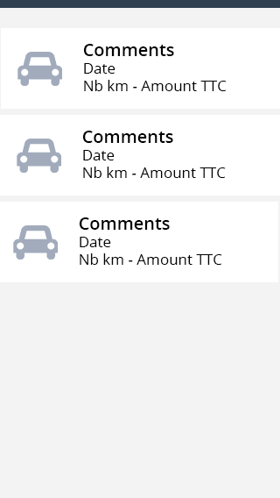

icon’s color : #a1abbc;

Settings :

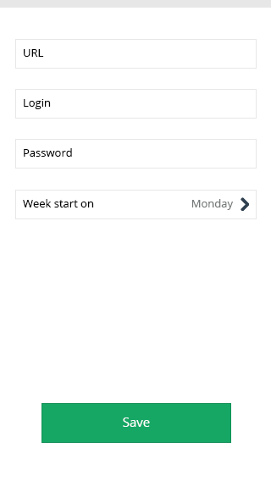

My profile : information came from ERP, and are not editable.

Input “Week start on” : user can choose when his week start (for example, if he choose to start his week on Sunday, it will change the view of timesheet statistics).

Synchronize :

When user click on synchornize (principal menu), this pop up appears :

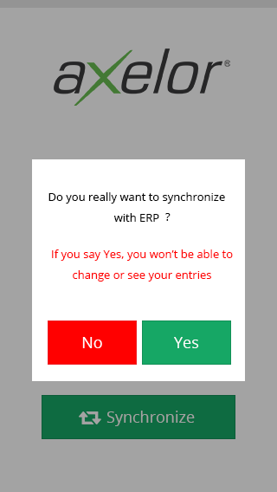

background pop up : #000 with opacity

Background pop up : #fff;
(no border)
Color : #000(black), #ff0000 (red)
Red button : #ff0000;
Green button : color #16a765, border : 1px solid #139057

? There are a need two types of synchronization functions.
ERP to APP - get project, expense types, profile information
APP to ERP - put timesheet records and expense records
When can I get such APIs? The backend developer knows which input and output will have each apis or I need to talk to him about details. ?

Add Leave Request :
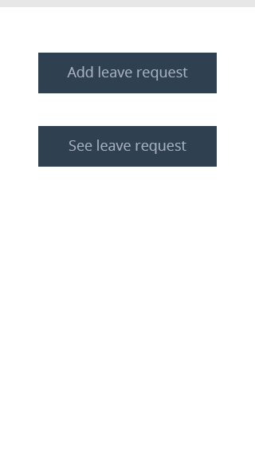

Add leave request :
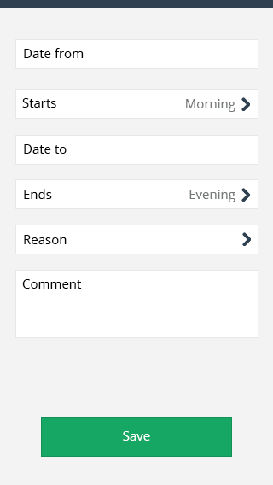

Date from / date to : select date works the same as select date’s timesheet
Starts / ends : can only choose between “Morning” or “Evening”, it works the same as timesheet’s select project. By default, starts on “morning” and ends on “evening”
Reason : Select value from ERP

See leave request :

