

|  |  |  |
| --- | --- | --- |
| |  | | --- | |  | | **PES University, Bengaluru** |
|  | (Established under Karnataka Act 16 of 2013) |
| **Department of Computer Science & Engineering** | |
| **Session: Jan - May 2022** | |

**Object Oriented Analysis and Design with Java - Laboratory UE19CS353**

**Mini Project**

Report on

**EMPLOYEE PAYROLL SYSTEM**

**By:**

**PRAVEEN OBLI VENKATESH – PES1UUG19CS350**

**PRATIKSHA D NAYAK - PES1UUG19CS349**

**PRUTHVI G KARIGIRI - PES1UUG19CS354**

**6th Semester ‘F’**

1. **Project Description**

The main objective of the Java Project on Payroll Management System is to manage the details of Employees, Payments, Salary. It also manages all information about the Employee, Payroll and Salary Slips. The project is totally built at administrator end of things. Only the administrator is guaranteed the access. The purpose of the project is to build an application that reduces the manual work .

We introduced Java Employee Payroll Management System (Payroll System) using SQLITE database that was developed using Java Netbeans.

The GUI components used to achieve our project is

JButton ,JTable, IText, JComboBox, JLabel ,JRadioButton ,JFrame, JPanel, Image Icons

JTextField.

Functions used

Add Record

Deleted Record

Update Record

Clear Fields

Login

Logout

Date & Time

PDF

Functionalists provided by the Java Project on Employee Payroll Management System.

Provides search facility such as searching for Employees, Salaries and reports.

Tracks all salaries and employee payments.

     Stores all information about employees to a secure Sql database.

     Manages all information of Employees.

     Simple GUI.

     Editing, adding, deleting and updating records couldn't be easier.

     Manages all information of employees salaries.

    Audit Trail to monitor activities.

    Manages all information of employee payslips.

    Manages all information of employee allowance.

    Manages all information of employee deduction.

1. **Analysis and Design Models**

**//add Usecase diagram, class diagram**

**USE CASE DIAGRAM**

**CLASS DIAGRAM**

**// State diagram for the classes with temporal behaviour**

**STATE DIAGRAM**

**//Activity diagram for the usecases implemented**

**ACTIVITY DIAGRAM**

1. **Tools and Frameworks Used:**

**sqlite(jdbc):**

Sqlite is a database tool which is very handy especially when using development environment like the one used in our project(netbeans). It has a very useful browse bar to search all tables in the database.

**Javax.imageIO:**

This package contains the basic classes and interfaces for describing the contents of image files, including metadata and thumbnails; for controlling the image reading process (ImageReader, ImageReadParam, and ImageTypeSpecifier) and image writing process (ImageWriter and ImageWriteParam); for performing transcoding between formats (ImageTranscoder), and for reporting errors (IIOException).

**JavaX.Swing:**

Provides interfaces that enable the development of input methods that can be used with any Java runtime environment. Provides a set of "lightweight" (all-Java language) components that, to the maximum degree possible, work the same on all platforms.

**Netbeans:**

It is a java development environment which is easy to implement front end and easy to install and implement the various extensions and packages required for the project.

1. **Design Principles and Design Patterns Applied**

**Singelton Design Pattern:**

This design pattern is implemented for the database connection class where only one instance can be created.

**Highlight any 2 design principles followed in your design**

**Single Principle:**

In addEmployee Only one responsibility is added which is to add employees.

**Open Close Principle:**

JFrame is extended by other classes and is then used by other classes. JFrame itself is not modified but the other classes that extend can use it in the desired way.

1. **Application Screenshots (3-4 important pages)**

**// screen shots of major usecases**

**//label all the screenshots**



Login page

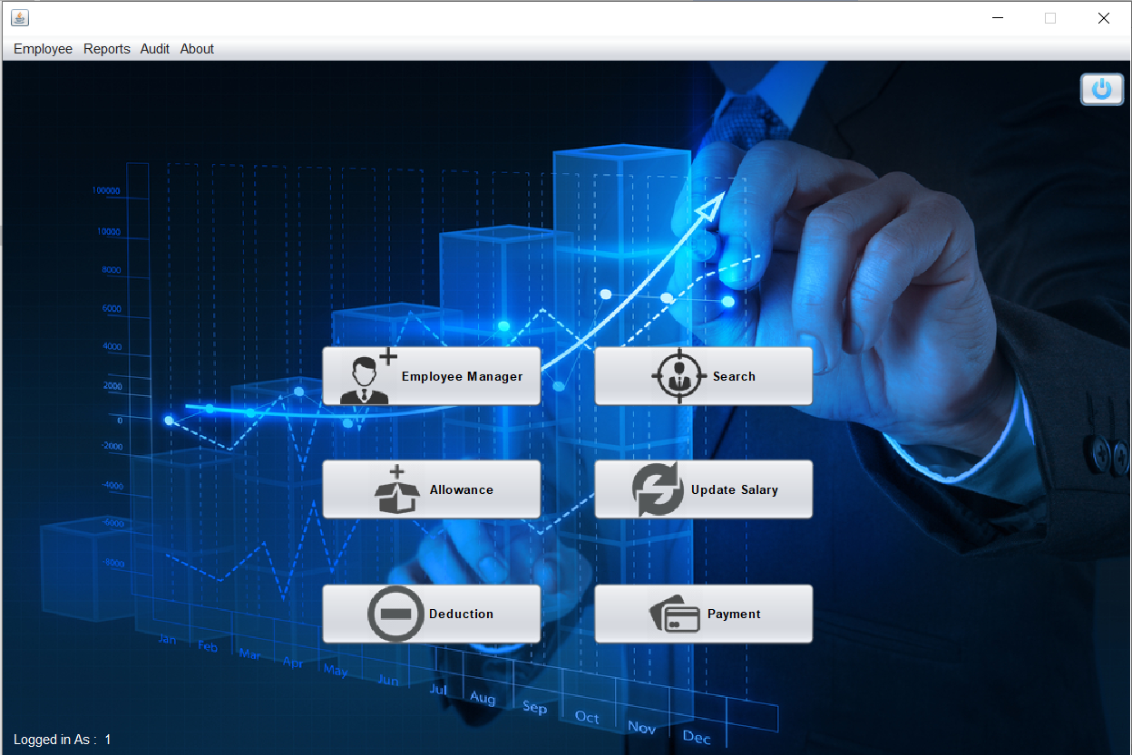

Main Menu

Add Employee

Search

Payslip

1. **Team member contributions**

|  |  |
| --- | --- |
| **NAME** | **CONTRIBUTION** |
| PRATIKSHA D NAYAK | User interface and payslip(including manage allowance, etc) |
| PRAVEEN V O | CONNECTION TO DATABASE |
| PRUTHVI G. K | Employee Information(including add, change, view, etc) |