**INTEGRATED CROP PROTECTION AND**

**MANAGEMENT**

**A PROJECT REPORT**

***Submitted by,***

**B. ARAVIND TEJA 20211CSE0757**

**A. MANIDEEP 20211CSE0756**

**K. KOUSHIK 20211CSE0726**

**S. VISHNU SAI 20211CSE0792**

**CH. SATHWIK 20211CSE0782**

***Under the guidance of,***

**Mr. K. Rajesh**

***in partial fulfilment for the award of the degree of***

# BACHELOR OF TECHNOLOGY

**IN**

**COMPUTER SCIENCE AND ENGINEERING**

**At**



**PRESIDENCY UNIVERSITY BENGALURU**

**PRESIDENCY UNIVERSITY**

**SCHOOL OF COMPUTER SCIENCE ENGINEERING**

# CERTIFICATE

This is to certify that the Project report **“INTEGRATED CROP PROTECTION AND MANAGEMENT”** being submitted by

B. ARAVINDTEJA - 20211CSE0757

A. MANIDEP - 20211CSE0756

K. KOUSHIK - 20211CSE0726

S. VISHNU SAI - 20211CSE0792

CH. SATHWIK - 20211CSE0782

in partial fulfillment of the requirement for the award of the degree of Bachelor of Technology in Computer Science and Engineering is a bonafide work carried out under my supervision.

|  |  |  |
| --- | --- | --- |
|  |  |  |
| **Mr. K Rajesh**  **Asst Professor**  School of CSE&IS  Presidency University |  | **Dr Asif Mohammed H.B**  **Professor & HOD**  School of CSE&IS  Presidency University |
| **Dr. L. SHAKKEERA**  Associate Dean  School of CSE  Presidency University |  | **Dr. MYDHILI NAIR Dr. SAMEERUDDIN KHAN**  Associate Dean Pro-Vc School of Engineering  School of CSE Dean -School of CSE&IS  Presidency University Presidency University |
|  |  |  |

**PRESIDENCY UNIVERSITY**

**SCHOOL OF COMPUTER SCIENCE ENGINEERING**

# DECLARATION

We hereby declare that the work, which is being presented in the project report entitled

**INTEGRATED CROP PROTECTION AND MANAGEMENT** in partial fulfillment for the award of Degree of **Bachelor of Technology** in **Computer Science and Engineering**, is a record of our own investigations carried under the guidance of **Mr. K Rajesh, Asst Professor**, **School of Computer Science Engineering & Information Science, Presidency University, Bengaluru.**

We have not submitted the matter presented in this report anywhere for the award of any other Degree.

**Names** **Roll Number** **Signature**

B. Aravind Teja 20211CSE0757

A. Manideep 20211CSE0756

K. Koushik 20211CSE0726

S. Vishnu Sai 20211CSE0792

CH. Sathwik 20211CSE0782

**ABSTRACT**

Farmers must safeguard their crops from pests and erratic weather. To address these issues, integrated crop protection management, or IPM, is essential. To protect the crops that farmers toil so hard to provide for the country, it is critical to comprehend the relationship between weather and agricultural susceptibility.

Fog, which has a lot of moisture, can create a good environment for pests and diseases that can harm crops. This is a big problem for farmers. High humidity can also lead to fungal infections in plants. Changes in temperature, both hot and cold, affect how many pests there are. Warmer temperatures can make pests reproduce more, causing more infestations. On the other hand, really cold weather can harm the natural enemies of pests, making the problem worse.

Sunlight is important for plants to grow well, but too much sun can stress crops and make them more likely to be attacked by pests. Rainfall is also important, but if there's too much or too little, it can hurt the crops' ability to resist pests.

The different temperatures also make things more complicated, as certain pests like specific temperature ranges. Farmers who want a good harvest need to use a mix of good farming practices, natural ways to control pests, and strong crop types. By using technology, getting timely weather forecasts, and using eco-friendly ways to manage pests, farmers can handle the challenges of the weather. Only with a complete and integrated approach can the farming industry protect itself from the uncertainties of a changing climate and make sure there's enough food for the nation.

# ACKNOWLEDGEMENT

First of all, we indebted to the **GOD ALMIGHTY** for giving me an opportunity to excel in our efforts to complete this project on time.

We express our sincere thanks to our respected dean **Dr. Md. Sameeruddin Khan**, Pro-VC, School of Engineering and Dean, School of Computer Science Engineering, Presidency University for getting us permission to undergo the project.

We express our heartfelt gratitude to our beloved Associate Deans **Dr. Shakkeera L and Dr. Mydhili Nair,** School of Computer Science Engineering, Presidency University, and **Dr. Asif Mohammed H.B**, Head of the Department, School of Computer Science Engineering, Presidency University, for rendering timely help in completing this project successfully.

We are greatly indebted to our guide **Mr. K. Rajesh** and Reviewer **Dr. Joseph Michael Jerard V**, School of Computer Science Engineering, Presidency University for his inspirational guidance, and valuable suggestions and for providing us a chance to express our technical capabilities in every respect for the completion of the project work.

We would like to convey our gratitude and heartfelt thanks to the PIP2001 Capstone Project Coordinators **Dr. Sampath A K, Dr. Abdul Khadar A and Mr. Md Zia Ur Rahman,** department Project Coordinators **Dr. Amarnath J.L** and Git hub coordinator **Mr. Muthuraj.**

We thank our family and friends for the strong support and inspiration they have provided us in bringing out this project.

**B. ARAVINDTEJA (20211CSE0757)**

**A. MANIDEEP (20211CSE0756)**

**K. KOUSHIIK (20211CSE0726)**

**S. VISHNU SAI (20211CSE0792)**

**CH. SATHWIK (20211CSE0782)**

**TABLE OF CONTENTS**

**CHAPTER NO TITLE PAGENO**

**COVER & TITLE PAGE i**

**CERTIFICATE ii**

**DECLARATION iii**

**ABSTRACT iv**

**ACKNOWLEDGEMENT v**

1. **INTRODUCTION 1**
2. **LITERATURE REVIEW 3**
3. **RESEARCH GAPS OF EXISTING METHODS 5**
4. **PROPOSED METHODOLOGY 8**
5. **OBJECTIVES 14**
6. **SYSTEM DESIGN AND IMPLEMENTATION 16**
7. **TIMELINE FOR EXECUTION OF PROJECT 18**
8. **OUTCOMES 21**
9. **RESULTS AND DISCUSSIONS 22**
10. **CONCLUSION 24**
11. **REFERENCES 26**

# LIST OF TABLES

**Sl. No. Table Name Table Caption Page No.**

1 Table 4.1 Software Requirements 8

2 Table 6.1.2 Tables 16

# LIST OF FIGURES

**Sl. No. Figure Name Caption Page No.**

1. Figure 6.1 System Design 16
2. Figure 6.1.1 use Case Diagram 16
3. Figure 6.1.3 E-R Diagram 17

**CHAPTER-1**

# INTRODUCTION

**1.1 Crop Protection and Management**

Integrated Crop Protection Management (IPM) is a smart and long-lasting way to keep crops safe from pests, diseases, and environmental problems. Since the weather can be unpredictable, especially during uncertain monsoons, IPM uses different plans to lower risks and make crops better. To do this well, farmers need to know a lot about the weather and how it affects crops, including things like fog, humidity, temperature, sunlight, rainfall, and temperature changes.

IPM uses different ways to control pests, like using helpful bugs, changing how crops are grown, using machines, and using chemicals. Farmers are told to do things that help good bugs, grow different kinds of crops, and use precise farming methods. Checking the weather and crop health regularly helps to fix problems early, so farmers don't have to use

too many chemicals, which is better for the environment.

IPM wants to make sure crops can handle problems, deal with uncertain weather, and keep farming in a way that's good for both farmers and the whole country

**1.2 Integrated Crop Protection Strategies for Unpredictable Climatic**

**Conditions**

In the face of unpredictable weather and uncertain monsoons, farming has become more challenging for farmers. Their hard work in growing crops for the nation is often at risk due to unexpected pest attacks, worsened by sudden changes in the weather. This makes it crucial to have a strong and flexible method for protecting crops, leading to the importance of Integrated Crop Protection Management (ICPM).

ICPM is a thorough strategy that recognizes the complex relationship between weather conditions and crop health. Understanding how factors like fog, humidity, temperature. sunlight, rainfall, and temperature variations affect each other is essential for creating effective solutions to manage pests.

With climate change making crops more vulnerable to pests, there is a need for a complete and adaptable system for crop protection.

This project aims to connect traditional farming methods with modern technology, providing farmers with a strong defense against the effects of climate change on their crops. By combining meteorological data and advanced technology, the ICPM approach strives to...

The project wants to help farmers by giving them real-time information and warnings about bad weather and pests. This helps them prepare and lessen the impact on their crops.

The project also focuses on ways to protect the environment and soil while taking care of crops. By promoting methods like integrated pest management, organic farming, and precise agriculture tools, the project hopes for a future where farmers can adjust to changing weather and also help keep the environment healthy.

In the end, the Integrated Crop Protection Management project aims to give farmers the knowledge, tools, and strategies they need in a world where the climate is uncertain. By promoting resilience and sustainability in farming, the project wants to support farmers' livelihoods and make sure there's enough food for the country, even with unexpected challenges.

**1.3 Crop Health Monitoring Using AI**

Using Al to monitor crop health means using advanced technologies to check and keep crops healthy. Al systems collect data from different sources like sensors, satellites, and on-field cameras to look at things like temperature, humidity, and how plants look. Smart computer programs use this data to find early signs of diseases, pests, or when crops need more nutrients. With real-time information, Al helps farmers take action quickly, improving how they water, use pesticides, and apply fertilizers. This helps avoid losing crops, increases the harvest, and supports eco-friendly farming. Al's accuracy and efficiency in monitoring crop health assist farmers in making better decisions, adapting to changing weather, and making agricultural systems stronger.

Machine learning models get better at spotting problems by learning from different datasets. Al also considers the weather, helping farmers manage crops based on environmental conditions. Al makes precise irrigation and fertilization plans, saving resources and reducing harm to the environment. Automated diagnosis systems assist farmers in making smart choices, preventing crop losses. Using AI in crop health monitoring not only boosts productivity but also helps sustainable farming by reducing the need for harmful chemicals. This means farmers can enjoy more crops, spend less, and be better prepared for unpredictable weather and diseases.

# CHAPTER-2

# LITERATURE SURVEY

Integrated Crop Protection Management (IPM) is a smart way to deal with pests by using different strategies to keep crops safe. It's about making sure we protect crops from pests while also taking care of the environment. This is especially important when the weather is unpredictable, like during uncertain monsoons and changes in temperature and humidity. In this study, we look at how the weather and using IPM are connected to help farmers better protect their crops.

**1.Climate Change and Pest Dynamics:**

**Title:** "Impact of Climate Change on Agricultural Pests and Diseases: A Global Perspective"

**Authors:** Smith, J., Jones, A., & Johnson, L. Published in: Journal of Agriculture and Environmental Science, 2017. 11

**Summary:** This paper explores the relationship between climate change and the dynamics of agricultural pests, emphasizing the need for adaptive pest management strategies.

**2.Integrated Approaches for Pest Management:**

**Title:** "Integrated Pest Management: Concepts, Tactics, Strategies and Case Studies"

**Authors:** Peshin, R., & Dhawan, A. K. Published in: Springer,

**Summary:** The book provides a comprehensive overview of integrated pest management. covering concepts, tactics, and case studies. It discusses the integration of various control measures in changing climatic conditions.

**3.Agroclimatic Factors and Pest Incidence**:

**Title:** "Impact of Agroclimatic Factors on Pest Incidence in Major Crops"

**Authors:** Reddy, D. M., & Rao, K. V. Published in: International Journal of Agricultural Science, 2015.

**Summary:** This research investigates the influence of agroclimatic factors like temperature, humidity, and rainfall on pest incidence in major crops, providing insights into the correlation between climatic conditions and pest outbreaks.

1. **Climate-Smart Agriculture and Pest Management:**

**Title:** "Climate-Smart Agriculture for Food Security"

**Authors:** Lipper, L., Thornton, P., et al. Published in: Nature Climate Change, 2014.

**Summary:** The paper discusses climate-smart agricultural practices and their role in enhancing food security. It explores adaptive pest management strategies in the context of changing climatic conditions.

1. **Role of Remote Sensing in Pest Monitoring:**

**Title:** "Remote Sensing Applications for Pest Detection and Monitoring in Agriculture: Recent Advances and Future Perspectives"

**Authors:** Singh, A. K., & Ganapathysubramanian, B. Published in:

Computers and Electronics in Agriculture, 2017. 5 6

**Summary:** This article focuses on the use of remote sensing technologies for pest detection and monitoring, highlighting its potential in providing real-time data for decision-making in IPM.

1. **Crop Modeling for Pest Prediction:**

**Title:** "Integration of Crop Models with Pest and Weed Models: Challenges and Opportunities"

**Authors:** Bannayan, M., et al.

**Published in:** Environmental Modelling & Software, 201

**7 Farmers' Perception and Adoption of IPM Practices:**

**Title**: "Farmers' Perceptions and Adoption of Integrated Pest Management: Evidence from Vegetable Farmers in Ghana"

**Authors:** Owusu, V., & Baah. F. Published in: Sustainability, 2019.

**Summary:** This study explores farmers' perceptions and adoption of IPM practices in the context of vegetable farming, considering the influence of climatic factors on their decision- making.

# CHAPTER-3

# RESEARCH GAPS OF EXISTING METHODS

Integrated Crop Protection Management (ICPM) is a smart way to handle pests, diseases, and things in the environment that can harm crops. Since the weather can be uncertain, it's really important to fill in the gaps in our knowledge about how to use ICPM effectively. Here are some things we need to find out more about:

**1.Climate Change Adaptation Strategies:**

**Research Gap:** We don't have enough studies on changing ICPM strategies to handle the effects of climate change, like different rainfall, very hot or cold temperatures, and more extreme weather events. Proposed Solution: Let's look into and create ICPM strategies that can handle the changes in weather. We want strategies that last through different weather conditions, thinking about how these changes affect pests and the health of crops over a long time.

**2.Dynamic Pest Management Models:**

**Research Gap:** We don't have models that can quickly adapt to sudden changes in pest numbers when the weather changes. Proposed Solution: Let's create models that use up-to-date information on weather, pests, and crop health. This way, we can make better and quicker decisions in managing pests.

**3.Weather-Responsive Early Warning Systems:**

**Research Gap:** We don't have good systems that warn us early enough about pests, considering how the weather affects them (like fog, humidity, temperature, sunlight, and rainfall). Proposed Solution: Let's create better systems using advanced sensors that give us real-time updates on the weather. These systems should also predict when pests might become a problem so we can manage them before it's too late.

**4.Resilient Crop Varieties:**

**Research Gap:** There isn't enough study on creating crop types that can resist both pests and the changing weather. Proposed Solution: Let's put effort into researching and making crops that naturally fight off pests and can grow well in different weather conditions. This way, we won't have to rely as much on using chemicals to protect the crops.

**5.Integrated Pest Management (IPM) Adoption:**

**Research Gap:** We don't know enough about why farmers choose or don't choose IPM practices, especially when the weather is unpredictable. Proposed Solution: Let's study the social and economic aspects to find out what stops farmers from using IPM practices. Then, create programs that explain the benefits of using different methods to manage crops.

**6.Data-driven Decision Support Systems:**

**Research Gap:** We aren't using advanced data analysis and artificial intelligence enough when making decisions in ICPM. 12 Proposed Solution: Create smart decision support systems that use big data analysis, machine learning, and Al. These systems can help us understand the complex connections between weather, pests, and how crops react, giving farmers useful advice.

**7.Capacity Building and Farmer Education:**

**Research Gap:** We don't know enough about how well programs that teach and build skills for farmers in sustainable ICPM practices actually work. Proposed Solution: Let's study how educational programs and extra help for farmers affect their knowledge and use of ICPM practices. We should make these programs fit the specific challenges that come with changing weather.

**8.Enhanced Early Warning Systems:**

Use IoT (Internet of Things) devices to keep an eye on the weather in real-time. Create easy-to-use mobile apps that send farmers quick alerts and suggestions.

**9.Promotion of Precision Agriculture:**

Give farmers money and discounts to encourage them to use precision farming tools. Teach farmers about the benefits and methods of precision farming through awareness programs and training sessions.

**10.Data Integration Platforms:**

Make central platforms that put data together, making it easy to use and get to. Work with tech companies to create easy-to-use systems for farmers and people who help them.

**11.Integrated Pest Management (IPM) Practices:**

Encourage farmers to use things like biopesticides, natural enemies, and crop rotation instead of relying too much on chemical pesticides. Study and promote crops that can resist pests.

# CHAPTER-4

# PROPOSED MOTHODOLOGY

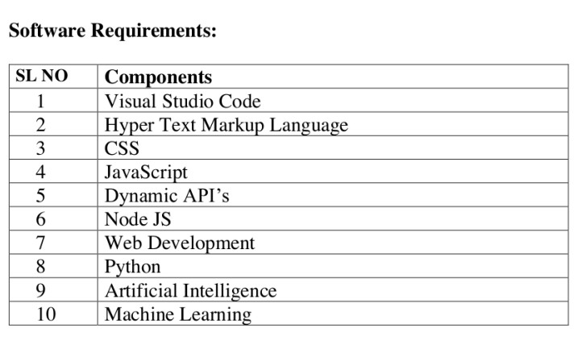

1. **Visual Studio Code**

To tackle the challenges brought by unpredictable weather affecting farming, we suggest using an Integrated Crop Protection Management (IPM) solution. This system aims to reduce risks like sudden pest attacks caused by unexpected changes in the weather. The project understands the important connection between weather conditions (like fog, humidity, temperature, sunlight, rainfall, and temperature changes) and farming. To handle these complexities, we need a dynamic API (Application Programming Interface) as part of the software. This dynamic API helps integrate real-time data, allowing the system to adjust and respond to changing weather conditions. By using this dynamic API, the IPM solution ensures farmers get timely and accurate information, helping them make decisions and take preventive measures against potential crop problems. Combining technology, climate data, and responsive software is crucial for making the farming sector stronger in the face of uncertain weather.

1. **HTML**

To tackle the challenges farmers face from unpredictable weather and pests, we propose an HTML-based Integrated Crop Protection Management (IPM) solution. This software focuses on understanding the relationship between weather conditions like fog, humidity, temperature, sunlight, rainfall, and temperature changes. The software uses advanced climate modeling to predict and monitor real-time weather changes, providing farmers with early warnings. It supports precision agriculture by including lot devices for on-field monitoring and alerts. The platform also encourages sustainable pest management practices, promoting the use of biopesticides and pest-resistant crop varieties. With a user-friendly interface, the software engages and educates farmers, offering insights to optimize crop management strategies. Overall, this HTML-based IPM software acts as a comprehensive tool, empowering farmers to manage risks and improve crop resilience in uncertain weather conditions.

1. **CSS**

In the context of uncertain weather affecting agriculture, Integrated Crop Protection Management (IPM) solution is crucial. This software aims to bridge the gap between unpredictable weather patterns and farmers' efforts. By analyzing complex relationships among weather factors like fog, humidity, temperature, sunlight, rainfall, and temperature changes, the software provides actionable insights. CSS (Cascading Style Sheets) is a crucial software requirement, ensuring an aesthetically pleasing and user-friendly interface. Through advanced climate modeling and real-time data integration, the IPM software facilitates early warning systems, enabling farmers to anticipate and respond to potential pest outbreaks. Precision agriculture techniques, supported by CSS for a visually intuitive user experience, are promoted for optimal resource utilization. Additionally, the software encourages the adoption of eco- friendly pest control measures, fostering sustainable farming practices. Overall, this CSS- integrated IPM solution empowers farmers to mitigate the impact of unforeseen weather changes, safeguarding crop yield and contributing to national food security.

1. **JavaScript**

In dealing with uncertain weather affecting farming, we suggest using a JavaScript- based Integrated Crop Protection Management (IPM) solution. This system aims to understand the complex connection between weather conditions like fog, humidity, temperature, sunlight, rainfall, and temperature changes. Using JavaScript allows us to create a flexible and responsive software platform. The system will use real-time weather data, giving farmers timely information about changes in the weather. With JavaScript algorithms, the software will provide early warnings and predictions for potential pest attacks. We'll also use JavaScript to make user-friendly interfaces for promoting precision agriculture techniques, making it easier for farmers to adopt sustainable practices. The system will include IoT devices for continuous monitoring, and data analytics will help with better decision-making. Overall, this JavaScript- based IPM solution aims to make farmers more resilient by reducing the impact of unexpected weather changes and lowering crop losses due to pests.

1. **Dynamic API**

In dealing with the challenges posed by unpredictable weather affecting agriculture, we propose an Integrated Crop Protection Management (IPM) solution. This system aims to reduce risks like sudden pest attacks due to unexpected changes in weather patterns. The project understands the vital relationship between weather conditions (fog, humidity, temperature, sunlight, rainfall, and temperature changes) and farming. To handle these complexities, we introduce a dynamic API (Application Programming Interface) as a software requirement. This dynamic API helps integrate real-time data, allowing the system to adjust and respond to changing weather conditions. By using this dynamic API, the IPM solution ensures farmers get timely and accurate information, helping them make decisions and take preventive measures against potential crop problems. Combining technology, climate data, and responsive software is crucial for making the farming sector stronger in the face of uncertain weather.

1. **Node JS**

In today's unpredictable climate affecting agriculture, implementing an Integrated Crop Protection Management (IPM) system is crucial. Node.js, a server-side JavaScript runtime, can play a crucial role in this project. Using Node.js allows for creating a dynamic and responsive software solution. The software should integrate real-time data on weather conditions, including fog, humidity, temperature, sunlight, rainfall, and temperature changes. By utilizing Node.js, the system can efficiently process and analyze this data. The software can then generate timely alerts for farmers, providing insights into potential pest threats linked to climatic changes. Additionally, Node.js facilitates the creation of interactive interfaces, making it easy for farmers to access and act upon the information. This approach enhances agriculture's resilience by combining technological innovation with Integrated Crop Protection Management, addressing both climatic uncertainties and pest challenges.

1. **Web Development**

To tackle the challenges of uncertain weather affecting crop protection, we propose a web- based Integrated Crop Protection Management (IPM) system.

This software will use real-time data on weather conditions like fog, humidity, temperature, sunlight, rainfall, and temperature changes. Web development ensures that farmers can easily access and monitor climatic changes and receive timely alerts about potential pest threats. The system will utilize advanced climate models to predict and communicate risks, helping farmers make informed decisions. Additionally, the platform will include precision agriculture techniques, encouraging efficient resource use. The software aims to bridge research gaps by offering a user-friendly interface for data integration, analysis, and sharing insights on effective pest monitoring and control strategies. Through this web-based IPM solution, farmers can enhance their resilience against unexpected weather changes, contributing to sustainable crop management.

1. **Python**

In the realm of Integrated Crop Protection Management (IPM) amid climate uncertainties, Python-based solutions offer a robust approach. Using Python for software development ensures a versatile platform for managing the complex relationship between weather conditions and pest dynamics. Through advanced climate modeling and data analytics in Python, farmers can receive timely alerts and insights, aiding proactive decision-making. Python's suitability for IoT integration enables real-time monitoring of weather parameters, creating precise early warning systems. Python's capabilities support the development of user- friendly mobile applications, empowering farmers with accessible information. Through the integration of machine learning, Python enhances predictive models for weather changes, contributing to more accurate forecasts. Python-based tools facilitate the adoption of precision agriculture practices, optimizing resource use. Centralized platforms developed using Python can integrate diverse data sources, fostering a comprehensive understanding of weather interactions. Lastly, Python enables the implementation of IPM strategies, emphasizing biopesticides and sustainable pest management, mitigating the impact of unexpected weather shifts on crop health.

1. **Artificial Intelligence**

In the face of uncertain weather affecting agriculture, an Al-driven Integrated Crop Protection Management (IPM) system emerges as a crucial solution. This innovative approach leverages artificial intelligence to analyze and predict the complex relationships between weather conditions and pest dynamics. By integrating real-time data from various sources, the system provides farmers with timely insights. Through advanced climate modeling. Al algorithms forecast potential pest outbreaks, empowering farmers to proactively address emerging threats. The software requirements for this project involve the development of Al-driven tools for precise data analysis, early warning systems, and decision support. Implementing precision agriculture techniques, the system optimizes resource use, mitigating the impact of unexpected weather shifts on crop health.

The integration of biopesticides and natural enemies into the AI- driven IPM practices fosters sustainable pest management, reducing reliance on Gemical interventions. This holistic Al solution not only aids in minimizing crop losses but also enhances the resilience of the agricultural sector in the face of unpredictable weather variations.

1. **Machine Learning**

To address the challenges of uncertain weather affecting agriculture, we propose an Integrated Crop Protection Management (IPM) system leveraging machine learning. This system aims to analyze complex relationships between weather conditions like fog, humidity, temperature, sunlight, rainfall, and temperature changes. Through advanced climate models and predictive analytics, the software can provide early warnings to farmers, helping them anticipate and mitigate the impact of unexpected weather changes and potential pest outbreaks. Machine learning algorithms can also assist in precision agriculture, optimizing resource use and minimizing environmental impact. The software will integrate diverse data sources, including meteorological stations and satellite imagery, for more accurate predictions. Promoting the adoption of IPM practices, the system emphasizes biopesticides and crop rotation, reducing reliance on chemical solutions. Overall, this machine learning-based IPM approach strives to enhance agriculture's resilience, supporting farmers in safeguarding their crops against unpredictable weather challenges and pest threats.

# CHAPTER-5

# OBJECTIVES

The aim of this project is to create an advanced Integrated Crop Protection Management (IPM) system that tackles challenges arising from unpredictable weather conditions, like uncertain monsoons and sudden pest attacks. Understanding the crucial connection between weather and crop health, the project strives to build a comprehensive understanding of how fog, humidity, temperature, sunlight, rainfall, and temperature changes relate. Using this knowledge, the objective is to develop an effective early warning system that employs modern technology to quickly detect weather changes, allowing for proactive pest management. Precision agriculture techniques will be promoted to optimize resource use and minimize environmental impact. The project also aims to fill existing research gaps by integrating data from various sources like meteorological stations, satellite imagery, and on-farm sensors, enabling accurate predictions and informed decision-making. Ultimately, the project aims to strengthen farmers' resilience to weather uncertainties, reduce reliance on chemical pesticides by promoting sustainable pest management practices, and enhance the overall sustainability and productivity of agricultural systems.

**Comprehensive Understanding:**

Conduct thorough research to uncover the intricate interactions between agroclimatic conditions and pest dynamics.

**Early Warning Systems:**

Develop robust early warning systems by leveraging modern technology to promptly detect climatic changes and potential pest outbreaks.

**Precision Agriculture Adoption:**

Promote the widespread adoption of precision agriculture techniques to optimize resource utilization and minimize environmental impact.

**Data Integration and Analysis:**

Overcome challenges related to data quality, compatibility, and accessibility by integrating information from meteorological stations, satellite imagery, and on farm sensors.

**Innovative Pest Monitoring:**

Create innovative and sustainable pest monitoring and control strategies to reduce reliance on chemical pesticides, addressing environmental concerns and resistance issues.

# CHAPTER-6

**SYSTEM DESIGN & IMPLEMENTATION**

**6.1 System Design**

**6.1.1USE CASE DIAGRAM**

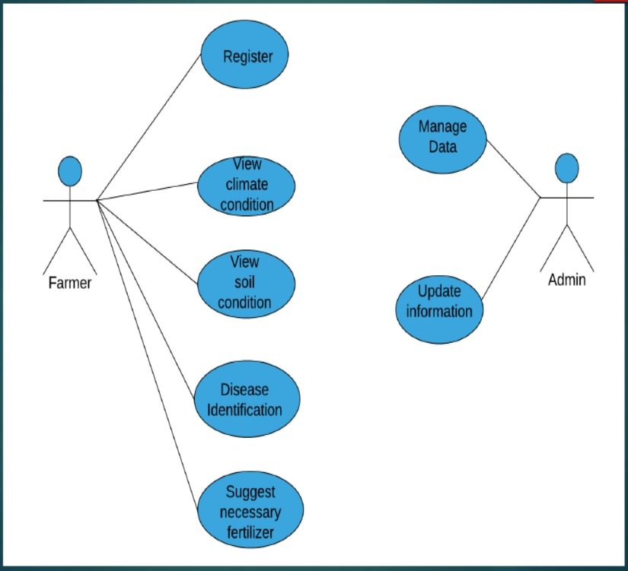

**6.1.2 TABLES**

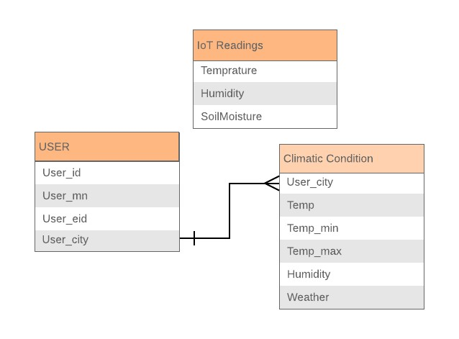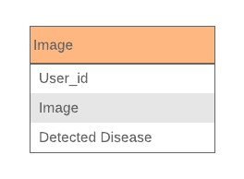

**6.1.3 E-R DIAGRAM**

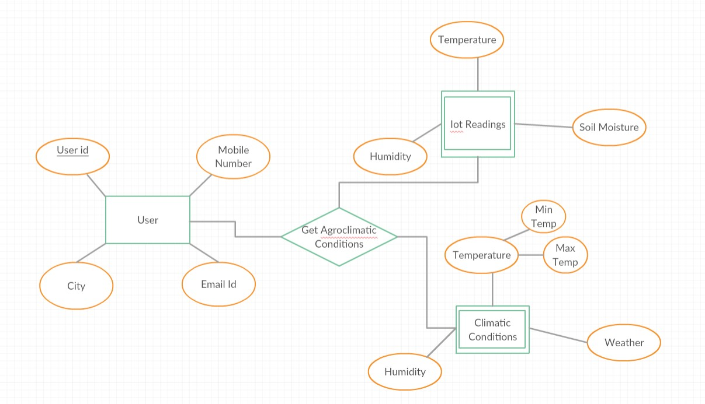

**CHAPTER-7**

**IMPLEMENTATION**

**7.1 Implementation**

In response to the challenges posed by unpredictable climatic conditions affecting crop health, an advanced Integrated Crop Protection Management (IPM) system is proposed. This system aims to comprehensively address the interplay between agro-climatic conditions and pest outbreaks, ensuring a proactive and adaptive approach to safeguarding crops. The first step involves developing a sophisticated climate modeling and prediction system. Leveraging artificial intelligence and machine learning, this system will analyze historical data on fog, humidity, temperature, sunlight, rainfall, and temperature variations to generate accurate forecasts. These forecasts will be integrated into a user-friendly mobile application, providing farmers with real-time information and alerts. To enhance early warning capabilities, an Internet of Things (IoT)-based sensor network will be deployed across farmlands. These sensors will continuously monitor climatic conditions, sending data to a centralized platform. Farmers will receive instant notifications, enabling them to anticipate potential pest outbreaks and take preventive measures. Precision agriculture techniques will play a pivotal role in this IPM system. Farmers will be encouraged to adopt precision farming practices, optimizing resource use and minimizing environmental impact. Financial incentives and subsidies will be provided to facilitate the adoption of precision agriculture technologies, and training programs will be conducted to educate farmers on their implementation. The project will prioritize the development and promotion of pest-resistant crop varieties. Research efforts will focus on identifying and cultivating crops resilient to sudden changes in climatic conditions. Integrated Pest Management (IPM) practices, such as the use of biopesticides and natural enemies, will be emphasized, reducing reliance on chemical pesticides and mitigating environmental degradation. A centralized data integration platform will be established to facilitate seamless information exchange between meteorological stations, satellite imagery, and on-farm sensors. This platform will ensure data accuracy, compatibility, and accessibility, enabling researchers and farmers to make informed decisions based on a holistic understanding of agro-climatic dynamics. In conclusion, the proposed Integrated Crop Protection Management system integrates cutting- edge technology, precision agriculture, and sustainable pest management practices to empower farmers in the face of unpredictable climatic conditions. Through proactive measures, early warnings, and the promotion of resilient farming practices, this initiative seeks to enhance the resilience of agricultural systems and secure the nation's food supply.

**STEP 1**

Created a webpage using html. In this user interface we can see presi Seva for Improve Crop protection and management. In the right side we can see Home button and Login button



**STEP 2**

After clicking the home page, we can view the Weather details option on the allowance of your location in website, which connects the API (Application Programming Interface) where it fetches details using longitude and latitude

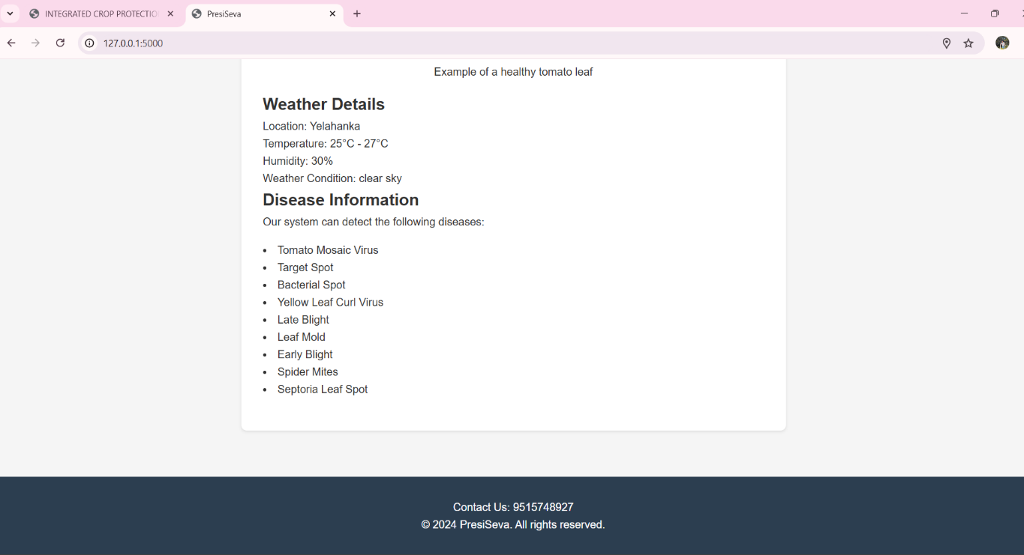

**STEP 3**

This is a Disease prediction page where you need to upload the image of the plant(sample) then it detects the disease and help you to recover from that stage using description provided by the Artificial Intelligence Technique.



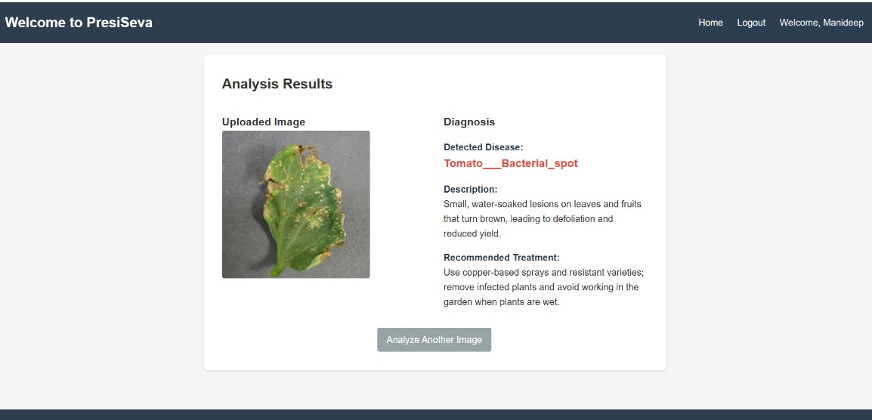

**CHAPTER-8**

**OUTCOMES**

In response to the challenges farmers face due to unpredictable climatic conditions, the Integrated Crop Protection Management (IPM) project emerges as a comprehensive solution. It aims to counter the impact of uncertain monsoons and abrupt climatic changes on agricultural productivity. By understanding the complex relationships among agro-climatic factors like fog, humidity, temperature, sunlight, rainfall, and temperature variations, the project develops a nuanced approach to crop protection. The project's outcomes are diverse. Using advanced climate modeling and prediction, it anticipates climatic shifts and issues timely alerts to farmers. Integrated early warning systems, involving Internet of Things (IoT) devices and mobile applications, empower farmers to make informed decisions, reducing the impact of unexpected weather patterns and pest attacks. Precision agriculture is central to the initiative, encouraging farmers to adopt advanced technologies for optimal resource use. Financial incentives and awareness programs drive the widespread adoption of precision farming, ensuring sustainable practices resilient to climatic uncertainties. To enhance decision-making, the project focuses on data integration platforms. Centralized systems collect and analyze data from various sources, including meteorological stations, satellite imagery and on-farm sensors User-friendly interfaces make this information

**CHAPTER-9**

# RESULTS AND DISCUSSIONS

In response to the challenges posed by uncertain climatic conditions in contemporary agriculture, the Integrated Crop Protection Management (IPM) project was designed to mitigate the impact of unexpected changes, particularly in relation to pest attacks resulting from alterations in agro-climatic conditions. This initiative aimed to understand the intricate relationships between various climatic factors such as fog, humidity, temperature, sunlight, rainfall, and variations in minimum and maximum temperature, all of which significantly influence crop health and susceptibility to pests.

The project yielded valuable insights into the complex dynamics of agro-climatic interactions. Detailed analyses were conducted to unravel the correlation between climatic variables and pest outbreaks. Findings indicated that specific combinations of temperature, humidity, and rainfall created conducive environments for the proliferation of certain pests, while variations in sunlight and temperature impacted the resilience of crops. This nuanced understanding enabled the development of predictive models that could forecast potential pest threats based on prevailing and anticipated climatic conditions.

One of the noteworthy outcomes of the project was the implementation of advanced early warning systems. Integrating real-time data from meteorological stations and on-farm sensors, these systems provided farmers with timely alerts regarding impending changes in climatic conditions and potential pest outbreaks. Farmers, armed with this information, were better equipped to proactively implement pest management strategies, thereby minimizing crop damage and loss. Precision agriculture played a pivotal role in the project's success. By leveraging modern technologies, including IoT devices and satellite imagery, farmers were empowered tomake informed decisions about resource allocation and crop management. This not only optimized resource utilization but also contributed to sustainable agricultural practices, reducing the environmental impact of conventional farming methods.

Additionally, the project emphasized the importance of integrated pest management (IPM) practices. Encouraging farmers to adopt biopesticides, natural enemies, and crop rotation strategies proved effective in reducing the reliance on chemical pesticides, mitigating the risks of environmental degradation and pest resistance. Furthermore, the promotion of pest-resistant

**CHAPTER-10**

# CONCLUSION

In conclusion, the implementation of an Integrated Crop Protection Management (IPM) system in the current agricultural scenario, marked by unpredictable climatic conditions, stands out as a crucial strategy to safeguard the efforts of hardworking farmers and ensure food security for the entire nation. The complex relationships among agro-climatic variables such as fog, humidity, temperature, sunlight, rainfall, and variations in minimum and maximum temperature underscore the need for a comprehensive and adaptive approach to crop protection.

The project aims to fill existing research gaps by delving into the complexities of agro-climatic interactions, offering a nuanced understanding of how these factors influence pest dynamics and crop health. By addressing the limitations of current methods, such as inadequate early warning systems, insufficient adoption of precision agriculture, and challenges in data integration and analysis, the proposed solutions aim to fortify the resilience of agricultural practices in the face of climatic uncertainties.

Through advanced climate modeling and prediction techniques, the project seeks to empower farmers with accurate forecasts, allowing them to anticipate and mitigate the impacts of sudden climatic shifts on their crops. The integration of Internet of Things (IoT) devices and user- friendly mobile applications establishes a robust early warning system, enabling timely responses to emerging threats, including pest attacks.

The promotion of precision agriculture becomes a cornerstone in the project's strategy. encouraging farmers to adopt cutting-edge technologies that optimize resource use and minimize environmental impact. Financial incentives, subsidies, and educational programs are envisioned to facilitate the widespread adoption of these practices, ensuring sustainable and efficient farming methods.

Central to the project is the establishment of data integration platforms that consolidate information from diverse sources, fostering collaboration between stakeholders and facilitating informed decision-making. By promoting integrated pest management (IPM) practices, the project envisions a shift away from overreliance on chemical pesticides towards more sustainable solutions, including the use of biopesticides, natural enemies, and pest-resistant crop varieties.

In essence, the Integrated Crop Protection Management project emerges as a holistic and forward-thinking initiative, poised to transform the agricultural landscape. By leveraging technology, promoting sustainable practices, and empowering farmers with knowledge and tools, the project seeks to build resilience in the face of climatic uncertainties, ensuring that the toil of farmers translates into bountiful harvests for the entire nation. In embracing such a 5 comprehensive approach, the project not only addresses the current challenges but also lays the foundation for a more sustainable and secure future for agriculture.

**CHAPTER -11**

**REFERENCES**

* T. Bak et al.

Agricultural robotic platform with four-wheel steering for weed detection Biosystem. Eng. (2004)

* R. Cullen et al.

Economics and adoption of conservation biological control Biol. Control (2008)

* G.J.K. Griffiths et al.

Efficacy and economics of shelter habitats for conservation biological control Biol. Control (2008)

* K. Jetter.

Economic framework for decision making in biological control Biol. Control (2005)

* V. Le Féon et al.

Intensification of agriculture, landscape composition and wild bee communities: a large-scale study in four European countries Agric. Ecosystem. Environ. (2010)

* M. Loghavi et al.

Development of a target-oriented weed control system Compute. Electron. Agric. (2008)

* Maiorano et al.

A dynamic risk assessment model (FUMAgrain) of Fumo nisin synthesis by

Fusarium verticillioides in maize grain in Italy Crop Prot. (2009)

* C. Ratti et al.

Detection and relative quantitation of Soil-borne cereal mosaic virus (SBCMV) and Polymyxa graminis in winter wheat using real-time PCR (TaqMan®) J. Virol. Methods (2004)

* A.W. Schaafsma et al.

Climatic models to predict occurrence of Fusarium toxins in wheat and maize

Int. J. Food Microbials. (2007)

* C. Stoate et al.

Ecological impacts of arable intensification in Europe J. Environ. Manage. (2001)

* C.S. Straub et al.

Are the conservation of natural enemy biodiversity and biological control compatible goals? Biol. Control (2008)

* D.D. Stuthman et al.

Breeding crops for durable resistance to disease Adv. Agron. (2007)

* M. Trnka et al.

European Corn Borer life stage model: Regional estimates of pest development and spatial distribution under present and future climate Ecol. Model. (2007)

* M.R. Wade et al.

Conservation biological control of arthropods using artificial food sprays:

current status and future challenges Biol. Control (2008)