

Change Log
Date | Version Description | Author
9/11/2007 | (V1.0) Initial Document | Ron Teitelbaum
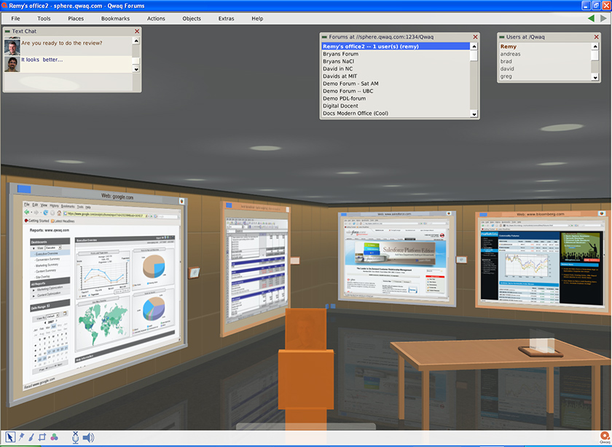  12/5/2007 | (V1.1) Added pthread support, removed check lib dependency | Brad Fowlow
12/5/2007 | (V1.2) Removed material already checked in to SVN | Brad Fowlow

On Ubuntu and Unix Systems

Compiling PyBridge

Product/Service Information
This document contains instructions on how to compile the PyBridge plugin code. PyBridge is an interface that connectes Python and Squeak. PyBridge contains a very useful call back mechanism Squeak.send() which allows Python to talk directly to Squeak.
460 S. California Avenue, Suite 304
Palo Alto, CA 94306
U.S.A.
Phone: +1-650-331-1437
Fax: +1-650-618-2727
Email: info@qwaq.com
Web: www.qwaq.com

Qwaq

Qwaq Compiling PyBridge Plugin

on Ubuntu and Unix Systems

1.0 Summary

The PyBridge Plug in allows Python Programs to speak directly to a running Squeak Image. This explains how to compile the PyBridge to work on Ubuntu and Unix systems.

2.0 Install Build Tools

Setup build environment for Ubuntu.
sudo apt-get install automake
sudo apt-get install autoconf
sudo apt-get install libtool
sudo apt-get install build-essential

3.0 Install Python2.4

PyBridge works with Python2.4. Ubuntu currently runs Python2.5 so you will need to install Python2.4 before setting up the VM to compile PyBridge. First install Python2.4
Execute the following from a sh terminal, with the cwd being /home/qwaq:
sudo apt-get install python2.4
sudo apt-get source python2.4
Configure the source to create pyconfig.h
From /home/qwaq/Python2.4-2.4.4
sudo chown qwaq -R .
sudo chgrp qwaq -R .
./configure
Make to create libpython2.4* file
From the Python2.4-2.4.4
make
Note that the VM source tree has references to /home/qwaq/python2.4-2.4.4, so the directory location is needed. Otherwise various sources in <vm source directory> platforms/unix/plugins/PyBridge will need updating to your paths.

4.0 VM Environment

4.1 Check out the VM build tree (source code, resources, vmmaker image)

Check out the source:
svn co https://source.qwaq.com/svn/qwavm/trunk <vm source directory>

4.2 Building Plug-in using VMMaker (Optional)

The plugin sources corresponding to the Monticello version of the PyBridge plugin are already present in SVN. If you change the squeak source for the plugin, and need to regenerate, use the image in <vm source directory> / image / QwaqVM.image. It may need to be brought current with Monticello before you start.

Load the configuration <vm source directory> / unixbuild/vmmaker.config
set the VMMaker platforms directory to <vm source directory>/platforms.
Set the platform to unix.
Set the src directory to: <vm source directory>/unixbuild/src
Move the PythonPlugin to external and generate.

5.0 Configure VM source build

Run the configure script
From the <vm source directory>/unixbuild/bld
../../platforms/unix/config/configure --with-src=unixbuild/src –prefix=/home/qwaq/bin/qwaqvm

6.0 Make Plugins
Now make the plugins
From the <vm source directory>/unixbuild/bld
make plugins
if that succeeds then install the plugins (into /home/qwaq/bin/qwaqvm, according to the prefix above)
make plugins install

7.0 Testing PyBridge
You can now restart Squeak to test the plugin. To test print the following Squeak code
Python initialize bridgeVersion
you should get something like: ‘PyBridge 1.0(alpha) from Sep 8 2008’

8.0 Questions and Comments

More information about configuration and compiling can be found at: http://www.squeakvm.org/unix/platforms/unix/doc/HowToBuildFromSource.html/HowToBuildFromSource-node5.html
Please feel free to contact Qwaq at info@qwaq.com for more information about Compiling PyBridge on Ubuntu. Your questions and comments are welcome
- Ron Teitelbaum Ron@USMedRec.com

