What is JavaScript?
JavaScript is a single-threaded, synchronous programming language used to create dynamic web pages. It can also handle asynchronous operations using callbacks, promises, and async/await.

*********************************************************************************************************

What are the features of Javascript
- Lightweight and Fast: JavaScript is a lightweight programming language that runs quickly in web browsers.
- Single-Threaded: It processes tasks one at a time, making it simple to manage, though asynchronous features like Promises help handle multiple tasks simultaneously.
- Event-Driven: JavaScript is designed to handle events (like clicks or key presses) in web applications.

*********************************************************************************************************
What are the different data types in JavaScript?

Primitive Data Types:These store single values and are immutable.

List of Primitive Types
Number – Represents integers and decimals
let a = 10;
let b = 3.14;
String – Text data
let name = "Shamitha";
Boolean – true or false
let isLoggedIn = true;
Undefined – Variable declared but not assigned
let x;
console.log(x); // undefined
Null – Empty or no value intentionally
let y = null;
BigInt – Very large integers
let big = 12345678901234567890n;
Symbol – Unique identifiers (used in advanced JS)
let id = Symbol("id");

Non-Primitive (Reference) Data Types
These store collections or complex data.

Types
Object
let person = {
name: "Shamitha",
age: 25
};
Array
let arr = [1, 2, 3, 4];
Function
function greet() {
console.log("Hello");
}

*********************************************************************************************************
What is the difference between var, let and const?
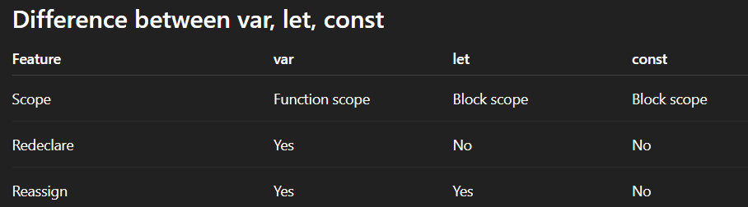

1. Var
console.log(score); // undefined (not an error!)
var score = 100;
Function scoped → accessible inside entire function, not block
function test() {
if (true) {
var x = 10;
}
console.log(x); // 10— it leaks out! Bug waiting to happen
}
Can redeclare
var a = 5;
var a = 10; // allowed
Can reassign
var a = 5;
a = 20;

2. Let
console.log(score); // ReferenceError: Cannot access before init
let score = 100; // TDZ ends here
Block scoped → only inside { }
if (true) {
let x = 10;
}
console.log(x); // Error
Cannot redeclare
let a = 5;
let a = 10; // Error

let name = "Alice";
let name = "Bob"; // SyntaxError: already declared
Can reassign
let a = 5;
a = 20; // allowed

let count = 0;
count = count + 1; // 1 — allowed

3. const
Block scoped → same as let
Cannot redeclare
const a = 5;
const a = 10; // Error
Cannot reassign
const a = 5;
a = 10; // Error
Objects/arrays can still change
const person = { name: "Sam" };
person.name = "John"; // allowed

General Example:
{
let a = 1;
const b = 2;
var c = 3;
}
console.log(a); // ERROR: a is not defined
console.log(b); // ERROR: b is not defined
console.log(c); // 3 (var is function-scoped)

*********************************************************************************************************
What is the difference between == and ===?

1. == (Loose Equality)
It will compare value and type and it will convert the type if they are different. This is called type coercion.
5 == "5" // true
true == 1 // true
false == 0 // true
null == undefined // true

2. === (Strict Equality)
It compares value AND type. It does NOT convert types.
5 === "5" // false (number vs string)
true === 1 // false
false === 0 // false
null === undefined // false null is a special object representing the intentional absence of a value, while undefined signifies that a variable has been declared but not assigned a value.
5 === 5 // true

*********************************************************************************************************

Why typeof null returns object?
Why typeof null === "object" is one of JS's most famous bugs, and it has a great story. When Brendan Eich wrote JavaScript in 10 days in 1995, values were stored internally as a type tag followed by the actual value. Objects used the tag 000. The problem? null was represented as a null pointer — all zero bits — so its tag also looked like 000. When typeof checked those bits, it saw 000 and returned "object". Wrong, but baked in.
A fix was proposed for ES6 (2015) — making typeof null return "null" — but it was rejected because it would have broken millions of existing websites that already relied on the buggy behavior. So it'll never be fixed.

*********************************************************************************************************
What is hoisting in JavaScript?
Hoisting moves declarations (not initializations) to the top of their scope before code runs. var declarations and function declarations are hoisted.

Example 1 — Variable Hoisting with var
console.log(a);
var a = 10;
Output:
undefined
What JavaScript actually does internally:
var a;
console.log(a);
a = 10;
So the variable is hoisted, but the value is not.

Example 2 — let and const Hoisting
console.log(a);
let a = 10;
Output:
ReferenceError
let and const are hoisted but not initialized, so they are in a Temporal Dead Zone (TDZ).

Example 3 — Function Hoisting
greet();

function greet() {
console.log("Hello");
}
Output:
Hello
Functions are fully hoisted, so you can call them before declaration.
*********************************************************************************************************What is the difference between null and undefined?
undefined means a variable has been declared but not assigned a value. null is an intentional absence of value — it's explicitly assigned.
let a;
console.log(a); // undefined

let b = null;
console.log(b); // null

*********************************************************************************************************
What is array vs object?
Array | Object
Ordered collection | Key-value pairs
Access by index | Access by key
const arr = [1,2,3];
const obj = { name: "John", age: 25 };

Array Methods
Method | Purpose
map | Transform array
filter | Filter elements
reduce | Accumulate value
forEach | Loop only

map
const arr = [1, 2, 3];
const result = arr.map(x => x * 2);
console.log(result); // [2, 4, 6]

filter
const arr = [1, 2, 3, 4, 5];
const even = arr.filter(x => x % 2 === 0);
console.log(even); // [2, 4]

reduce
[1,2,3,4].reduce((sum, x) => sum + x, 0);
// 10

Find
const arr = [1, 2, 3, 4, 5];
const even = arr.find(x => x % 2 === 0);
console.log(even); // 2

some
Returns true if at least one element satisfies condition
const arr = [1, 2, 3, 4];
const result = arr.some(x => x > 3);
console.log(result); // true

every
Returns true if all elements satisfy condition
const arr = [1, 2, 3, 4];
const result = arr.every(x => x > 0);
console.log(result); // true

*********************************************************************************************************

a)The classic var interview question: what does this print? for(var i=0;i<3;i++){setTimeout(()=>console.log(i),0)} — it prints 3,3,3 (not 0,1,2) because var leaks out of the for block.
b)for (let i = 0; i < 3; i++) {
setTimeout(() => console.log(i), 0);
}
// Prints: 0, 1, 2 (each loop has its own i)

*********************************************************************************************************
How does Array.map differ from Array.forEach?
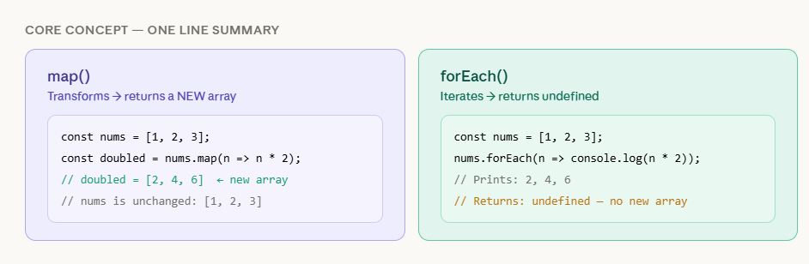
The return value inside the callback is discarded.
forEach can never be chained. Since it returns undefined, calling .filter() or .reduce() after it throws a TypeError. map on the other hand returns a real array, so you can chain freely: .map().filter().reduce() is a very common pattern for transforming data pipelines.
The decision rule is straightforward: if you need a new array out of the operation, use map. If you're just doing something with each item — logging it, saving it to a database, updating the DOM — use forEach.

*********************************************************************************************************
What are truthy and falsy values?
In JavaScript, truthy values are values that evaluate to true in a boolean context, and falsy values are values that evaluate to false. JavaScript has a few falsy values like false, 0, empty string, null, undefined, a+nd NaN, and all other values are considered truthy.
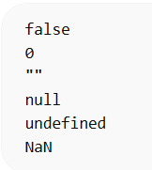
Example: if (0) {
console.log("Hello");
} else {
console.log("Falsy");
}
Output: Falsy
2)if ([]) {
console.log("Hello");
} Empty array is truthy
3)if ({}) {
console.log("Hello");
} Empty object is truthy
4)console.log(Boolean("")); //false
console.log(Boolean(" ")); //true
Because empty string is falsy, but string with space is truthy.
5)console.log(5 > 3 > 2) false
5>3 returns true
true>2 in JS it is 1>2 returns false
6)console.log([] === []) or [1,2,3]==[1,2,3] false because they represent two different objects in the memory
7)console.log("10" < "9") Here it is string and it compares the unicode values character by character 1<9 so returns true
console.log(10 > 5); true
8)console.log(NaN === NaN) returns false. It represents not a number
9)console.log(true == 1) it will get converted to 1==1 so returns true JS uses type coercion

*********************************************************************************************************
Explain about Objects in Javascript
An object is a dynamic data structure that stores related data as key-value pairs, where each key uniquely identifies its value.
The values of properties can be primitives, objects, or functions (known as methods when defined inside an object).
Objects are mutable and dynamic properties can be added, modified, or deleted at any time.
We can create Objects in two ways
a)Using String literal
let abc={
name: “Sam”,
age: 16
};
console.log(obj);
b)Using new Object() method
let abc=new Object();
abc.name=”sam”,
abc.age=16;
console.log(abc);

*********************************************************************************************************
Explain about Implicit Type Coercion
Implicit type coercion in javascript is the automatic conversion of value from one data type to another.
String coercion:
String coercion takes place while using the ‘ + ‘ operator. When a number is added to a string, the number type is always converted to the string type.
var x = 3;
var y = "3";
x + y // Returns "33"

var x = 24;
var y = "Hello"; 24Hello
In case of ‘-’ string is converted to number.

var x = 3;
Var y = "3";
x - y //Returns 0 since the variable y (string type) is converted to a number type

*********************************************************************************************************

What do you mean by strict mode in javascript and characteristics of javascript strict-mode?
In ECMAScript 5, a new feature called JavaScript Strict Mode allows you to write a code or a function in a "strict" operational environment.

Characteristics of strict mode in javascript
- Duplicate arguments are not allowed by developers.
- In strict mode, you won't be able to use the JavaScript keyword as a parameter or function name.
- The 'use strict' keyword is used to define strict mode at the start of the script. Strict mode is supported by all browsers.
- Engineers will not be allowed to create global variables in 'Strict Mode.

*********************************************************************************************************

Explain “this” keyword.
The “this” keyword refers to the object that the function is a property of.
var obj = {
name: "vivek",
getName: function(){
console.log(this.name);
}
}
obj.getName();
In the above code, at the time of invocation, the getName function is a property of the object obj , therefore, this keyword will refer to the object obj, and hence the output will be “vivek”.
*********************************************************************************************************

What are object prototypes?
All javascript objects inherit properties from a prototype. For example,
- On top of the chain is Object.prototype. Every prototype inherits properties and methods from the Object.prototype.
- Date objects inherit properties from the Date prototype
- Math objects inherit properties from the Math prototype
- Array objects inherit properties from the Array prototype.
- A prototype is a blueprint of an object.
*********************************************************************************************************

What is memoization?
Memoization is a form of caching where the return value of a function is cached based on its parameters.
function addTo256(num){
return num + 256;
}
addTo256(20); // Returns 276
addTo256(40); // Returns 296
addTo256(20); // Returns 276

function memoizedAddTo256(){
var cache = {};

return function(num){
if(num in cache){
console.log("cached value");
return cache[num]
}
else{
cache[num] = num + 256;
return cache[num];
}
}
}
var memoizedFunc = memoizedAddTo256();

memoizedFunc(20); // Normal return
memoizedFunc(20); // Cached return

Basic Operations on JavaScript Objects

Accessing Object Properties

You can access an object’s properties using either dot notation or bracket notation
let obj = { name: "Sourav",
age: 23 };

// Using Dot Notation
console.log(obj.name);
// Using Bracket Notation
console.log(obj["age"]);
Dot notation is cleaner but only works with valid identifier keys. Bracket notation works with any string — spaces, dynamic variables, reserved words.

Modifying Object Properties
Properties in an object can be modified by reassigning their values.
let obj = { name: "Sourav", age: 22 };
console.log(obj);//{"name":"Sourav","age":22}
obj.age = 23;
console.log(obj);//{"name":"Sourav","age":23}

Adding Properties to an Object
You can dynamically add new properties to an object using dot or bracket notation.
let obj = { model: "Tesla" };
obj.color = "Red";
console.log(obj);//{"model":"Tesla","color":"Red"}

Removing Properties from an Object
The delete operator removes properties from an object.
let obj = { model: "Tesla", color: "Red" };
delete obj.color;
console.log(obj);//{"model":"Tesla"}

Checking if a Property Exists
You can check if an object has a property using the in operator or hasOwnProperty() method.
let obj = { model: "Tesla" };
console.log(obj.hasOwnProperty("model"));//true

Merging Objects
Objects can be merged using Object.assign() or the spread syntax { ...obj1, ...obj2 }.
let obj1 = { name: "Sourav" };
let obj2 = { age: 23};
let obj3 = { ...obj1, ...obj2 };
console.log(obj3);//{"name":"Sourav","age":23}

The Object.assign() method is used to copy the values and targets from one or more source objects to a target object.
target: It is the target object to which values and properties have to be copied
sources: It is the source object from which values and properties have to be copied.
a)
const obj1={‘a”:1}
const obj2= Object.assign({},obj1);
console.log(obj2);//{“a”:1}

b)
let obj1 = { a: 10 };
let obj2 = { b: 20 };
let obj3 = { c: 30 };

let new_obj = Object.assign({}, obj1, obj2, obj3);
console.log(new_obj);//{“a”:10,”b”:20,”c”:30}

Object Length
You can find the number of properties in an object using Object.keys().
let obj = { name: "Sourav", age: 23 };
console.log(Object.keys(obj).length);

Object keys and Object values and Object.entries()
Returns array of keys
const user = { name: "John", age: 25 };
Object.keys(user);
// ["name", "age"]

Returns arrays of values
Object.values(user);
// ["John", 25]

Returns array of key value pairs
Object.entries(user);
// [["name", "John"], ["age", 25]]

Object Methods
Functions inside objects are called methods.
const user = {
name: "John",
greet() {
return "Hello " + this.name;
}
}; this refers to the current object.

Optional Chaining (?.)
Used to safely access nested properties without error.
const user = {
address: {
city: "Delhi"
}
};
console.log(user.address?.city); // Delhi
console.log(user.contact?.phone); // undefined (no error)

Object Cloning means copying objects.
Using spread operator
const user = { name: "John" };
const copy = { ...user };
Using Object.assign()
const copy = Object.assign({}, user);

*********************************************************************************************************
Explain about DOM
DOM (Document Object Model) represents the HTML page as a tree structure where:
- Each HTML tag = node
- Parent-child relationship exists
- JavaScript can access and modify these nodes
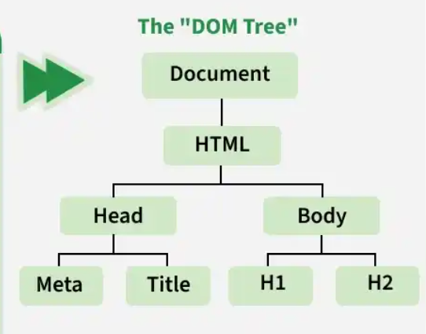

Approaches to select DOM elements in JavaScript:
- document.getElementById("id")
- document.getElementsByClassName("class")
- document.getElementsByTagName("tag")
- document.querySelector("css selector")
- document.querySelectorAll("css selector")
Event Bubbling
Event starts from target element and moves upwards to parent elements.

Example
<div id="parent">
<button id="child">Click</button>
</div>
document.getElementById("parent").addEventListener("click", () => {
console.log("Parent clicked");
});
document.getElementById("child").addEventListener("click", () => {
console.log("Button clicked");
});

Output when button clicked:
Button clicked
Parent clicked
👉 Event goes child → parent → document
This is event bubbling.

Event Capturing
Event goes from parent → child first (opposite of bubbling).

Syntax
addEventListener("click", handler, true);

Example
parent.addEventListener("click", () => {
console.log("Parent");
}, true);

child.addEventListener("click", () => {
console.log("Child");
}, true);

Output:
Parent
Child

Event Delegation (Very Important Interview Question)
Instead of adding event listener to multiple child elements, we add one event listener to parent and handle events using bubbling.

Example
<ul id="list">
<li>Item 1</li>
<li>Item 2</li>
<li>Item 3</li>
</ul>
document.getElementById("list").addEventListener("click", (e) => {
console.log(e.target.textContent);
});
👉 Click any li → parent handles it.

preventDefault()
Stops default browser behavior.

Example (form submit)
form.addEventListener("submit", (e) => {
e.preventDefault();
console.log("Form submitted without page reload");
});

stopPropagation()
Stops event bubbling or capturing.

Example
child.addEventListener("click", (e) => {
e.stopPropagation();
console.log("Child clicked");
});

*********************************************************************************************************

Explain event listeners in JS
The addEventListener() method is used to attach an event handler to an element in the DOM (Document Object Model). It listens for specific events (such as click, keydown, or submit) on that element and executes a function when the event occurs.
Syntax
element.addEventListener(event, function, useCapture);
element: The DOM element you want to listen for events on (for example, document, button, div).
event: The type of event you want to listen for, such as 'click', 'keydown', 'submit', etc.
function: The function to be executed when the event is triggered. It could be an anonymous function or a reference to a named function.
useCapture (optional): A boolean value that specifies whether to use event capturing.

The removeEventListener removes the attached event handler, but it requires the same function reference that was used while adding the event.
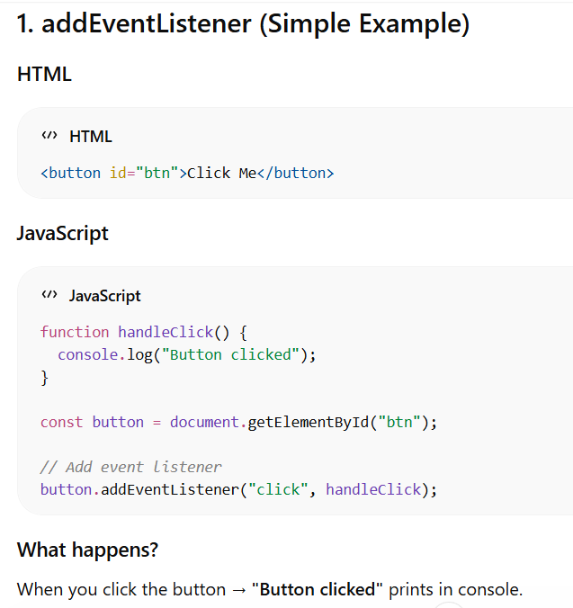
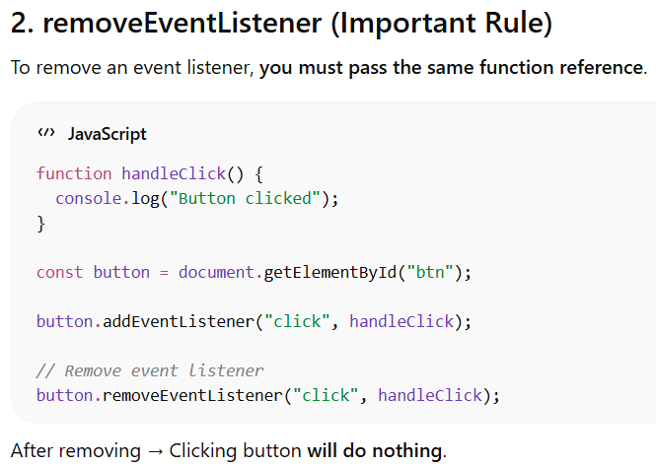

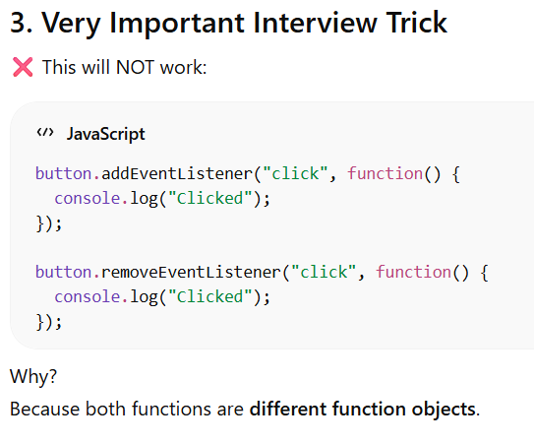
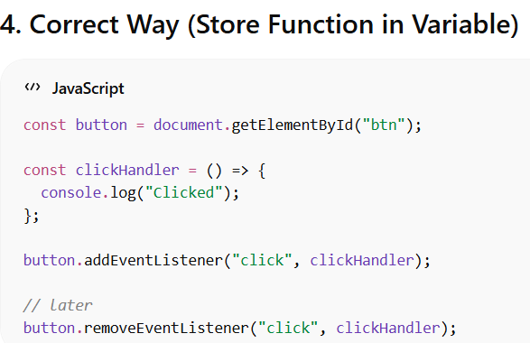

*********************************************************************************************************

Explain about functions in JavaScript
Functions in JavaScript are reusable blocks of code designed to perform specific tasks.

function greet(name) { // 'name' is a parameter
console.log("Hello " + name);
}
greet("Alice"); // "Alice" is the argument

Types of Functions
a)Named Function: A function having its own name declared is called named function.

function greet() {
return "Hello!";
}
console.log(greet());

b)Anonymous Function:A function that does not have a name.
() => {
console.log("Parent");
}
c)Function Expression: When you assign a function (can be named or anonymous) to a variable. The function can then be used by calling that variable.
const add = function(a, b) {
return a + b;
};
console.log(add(2, 3));

d)Arrow Function:A new way to write functions using the => syntax.
const square = n => n * n;
console.log(square(4));

e)IIFE Immediately Invoked Function Expression
A function that runs immediately after being defined.

(function() {
console.log("I run immediately");
})();

Arrow Function version: (() => {
console.log("Immediate");
})();

f)Callback Functions
A callback function is passed as an argument to another function and is executed after the completion of that function.
function greet(name, callback) {
console.log("Hello " + name);
callback();
}

function sayBye() {
console.log("Bye");
}
greet("John", sayBye);

Output :Hello John
Bye

g)Pure Functions
Pure functions return the same output for the same inputs and do not produce side effects.
function add(a, b) {
return a + b;
}

h)Higher Order Function
A Higher Order Function is a function that:
- Takes another function as argument OR
- Returns a function
function operate(a, b, operation) {
return operation(a, b);
}
function add(x, y) {
return x + y;
}console.log(operate(5, 3, add)); // 8

Built-in Higher Order Functions
- map()
- filter()
- reduce()
- forEach()
i)Closures:
A closure is when an inner function remembers variables from its outer function even after the outer function has finished executing.
function outer() {
let count = 0;
return function inner() {
count++;
console.log(count);
}; }
const counter = outer();
counter(); // 1
counter(); // 2
counter(); // 3
j)Function Currying:
Currying means converting a function with multiple arguments into multiple functions each taking one argument.
a)function add(a, b) {
return a + b;
}
add(2, 3);

b)function add(a) {
return function(b) {
return a + b;
};
}
add(2)(3);

c)const add = a => b => a + b;
console.log(add(5)(3)); // 8

Function Binding
Binding means fixing the value of this in a function.
Sometimes this changes depending on how function is called, so we bind it.

Example
const user = {
name: "John"
};

function greet() {
console.log("Hello " + this.name);
}

const boundGreet = greet.bind(user);
boundGreet(); // Hello John

call(), apply(), bind()
These are used to control this keyword.

call()
Calls function immediately and passes arguments separately.
function greet(city) {
console.log(this.name + " from " + city);
}

const user = { name: "John" };

greet.call(user, "Delhi");

apply()
Same as call but arguments passed as array.
greet.apply(user, ["Mumbai"]);

bind()
Does NOT call immediately. Returns new function.
const newFunc = greet.bind(user, "Chennai");
newFunc();

*********************************************************************************************************

ES6+ Features (Very Important for React)

What are template literals?
Template literals are strings defined using backticks that support interpolation, multi-line text
etc.

1. String Interpolation (Most Important ⭐)
You can embed variables or expressions using ${}
const a = 10;
const b = 20;
console.log(`Sum is ${a + b}`); // Sum is 30

2. Multi-line Strings
No need for \n
const text = `This is line 1
This is line 2
This is line 3`;
console.log(text);

*********************************************************************************************************

What are arrow functions and how do they differ from regular functions?
Arrow functions are shorter syntax for the functions introduced in ES6.
Arrow Functions: They do not have their own this. It inherits this from surrounding scope. Cannot be used as constructor. No arguments object. Use arrow functions for array methods, react event handlers and hooks.

const obj = {
name: "Sam",
arrow: () => {
console.log(this.name);
}
};
obj.arrow(); // undefined

Regular Functions: They have their own this.Can be used as constructor. Has arguments objects. It must be used with object methods and constructor.

const obj = {
name: "Sam",
regular: function() {
console.log(this.name);
}
};
obj.regular(); // Sam

*********************************************************************************************************
What is Destructuring?
It is a javascript ES6 feature extracting values from arrays or objects into variables in a simple way.
A)Object Destructuring.
const user = { name: "John", age: 25 };
const name = user.name;
const age = user.age;
We write:
const { name, age } = user;
console.log(name); // John
console.log(age); // 25
B)Array Destructuring
const numbers = [10, 20, 30];
const [a, b, c] = numbers;
console.log(a); // 10
console.log(b); // 20
C)Default Values
If property not present, default value is used.
const user = {
name: "John"
};
const { name, age = 20 } = user;
console.log(age); // 20
D)Swap Variables Using Destructuring
Very common interview question.
let a = 10;
let b = 20;
[a, b] = [b, a];
console.log(a); // 20
console.log(b); // 10

*********************************************************************************************************What is Optional Chaining (?.)
Used to safely access nested properties without error.
const user = {
address: {
city: "Delhi"
}
};
console.log(user.address?.city); // Delhi

*********************************************************************************************************

What is Spread Operator(...)?
The spread operator expands elements of an array or object into individual elements.
Used for:
- Copy arrays
- Copy objects
- Merge arrays/objects
a)
const arr1 = [1, 2, 3];
const arr2 = [...arr1];
console.log(arr2); // [1, 2, 3]

b)
const a = [1, 2];
const b = [3, 4];
const merged = [...a, ...b];
console.log(merged); // [1,2,3,4]

c)const user = { name: "John", age: 25 };
const copy = { ...user };

d)const obj1 = { a: 1 };
const obj2 = { b: 2 };
const merged = { ...obj1, ...obj2 };

*********************************************************************************************************
What is REST Operator(...)?
The rest operator collects multiple elements into a single array.
Used in:
- Function parameters
- Destructuring

function sum(...numbers) {
return numbers.reduce((a, b) => a + b);
}
sum(1, 2, 3, 4); // 10
Here ...numbers collects all arguments into an array.

*********************************************************************************************************
What are default parameters?
Default parameters allow function parameters to have default values if no value is provided.

function greet(name = "Guest") {
console.log("Hello " + name);
}
greet(); // Hello Guest
greet("John"); // Hello John

*********************************************************************************************************
What are modules(import/export)?
JavaScript modules allow splitting code into multiple files.

Export

File: math.js
export function add(a, b) {
return a + b;
}
export const pi = 3.14;

Import

File: app.js
import { add, pi } from "./math.js";
console.log(add(2, 3))

*********************************************************************************************************

What is temporal time zone?
The time between variable hoisting and initialization is called TDZ. We get referrenceerror here.

*********************************************************************************************************
What are scopes?
Scope determines where the variables are accessible
Types:
Global scope : Here variables is declared outside the function or block so that it can be accessed anywhere in the program.
var x = 10;
function fun1() {
console.log(x);
}

fun1();
Function scope: Here the variable can be accessed only within the function.
function fun2(){
let x = 10;
console.log(x);
}
fun2();
Block scope: block scope refers to variables declared with let or const inside a { } block. These variables are accessible only within that block and not outside it.
{
// Var can Accessible inside & outside the block scope
var x = 10;

// let , const Accessible only inside the block scope
const y = 20;
let z = 30;

console.log(x);
console.log(y);
console.log(z);
}
console.log(x);
*********************************************************************************************************

Is JavaScript synchronous or asynchronous?
JavaScript is single-threaded synchronous, but supports asynchronous behavior using:
- Callbacks
- Promises
- Async/Await
- Event Loop
*********************************************************************************************************

Asynchronous JavaScript

JavaScript executes code one line at a time.
myDisplayer("A");
myDisplayer("B");
myDisplayer("C");

The output is always A,B,C

The JS functions are also executed in the sequence they are called.
function myFirst() {
myDisplayer("Hello");
}

function mySecond() {
myDisplayer("Goodbye");
}
myFirst();
mySecond();

Output: Hello Goodbye

Why Async Code?
Some tasks take time to complete. To stay responsive JS use aysnc programming.
Asynchronous flow refers to how JavaScript allows certain operations to run in the background and let their results be handled when they are ready.

myDisplayer("A");
setTimeout(function() {
myDisplayer("B");
}, 1000);
myDisplayer("C");

Output: ACB

Javascript Events:
Events are actions or occurrences that happen in the browser, often triggered by user interactions (like clicks, keypresses, or form submissions) or by the browser itself (like page loading or resizing).

<p id=”demo”>Click the button to display the date.</p>
<button onclick="displayDate()">The time is?</button>
<script>
function displayDate() {
document.getElementById("demo").innerHTML = Date();
}
</script>

Asynchronous vs Parallel:
Parallel means doing multiple things at the same time on different processors.
Asynchronous means switching between tasks, not necessarily running them simultaneously.

*********************************************************************************************************
Javascript Timeouts
a)The setTimeout() method:
The setTimeout() method schedules a function to run once after a delay in milliseconds.

setTimeout(myFunction, 3000);
function myFunction() {
document.getElementById("demo").innerHTML = "I love You !!";
}
3000 is the number of milliseconds before myFunction will be called.
When you pass a function as an argument, remember not to use parenthesis.
Right: setTimeout(myFunction, 3000);
Wrong: setTimeout(myFunction(), 3000);

b)The setInterval() method:
The setInterval() method schedules a function to run repeatedly at intervals.

<h2 id="demo"></h2>
<script>
setInterval(myFunction, 1000);
function myFunction() {
let d = new Date();
document.getElementById("demo").innerHTML=d;
}
</script>

*********************************************************************************************************

JavaScript Callbacks:
A callback function is passed as an argument to another function and is executed after the completion of that function.
1. Basic Synchronous Callback
function greet(name, callback) {
console.log('Hello, ' + name + '!');
callback();
}
function sayBye() {
console.log('Goodbye!');
}
greet('Alice', sayBye);

// Output:
// Hello, Alice!
// Goodbye!
How it works:
greet() accepts a function as a parameter
After execution, it calls the callback function

2. Asynchronous Callback with setTimeout
console.log('Start');
setTimeout(function() {
console.log('This runs after 2 seconds!');
}, 2000);
console.log('End');
// Output:
// Start
// End
// This runs after 2 seconds!

3.Callback with Event Handling:
Callback functions can be used for event handling.

<button id="myButton">The time is?</button>
<p id="demo"></p>
<script>
function displayDate() {
document.getElementById("demo").innerHTML = Date();
}
document.getElementById("myButton").addEventListener("click", displayDate);
</script>
In the example above, displayDate is a callback function passed as an argument to the addEventListener() method. displayDate will be called when a user clicks the button with id="myButton".

CallBack Drawbacks:
When there is a chain of callbacks happening then the code become difficult to debug and causes callback hell or pyramid of doom
step1(function(r1) {
step2(r1, function(r2) {
step3(r2, function(r3) {
console.log(r3);
});
});
});
*********************************************************************************************************
Javascript Promises
A Promise is an object representing the eventual completion (or failure) of an asynchronous operation. It provides a cleaner way to handle async code compared to callbacks.

Three states of Promise:
a)Pending State: Initial stage operation has not yet been completed
b)Resolved State
c)Rejected State

1)Creating Basic Promise
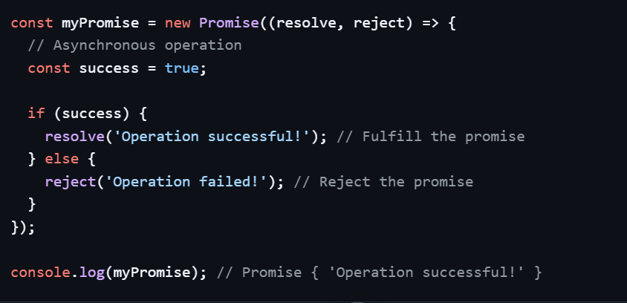

2)Using .then() method to handle resolved promises
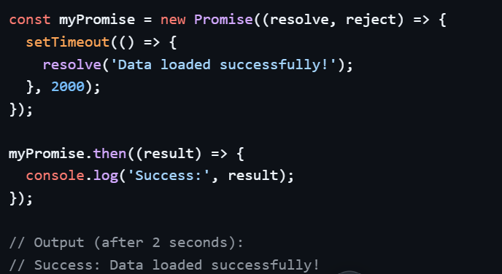

3)Using .catch() to handle rejected promises
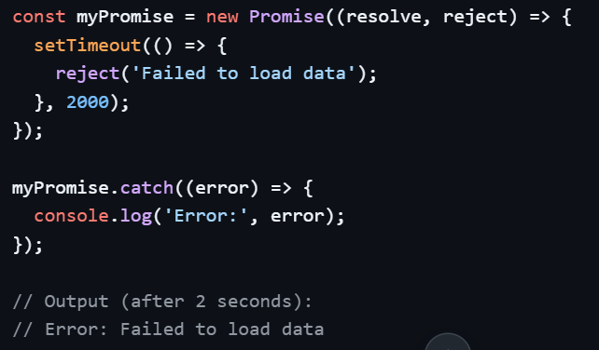

4)Using .finally() for cleanup
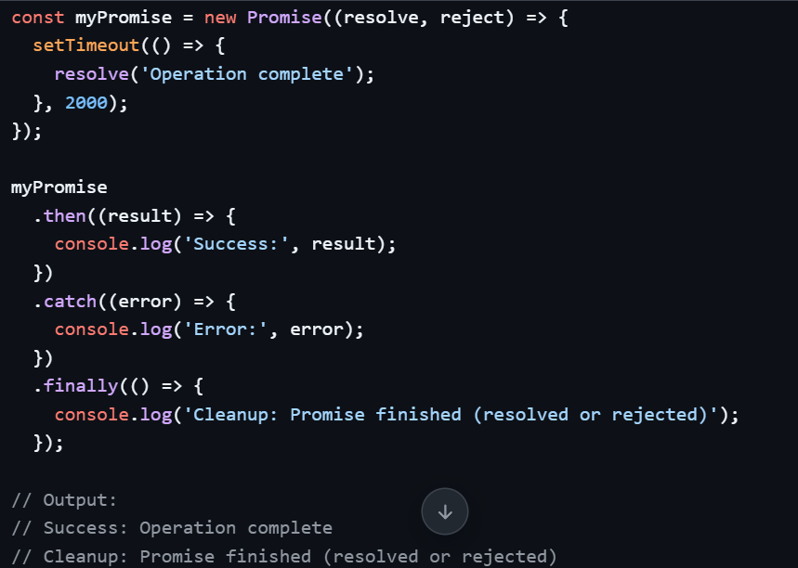

Promise API Static Methods
Promise.all
Waits for all promises to resolve. If any promise rejects, the whole thing rejects immediately.
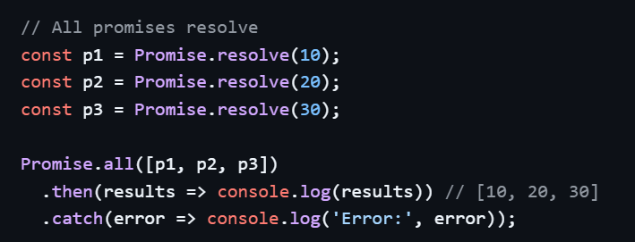

Promise.allSettled
Waits for all promises to settle (resolve OR reject) and returns their individual statuses.
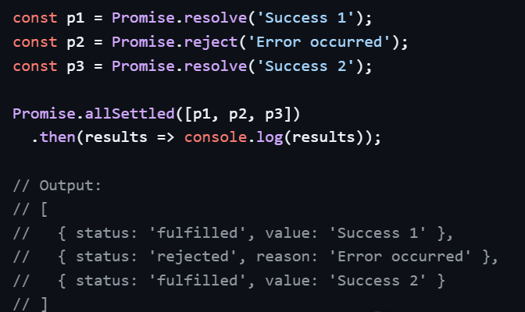
Promise.race
Resolves or rejects as soon as the first promise settles (whichever comes first).
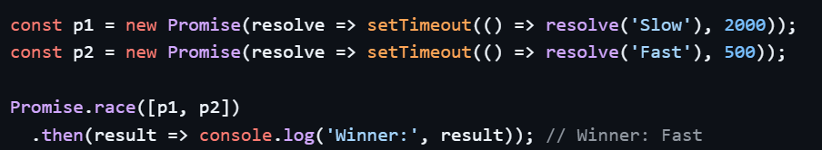
Promise.any
Resolves as soon as any promise resolves. Rejects only if ALL promises reject.
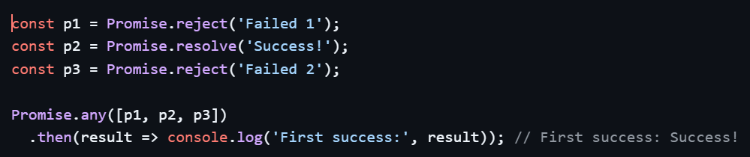
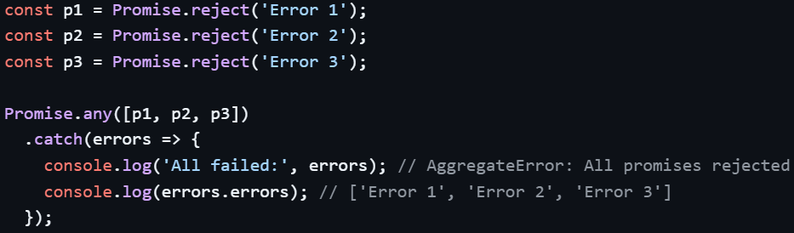

*********************************************************************************************************

Explain call(), apply(), and bind() methods in JavaScript
JavaScript offers call(), apply(), and bind() to control the value of this inside functions.

a)call()
The call() method invokes a function immediately. It takes the this value as the first argument, followed by arguments passed individually.

Syntax: function.call(thisArg, arg1, arg2, ...)
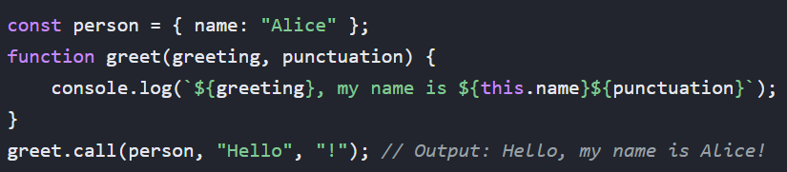

b)apply()
The apply() method is identical to call(), except it takes arguments as an array.
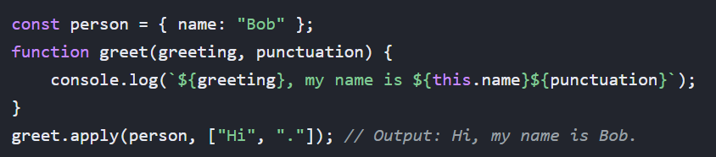

c)bind()
Unlike the others, the bind() method does not execute the function immediately. Instead, it returns a new function with a permanently bound this context that can be executed later.

Syntax: let newFunc = function.bind(thisArg, arg1, ...)
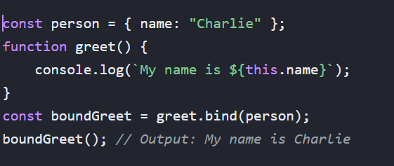

*********************************************************************************************************

Explain even loop in Javascript
Event loop is an important concept in Javascript that enables Asynchronous programming.
Since JS is single threaded, it uses event loop to manage the execution of multiple tasks without blocking the main thread.

Working of Event Loop:
Call Stack: Here the function execution is managed.
Web APIS: These consist of apis like setTimeout, setInterval, DOM Events, fetch.
Callback Queue: Here low priority tasks like setTimeout, setInterval are kept.
Microtask: Here tasks related to promises and functions like then(), catch(), finally() are placed and they have higher priority than callback queues.
Event loop: It checks whether the callstack is empty and if empty it will see if there are tasks in microtask or callback queue.
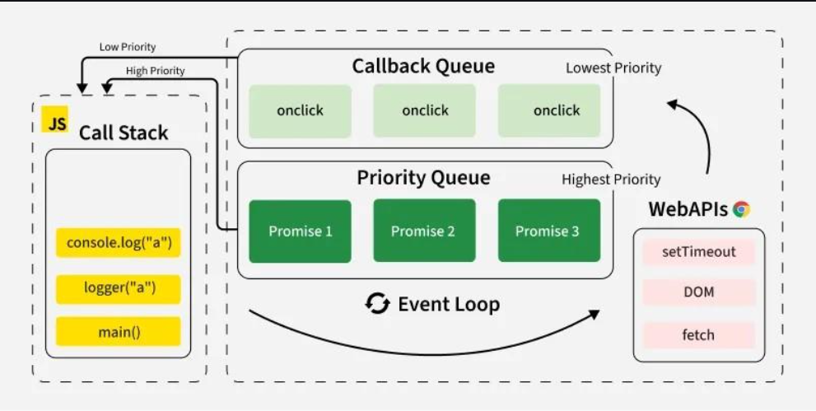

From basic to advanced the flow of execution:
1)
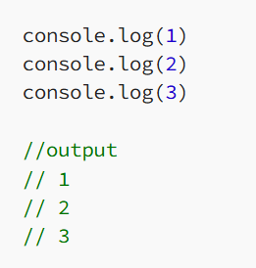
Here JS goes to the first line ,puts console.log(1) into the callstack and prints it output and then removes it from the callstack after its execution.
Then JS goes to second line puts console.log(2) into the callstack and then executes it and prints 2 and removes it from callstack and similar to the third line as well.

2)
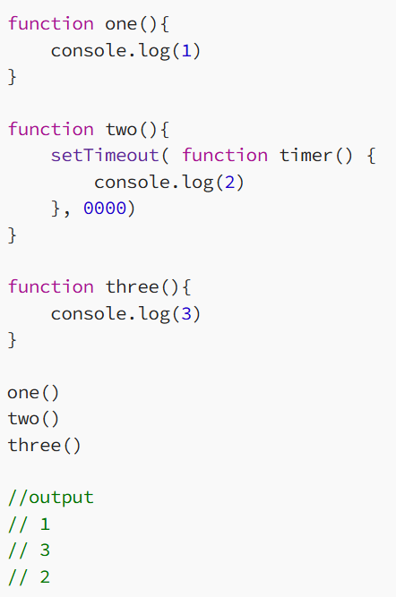

Here the JS will read the first function one() and puts it into the callstack and prints the output and then terminates it.
After that for the second function since it is an asynchronous function it will be a WEBAPI and it will be placed in the callback queue.
Next the JS will add the function three() into the callstack and executes it and then removes it from the callstack. Now the eventloop sees that the callstack is empty so it will take the task from callback queue and adds it to the callstack and then executs it and then removes it from the callstack.

3)
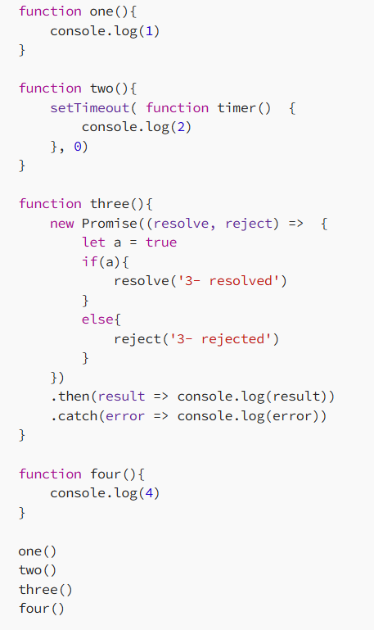
Here the output is
//1
//4
//“3- resolved”
//2

When it comes for function three a new promise object is created and it will be placed in microtask queue. After this then() will be added to the microtask queue. And setTimeout will be added to callback queue.
So first 1 and 4 are printed then according to priority event loop will pick the task from microtask and print it with then() method and then when the call stack is empty event loop will then add setTimeout function in callstack execute it and then print it and then terminate it .

