1)How does HashMap work internally? What happens during resizing?
1. Basic Structure
Array of Buckets: Internally, a HashMap consists of an array, where each element is referred to as a bucket. Each bucket stores a linked list or a binary tree of entries.
Entries (Nodes): Each entry in the HashMap contains a key-value pair, along with the hash value of the key and a reference to the next entry in case of collisions.
static class Node<K,V> {
final int hash; // Hash of the key
final K key; // Key object
V value; // Value object
Node<K,V> next; // Reference to the next node in case of collision
}
2. Key Operations
a. Hashing: When you insert a key-value pair into a HashMap, it computes a hash code for the key. The hash code is an integer value derived from the key's hashCode() method.
b. Index Calculation (Bucket Mapping): Once the hash code is calculated, HashMap determines the index of the bucket where the entry should be stored by using the modulo operation (hash % array.length). In Java, this is implemented with a bitwise AND operation:
int bucketIndex = (n - 1) & hash; // n is the size of the bucket array
c. Put Operation : Calculate the hashcode and bucket index and then
Insert into Bucket:
If the bucket is empty, the entry is inserted directly.
If there is already an entry at that index (collision), the HashMap uses chaining to resolve the collision, i.e., the new entry is added as the next node in a linked list or as a node in a binary tree (if the bucket contains many nodes).
d. Get Operation: Calculate the hashcode and bucket index and then
If it’s a single node: compare keys (first by hash, then equals).
If it’s a list: walk nodes, checking equals.
If it’s a tree: do a tree search (≈ O(log n) within that bucket)
e. Remove Operation: Compute Hash and Index and Traverse Bucket: The bucket is then traversed to find the node with the matching key, which is removed from the linked list (or tree).
2)How is the collision handled?
Chaining with Linked List (Pre-Java 8)
When two or more keys produce the same hash and map to the same bucket index, a collision occurs. In earlier versions of Java, collisions were handled using separate chaining. This means that multiple entries with the same bucket index are stored in a linked list at that index. If multiple keys collide, they are added as nodes in a linked list within the same bucket. When searching, HashMap traverses the linked list and compares the keys using the equals() method.
Chaining with Tree (Post-Java 8)
In Java 8 and later, if the number of entries in a bucket exceeds a certain threshold (8 entries), the linked list is converted to a binary search tree (BST). This improves the search time from O(n) to O(log n) in cases of excessive collisions.
Treeification: When the linked list at a bucket exceeds a threshold (default 8), HashMap converts it into a TreeNode (balanced binary tree) to speed up searches and retrievals. This is called treeification.

3)What happens during resizing?
Resizing occurs when the number of entries exceeds the threshold.
Capacity Doubling: The internal array capacity is doubled to reduce collisions (e.g., from 16 to 32).
Rehashing: Since the array size (n) changes, the index for every existing entry must be recalculated using hashCode(key) & (newCapacity - 1).
Transfer: All elements are moved from the old, smaller table to the new, larger table.

4)How do you implement custom sorting using Comparator and Comparable?
Custom sorting in Java is achieved by implementing either the Comparable interface to define a single "natural" sort order within a class or by using the Comparator interface to define multiple, external sorting strategies.
Implementing Custom Sorting with Comparable
- The class itself implements Comparable<T> and overrides the compareTo(T o) method.
- The Collections.sort(list) or Arrays.sort(array) methods can then sort instances of this class automatically.
- compareTo() Method Logic: This method compares this object with the specified object (o) and returns:
-A negative integer if the current object is less than the specified object.
-Zero if the current object is equal to the specified object.
-A positive integer if the current object is greater than the specified object.

Implementing Custom Sorting with Comparator
- You create a separate class (or use lambda expressions in Java 8+) that implements the Comparator<T> interface and overrides the compare(T o1, T o2) method.
- Usage: The Collections.sort(list, comparator) or Arrays.sort(array, comparator) methods take the Comparator instance as an argument.
- compare() Method Logic: This method compares its two arguments (o1 and o2) and returns a negative integer, zero, or a positive integer based on their relative order, just like compareTo().

5) What is Java Memory Model (JMM) and volatile keyword?
The Java Memory Model (JMM) is a specification defining how multi-threaded programs interact with memory, ensuring variable visibility and ordering across CPU caches and main memory to guarantee consistency. The volatile keyword ensures that a variable is always read from and written directly to main memory, bypassing local thread caching, thus providing immediate visibility to all threads.
6)How do you sort a map in java?
1)By Keys (Natural Order): Use a TreeMap to automatically sort by keys
2)By Values: a)by stream API use sorted(Map.Entry.comparingByValue())
b)by converting it into list and then use Collections.sort and then add back to LinkedHashMap.

7) Your Spring Boot app works locally but fails after deployment. What are the first 3 things you check?
Environment Variables and Configuration: Verify that the production environment has the correct database URLs, credentials, API keys, and other required configuration properties set correctly. A common issue is a mismatch between local .properties files and production environment variables.
Database Connectivity: Ensure the production database is reachable, its credentials are valid.
Logs and Application Health: Immediately check the deployed application's logs for specific error messages or stack traces. Platform-specific tools like Heroku Logs, AWS CloudWatch Logs, or Kubernetes Pod Logs provide insight into startup failures or runtime exceptions.

8) How to prevent multiple users in updating table?
1. Database Locking Mechanisms
Pessimistic Locking: Lock the record or table when a user starts a transaction, preventing others from accessing it until the transaction is complete.
Optimistic Locking: Allow multiple users to access the record but check for conflicts before committing changes, typically using a version or timestamp column.
2. Using Middleware or ORM
ORM Frameworks: Use built-in support for handling concurrent updates provided by Object-Relational Mapping frameworks like Hibernate for Java.

9) INNER JOIN returns only the rows that have matching values in both tables.
OUTER JOIN can be further divided into three types: LEFT JOIN, RIGHT JOIN, and FULL JOIN.
A LEFT JOIN returns all rows from the left table, and the matched rows from the right table.
A RIGHT JOIN returns all rows from the right table, and the matched rows from the left table.
A FULL JOIN returns all rows from both the tables.

10)Methods to Exclude Classes/Beans
Using @ComponentScan with excludeFilters
Using @SpringBootApplication with exclude or excludeName
Using @Profile Annotations

11)If we are using large objects int the application, how we do make sure to release them?
Nullify References: Explicitly set large object references to null when they are no longer needed.
Monitor and Profile: Use profiling tools to monitor memory usage and identify leaks.
Object Pools: Reuse frequently used large objects to reduce garbage collection overhead.

12)How hashset find duplicate values?
In Java, a HashSet is a collection that does not allow duplicate elements. It uses a hash table for storage, which means it relies on the hashCode() and equals() methods to determine if two objects are considered equal (i.e., duplicates).
How HashSet Finds Duplicate Values
Hash Code Calculation:
When you add an element to a HashSet, it first calculates the hash code of the element using the hashCode() method.
The hash code is an integer value that helps in determining the bucket location in the hash table where the element should be stored.
Bucket Location:
The hash code is used to determine the bucket (or index) in the hash table where the element might be stored.
If the bucket is empty, the element is added to that bucket.
Collision Handling:
If the bucket already contains one or more elements (a collision), the HashSet will iterate through the elements in that bucket to check for duplicates.
It uses the equals() method to compare the new element with the existing elements in the bucket.
Equality Check:
If the equals() method returns true for any existing element in the bucket, the new element is considered a duplicate and is not added to the HashSet.
If the equals() method returns false for all existing elements in the bucket, the new element is added to the HashSet.

13) If we perform delete operation on list, which list we should use and why?
LinkedList
Use ArrayList if we need faster acess to data
Use LinkedList for performing data manipulation and to do insertion deletion faster.

14)How do you manage these in current project - CI/CD, Devops, code quality
Jenkins: An open-source automation server that supports building, deploying, and automating any project.
DevOps Practices:Docker: Containerization platform to package applications and their dependencies.
SonarQube: A platform for continuous inspection of code quality.

15) How to monitor OutOfMemoryException
a)GC logs analysis.
b)Heap Dump Analysis
c)Profiling and Monitoring Tools like JVisualM, JConsole

Note: @Autowird annotation is used for automatic dependency injection
->And also to increase the size of the memory it is present in jar file.
->JavaC is a java compiler provided by the JDK. It converts the source code to byte code.
->String belongs to java.lang.String class.
->SpringBoot starters are set of pre defined dependency descriptors that help developers bootstrap spring application easily.
->We can externalize configuration in springboot using application.properties files, YAML files, Environment variables and also by command line arguments.
->We need functional interfaces to enable lambda expressions and method references in java. They improve code readability reducing boilerplate code.
->Spring security is a framework which provides authentication, authorization, and protection against common attacks.

16)Difference between HashMap and ConcurrentHashMap
HashMap | ConcurrentHashMap
HashMap is non-synchronized in nature meaning it is not thread safe. | ConcurrentHashMap is thread-safe and synchronized.
Its performance is high because many number of threads can perform tasks simultaneously. | Its performance is relatively slow because if one threads performs the task the other thread should wait until the first threads finishes its work.
When one thread is iterating the hashmap object and if other object is trying to modify then we will get concurrentmodificationexception. | Here we wont get any exception during iteration.

17)How do we prevent inserting incomplete/inconsistent records in to database
1. Database Constraints
a. NOT NULL Constraints:
b. UNIQUE Constraints:
c. CHECK Constraints:
2. Transactions
Use transactions to ensure that a series of operations either all succeed or all fail, maintaining database consistency.
3. Application-Level Validation
Perform validation in your application code before inserting data into the database.

18)Java 17 Features
1)Sealed Classes and Interfaces: Sealed classes restrict which classes can extend or implement them, improving type safety.
2)Pattern Matching: Allows the switch expression to be tested against different patterns and also supports null handling
Switch(obj):
Case String: Sysout(“String”);
Case Integer: Sysout(“Integer”);
Case null: Sysout(“null”);
3)Strong encapsulation of JDK internals
4)Removal of Applet API
5)New MacOS Rendering pipeline for better graphics performance.

19)Java 21 Features
1)Pattern Switching for Switch
2)Record Patterns: Record Pattern consists of a record class type and pattern list which is used to match against corresponding record component values.
3)Introduction of virtual threads in java platform where they can do the tasks quickly
4)Java emoji support tools
5)Improved null pointer exception messages.

20) What are different ways we can create beans? How we can create multiple instances of the same bean?
XML Configuration:
Define beans in an XML configuration file.
Annotation-Based Configuration:
Use annotations to define beans directly in the Java classes.
Java@Component
public class MyClass {
// Bean definition
}

Alternatively, you can use @Bean annotation in a configuration class.
Java@Configuration
public class AppConfig {
@Bean
public MyClass myBean() {
return new MyClass();
}
}
To create multiple instances of the same bean in Spring, use the @Scope("prototype") annotation to ensure a new instance is created on every request.

21)What is @Transactional?
@Transactional is a Spring Framework annotation that wraps a method (or class) in a database transaction so Spring can automatically begin, commit, or roll back work based on success/failure—without you manually managing transactions.
What it does (at a glance)
- Starts a transaction when the annotated method is entered (if one isn’t already active, depending on propagation).
- Commits when the method returns normally.
- Rolls back when certain exceptions occur (configurable).

22)Aggregation and Composition
Aggregation and composition are both types of associations that represent relationships between objects in object-oriented programming.
Aggregation represents a "has-a" relationship where the child can exist independently of the parent. It is a weaker form of association.
The parent and child have their own lifecycles.
Example: A university and a student. A student can exist independently of a university, and a university can exist without a particular student.

Composition
Composition represents a "part-of" relationship where the child cannot exist independently of the parent. It is a stronger form of association.
Example: A house and a room. A room cannot exist independently of a house, and if the house is destroyed, the room is also destroyed.

23)Explain difference between shallow and deep comparison in Strings with example?
Shallow Comparison
Shallow comparison checks if two string references point to the same memory location. This is done using the == operator. It does not compare the actual content of the strings but rather their memory addresses.
Deep Comparison
Deep comparison checks if two strings have the same content, regardless of whether they are stored in different memory locations. This is done using the .equals() method.

34)Why use char array instead of strings to store password?
Immutability of Strings
Strings are immutable: Once a String object is created, it cannot be changed. This means that if a password is stored as a String, it will remain in memory until the garbage collector removes it. During this time, it could potentially be exposed to memory dumps or other forms of unauthorized access.

Char arrays are mutable: In contrast, a char[] can be modified. After the password is used, the array can be explicitly overwritten with other data (e.g., zeros), reducing the window of time during which the password is in memory.

35)Is it possible to iterate and remove an element of an Array list at same time?
Yes, by using the right iteration pattern or else you will get concurrentmodificationexception. Iterate using an Iterator and call the iterator’s remove() after you decide an element should go.
36)How to implement single threaded application in Java?
Implementing a single-threaded application in Java means that the application will execute all tasks sequentially in a single thread, typically the main thread. This approach is straightforward and suitable for simple applications where concurrency is not required.

37)Relationship between hashcode and equals method
The relationship between hashcode and equals method is governed by the following contract:
1)If two objects are equal according to the equals method then they must have the same hashcode.
2)If two objects have the same hashcode then it not necessarily mean that they are equal.
3)Consistency: If the fields used in the equals method don’t change then repeated calls to the equals()/hashcode() must return the same consistent values.
This contract is important for the correct functioning of hash based collections like HashMap and HashSet. If the contract is violated then they may not function properly it will lead to unexpected behaviour like:
a)Not able to find the element in the collection even though object is present.
b)Duplicate elements

38)What is immutable class and immutable object and how to create an immutable class?
An immutable class is the one whose instance cannot be modified once they are created. The immutable objects are inherently thread-safe and can be shared freely between threads without synchronization.
1)Make the class as final .This will prevent other classes from extending it.
2)Make the fields as private final so that they are not accessible or modifiable directly.
3)Provide a constructor to initialize all the fields.
4)Don’t provide setter methods.
5)Perform deep copies for mutable objects. If the class has fields that are mutable objects, ensure that copies of these objects are used both when setting the fields and also when returning them from methods.

Ex: public class final ImmutableClasss{
private final String name;
private final int age;
private final Date d;
public ImmutableClass(String name, int age, Date d)
{
this.name=name;
this.age=age;
this.d=new Date(d.getTime());
}
public String getName(){
Return name;
}
public int getAge(){
Return age;
}
Public Date getd(){
Return new Date(d.getTime());
}

39)What are the ways to set Active profiles in SpringBoot?
1)Using application.properties files or YAML file.
2)Using command line arguments.
3)Using Environment variables.
4)Using programmatically in code like spring.profiles.active=dev
40)When you encounter an error indicating that the "application context is getting failed" in a Spring Boot application what does it mean?
It means Spring application context is not initialised properly. This can happen due to configuration issues, bean creation failures or dependency injection problems.

41)How did you deploy a Spring boot application in Cloud?
1)Prepare your application.
2)Choose cloud Provider.
3)Configure the cloud environment.
4)Deploy your application

42)How to enable Debug logs in Spring boot Application?
1)Modify the application.properties files. There set the logging level to DEBUG.
2)Using command line argument. When you run the application set the logging level to DEBUG.

43)How to make 2 service calls in parallel in Spring boot application?
1)Combine @Async annotation with CompletableFuture
2)Use completableFuture.supplyasync() method with custom ExecutorService

44)What is JavaFx?
It provides a set of graphics and media packages which enable developers to create rich client applications.

45)What is the difference between Heap and Stack?
Stack is used for static memory allocation. It stores local variables and function call information.
Public void Function(){
Int x=10;
Int y=20;
}// x and y are stored in stack memory and they are removed when Function() exits.

Heap is used for dynamic memory allocation. It stores objects and data that needs to be accessed globally and have a longer lifetime.
NewClass a=new NewClass();//a is stored in heap and it remains in heap memory until it is no longer unreferenced and garbage collected.

46)Difference between @Autowired and @Inject
@Inject is Standard based DI. Supported by Jakarta EE and also by spring
@Autowired is Spring based DI. Supported by spring.

47) What is the difference between ApplicationContext and BeanFactory?
BeanFactory is lightweight IOC container for lazy loaded initialization best for memory constrained, simple applications.
Application context extends bean factory used for more advanced eager initialization with features like annotation based config, event handling making it more suitable for enterprise and springboot applications.

48)What are some of the SB actuator endpoints?
/actuator/health, /actuator/loggers, /actuator/info, /actuator/metrics.

49)What is the use of CommandLineRunner and ApplicationRunner?
Both are functional interfaces in springboot which allow developers to execute code immediately after spring application context is fully initialised just before Springapplication.run() method finishes.

50)What is a singleton class?
It is a design pattern which ensures that a class has only one instance and provides global access to it.
Steps to create a Singleton Class
1)Create private static instance of the singleton class to ensure only one instance is returned.
2)Create private constructor to prevent from direct instantiation.
3)Create static method getInstance() to return the instance
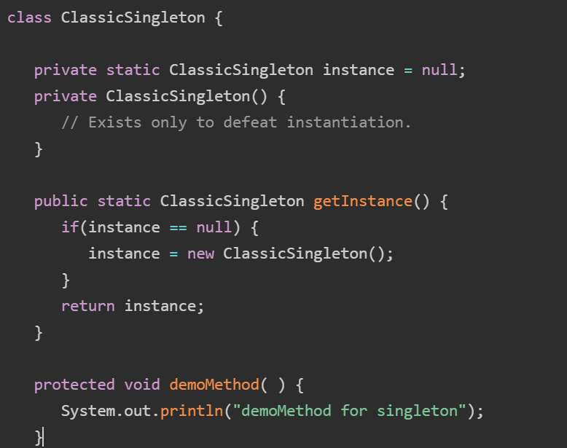
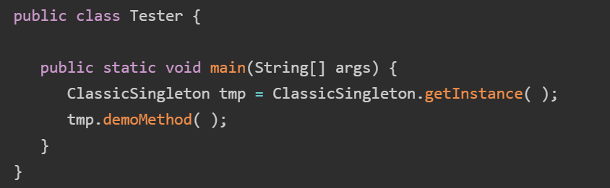

51)What is try with resources and multi catch statement?
It is a java 7 feature which ensures that resources like files, database connections, network sockets are closed automatically when they are used. The resources are written inside the parenthesis of the try and java will close them automatically when they are used.

Multi catch statement is also java 7 feature which ensures that a single catch statement can catch many exceptions at a time reducing boiler plate code and increasing readability.
try {
} catch (ArithmeticException | ArrayIndexOutOfBoundsException e) {
System.out.println("A math or array error occurred: " + e.getMessage());
}

52)How GC works?
It uses mark and sweep algorithm.
The GC will collect all the unused objects present in the heap memory traced through GC roots and then will sweep them all means reclaims the memory space used by these objects.

53)In a multithreaded env, multiple threads are modifying the collection how do you manage?
Use thread safe collections like CopyOnWriteArrayList, ConcurrentHashMap, ConcurrentLinkedQueue

54)What is RESTFUL API?
RESTful API is an interface that two computer systems use to exchange information securely over the internet using HTTP methods like GET, DELETE, POST, PATCH, PUT.

55)What are virtual threads in Java 21 and how do they differ from platform threads?
Virtual threads are lightweight threads managed by the JVM rather than OS allowing for millions of concurrent tasks.
One difference is that we can have many virtual threads running the same java process.
Other difference is that virtual threads are bound for short termed IO bound tasks whereas platform threads are meant for long running CPU bound tasks.

56)What is record class?
It is used to define simple, transparent carriers for immutable data with minimal boilerplate code.
It is declared using record keyword. It automatically generates constructors, accessor methods, equals(), hashcode(), toString().
All fields are implicitly private and final

57)What are text blocks and where are they useful?
Text blocks are used to declare multi-line strings more efficiently eliminating the need of delimiters, string concatenation etc.
Used in the region of string literal to enhance clarity and readability of the code.
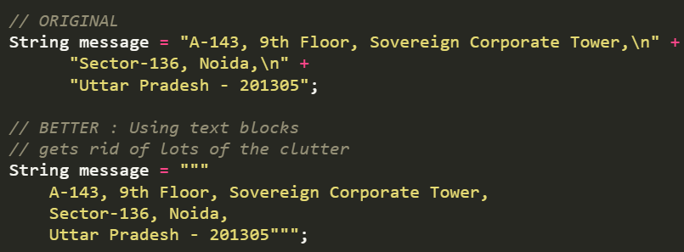

58) How do you capture heap/thread dumps?
Heap dump is a snapshot of all the objects in the memory in the JVM at a certain moment. They can be used to troubleshoot memory leaks and memory usage. Heap dumps are usually stored in binary format in hprof files. JDK has many tools to capture heap dumps. All these tools are present inside the bin folder inside the JDK home directory. So these tools include jmap, JVisualVM (it is a graphical UI tool).

59)What is the difference between equals() and hashCode(), and why is it important?
equals() and hashCode() are Java Object methods used to compare object equality and generate hash identifiers.
- equals(Object obj): Determines if two objects are "logically equal".
- hashCode(): Returns an integer representation (hash) of an object. This hash determines the "bucket" where the object is stored .
Why They Are Important:
- Collection Behaviour: HashMap, HashSet, and Hashtable use hashCode() to find the correct bucket and equals() to check for duplicate keys within that bucket.
- Performance: A well-distributed hash code allows quick lookups. Poorly implemented hashCode() causes high collision rates, making lookups slower.
- Data Integrity: If you override equals() but not hashCode(), you violate the contract, meaning set.contains(new Person("Alice")) might return false even if a matching object was previously added.

60)How you integrate Kafka with springboot?
Link

61)How does Sprinboot work internally?
Spring Boot auto-configuration internally works through a combination of classpath scanning, configuration metadata files, and conditional annotations.
1)Entry point : The application begins from @SpringBootApplication
2)Locating the auto-configuration candidates
3)Applying conditional logic
4)Bean Registration: If all the conditions on the specific auto-configuration class are met, SB proceeds to register the beans within the class.

62) If you add a null value to an empty Set, what will be the size of the Set?
1 .. If we add null again then set size will be one only because set will allow null value only once.

63)What is @Generated Value annotation?
It is used for automatically generating primary key values mostly for database entities like ID.

64)What methods do Optional class provide and when to use it and when to avoid it?
Methods: Of, OfNullable, isPresent, isEmpty, get
When to use: Can be used with the methods which do not return any result(Eg findByUserId)
When to avoid:Do not use for method parameters, class fields, or collections/arrays, as this can lead to unnecessary overhead, serialization issues, and less readable code.

65)What happens if the @FunctionalInterface annotation is not used?
Nothing will happen and the interface will be treated as functional interface only as long as one abstract method is present.
Some problems include
a)Code may break later: Suppose you are using the code in the context of functional programming and some other changes are made then this will affect the context.
b)Less Clear understanding:
Developers will assume that it is not a functional interface and may sometimes unknowingly add some more abstract methods.

66)Why is Optional not recommended as a method parameter?
Because it was designed as method return type. Using it in method parameter will lead to less readable code, increasing overhead and confusion for the caller.

67) How do you safely stop a running thread?
The modern way to stop a thread is by using Boolean flag and Thread.interrupt() method.

68)Swap two variables using third variable
Int a=10,b=20;
A=a+b;
B=a-b;
A=a-b;

69)What happens when a thread pool queue is full?
When a thread pool queue is full, the behavior depends on the configured maximum pool size and the rejection policy. Generally, the pool will first attempt to create new threads (up to the maximum pool size) to handle the overflow, but if the maximum is already reached, the pool will reject new tasks.

70)A REST API is slow only in production, not locally. How do you debug it?
a) Use Application Programming tools like DataDog, Prometheus to monitor where the time is being spent within the request lifecycle.
b) Implement Detailed Logging
c) Monitor key metrics

71)How to fix a slow API?
1)Start by optimizing the DB queries. Use indexing for primary keys.
2)Cache the frequently used data using Redis instead of each time calling the DB.

72)You changed application. properties but changes are not reflecting. Why?
Changes in application.properties are not reflected because the application was not restarted or the property source is being overridden by another configuration like an active profile or environment variable.

73)Explain the concept of Bean scopes in Spring Boot?
Bean scopes in Spring Boot define the lifecycle and visibility of Spring-managed beans. They determine how instances of a particular bean are created,managed, and shared within the application context.

Spring Boot provides several bean scopes, including:
Singleton: The default scope. A singleton bean is created only once, and the same instance is shared across all requests. It remains in the application
context until the application shuts down.
Prototype: A new instance of the prototype bean is created each time it is requested. It allows multiple instances of the same bean to coexist within the
application.
Request: A new instance of the request-scoped bean is created for each HTTP request. It is useful when you want to store data specific to a single
request, such as user session information.
Session: A new instance of the session-scoped bean is created for each user session. It maintains the state specific to a user's session across
multiple requests.

Application: A new instance of the application-scoped bean is created once for the entire application. It is shared across all requests and sessions.
WebSocket: A new instance of the web socket-scoped bean is created for each WebSocket session.

74) What is the difference between synchronous REST calls and asynchronous messaging?
- Coupling & Availability: Sync is tightly coupled; if the receiver is down, the request fails. Async is loosely coupled; messages can be buffered in a queue if the consumer is offline.
- Performance & Latency: Sync may cause bottlenecks and higher latency during high load. Async improves performance and scalability by offloading tasks.
75) How does JVM decide when to perform garbage collection?
The Java Virtual Machine (JVM) automatically decides when to perform garbage collection (GC) primarily when the heap memory is running low or a specific memory area becomes full.

76)

1)Implement Stack using array

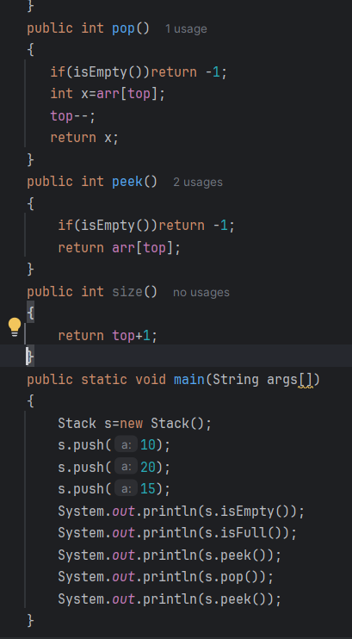
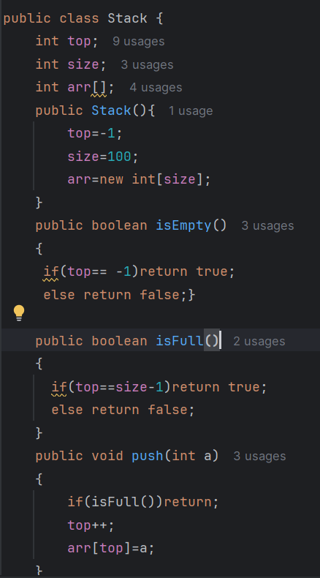
2

2)Min Stack

