Latency and Throughput
Latency means the time taken by the data to travel from source to destination. Low latency systems are important for real-time applications. Online gaming requires low latency to provide real- time interactions with the players. Unit of measurement is milliseconds.
Factors impacting latency:
a) Location: One of the most important factors is the location of where data originates and its intended destination. If your servers are in a different geographical region from your device, the data has to travel further, which increases latency.
b) Network Congestion: Network congestion occurs when there is a high volume of data being transmitted over a network. The increased traffic on the network causes packets to take longer routes to their destination.
c) Protocol efficiency: Some networks require additional protocols for security. The extra handshake steps create a delay.
d)Network Infrastructure: Network devices can become overloaded, which results in dropped packets. As packets are delayed or dropped, devices retransmit them. This adds additional latency.

Throughput is the amount of data that can be transferred over a network in given time. High throughput is required for data-intensive applications. A data analytics process requires high throughput to process and analyze large datasets. Unit of measurement is megabytes per second.
Factors affecting throughput:
a) Bandwidth: If your network capacity has reached the maximum bandwidth of your transmission medium, its throughput will never be able to go beyond that limit.
b) Packet loss: Packet loss can occur for a variety of reasons, including network congestion, faulty hardware, or misconfigured network devices. When packets are lost, they must be retransmitted. This results in delays and reduces the overall throughput of the network.
c)Network Topology: Network topology refers to the number of network devices, the bandwidth of the network links, and the distance between devices in a network path. A well-designed network topology provides multiple paths for data transmission, reduces traffic bottlenecks, and increases throughput.

How can you improve latency and throughput?

Caching: Caching in networking refers to the process of storing frequently accessed data geographically closer to the user. For example, you can store data in proxy servers or content delivery networks (CDNs).
Your network can deliver data from the cached location much faster than if it had to be retrieved from the original source. And the user receives data much faster, improving latency. Additionally, because the data is retrieved from a cache, it reduces the load on the original source. This allows it to handle more requests at once, improving throughput.

Transport protocols: By optimizing the transport protocol that you use for specific applications, you can improve network performance.
For instance, TCP and UDP are two common network protocols. TCP establishes a connection and checks that you receive data without any errors. Because of its goal of reducing packet loss, TCP has higher latency and higher throughput. UDP does not check for packet loss or errors, transmitting several duplicate packets instead. So, it gives minimal latency but a higher throughput.
Depending on the application that you are using, TCP or UDP may be the better choice. For example, TCP is useful for transferring data, while UDP is useful for video streaming and gaming. You must monitor both latency and throughput to achieve high network performance.

Virtual vs Horizontal scaling
Pros of Vertical Scaling:
Simplicity: Vertical scaling is relatively simple to implement as it doesn't require changes to the application architecture.
Lower latency: Since all the resources are located on a single machine, vertical scaling can eliminate the need for inter-server communication thus lowering the latency.
No Major Code Changes: Often requires little to no adjustments to your application's codebase.

Cons of Vertical Scaling:
Limited scalability: There is a limit to how much a single machine can be upgraded.
Single point of failure: With all resources on one server, any hardware failure can bring down the entire system.
Higher Costs in the Long Run: High-end servers with powerful CPUs and large amounts of RAM can get very expensive as you scale.

Pros of Horizontal Scaling:
Near-Limitless Scalability: You can continue to add nodes as long as your architecture supports it, providing the ability to handle larger loads.
Improved fault tolerance: The failure of one node does not bring down the entire system, minimizing downtime.

Cons of Horizontal Scaling
Complexity: Distributing the application across multiple servers introduces complexity in terms of data consistency, load balancing, and inter-server communication.
Increased latency: Communication between servers can introduce additional latency compared to a single machine.
Cost: Initial setup and maintenance costs can be higher due to the complexity of the infrastructure.
Things to consider to decide between vertical and horizontal scaling:
Cost, Workload, Architectural Complexity, Future Growth.

Scalability vs Performance
Scalability is about size: "Can the system grow to handle more work?"
Performance is about speed: "How fast can the system complete a task?
They often pull in opposite directions and improving one can sometimes impact the other.
Example: Adding more machines to a system can make it more scalable, but the complexity of managing these machines and coordinating tasks across them might introduce delays affecting performance.
Conversely, optimizing for performance with minimal resources may create scalability issues when user demand increases.

Strong vs Eventual Consistency
Strong consistency means that as soon as a data update occurs, any subsequent access to that data will reflect the update. Strong consistency is the right choice when your application needs immediate correctness and absolute accuracy.
Example: In a banking system, when you transfer money from one account to another, the system updates the balances immediately.

Eventual consistency, on the other hand, means there might be a delay before an update is visible across all nodes in a system. But, it's guaranteed that if no new updates are made, eventually, all accesses to that data will return the updated value.
Example: On a social media platforms like Instagram, when you post a new photo, it might not immediately appear on all your followers' feeds. However, after a short period, everyone will be able to see the latest updates.

Choosing the Right Consistency Model

1. Data Criticality
High (e.g., financial transactions, inventory management) → Use strong consistency.
Lower (e.g., social likes, view counts, analytics) → Eventual consistency is often sufficient.

2. User Experience Expectations

3. Performance (Latency) Requirements

4. Availability Requirements

5. Scalability Needs
Batch vs Stream Processing

Batch processing is a traditional approach to data processing that has been around for decades.
Collecting and storing data over a period of time (hours, days, or even weeks).
Processing this data in bulk at scheduled intervals.Producing some output data.

Key Characteristics:
Scheduled: It processes data at scheduled intervals, such as daily, weekly, or monthly.
High throughput: Since large volumes of data are processed together, it achieves high throughput.
Latency: There is inherent latency because data is processed after being accumulated over a period.
Consistency: It ensures that the entire dataset is processed consistently.
Example Use Cases:
Generating end-of-day reports.
Processing payroll at the end of the month.
Performing large-scale ETL (Extract, Transform, Load) tasks.

Batch Processing Workflow

1. Data Collection:
Data is collected over time and stored in a buffer, file system, database, or data warehouse. This phase can last for hours, days, or even months, depending on the business requirement.

2. Pre-processing:
Before the batch is processed, the system may perform a series of preparatory steps such as data validation, cleaning, filtering, or aggregating.

3. Batch Execution:
Once the data is ready, it is processed as a single unit.
This can involve:Running computations over the data.
Performing ETL (Extract, Transform, Load) operations.

4. Post - processing :
After the execution, the processed data is typically written back to the database, storage, or sent to another system for further use. Reporting or analytics tasks can also be triggered in this step.

Challenges in Batch Processing:
Latency: The time it takes to collect data can be a bottleneck in situations where timely insights are required.
Storage: Batch systems require large amounts of storage to collect and hold data before processing. Storing massive datasets over time can be costly.
Resource Spikes: Batch processing jobs often consume significant system resources when they run, causing spikes in CPU, memory, and disk usage. This can slow down other system operations, especially during peak hours.
Failure and Error Handling: If an error occurs during a batch process, the entire batch may need to be reprocessed, leading to inefficiency and delays.

Stream Processing
Stream processing is a more recent approach that has gained popularity with the rise of real-time data and the need for immediate insights.
It involves processing data in real time or near real time as it arrives.

Key Characteristics:
Real-time processing: Data is processed as soon as it is received.
Low latency: Stream processing systems are designed to provide low-latency responses, often within milliseconds or seconds.
Event-driven: Processing is triggered by events, making it suitable for real-time applications.
Infinite data streams: Stream processing systems work on continuous flows of data, as opposed to finite datasets in batch processing.
Example Use Cases:
Monitoring sensor data in IoT systems.
Detecting fraud in financial transactions in real-time.

For fraud detection, they implement stream processing to analyze transactions in real-time and flag suspicious activities immediately.

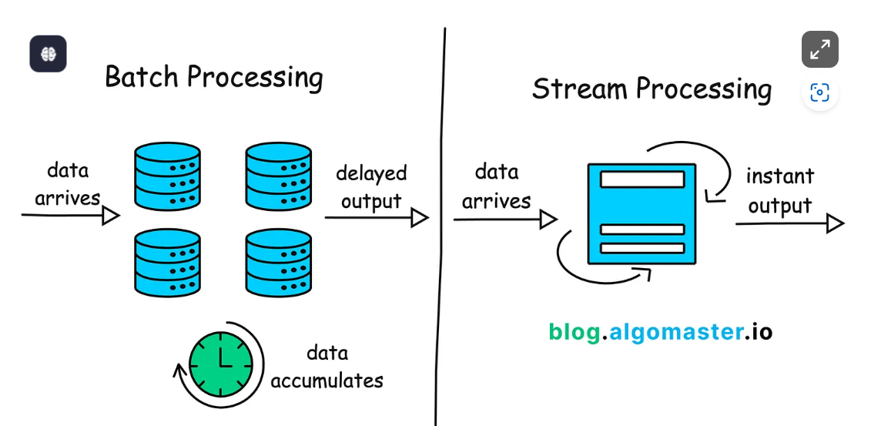

Read-Through vs Write-Through Cache
Cache strategies are classified as read-through and write-through caches. A read-through cache checks the cache first when data is requested. If the data isn't there (cache miss), it's loaded from the slower primary storage into the cache before being returned. It is useful for read-heavy applications where data is frequently accessed but not often updated, reducing the load on the primary storage and improving read performance.
Example: In an online store, when a customer views a product for the first time, the product details are fetched from the database and stored in the cache. Subsequent views are served from the cache, speeding up the response time and reducing database queries.
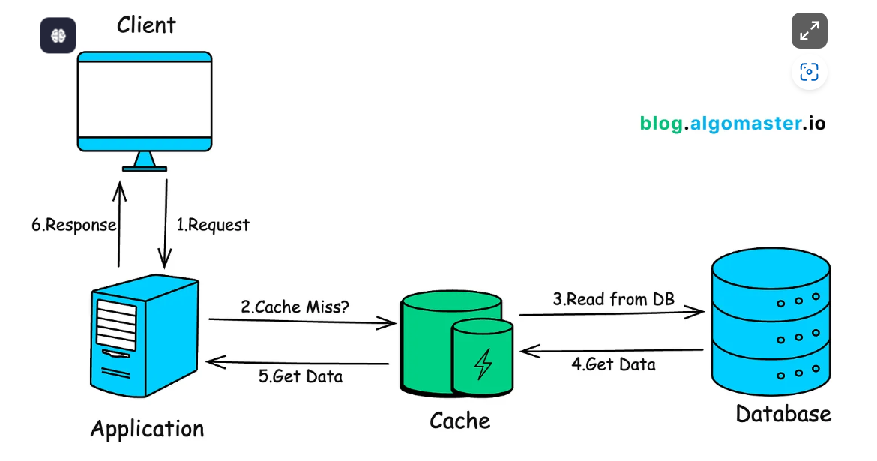
A write-through cache simultaneously writes data updates to the cache and primary storage, ensuring up-to-date data and reducing data loss risks. It's beneficial for write-heavy applications. All writes are instantly reflected in both the cache and primary storage.
Example: A movie ticket booking system uses a write-through cache to prevent overbooking by immediately recording bookings both in the cache and the database.
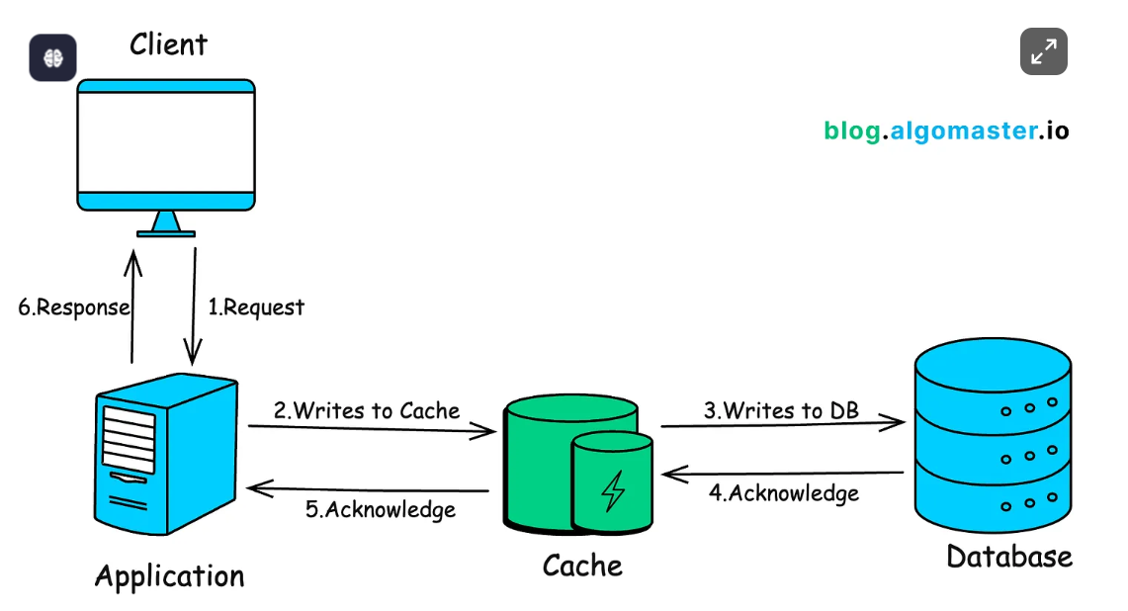
Push vs Pull Architecture
Push Architecture
Here the data is pushed from the central server to the client as soon as it become available. The server initiates the communication pushing information to the clients without waiting for any requests.
Examples:
Notifications Systems: Mobile push notifications that alert users to new messages, updates, or events.
Live Feeds: Real-time data feeds like stock market tickers or social media updates.
Streaming Services: Video or music streaming platforms that push content to users.

Pull Architecture
In a pull architecture, clients request data or updates from the server as needed. The client initiates the communication, pulling information from the server when it requires specific data.

Examples:
Web Browsing: Browsers request web pages or resources from servers as needed.
APIs: RESTful APIs where clients request data from a server.
Database Queries: Applications querying a database to retrieve specific data.

Choose Push Architecture When:
Building real-time or near-real-time systems (e.g., live dashboards, instant messaging)
Dealing with time-sensitive data (e.g., stock prices, emergency alerts)
Working with sources that produce data at unpredictable intervals
Bandwidth efficiency is crucial, and you want to avoid unnecessary data transfers

Choose Pull Architecture When:
Building systems that can tolerate some delay in data updates
Working with stable, predictable data sources
Implementing systems where receivers need to control their data intake
Dealing with unreliable network conditions where failed pushes could lead to data loss

Synchronous vs Asynchronous Communication
Synchronous processing means tasks are performed one after another. A task must be completed before the next one starts, and the system waits for the outcome before proceeding.
Example: When you make an online purchase, the payment process is synchronous. After you click "Pay Now," you wait for the transaction to process. The website does not let you move forward until it confirms that your payment was successful.
Asynchronous processing allows tasks to run in the background and doesn't need to wait for it to complete before starting another one.
Example: Uploading photos on social media happens asynchronously in the background. You can keep scrolling or exit the app while the photo uploads.

Factors to Consider
When deciding between synchronous and asynchronous communication, consider the following factors:
Performance: Asynchronous communication can lead to better performance and throughput as the sender and receiver can work independently.
Scalability: Asynchronous communication allows for better scalability as the system can handle a higher load by processing messages concurrently.
Reliability: Asynchronous communication can provide better reliability through message persistence and retries in case of failures.
Complexity: Asynchronous communication introduces additional complexity in terms of message ordering, error handling, and coordination between components.
Real-time requirements: If the system requires real-time interactions or immediate responses, synchronous communication may be more suitable.
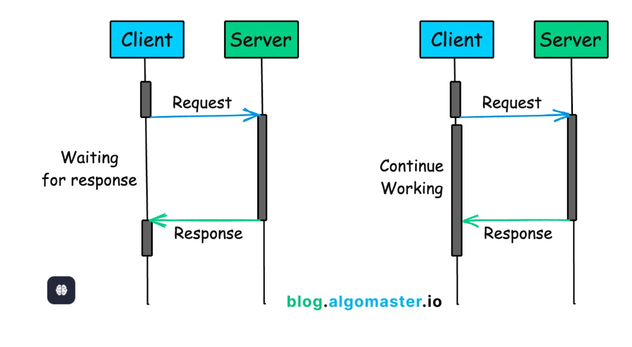 Stateful vs Stateless Architecture
A stateful system remembers past interactions. It stores information about the current session, making it possible to have continuity and context in subsequent interactions without needing to start from scratch each time.
Example: During online shopping, when you add items to your cart, the website remembers your selections. If you navigate away to browse more items and then return to your cart, your items are still there, waiting for you to check out.
A stateless system does not keep track of past interactions. Each request is treated as new, with no information retained from previous requests.
Example: Many RESTful web services, operate without remembering past requests. For instance, when you make a query to a public API for weather information, you provide all necessary details (like location) with each request.

