Q1 What are microservices?
Microservices is an architecture where the application is exposed as loosely coupled services that can be independently developed, deployed, and maintained. Each service exposed is referred to as Microservice. Each service performs a unique function.

Speciality of this architecture is that polyglot architecture is supported. For example, if a team is working on one of the microservice using Java, Spring Boot, and MySQL, another team can work on another microservice using Python, Node JS, and NoSQL.

- Different microservices can use a different version of the same programming language.
- Different microservices can use different programming languages.
- Different microservices can use different architectures as well.

Q2 Why microservices?
In the case of monolith applications, there are several problems like
Same code base for presentation, business layer, and data access layer. Application is deployed as a single unit.
Complex to maintain and scalability is an issue.
Microservice solves the above problems.

Q3 What are the cons of microservices?
1) Management of large number of services is difficult.
2) Communication between microservices is complex.
3) Increased efforts for configuration and other operations
4) Due to the decentralized nature of microservices, more microservices will mean more resources hence high Investment
5) Debugging of problems is harder unless the right instrumentation is followed during design and development.

Q4 Explain the difference between a Monolithic architecture and MicroServices architecture.
Definition:
- A Monolithic architecture is a single, unified application where all components (UI, business logic, DB access) are tightly coupled.
- Microservices architecture splits the application into small, independent services, each handling a specific business function.

Key Differences:
- Deployment: Monolith is deployed as one unit; microservices are deployed independently
- Scalability: Monolith scales as a whole; microservices scale per service
- Codebase: Monoliths have same code base for each layer while microservices have different codebase for different layers.
- Failure Impact: One failure can crash monolith; microservices isolate failures

When to Use:
- Use Monolith for small apps or small teams
- Use Microservices for large, scalable systems with multiple teams and when your need to reduce time to market, scalable better software and faster development.
Microservices add flexibility but also introduce distributed system complexity.

Q5 What are the main components of microservices?
- Microservices
- API Gateway
- Load Balancer
- Authentication and Authorization
- Service Discovery
- Container and Orchestration
- Distributed Logging
- Distributed Tracing
- Database
- Monitoring & Alerting

Q6 What is an API Gateway, and why is it needed in a microservices architecture?
Definition:
An API Gateway is a single entry point for all client requests in a microservices architecture.
The Problem — What happens WITHOUT an API Gateway?
Imagine you have a mobile app and 5 microservices behind it. Without an API Gateway, the client has to call each service directly. Here is what goes wrong:
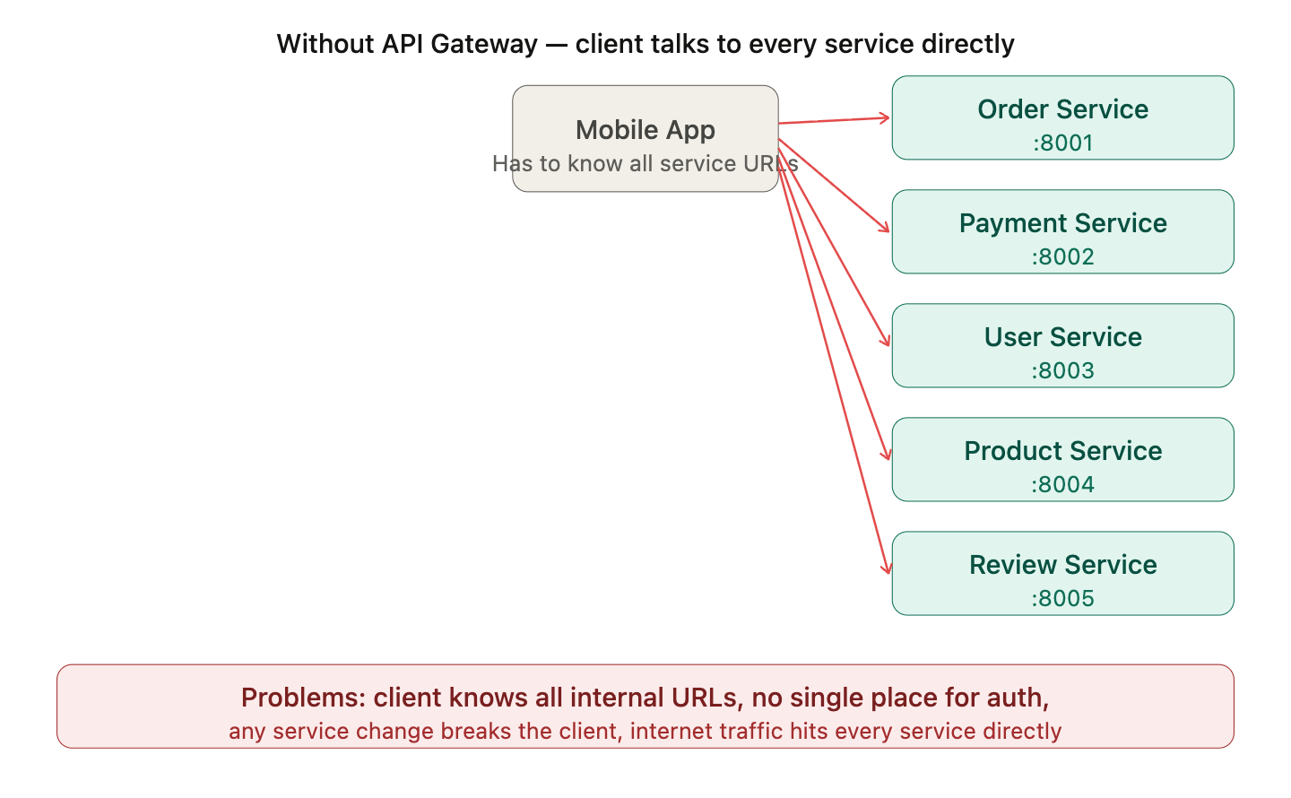
The specific problems this causes:
1. Client knows too much: The mobile app has to know every service's URL and port. If you rename a service, move it, or split it into two — you have to update every client app. You can't update a mobile app instantly — millions of users may still be on the old version.
2. No single place for auth: Every service has to implement authentication and authorization independently. If you want to add rate limiting or SSL, you have to do it in all 5 services.
3. Internal services exposed to internet: Every service is directly reachable from the outside world, which is a massive security risk.

The Solution — API Gateway
An API Gateway sits between the client and all your services. It is the single-entry point for all client requests. The client only ever talks to the gateway — it never knows what services exist behind it.
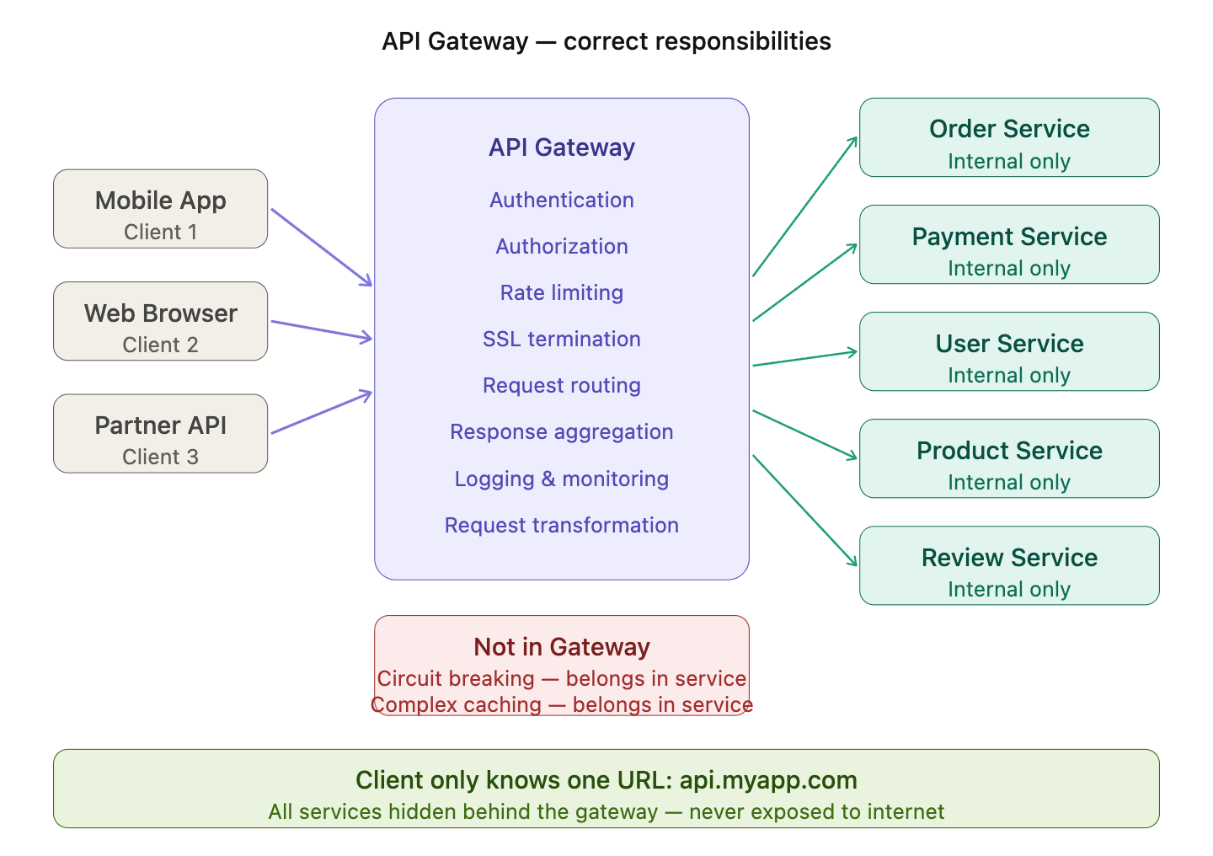

What Exactly Does API Gateway Do?

1. Request Routing
- Based on URL/path, it forwards request
Example:
/orders → Order Service
/users → User Service
2. Protocol Translation
The API gateway can translate many protocols like HTTP, Websockets and GRPC. This helps the client to choose the communication protocol without changing the microservices themselves.

3. Load Balancing
- If multiple instances exist:
Order Service → Instance1, Instance2
- Gateway picks one (Round Robin, etc.)
- @LoadBalanced is annotation used for load balancing
@LoadBalanced
@Bean
public RestTemplate restTemplate() {
return new RestTemplate();
}

4. Authentication & Authorization
- It handles a and a based on API keys, Oauth tokens, JWT tokens.
- No need to implement auth in every service
- Implementation using Filters
5. Rate Limiting
- It also enforces rate limiting to prevent the client making too many requests in short period of time.
Max 100 requests/min per user
spring:
cloud:
gateway:
routes:
- id: order-service
uri: lb://ORDER-SERVICE
predicates:
- Path=/orders/**
filters:
- name: RequestRateLimiter
args:
redis-rate-limiter.replenishRate: 10
redis-rate-limiter.burstCapacity: 20

6. Response Aggregation
Instead of client calling multiple services individually the API Gateway will call it together and sends the response in combined manner.
Client → Order
Client → Payment
Client → User
Gateway does:
Client → Gateway → (calls multiple services)
↓
returns combined response
@RestController
public class AggregationController {
@Autowired
private RestTemplate restTemplate;
@GetMapping("/order-details/{id}")
public Map<String, Object> getOrderDetails(@PathVariable int id) {
Object order = restTemplate.getForObject(
"http://ORDER-SERVICE/orders/" + id, Object.class);
Object user = restTemplate.getForObject(
"http://USER-SERVICE/users/" + id, Object.class);
Map<String, Object> response = new HashMap<>();
response.put("order", order);
response.put("user", user);
return response;
}
}
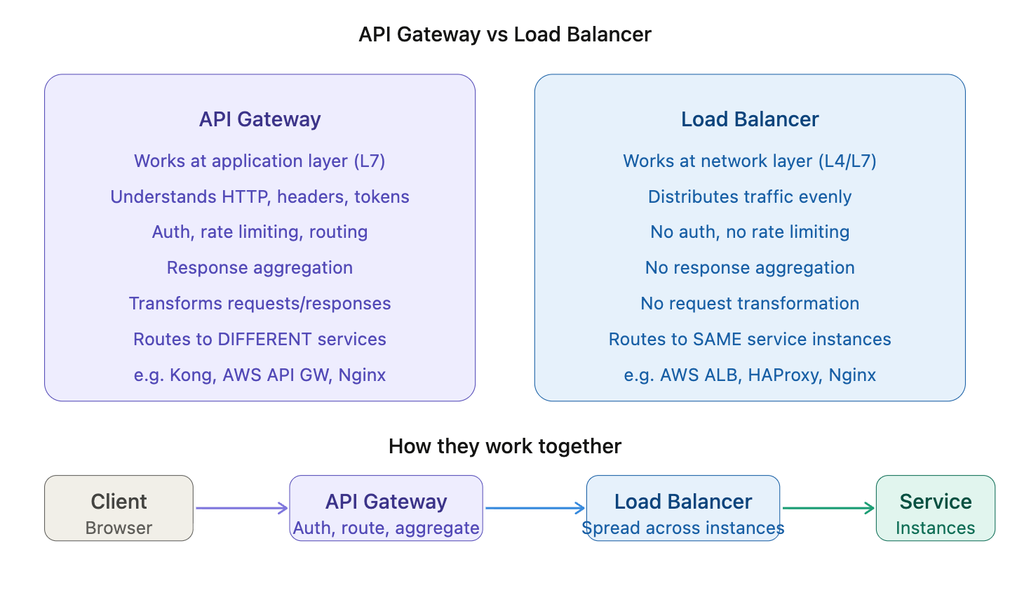

Q7. What is API Versioning?
API Versioning is the practice of maintaining multiple versions of an API so that changes can be introduced without breaking existing clients.

Why Do We Need It?
Imagine:
v1 → returns: name
v2 → returns: firstName + lastName
If you change API directly:
- Old apps break ❌
- Clients fail ❌
With versioning:
- Old clients use v1
- New clients use v2
Examples are public API’s given by software companies used for many integrations

Q8. How do microservices communicate with each other? Can you explain the difference between synchronous and asynchronous communication, and when you would use each?

1. Synchronous Communication
Service A sends a request to Service B and waits — it cannot do anything else until it gets a reply. Like a phone call — both parties must be active at the same time.
Protocols used: REST over HTTP, gRPC
The Problem it creates: Imagine Order Service calls Payment, then Email, then Inventory, then Warehouse — all one-by-one waiting for each. Total time = sum of all individual times. Worse, if Email Service crashes, your entire order fails — even though email is not critical to completing an order. This is called cascading failure.
When to use it anyway: Only when you genuinely cannot proceed without the answer. Example — you must confirm the payment succeeded before you confirm the order to the user. You can't fake that answer.

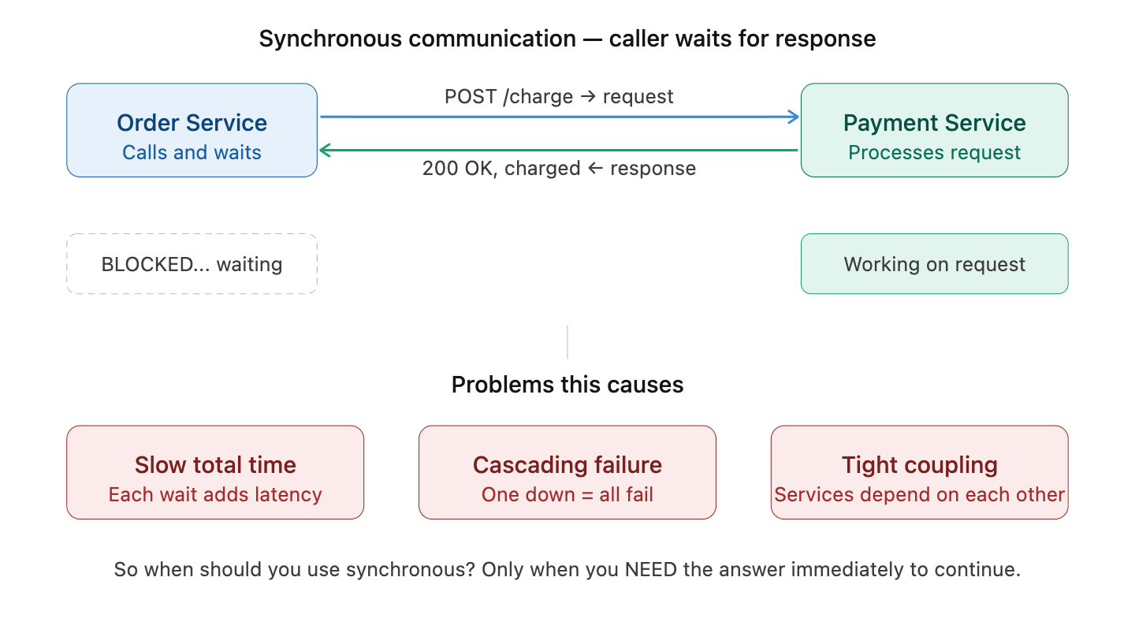

2. Asynchronous Communication
Services don't wait for immediate responses. Communication happens through events and messages.
What is it? Service A publishes an event to a message queue and moves on immediately. It doesn't wait, doesn't know who is consuming the message, and doesn't care when it's processed. Like sending an email — you send it and carry on with your day.
Protocols/tools used: Kafka, RabbitMQ, AWS SQS, Azure Service Bus
The key insight: Order Service publishes one event — order.placed — and three services independently consume it at their own pace. If you later add a Loyalty Points Service, you just add a new consumer. Order Service code doesn't change at all.
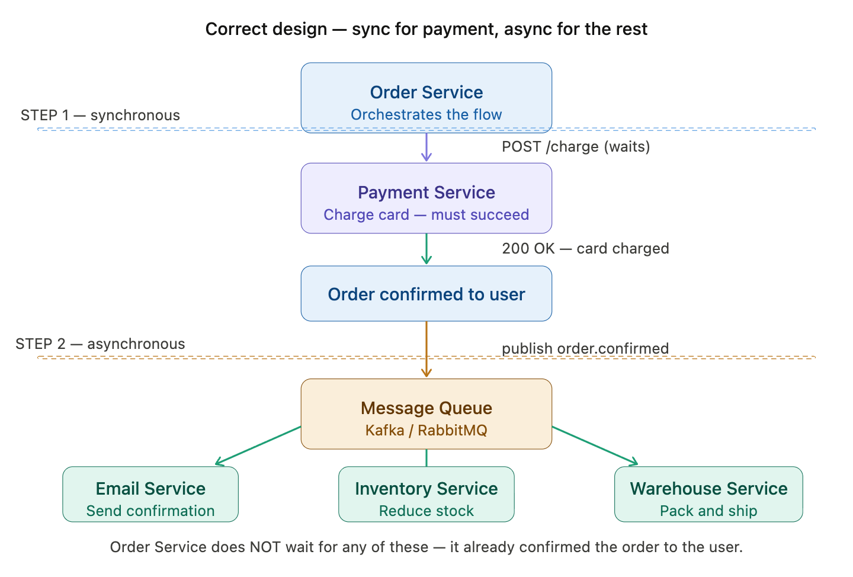

Q9. What is a Service Discovery in microservices? Why is it needed — what problem does it solve? And can you explain the difference between client-side and server-side service discovery?
Earlier applications consisted of only one server. Now in this modern world there are dozens of servers and each having multiple instances running and thus scaling up and down as needed. This makes services hard to efficiently find and communicate with each other. That’s where service discovery comes into play.

Service discovery is a mechanism in distributed systems which allows services to find and communicate with each other. It hides the complex details of the service locations and allows services to interact without knowing the exact network spots. Service discovery registers and maintains record of all the services like IP addresses and port number in service registry.

Service Registration Options

Manual Registration: In manual registration, service details are added to the registry manually by a developer or operator.

Self-Registration: In self-registration, the service is responsible for registering itself with the service registry when it starts.

3rd Party Registration: In third-party registration, an external agent or "sidecar" process handles service registration.

Automatic Registration by Orchestrators: In modern orchestrated environments like Kubernetes, service registration happens automatically.

Client-Side Service Discovery
In this model, the responsibility for discovering and connecting to a service lies entirely with the client.
How it works?
Service Registration: Services (e.g., UserService, PaymentService) register themselves with a centralized service registry. They provide their network details (IP address and port) along with metadata like service health or version.
Client Queries the Registry: The client (a microservice or API gateway) sends a request to the service registry to find the instances of a target service (e.g., PaymentService).The registry responds with a list of available instances, including their IP addresses and ports.
Client Routes the Request: Based on the information retrieved, the client selects one of the service instances (often using a load balancing algorithm) and connects directly to it.
Example Workflow: Let’s consider a real-world example of a food delivery app:
A Payment Service has three instances running on different servers.
When the Order Service needs to process a payment, it queries the service registry for the location of the Payment Service.
The service registry responds with a list of available instances (e.g., IP1:Port1, IP2:Port2, IP3:Port3).
The Order Service chooses an instance (e.g., IP1:Port1) and sends the payment request directly to it.

Server-Side Service Discovery
In this model, the responsibility for discovering and connecting to a service lies entirely with the centralised server called API gateway or loadbalancer.

How it works?
Service Registration: Services register themselves with a centralized service registry, similar to client-side discovery
Client Sends Request: The client sends a request to a load balancer or API gateway, specifying the service it wants to communicate with (e.g., payment-service
Server Queries the Service Registry: The load balancer or gateway queries the service registry to find available instances of the requested service.
Routing: The load balancer selects a suitable service instance (based on factors like load, proximity, or health) and routes the client’s request to that instance.
Response: The service instance processes the request and sends the response back to the client via the load balancer or gateway.
Example Workflow
Let’s take an example of an e-commerce platform with microservices for "Order Management" and "Payment Processing." Registration: The PaymentService registers two instances with the service registry:
Instance 1: IP1:8080 Instance 2: IP2:8081
Client Request: The OrderService sends a request to the load balancer or API gateway, specifying the PaymentService. Discovery and Routing: The load balancer queries the service
registry and retrieves the list of available PaymentService instances. It selects one instance (e.g., IP1:8080) and routes the request to it.
Processing and Response: The selected instance of PaymentService processes the request and sends the response back to the OrderService via the load balancer.

Q10. What is fault tolerance in microservices?
- What problem does it solve?
- Can you explain the Circuit Breaker pattern in detail?
- What is the difference between fail fast and retry strategies?
- Have you heard of Bulkhead pattern? What problem does it solve?

The Core Problem — One failing service brings down everything
In microservices, if one of the services starts failing or becomes slow and if you don't handle it, the failure spreads like a virus through your entire system. This is called a cascading failure.
Fault tolerance means designing your system so that when one part fails, the rest of the system keeps working without affecting the user experience. There are three main patterns for this — Circuit Breaker, Fail Fast vs Retry, and Bulkhead.

Pattern 1 — Circuit Breaker
The Problem
Order Service keeps calling Payment Service even though Payment Service has been failing for the last 30 seconds. Every call waits for a timeout (say 10 seconds) before giving up. All those waiting threads pile up and Order Service itself crashes. Why keep trying something that is clearly broken?
The Solution
We can use Circuit Breaker. When failures cross a threshold, it "trips" — just like an electrical fuse — and immediately stops sending requests. Instead of waiting 10 seconds for a timeout, it returns an error in milliseconds. This frees up threads and keeps Order Service healthy.
It has got three states:

Closed State:
In the Closed state, the circuit breaker operates normally, allowing requests to flow through between services.
During this phase, the circuit breaker monitors the health of the downstream service by collecting and analyzing metrics such as response times, error rates, or timeouts.

Open State:
When the monitored metrics breach predetermined thresholds, signaling potential issues with the downstream service, the circuit breaker transitions to the Open state.
In the Open state, the circuit breaker immediately stops forwarding requests to the failing service, effectively isolating it.

Half-Open State:
After a specified timeout period the CB will transition to half-open state. It will send limited number of trial requests to the downstream service. If the response is got indicating service recovery, then CB will again go back to closed state. Or else if the trail request fails then it will be further evaluated.

Some of the tools which implement CB pattern are
1)Netflix Hystrix:
Hystrix is an open-source Java library that provides an implementation of the circuit breaker pattern to handle faults tolerance and latency in distributed systems and microservices architectures.
2. Resilience4j:
Resilience4j is a lightweight, easy-to-use library, designed with functional programming approach.
Key features of Resilience4j include:
a)Retry
b)Rate Limiting
c)Fallback: It allows for designing fallback responses if any failure occurs.
d)Functional Programming

Pattern 2 — Fail Fast vs Retry
These are two opposite strategies for handling failures. The right choice depends on the situation.
Fail Fast — when a failure is definitive (circuit is open, service is completely down), return an error immediately. Don't waste time waiting for timeouts.
Retry with exponential backoff — when a failure might be temporary (brief network blip, momentary overload), wait and try again. Each retry doubles the wait time — 1s, 2s, 4s, 8s — to avoid hammering the struggling service.

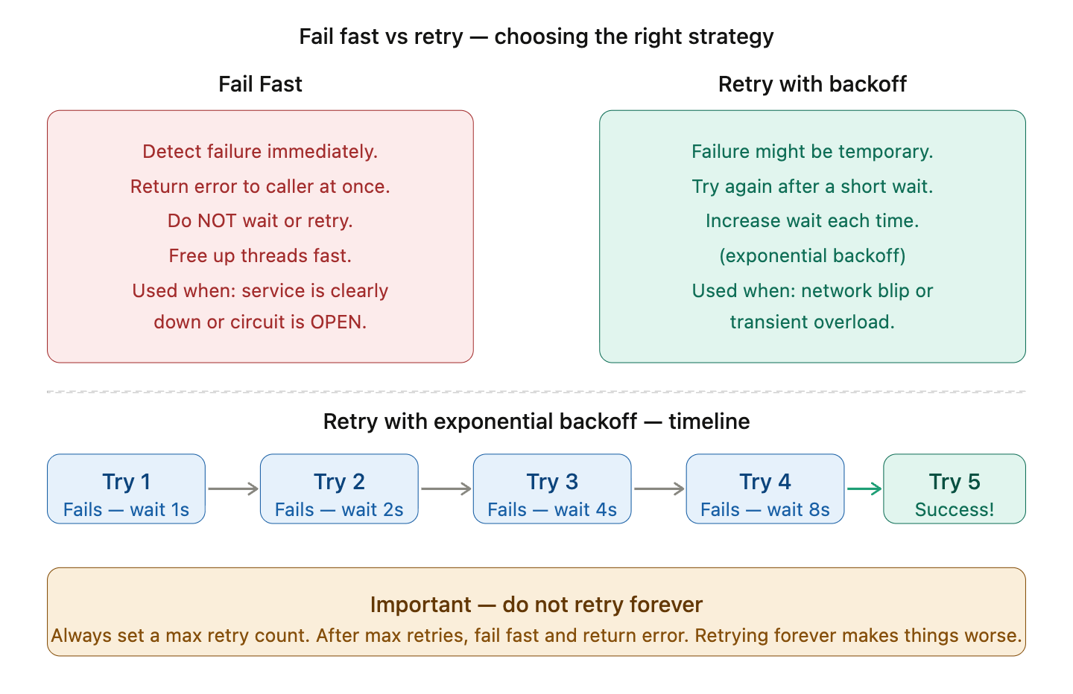

Pattern 3 — Bulkhead
The Problem
Imagine Order Service calls both Payment Service and Recommendation Service using a shared pool of 10 threads. Recommendation Service suddenly becomes very slow. All 10 threads get stuck waiting for Recommendation Service. Now Payment Service calls also have no threads available — even though Payment Service is perfectly healthy. A non-critical feature (recommendations) has killed a critical feature (payments).
The Solution — Bulkhead Pattern
In microservices, you give each downstream service its own isolated thread pool. A failure in one pool cannot affect another.
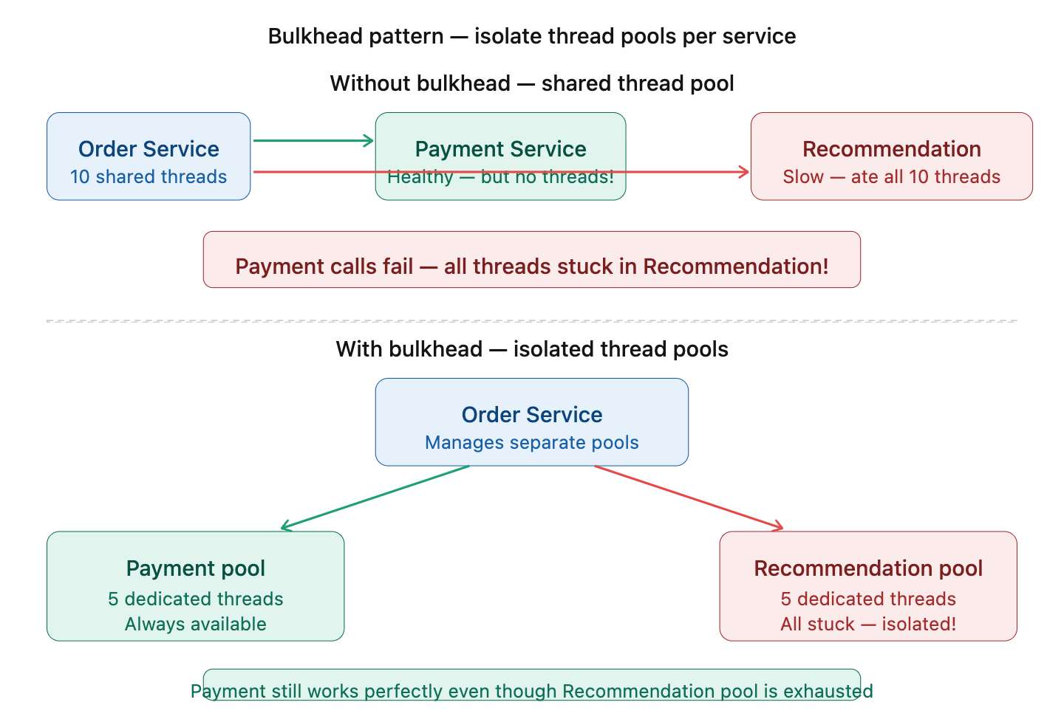

Q11. What is distributed tracing in microservices?
- What problem does it solve?
- Have you heard of Zipkin or Jaeger? What are they?
- What is a trace ID and span?
- How does a request get traced across multiple services?

The Problem — Debugging in microservices is a nightmare
In a monolith, when something goes wrong, you look at one log file. You can trace exactly what happened line by line. But in microservices, a single user request touches 5, 10, or even 20 services. Each service writes logs to its own log file on its own server. When a request is slow or fails, you have no idea which service caused it.

The Solution — Distributed Tracing
The idea is simple. When a request enters your system, assign it a unique ID called a Trace ID. Every service that handles this request passes this ID along in the request headers. Every log line includes this Trace ID. Now you can collect all logs across all services for one request by simply searching for that one Trace ID.
Trace ID — a single unique ID assigned to the entire request journey. All logs across all services share this one ID. Think of it as the "case number" for one request.
Span — represents work done in one service. Each service creates its own span with a start time and end time. A span knows its own duration, its parent span, and its trace ID. A trace is made up of many spans stitched together.

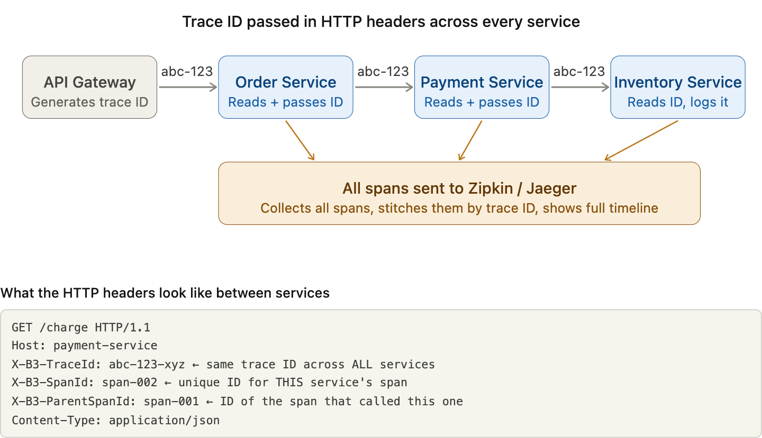

Zipkin and Jaeger — what are they?
Both are distributed tracing servers — they collect all the spans from all your services, stitch them together by Trace ID, and give you a visual timeline showing exactly how long each service took.
Zipkin — created by Twitter, simpler to set up, widely used with Spring Boot via Spring Cloud Sleuth / Micrometer Tracing.
Jaeger — created by Uber, more feature-rich, better for large scale systems, supports OpenTelemetry standard.

Q12. What is a saga pattern in microservices?
- What problem does it solve?
- What is the difference between choreography and orchestration sagas?
- What happens when a step fails — how do you rollback in a distributed system?

The Problem — Distributed Transactions
In a monolith, if you want to do multiple things atomically (all succeed or all fail), you use a database transaction. If anything fails, the database rolls everything back. Simple.
But in microservices, each service has its own database. You cannot span a single database transaction across multiple services. So what happens when you need multiple services to all succeed together?
This is the core problem. You cannot use a traditional ACID database transaction across services. You need a different approach to ensure consistency. That is what the Saga Pattern solves.

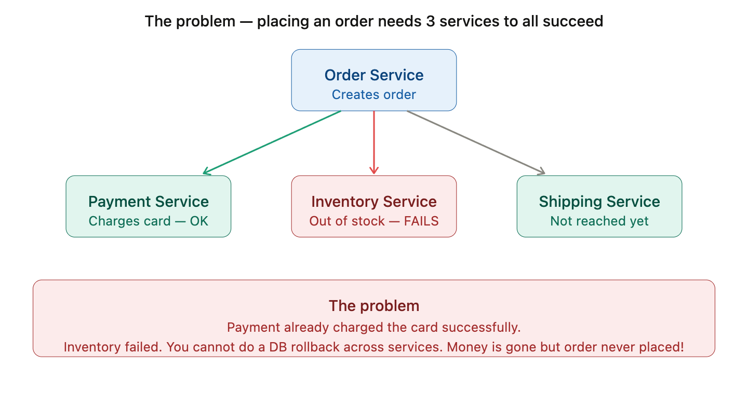

The Solution — Saga Pattern
A Saga breaks a distributed transaction into a sequence of local transactions — one per service. Each service does its own local DB transaction and then triggers the next step. If any step fails, the saga runs compensating transactions to undo what the previous steps did.
A compensating transaction is simply the reverse operation — if Payment Service charged the card, the compensating transaction is to refund the card.
There are two ways to implement a Saga:

Approach 1 — Choreography Saga
Each service listens for events and decides what to do next on its own. There is no central coordinator. Services communicate via a message queue.
How choreography works: Each service listens to events on a message queue and reacts. Order Service publishes order.created → Payment Service hears it and charges → publishes payment.charged → Inventory hears it and reserves stock → and so on. No one is in charge — services just react to what they hear.
When it fails: Inventory publishes stock.failed → Payment hears it and issues a refund → Order hears the refund and cancels the order. Everything unwinds in reverse automatically.
Drawback: As the number of services grows, the event flow becomes very hard to follow. You have to look at many services to understand what the full saga does.

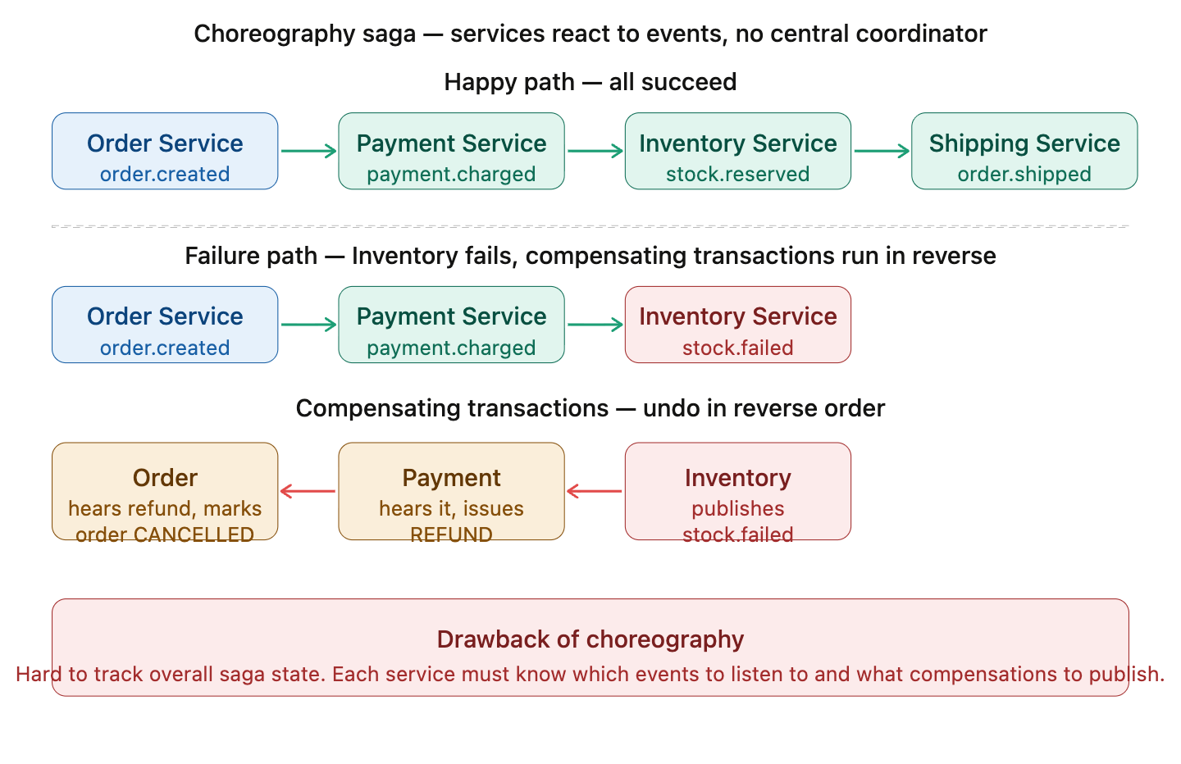

Approach 2 — Orchestration Saga
A central Saga Orchestrator tells each service what to do and when. It knows the full flow and is responsible for calling compensating transactions when something fails.
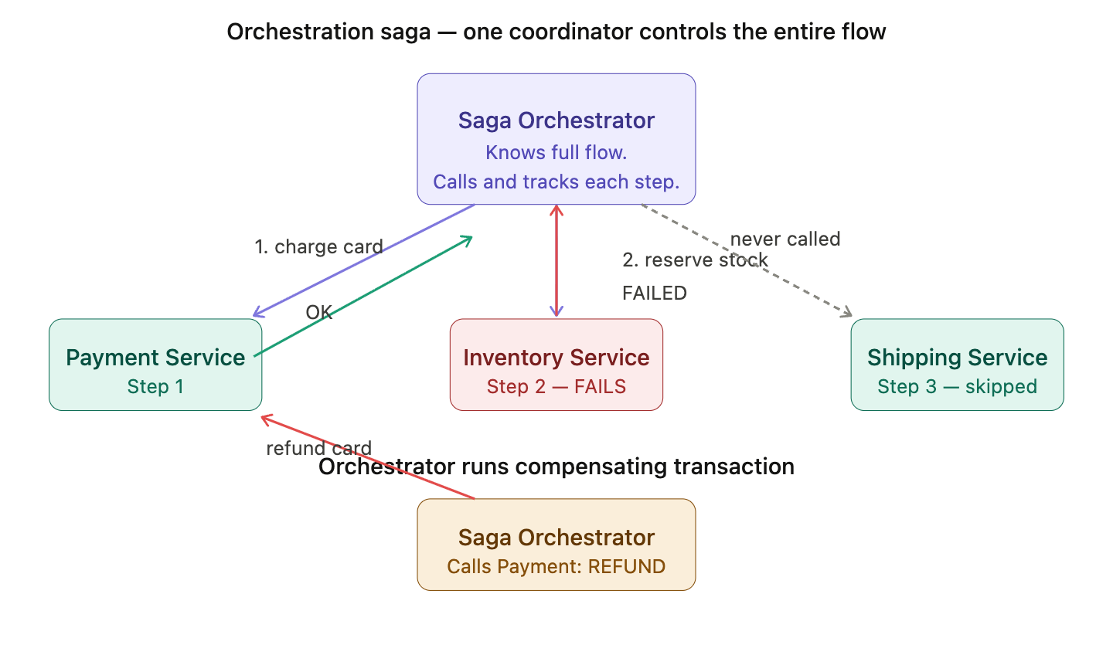
How orchestration works: The Saga Orchestrator calls Step 1 (Payment), waits for OK, then calls Step 2 (Inventory), gets FAILED, and immediately calls the compensating transaction on Payment (refund). Shipping Service is never even called because the orchestrator knows the saga failed before reaching that step.
Advantage over choreography: The entire saga logic lives in one place — the orchestrator. Easy to read, debug, and monitor.

Compensating Transactions — How rollback works
Since you cannot do a real database rollback across services, you write a compensating transaction for every step — a business-level undo operation.

Q13. What is CQRS (Command Query Responsibility Segregation)?
- What problem does it solve?
- What is the difference between a Command and a Query?
- How does CQRS work with Event Sourcing?
- What are the trade-offs of using CQRS?

The Problem — One model trying to do everything
In a traditional application, you use the same database model for both reading and writing data. This works fine for simple applications but breaks down at scale.
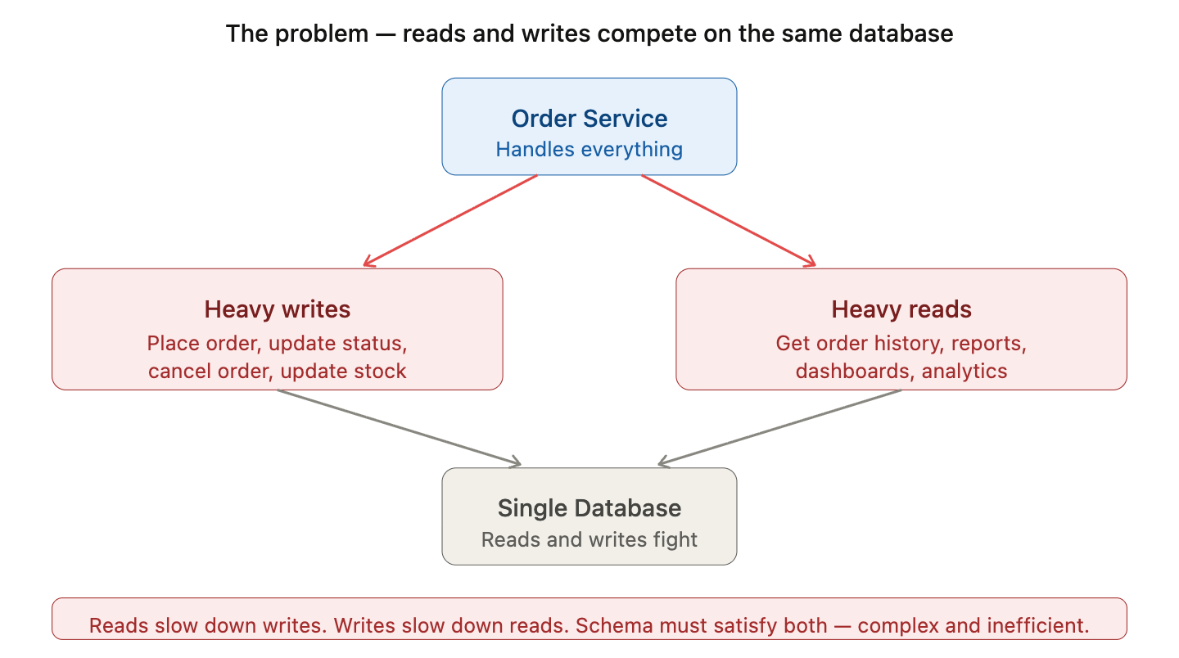
The specific problems this creates:
1. Read and write loads are very different. In most applications, reads happen 10x or 100x more than writes. But both are hitting the same database. A slow analytics query locks rows and slows down order placement.
2. Schema has to serve two purposes. A normalized schema is great for writes (no duplication, easy to update). But reads often need denormalized, joined, pre-aggregated data. One schema cannot be optimal for both.
3. You cannot scale them independently. If reads are the bottleneck, you cannot scale just the read side without also scaling the write side.

The Solution — CQRS
CQRS stands for Command Query Responsibility Segregation. The core idea is dead simple:
Split your application into two completely separate models:
- Command side — handles all writes (create, update, delete)
- Query side — handles all reads (get, list, search, report)
Each side has its own model, its own database, optimized for its own purpose.
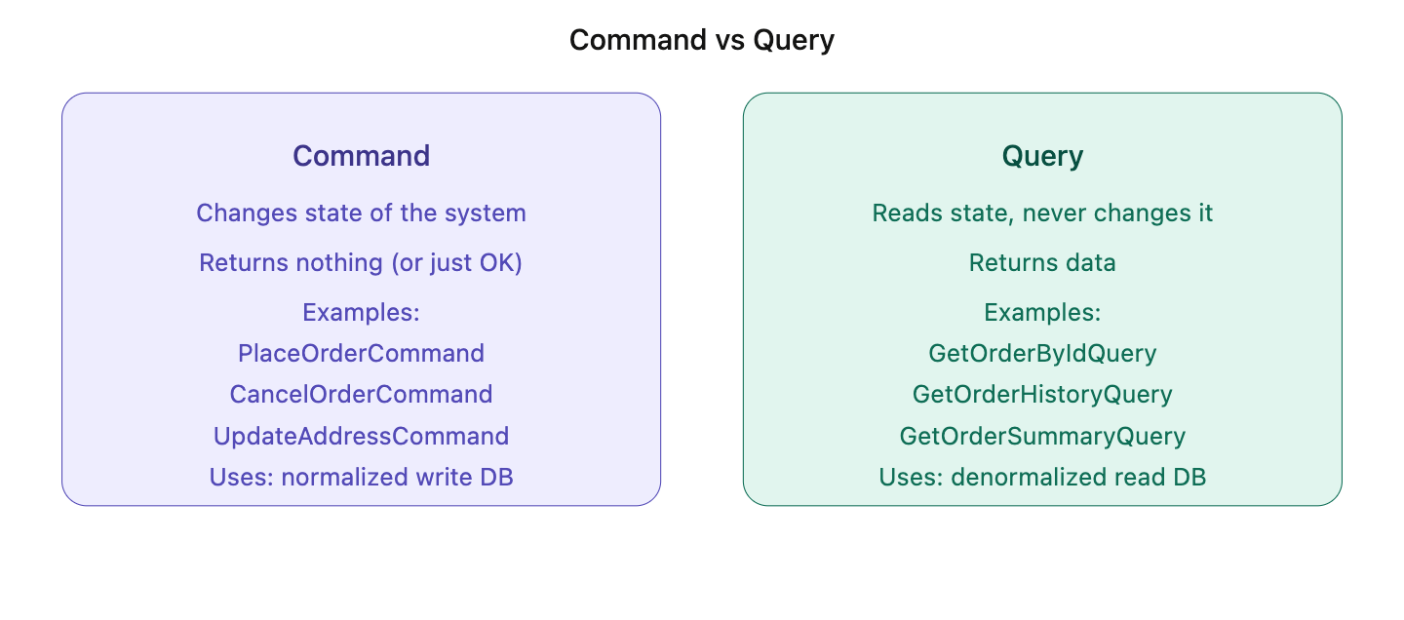

How CQRS works — the full architecture
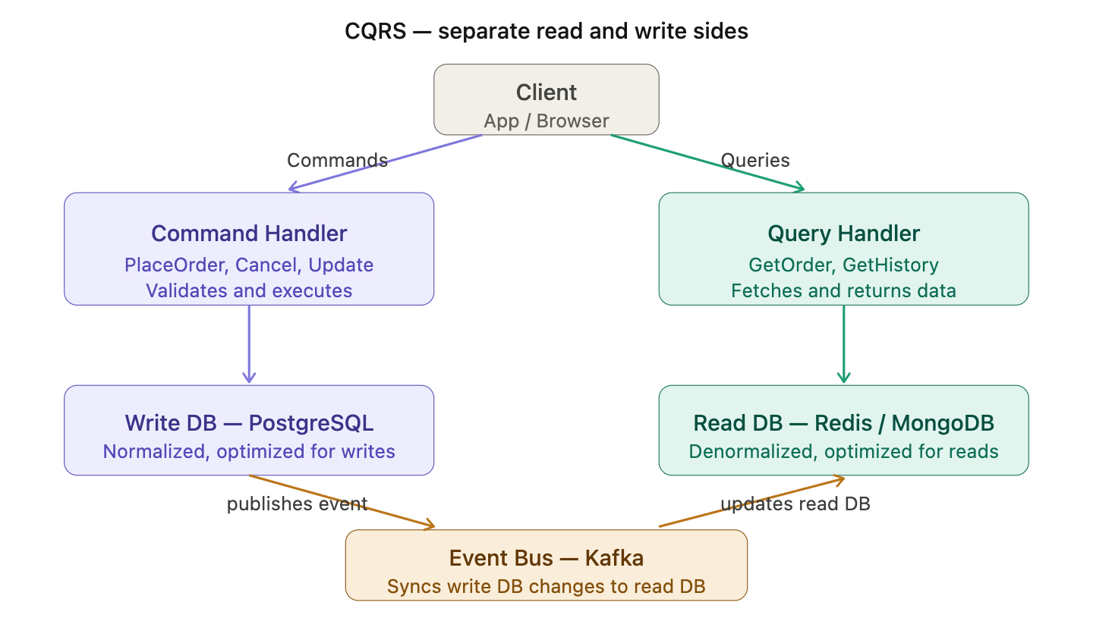
Here Read DB comes and Redis cache is different system as cache is only used for most recently used data.

CQRS with Event Sourcing
Event Sourcing is a pattern that pairs naturally with CQRS. Instead of storing the current state of an entity, you store the full history of events that led to that state.
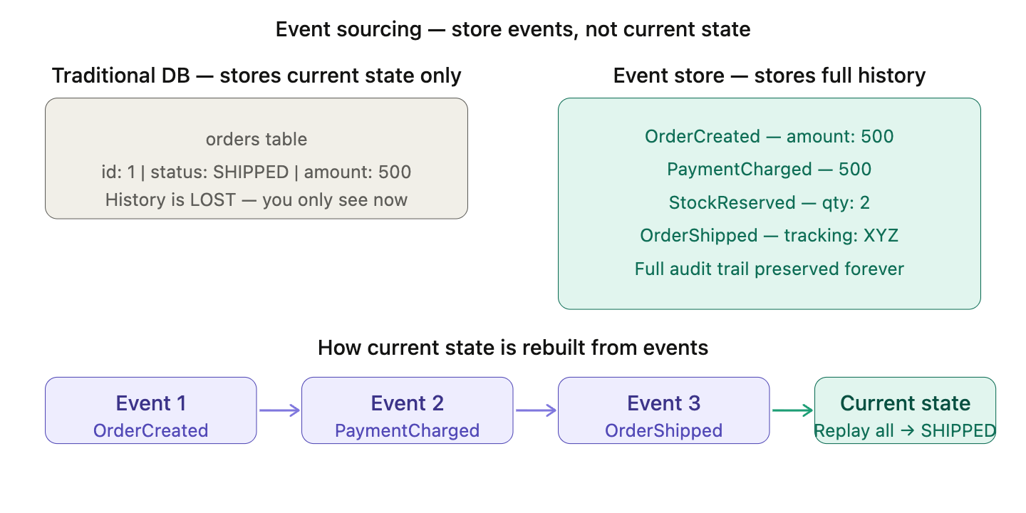
Event Sourcing stores every change as an immutable event in an event store. To get the current state, you replay all events from the beginning. This pairs perfectly with CQRS — the Command side appends events to the event store, and those events are published to the Event Bus to update the Read DB.

A real world analogy — your bank account
Think about your bank account. Your bank never stores just your "current balance" and overwrites it every time you spend money. That would be terrifying — one bug and your balance is gone with no way to recover it.
Instead, your bank stores every transaction — every credit, every debit — as an immutable record. Your current balance is just the sum of all those transactions.
That is exactly what Event Sourcing is.

replaying millions of events every time is slow!
If an account has 10 years of transactions, replaying all of them every time someone checks their balance would be very slow. This is solved with Snapshots.
A snapshot is a saved copy of the current state at a point in time. Instead of replaying from the very beginning, you start from the latest snapshot and only replay events that happened after it.
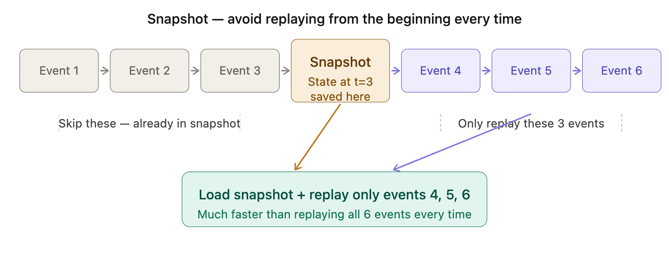
3 key benefits
1. Full audit trail — you know everything that ever happened Every change is recorded with a timestamp. You can answer questions like "what was the state of this order at 10:05am last Tuesday?" — just replay events up to that point. A traditional DB cannot do this.
2. Time travel — reconstruct state at any point in time Replay events up to event 3 → you see the state as it was after event 3. This is impossible with a traditional DB that only stores current state.
3. Event-driven by nature — pairs perfectly with CQRS Every event published to the event store automatically becomes an event that can update your read DB, trigger notifications, or feed into analytics — all from the same stream of events.

Q14. What is a service mesh in microservices?
- What problem does it solve?
- What is a sidecar proxy?
- What are the responsibilities of a service mesh?
- Have you heard of Istio or Linkerd? What are they?
- How is a service mesh different from an API Gateway?

The Problem — Service-to-service communication is a mess
As your microservices grow from 5 to 50 services, every service needs to handle the same cross-cutting concerns when talking to other services:
- Retry failed calls
- Circuit breaking
- Encrypt traffic between services (mTLS)
- Track how long calls take (observability)
- Load balance across instances
The problem is every team is implementing this logic themselves, in every service, in every language. Java team uses Resilience4j. Python team builds their own retry logic. Go team does something else. It is duplicated everywhere and inconsistent.

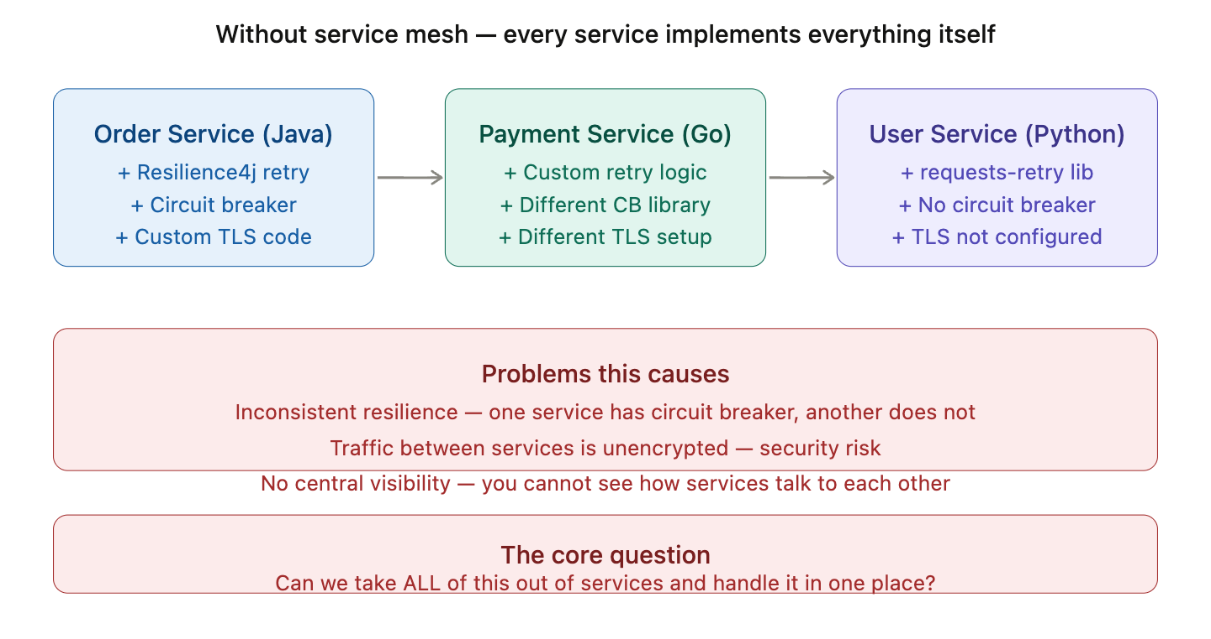

The Solution — Service Mesh
A service mesh takes ALL of that cross-cutting communication logic completely out of your services and handles it transparently at the infrastructure level. Your services just send requests — the mesh handles everything else.
The way it does this is through a sidecar proxy.

What is a Sidecar Proxy?
This is the key concept. For every service instance, the mesh deploys a tiny proxy container right next to it — called a sidecar. Every single request going IN or OUT of your service goes through this sidecar proxy. Your service never talks to the network directly.
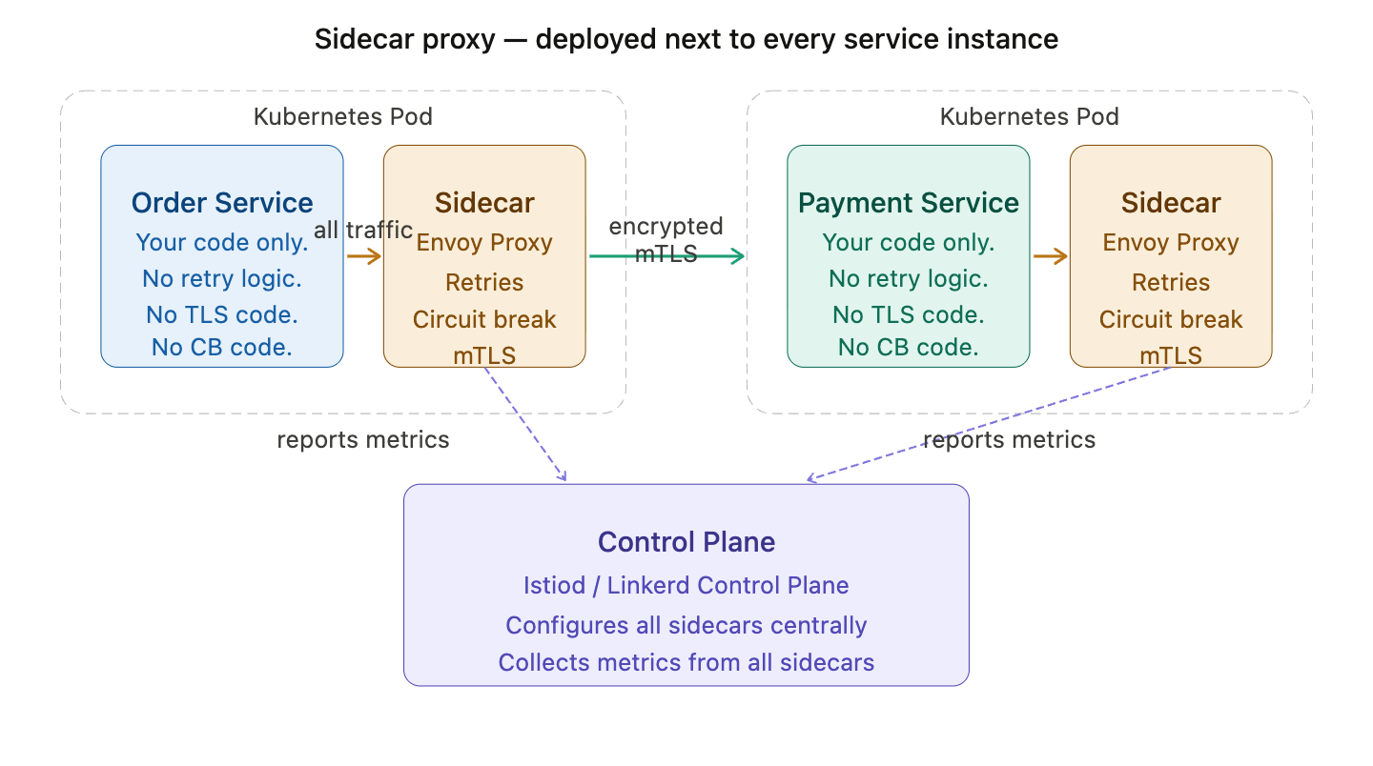
The sidecar is deployed automatically by the mesh — you don't write any code for it. In Kubernetes, Istio injects the Envoy sidecar into every pod automatically when the pod starts. Your service just sends a normal HTTP request — the sidecar intercepts it, encrypts it, applies retry rules, handles circuit breaking, records metrics, and sends it along. The receiving service's sidecar decrypts it and passes it to the service.
The Control Plane (Istiod in Istio) is the brain — it configures all the sidecars centrally with the rules you define, and collects metrics from all of them.
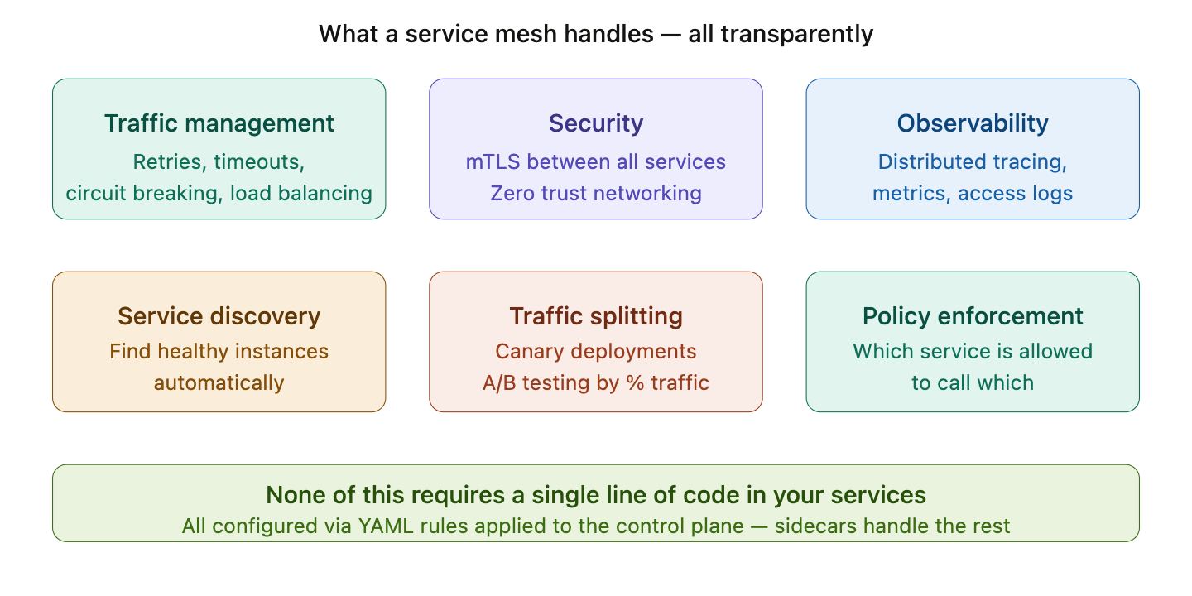

mTLS (Mutual TLS) — In most systems, only the server proves its identity (like HTTPS). mTLS means both sides prove their identity. So Order Service proves it is Order Service, and Payment Service proves it is Payment Service — before any data is exchanged. The mesh handles all certificate management automatically. Your code does nothing.
Traffic splitting — You can tell the mesh "send 90% of traffic to v1 of Payment Service and 10% to v2." This is how you do safe canary deployments — gradually roll out a new version to a small percentage of users without any code changes.
Policy enforcement — You can define rules like "only Order Service is allowed to call Payment Service." If Inventory Service tries to call Payment Service directly, the mesh blocks it. This is called zero trust networking.

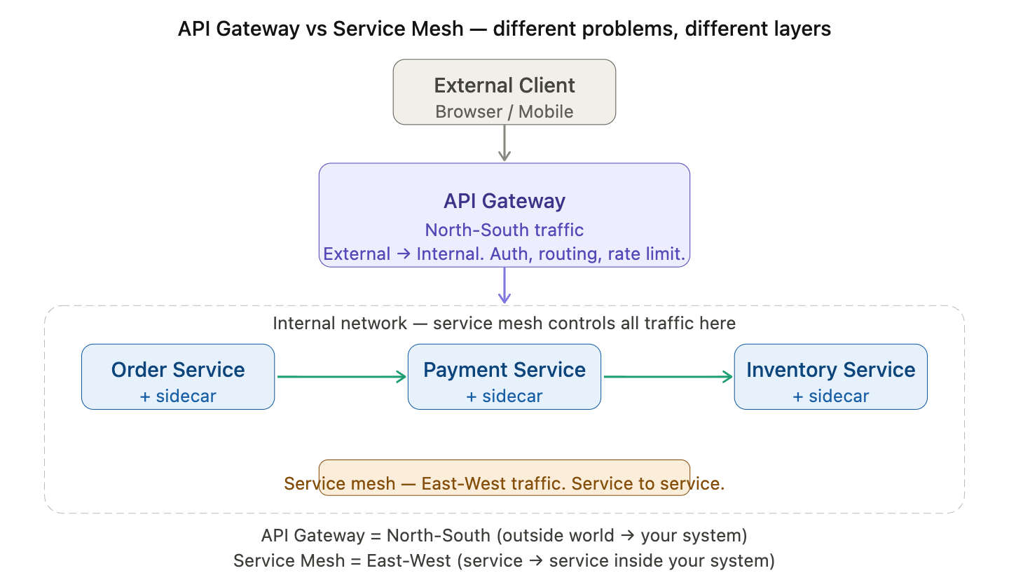

API Gateway handles North-South traffic — requests coming from outside your system into your system. It is the front door. It handles auth, rate limiting, and routing for external clients.
Service Mesh handles East-West traffic — requests flowing between services inside your system. It handles retries, mTLS, circuit breaking, and observability for internal service-to-service communication.
They complement each other — most production systems use both. The API Gateway is the entry point, and the service mesh manages everything that happens inside.

Q15. What is containerization and orchestration in microservices?
- What problem does Docker solve?
- What is the difference between a container and a virtual machine?
- What problem does Kubernetes solve — why can't you just use Docker alone?

What problem does Docker solve?
The Problem — "It works on my machine"
Every developer has said this. Your application works perfectly on your laptop but crashes on the server. Why? Because the server has a different OS, different Java version, different environment variables, different library versions. Setting up a new server means hours of manual configuration — and it still might not match your local environment exactly.
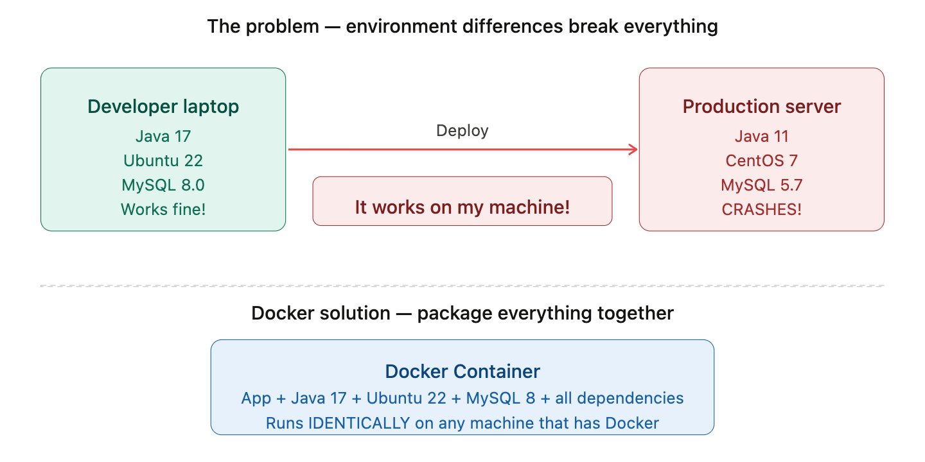
Docker packages your application and ALL its dependencies — the runtime, libraries, OS files, config — into a single unit called a container. This container runs identically on any machine that has Docker installed. No more "it works on my machine."

Container vs Virtual Machine
Both containers and VMs isolate applications. But they do it very differently.
A VM runs a full guest OS inside it — that is gigabytes of overhead per VM, and takes minutes to boot. A container shares the host OS kernel — it only packages the app and its libraries. Containers are megabytes in size and start in milliseconds.
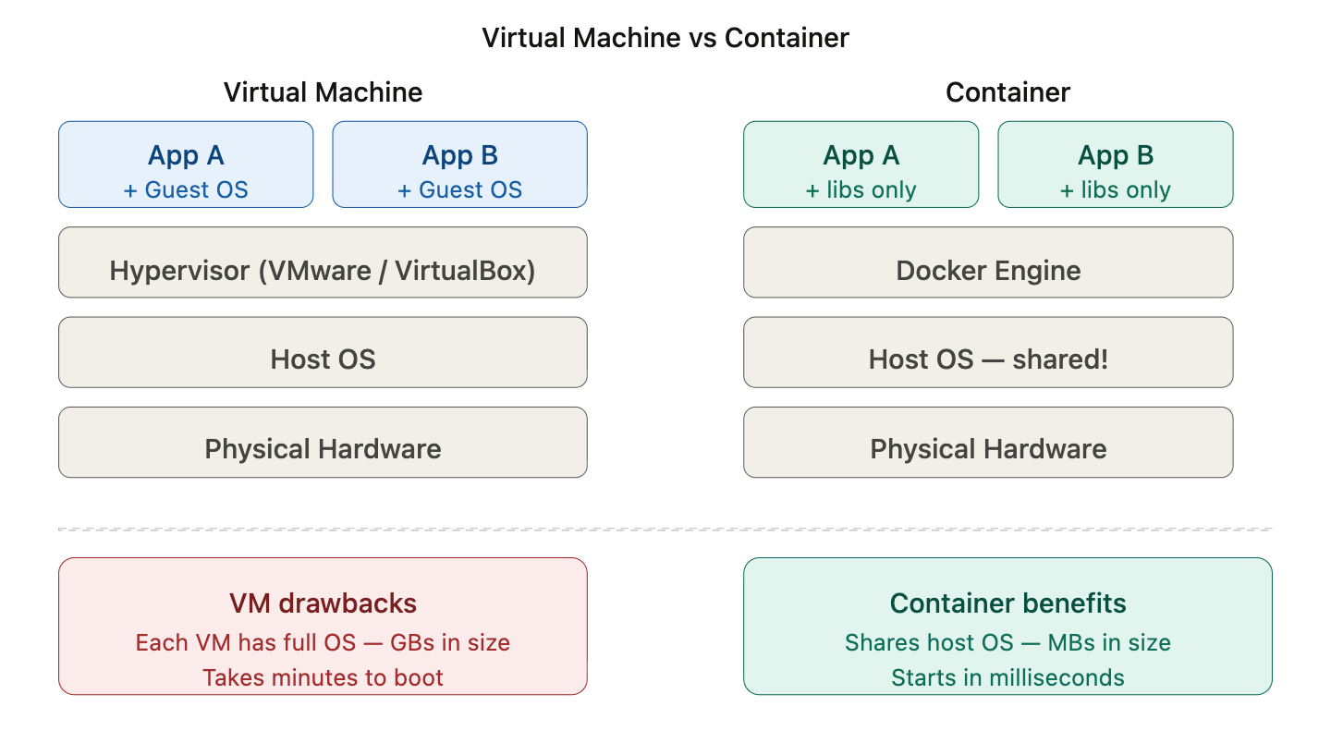

Why can't you just use Docker alone?
Docker is great for running one container. But in production you have hundreds of containers across many servers. Docker alone cannot answer these questions:
- If a container crashes, who restarts it?
- How do you distribute containers across 10 servers efficiently?
- How do containers find each other across servers?
- How do you roll out a new version with zero downtime?
- How do you scale from 2 containers to 20 when traffic spikes?
Kubernetes solves all of this. It is a container orchestration platform — it manages, schedules, scales, and heals your containers automatically.

Q16. What is inter-service communication security in microservices?
- What problem does it solve?
- What is mTLS and how is it different from regular TLS?
- What is JWT and how is it used for service-to-service authentication?
- What is the difference between authentication and authorization in microservices?
- How does an API Gateway handle security for all services?

The Problem — Services blindly trust each other
In a microservices system, services talk to each other constantly over the network. Without security, any service — or any attacker who gets inside your network — can call any other service freely. There is no way to verify who is calling you or whether they are allowed to.
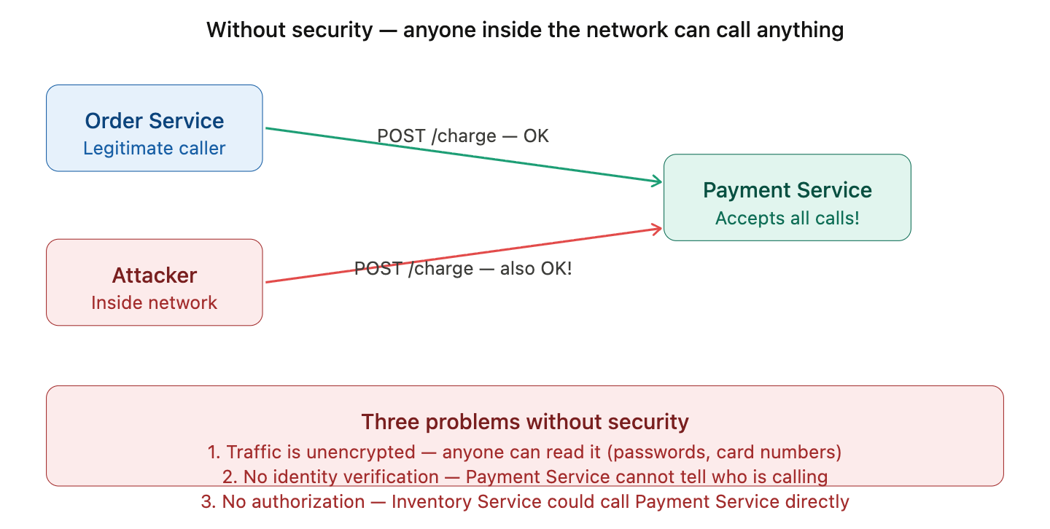

Problem 1 — Traffic is unencrypted. Anyone can read it.
The problem: When Order Service calls Payment Service over the internal network, the data travels as plain text. Any attacker who gets into your network can intercept and read card numbers, passwords, and personal data. This is called a man-in-the-middle attack.
Solution — mTLS encrypts all traffic AND verifies both sides
How mTLS solves it: Both services exchange certificates before any data flows. This does two things — it encrypts all traffic (attacker sees gibberish) and it verifies both identities (Order Service knows it is really talking to Payment Service and vice versa). In Istio you just set mode: STRICT and every service-to-service call uses mTLS automatically.
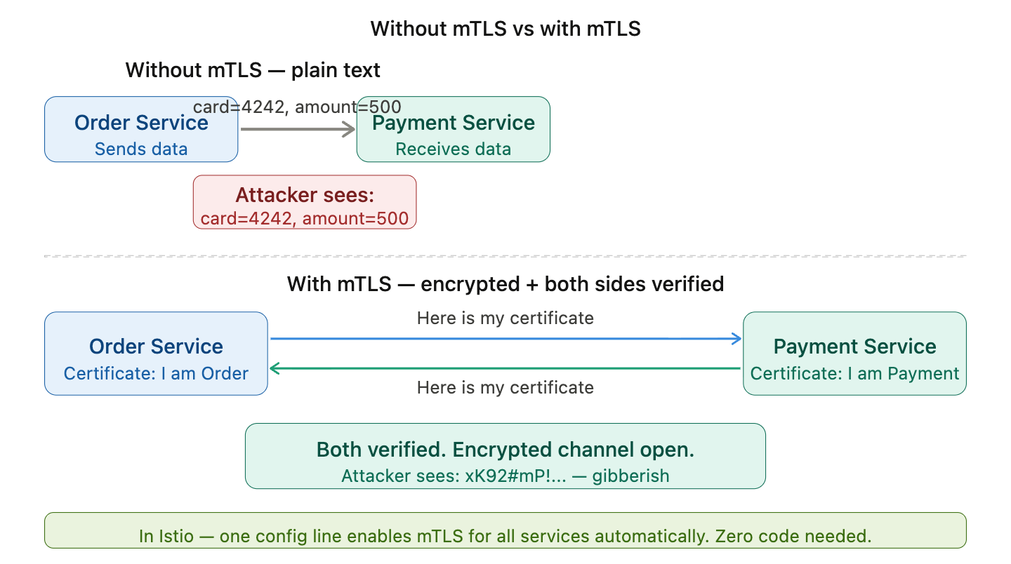

Problem 2 — No user identity. Services don't know who the end user is.
The problem: Even after mTLS verifies that Order Service is talking to Payment Service, neither service knows WHO the end user is. Is this a valid logged-in user? Are they an admin or a customer? Without this, anyone who can reach the API can perform any operation.
Solution — JWT carries verified user identity across all services
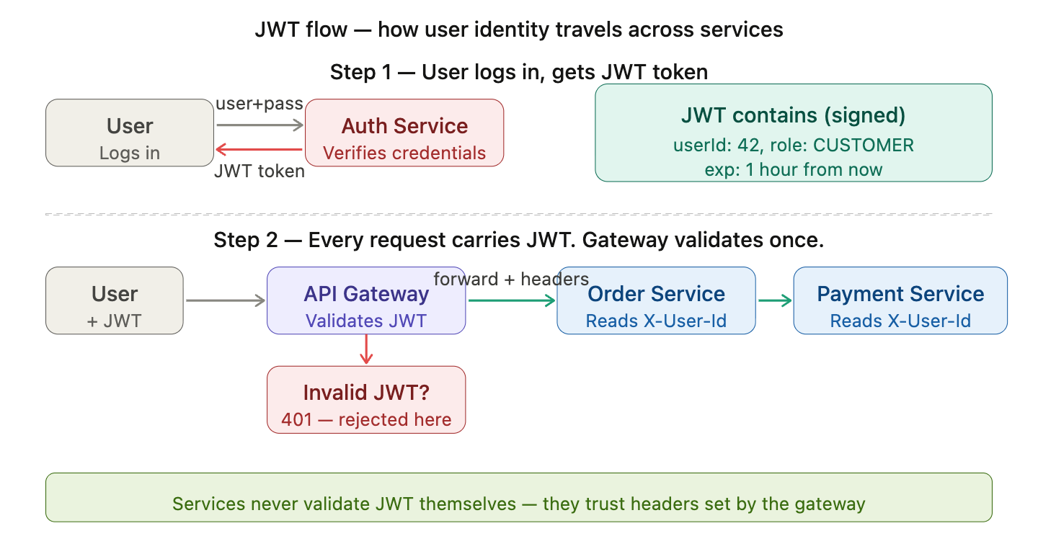
How JWT solves it: On login, Auth Service issues a signed JWT containing userId and role. The user sends this token in every request. The API Gateway validates the signature — if invalid or expired, the request is rejected immediately with 401. If valid, the gateway extracts userId and role and adds them as trusted headers (X-User-Id, X-User-Role) before forwarding to internal services. Each service simply reads those headers — no need to validate the JWT again.

Problem 3 — No authorization. Any service can call any other service.
The problem: Even with mTLS and JWT, there is nothing stopping Inventory Service from calling Payment Service directly and triggering a charge. Services should only be allowed to call services they are supposed to call.
Solution — Two-level authorization
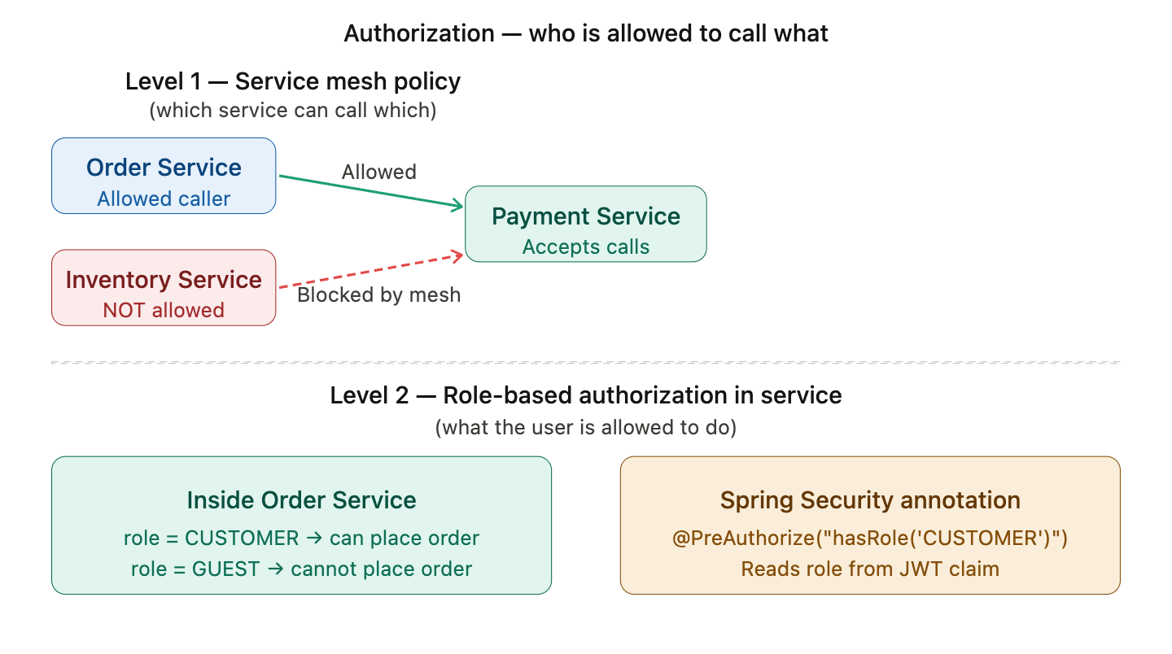
How authorization is solved at two levels:
Level 1 — Service mesh policy (service-to-service): You define authorization policies in Istio saying "only Order Service is allowed to call Payment Service." If Inventory Service tries to call Payment Service, the sidecar proxy blocks it before the request even reaches Payment Service.
Level 2 — Role-based authorization (user-to-operation): Inside each service, you check the user's role from the JWT claims. A CUSTOMER can place an order, a GUEST cannot. In Spring Boot this is one annotation — @PreAuthorize("hasRole('CUSTOMER')").

20)How would you monitor microservices
Core Strategies for Microservices Monitoring
Metrics: Use Prometheus to track "Golden Signals" (Latency, Traffic, Errors, Saturation).
Logs: Implement centralized, structured logging (JSON) with tools like Elasticsearch.
Traces: Use distributed tracing (Jaeger, Zipkin, OpenTelemetry) to track requests across service boundaries.

21)Database per service- why is it recommended?
Decoupling Services: Each microservice operates independently, without depending on a shared database schema. This decoupling ensures that changes to the database of one service don’t affect the others.
Improved Scalability: Since each microservice manages its own database, you can scale the services independently.
Fault Isolation & Resilience: Database failures in one service are contained, preventing a "domino effect" that could crash the entire application.
Security: Enhanced security through granular access controls, as each service only has permission to access its own data.

22)How do you deploy microservices independently?
Key Steps for Independent Deployment
1)Separate Code and Pipelines:
Every microservice must have its own source code repository. A change to one service triggers a deployment pipeline restricted only to that specific service.
2)Containerization: Package your service, its runtime, and dependencies into a container image (like Docker). This guarantees the service runs exactly the same way in production as it did in testing.
3)Orchestration: Use orchestrators like Kubernetes or Amazon ECS. They will manage, schedule and scale the containers as needed.

Deployment Patterns:

Blue-Green Deployment
Blue-green deployment is a deployment strategy that utilizes two identical environments, a “blue” (aka staging) and a “green” (aka production) environment with different versions of an application or service. Quality assurance and user acceptance testing are typically done within the blue environment that hosts new versions or changes. User traffic is shifted from the green environment to the blue environment once new changes have been testing and accepted within the blue environment.

Canary Deployment
A canary deployment is a deployment strategy that releases an application or service incrementally to a subset of users. All infrastructure in a target environment is updated in small phases (e.g: 2%, 25%, 75%, 100%). A canary release is the lowest risk-prone, compared to all other deployment strategies, because of this control.

13)How can you ensure backward compatibility in microservices?
14)What is OAuth and why it is used?
18)How do you handle data consistency in microservices?
22)How do you perform logging in distributed microservices?
29)What is a consumer group in Kafka?
Consumer groups allow Kafka consumers to work together and process events from a topic in parallel. Consumers are assigned a subset of partitions from a topic or set of topics and can parallelize the processing of those events.

30)How do you implement idempotent REST APIs?
Idempotency is a property of API design that ensures that making the same request multiple times produces the same result as making it once.
Consider an API endpoint that is designed to sign up a new user account in a web application. If this API is idempotent, it means that no matter how many times the API is called with the same input data (e.g., the same email and password), it will create the user account only once, and any subsequent invocations will have no further effect.
Use Cases:
Payment Processing: Idempotent APIs prevent double charging when processing payments.
Order Processing: Idempotent APIs in e-commerce platforms avoid duplicate orders.
File Uploads: Idempotent APIs for file uploads prevent unnecessary duplication.
How to implement idempotent Rest APIS
Assign unique identifiers: Use UUIDs or other unique identifiers for each request to track and identify requests.
Idempotent HTTP methods: Design APIs using idempotent HTTP methods like GET, PUT, and DELETE. These methods ensure that multiple identical requests have the same effect as a single request.
Expiration time for idempotency keys: Set a reasonable expiration time

.

What are topics, partitions, offsets?
How do you handle duplicate messages?

Eventual consistency
Distributed locks
2 phase commit
Caching/types/invalidation strategies
Jwt vs asession -based auth?
Qauth2 vflow
Autoscaling strategies

