ABSTRACT
The Client Portal named MyClistal (My Client and Service Portal) is a secure online platform designed to streamline client accounting firm interactions, ensuring safe handling of sensitive financial data and improving workflow efficiency. The portal enables clients to exchange documents securely, track tasks, view deadlines/calendar and billings. Core features include secure login with role based access, file sharing with version control, task tracking, and dashboards, while advanced features include Jira style workflow management, calendar integrations, notifications, and accounting specific modules such as billing and e-signatures. Built with React for the frontend and Node.js/Express for the backend, the portal ensures both usability and security.

Keywords: Client portal, Accounting management, Secure file sharing, Workflow tracking, Compliance management.

Our Team
Krijesh Karki | Supervisor
Shiwams Phuyal | Frontend Developer and System Tester
Suprim Bhattarai | Full Stack Developer (Backend Focused)

Table of Contents
ABSTRACT 1
Our Team 2
1.INTRODUCTION 4
1.1 Background 4
1.2 Problem Statement 4
1.3 Objectives 4
1.4 Scope and Limitation 4
Scope 4
1.5 METHODOLOGY 5
Phases of Development 5
2.SYSTEM ANALYSIS AND DESIGN 5
2.1 System Analysis 5
2.1.1 Requirement Analysis 5
2.1.2 Feasibility Analysis 6
2.1.3 Schedule Feasibility 7
UI WireFrame 8

- INTRODUCTION

1.1 Background
Accounting firms handles vast amounts of sensitive financial information and client communications, where traditional methods such as email exchanges and offline document handling pose risks of inefficiency and data breaches. A centralized client portal helps address these concerns by ensuring secure data exchange, task tracking, and transparent workflows. With integrated features like compliance alerts, billing, and calendar synchronization, the portal ensures smooth collaboration between clients and accounting professionals.

1.2 Problem Statement
Most current methods of client accounting firm communication and document handling rely heavily on fragmented tools such as emails, spreadsheets, and physical files. These practices increase the chances of miscommunication, lost deadlines, and compliance issues. Clients often lack real time visibility into their ongoing tasks or document status, while staff struggle with repetitive follow ups. Without a proper platform, efficiency and trust are compromised. The proposed Client Portal named MyClistal aims to solve these challenges by providing a secure, centralized, and user friendly system.

1.3 Objectives
The objectives of this project are:
- To create a secure platform for exchanging financial documents between clients and firms.
- To implement task and compliance tracking for improved answerability.
- To provide calendar integration for deadline management.
- To enable real time updates and communication between clients and staff.
- To integrate accounting specific features such as billing, e-signatures, and compliance alerts.

1.4 Scope and Limitation

Scope
- Secure Authentication: Role based login with MFA (Multi Factor Authentication).
- Document Sharing: File uploads, versioning, and audit trails.
- Task Tracking: Jira-style workflows with progress indicators.
- Calendar Integration: Sync with Google/Outlook.
- Notifications: Automated reminders via email, SMS, or push.
- Accounting Modules: Billing, e-signatures, compliance alerts.

1.5 METHODOLOGY
The Iterative Waterfall Model is used, balancing structure with flexibility. Each phase is followed by feedback loops for refinement.

Phases of Development
- Feasibility Study: Evaluates practicality, cost, risks, and technical requirements.
- Requirement Analysis: Collects and documents both functional (document exchange, workflows, calendar sync) and non-functional (security, usability, scalability) requirements.
- System Design: Defines architecture, database schema, UI wireframes, and workflow processes.
- Coding and Module Testing: Develops frontend in React.js and backend in Node.js/Express.
- Integration and System Testing: Ensures different modules (authentication, file sharing, task tracking) work seamlessly.
- Deployment and Maintenance: Deploys portal on platforms and ensures continuous updates, bug fixes, and enhancements.

- SYSTEM ANALYSIS AND DESIGN

2.1 System Analysis
The system addresses inefficiencies in document exchange, task tracking, and compliance monitoring. It ensures both clients and staff have a transparent and centralized platform.

2.1.1 Requirement Analysis
Functional Requirements:
- Secure login with MFA (Multi Factor Authentication) and role-based access.
- Document sharing with version control and audit trails.
- Task and compliance tracking with visual indicators.
- Calendar synchronization with Google/Outlook.
- Notifications via email/SMS.
- Accounting modules for billing, e-signatures, and compliance alerts.

Non-Functional Requirements:
- Scalability: Support for multiple firms and large client bases.
- Security: MFA and compliance with proper standards.
- Reliability: High uptime and backup mechanisms.
- Usability: Simple UI for clients with minimal technical knowledge.

2.1.2 Feasibility Analysis
- Technical Feasibility: The system uses React.js (frontend), Node.js/Express (backend), and MongoDB (database). Cloud hosting ensures scalability.
- Operational Feasibility: Both clients and staff benefit from transparent workflows, document security, and automated compliance alerts.
- Economic Feasibility: Open-source technologies minimize costs. Estimated development cost is significantly lower compared to commercial portals. The hosting cost is approximately USD 2.99 per year, making it highly affordable for deployment and maintenance.
- Legal Feasibility: The portal is ensured through compliance with data protection and accounting-related regulations. Sensitive client information will be handled securely with multi-factor authentication (MFA), aligning with global standards such as GDPR (General Data Protection Regulations). This guarantees that the system can be safely used by firms handling financial data.
- Resource Feasibility: The development team consists of three skilled members covering frontend, backend, and database. Additionally, widely available tools such as GitHub for version control, and Jira for task management will be used to streamline collaboration and project management.

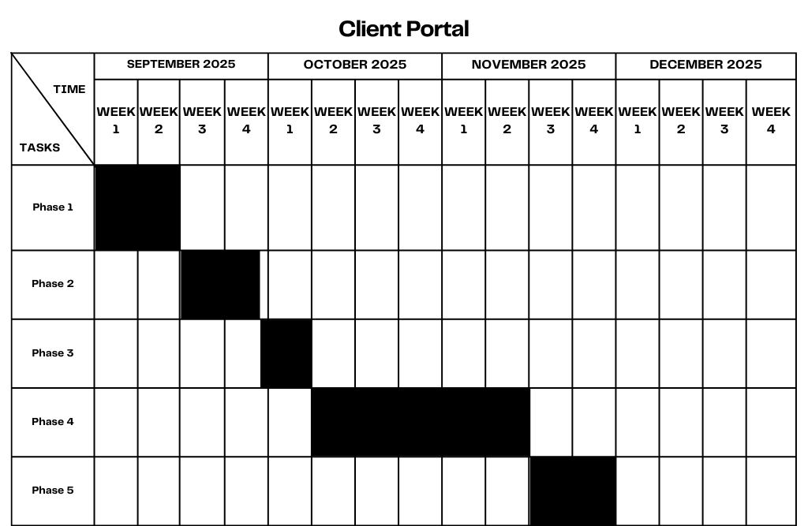
2.1.3 Schedule Feasibility

The project follows a phased approach with defined timelines:
- Phase 1 (Sept 8 – Sept 14): Research and Wireframing
- Phase 2 (Sept 15 – Sept 28): Basic Coding and Setup
- Phase 3 (Sept 29 – Oct 5): Demo Deployment
- Phase 4 (Oct 6 – Nov 16): Major Feature Development
- Phase 5 (Nov 17 – Nov30): Testing and Final Deployment

UI WireFrame

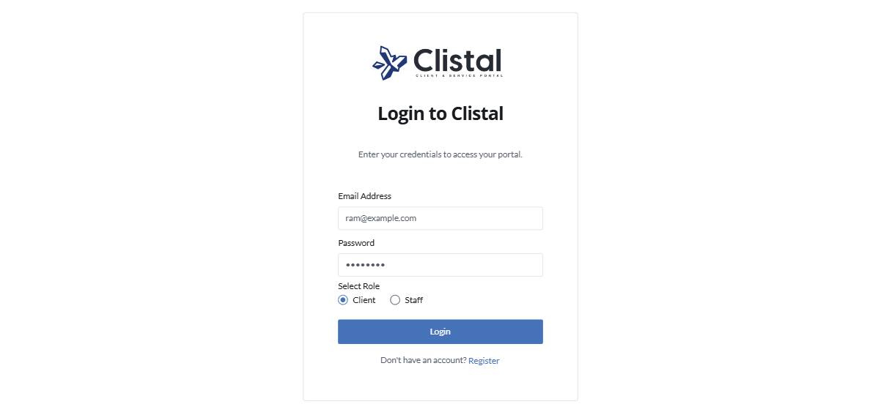
Login


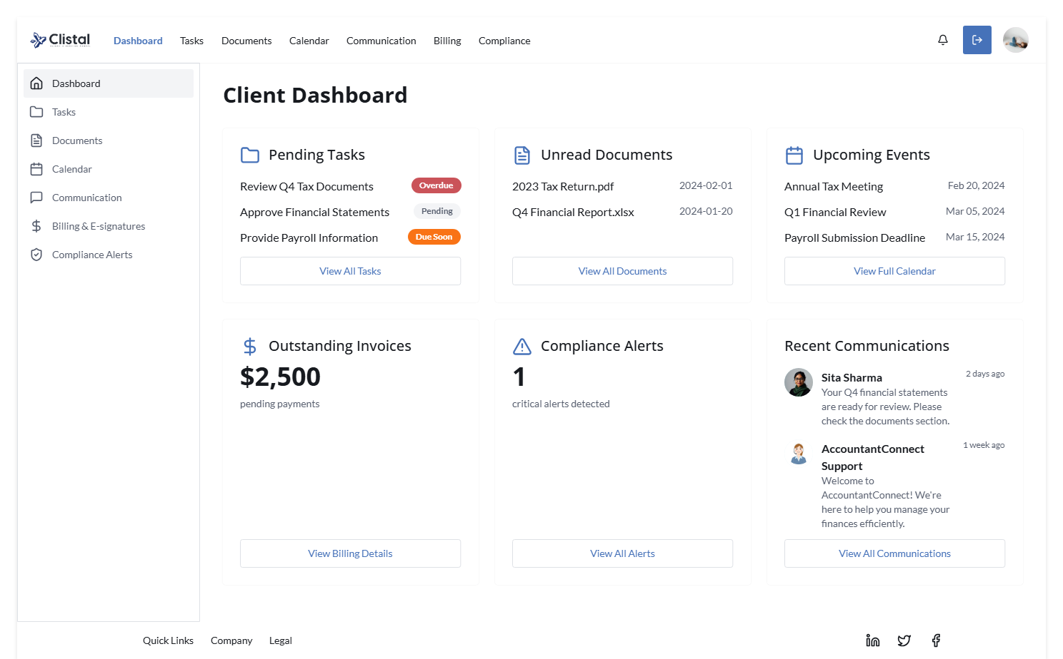
Client Dashboard

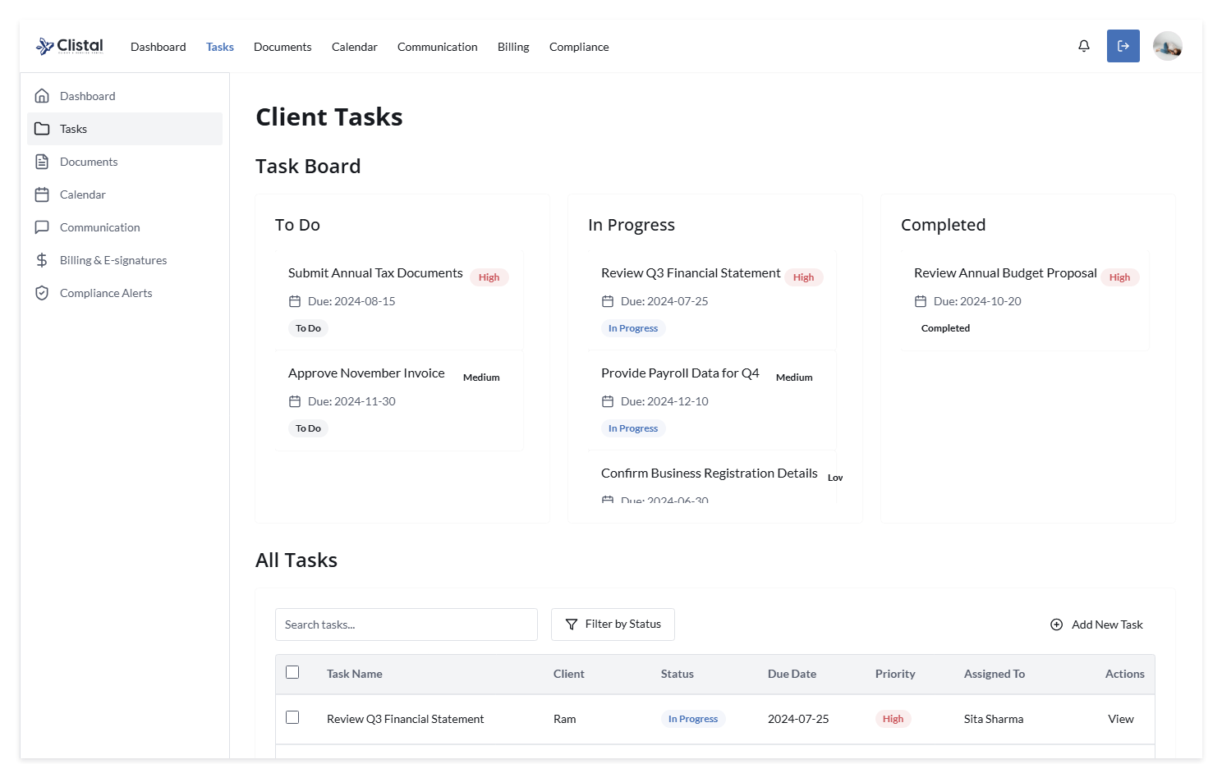
Client Tasks (Optional)

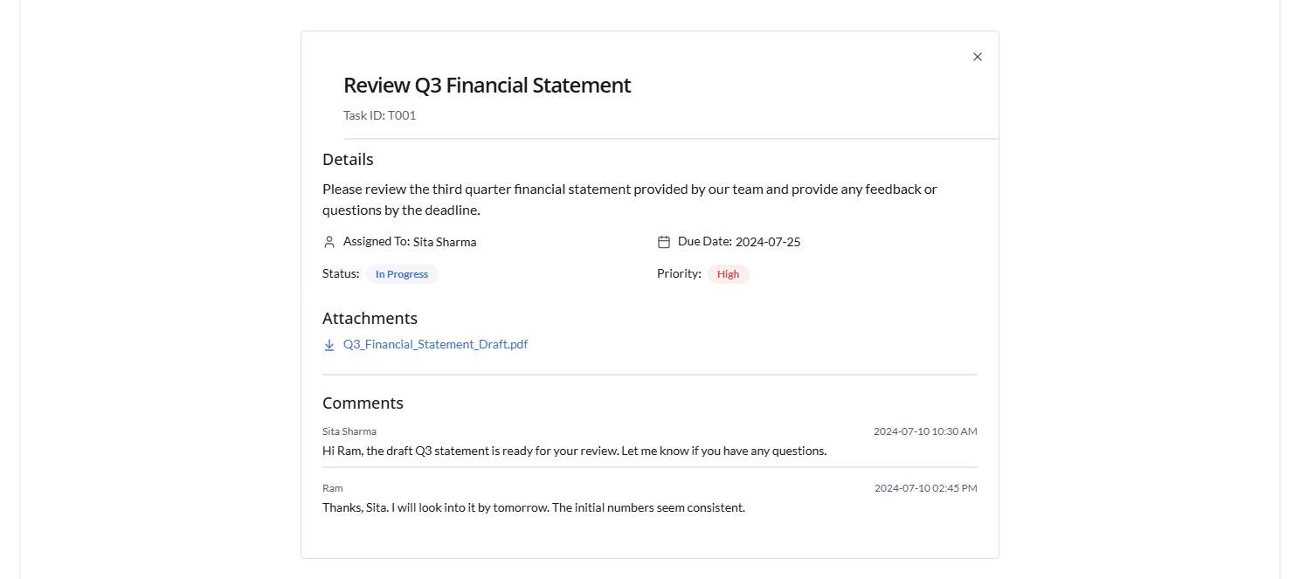
Client Tasks 2 (Optional)

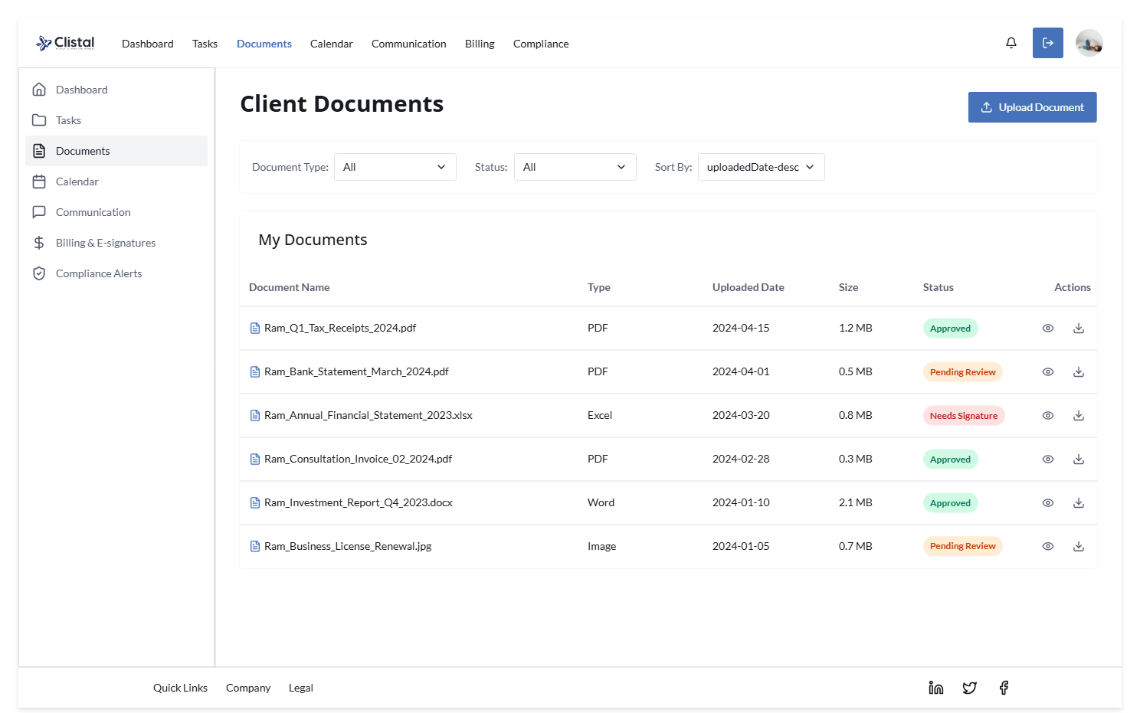
Client Documents

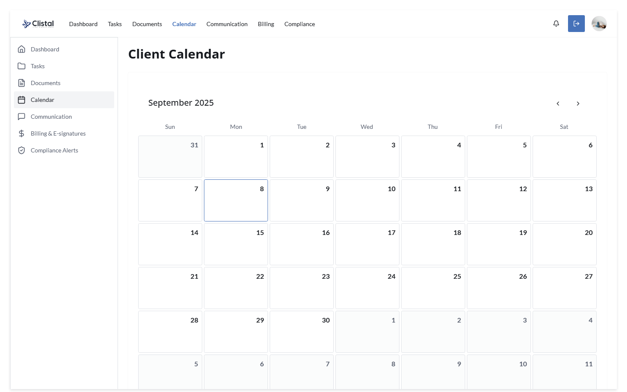
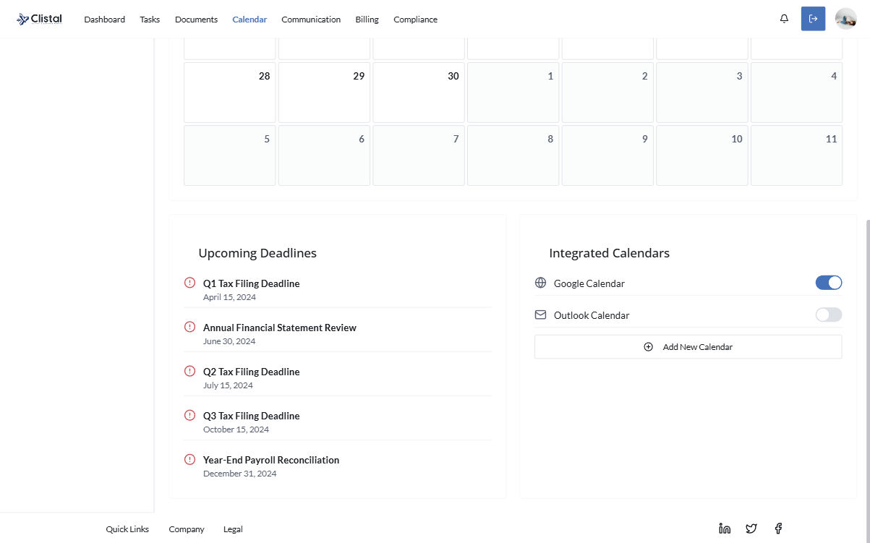
Client Calendar
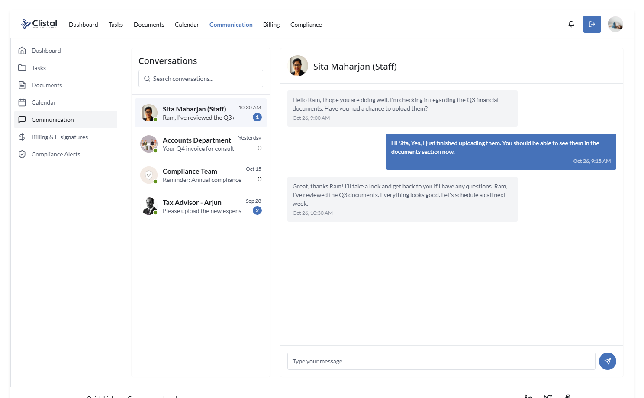
Client Communication (Optional)

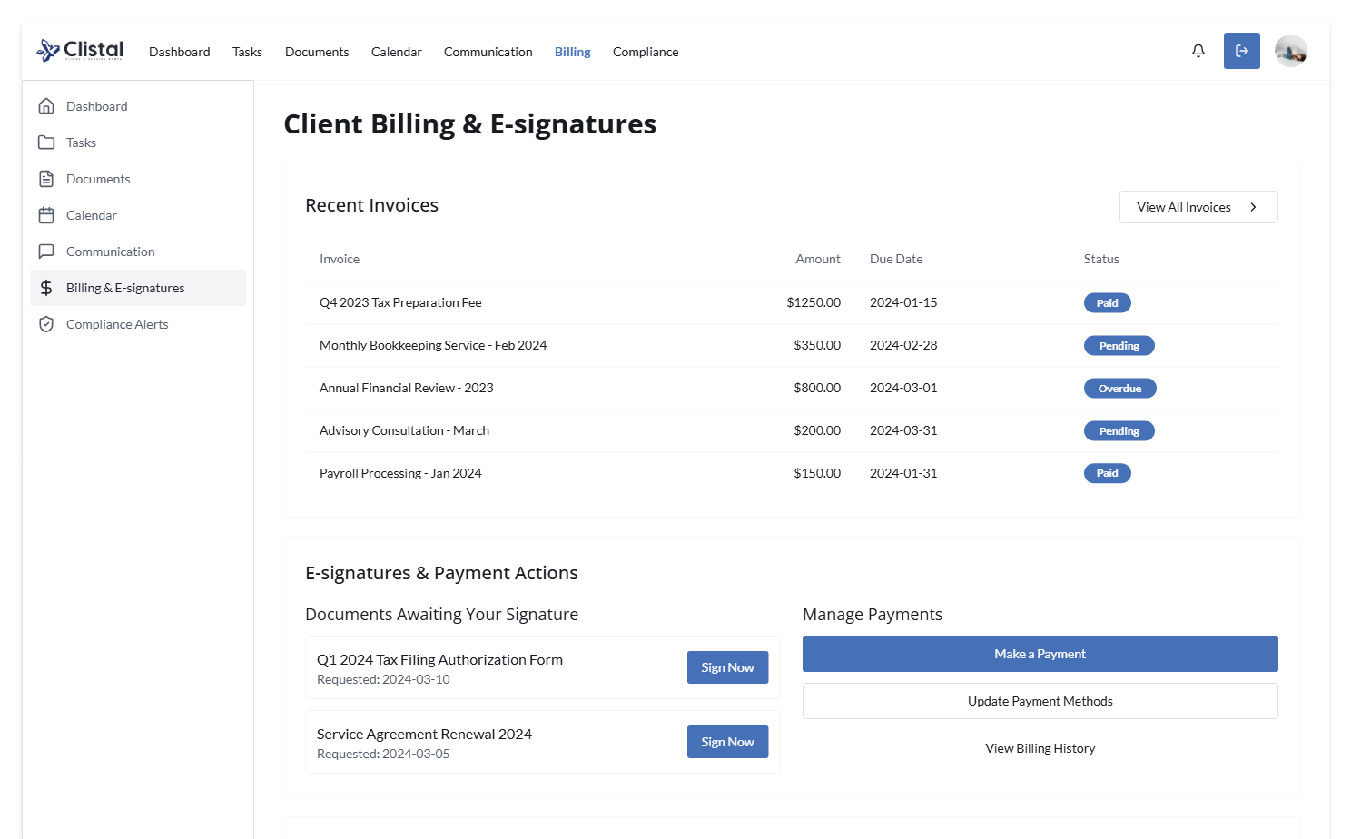
Client Billing and E-signatures

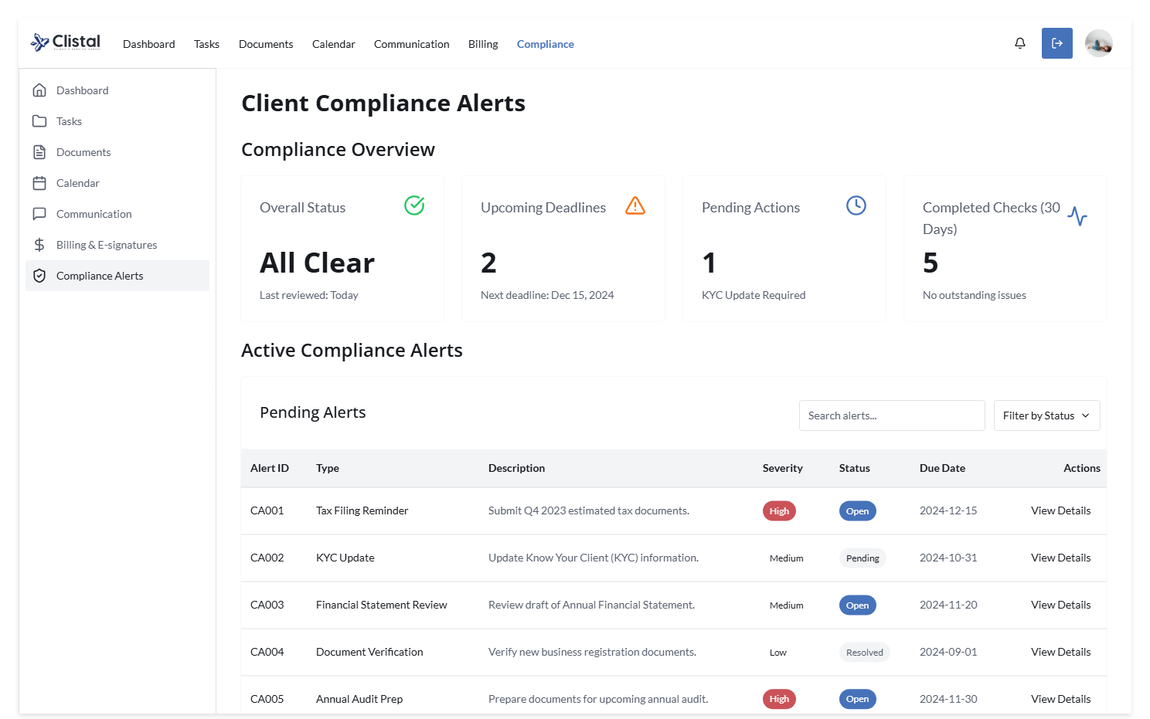
Client Compliance Alert

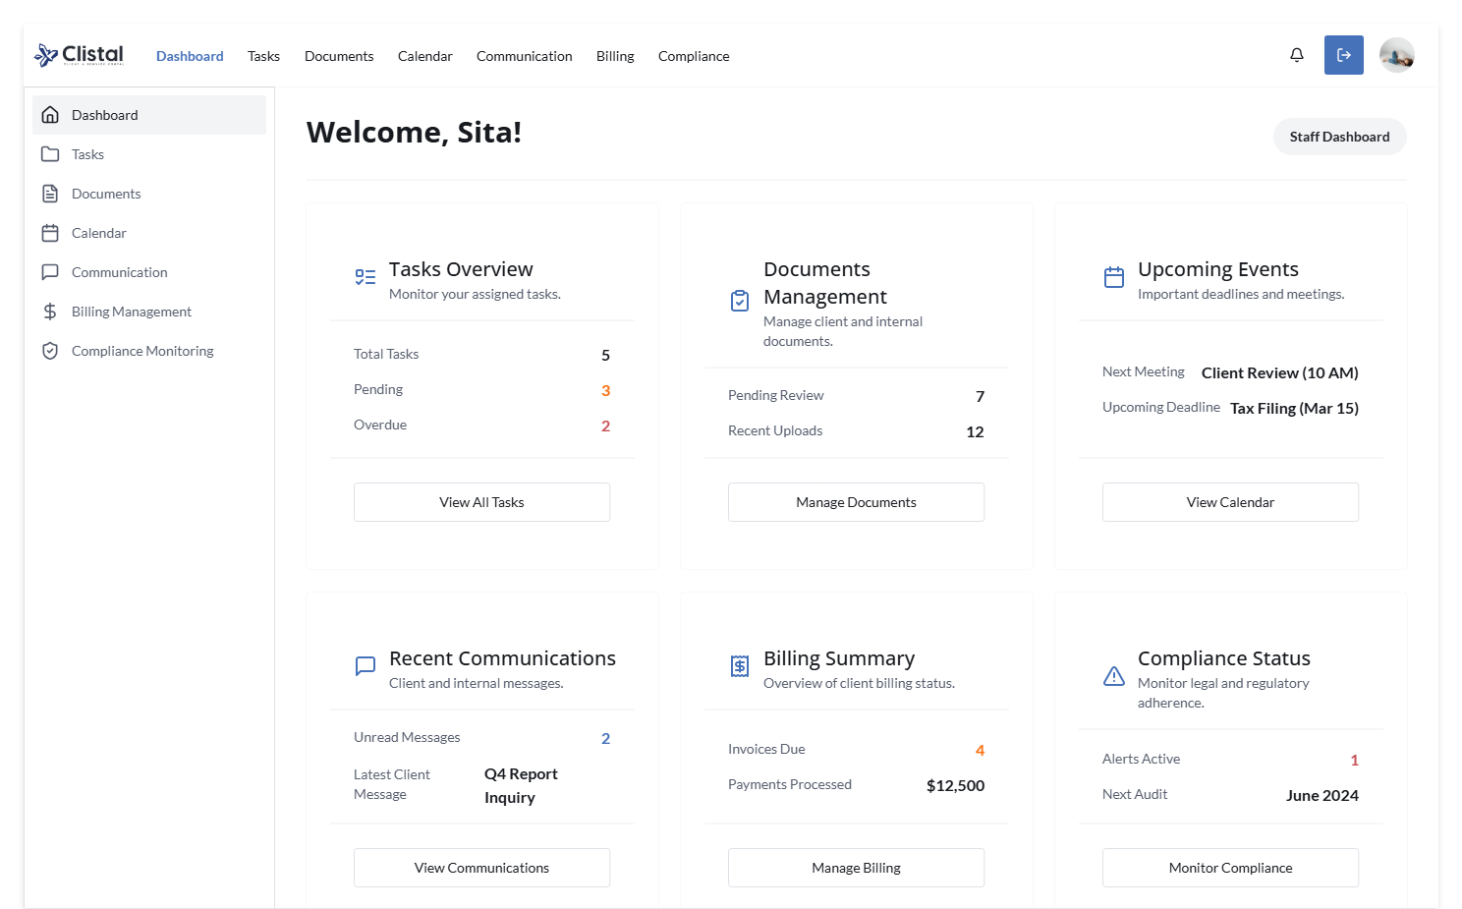
Staff Dashboard

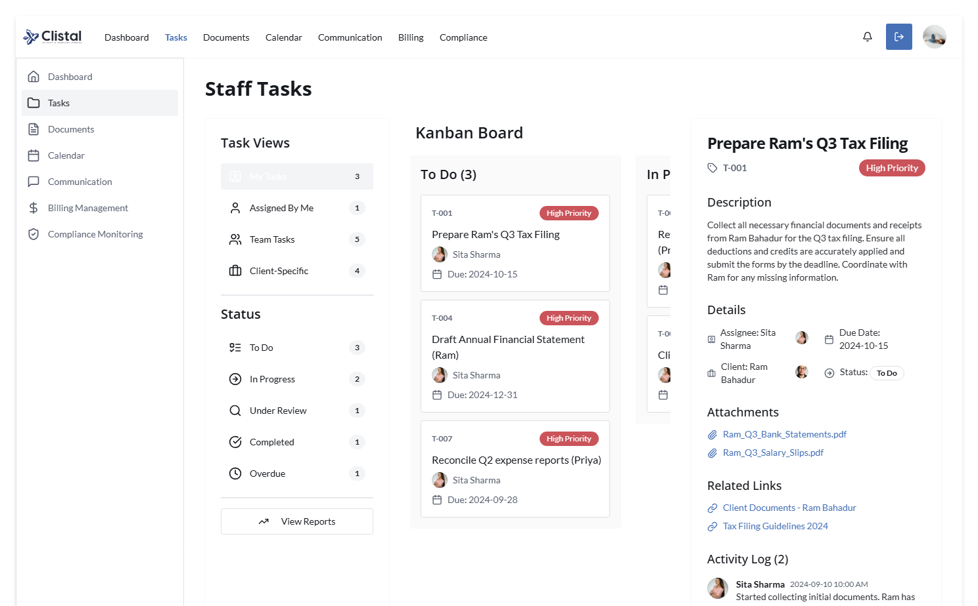
Staff Task

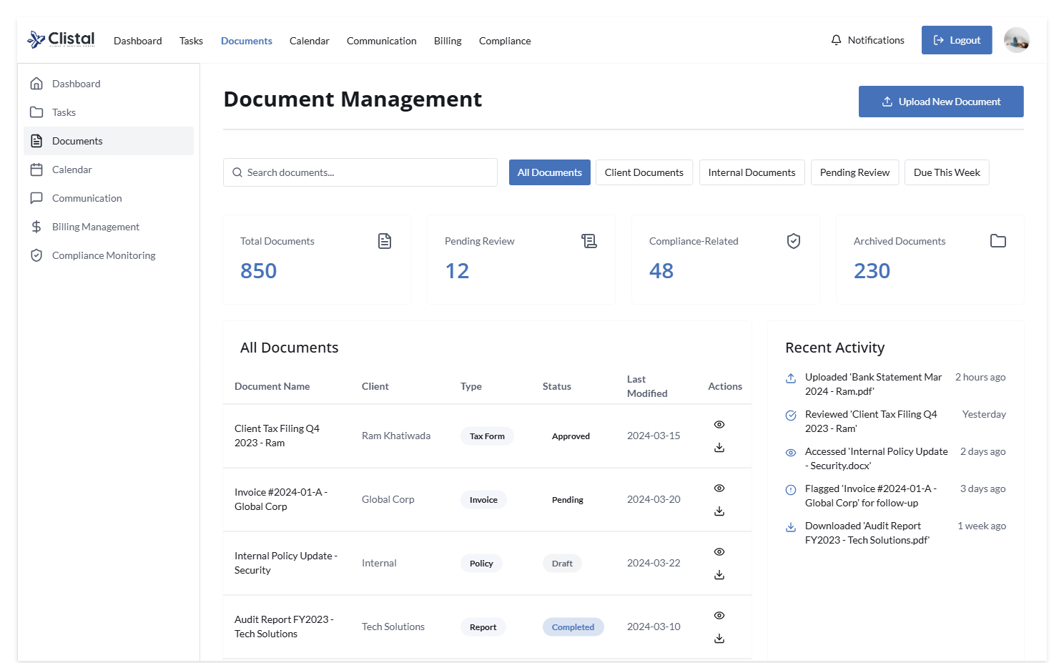
Staff Documents

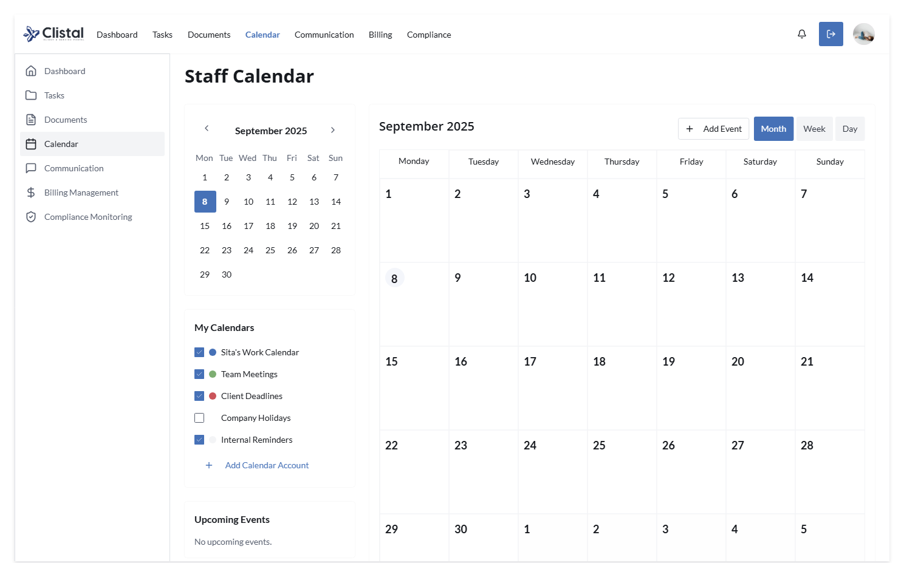
Staff Calendar

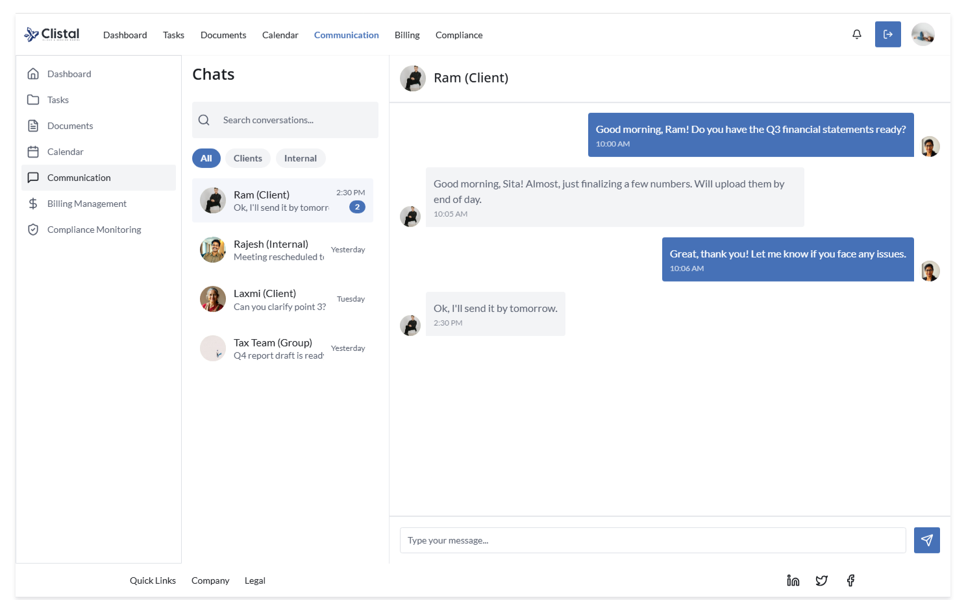
Staff Communication (Optional)

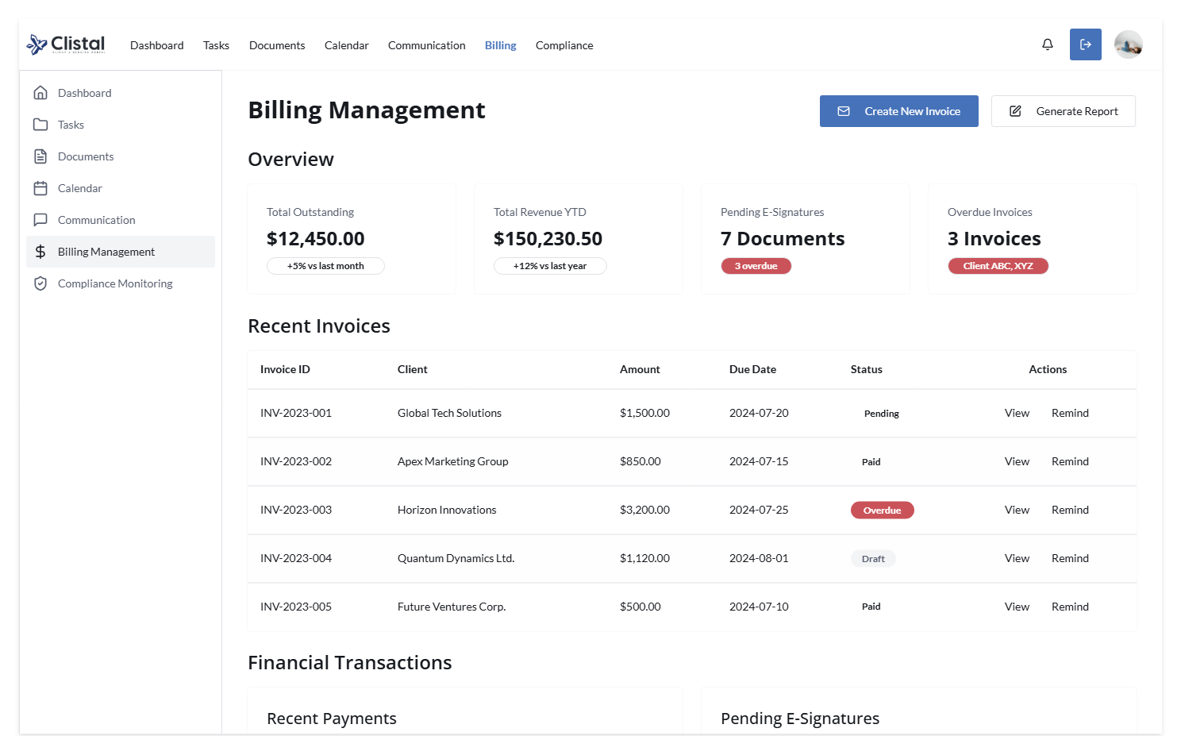
Staff Billing Management

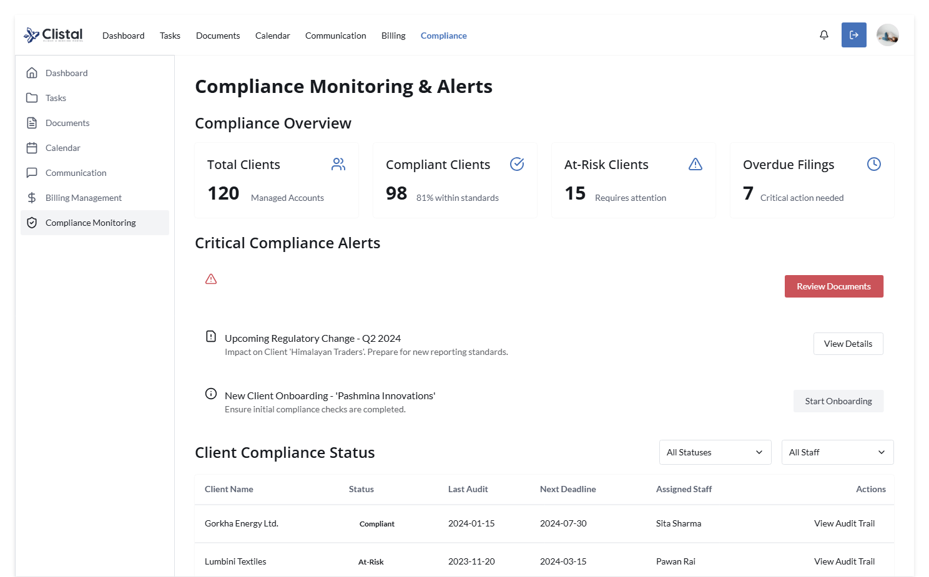
Staff Compliance

