**Assignment : 01**

**Title : Create an account in AWS and configure the budget.**

**About Amazon Web Service :** Amazon Web Services is one of the most emerging platforms offering services (by using all kind of technologies) that meets the need of any type of business. The AWS Free Tier automatically gets activated on each new AWS account. This lets the user explore all the AWS services free of cost up to specified limits for each service.

1. **Steps to create Amazon Web Service Account(AWS) account :**
2. Visit the *[AWS Free Tier webpage](https://aws.amazon.com/free/?all-free-tier.sort-by=item.additionalFields.SortRank&all-free-tier.sort-order=asc&awsf.Free Tier Types=*all&awsf.Free Tier Categories=*all" \t "https://beetechnical.com/cloud-computing/what-is-aws-free-tier-how-to-use-that/_blank)* & click on Create a free account option.

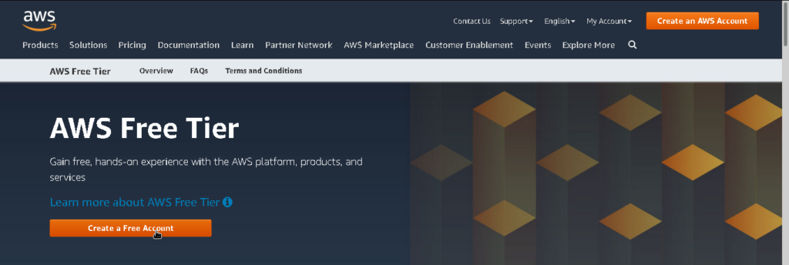

1. Provide your mail id that was never registered with Amazon AWS before then type a password and confirm it and give an *[AWS account](https://beetechnical.com/cloud-computing/how-to-use-aws-for-wordpress-hosting-detailed-guide-2020/)*name that you can also change after you sign up.

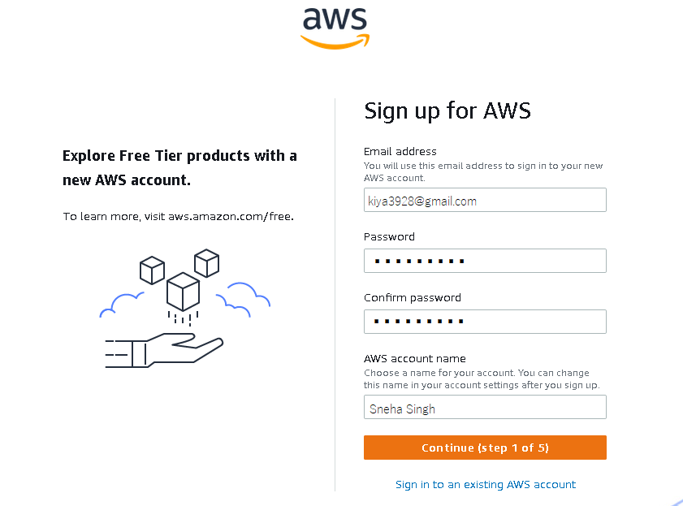

1. Select your AWS type (Professional/ Personal), in our case we choose the ***Personal*** one , provide other details such as name, address, phone number, state, city, Accept the Terms and conditions and then click Create Account and Continue.

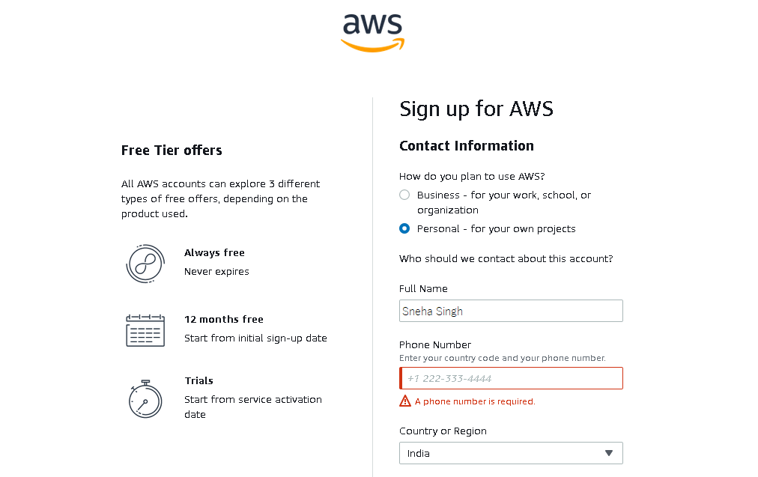

1. Lastly, you have to give the payment details so that after the trial is over they can charge you. After you are done with everything, your  AWS Free Tier account will get activated. For the payment , all the credit cards except for RuPay are accepted. I have used my Airtel payments bank account card to complete the creation of my AWS account.

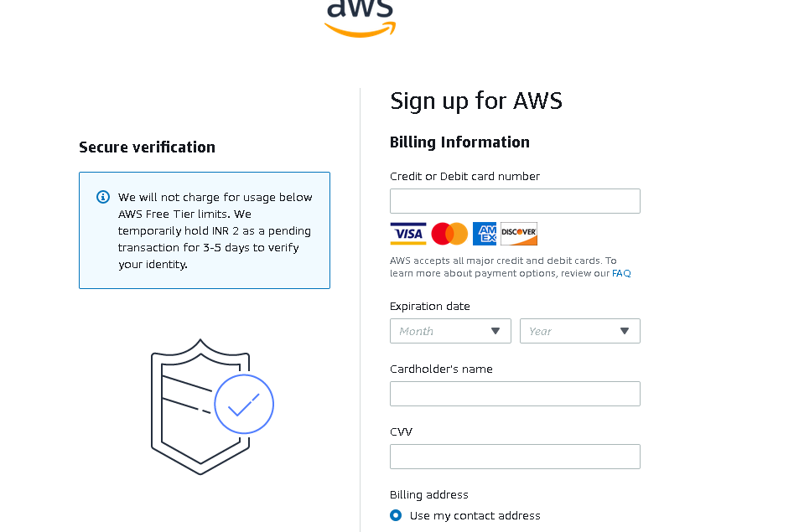

Now, we can easily log in to our AWS management console with our login credentials that is the email Id and password .

###### Steps to create and configure a budget :

1. Sign in to the AWS Management Console and open the AWS Cost Management console.
2. On the right side of the navigation bar, choose your account name, and choose ***Billing Dashboard***, then on the left side under ***Cost Management*** choose ***Budgets***.
3. At the top of the page, choose ***Create budget***

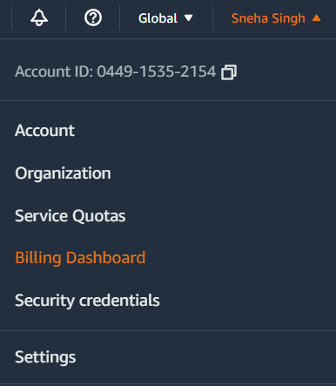 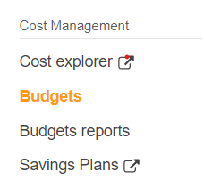 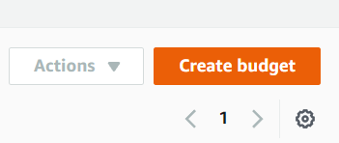

1. Under ***Budget setup***, choose ***Customize (advanced)****.*
2. Under ***Budget types****,* choose ***Cost budget***. Then, choose ***Next***.

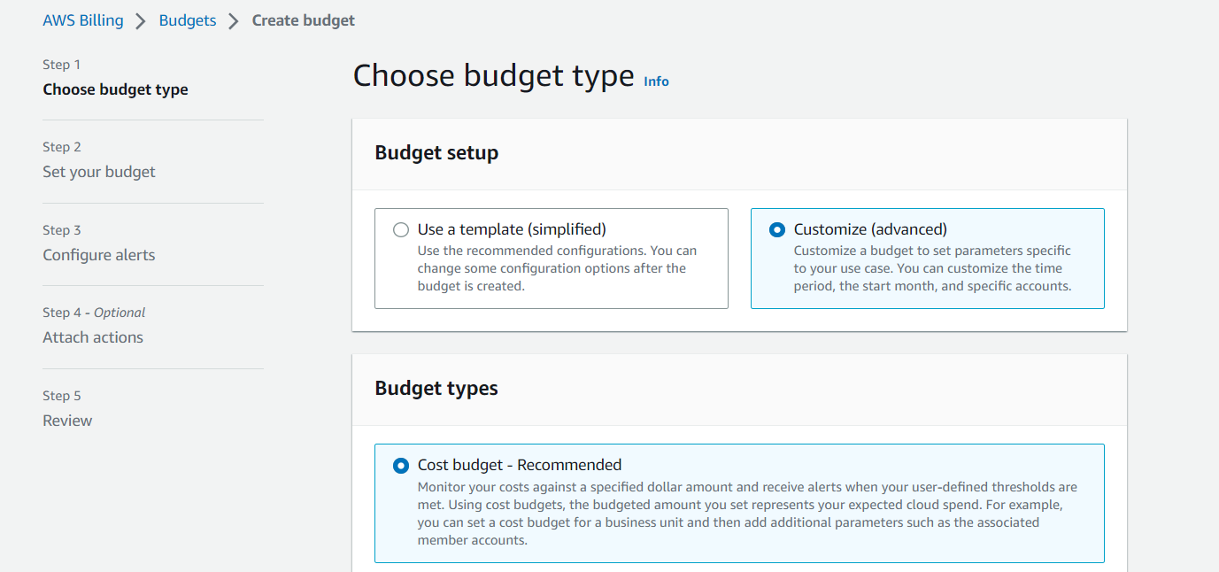

1. Under ***Details***, for ***Budget name***,lets say ***Budget-1*** enter the name of your budget. Your budget name must be unique within your account. It can contain A-Z, a-z, spaces, and the following characters:_.:/=+-%@ .
2. Under***Set budget amount***, for **Period**, choose how often you want the budget to reset the actual and forecasted spend. Select **Daily** for every day, ***Monthly*** for every month, **Quarterly** for every three months, or **Annually** for every year. We are choosing ***Monthly***
3. For **Budget renewal type**, choose ***Recurring budget***for a budget that resets after the budget period. ***Budgeted Amount - $1.00 ,*** Choose ***Next.***

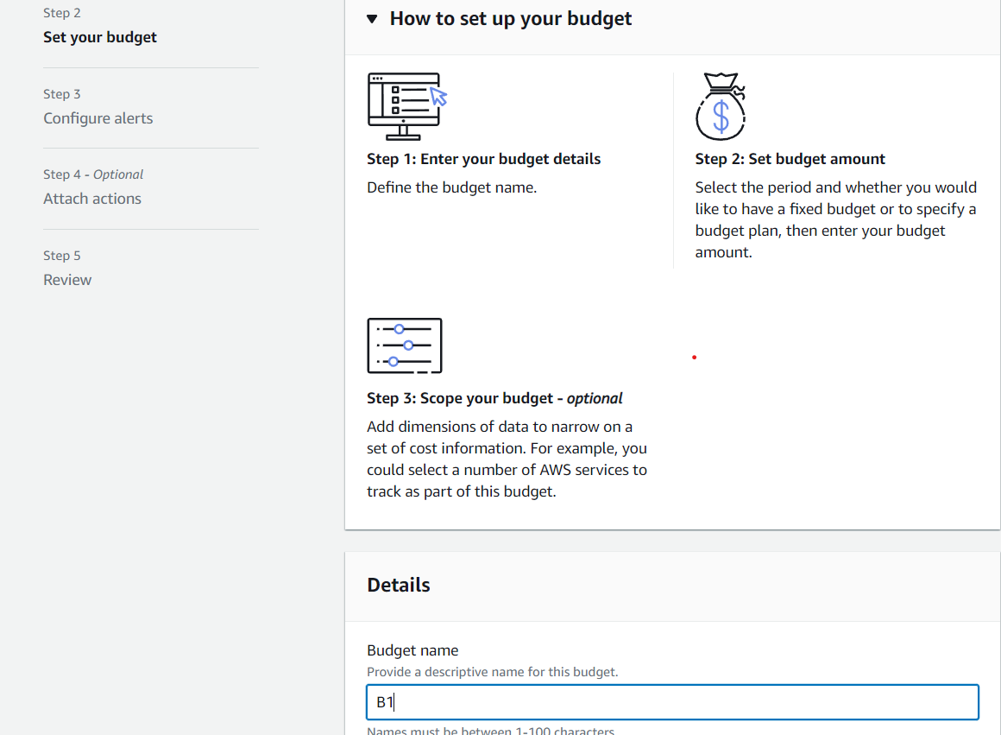 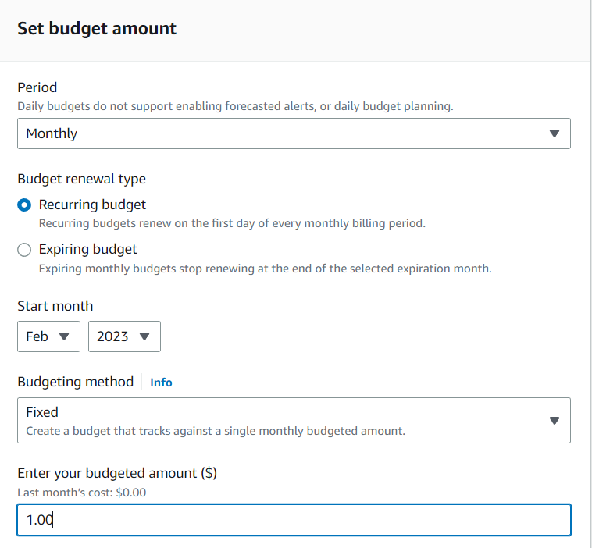

1. Choose ***Add an alert threshold***.
2. Under ***Set alert threshold***, for **Threshold**, enter the amount that must be reached for you to be notified. This can be either an absolute value or a percentage. For example, say you have a budget of 200 dollars. To be notiﬁed at 160 dollars (80% of your budget), enter **160** for an absolute budget or **80** for a percentage budget. We Choose ***Percentage budget***.
3. Under ***Notification preferences***, for***Email recipient*s**, enter the email addresses that you want the alert to notify. Separate multiple email addresses with commas.Review your budget settings, and then choose ***Create budget****.*

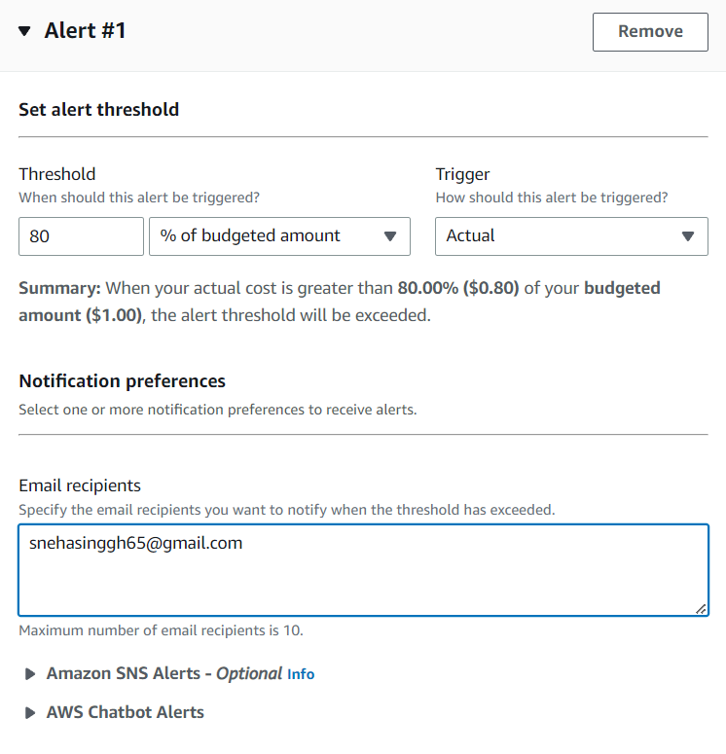 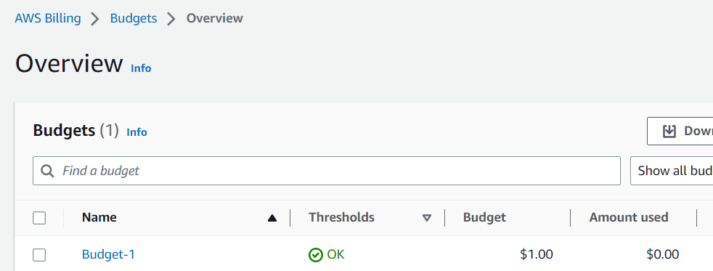

The budget has been created . And it can be observed in the the overview section of the Budgets as ***Budget-1***

**Assignment : 02**

**Title : Create MFA for authentication.**

# Multi - Factor authentication (MFA) :MFA adds extra security because it requires users to provide unique authentication from an AWS supported MFA mechanism in addition to their regular sign-in credentials when they access AWS websites or services.For increased security, we recommend that you configure multi-factor authentication (MFA) to help protect your AWS resources. You can enable MFA for the AWS account root user and IAM users. When you enable MFA for the root user, it affects only the root user credentials.

# Using multi-factor authentication (MFA) in AWS :

1. Sign in to the AWS Management Console.
2. On the right side of the navigation bar, choose your account name, and choose ***Security credentials***. If necessary, choose **Continue to Security credentials**.
3. In the ***Multi-Factor Authentication (MFA)***section, choose ***Assign MFA device****.*

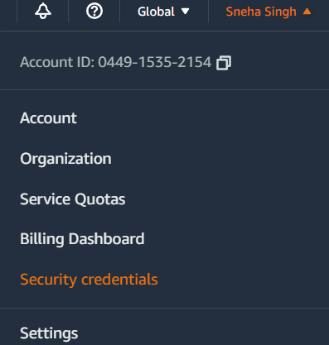 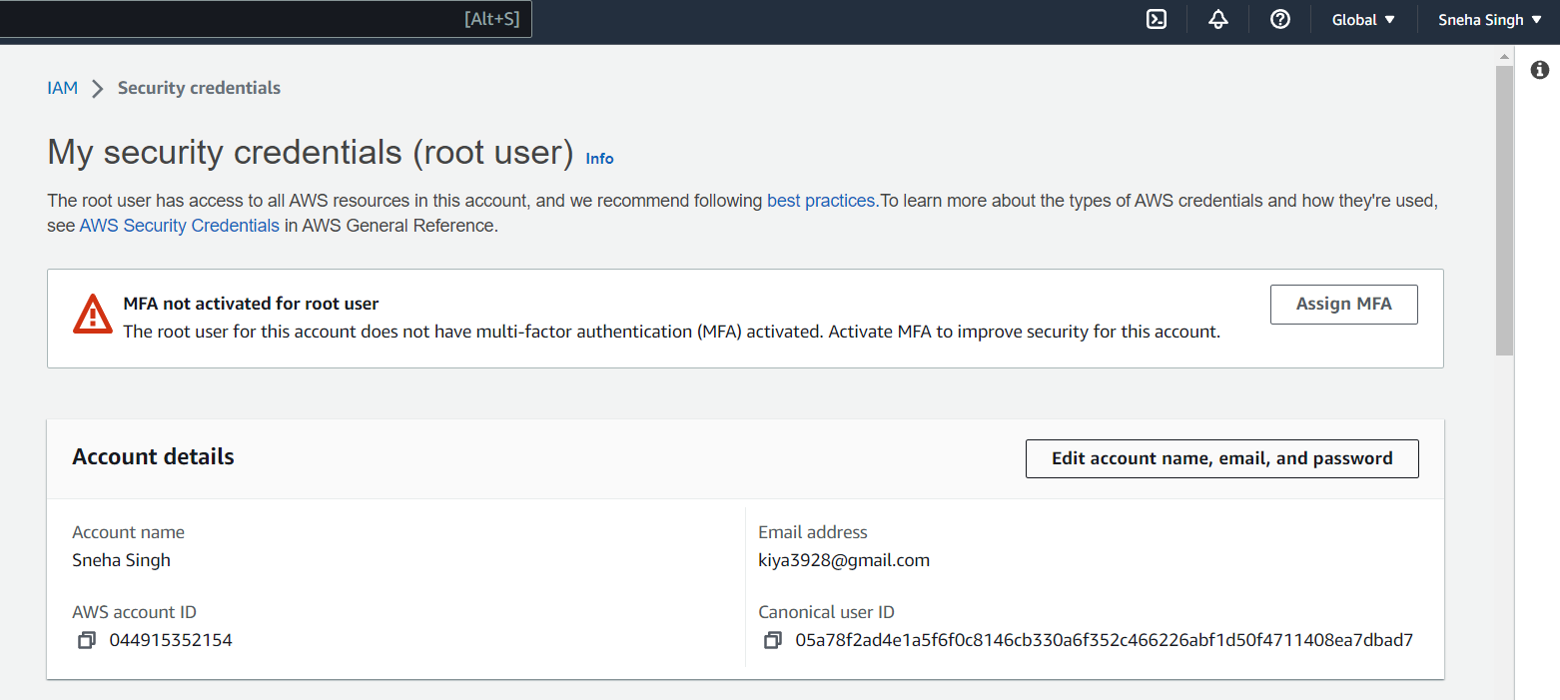

1. In the wizard, type a ***Device name*** let it be ***d1***, choose***Authenticator app***, and then choose ***Next****.*
2. It displays configuration information for the virtual MFA device, including a QR code graphic. The graphic is a representation of the secret configuration key that is available for manual entry on devices that do not support QR codes.

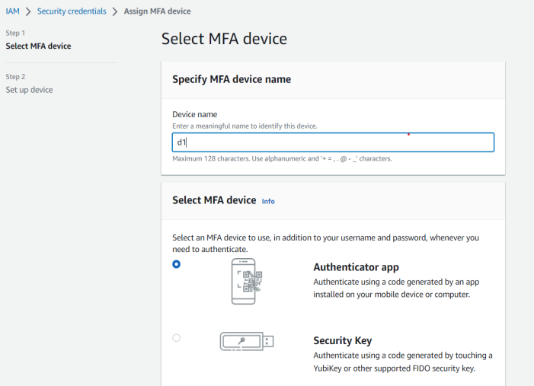 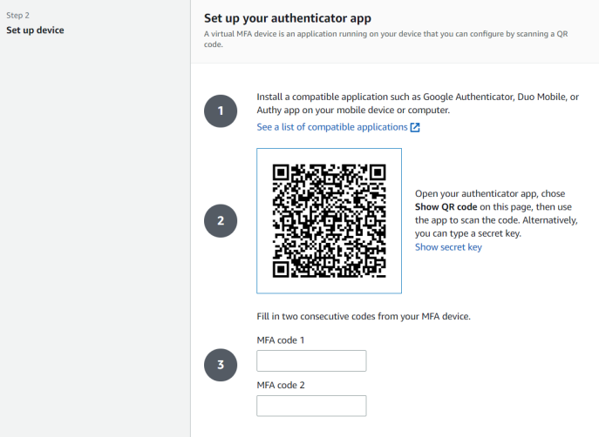

1. Open the virtual MFA app on the device.
2. To use the QR code to configure the virtual MFA device, from the wizard, choose ***Show QR code***. Then follow the app instructions for scanning the code. For example, you might need to choose the camera icon or choose a command like ***Scan account barcode***, and then use the device's camera to scan the QR code. We have used the ***Google Authenticator*** app for authentication.
3. The device starts generating six-digit numbers.
4. In the wizard, in the ***MFA code 1***box, type the one-time password that currently appears in the virtual MFA device. Wait up to 30 seconds for the device to generate a new one-time password. Then type the second one-time password into the ***MFA code 2*** box. Choose ***Add MFA.***

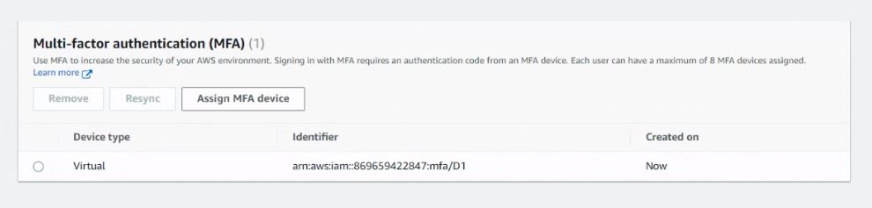

The device is ready for use with AWS. For information about using MFA with the AWS Management Console.

Now , when we sign out of the console , everytime we log in again we need to enter the MFA code generated by the Authenticator app to successfully sign in to our AWS account.

**Assignment : 03**

**Title : Create IAM user and thereby give full access of S3**

**AWS Identity and Access Management (IAM):** It is a web service that helps you securely control access to AWS resources. With IAM, you can centrally manage permissions that control which AWS resources users can access. You use IAM to control who is authenticated (signed in) and authorized (has permissions) to use resources.

**Steps to create an IAM User :**

1. **Creating a user :**
2. Sign in to the AWS Management Console and open the IAM console
3. In the navigation pane, choose ***Users*** and then choose ***Add user***.
4. Type the user name for the new user , Lets say ***U1***. This is the sign-in name for AWS.
5. Select the type of access this user will have.

We will go for***Console password****,* choose one of the following:

***Auto-generated password*** – The user gets a randomly generated password that meets the [account password policy](https://docs.aws.amazon.com/IAM/latest/UserGuide/id_credentials_passwords_account-policy.html).

***Custom password***– The user is assigned the password that you type in the box. We will assign a password we want to give for the IAM username.

1. Uncheck ***Users must create a new password at next sign-in,***choose ***Next.***

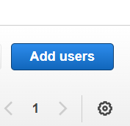 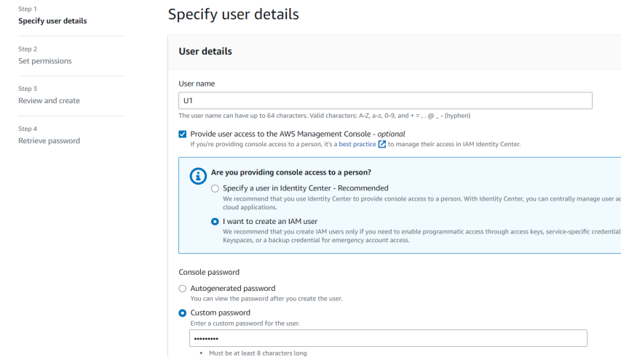

1. On the***Set permissions*** page, specify how you want to assign permissions to this set of new users:

***Add user to group*** – Choose this option if you want to assign the user to one or more groups that already have permissions policies. IAM displays a list of the groups in your account, along with their attached policies.

1. On the ***Review and create*** page, review all of the choices you made up to this point. When you are ready to proceed, choose ***Create user***.

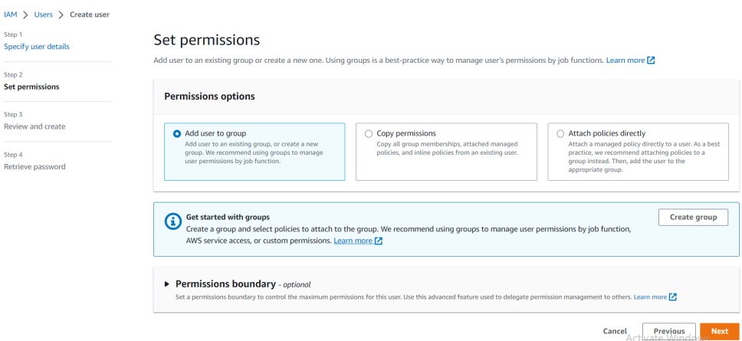 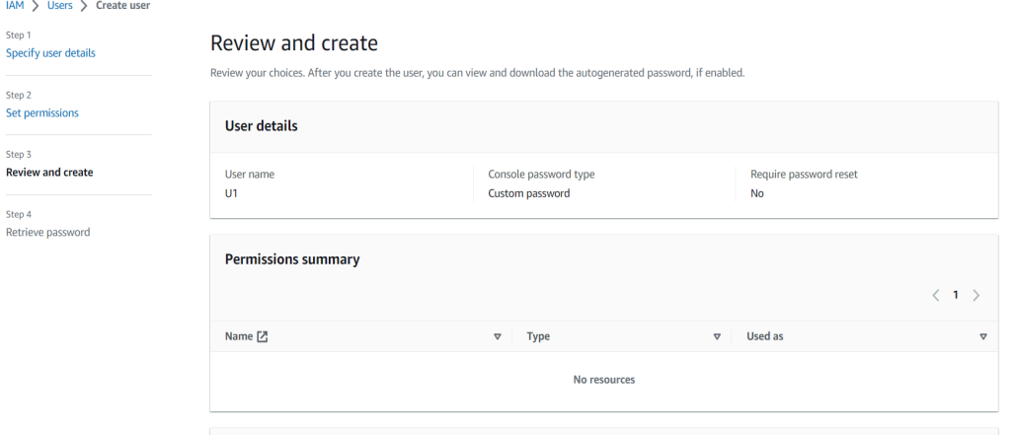

8. To save the password, choose ***Download.csv*** and then save the file to a safe location. Choose ***Return to users list.***

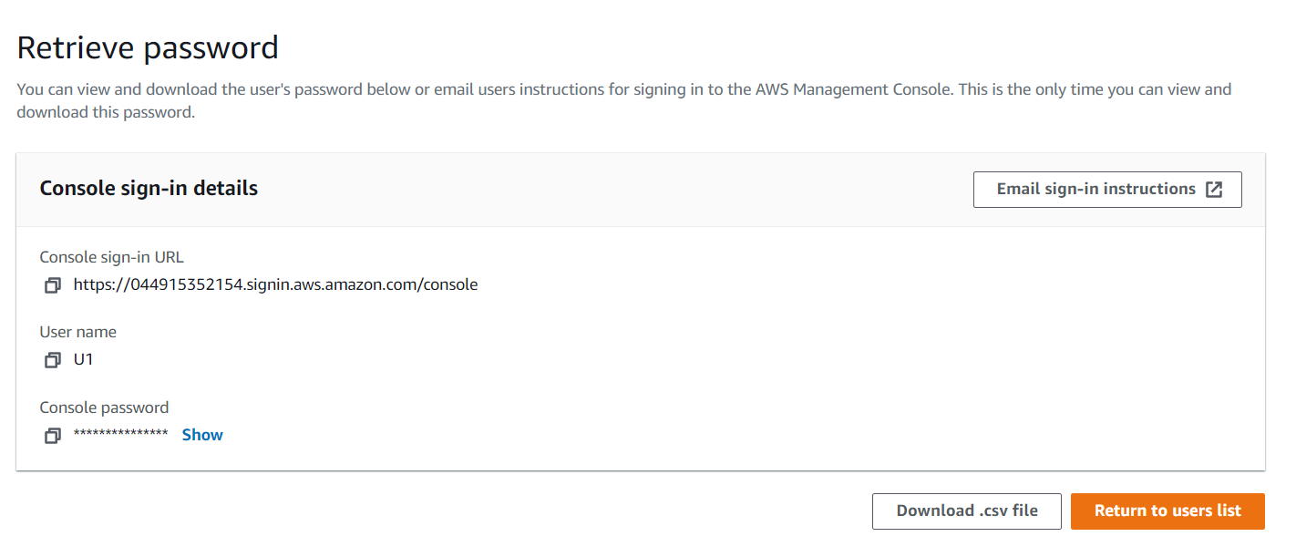

1. **Creating a group and adding the user to it:**
2. As the user U1 is created , Click on the ***user U1***.

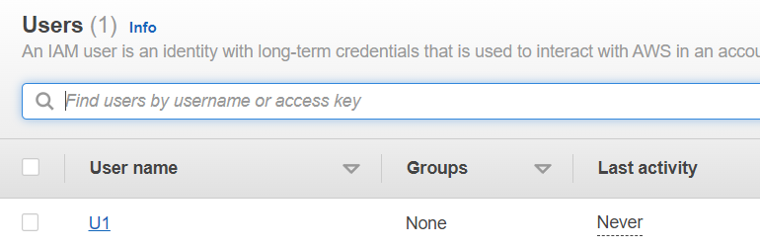

1. On clicking U1 it will show all the summary , description and properties related to the User created. It will consist of tabs like **Permissions, Groups , Tags , Security credentials** and **Access advisor**. Choose ***Groups*** and then click on ***Add user to groups***. Choose ***Create group***.
2. Create user group window will appear , provide with a ***User group name g1*** lets say. In ***permission policies*** search for ***S3*** and select first two options , which means the group will provide full access for S3.

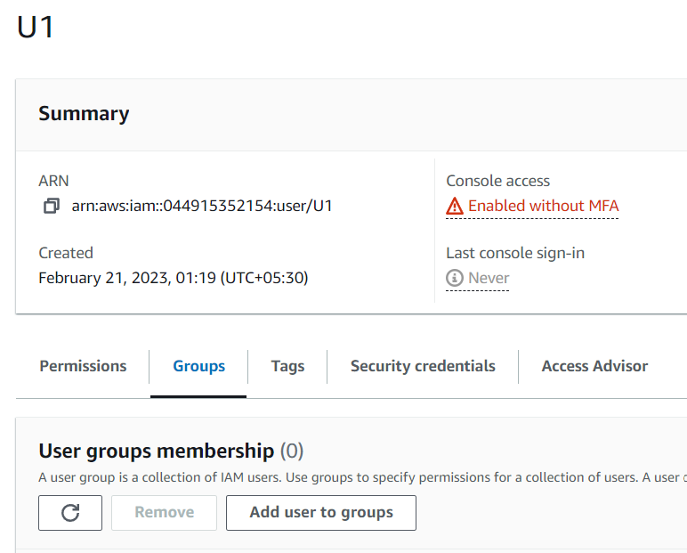 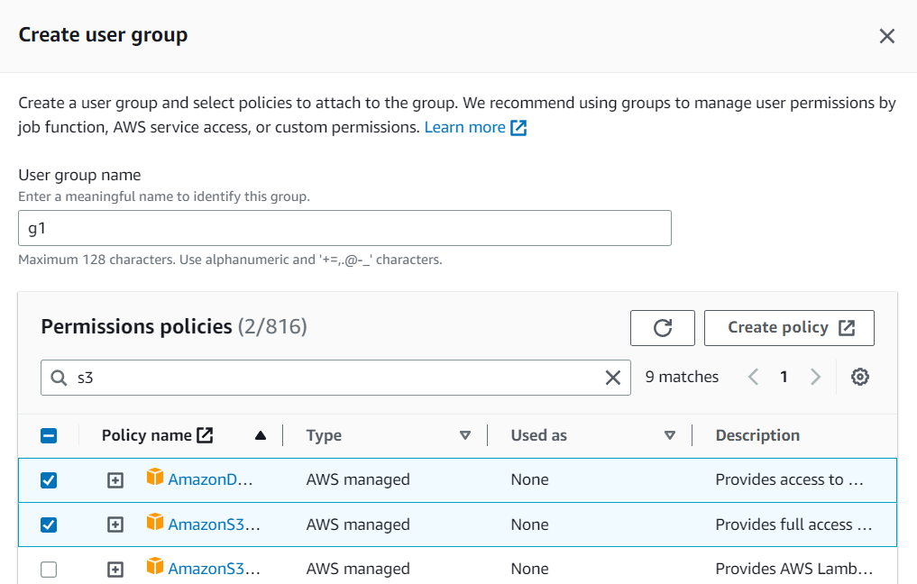

4.Complete the step and then the g1 appears in our user group list , Choose ***Add user to group(s).***

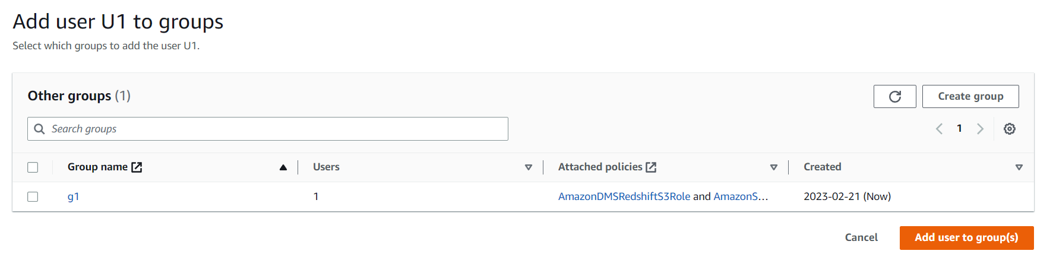

5.The user U1 is added to group g1 and now we can login to the AWS console as IAM user using the username / login credentials of user U1.

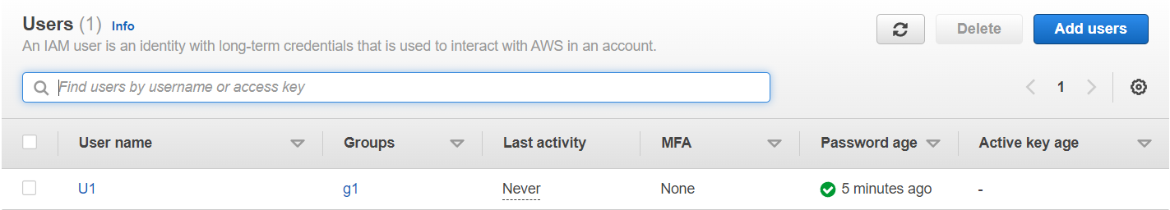

Log in to your AWS account using the ***account id, password and username*** generated by the user U1 created , which were already saved in the .csv file, saved earlier. Now, you can continue using the AWS console as an ***IAM user***.

