**Assignment** : 10

**Title** : Deploy a project from github to EC2 by creating new security group and user data.

* First open your github account , go to your repository that was already created in previous assignments - <https://github.com/itsmesneha/SNEHAREPO>
* Make sure that your repository is made **‘public’**

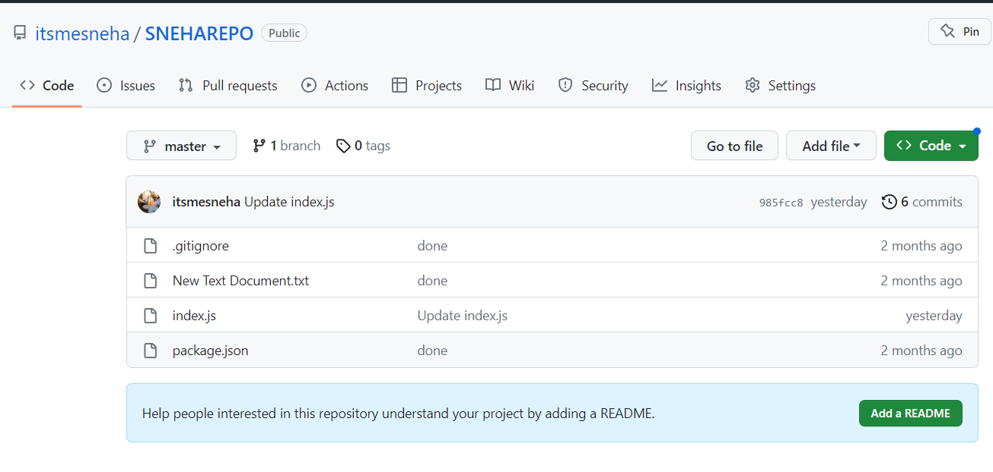

* If the repository is not public, go to **Settings** -> scroll down to ****Change repository visibility** and make change visibility to public.**

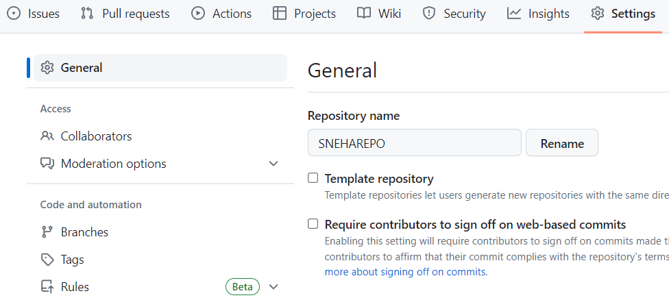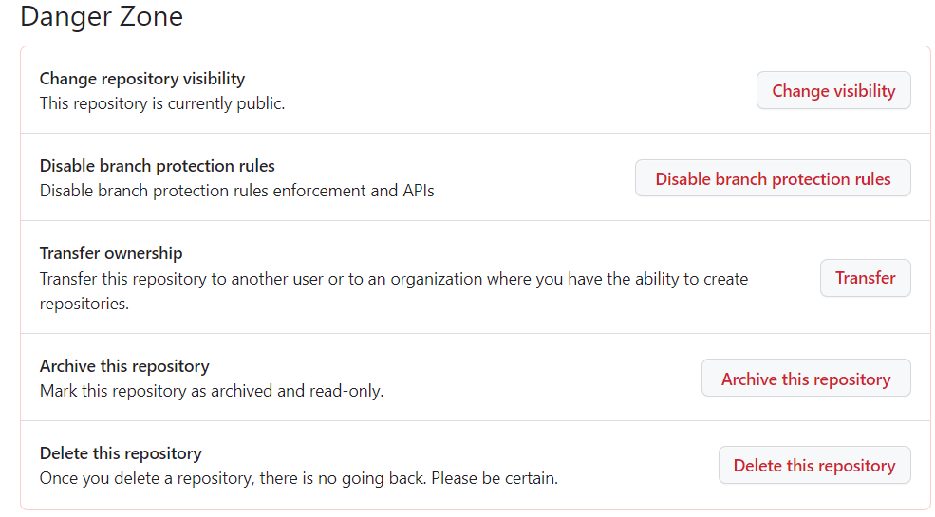

**Steps to create a security group :**

1. Go to EC2 Dashboard -> **Security Groups**
2. Delete all security groups (default cannot be deleted) -

Select the security group , go to **actions** - choose **Delete Security groups**

1. Click on **Create Security Group** to create a new security group.

