Assignment : 04
Title : Create a private bucket in AWS.Upload a file and check by presigned URL that you can access the file or not.

Simple Storage Service(S3) :
Amazon Simple Storage Service (Amazon S3) is an object storage service that offers industry-leading scalability, data availability, security, and performance. Customers of all sizes and industries can use Amazon S3 to store and protect any amount of data for a range of use cases, such as data lakes, websites, mobile applications, backup and restore, archive, enterprise applications, IoT devices, and big data analytics. Amazon S3 provides management features so that you can optimize, organize, and configure access to your data to meet your specific business, organizational, and compliance requirements.

Steps to create a private bucket:
- Sign in to the AWS Management Console and open the Amazon S3 console .
- In the left navigation pane, choose Buckets.
- Choose Create bucket.
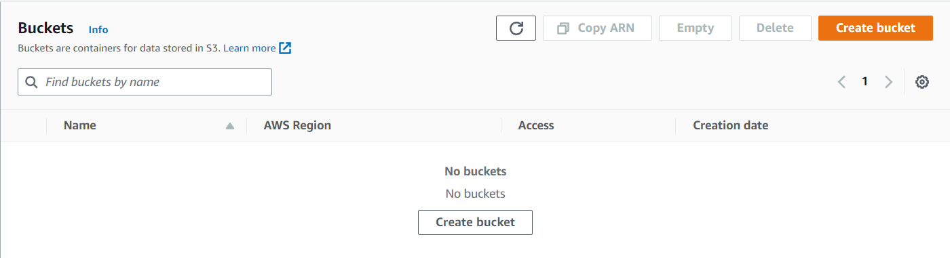
The Create bucket page opens.
- For Bucket name, enter a name for your bucket. - ‘snehaprivatebucket’
The bucket name must:
- Be unique within a partition.
- Be between 3 and 63 characters long.
- Consist only of lowercase letters, numbers, dots (.), and hyphens (-). For best compatibility, we recommend that you avoid using dots (.) in bucket names, except for buckets that are used only for static website hosting.
- Begin and end with a letter or number.

- For Region, choose the AWS Region where you want the bucket to reside.
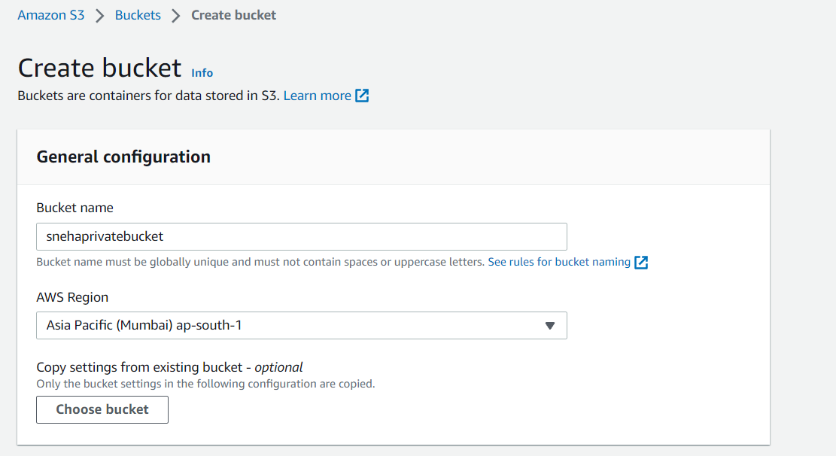
- Under Object Ownership, to disable ACLs to control ownership of objects uploaded in your bucket.

Bucket owner enforced – ACLs are disabled, and the bucket owner automatically owns and has full control over every object in the bucket. ACLs no longer affect access permissions to data in the S3 bucket. The bucket uses policies to define access control.

Check Block Public Access settings for this bucket checkbox to create private bucket.

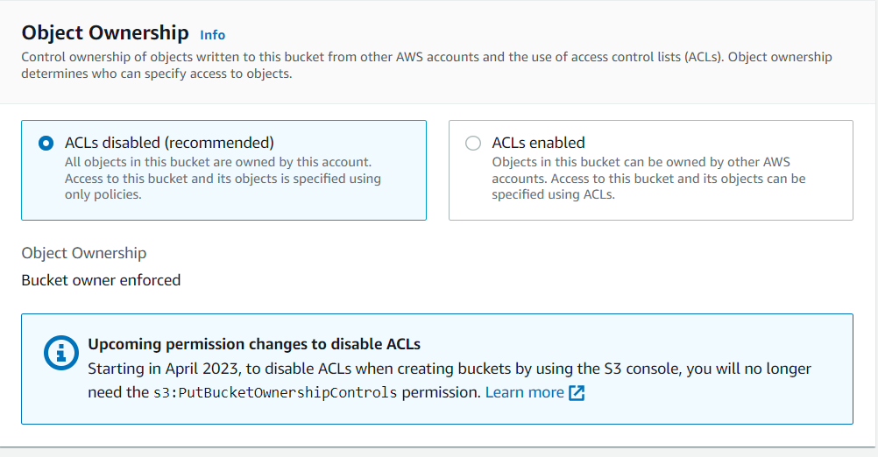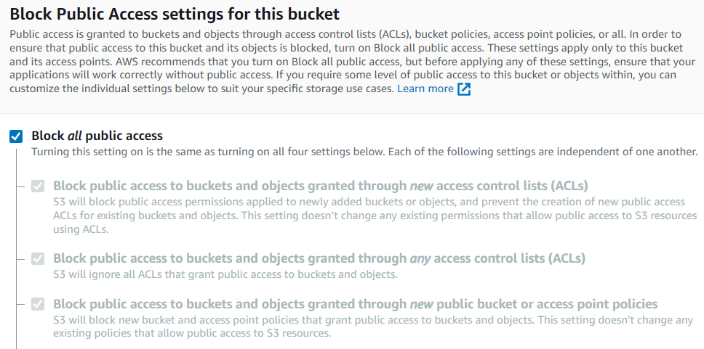
- Choose Create bucket.
The private bucket is created .
Steps to upload files and create presigned url:
- Once the bucket is created , it is visible in the list of buckets.
- Click on the bucket .
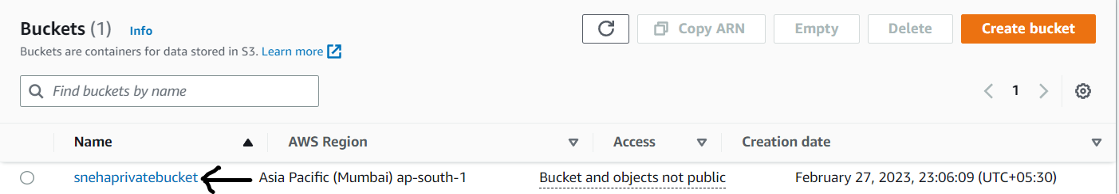

- Click on upload .The upload page opens - select add files and add the required files and documents required and then click on upload.
The files are uploaded in the private bucket.

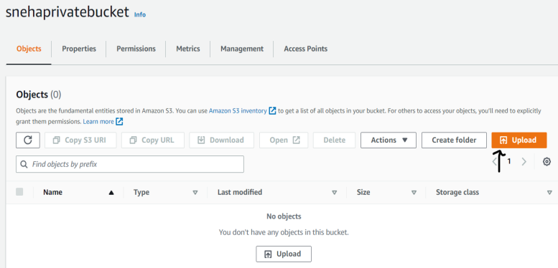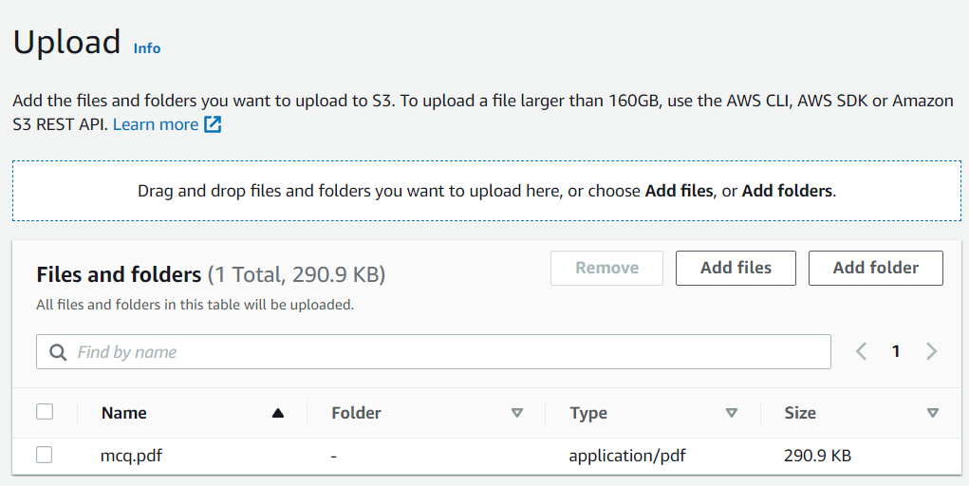
- Now click on the uploaded file and copy the object URL from its properties and open the url in a new window.
You will get a message as Access denied as the object in the bucket is private and therefore cannot be accessed publicly.
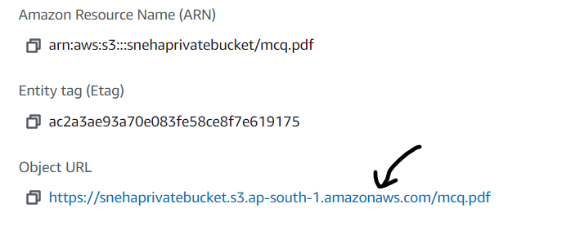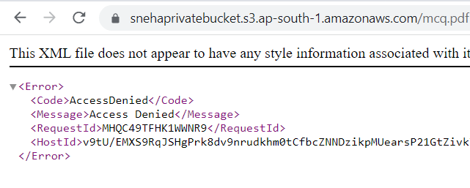

- We can provide access to our private files by using the presigned URL.
Select the object(file) then click on actions.
From the list select and click on Share with a presigned URL.

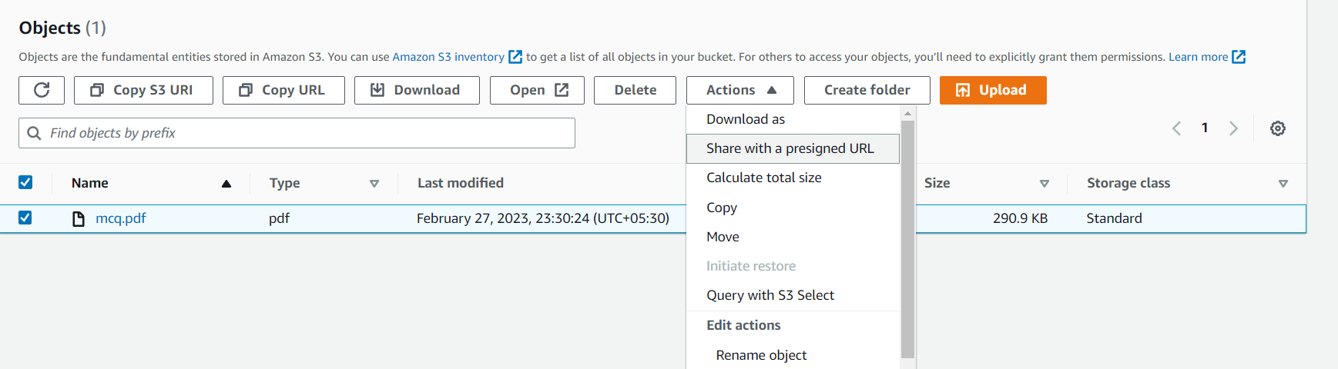
- The Share with a presigned url dialogue appears.
Enter the time interval untill the URL expires.
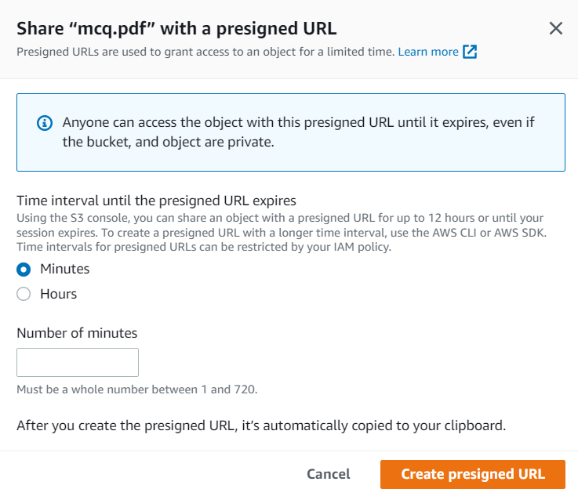
Click Create presigned URL. The presigned URL for the object is created.

Copy the presigned URL and use it in a new tab to access the file publicly for the time limit assigned.

7. When you open the object URL in a new tab . The document uploaded in the private bucket or the object of the bucket is accessed publicly but only untill the time limit by the created presigned URL.
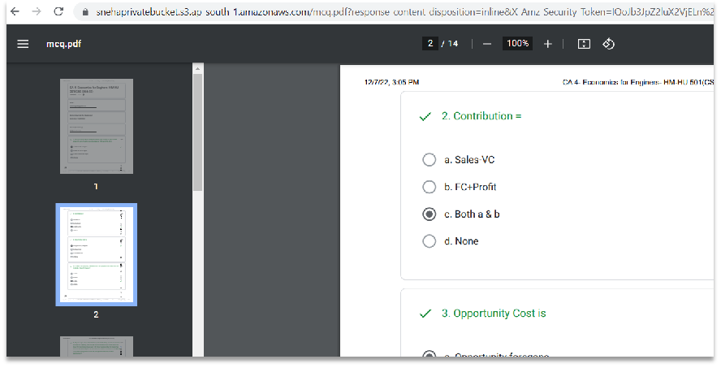

Assignment : 05
Title :Create a public bucket in AWS. Upload a file and give the necessary permission to check the file URL is working or not.

Steps to create a public bucket :
- Sign in to the AWS Management Console and open the Amazon S3 console .
- In the left navigation pane, choose Buckets.
- Choose Create bucket.
The Create bucket page opens.
- For Bucket name, enter a name for your bucket. - ‘snehapublicbucket’11
- For Region, choose the AWS Region where you want the bucket to reside.
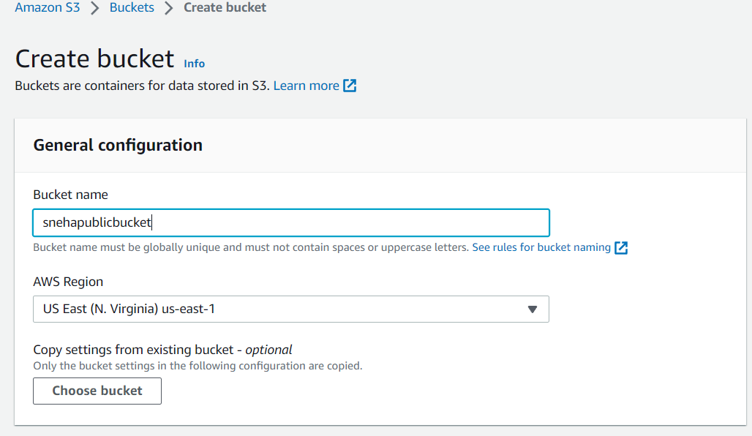
- Under Object Ownership, to enaable ACLs to control ownership of objects uploaded in your bucket.
Bucket owner enforced – ACLs are enabled,
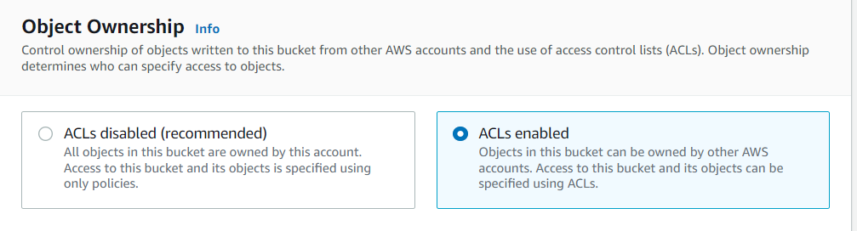

Uncheck Block Public Access settings for this bucket checkbox to create private bucket. Tick the acknowledgement box.
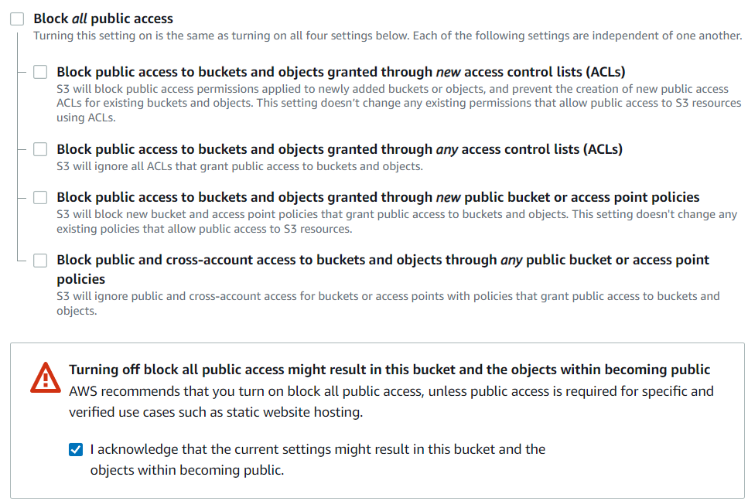

Click on Create Bucket.

Steps to upload files and allow public access:
- Once the bucket is created , it is visible in the list of buckets.
- Click on the bucket .
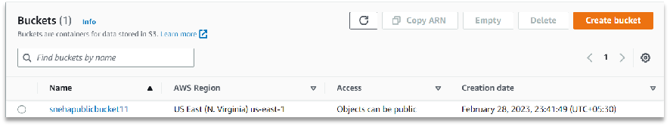

- Click on upload .The upload page opens - select add files and add the required files and documents required and then click on upload.
The files are uploaded in the public bucket.
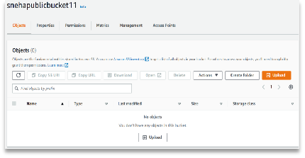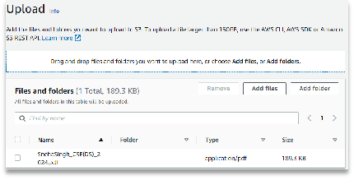
- Now click on the uploaded file and go to Permissions and then in the Access Control List , click edit and a dialogue box appears.
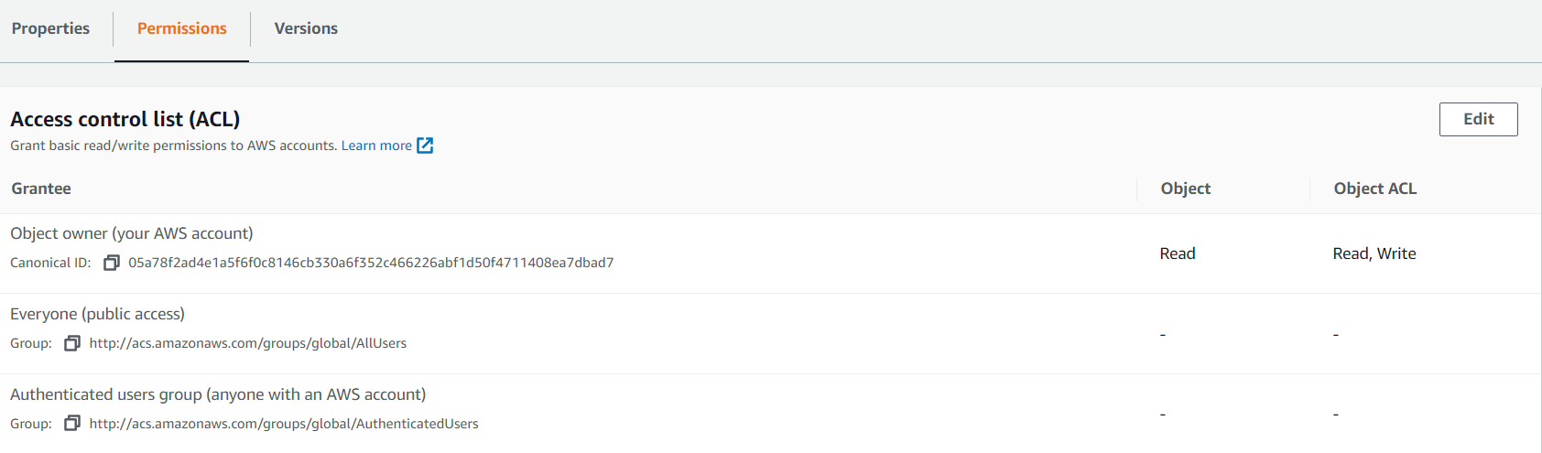
- Check the read permission for object and object’s ACL under Everyone(public access) .
Tick I Understand the effects…
- Click on save changes.
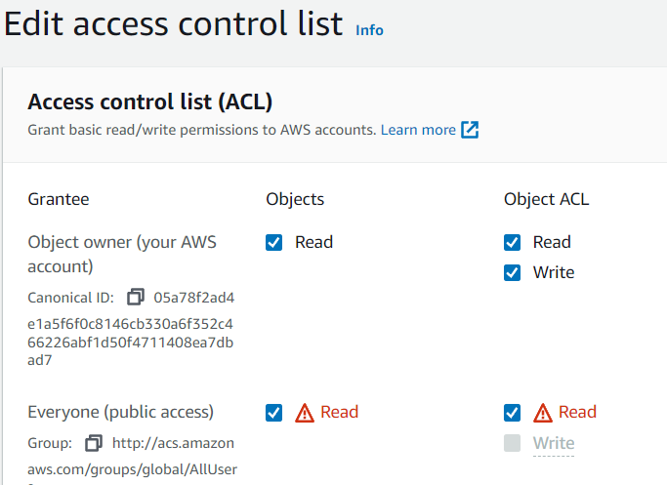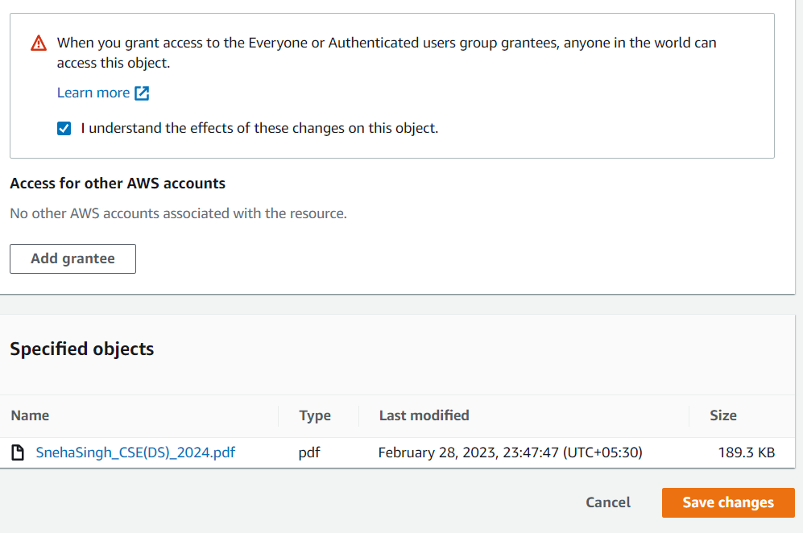
- Now click on the uploaded file and copy the object URL from its properties and open the url in a new window.
- When you open the object URL in a new tab . The document uploaded in the public bucket or the object of the bucket is accessed publicly
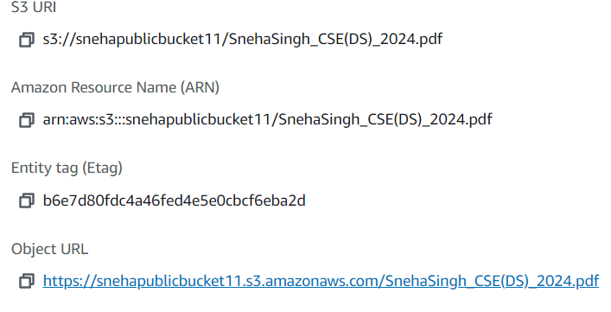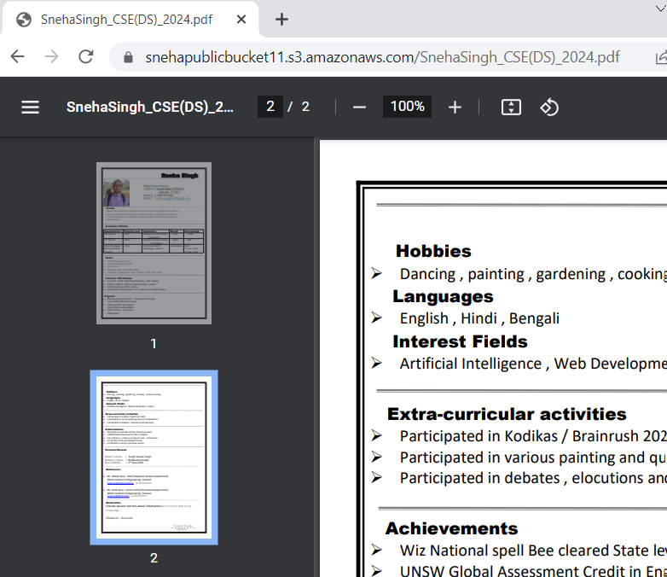

NOTE : If you do not edit the permissions of the ACL list , the access of the object will still be denied even if it is an object of a public bucket.

Assignment : 06
Title : Upload a static website in S3

Steps to create a public bucket , change permissions and host a static website on S3:
1Sign in to the AWS Management Console and open the Amazon S3 console .
- In the left navigation pane, choose Buckets.
- Choose Create bucket.
The Create bucket page opens.
- For Bucket name, enter a name for your bucket. - ‘snehapublicbucket’11
- For Region, choose the AWS Region where you want the bucket to reside.
- Under Object Ownership, to enaable ACLs to control ownership of objects uploaded in your bucket.
Bucket owner enforced – ACLs are enabled,

Uncheck Block Public Access settings for this bucket checkbox to create private bucket. Tick the acknowledgement box.

Click on Create Bucket.

Public bucket is created.
- Once the bucket is created , it is visible in the list of buckets. Click on the bucket .
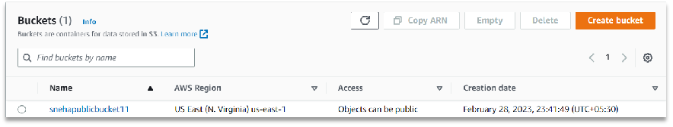
- Go to properties , and scroll down to Static Website hosting and click on Edit.
- In the Edit static Website hosting, Enable the Static Website hosting and specify the index document as Index.html.
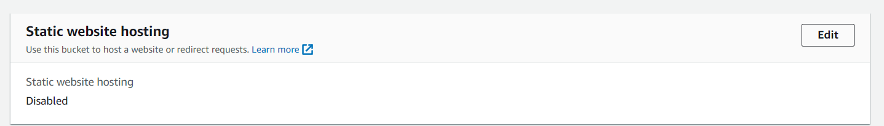

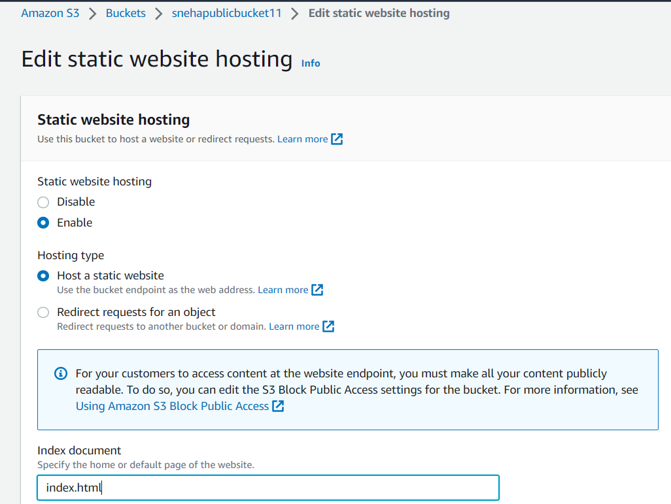
Now we will upload a folder containing 3 files in .html which will be our static websites namely - index.html, next.html, about.html .
The code snippet for example :

<html>
<body bgcolor="lightgreen">
welcome
<a href="next.html">Next page</a>
<a href="about.html">Aboutpage</a>
<body>
</html>

- Upload the folder containing the files:
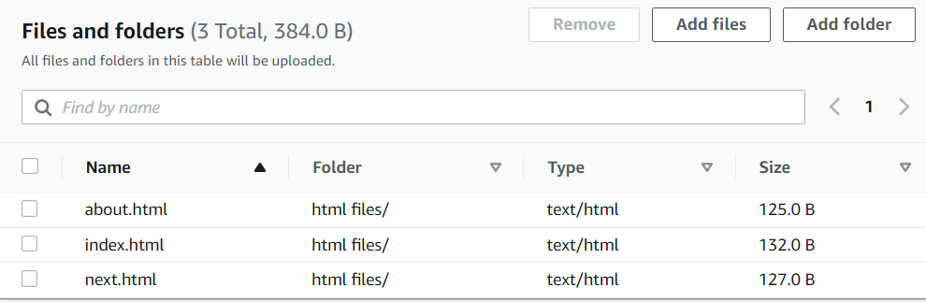
Upload ->
Add folders ->
select folder->
Upload

- Now select all the folders to change their ACL permissions such that the files will now be accessed publicly.
Select the three files (objects) ,then go to actions and click on the downward arrows , scroll down to click on Make public using ACL. In the make public page all the files will be listed just click on Make public and the files will now be available publicly.
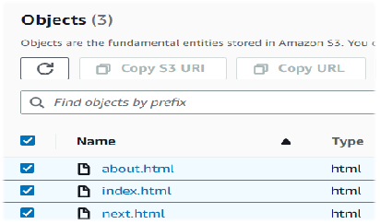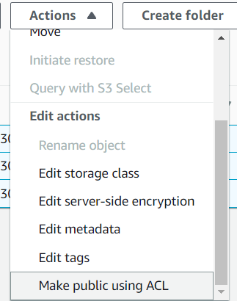
Make public using ACL
- Click on index.html
Go to properties
In Object overview , see the object URL.
Copy the object URL
Paste it in a new web window to see whether it can be accessed publicly.
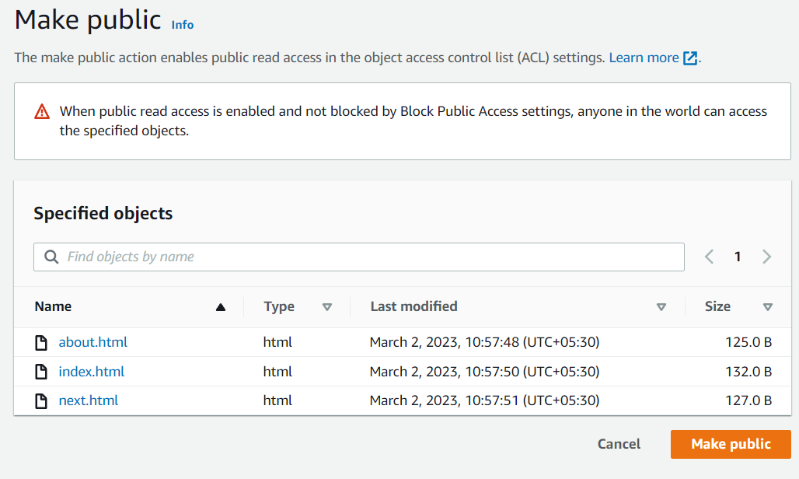
Object Properties :

1.Index.html
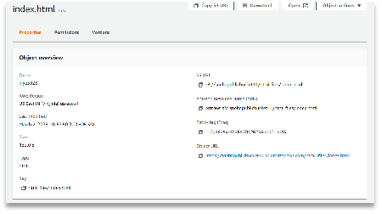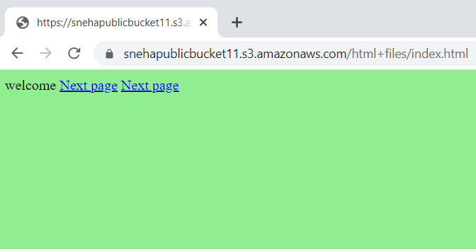

2.About.html
3.Next.html

