PHP Learning Notes
PHP Hypertext Preprocessor (PHP) is a programming language that you can use on the web to build an awesome, scalable and easily maintainable website or web application. It integrates super well with html. It is a server side language.

The file extension of PHP is .php. To run the php file in command prompt or CLI, the command is php <filename>. And to run on the local host the command is “php -S localhost:8000”.

PHP is tightly coupled with HTML language.
echo(“Hello World”) -> print something on the screen
PHP executes instruction in order or line by line.

Variables:
Act as containers for reusable/changeable data — avoids manually editing repeated values everywhere.
$Name = “Umaima”;

DataTypes:
- String: $name = “xyz”;
- Boolean: $isMale = false;
- Numbers:
- Integer $age = 20;
- Floating points $gpa = 3.82
Null means no values or undefine

Type | Description | Example
String | Plain text, needs quotes | “My name is xyz”
Integer (int) | Whole number, no decimal | 30, -5
Float / Double | Decimal number | 3.78, -5.34
Boolean | true/ false | True, false
Null | No value | null

The var_dump() function returns the data type and the value:
var_dump("John");

Working with String:
Common string functions are:
- strtolower($phrase)
- strtoupper($phrase) -> can also pass string directly instead of variable.
- strlen($phrase) -> get the number of character
- $phrase[0] -> used for indexing starting from 0
- We can do modification/ replaces the character $phrase[2] = “G”;
- str_replace(“Giraffe”,”Panda”,$phrase); it replaces the occurrence of giraffe with panda in the phrase variable.
- substr($phrase,8) also adds the ending number.index count the space also.

Working with Numbers:
- Maths operations like echo addition (5+9), subtraction (-), multiplication (*), modulus (%)
- Order of operations: use parenthesis or follow the precedence order
- Increment ($num++), decrement ($num- -) or $num +=25, -=, *=, /=
- Absolute abs(-19)
- Power pow(2,4) => 2^4
- Square root sqrt(144);
- Maximum max(2,44); min; round(3.4) => round acc to rule, ceil (3.3) always round up, floor (3.4) always round down

Difference between echo and print:
- Echo has no return value while print has a return value of 1 so it can be used in expressions.
- Echo can take multiple parameters while print can take only one argument.
- Echo is marginally faster than print statement.
Example:
print "<h2>PHP is Fun!</h2>";
print "Hello world!<br>";
print "I'm about to learn PHP!";

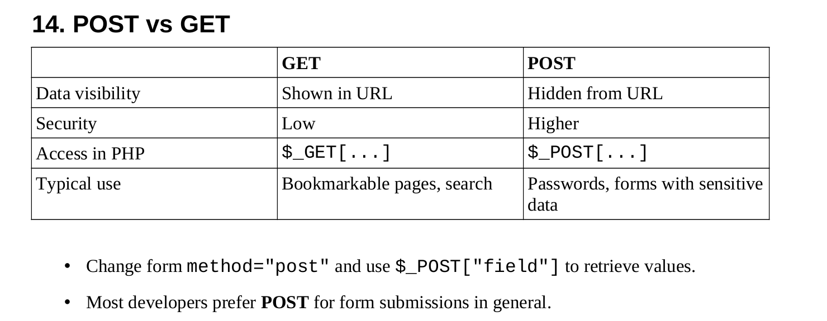

Arrays:
An array is a container that stores multiple values unlike a variable that holds only one value.
We can declare the array like this:
$friend = array(“Ayesha”,”Sara”,”Umaima”)

Access the array elements through indexing $friend[0]
In PHP, an array can store multiple values of the same data type or different data types. Unlike some programming languages (such as Java or C#), PHP arrays are not restricted to a single data type.

count($array) — number of elements.

Using Checkboxes
Checkbox group with matching name="fruits[]" (square brackets) stores checked values as an array.
<input type="checkbox" name="fruits[]" value="Apple"> Apple<br>
<input type="checkbox" name="fruits[]" value="Banana"> Banana<br>

Retrieve in PHP:
$fruits = $_POST["fruits"];
echo $fruits[0];

Associative Arrays:
- Store key → value pairs instead of numeric indexes:
$grades = array("Jim" => "A+", "Pam" => "B-", "Oscar" => "C+");
echo $grades["Jim"]; // A+
- Keys must be unique; values can repeat.
- Modify: $grades["Jim"] = "F";
- count($grades) still works.
- Useful for looking up dynamic data submitted by users, e.g. $grades[$_POST["student"]].

Functions
- Groups reusable code into a named block:

function sayHi($name)
{ echo "Hello $name"; }
sayHi("Mike"); // must "call" the function to run it

- Parameters let you pass data in; a function can take multiple parameters.
- Code inside a function only runs when the function is called.

Return Statements
- return sends a value back to the caller and immediately exits the function (code after return never runs).

function cube($num)
{ return $num * $num * $num; }
$result = cube(4); // 64

- Can return any data type: number, string, array, associative array, or nothing at all.

If Statements
- Basic decision-making structure:
if ($isMale)
{ echo "You are male"; }
else
{ echo "You are not male"; }
- Logical operators:
- && (AND) — both conditions must be true
- || (OR) — at least one must be true
- ! (NOT / negation) — flips true/false
- elseif lets you check additional conditions in sequence before the final else.

If Statements — Comparisons
- Comparison operators: >, <, >=, <=, == (equal), != (not equal)
- Comparisons resolve to a boolean and can be used directly as if conditions:
function getMax($num1, $num2)
{ if ($num1 > $num2)
{ return $num1; }
else { return $num2; }
}
- Works for numbers and strings alike.

Switch Statements
- Cleaner alternative to a long if/elseif chain when comparing one value against many possibilities:
switch ($grade)
{ case "A":
echo "You did amazing";
break;
case "B":
echo "You did pretty good";
break;
default:
echo "Invalid grade";
}
- break exits the switch after a matching case (omitting it causes fall-through into the next case).
- default handles any value not matched by a case.

While Loops
- Repeats code while a condition remains true:
- $index = 1;
while ($index <= 5) {
echo $index; $index++;
}
- Condition is checked before each iteration.
- Infinite loop warning: forgetting to update the loop variable causes the condition to stay true forever — can crash/slow the browser.
- do-while loop: executes the loop body once before checking the condition:
do {
echo $index;
} while ($index <= 5);

For Loops
- Combines initialization, condition, and increment into one line — ideal when tracking an iterating variable:
for ($i = 1; $i <= 5; $i++) {
echo $i;
}
- Very common for looping through arrays:
$luckyNumbers = array(4, 8, 15, 16, 23, 42);
for ($i = 0; $i < count($luckyNumbers); $i++) {
echo $luckyNumbers[$i];
} (Start at 0 since array indexes are zero-based; use < not <= since the last index is count - 1.)

Comments in PHP:
- We have two types of comments that is single line and multi-line comment
- Single line comment is done through “//”
- Multi-line block comment use a starting and ending “/* */”
- Comments are ignored by PHP. It is used for taking notes, documentation or commenting out code temporarily for testing without physically deleting the code.

Including HTML:
- It is used to pull the contents on another file into the current file. It is useful for reusable header/ footer templates such as:

<?php> Include “header.html”
Page content
Include “footer.html” ?>

- Update the header/footer file once, and the changes reflect across every page that includes it. It promotes modular website design.

Including PHP files:
- Include also works with .php files, not just html.
- It enables template with variables: define an empty template file with variables (e.g. $title, $author, $wordCount), then assign values to those variables before the include statement in the file that uses it.
- Can also include files containing reusable functions and variables (e.g. a useful-toolsphp a utility file) to use that functionality anywhere it's included.

Classes and Objects:
- A class is a blueprint/ custom data type while an object is an instance of that class.
class Book{
var $title;
var $author;
var $pages;
}

$book1=new Book();
$book1->title = “Harry Potter”;
$book1->author = “JK Rowling”;
$book1->pages = 400;

- We can access the attributes of the class with “->”.
- Multiple objects of the same class can hold independent data (e.g. $book2 for a different book)

Constructors:
- Special method __construct() runs automatically whenever a new object is created. It is used to set initial attribute values in one step.

class Book{
var $title;
var $author;
var $pages;

Function __construct($aTitle, $aAuthor, $aPages){
$this-> title=$aTitle;
$this->author=$aAuthor;
$this->pages=$aPages;
}
}
$book1=new Book(“Harry Potter”, “JK Rowling”, 400);
- $this refers to the current object being created or used.
- It drastically reduces the code needed to create fully populated objects.

Object Functions (Methods):
- Functions defined inside a class that operate on that object’s own data.

class Student{
var $name;
var $major;
var $gpa;

function __constructor($name, $major, $gpa){
$this->name = $name;
$this->major = $major;
$this->gpa = $gpa;
}

function hasHonors(){
If ($this->gpa >= 3.5){
return “true”;
}else{
return “false”;
}
}
}
$student1->hasHonors(); // uses that specific object's GPA.

- Write once and we can reuse across every object of that class. $this always refers to the calling object’s own data.

Getters & Setters:
- Visibility modifiers control access to attributes:
  - Public: accessible from anywhere.
  - Private: accessible only from inside the class itself.
- Pattern for controlled/validated access

class Movie{
public $title;
private $rating;
function __construct($title, $rating){
$this->title = $title;
$this->setRating($rating);
}

function getRating(){
return $this->rating;
}

function setRating($rating){
if ($rating == “G” || $rating == “PG” || $rating == “PG-13” || $rating == “R” || $rating == “NR” ){
$this->rating = $ rating;
}else {
$this->rating = “NR”;
}
}
}

- Getters/setters let us validate or restrict what values can be assigned (e.g. only allow valid movie ratings), enforcing rules even through the constructor.

Inheritance:
- A class can extend another class to inherit all its attributes/ methods.

class chef{
function makeChicken() {echo “The chef makes chicken”;}
function makeSalad() {echo “The chef makes salad” ;}
function makeSpecialDish(){ echo “The chef makes bbq ribs” ;}
}

class ItalianChef extends Chef{
function makePasta() { echo “The chef makes pasta” ;}

// overriding an inherited method:
function makeSpecialDish() { echo “The chef makes chicken parm” ;}
}

- ItalianChef automatically gets the makeChicken() and makeSalad() from Chef, plus its own function/method makePasta().
- Overriding: redefining a parent method inside the child class replaces that behavior only for the child.
- Use inheritance when one class is a more specialized version of another (“is-a” relationship) to avoid duplicating code.

