PEARLS AQI PREDICTOR
Air Quality Forecasting System for Karachi
Project Report

10 Pearls Shine Internship Program
Prepared By Umaima Abdul Rauf
Email: umaimarauf2005@gmail.com

1. Project Overview
Pearls AQI Predictor is an automated, end-to-end machine learning system that forecasts short-term air quality conditions in Karachi. The system collects live AQI, pollutant, and weather data, engineers predictive features, stores them in the Hopsworks Feature Store, trains an XGBoost forecasting model, and publishes a rolling 3-day AQI forecast through an interactive Streamlit dashboard.
The pipeline is fully serverless and automated: a feature pipeline refreshes data every hour, and a training pipeline retrains and re-registers the model daily, both orchestrated through GitHub Actions.

Objectives
- Collect AQI, pollutant, and weather data automatically from Open-Meteo.
- Build and maintain a historical environmental dataset for Karachi.
- Engineer time-based, lag, rolling, trend, ratio, and interaction features for forecasting.
- Store engineered features centrally in the Hopsworks Feature Store.
- Train, evaluate, and version machine learning models for AQI prediction.
- Forecast AQI for the next 3 days on a rolling basis.
- Automate feature and training pipelines using GitHub Actions.
- Provide an interactive Streamlit dashboard with explainability and alerts.

2. End-to-End Pipeline & Architecture
Data flows from external APIs through feature engineering into the Hopsworks Feature Store, which feeds both model training and prediction. Model training runs daily and registers new model versions; the prediction pipeline retrieves the latest feature row and the registered model to generate a 3-day forecast, which is served on the Streamlit dashboard.
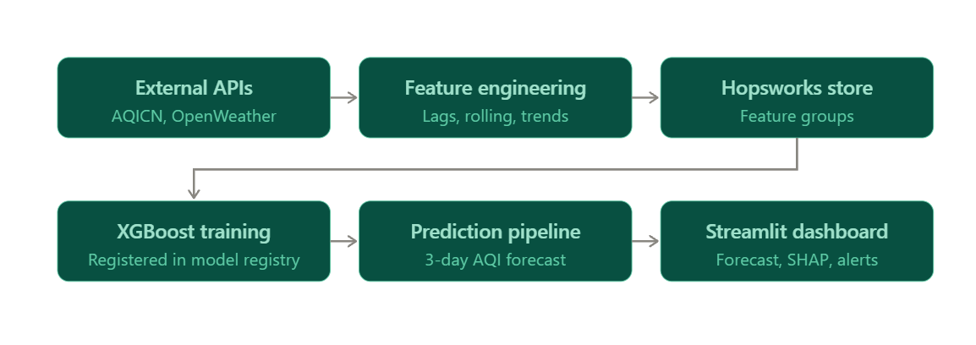

Pipeline Automation (GitHub Actions)
Feature Pipeline runs every hour:
1. Fetch latest AQI and weather data
2. Update the raw dataset
3. Perform feature engineering
4. Connect to Hopsworks
5. Insert features into the Feature Group

Training Pipeline runs daily:
1. Fetch latest data and engineer features
2. Update Hopsworks with new features
3. Retrieve historical features for training
4. Train the XGBoost model
5. Evaluate the model (MAE, RMSE, R²)
6. Register the model in the Model Registry
7. Generate and save the 3-day forecast

3. Data Collection & Feature Engineering
Environmental data is collected from Open-Meteo, covering AQI, PM2.5, PM10, NO₂, SO₂, CO, O₃, temperature, humidity, and precipitation. This raw data is transformed into a rich feature set for forecasting:
- Time features — day, month, day of week, day of year, weekend indicator, and cyclical encodings.
- Lag features — 1, 2, 3, 7, 14, 21, and 30-day historical lags.
- Rolling features — mean, standard deviation, min, and max over 3, 7, 14, and 30-day windows.
- Trend features — AQI/pollutant change, percentage change, and AQI momentum.
- Ratio features — e.g. PM2.5/PM10, NO₂/O₃, CO/NO₂.
- Weather interaction features — e.g. temperature × humidity, PM2.5 × humidity.

Hopsworks Feature Store
The Hopsworks Feature Store centralizes historical AQI, pollutant, weather, lag, and rolling-statistic features in a single feature group (aqi_features), replacing local CSV files as the source of truth for both training and inference.
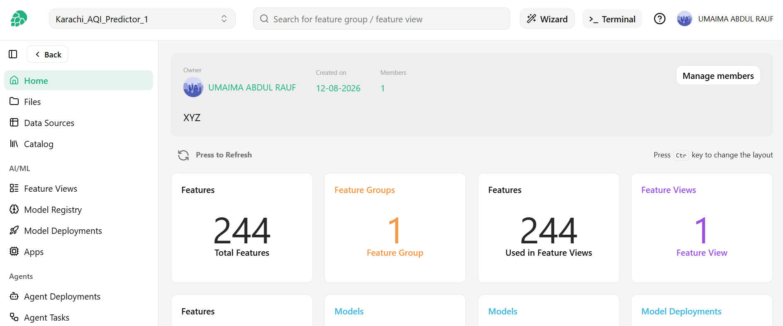

4. Machine Learning & Model Registry
The primary forecasting model is XGBoost, performing multi-output prediction for AQI at t+1, t+2, and t+3 days ahead. Models are evaluated using MAE, RMSE, and R², with Random Forest, Ridge Regression, and TensorFlow/PyTorch models available for experimentation.
Trained models are versioned in the Hopsworks Model Registry, enabling comparison, reproducibility, and controlled deployment of the best-performing version.
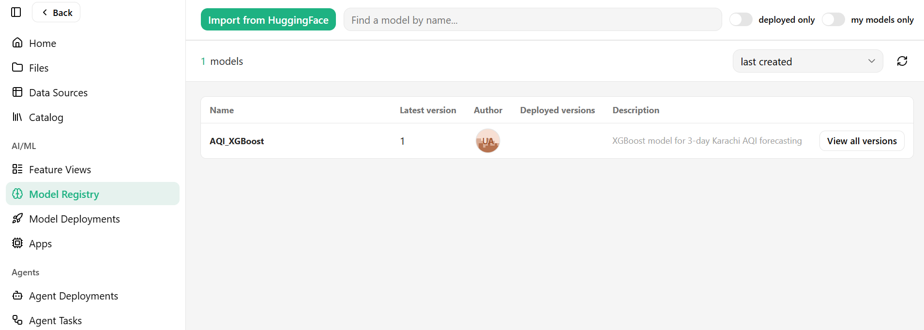

Forecast | RandomForest_MAE | RandomForest_RMSE | XGBoost_ME | XGBoost_RMSE
AQI_day_1 | 10.566999 | 14.558915 | 10.167212 | 13.944478
AQI_day_2 | 15.328934 | 19.901658 | 16.154434 | 20.779384
AQI_day_3 | 16.630505 | 20.780179 | 16.762005 | 21.389086

Forecast | XGBoost_MAE | XGBoost_RMSE | XGBoost_R2
AQI_day_1 | 10.167 | 13.944 | 0.708
AQI_day_2 | 16.154 | 20.779 | 0.353
AQI_day_3 | 16.762 | 21.389 | 0.312

5. Streamlit Dashboard
The dashboard is a presentation layer only it does not retrain the model. It reads the latest features and prediction results and renders current conditions, the 3-day forecast, historical trends, SHAP explanations, and hazard alerts.
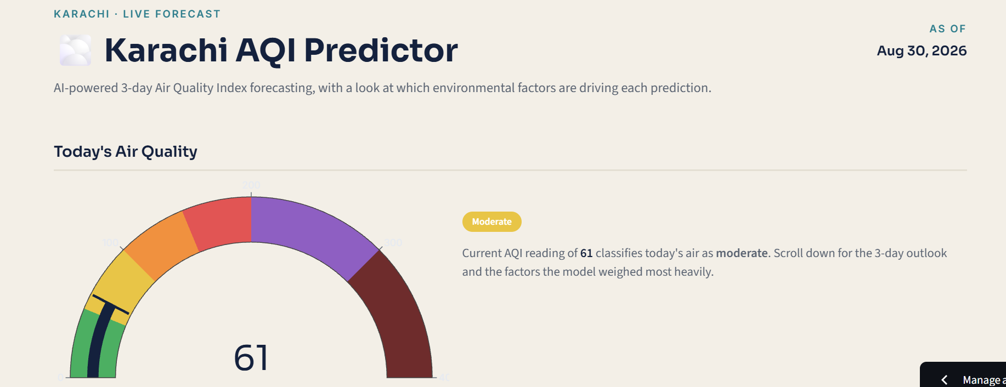
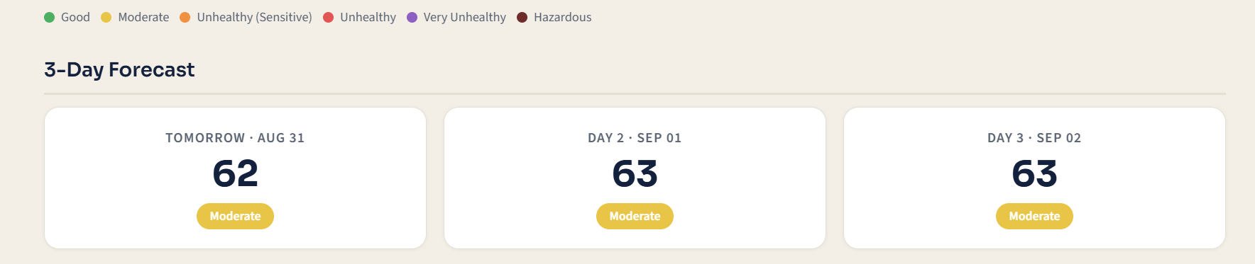
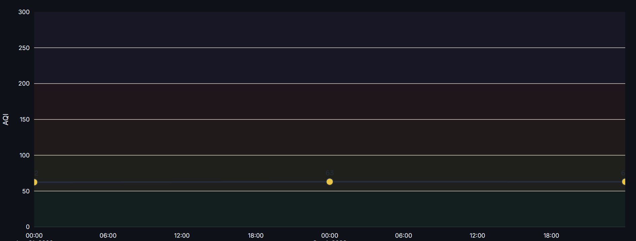

AQI Categories
AQI Range | Category
0–50 | Good
51–100 | Moderate
101–150 | Unhealthy for Sensitive Groups
151–200 | Unhealthy
201–300 | Very Unhealthy
301+ | Hazardous

Explainable AI (SHAP)
SHAP is used to explain which features contribute most to each prediction typically PM2.5, PM10, AQI lag values, NO₂, humidity, temperature, and rolling AQI statistics making the forecasting system more interpretable to end users.
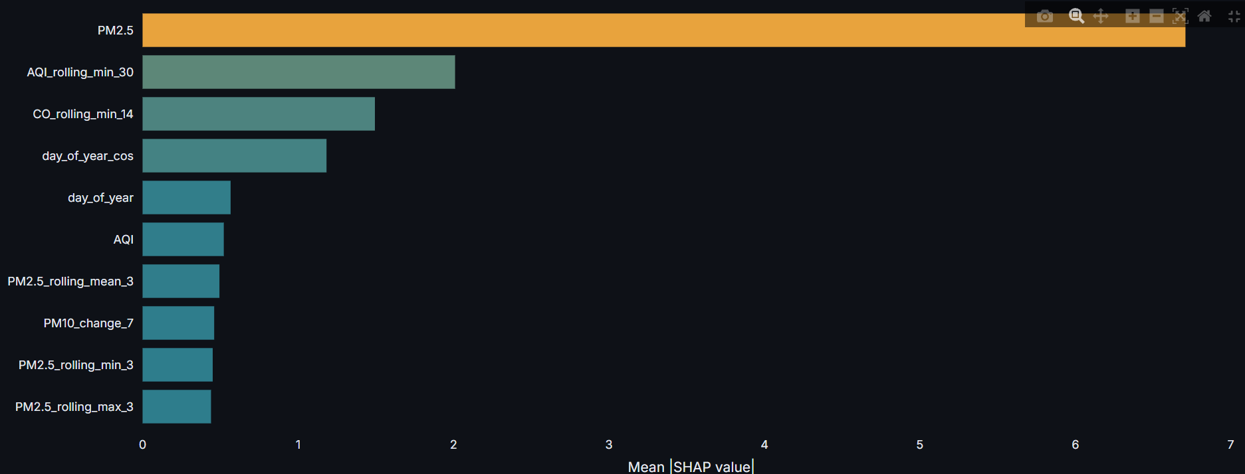
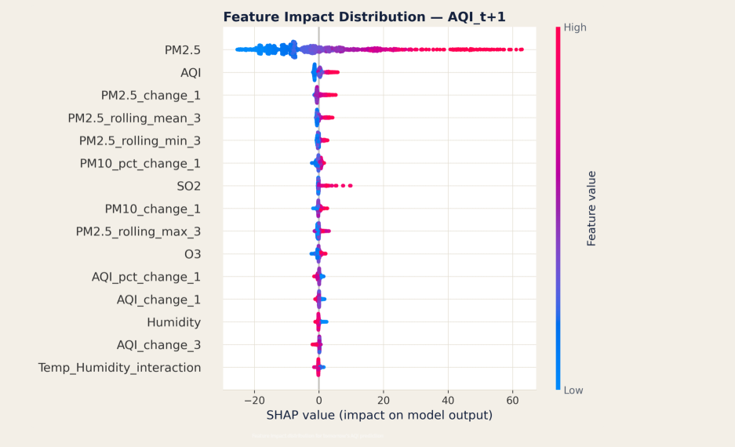

6. Technology Stack
Technology | Purpose
Python | Core development
Pandas / NumPy | Data processing and numerical computation
Scikit-learn | ML utilities and evaluation
XGBoost | AQI forecasting
TensorFlow | Deep learning experimentation
SHAP | Model explainability
Hopsworks | Feature Store and Model Registry
GitHub Actions | CI/CD automation
Streamlit | Web dashboard
Flask | API layer
Open-Meteo | External data sources

7. Conclusion
Pearls AQI Predictor demonstrates a complete, production-style MLOps workflow for environmental forecasting combining automated data collection, a centralized feature store, versioned model training, explainable predictions, and an accessible dashboard, all orchestrated through continuous integration. The architecture separates concerns cleanly between data engineering, modeling, and presentation, making it straightforward to extend to new cities, models, or alerting channels.

