**Answers**

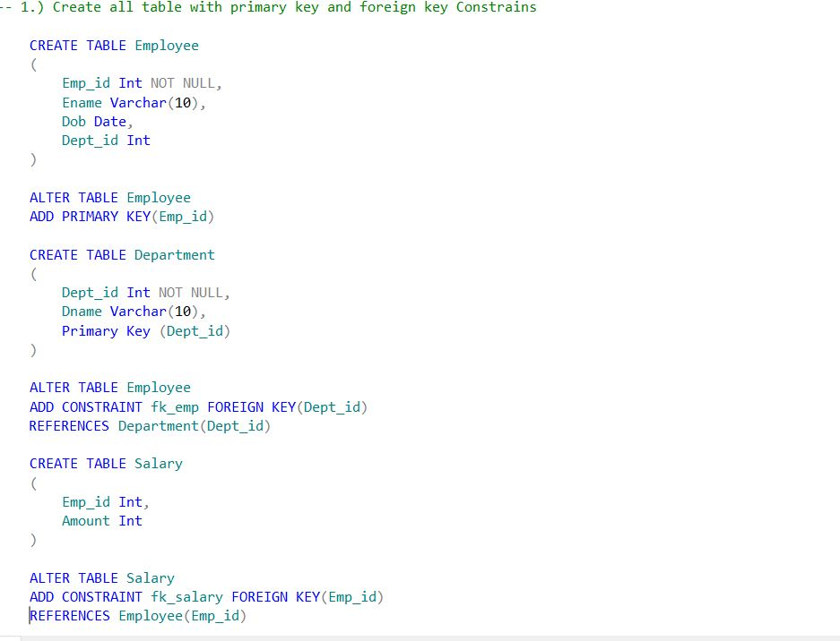

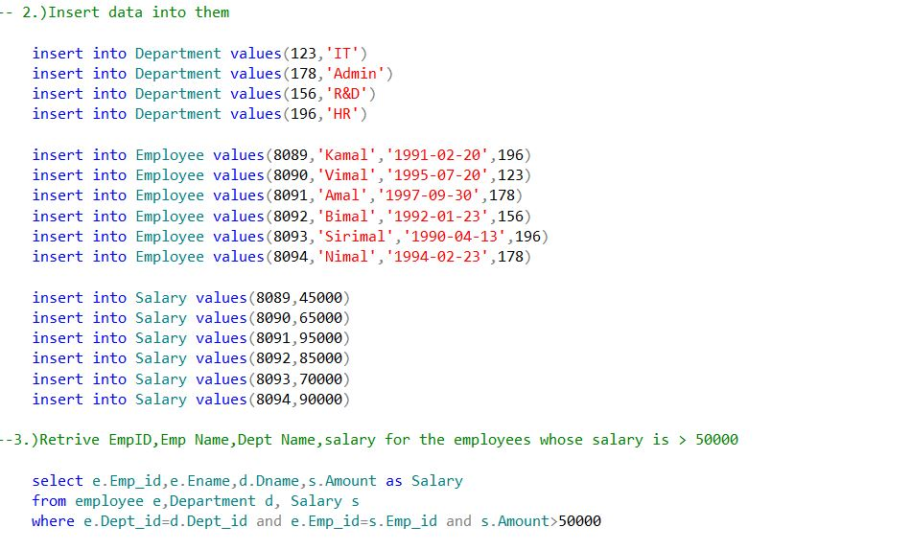

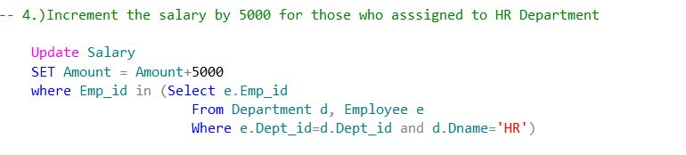

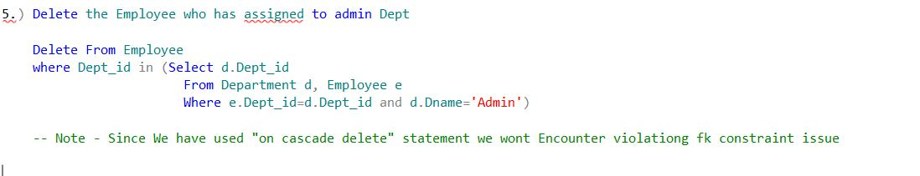

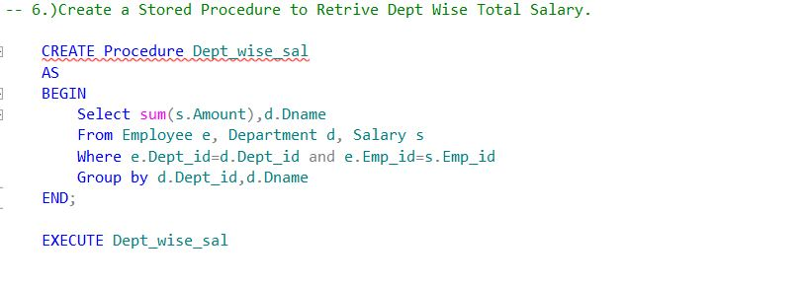

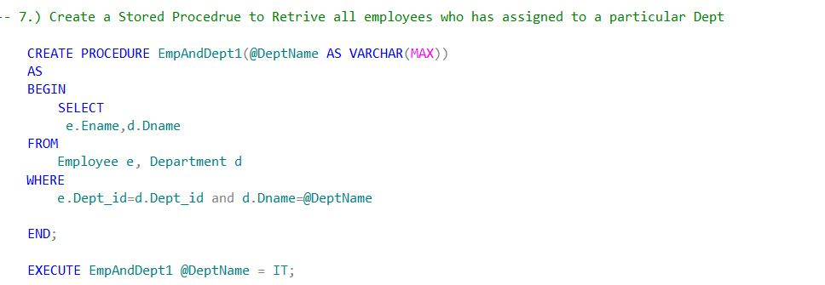

Queries:

-- 1.) Create all table with primary key and foreign key Constrains

CREATE TABLE Employee

(

Emp_id Int NOT NULL,

Ename Varchar(10),

Dob Date,

Dept_id Int

)

ALTER TABLE Employee

ADD PRIMARY KEY(Emp_id)

CREATE TABLE Department

(

Dept_id Int NOT NULL,

Dname Varchar(10),

Primary Key (Dept_id)

)

ALTER TABLE Employee

ADD CONSTRAINT fk_emp FOREIGN KEY(Dept_id)

REFERENCES Department(Dept_id)

CREATE TABLE Salary

(

Emp_id Int,

Amount Int

)

ALTER TABLE Salary

ADD CONSTRAINT fk_salary FOREIGN KEY(Emp_id)

REFERENCES Employee(Emp_id) ON CASCADE DELETE

-- 2.)Insert data into them

insert into Department values(123,'IT')

insert into Department values(178,'Admin')

insert into Department values(156,'R&D')

insert into Department values(196,'HR')

insert into Employee values(8089,'Kamal','1991-02-20',196)

insert into Employee values(8090,'Vimal','1995-07-20',123)

insert into Employee values(8091,'Amal','1997-09-30',178)

insert into Employee values(8092,'Bimal','1992-01-23',156)

insert into Employee values(8093,'Sirimal','1990-04-13',196)

insert into Employee values(8094,'Nimal','1994-02-23',178)

insert into Salary values(8089,45000)

insert into Salary values(8090,65000)

insert into Salary values(8091,95000)

insert into Salary values(8092,85000)

insert into Salary values(8093,70000)

insert into Salary values(8094,90000)

--3.)Retrive EmpID,Emp Name,Dept Name,salary for the employees whose salary is > 50000

select e.Emp_id,e.Ename,d.Dname,s.Amount as Salary

from employee e,Department d, Salary s

where e.Dept_id=d.Dept_id and e.Emp_id=s.Emp_id and s.Amount>50000

-- 4.)Increment the salary by 5000 for those who asssigned to HR Department

Update Salary

SET Amount = Amount+5000

where Emp_id in (Select e.Emp_id

From Department d, Employee e

Where e.Dept_id=d.Dept_id and d.Dname='HR')

5.) Delete the Employee who has assigned to admin Dept

Delete From Employee

where Emp_id in (Select e.Emp_id

From Department d, Employee e

Where e.Dept_id=d.Dept_id and d.Dname='Admin')

-- 6.)Create a Stored Procedure to Retrive Dept Wise Total Salary.

CREATE Procedure Dept_wise_sal

AS

BEGIN

Select sum(s.Amount),d.Dname

From Employee e, Department d, Salary s

Where e.Dept_id=d.Dept_id and e.Emp_id=s.Emp_id

Group by d.Dept_id,d.Dname

END;

EXECUTE Dept_wise_sal

-- 7.) Create a Stored Procedrue to Retrive all employees who has assigned to a particular Dept

CREATE PROCEDURE EmpAndDept1(@DeptName AS VARCHAR(MAX))

AS

BEGIN

SELECT

e.Ename,d.Dname

FROM

Employee e, Department d

WHERE

e.Dept_id=d.Dept_id and d.Dname=@DeptName

END;

EXECUTE EmpAndDept1 @DeptName = IT;