Centre for Technology Alternatives for Rural Areas

2019
Fresher’s Hand Book
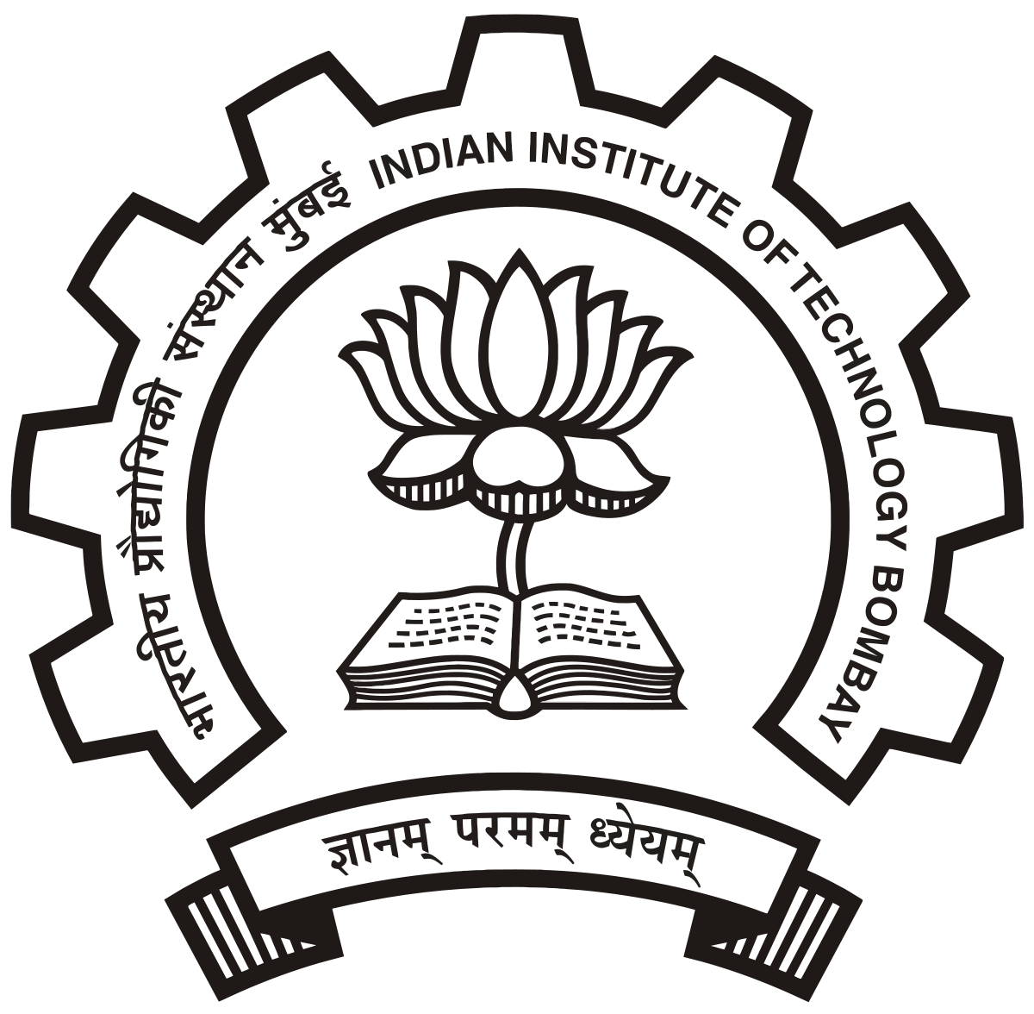
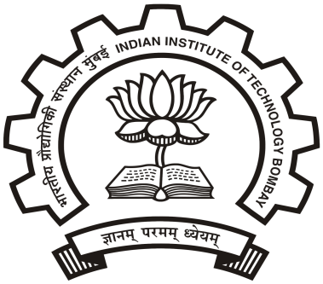

Introduction

In the last two decades, our country has witnessed significant and rapid changes in several spheres and at an increasingly rapid speed. The economic reforms and the policies of liberalization, globalization, and privatization have resulted in momentous changes in perspectives, policies, and practices pertaining to technology, development, and the interrelationship between the two. CTARA (The Centre for Technology Alternatives for Rural Areas) is also gearing itself to face the challenges posed by these changes through research projects as well as new academic and training programs. CTARA now has an M. Tech. Program in Technology and Development (started in July 2007) and a PhD Program. Apart from these programs, CTARA also offers Technology and Development Supervised Learning (TDSL) courses to the B.Tech students across the Institute. CTARA has over the years developed relations with various governmental departments at the centre and in different states; industrial houses, and non-governmental/ community-based organizations.

Our Vision:
To use our knowledge, expertise and skills for the benefit of the marginalized and disadvantaged sections of society and the neglected regions of the country.

Our Mission:
Our long-term mission is to make a contribution at the perspective, policy and practice levels to all dimensions of the interrelationship between the technology and development, including the techno economic, financial, socio-cultural, legal, governance and institutional dimensions. Our medium-term mission is to establish CTARA as a leading academic and research center.
CTARA believes in carrying out multi-disciplinary, multi-dimensional and grounded policy studies and research on key technology and development related sectors and issues. Further, CTARA carries out development and dissemination of technologies relevant for the felt needs of rural society, especially of neglected sections and regions.

Message from Head of the Department

CTARA started in 1985 with the express purpose of attending to and learning from the problems of rural India. It started first as a research center and as a platform for faculty and students to come together, discuss and work on such problems. The paradigm that evolved and guided us in that period was of appropriate technology, which included within it, the notion of region-specific solutions, field work and interfacing with the informal sectors.
In subsequent years, CTARA did many projects of increasing significance; among these was our interaction with the Khadi and Village Industries Commission (KVIC), various engineering devices and tools, and the Gudwanwadi drinking water initiative. Based on this experience, in 2007, we started the M. Tech program in Technology and Development. This is an inter-disciplinary program which focuses on the training of the Development Professional, a position in increasing demand. The development agenda is now the key to the progress of India and its people. This agenda needs informed policy and implementation, design and analysis of key programs, interfacing with NGO's and civil society, tracking performance and an interdisciplinary study of a wider set of problems so as to reduce them to a set of disciplinary research. Our program is structured precisely around these ideas. The program itself has been widely appreciated and is attracting a broad spectrum of top students. CTARA now has a variety of interactions with the wider society. We engage with numerous NGOs, delivering solutions and studies. We engage with government agencies and a variety of ministries. We also work with many educational institutions in India and abroad.
Besides core faculty, CTARA boasts of a wide variety of associated and adjunct faculty. They bring experience and rigor from a wide variety of fields such as governance, policy, grass-root work, and consultancy and so on.
For prospective students, CTARA holds an attractive proposition, not only because of the future prospects for the development professional, but also for the spirit of creativity and innovation that we train into our students. I must stress that the M. Tech program is demanding in terms of rigor, honesty and hard work, but then so is the development agenda. Our students are our assets and our ambassadors wherever they work.
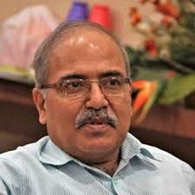
Prof. Satish Balram Agnihotri
Office Phone: (022) 2576 7870
Email: sbagnihotri@iitb.ac.in
sbagnihotri@gmail.com

Message from Faculty Adviser

Congratulations to the incoming 2019-21 M. Tech batch for successfully getting admitted into the CTARA program at the prestigious IITB. Over the past decades, CTARA has achieved international recognition as a center that focuses on critical issues that impact rural communities. As much as you look forward to starting your journey in IITB and CTARA, I am looking forward to working with you all. Your batch will be the first batch for me as faculty advisor and therefore, I am personally eager to meet you all.
For many students, this will be the first time staying away from family, friends and well-wishers…, however, as mentioned in the Head’s statement, CTARA is a unique program that works for the marginalized communities, and also instills in each student qualities and traits that may not be found in traditional educational streams. On that note, even though missing family is hard, everyone should be proud to enter IITB under renowned CTARA program. The CTARA family has experienced members who can help you easily get accustomed to the new place, and as your FacAd, I will be happy to help, advice and guide you as and when needed.
Rural issues and problems are complex and interdisciplinary in nature. Therefore, CTARA is an interdisciplinary department that houses students from various disciplines. This might be new to many students who have been associated with only one discipline or taking classes on one discipline. E.g. mechanical engineers attending lectures on water, soil and malnutrition, and computer engineers doing projects on climate change. As a result, there will be differences among students with learning paces, adapting to new research methodologies and transforming as an interdisciplinary student. So, please don’t compare with others, but work hard and keep focused on the work. This focus, along with guidance from CTARA faculty will aid in this transformation, which will eventually help you overcome these issues. It will also develop skills necessary for working in rural areas.
As you progress as a CTARA student, I hope you build on the CTARA strengths and excel in thematic research areas focusing on rural areas. There are plenty of themes, that can suit different interests and personalities, ranging from physical sciences, social sciences, food and agricultural sciences and computer simulations. Each theme plays vital role in establishing connections between Technology and Development, which is core to CTARA.
As your FacAd, I once again welcome you all to the CTARA family.
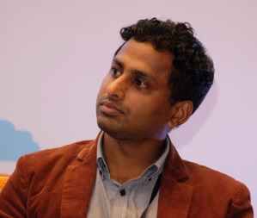
Prof. Pennan Chinnasamy
Office Phone: (022) 2576 7297
Email: p.chinnasamy@iitb.ac.in

Message from the ISCP Team
Dear New Entrants,
We take this opportunity to welcome you to one of the most prestigious institutes of the country. We congratulate you on having achieved this feat. With our personal experiences we can vouch that your stay here at the campus would be exciting. From potential leopard sightings to potential bumping into movie stars - a lot of excitement awaits you. Wonderful, all-night banters, amazing wing cultures and mad birthday celebrations are a few things that you will carry from here when you leave, obviously along with the degree. You will also become a part of a culture where people want to perfect their craft and thus work day in and day out at it. Hence there will be great opportunities to learn both inside as well as outside the classrooms. Thus, it is a whole new cosmos to enter and along with the excitement, there might be a few challenges too. We at ISCP (Institute Student Companion Programme) work towards providing you with the tools to take care of these challenges and have a happy stay with the IIT Bombay family.
The primary objective of the Companion Programme under which the ISCP team works is to build a relationship of trust and comfort between the final year students and the incoming students of the PG Programmes. Once this is established life at campus becomes so much easier than what it would have been without it. The knowledge and the experience that the senior batch has gained with their stay at the campus helps smoothen in the process of settling in. From the lingo on campus to the Terminology in the classroom, from the grading to the syllabus, from the profile to placements, from Tagda Franky to bhindi rice all becomes ingrained so much as if it were you always.
On campus you might always be short on time as there is so much to do and when there is so much to do time flies at sonic speeds. Managing the academics along with extra-curricular activities and your social life may seem a daunting task at times. The ISCP programme thus provides you a Student Companion with whom you can share your academic and non- academic problems. These are self-motivated volunteers who want to genuinely help you in a tough situation as a giving back act of what they received from the programme.
You can look up to the team for any initial information in things that you are venturing out at be it academics or extra-curriculars, any academic or non- academic issues that you are facing, any sort of support, any requirement that you want to raise up as a part of the student community and last but certainly not the least just for normal interaction because that is all the programme holds at its core.
Come be a part of this immense pool of wisdom and make it more happening and diverse.
Tumul Rai  tumulrai91@gmail.com  7275362979 | Uroosa Warsi  uroosawarsi134@gmail.com  7835877634 | Avinash Singh  avinashindolia007@gmail.com  9058076777
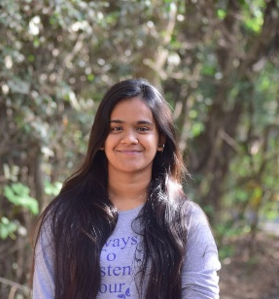
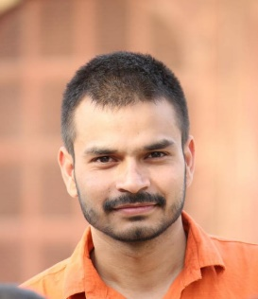
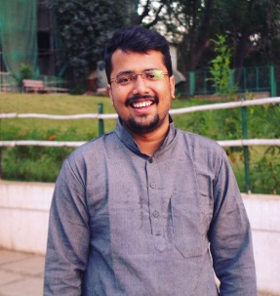

Message from Postgraduate Academic Council (PGAC)

Hello Friends,
Congratulations on being selected to be a part of IIT Bombay and a cordial welcome to this new world.
You must have realized by now that you are undergoing a phase of substantive transformation, and this might be daunting for some of you. The academic curriculum of this institution might seem different and perhaps new in comparison to what you were exposed to during your undergraduate education. To appease all the apprehensions that you have, the Post Graduate Academic Council (PGAC) along with the team of ISCP will try to address all the queries that you will be having during your entire Master’s Programme.
IIT Bombay is known to offer the students a very dynamic environment and a reasonable amount of freedom so that the individual can pursue their heart’s desire. Be it academics, sports, cultural, or any other activity, you will be finding myriad opportunities to build up your personality and add value to your life. I am hoping that you will be able to explore the unending map of possibilities, push your boundaries, break all the walls and bring out the best version of yourself by the time you finish your Degree Programme.
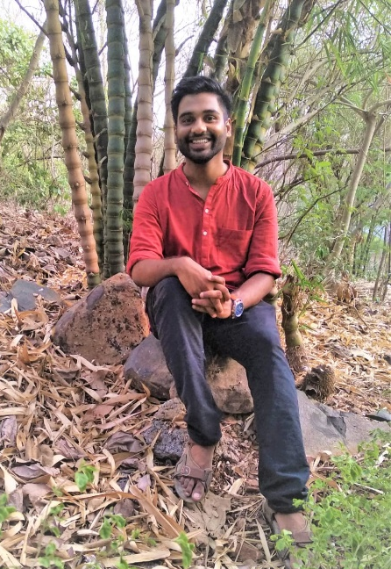
I wish you good luck and hope to see you around. We are looking forward to interacting with you
Himanshu Bishwash
imr@iitb.ac.in
8698965842/ 9867110738
Welcome Message from General Secretary (Students’ Council, CTARA)
It is an honour and privilege for me to welcome you, on behalf of the all Master's and PhD students of the Centre for Technology Alternatives for Rural Areas (CTARA), IIT Bombay. Heartiest congratulations for making it into one of the premier institutes in the country.
You are now a part of the CTARA family where you will get ample opportunities to explore multiple disciplines mainly focused on rural development. You are about to begin one of the most exciting times in your life.
As the General Secretary of CTARA's Student Council, our team and I, we will work hard to address all your concerns and help you to the best of our abilities. Our main priority is to support you in your academic endeavours and we will try our best to make your CTARA experience fruitful.
Best wishes to all of you in your new endeavour.
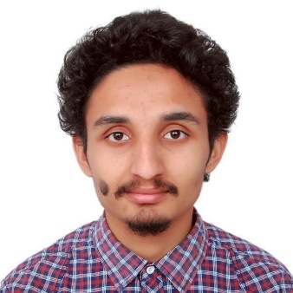
Gagan Gautam
183352001@iitb.ac.in
9758822284

Our Department ISCP Team

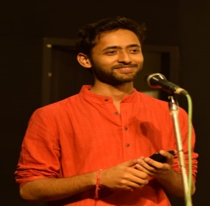 | Rohit Kumar Prince | rohitkumarprince12@gmail.com | 7278233058
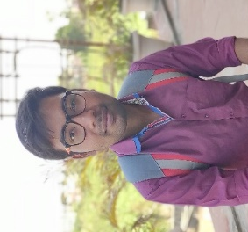 | Shailesh Holkar | ssholkar100@gmail.com | 7219745991
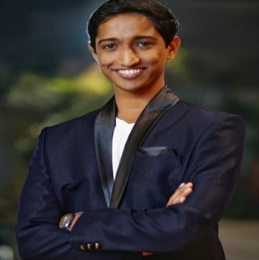 | Prathamesh Antarkar | prathameshantarkar@gmail.com | 99750 95723
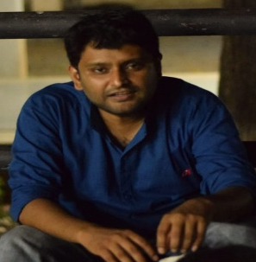 | Gaurav Kishore Dubey | gaurav.kishore.311@gmail.com | 79050 23780
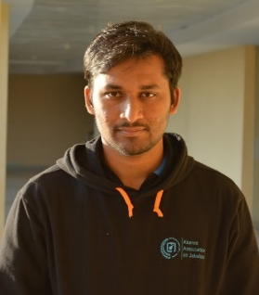 | Vennam Thirumal Reddy | vtr3999@gmail.com | 95503 55571
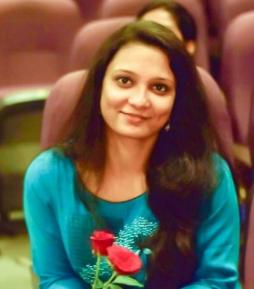 | Divya Singh | divyasingh1111@gmail.com | 91318 80442

Our Department Students Council
Name | Email | Contact | Designation
Gagan Gautam | gagangautam1234@gmail.com | 9758822284 | General Secretary
Jayesh Dayma | daymajayesh@gmail.com | 9998530484 | Cultural Secretary
Satish Dulla | satishdulla@gmail.com | 9567034719 | Sports Secretary
Nilesh Vadgave | vadgave.nilesh56@gmail.com | 9146400664 | Secretary Publishing and Design
Swapnil Labade | swapnilclabde93@gmail.com | 9004524549 | Secretary External Affairs
Sameer Kulkarni | kulkarnisr1495@gmail.com | 8087516268 | Department Placement Coordinator

FACULTY MEMBERS AND THEIR RESEARCH INTERESTS

Prof. A. W. Date  (Emeritus Professor) | awdate@me.iitb.ac.in | Heat Transfer, Thermodynamics and Energy Conversion, Energy Systems, Appropriate Technology
Prof. Amit Arora | aarora@iitb.ac.in | Bioenergy, Bioprocessing, Downstream Processing, Food Processing, Membrane separations, Process Design and Development, Microwave Technology, Paper and Pulp Engineering
Prof. Anand B. Rao | a.b.rao@iitb.ac.in | Energy and Environment, Climate Change, Carbon Capture and Sequestration, Renewable and Energy Efficiency, Sanitation and Waste Management, Rural electrification, Energy Policy and Planning, Technology Assessment
Prof. Bakul Rao | bakulrao@iitb.ac.in | Environmental impact framework for rural areas, State of environment studies, Field assessments & remediation, Matrix characterization, Climate change
Prof. Milind A. Sohoni | sohoni@iitb.ac.in | Combinatorial Optimization, Mathematical Programming, Algorithms, Drinking Water for Rural Areas
Prof. N. C. Narayanan | ncn@iitb.ac.in | Water Policy and Governance,Development Theory,Transdisciplinary Research,Scaling up decentralised PV Solutions,Environment and development (political ecology)
Prof. N. G. Shah | nshah@iitb.ac.in | Post Harvest Process Engineering, Small Scale Renewable Energy Applications and Agro-based Industrial Development
Prof. Pennan Chinnasamy | p.chinnasamy@iitb.ac.in | Surface water and groundwater management, water accounting and budgeting, remote sensing, Large Data Analysis, GIS and climate change impact on water resources.
Prof. Priya Jadhav | jadhav_priya@iitb.ac.in | Rural Electrification, Energy efficiency, Energy usage in irrigation: Technology and Farmer behavior, Solar Photovoltaics, Organizational models in electricity distribution
Prof. Satish B. Agnihotri | sbagnihotri@iitb.ac.in, sbagnihotri@gmail.com | Child malnutrition, Renewable Energy and Energy Policy, Gender, Rural development and technology scale up, Use of Mapping Techniques in social Sector planning, Public Policy
Prof. Subodh Wagle | subodh.wagle@iitb.ac.in | Analysis of On-Ground Performance of Public Policies, Policy and Institutional Dimensions of Solar Technology Dissemination, Analysis of Regulatory Governance in India, Urban Water Issues
Prof. Vishal R. Sardeshpande | vishal.sir@iitb.ac.in, vishalsir@gmail.com | Thermal engineering and heat transfer, Product development, Energy efficiency and benchmarking, Solar energy, Social enterprise, Technology for rural MSME (Micro small medium enterprises), Biogas / biomass systems
Prof. Pankaj Sekhsaria | pankaj.sekhsaria@iitb.ac.in | Science and Technology Studies, S&T visioning and policy making, Technology, Society and Development, Citizen Science, Wildlife Conservation, Island Studies, Andaman and Nicobar Islands, Media Studies
Prof. Rupal Dalal | dalal_rupal@yahoo.com | Pediatric Care and Medicine, 1st 1000 days health and nutrition of child, Lactation Education, Community involvement in Pediatric nutrition and urgent care issues.

RuTAG
Rural Technology Action Group or RuTAG is a brain child of the Principal Scientific advisor (PSA) to the Government of India. RuTAG was devised to be a mechanism to achieve rural advancement through S&T interventions. The interventions are essentially demand driven and have focus on problems associated with marginal communities in rural areas.
Project | Principal Investigator | Associated NGO
Modifying Design of De-husking Machine for minor Millets in Maharashtra | Prof. Anand B. Rao, Centre for Technology Alternatives for Rural Areas | Shashwat, Pune, Maharashtra
Work process and product optimisation, Value creation and Livelihood augmentation for Sankheda craft-based furniture making community | Prof. R. Sandesh, Industrial Design Centre | GRISERVE-BAIF Vadodara
Design of protective dress to be worn while harvesting honey from Beehive in wilder | Prof. R. Sandesh, Industrial Design Centre | Centre for Bee Development (CBD), Wardha, Maharashtra
Livelihood augmentation using Coconut Shell with Design and Technology intervention, optimised production and contemporary design development | Prof. R. Sandesh, Industrial Design Centre | Lupin Foundations, Kudal, Maharashtra
Designing a Tool for Removal of Calyces from Ambadi Fruit | Prof. R. Sandesh, Industrial Design Centre | Centre of Science for Villages (CSV), Wardha, Maharashtra
Onboard Fish Hold Cooling and Potable Water Generation using Trawler Engine Exhaust Heat | Prof. Upendra Bhandarkar & Prof. Milind Rane, Department of Mechanical Engineering, Prof. Shireesh Kedare, Department of Energy Science & Engineering | Center for Social Action (CSA), Mumbai
Design Improvement of Chironji Decortication Machine | Prof. Amit Arora, Centre for Technology Alternatives for Rural Areas, Prof. Upendra Bhandarkar, Department of Mechanical Engineering | Madhya Pradesh Vigyan Sabha (MPVS), Madhya Pradesh
Improving efficiency of aerators in aquaculture | Prof. Milind Rane, Department of Mechanical Engineering | Center for Social Action (CSA), Mumbai
Design improvisation of Hirda decortication machine | Prof. Anirban Guha, Department of Mechanical Engineering, Prof. Narendra Shah, Centre for Technology Alternatives for Rural Areas | Shashwat, Manchar, Maharashtra
Designing small scale equipment to extract Kokumoi | Prof. Amit Arora, Centre for Technology Alternatives for Rural Areas | Lupin Foundation, Sindhudurg, Maharashtra
Designing a Portable System to Lift a Downer Cow | Prof. Tanmay Bhandakkar, Department of Mechanical Engineering | Amboulim Nagrik Samiti, Goa
Hybrid Solar Food Dryer to Dry Agriculture Produce | Prof. Shireesh Kedare, Department of Energy Science & Engineering, Prof. Manaswita Bose, Department of Energy Science & Engineering | BAIF Development Research Foundation, Maharashtra
Evaluation of locally available fibres for water storage tank construction in rural villages for watershed management | Prof. T. I. Eldho, Department of Civil Engineering | Jalvardhini Pratishthan, Maharashtra
Hand operated machine for making dhoop sticks from cow dung | Prof. Ganesh Ramakrishnan, Department of Computer science engineering | Venumadhuri, Kolhapur, Maharashtra
Process and product improvements in Kolhapur type Jaggery making unit: possibilities of value addition through’ liquid jaggery’ (kakvi) making | Prof. Narendra Shah, Centre for Technology Alternatives for Rural Areas | Shree Laxmi Rural Technologies Alternatives Charitable Society
Design of the floating structure for fishing nets for cage fishing | Prof. Siddhartha Ghosh, Department of Civil engineering | Shashwat, Pune, Maharashtra
Old saree cutting machine for handlooms operated by visually challenged individuals | Prof. Suhas Joshi, Department of Mechanical Engineering  Prof. Bakul Rao, Centre for Technology Alternatives for Rural Areas | Grameen Shramik Pratishthan, Latur, Maharashtra

Unnat Maharashtra Abhiyan (UMA)

Unnat Maharashtra Abhiyan (UMA) is a project of the Ministry of Higher and Technical Education, Government of Maharashtra. Its mandate is to build an independent and public knowledge infrastructure for the state of Maharashtra which will bring socio-economic and cultural development for its people, especially those in the bottom 80% of the socio-economic strata.
- Sugve Water Scheme: Multi-village drinking water scheme analysis (September, 2011)
- Drinking water solutions for Varcha Tembha -- Analysis and Design report (March, 2015)
- Improving Drinking Water Provisioning in Parbhani City -- Phase I report (May, 2015)
- Watershed interventions for habitations in Kurlod and Botoshi - Phase II report (July, 2015)
- Vajreshwari-Ganeshpuri Rural Regional Scheme -- Feasibility Report on Options for Scheme Improvement and Augmentation (March, 2016)

Technology and Development Solutions Cell (TDSC)

Technology and Development Solutions Cell is a resource centre for providing technology-based solutions for development sector. Projects undertaken include
- Support for the assessment of Jalyukta Shivar Abhiyan works in Amravati district
- Water-resources based livelihood planning for Mokhada taluka
- Taluka level Jalyukta Shivar Abhiyan training for Palghar District
- Evaluation of Thakkar Bappa Yojana in Palghar district
- Rural Drinking water in Thane district
- Rural Drinking water in Palghar district

Fellowships

There are several fellowships available for CTARA students. At present there is one TATA fellow and 5 (Hindustan Aeronautics Limited) HAL fellowships. The Ministry of Rural Development (MoRD) and UNICEF fellowships are awarded after graduation based on the Masters Project (MTPs) done for dissertation. The list of fellows is provided below.
TATA fellowship is awarded every year to those who aim to develop solutions for the challenges faced by resource-constrained communities within India and across the world using an end-to-end innovation approach. Tata Centre for Technology and Design at IIT Bombay was established in 2014 with support from the Tata Trusts, to help and guide such students.MoRD fellowship aims to incentivize research which is applicable in the development sector and aims to enhance the outcomes of flagship programs of MoRD. These programs include (i) the Mahatma Gandhi National Rural Employment Guarantee Scheme (MG-NREGS), (ii) the Inregrated Watershed Development Program (IWMP), and (iii) the Pradhan Mantri Gram Sadak Yojana (PMGSY). The fellowship will require the student to pursue research in the award area through his/her M.Tech project. The guide will ensure that the outcome of the research aims to benefit the conduct of the MoRD program and enhances its outcomes. The fellowship will provide suitable finances, data and access to enable this research. These topics keep changing according to the projects of MoRD
UNICEF Students in CTARA are already working on issues related to nutrition in specific areas, as well as for context specific planning at the District Level, both as part of their curricular activity and through UNICEF-CTARA Fellowships. These Fellowships are given to students from CTARA, Humanities and Social Sciences (H&SS) and Biological Sciences and Bio Engineering (BSBE). Till now, 14 Masters students have received this fellowship and have been involved in various projects covering different aspects of child malnutrition: nutrient-rich product development, maternal health, nutrition education and awareness, data collection, analysis and interpretation etc.

Details of fellowship for 2017-2019
Name | Fellowship
Anwesha Lahiri | UNICEF
Puja Roy | UNICEF
Nilanjana Lahiri | UNICEF
Pratyush Mohanta | UNICEF
Suveena D. | UNICEF
Vivek Shinde | MoRD
Himanshu Dubey | MoRD
Ayush Kumar | MoRD
Sameer Kulkarni | TATA
Mukul Yambal | HAL
Thirumal Reddy | HAL
Satish Dulla | HAL
Swagatika Priyambada | HAL
Aman Srivastava | HAL
.

Events
- "Five Day CEP-GIAN Course on Microwave Heating and Processing of Foods" at IIT-Bombay during 13 -17 May 2019.
Processed foods are increasingly being accepted in the Indian society and an increasing number of ready-to-eat (RTE) food products are being introduced into the Indian market. Simultaneously, the sales of microwave ovens are also increasing. For successful development of food products for microwave oven, one needs to understand the interaction between microwaves, food materials packaging used and the related heat and mass transfer. Microwave heating also has several unique applications within food manufacturing. The course aims to give relevant exposure in both theoretical and practical aspects of Microwave Heating and Processing of Foods to multiple stakeholders such as students, food scientists/engineers, food technologists, and those working within the food industry.
- A 3-Day Dialogue Workshop for Farmers of Sheti Seva Group was organized by CTARA, IIT Bombay in association with Agricultural Technology Management Agency (ATMA) from 19th to 21st February, 2019. 34 farmers from Parbhani participated in this workshop.
- As part of its Diamond Jubilee Celebrations, CTARA organized a District Development Dialogue on 8th February on ‘Scalable Best Practices – Learnings from the field’ through its CSR Study Unit supported by the Department of Public Enterprises (DPE).
The workshop had participation from PSEs, district administrations, few award-winning start-ups and CSR implementing agencies and showcased their work as well as work going on at the institute. The purpose was to enable the stakeholders to learn from one another for scaling up these practices in the field further.
It had presentations from various participants and a poster presentation of about 50 cases. Additional Secretary DPE Shri Madhukar Gupta presided over the inaugural session.

- CTARA) is spearheading a two-day workshop on "Agriculture and the Imperatives of Food and Nutrition Security" in association with Asia-Pacific Association of Agricultural Research Institutions (APAARI) and National Bank for Agriculture and Rural Development (NABARD).
Following are the Proposed Focus areas for this workshop:
•Availability, accessibility, utilization and stability of food
•Integration of food-processing and logistics in controlling food-prices
•District (local government) level decentralized planning for nutrition security
•Regional and local food and nutrition security
•Linkages between agriculture, income, livelihoods, and malnutrition.

CTARA's achievements in various events for the year 2018-19

- M. Tech student Aman Srivastava presented two abstracts at International Conference on "Climate Change Impact, Vulnerability and Assessment: Emphasis on India and Neighborhood" (CCIVA-2019) organized by department of CORAL, IIT Kharagpur between Feb 26 to Mar 2.
- MTech students, Jeffrey Immanuel and Anshul Singh published a discussion paper titled "Coastal Regulation Zone, 2018" in Economic and Political Weekly (EPW) under the guidance of Prof. N.C. Narayanan.
- Rajat Singhal, M. Tech student (Batch: 2017-2019) has won best poster presentation at International Symposium on Edible Alliums: Challenges and Opportunities (Feb 2019), Pune.
- ‘Vernacular Science: The Science of Delivery’ by Prof. Milind Sohani at TEDx IIT Bombay on January 19th 2019
- PhD student Priyabrata Pradhan's paper on 'Production and Utilization of Fuel Pellets from Biomass: Pilot Scale to Field Review' with impact factor 3.96, has been accepted for publication in 'Fuel processing technology'.
- IITB-APAARI-NABARD workshop (6th-7th Dec. 2018) on agriculture and imperatives food and nutrition security
- CTARA PhD student, Siva Muthuprakash K.M, has been awarded Lok Sabha research fellowship for the year 2018-19 for writing a book in English/ Hindi on the theme “Impact Assessment of Agricultural Policies by Lok Sabha for the prospects of farmers’ income and farm productivity” by the fellowship committee of Lok Sabha.
- Pooja Prasad, PhD student was given the Barry Richmond Scholarship Award by the System Dynamics Society, at the conference held in Iceland. She received this award for her work relating to irrigation and farmers' livelihoods.

Achievements in IIT Inter-Department Sports
Girls
Sport | Name | Medal
Long Jump | Divya Singh | Gold
100 m | Divya Singh | Bronze
Badminton | Nisha B Sathish | Silver
Badminton | Namita Sawant | Silver
Badminton | Athira Madhusudan Panicker | Silver
Badminton | Reshma Sahoo | Silver
Squash | Nisha B Sathish | Silver
Squash | Namita Sawant | Silver
Squash | Sakshi Pandey | Silver
Lawn Tennis | Nisha B Sathish | Bronze
Lawn Tennis | Divya Singh | Bronze
Lawn Tennis | Shweta Vinayak Naik | Bronze
Lawn Tennis | R. Divya Venkata Gowari | Bronze
Vollyball | Akanksha N Chavan | Bronze
Vollyball | Nisha B Sathish | Bronze
Vollyball | Namita Sawant | Bronze
Vollyball | Manasi Bhopale | Bronze
Vollyball | Suveena D | Bronze
Vollyball | Athira Madhusudan Panicker | Bronze
Vollyball | Anamika M.P. | Bronze
Vollyball | Shweta Vinayak Naik | Bronze
Vollyball | Divya Singh | Bronze

Boys
Sport | Name | Medals
100 m | B Vamsee Krishna | Silver
200 m | B Vamsee Krishna | Bronze
1500 m | B Vamsee Krishna | Bronze
Disc throw | Satish Dulla | Bronze
Shotput | Satish Dulla | Bronze
Volleyball | Satish Dulla | Gold
Volleyball | Vennam Thirumal Reddy | Gold
Volleyball | Gagan Gautam | Gold
Volleyball | Ganesh Hegade | Gold
Volleyball | B Vamsee Krishna | Gold
Volleyball | Yatin Diwakar | Gold
Volleyball | Shinde Vivek Rajendra | Gold
Volleyball | Gopal G. Chavan | Gold
Volleyball | Abhishek Khaire | Gold

Placements
Coming to the placement details, for the batch 2017-19, students performed extremely well and to get placements in well acknowledged companies in respective domains. Apart from that few students also opted to work with the organizations like UNICEF and MoRD.
Details of students placed 2017-19
Name | Company
Mridul Garg | HSBC Global Service Centre
Shahnawaz | Micron Semiconductor Asia Pte Ltd
Pawan Kamble | Zinnov Management Consulting Pvt Ltd
Hitesh Mahawar | Kotak Mahindra Bank
Rajat Singhal | Delhivery
Sudhanshu Kulkarni | Boeing India
Divya Gowri | Micron Semiconductor Asia Pte Ltd
Girish Chandankar | HCL Technologies Ltd
Siddhant Rai | Reflexis Inc.
Shwetabh Singh | HSBC Global Service Centre

For queries and further information visit our website www.ctara.iitb.ac.in

