Name:- Chotaliya Hiten Mikeshbhai

Roll no:-09

Question1:Develop a user registration form and store its data in any database using Express.  Form should also contain file upload (single, multiple) with validations.

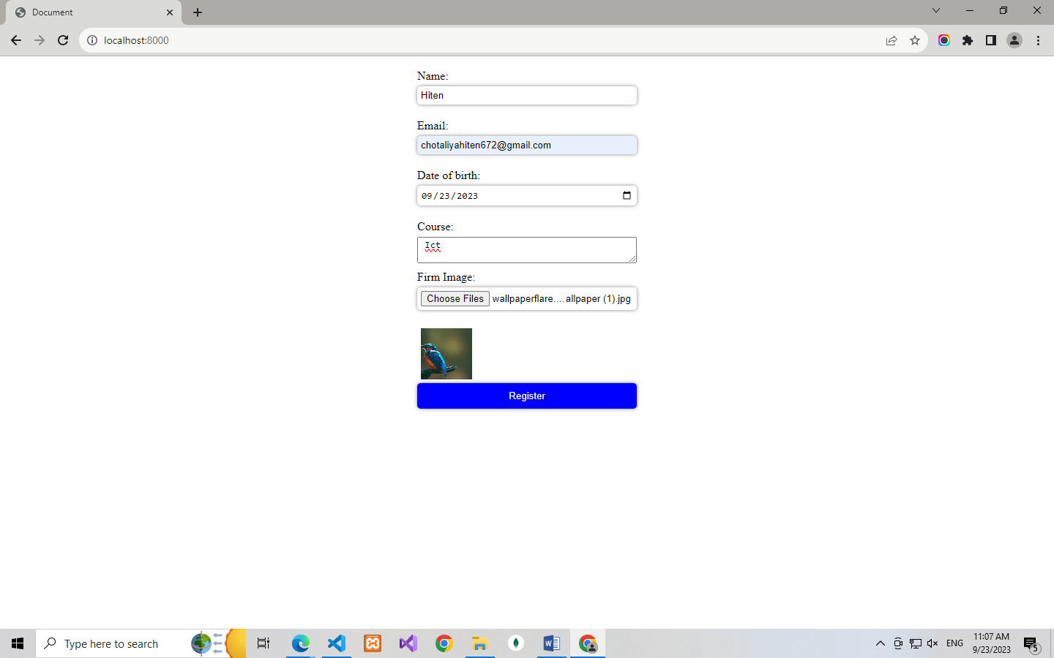

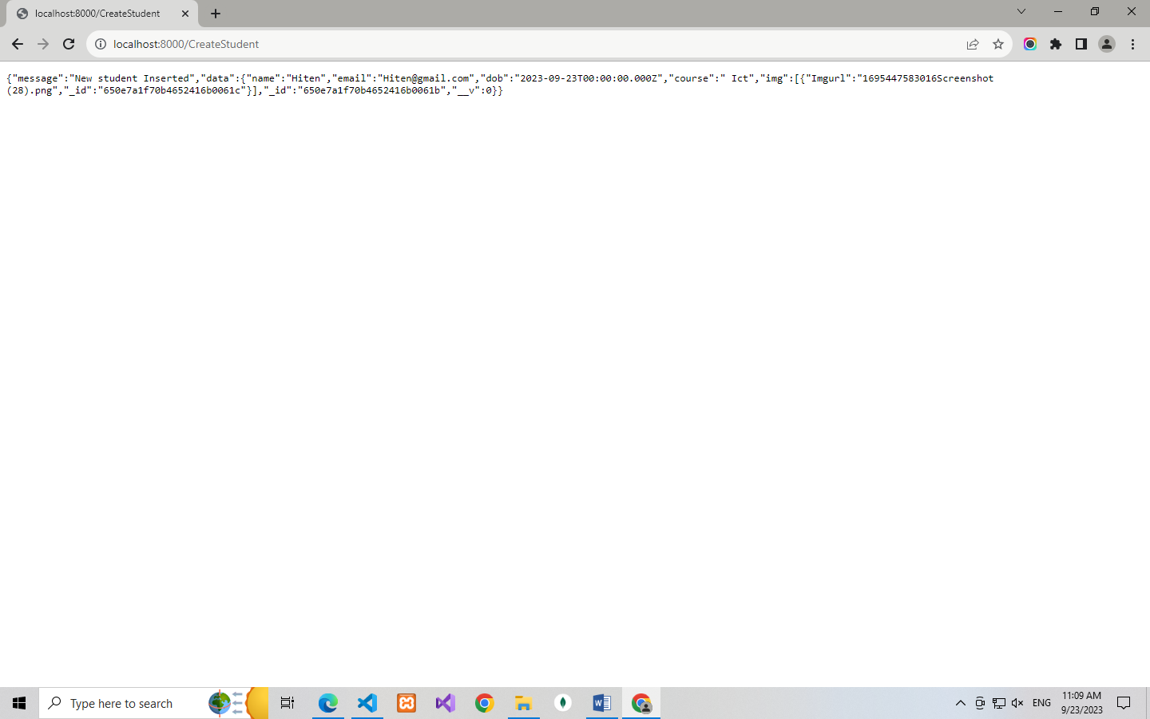

2) Express Login application with file session store.

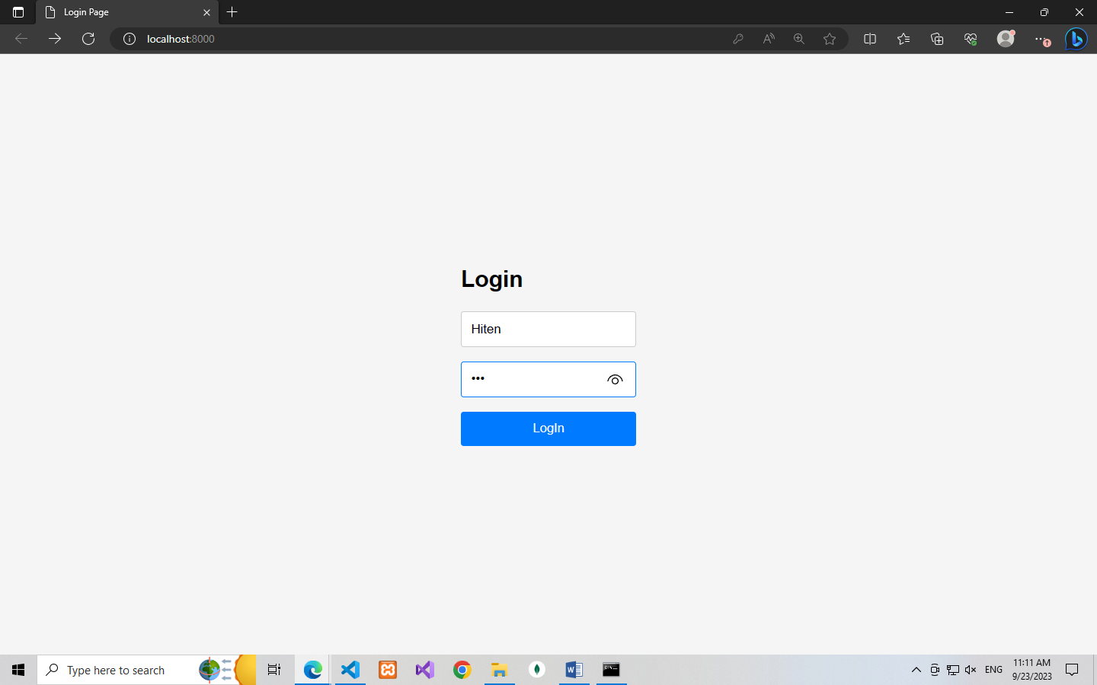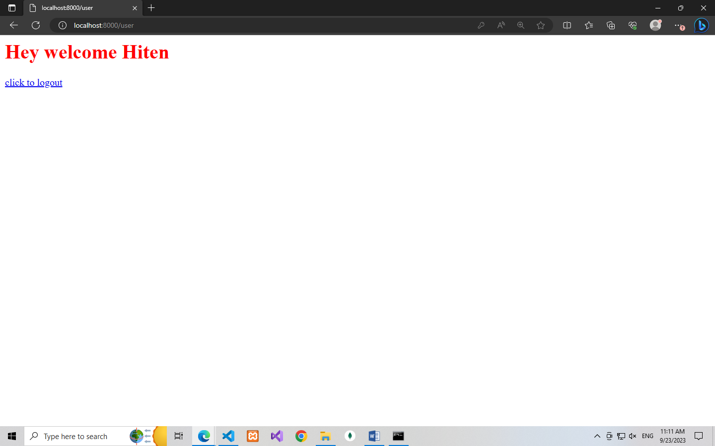

3) Express Login application with redis session store.

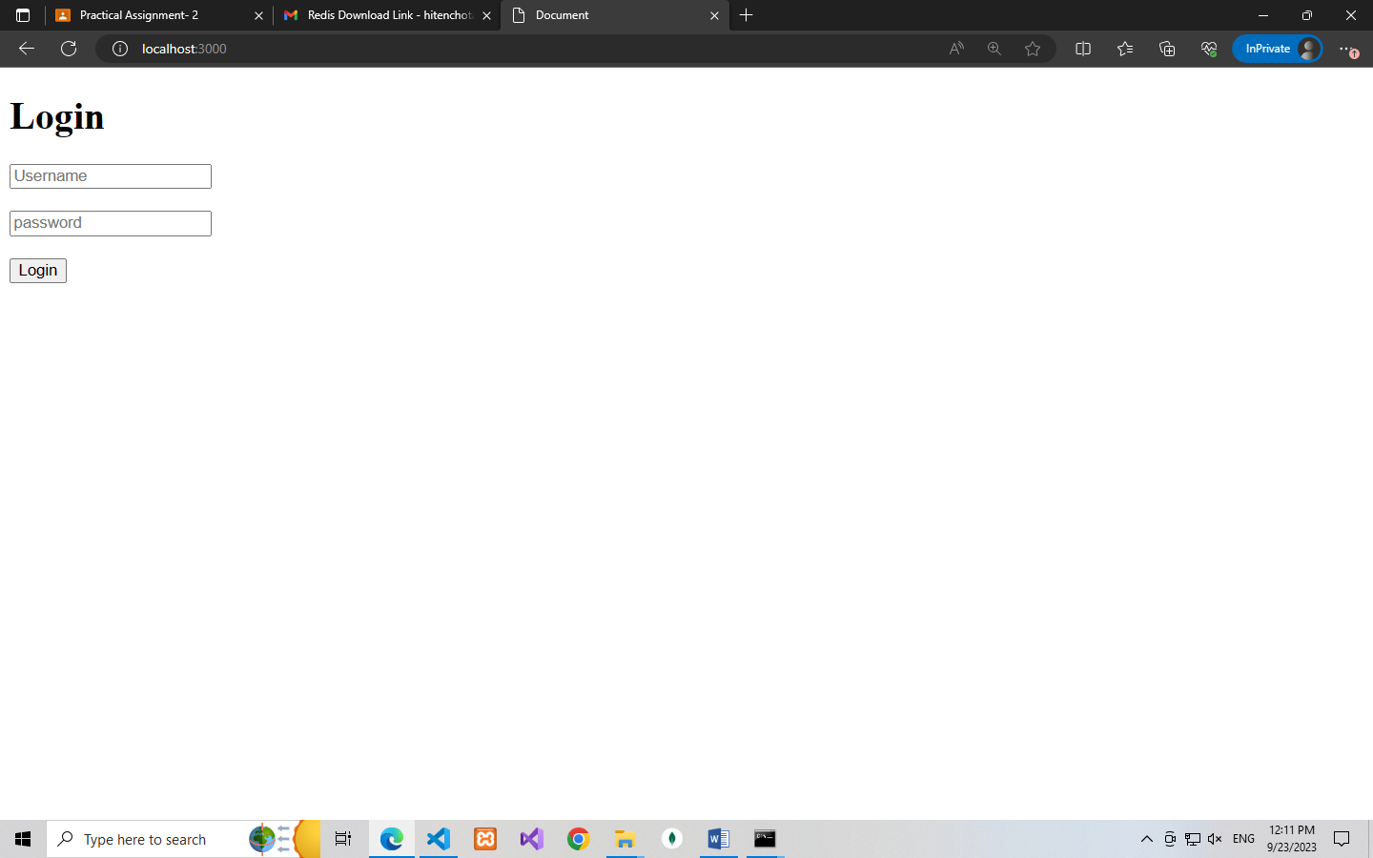

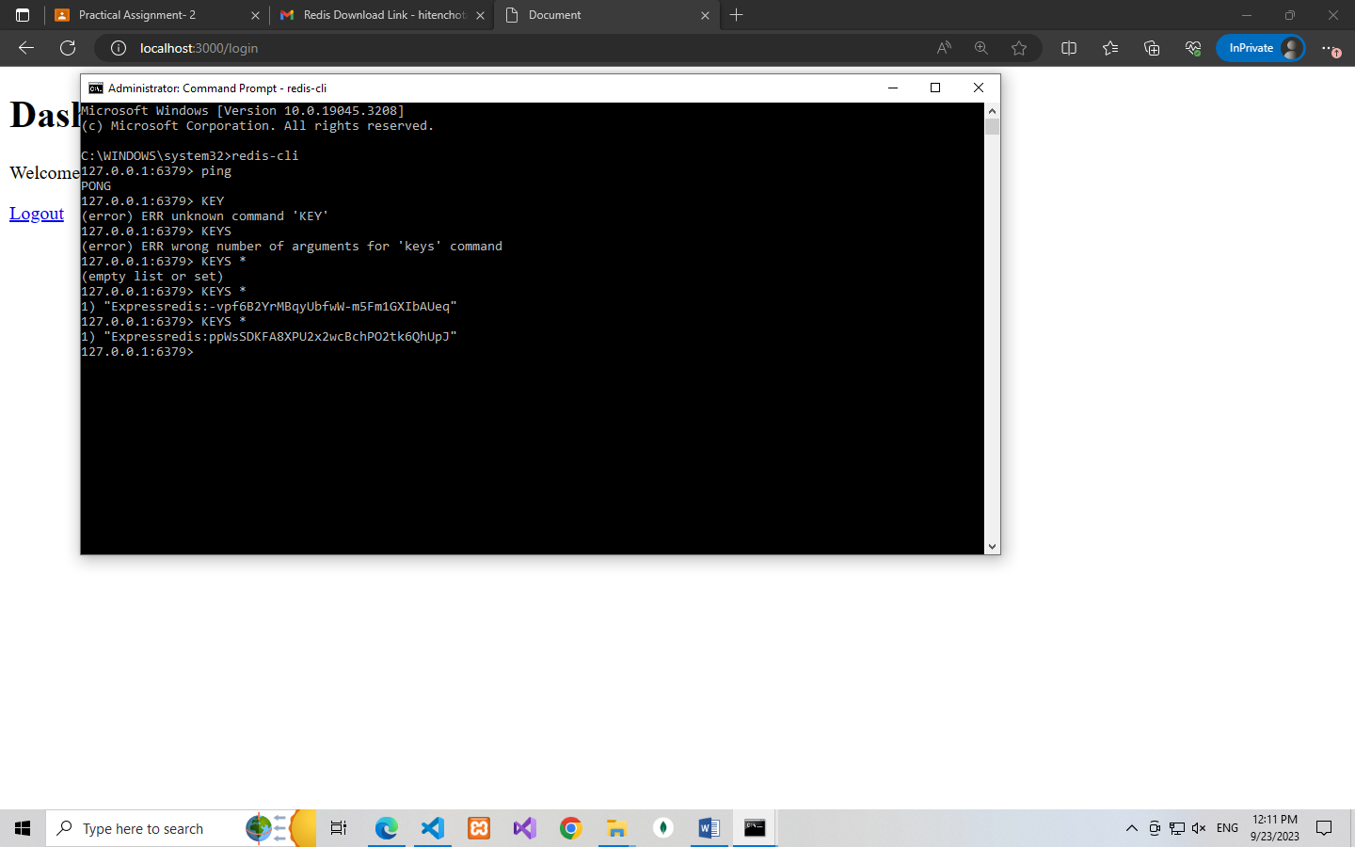

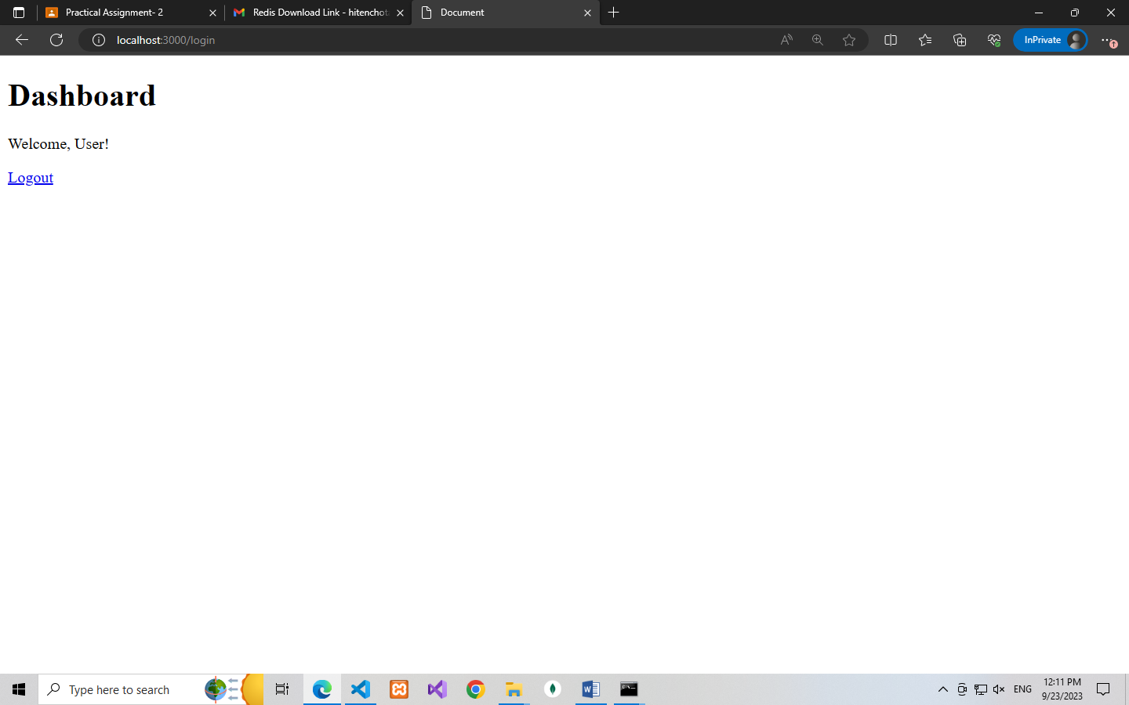

4) Login with JWT, CRUD operations for students table with mongoose, express and any one  
template engine, Logout.

Register

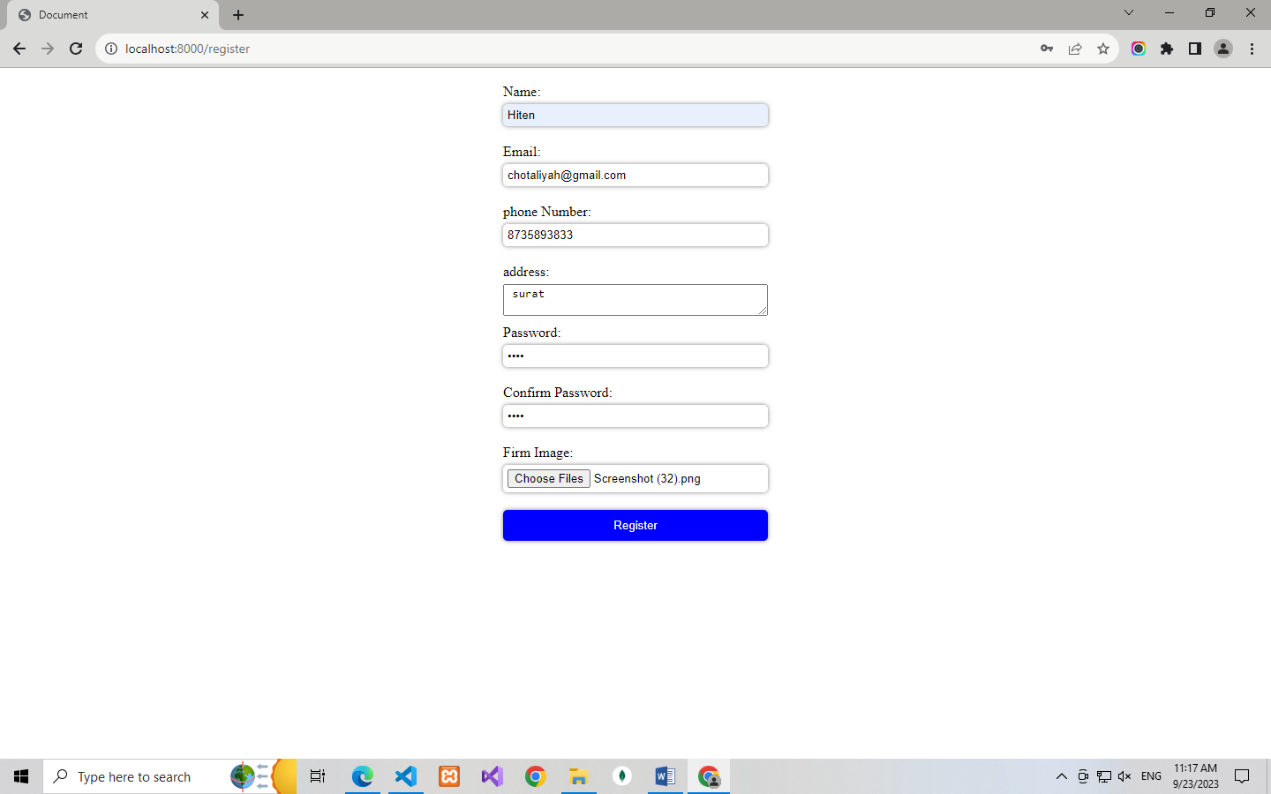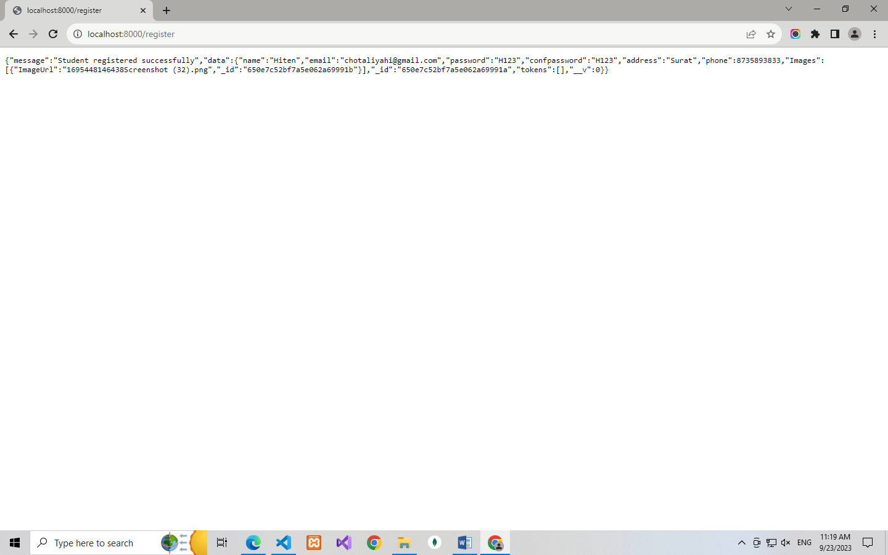

Login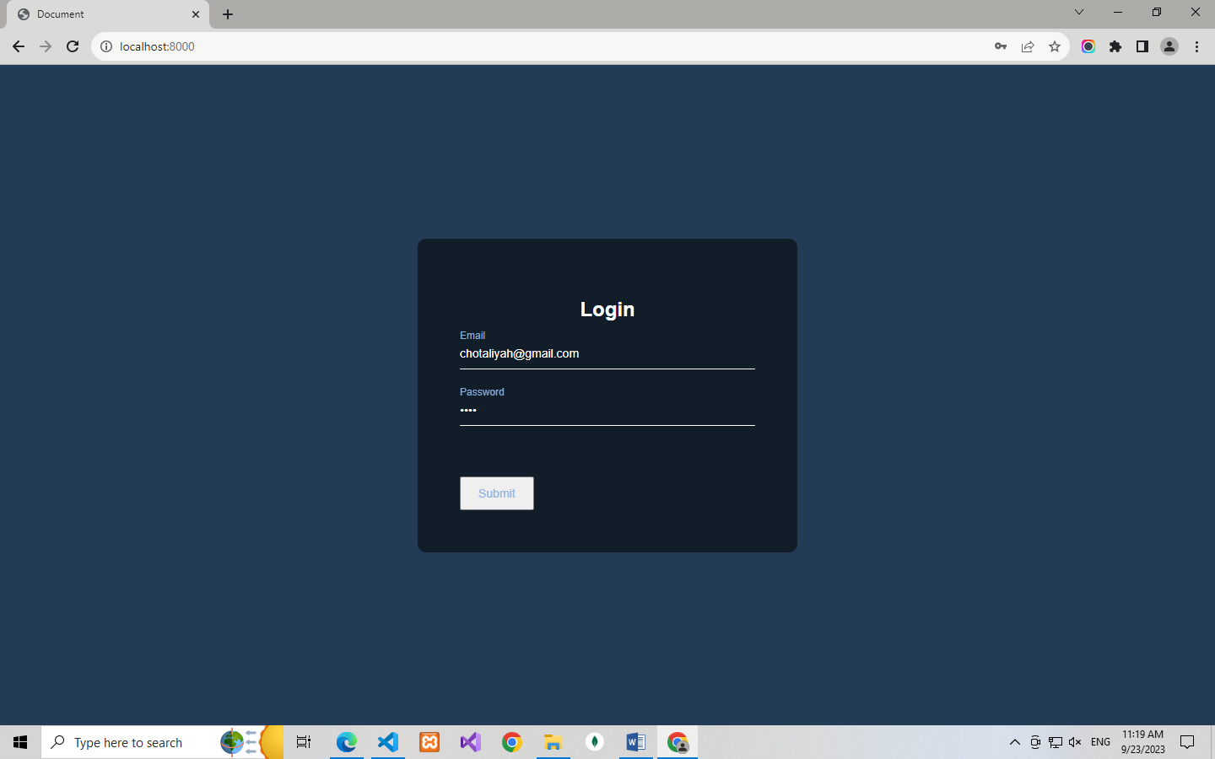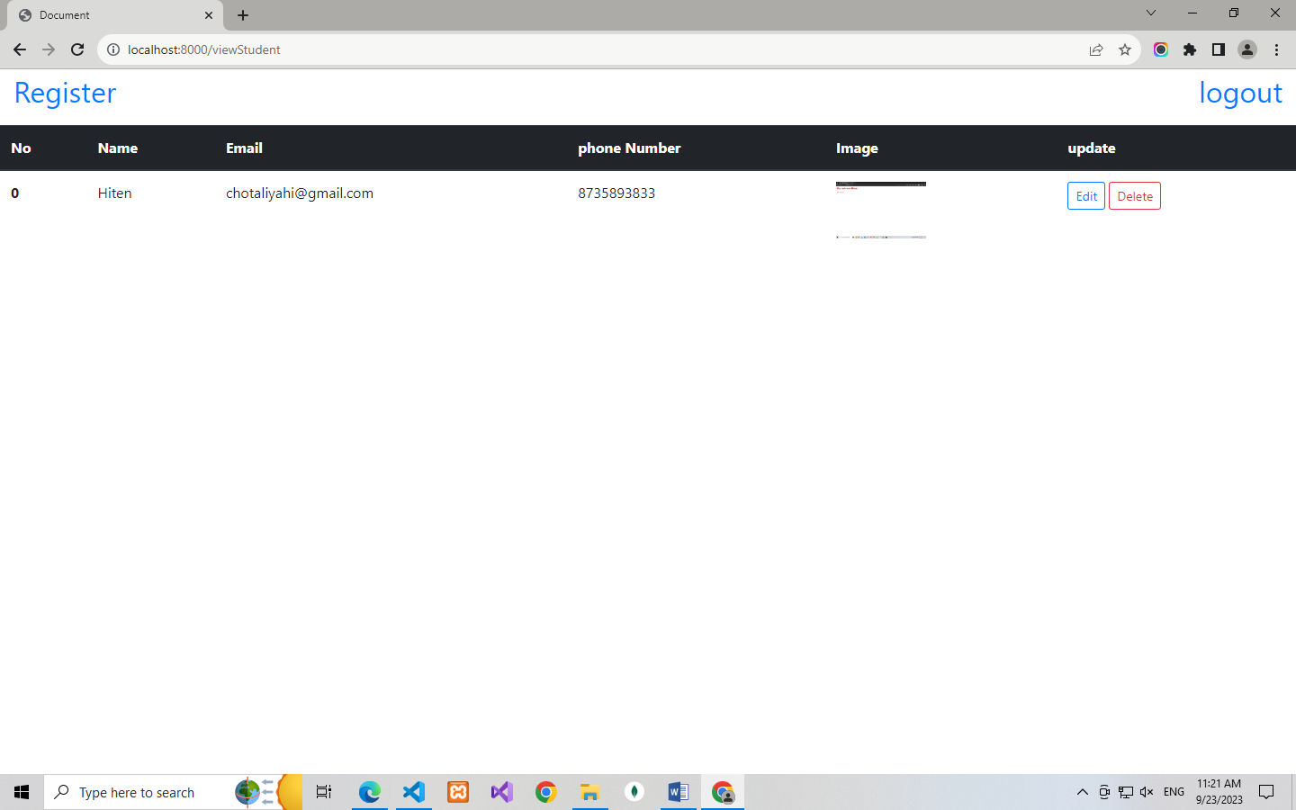

Edit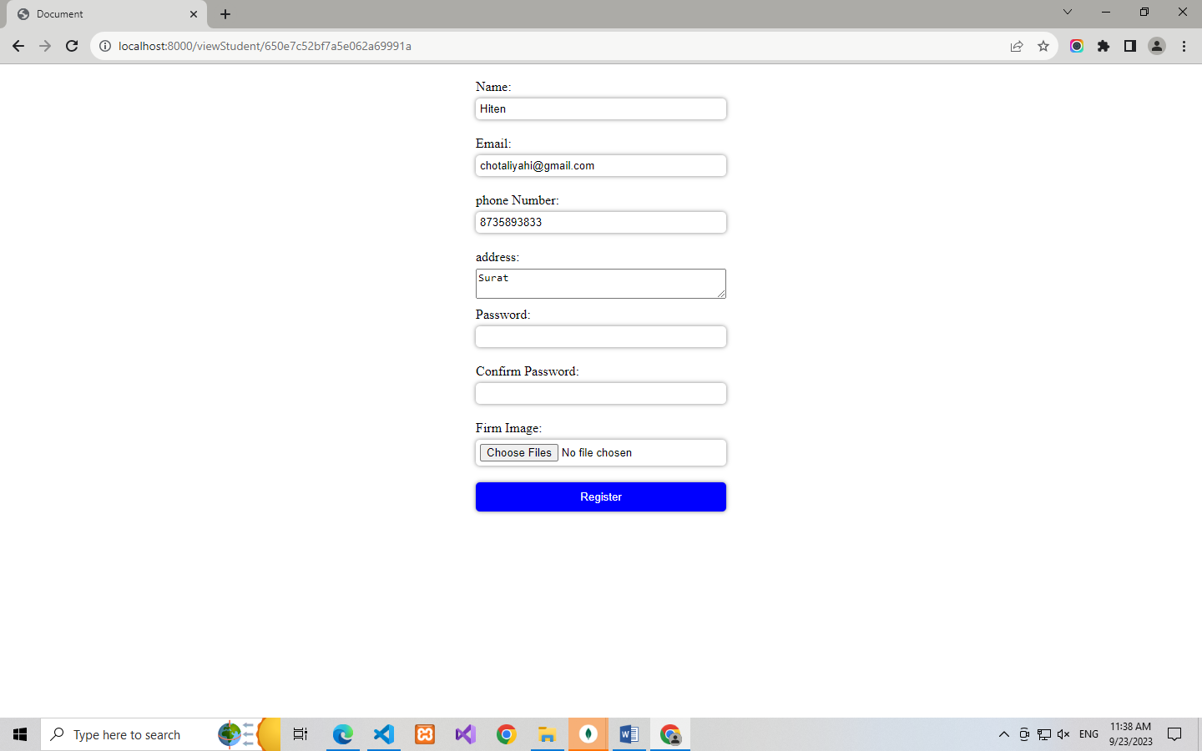

Delete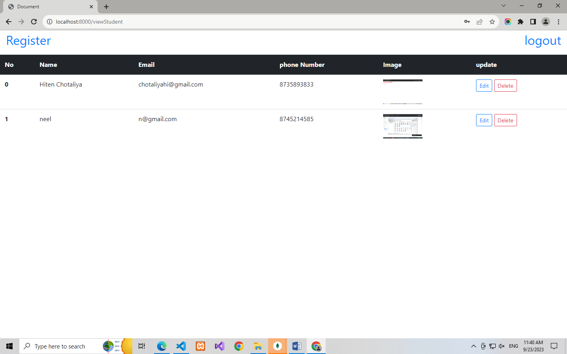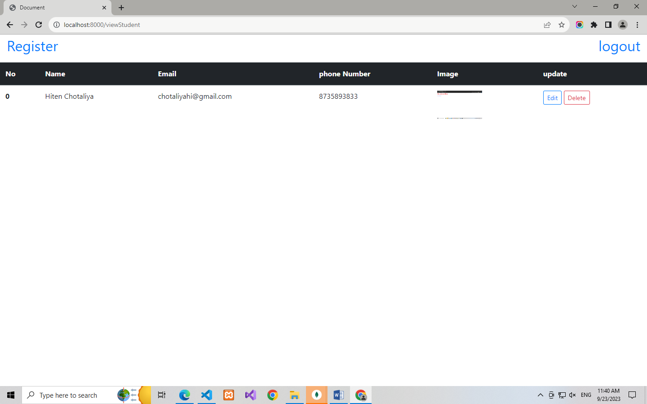

Question5:Login with JWT, CRUD operations for students table with mongoose, express and  
frontend(html,css,javascript/jquery/angularjs), Logout.