
Spectre LinkedIn Playbook
Master content, posting schedule, tags and engagement routine
Prepared 17 October 2026 · All times in IST

1. Goal and approach
The goal is to build awareness of Spectre and drive visitors to the project page. Six posts and five animations, each pairing one idea with one visual, build the story in order: the hook, why it is hard, how it works, why it is private, and what comes next.
- One idea per post. Each post stands alone, so a new reader does not need to have seen the others.
- Links go in the first comment, not the post body. Posts end with "Link in the first comment."
- Every post ends with a real question, because comments are the strongest signal you can earn.
- Do not mention the 20 October date in any post, comment or caption.
- Post from your personal profile. Personal profiles generally reach more people than company pages. Reshare from the Axiom Labs page afterwards if you want.
An honest note: LinkedIn's ranking system is not public, and no tactic guarantees reach. Everything here is a widely used practice, not a promise. The tracking sheet in Section 8 is how you find out what works for your audience.

2. Schedule at a glance
# | When (IST) | Post | Asset
1 | Sat 17 Oct, 7:30 PM | The hook: why IR spectra are hard to read | spectre_launch_teaser.gif
2 | Sun 18 Oct, 10:00 AM | Why the problem is hard (inverse problem) | spectre_gif2_same_region.gif
3 | Mon 19 Oct, 8:30 AM | The design decision (explainable by design) | spectre_gif3_two_readers.gif
4 | Mon 19 Oct, 7:30 PM | The engineering angle (no backend) | spectre_gif4_nothing_leaves.gif
5 | Tue 20 Oct, 8:30 AM | The open question | Text only, or a poll
6 | Thu 22 Oct, 8:30 AM | What's next (NMR) | spectre_gif5_nmr_next.gif

Why these slots: Tuesday to Thursday mornings are the most commonly cited windows for professional reach, so the strongest ideas sit near them. Post 1 goes out on a Saturday evening to open the story with less competition. Posts 3 and 4 are on the same day with an 11-hour gap, which keeps each post's first-day window to itself. Treat the times as a starting point and adjust once you see your own numbers.

3. Before you post: checklist
Do these first. Several posts send readers to the page, so the page has to work when they arrive.
- Fix the Spectre buttons. "Source Code" and "Interactive Playground" both currently link to your GitHub profile, not a specific repository or demo. Point them at the real links.
- Open the Spectre page on your phone and on a laptop. Confirm the playground loads quickly, because most LinkedIn traffic arrives on mobile.
- Verify every claim in the posts: runs fully client-side, no backend, no upload; MIT licence; rule engine and 1D CNN running together; every prediction traced to peaks.
- Check the animations match reality. The spectra in the GIFs are illustrations. In particular, "flagged for review" in the two-readers GIF assumes Spectre marks calls where the rule engine and CNN disagree. If it does not, change that caption before posting.
- Update your profile. Upload the new banner and profile logo, and add the Spectre page to your Featured section.
- Refresh your headline so a visitor knows what you are building. Example: "Mathematics at IISER Tirupati | Building Spectre: explainable IR spectroscopy in the browser | Axiom Labs".
- Optional: add a simple visitor counter (such as GoatCounter or Plausible) so you can see which post sends traffic. The first-comment links include a campaign tag for each post.
- Save all six first comments in your phone's notes so you can paste them within a minute of posting.

4. The posts
Copy each post exactly as shown, including the final hashtag line. Paste the first comment immediately after publishing.

Post 1: The hook (why IR spectra are hard to read)
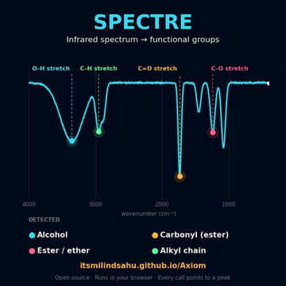 | When: Sat 17 Oct, 7:30 PM IST  Asset: spectre_launch_teaser.gif (upload natively)  Goal: Introduce Spectre to a broad audience. Optimise for stopping the scroll and for comments.

Post copy
An infrared spectrum looks like noise to most people.
To a trained chemist, it's a readable record: a broad dip near 3300 cm⁻¹ points to O–H, a sharp one near 1715 points to a carbonyl. Decades of that pattern-matching are written into correlation tables.
I wanted to see how far you could push that idea in software, without losing the ability to ask "why did you say that?"
So I built Spectre. It takes a raw IR spectrum and works out the functional groups behind it. Every call points to the peaks that caused it.
Runs in your browser. Open source.
Which spectrum would you throw at it first?
Link in the first comment.
#Spectroscopy #Chemistry #MachineLearning #OpenSource #Research

First comment (post within one minute)
Try Spectre here: https://itsmilindsahu.github.io/Axiom/spectre.html?utm_source=linkedin&utm_campaign=spectre_p1
If you work with IR data, tell me what you'd test it on.

Hashtags: #Spectroscopy #Chemistry #MachineLearning #OpenSource #Research
Mentions: Tag collaborators who actually worked on Spectre (for example Paarth Potnis, if he contributed). Maximum 2 to 3 people.

Post 2: Why the problem is hard (inverse problem)
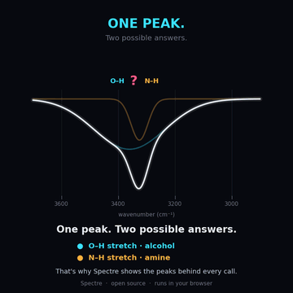 | When: Sun 18 Oct, 10:00 AM IST  Asset: spectre_gif2_same_region.gif (upload natively)  Goal: Show depth. This is your most 'teachable' post, so it should earn saves and expert comments.

Post copy
Going from molecule to spectrum is a lookup. Going from spectrum to molecule is an inverse problem, and it's genuinely ill-posed.
Why?
→ O–H and N–H both absorb near 3300 cm⁻¹
→ Hydrogen bonding turns sharp peaks into broad ones
→ Below 1500 cm⁻¹ (the fingerprint region), bands overlap so heavily that individual assignments blur
→ Different molecules can produce nearly identical spectra
That's why "just train a classifier" isn't a satisfying answer. You need to know when the evidence is strong and when it isn't.
That's the problem I've been working on with Spectre.
Chemists: what's the most misleading peak you've ever seen?
Link in the first comment.
#InverseProblems #Spectroscopy #AnalyticalChemistry #MachineLearning

First comment (post within one minute)
More on the project: https://itsmilindsahu.github.io/Axiom/spectre.html?utm_source=linkedin&utm_campaign=spectre_p2

Hashtags: #InverseProblems #Spectroscopy #AnalyticalChemistry #MachineLearning
Mentions: None needed. If a chemist you know engaged with Post 1, reply to them in the thread instead of tagging.

Post 3: The design decision (explainable by design)
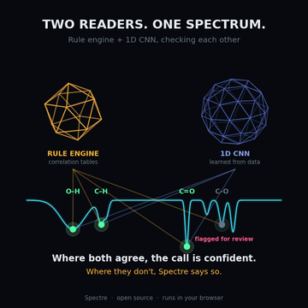 | When: Mon 19 Oct, 8:30 AM IST  Asset: spectre_gif3_two_readers.gif (upload natively)  Goal: Reach the ML audience. Strong opinion plus a concrete design choice invites debate.

Post copy
I made one design decision on Spectre that shaped everything else:
Every prediction has to point at specific peaks.
A neural network alone can be accurate and still be impossible to audit. A rule engine alone is auditable and brittle on messy real-world spectra.
So Spectre runs both: a rule engine built on classic IR correlation tables, alongside a 1D convolutional network. The rules give you traceable reasoning. The network handles the cases where real spectra don't follow the textbook.
Accuracy you can't inspect is a liability in science. I'd rather build the version where you can check the work.
Do you think explainability matters more than accuracy? Tell me where you land.
Link in the first comment.
#ExplainableAI #MachineLearning #DeepLearning #Chemistry

First comment (post within one minute)
Project page: https://itsmilindsahu.github.io/Axiom/spectre.html?utm_source=linkedin&utm_campaign=spectre_p3

Hashtags: #ExplainableAI #MachineLearning #DeepLearning #Chemistry
Mentions: None needed. This post works best as a debate, so reply to every disagreement with a question.

Post 4: The engineering angle (no backend, no upload)
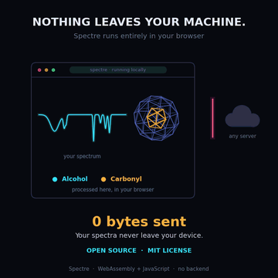 | When: Mon 19 Oct, 7:30 PM IST  Asset: spectre_gif4_nothing_leaves.gif (upload natively)  Goal: Reach developers and privacy-minded scientists. Keep a gap of at least 10 hours after Post 3.

Post copy
No backend. No upload. No API key.
Spectre runs entirely in the browser with WebAssembly and JavaScript. Your spectrum never leaves your machine.
That was a deliberate constraint. Spectroscopic data is often unpublished, proprietary or from a project nobody wants to send to a third-party server. Client-side inference removes that question entirely, and it means the tool still works in a lab with a bad connection.
It's also open source under MIT.
Sometimes the most useful scientific software is the kind you can open and use in ten seconds.
What's the one feature you'd want in a tool like this?
Link in the first comment.
#WebAssembly #OpenSource #Privacy #Spectroscopy

First comment (post within one minute)
Try it (nothing to install): https://itsmilindsahu.github.io/Axiom/spectre.html?utm_source=linkedin&utm_campaign=spectre_p4

Hashtags: #WebAssembly #OpenSource #Privacy #Spectroscopy
Mentions: Optional: one developer or open-source contact who genuinely cares about client-side tools.

Post 5: The open question (built for comments)
TEXT POST  or poll | When: Tue 20 Oct, 8:30 AM IST  Asset: Text only. Optional: post it as a LinkedIn poll with the four options below.  Goal: Pure engagement and expert feedback. Text-only questions can pull in people who skip visuals.

Post copy
A question for anyone who has worked with IR or any spectral data:
When an automated tool tells you "this sample contains a carbonyl," what would make you trust it?
→ Seeing the exact peak it used?
→ A confidence score?
→ Agreement with a rule-based check?
→ Something else?
I'm asking because it shaped how I built Spectre, and I'd like to know where I'm wrong.
Link in the first comment if you want to see what I landed on.
#Spectroscopy #Cheminformatics #Chemistry #AI

First comment (post within one minute)
What I landed on: https://itsmilindsahu.github.io/Axiom/spectre.html?utm_source=linkedin&utm_campaign=spectre_p5

Hashtags: #Spectroscopy #Cheminformatics #Chemistry #AI
Mentions: Tag 2 to 3 people who work with spectra and would have a real opinion. Ask them in a comment, not in the post body.

Post 6: What's next (NMR)
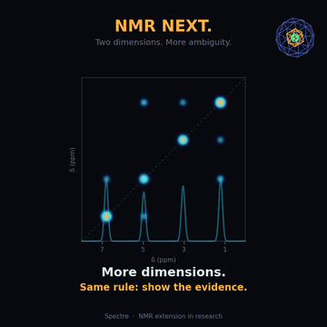 | When: Thu 22 Oct, 8:30 AM IST  Asset: spectre_gif5_nmr_next.gif (upload natively)  Goal: Invite collaborators and signal momentum. This post should convert readers into conversations.

Post copy
Infrared is the first step. The same inverse-problem framing, going from raw signal back to structure, applies to NMR, and that extension is in active research.
NMR is harder: more dimensions, more ambiguity, and more at stake in explaining each assignment.
If you work in spectroscopy, cheminformatics or inverse problems, I'd like to compare notes.
Link in the first comment.
#NMR #Spectroscopy #Cheminformatics #InverseProblems #Research

First comment (post within one minute)
Project page and contact: https://itsmilindsahu.github.io/Axiom/spectre.html?utm_source=linkedin&utm_campaign=spectre_p6

Hashtags: #NMR #Spectroscopy #Cheminformatics #InverseProblems #Research
Mentions: Tag people who replied thoughtfully to earlier posts (with their consent). This is the right post for it.

5. How to post: the routine
Run this same routine for every post.
- 15 minutes before: leave 4 to 5 thoughtful comments on other people's posts in spectroscopy, chemistry, ML and student research. Real comments, not "great post". They put your name in front of the right people just before you post.
- Upload the GIF natively (use the attach-image option rather than a link). It autoplays in the feed. The first line of the post is what shows before "see more", so the hook has to work on its own.
- Paste the copy exactly, keeping the blank lines between paragraphs. Short paragraphs read well on mobile.
- Publish, then comment within a minute. Paste the first comment with the link. Posting the link there instead of in the body is a widely used way to avoid a drop in reach.
- Stay online for the first 60 to 90 minutes. Reply to every comment, ideally within 15 minutes, and make each reply a real answer plus a follow-up question. Early conversation is what widens a post's audience.
- Send it personally to a few people (3 to 5) who would genuinely care about the topic. Keep the note short and give them a reason, such as "you work with IR data, I'd value your view". This is not the same as asking for likes.
- Do not edit or delete in the first hour, and do not repost the same content later. If you spot a typo, fix it and move on.
- After 24 hours, log the numbers in the tracking sheet, reply to late comments, and note which hook and which GIF performed best.

Things to avoid
- Engagement pods and "comment YES to get the link" tactics. They are easy to spot and can hurt reach.
- More than one post in a 10-hour window, or more than two in a day.
- Tagging people who have not agreed to it, or tagging more than 3 to 5 people in one post.
- Using more than 5 hashtags, or generic ones such as #viral or #trending.
- Quoting an accuracy number you have not measured. Say what the tool does and let readers judge.

6. Tags: hashtags and mentions

Hashtag principles
- Use 3 to 5 hashtags per post, at the end, on their own line.
- Mix one broad tag (reach), two niche tags (the right readers) and one community or technique tag.
- Keep #Spectroscopy on most posts. Repeating one core tag helps LinkedIn learn what you post about.
- Check the follower count LinkedIn shows next to a hashtag when you type it, and prefer tags that are active but not enormous.

Type | Hashtags | Use in
Broad | #MachineLearning #AI #OpenSource #Research | Posts 1, 2, 3, 5
Niche (science) | #Spectroscopy #Chemistry #AnalyticalChemistry #Cheminformatics #InverseProblems #NMR | All posts
Technique and values | #ExplainableAI #DeepLearning #WebAssembly #Privacy | Posts 3 and 4

Mention (tagging) rules
- Co-builders first. Tag people who worked on Spectre, with their agreement. They will comment and share, which is the main benefit of tagging.
- Domain experts second. Tag a chemist or ML practitioner only when you are genuinely asking for their view, and prefer doing it in a comment, not in the post body.
- Institutions are your call. Your site describes Axiom Labs as independent and run without any administration, so tagging a university may send a mixed message. Decide deliberately.
- Do not tag supervisors or faculty without asking them first.

7. Reply bank
Starting points for the questions you are likely to get. Adapt them in your own voice, and fill the bracketed parts only with facts you have checked.
If someone asks | Reply along these lines
How accurate is it? | I'd rather show you than quote one number. Every call points to the peaks behind it, so you can judge each one yourself. [Add measured results here once you have a validation set.]
Is it open source? | Yes, MIT licensed. The source and demo are linked from the project page.
Does my data get uploaded? | No. It runs in your browser with WebAssembly and JavaScript, with no backend, so the spectrum stays on your machine. [Confirm this holds for every feature first.]
Does it do NMR? | Not yet. The NMR extension is in research. IR comes first.
How do the rules and the CNN work together? | A rule engine built on IR correlation tables runs alongside a 1D CNN, and every prediction points to specific peaks. Which part would you like me to go deeper on?
Can I collaborate? | Yes, please. Message me with what you work on, or use the Join page on the site.
It got my spectrum wrong. | That's exactly the feedback I want. Can you share the spectrum, or describe it? Edge cases are how this gets better.
Why not just use a library search? | Library search answers "which spectrum matches this molecule?" Spectre goes the other way, from the spectrum to the functional groups behind it.

8. Tracking sheet
Fill this in 24 hours after each post. After three posts, look for the pattern: which hook, which visual and which time slot earned the most comments and site visits.
Post | Impressions | Reactions | Comments | Reposts | Site visits | Notes
Post 1
Post 2
Post 3
Post 4
Post 5
Post 6

What to look for: comments matter more than reactions. A post with fewer impressions but more expert comments is usually the better signal. Use the winning hook as the template for follow-up posts.

9. After the six posts
Ideas for the following two weeks, once people have seen the tool.
- "The spectra it got wrong": a post sharing real failure cases and what you learned. Honest posts like this tend to earn trust.
- A five-peak guide to reading an IR spectrum as a carousel (PDF with 6 to 8 slides). Highly saveable.
- A real result: a screenshot of Spectre analysing a real spectrum, with the peaks it used highlighted.
- Build story: why you chose the browser-only constraint, and what it cost you.
- A user story, with permission: someone who tried Spectre and what they found.
- Collaboration call for the NMR extension, naming the specific skills you need.

10. Appendix: assets and alt text
Add the alt text when you upload each GIF. It helps screen-reader users and costs nothing.
File | Alt text
spectre_launch_teaser.gif | Animation of an infrared spectrum drawing itself, then four labelled peaks (O–H, C–H, C=O, C–O) lighting up and being matched to functional groups, under the title Spectre.
spectre_gif2_same_region.gif | Two absorption peaks, O–H in cyan and N–H in amber, slide together near 3300 wavenumbers and merge into one band, with the caption: one peak, two possible answers.
spectre_gif3_two_readers.gif | A rotating amber icosahedron labelled rule engine and a rotating blue geodesic sphere labelled 1D CNN each point beams at peaks on a spectrum. Three peaks turn green where both agree and one is flagged for review.
spectre_gif4_nothing_leaves.gif | A spectrum drops into a browser window and a wireframe shape spins up beside it. An upload arrow toward a cloud server hits a barrier marked with a cross. The counter reads 0 bytes sent.
spectre_gif5_nmr_next.gif | One-dimensional spectrum peaks unfold into a two-dimensional map with diagonal and cross-peaks, under the heading NMR next. A corner wireframe gains a third nested shape.
axiom_labs_banner_1584x396.png | LinkedIn banner: Axiom Labs wordmark with the tagline 'We start from axioms, not assumptions' beside a blue geodesic sphere containing an amber icosahedron.
axiom_labs_profile_logo.png | Profile logo: a blue wireframe geodesic sphere containing an amber icosahedron on a dark background.

Note: the spectra, agreement markers and NMR map shown in the animations are illustrations drawn for the story. They are not output from Spectre. Do not describe them as real results.

