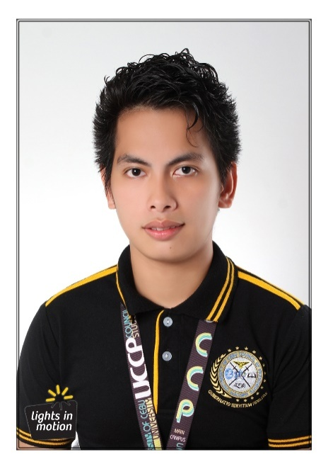

**Carlo C. Gudito**

827 – L Bayabas St., Basak San Nicolas, Cebu City

Contact no.: 09335836937

Email Address: [carlogudito102791@gmail.com](mailto:carlogudito102791@gmail.com)

**OBJECTIVES**

* To obtain a full time position which offer a professional working environment that would enhance my capabilities while working towards organization's success.

**SKILLS**

* Excellent Customer – Service skills
* Computer literate putting emphasis Microsoft Office
* Graphic editing using Adobe Applications
* Average programmer using PHP, JavaScript, HTML5, CSS3 languages
* Project Organizer

**PERSONAL DATA**

* Age: 25
* Gender: Male
* Status: Single
* Date of Birth: October 27, 1991
* Height: 5'6”
* Weight: 110 Lbs.
* Citizenship: Filipino
* Language Spoken: English, Filipino and Cebuano

­­­­­

**EDUCATIONAL BACKGROUND**

Tertiary: University of Cebu – Main Campus

Sanciangko St., Cebu City

Bachelor of Science in Information Technology

2014 - Present

Secondary: Inabanga High School

Nabuad Inabanga Bohol

2009 – 2010

Primary: Inabanga Central Elementary School

Poblacion Inabanga Bohol

2004 – 2005

**ORGANIZATION**

* Philippine Junior Jaycees, Incorporated – University of Cebu Chapter
  + 2014 – 2015 University of Cebu Sub Chapter PRO
  + 2015 – 2016 Governmental Affair Commissioner
* University of Cebu Council of President – Main Campus
  + 2015 – 2016 Associate
  + 2016 – 2017 Planning and Monitoring Unit
* Philippine Junior Jaycees, Incorporated – Cebuano Chapter
  + 2016 – Present Charter President

**EXTRACURRICULAR ACTIVITIES**

* Milo Marathon Volunteer
  + 38th National Milo Marathon – Cebu
  + 40th National Milo Marathon – Cebu
* Sinulog Foundation Inc. – Volunteer
  + Sinulog Festival 2015
  + Sinulog Festival 2016
  + Sinulog Festival 2017
* Philippine Junior Jaycees, Incorporated Delegate
  + 2015 National Convention – Cagayan de Oro City
  + 2016 National Convention – Tacloban City

**WORKING EXPERIENCE**

IT Support (OJT) Vicente Sotto Memorial Medical Center

Management Information System Department

April 4, 2017 - May 21, 2017 (250 Hrs.)

Sales Promo Ban Kee Trading Inc.

Metro Gaisano Colon Branch

September 2013 – April 2014

Agent Specialist Lex Services Inc. affiliated of Malayan Insurance Company

Star Appliance Center Inc. (SM Cebu Annex Branch)

January 2012 – September 2012

Sales Promo Apruva, Baby Looney Tunes & Disney Baby Infant Furniture

Cuddly International Corporated

St. Apollonia Manpower Services

Metro Gaisano Ayala Cebu Branch

August 2011 – January 2012

Food server Vicsal Development Corporation

Metro Gaisano Ayala Cebu Branch

February 2011 – July 2011

Busboy Vicsal Development Corporation

Metro Gaisano Ayala Cebu Branch

July 2010 – December 2010

**CHARACTER REFERENCES**

Ms. Dulce Sumaylo

Metro Gaisano Ayala Cebu Branch, Food Avenue OIC

Vicsal Development Corporation

Mr. Nicasio Silfavan

Store Supervisor

Star Appliance Center Inc. (SM Cebu Annex Branch)

Mr. Allen G. Rama

MIS Team Leader (CMT III)

Vicente Sotto Memorial Medical Center