# CHAPTER 1

**INTRODUCTION**

**Rationale of the Study**

Even then, authors have come across with the difficulty of publishing their books. All authors have their own creative ideas on how to write stories but not all of them are given the chance to be articulate with grammar and even with the style. Authors need publishers to provide them with reliable copywriters who can help furnish their work and turn their ideas into books. In return, publishers need good authors to write books for them.

At present, traditional and self-publishing are two prevalent ways of getting a work published. In the traditional way of book publishing, once the author finished writing the manuscript, the author then writes a proposal and submits it to the publishing house. It is then the copywriter who will read the manuscript and weigh if it is good enough for the house to publish or not. If the copywriter likes the manuscript, the publisher will offer a contract for the author to sign.

Meanwhile, the process is a bit different for self-publishing. An author who decides to self-publish basically becomes the publisher. The author must proofread the final text and provide the funds required to publish the book, as well as the camera-ready artwork. The author is responsible for marketing and distributing the book, filling orders, and running advertising campaigns.

In the past, the author had to decide on the number of copies to print, sometimes resulting in stacks of unsold books gathering dust in the garage. Fortunately, the Print on Demand (POD) technology now used by some self-publishing companies is introduced. It means that authors can have fewer copies printed—only as many as they need, in fact. However, it would really be difficult for an author to self-publish given the fact that there is only a limited time, budget, and supplies making the first option a much better way to publish books.

Authors find it hard to look for publishers that suit their style and when they find one, they may not be able to meet the standards of publishers. It is a given fact that aspiring authors will surely have difficulty finding a publisher especially if they lack connection. They need a way to meet their local publishers in one platform and see if these publishers might be interested in their works.

Meanwhile, new challenges are faced by the publishing industry that had been functioning for decades. It is the proliferation of the web and the new accessibility of self-publishing. As technology forges ahead, this segment lags behind-reluctance to embrace new media is common among traditional publishers and cynics allege that the death of print is approaching. But having recovered from similar catastrophes, such as the introduction of radio, television, and Compact Disc Read-Only Memory (CD-ROM), the book publishing industry is realistically predicted to weather the storm. The publishing industry has massive audiences with global reach, savvy newsrooms that create Omni-channel content around the clock, and a technology infrastructure that brings speed, efficiency and intelligence to the forefront. The degree of convergence will only accelerate as we see old-school publishers try to be more like the new-school ones, and vice versa.

We have seen publishers become creative agencies   such as Vice’s Virtue or HuffPost’s Partner Studio where they help advertisers connect with audiences in a more authentic and natural way often through the lens of creating branded content. We have seen publishers become research institutes such as Business Intelligence and the Economist’s Intelligence Unit that provide data and analysis for a healthy subscription fee. We have seen publishers become event organizers such as Forbes’ Summit Conferences and Code Conference where they leverage their brand and bring people together around topics specific to an industry or C-level executive. And for sure, we will see publishers establish online partnerships to suffice their needs.

With the existing problem that authors encountered and with the advent of internet, developers found a way to give rise to online writing platforms like Wattpad, Asianfanfics, Freelancer and Typotic which help enable authors to share their works, connect with other people who share the same passion, and have the chance to be noticed by the publishing industry. On the contrary, most of these writing platforms will only benefit those authors who have already gained more followers depending on how long they have stayed on the particular site and the more chances of getting their works more popular. Thus, an online platform to give new and old members equal opportunities would surely benefit these authors who have not published their works yet.

As aspiring Information Technology (IT) professionals and solution providers, the researchers came up with the idea of developing an online writing platform that will cater both the needs of the authors and publishing companies and will hopefully resolve the problems and satisfy their needs. Through the proposed system, authors, publishers, and even copywriters will meet in one single platform to do their daily transactions. The proposed system, SulaTroniko offers a web application that can be used by authors to meet their local publishers and in return, it will also allow publishers to seek for possible authors who can provide them with good manuscripts which can then be the next best-selling books.

Through this system, authors can upload their manuscripts. However, authors and publishers should be able to provide the necessary requirements in creating an account like providing their payment details. Once their works are ready, they can search for publishers that will fit their specialized genre. The author can then contact the publisher and send the latter a message stating the intentions. Attached will be the synopsis of the manuscript which is then reviewed by the publisher. If they found the manuscript satisfactory, the publisher will assign a copywriter for the author. The copywriter will do the necessary revisions until the author will approve the copy. The system will also provide close monitoring for the author to check the progress of work from time to time. Once it has been approved, the transaction is considered close. The system will deduct the amount of money from both publisher and author. Once the book had been successfully published, the publisher will add it to the latest published on its profile.

In this study, the researchers aim to provide a system which is convenient and reliable that guarantees a strong connection for authors, publishers, and copywriters.

**Objectives of the Study**

The main objective of the study is to design and develop an online writing platform. This platform facilitates the authors to find their local publishers that are fit to the genre of their works, contact them to establish connection, and if these publishers would like their written works, they will assign a copywriter for that particular author to review their manuscript to be ready for its publishing. Furthermore, the proposed system is comprised of web platform that can:

1. Connect users such as authors, publishers, and copywriters;
2. Execute SulaTroniko transactions such as user account search, recommendations, and payment deductions;
3. Monitor the revisions made by copywriters;
4. Send real-time notifications on new transaction updates;
5. Rate and review users accounts;
6. Generate relevant and comprehensive reports for the publishers.

**Scope and Limitations of the Study**

SulaTroniko web platform is intended for authors, publishers, and copywriters. Its goal is for authors to immediately seek publishers that fit the genre of their written works and find copywriters who can polish their manuscript; allow publishers to maximize their profit margin and gain more authors; and to innovate the publishing industry. This system is a web-based platform. Thus, internet connection is needed to access it.

The system allows authors to contact publishers with an attached synopsis of their work. The publisher can either accept or reject the synopsis. If they deem the work worth publishing, they will assign a copywriter for the author.

As for the copywriters, once a new task is given to them, they will contact the author and negotiate about the work. Each revision phase, the copywriter needs to upload the edited version of the copy and allow authors to monitor their works. Once the final revision is approved, copywriters will contact the publisher for the printing of the book. The publisher will then add the book to its published area. Authors can add a review and rate these publishers and they are also allowed to upload manuscripts of their works which have not yet been published.

Meanwhile, the proposed system does not include detecting copyright infringement. It is already in the publisher's side and the copywriter’s job to determine whether the work is originally made by the author. In addition, publishers have people checking the credibility of the manuscript using high-end tools.

This study will only be conducted in Metro Cebu. However, the system is applicable in the whole Philippines if deemed necessary.

The online writing platform includes the following features:

* **Account Management.** The case when authors, publishers, copywriters and admin are given the privilege to manage their accounts like changing passwords, photos, personal information and others.
* **Published Works**. Once a work is successfully published, it will be posted on the publishers’ profile as well as the other published works.
* **User Monitoring.** Publishers can monitor the authors who contacted them. The publisher can post their newly published books and they can accept or decline any works from the authors.
* **Work Monitoring.** Authors can check the revisions made by the copywriters to their works from time to time. They have the opportunity to correct them if need be.
* **Rate Users.** Each author can rate their publisher and can also leave comments, feedbacks, or suggestions.
* **User Search.** Authors can search for local publishers that specializes the same genre of their choice and vice versa. Only the users with the same preferred genre will be provided. The website can also recommend authors and publishers.
* **Notification.** The proposed system is capable of sending updates and information to the intended users through push notification.
* **Recommendation.** The system shall filter the genre of the manuscripts and will recommend publishers for the authors.

SulaTroniko will attend to its users’ needs and shall uphold the Terms and Conditions for the benefit of its customers. On the other hand, the system shall not take part on the contract or agreement between the author and publisher. It shall allow interactions between the abovementioned users but shall not be held reliable for any untoward contract breach that may occur.

The following is the list of technical behavior of the proposed system:

* + **Compatibility.** This system is compatible with Windows 7 up to its latest version.
  + **Usability.** The application must have an internet, Wi-Fi or data connection to be able to achieve a real-time processing; returning the results sufficiently quickly to the affected environment or device used and also gathered data from the server.
  + **Accessibility.** This application is accessible to any web browser such as Google Chrome, Mozilla Firefox, Internet Explorer and etc.
  + **Privacy.**
    - The application uses password encryption method to make sure the user’s security and privacy.
    - The application ensures that any private information from the users must not be shown to anyone unless if it is a requirement for both parties to check for some important reasons and considerations.

**Significance of the Study**

The study will offer immediate access to authors who are having difficulty in looking for publishers that will accept their work for publishing. It will allow them discover other authors who share the same interest and passion. It will also provide equal chances to those who are just new in the writing industry.

This study is specifically beneficial to the following:

* **Authors:** Authors are allowed to post their own manuscripts and let their works be discovered by other people. These manuscripts can also be examined by publishers if they are worthy to be published.
* **Publishers:** Publishers can surely benefit to this writing platform as it will allow them seek good authors and manuscripts.
* **Copywriters:** It would be easier for copywriters to communicate with authors and keep in touch with them on how the manuscripts should go about. They can also post the revisions of the manuscripts.
* **Proponents:** The proponents of this study are far beyond grateful for the knowledge we gained in this field though it may be different from our course.
* **Future Researchers:** For the researchers in the future who wish to use this as a related study, this would truly be beneficial to them as it is for its proponents.

**Flow of the Study**

Figure 1 illustrates the process on how and why the researchers came up with SulaTroniko as the proposed system.

**Objectives of the Study**

**Related Literature**

**Related Studies**

**INPUT**

**Customer Validation**

**Agile Methodology**

**Dynamic Systems Development Method**

**PROCESS**

**OUTPUT**

**SulaTroniko: A web platform that connects authors and local publishers**

## Figure 1: Flow of the Study

**Definition of Terms**

The terms are conceptually and operationally defined for a better understanding of the readers.

* **Copywriters** - The editors who will review the works of authors and make revisions to improve the document.
* **Copy** - Manuscript or any written work that is subject for revision.
* **Genre** - A particular type or category of literature used as filter when searching for users.
* **Work-in-Progress** - It contains the number of tasks that had been completed and are yet to be done.
* **Traditional publishing** - Traditional publishing refers to the established system of getting a book deal, which involves submission to agents over a period of time, usually a number of rejections and then being accepted.
* **Self-publishing** - Is the publication of any book, album or other media by its author without the involvement of an established publisher.
* **Camera-ready artwork** - The term used in the printing industry referring to a digital document ready to be printed.
* **Print-on-Demand** - Is a printing technology and business process in which book copies (or other documents) are not printed until the company receives an order, allowing prints of singular or small quantities.
* **C-level executive** - C-level jobs are the top executive or highest level corporate positions in a company.
* **Synopsis** - Is a brief summary of the major points of a subject or written work or story, either as prose or as a table; an abridgment or condensation of a work.
* **CD-ROM** - Is an adaptation of the CD that is designed to store computer data in the form of text and graphics, as well as hi-fi stereo sound.
* **Dynamic Systems Development Method** - (DSDM) is an agile project delivery framework, initially used as a software development method.

# CHAPTER II

**REVIEW OF RELATED LITERATURE AND STUDIES**

**Review of Related Literature**

Book publishing serves as the million-copy fiction writer and the specialist author with sales of fewer than 300 copies. Books can be published profitably for tiny markets which though limited in scale are many in number. As a long-established industry, publishing developed over time a worldwide distribution system through which its output of physical books could be traded in a regulated and controlled way. This ecosystem now coexists with digital distribution through which content can be sold and distributed right around the world on to mobile devices such as smart phones and tablets. While this offers an exciting opportunity, at the same time publishers have to complete vigorously against other forms of entertainment, learning processes and information sources. (Phillips, 2014)

Of all of the trade book categories, adult trade has all the glitz because of its big authors; and mass market paperbacks had a substantive impact on American culture; but, since the 1980s, the growth engine of the entire trade category has been the juvenile and Young Adult (YA) sector. These are two very different types of books. Juvenile title ranges from plastic books to thick cardboard books to the popular Golden books and large, colorful story books to chapter books. YA books deal with more mature subjects: vampires; private school cliques; stories about death and survival in ‘games’ world. Between 2003 and 2005: total print and digital for juvenile and YA increased 17.43%. The expected high point of total net publishers’ revenues was 2013, with declines posted for 2014 and 2015; these declines were due to: (a) a sharp decrease in digital e-book sales; and (b) a lower suggested retail price for e-books. (Albert N. Greco, 2014)

Gone are the days when the chance of publishing and promoting stories or poems was a herculean task. Before the emergence of technology, traditional writers need to find an agent who will help them find a publisher. Before finding an agent, they need to identify the right category for their writing. If they want to be a non-fiction writer, they need to submit a book proposal with three sample chapters and a synopsis of each chapter.

However, over the years of continuous innovation, writers have found the means that allow them to share their works online. These websites are free of use and would allow them to post unlimited stories and gain more followers. This opened the door for publishers to discover these ghost writers who have already made their name in the writing industry. With the provision of free publishing platforms on the web, writers can come out of the shadows to showcase their work with wide audience and with minimal constraints.

Being an internet savvy lets people be familiar with some recent success stories about writers such as James Dashner whose successful novel The Maze Runner was originally posted online or Denny R with a pseudonym HaveYouSeenThisGirl who was able to publish the Rom-Com, Diary ng Panget, originally on Wattpad.

**Related Studies**

The proponents decided to use the following related online writing websites in order to benchmark the functionalities of these existing web platforms to the proposed system. These platforms serve as the foundations in the development of SulaTroniko: An Online Matching Platform for Philippine Authors and Publishers.

**Wattpad**

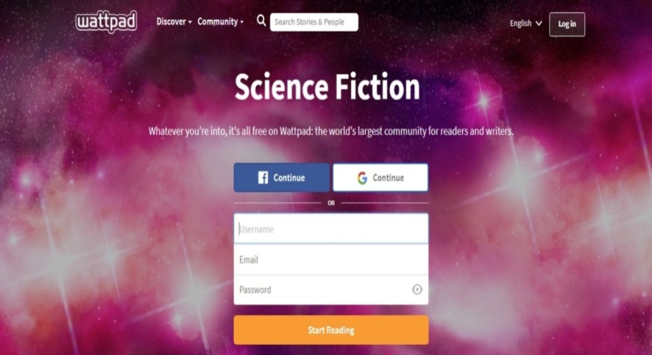Wattpad is a free online storytelling community where users post written works such as articles, stories, fan fiction, and poems, either through the website or the mobile app. The user-generated content is submitted by writers of all levels who are given an equal chance to write popular works. Figure 2 shows Wattpad’s landing page.

Figure 2: Landing page

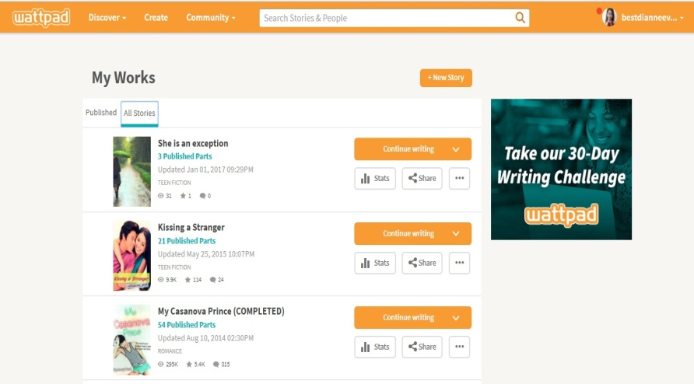**My Works**

As shown in Figure 3, Wattpad authors can check the progress of their works and can post new stories. There is also a statistics showing the average number of readers, how many chapters are there, and how many comments were left by the readers.

Figure 3: My Works

**Genre**

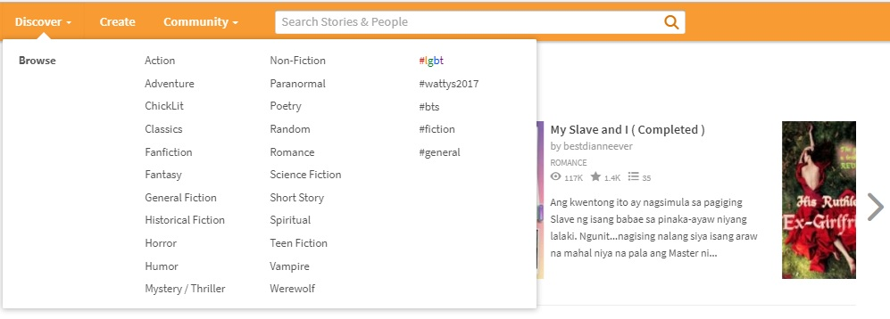In Figure 4, authors can choose the genre of their choice. Once the user chooses a genre, he/she will be prompted to another page which is the list of works with the genre that have been clicked.

Figure 4: Genre

**Discussions**

Figure 5 shows that Wattpad allows users to join different clubs to meet other members and discuss their interest. As for the proposed system, the discussions would be the reviews of authors for the publisher.

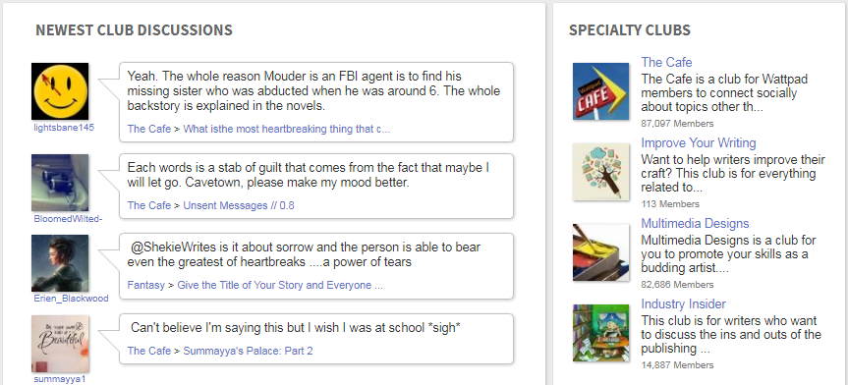

Figure 5: Dicussions

**Freelancer**

Freelancer is a global crowd sourcing marketplace website, which allows potential employers to post jobs that freelancers can then bid to complete. Founded in 2009, its headquarters is located in Sydney, Australia. Refer to Figure 6 for the website.



Figure 6: Landing Page

**Payment Method**

Figure 7 illustrates that users can choose the payment method on how the money will be transferred to his/her account. Users are required to accomplish this once the account has been set up.

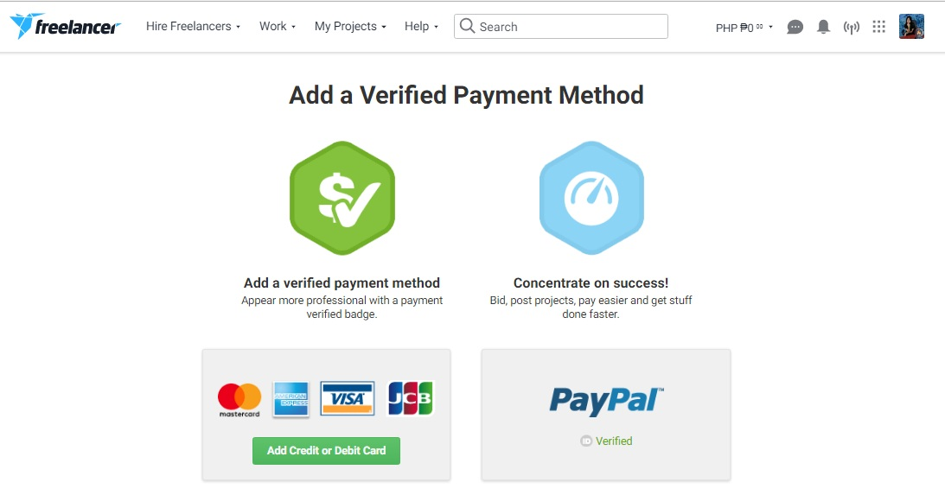

Figure 7: Payment Method

**Transaction History**

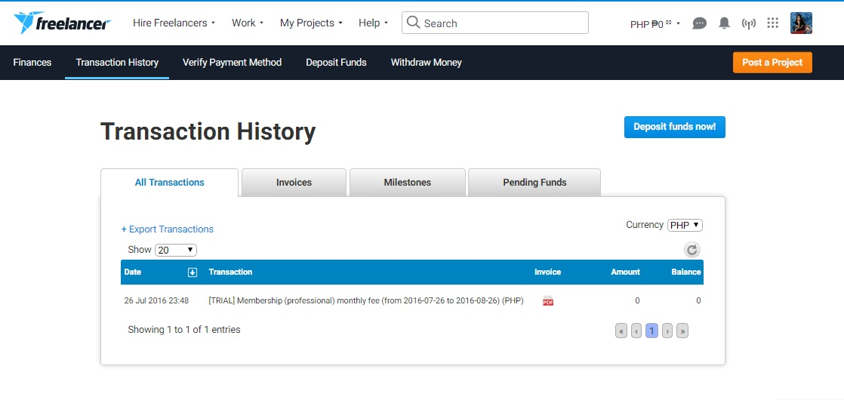 View summary information about your transactions, and adjust the time period for which you want to view transactions from the past 10 days to the past 90 days using a slider. Search for any transaction type or transaction method.

Figure 8: Transactions

**Comparative Matrix**

Comparative Matrix is a checklist and comparison between SulaTroniko and other related existing systems and have been evaluated, compared and calculated the percentage according to the number of features covered among by the other competitors.

**Table 1**

**COMPARATIVE MATRIX**

|  |  |  |  |  |  |
| --- | --- | --- | --- | --- | --- |
| RELATED STUDIES | FEATURES | LIMITATIONS | PLATFORM DETAILS | SUPPORT | MONETIZATION SCHEME |
| NAME: WATTPAD  URL: https://www.wattpad.com/  YEAR: 2006  PROPONENT(S):   * Allen Lau * Ivan Yuen | * Message Board * Spell checker * Statistics * Library | * Wattpad |  |  |  |
| NAME: CANDYMAG  URL: https://www.candymag.com/  YEAR: 2008  PROPONENT(S):   * Macy Alcaraz * Clare Magno |  |  |  |  |  |
| NAME: ASIANFANFICS  URL: http://www.asianfanfics.com/  YEAR: 2009  PROPONENT(S):   * Jason Ado |  |  |  |  |  |
| NAME: TYPOTIC  URL: https://typotic.com/  YEAR: 2014  PROPONENT(S):   * Priit Leet |  |  |  |  |  |

**Legal Bases**

Of all the intellectual property rights relevant to the book publishing industry, copyright remains the most significant. Typically, the first owner of copyright in any created work – a novel, a biography, a letter, a drawing, a photograph, a song, a concerto – is the person who created it, (leaving aside national legislation which gives the employer the copyright in an employee’s work created in the course of employment, and other cases). The publisher will have to enter into a legal relationship with the creator – author/writer of a manuscript – in order to publish the work and issue copies of it in sufficient quantities to satisfy the needs of the public. The publisher does this by virtue of a contract in which the author either assigns copyright to the publisher or, more usually, grants to the publisher an exclusive, or non-exclusive, license.

There is no law that can protect an idea which has not yet been expressed. Hence, copyright does not protect ideas. The underlying principle of intellectual property law is to protect and reward the products of the mind, but an idea has to be expressed in some form before it can be the subject of legal protection. Thus, the letter must be written; the landscape must be drawn, painted or photographed; the song must be taken down in musical notation or recorded before its creator can claim rights over it. Books often contain more than one copyright: in the literary content (the text) and also in different artistic works if it contains drawings, paintings or photographs. Each one of these copyright works is the subject of a contractual agreement permitting its reproduction and publication, and, where the publisher does not himself acquire the rights contractually, he acquires a license to exploit them. He therefore needs a good understanding of the different types of contracts that cover all these rights. (Managing Intellectual Property in the Book Publishing Industry)

Meanwhile, there is also another problem faced by publishers which is the plagiarism. It presents a problem more tangible than academic integrity for publishers and authors because in many cases plagiarism results in copyright infringement, making both parties vulnerable to litigation and financial losses. When a publisher assumes the rights to a manuscript from an author through a copyright transfer agreement, the publisher also assumes the responsibility to ensure that the manuscript does not infringe upon the rights of other copyright holders. (COPYRIGHT INFRINGEMENT: WHO IS RESPONSIBLE, AUTHOR OR PUBLISHER?)

CHAPTER III

RESEARCH METHODOLOGY

**Software Engineering Methodology**

The proponents decided to use Dynamic Systems Development Method (DSDM) for the development of SulaTroniko. DSDM is an agile software development methodology. It is an iterative, incremental approach that is largely based on the Rapid Application Development (RAD) methodology. Within each phase, DSDM relies on several different activities and techniques based on these principles such as:

* Projects evolve best through direct and co-located collaboration between the developers and the users.
* Self-managed and empowered teams must have the authority to make time sensitive and critical project-level decisions.
* 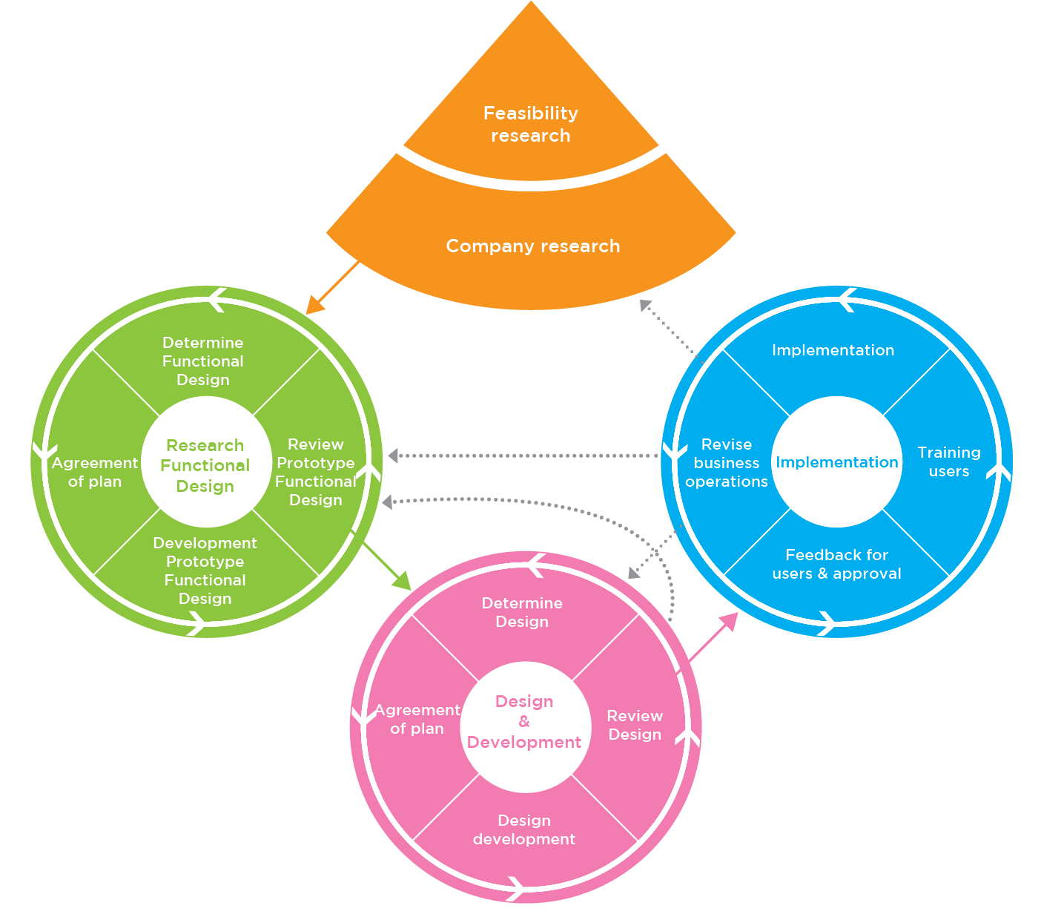Design and development is incremental and evolutionary in nature and is largely driven by regular, iterative user feedback.

Figure 9: Dynamic Systems Development Method

**Planning/Conception-Initiation Phase**

The planning/conception initiation phase contains Business Model Canvas, Gantt chart, Program Workflow, Functional Decomposition Diagram and validation board which is used in developing SulaTroniko.

**Business Model Canvas**

Figure 10 shows what SulaTroniko is and what it is capable of, especially for the users of this system. It is intended to help the authors, publisher, and copywriters who are having problems in finding their needs and to provide a connection between them.

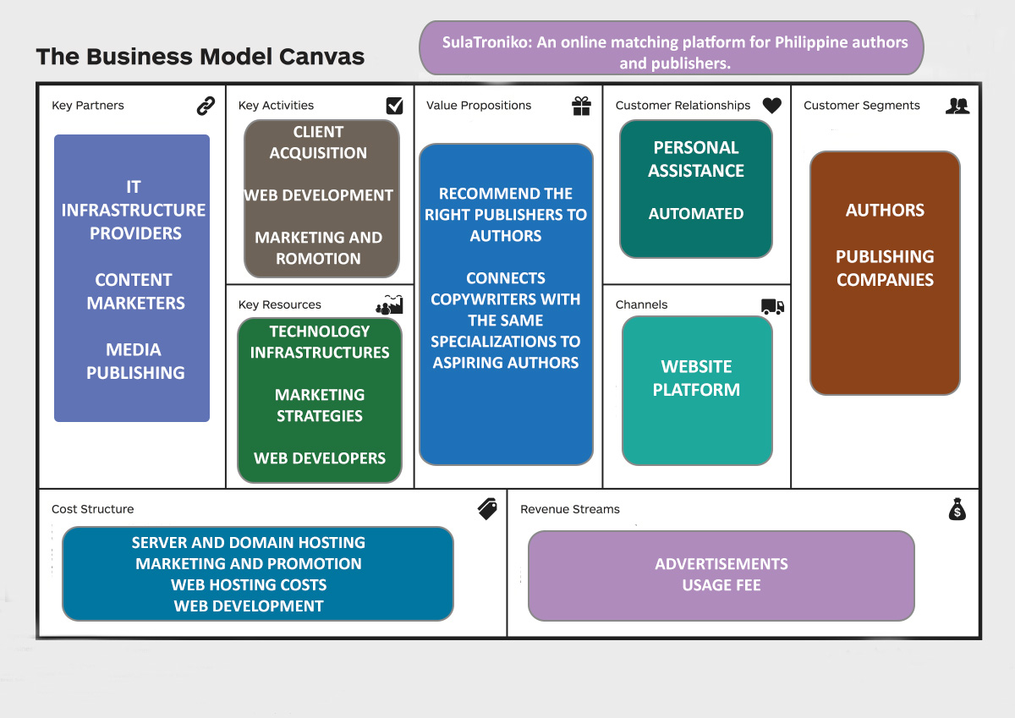

Figure 10: BMC

**Program Workflow**

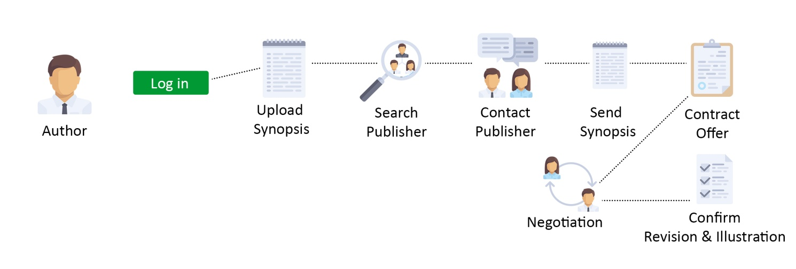 Program workflow is a series of tasks to produce a desired outcome. It describes the sequential steps on how the program works. It is the best way to understand how SulaTroniko actually works.

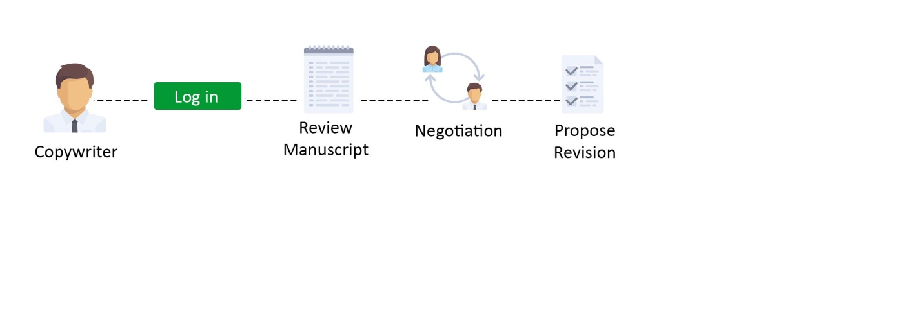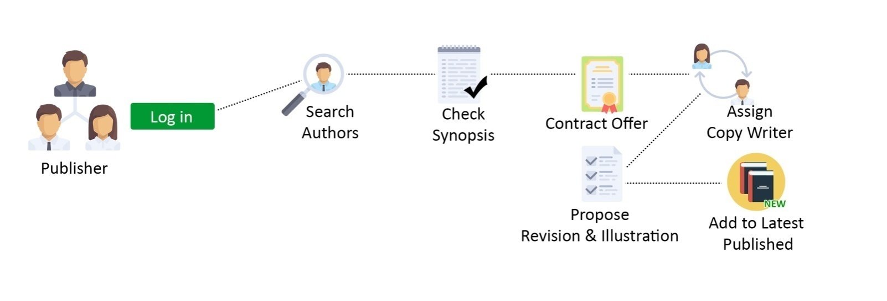

Figure 13: Program Workflow - Copywriter

Figure 12: Program Workflow - Publisher

Figure 11: Program Workflow - Author

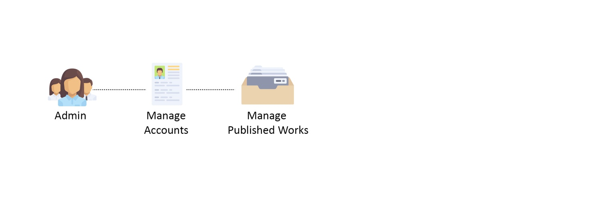

Figure 14: Program Workflow - Admin

**Validation Board (Stage 1)**

**TABLE 2**

**VALIDATION BOARD**

START UP IDEA: SulaTroniko: An Online Matching Platform for Philippine authors and publishers.

STAGE: VALIDATION BOARD STAGE 1

|  |  |  |  |
| --- | --- | --- | --- |
| Experiment | 1 | 2 | 3 |
| Customer | Authors | Publishing Companies | Copywriters |
| Problem | Difficulty in looking for publishing companies which would be willing to publish their works. | Difficulty in searching for authors with good ideas. | Difficulty in editing the specified genre given by the publisher regarding a particular manuscript. |
| Solution |  |  |  |
| Riskiest Assumption | The problem exists. | The problem exist | The problem exists. |
| Success Criteria | 70% through online interview | 70% through personal interview | 70% through personal interview |
| Results & Discussions | 32/38 = 84% VALID | 6/8 = 75% VALID | 8/8 = 100% VALID |
| Learning | 32 out of 38 authors who were interviewed claimed that they find it hard to look for publishers due to the lack of connection in the publishing industry, do not have enough time to look for publishers, fear of being rejected, and the with less publishers found in the locality. | 6 out of 8 publishing companies agreed that online presence would be a great help to attract possible authors. The other two publishers declined the idea since they already have websites established for their companies. | All copywriters experienced the same problem about the difficulty in editing a manuscript with a genre that does not fit to their specialty. |

Based on the data we gathered above, 84% of authors who write online agreed that there is a dire need to establish a website platform that allows authors and publishers to connect with each other. The second column states that other publishing companies have already launched their own websites. However, those websites are only focused towards advertisement and not primarily on seeking for possible authors. The last column, on the other hand, copywriters have faced the same problem regarding the difficulty they experienced in the process of revising manuscripts assigned to them by their publishers. It only shows how hard it is to work on something they have limited knowledge with.

Base on this given data, we conclude that our proposed idea would be a useful tool for authors and publishers as well as its copywriters.

**Gantt Chart**

The planning and scheduling of the system are determined using this technique. This common technique is represented by phased and levels so that it can be easily understood by the readers and the proponents. It shows the schedule of activities that were done and will be done in the development of the project.

SulaTroniko started on April 2017 up to October 2017 for its documentation which has a total of 31 tasks and will start the implementation from November 2017 to March 2018 which also has 14 tasks to be done.

**TABLE 3**

**GANTT CHART**

|  |  |  |
| --- | --- | --- |
| **Task Name** | **Start Date** | **End date** |
|
| **July** | | | | **August** | | | | **September** | | | | **October** | | | |
| 3 | 4 | 1 | 2 | 3 | 4 | 1 | 2 | 3 | 4 | 1 | 2 | 3 | 4 | 1 | 2 | | 3 | 4 |
| Software Engineering Methodology | 10-Apr | 12-Apr |  |  |  |  |  |  |  |  |  |  |  |  |  |  |  |  | |  |  |
| Gantt Chart | 10-Apr | 12-Apr |  |  |  |  |  |  |  |  |  |  |  |  |  |  |  |  | |  |  |
| Customer Validation | 13-Apr | 29-May |  |  |  |  |  |  |  |  |  |  |  |  |  |  |  |  | |  |  |
| Review of Related Literature | 30-May | 11-Jun |  |  |  |  |  |  |  |  |  |  |  |  |  |  |  |  | |  |  |
| Review of Related Studies/Projects | 30-May | 11-Jun |  |  |  |  |  |  |  |  |  |  |  |  |  |  |  |  | |  |  |
| Review of Related Theories (if necessary) | 30-May | 11-Jun |  |  |  |  |  |  |  |  |  |  |  |  |  |  |  |  | |  |  |
| Review of Related Legal Basis (if necessary) | 30-May | 11-Jun |  |  |  |  |  |  |  |  |  |  |  |  |  |  |  |  | |  |  |
|  |  |  |  |  |  |  |  |  |  |  |  |  |  |  |  |  |  |  | |  |  |
| Landing Page | 11-Jun | 12-Aug |  |  |  |  |  |  |  |  |  |  |  |  |  |  |  |  | |  |  |
| Program Flow | 12-Jun | 25-Jun |  |  |  |  |  |  |  |  |  |  |  |  |  |  |  |  | |  |  |
| Functional Decomposition Diagram | 24-Jun | 8-Jul |  |  |  |  |  |  |  |  |  |  |  |  |  |  |  |  | |  |  |
| Storyboard/Wireframe | 30-Jun | 16-Jul |  |  |  |  |  |  |  |  |  |  |  |  |  |  |  |  | |  |  |
| Use Case Diagrams | 15-Jul | 5-Aug |  |  |  |  |  |  |  |  |  |  |  |  |  |  |  |  | |  |  |
| Entity Relationship Diagrams | 15-Jul | 5-Aug |  |  |  |  |  |  |  |  |  |  |  |  |  |  |  |  | |  |  |
| Technology Stack | 15-Jul | 5-Aug |  |  |  |  |  |  |  |  |  |  |  |  |  |  |  |  | |  |  |
| Network Design | 15-Jul | 5-Aug |  |  |  |  |  |  |  |  |  |  |  |  |  |  |  |  | |  |  |
| Deployment Diagram | 15-Jul | 5-Aug |  |  |  |  |  |  |  |  |  |  |  |  |  |  |  |  | |  |  |
| Test Plan | 15-Jul | 5-Aug |  |  |  |  |  |  |  |  |  |  |  |  |  |  |  |  | |  |  |
| Project Scope | 30-Jul | 18-Aug |  |  |  |  |  |  |  |  |  |  |  |  |  |  |  |  | |  |  |
| Project Limitations | 30-Jul | 18-Aug |  |  |  |  |  |  |  |  |  |  |  |  |  |  |  |  | |  |  |
| Objectives of the Study | 30-Jul | 18-Aug |  |  |  |  |  |  |  |  |  |  |  |  |  |  |  |  | |  |  |
| Significance and Impact of the Study | 30-Jul | 18-Aug |  |  |  |  |  |  |  |  |  |  |  |  |  |  |  |  | |  |  |
| Flow of the Study | 30-Jul | 18-Aug |  |  |  |  |  |  |  |  |  |  |  |  |  |  |  |  | |  |  |
| Definition of Terms | 30-Jul | 18-Aug |  |  |  |  |  |  |  |  |  |  |  |  |  |  |  |  | |  |  |
| Rationale of the Study | 30-Jul | 18-Aug |  |  |  |  |  |  |  |  |  |  |  |  |  |  |  |  | |  |  |
| List of Program Modules | 8-Aug | 18-Aug |  |  |  |  |  |  |  |  |  |  |  |  |  |  |  |  | |  |  |
| Business Model Canvas V.1 | 15-Aug | 9-Sep |  |  |  |  |  |  |  |  |  |  |  |  |  |  |  |  | |  |  |
| Roadmap V.1 | 9-Sep | 17-Sep |  |  |  |  |  |  |  |  |  |  |  |  |  |  |  |  | |  |  |
| Explainer/Concept Video V.1 | 3-Aug | 20-Sep |  |  |  |  |  |  |  |  |  |  |  |  |  |  |  |  | |  |  |
| Bibliography | 20-Sep | 29-Sep |  |  |  |  |  |  |  |  |  |  |  |  |  |  |  |  | |  |  |
| Other Relevant Documents for Capstone41 | 1-Oct | 30-Oct |  |  |  |  |  |  |  |  |  |  |  |  |  |  |  |  | |  |  |

**Functional Decomposition Diagram**

FDDs are used by the system analysts to decompose the intended function into a number of sub functions that each solves a part of the problem. The sub function themselves may be further decomposed into yet more primitive functions, and so on. The FDD will serve as a guide to the programmer to know the function needed in the implementation of the system to achieve the objectives of the study.

Figure 15 shows the Functional Decomposition Diagram of SulaTroniko and illustrates the breaking down or decomposing of the complex systems into lower-level functionalities which is much easier to understand and analyze.

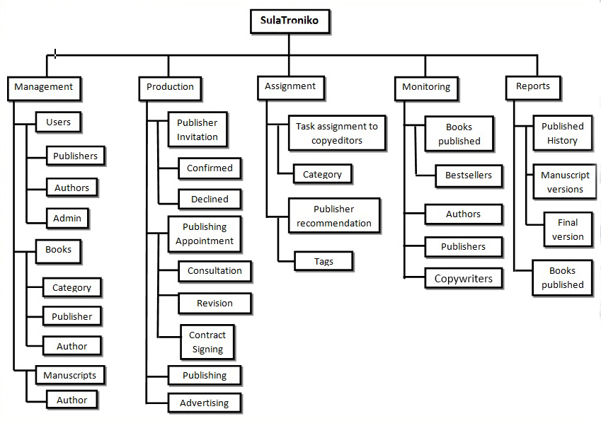

Figure 15: FDD

**Analysis-Design Phase**

This is where the researchers break down the deliverables in the high-level Project Charter into the more detailed business requirements.

**Use Case Diagrams**

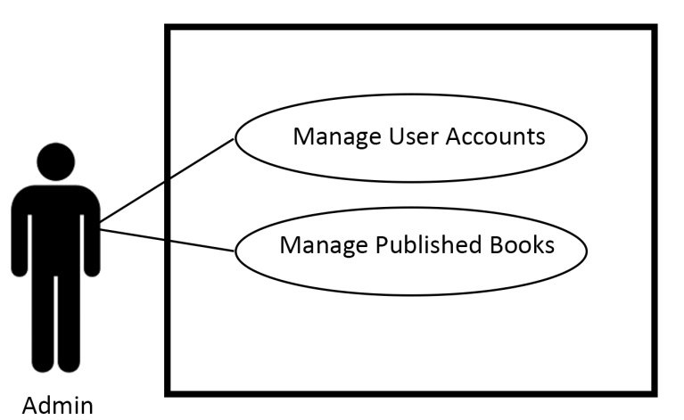Figure 16 shows the interaction between the author and publisher without the interference of the administrator. The administrator can only manage the accounts of each user; however, it shall refrain from participating in the actual transaction.

Figure16:Use Case – Admin

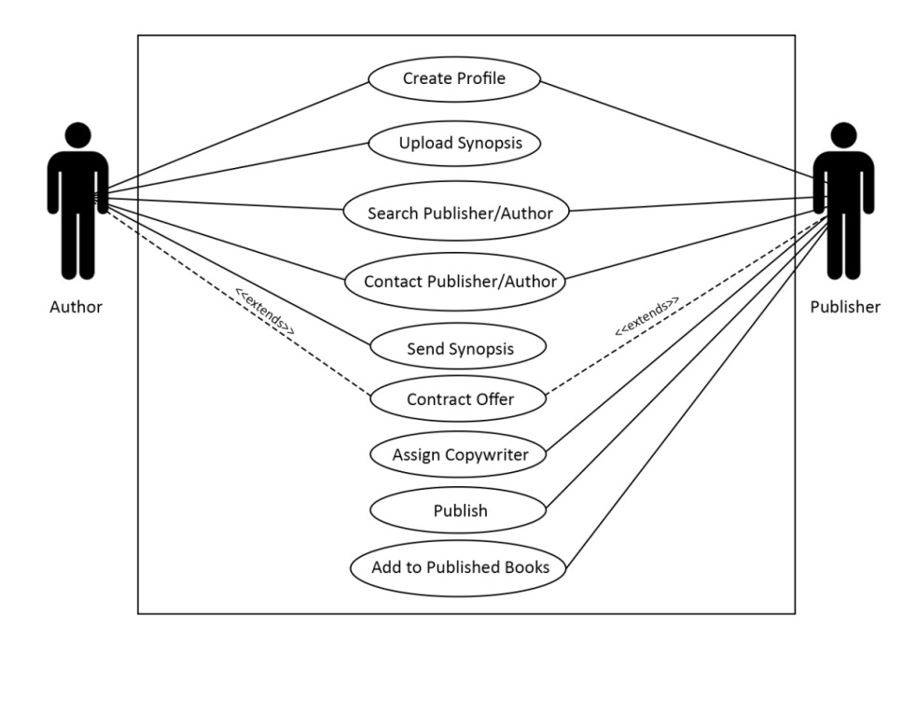Figure 17 shows that once the author successfully creates an account, he/she can upload the synopsis of his/her work and can start looking for publishers to send the synopsis of their work. If the publisher likes the work, it shall assign a copywriter for the author.

Figure17:Use Case – Author to Publisher

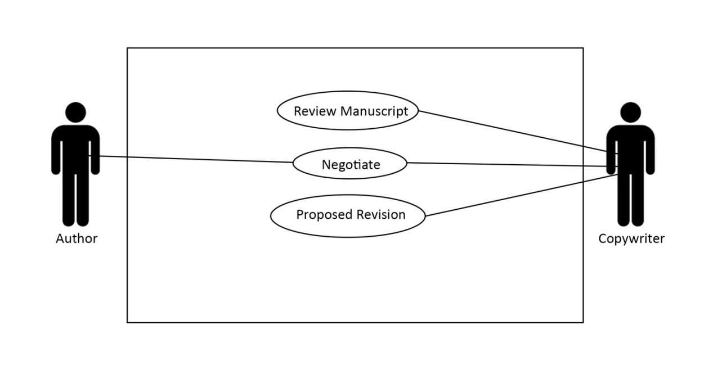Figure 18 illustrates the negotiation between the author and copywriter. Once the revisions are made, the copywriter will continuously update the author by posting it on the working-in-progress area.

Figure17:Use Case – Author to Publisher

Figure18:Use Case – Author to Copywriter

**Story Board**

Storyboard shows the graphic organizer in the form of illustrations displayed in sequence for the purpose of pre-visualizing how SulaTroniko works.

**WEB STORYBOARD**