**Introduction**

This project report outlines the development and functionality of an online KMS activation script designed to activate Windows and Office products using online KMS servers. The script is intended to provide a convenient and automated way for users to activate their software without requiring manual intervention.

**Problem Analysis**

The primary problem addressed by this script is the need for a simple and effective method to activate Windows and Office products without manually entering activation keys. KMS activation offers a potential solution by allowing products to be activated remotely using online servers.

**Key Features and Functionality**

The script offers the following key features:

* **Activation:** Activates Windows and Office products using online KMS servers.
* **Check Activation Status:** Displays the activation status of Windows and Office products.
* **Create Renewal Task:** Creates a scheduled task to automatically renew the activation.
* **Complete Uninstall:** Removes the renewal task and clears KMS cache.
* **Extract OEM Folder:** Creates a folder containing files for pre-activation during Windows installation.
* **Supported Windows and Office Versions:** The script claims to support Windows 7 (VL), Windows 8/8.1/10, Windows Server 2008R2/2012/2012R2/2016/2019, and Office (VL) 2010/2013/2016/2019. However, compatibility may vary depending on specific versions and configurations.

**Technical Details**

**Language:** The script is written in the Batch scripting language, which is a scripting language used in Windows environments.

**Libraries and Tools:** The script utilizes various Windows commands and tools, such as:

* fsutil: Checks for administrator privileges.
* color: Sets the command prompt's color.
* mode: Configures the command prompt's dimensions.
* title: Sets the command prompt's title.
* setlocal: Enables local variables.
* cls: Clears the screen.
* echo: Prints messages to the console.
* choice: Prompts the user for input.
* call: Calls another script or batch file.
* del: Deletes files.
* md: Creates directories.
* cd: Changes the current directory.
* if: Performs conditional checks.
* for: Iterates over a set of items.
* set: Sets variables.
* wmic: Interacts with Windows Management Instrumentation (WMI) to retrieve system information and perform management tasks.
* reg: Modifies the Windows registry.

**KMS (Key Management Service):** KMS is a licensing system used by Microsoft to activate volume licensed versions of Windows and Office products. KMS servers act as central activation authorities, verifying product keys and granting activation licenses to client machines. KMS offers benefits such as centralized management, reduced administration, improved security, and scalability

**OEM Folder:** This folder contains files that can be used to pre-activate Windows during installation. By placing the OEM folder in the installation media's "sources" directory, Windows can activate automatically upon first online connection.

**Interface:**

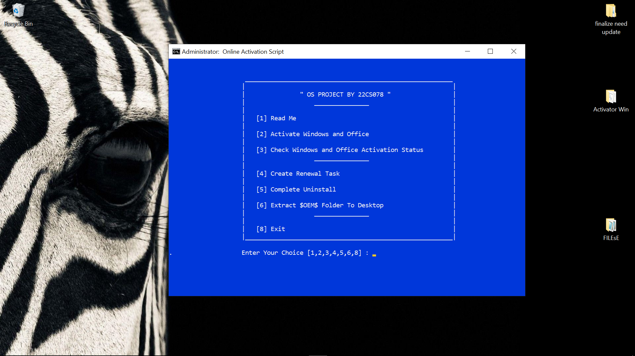

**Conclusion**

This project report provides an overview of the online KMS activation script, including its functionality, technical details, and limitations. It's essential to use this script with caution and consider the potential risks involved. For legitimate software use, it's recommended to purchase licenses through authorized channels.