**SRS**

## INTRODUCTION

### **Introduction:**

* Technology has become an inevitable part of our lives. We cannot imagine to survive without technology in today’s fast-moving world. When employment, socialization and cultural propagation happens with globalization, we cannot survive without technological involvements. Technological advancements have had a huge impact on the online education,

### **Project Summary:**

* In our website, there are going to be 3categories of account - User, Administrator, and Faculty. **Administrator** can manage the website, can add and remove categories, courses and hide inappropriate reviews written by users. **Users** can explore the website without login but they can't use the main features of our website and to use them, they need to join our website and then they can login from their respective devices and browse courses which they like to join . Faculty can create meeting and provide materials.

### **Main Purpose:**

* Our main purpose is to continuously provide better education
* The purpose of our website is to provide a better education and help them to prepare for exams

### **Scope:**

* Our website is **user-friendly** and is developed by keeping in mind about every type of students and their needs, student can choose courses. All those students provide better course with affordable price.

## SYSTEM REQUIREMENT STUDY

#### **User:**

* + - User will be a visitor if he visits our website without login. User will have to create an account and after that user can login to our website using the email and password. Users can select courses from our website and can also select a batch of choice .

#### **Admin:**

* Admin will maintain the website. Admin can add, update and delete categories. Admin can add new courses and can also remove courses which are not available right now. Admin can update course description and other information regarding courses. Admin can view all the reviews written by users and will be able to hide inappropriate reviews written by users.

#### **Faculty :**

Faculty will create a meeting. Faculty can upload materials for students and conduct tests.

### 

#### **Regulatory policies:**

* + Look and feel as well as the user interface of this website should be easy with user-friendly navigation. Commonly used icons are used for easy understanding of users.

#### **Reliability requirement:**

* + On our website, we have used different validation like e-mail id validation, and contact number validation and user authentication.

#### **Safety & Security consideration:**

* + The website has a high level of security and safety consideration above any of features. So that an unauthorized person cannot access the website.
  + User doesn’t log into the website and that the user be able to see explore the website and can't be able to use main features. User without login can't select courses etc. It is designed to be a highly protected and safe website where the users possess access rights regarding to its roles only

## SYSTEM ANALYSIS

### **Study of Current System:**

* I have analysed many online websites which are related to our sites. As we know all websites have their pros and cons in their functionality. In our case many well- known companies have already made the kind of websites that we are supposed to make but our functions of websites and the service given make it different from other websites.
  + - Most of the websites which are related to our project have the same functionality and they just change the name and UI of the website.

### **Function of the System:**

**Use Case Diagram of User:**

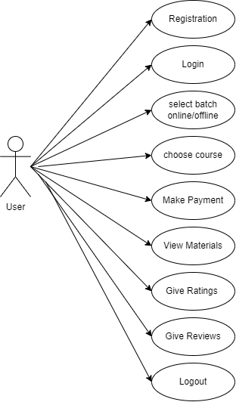

#### 

#### 

#### 

#### 

#### 

#### 

#### 

#### 

#### 

#### 

#### 

#### 

#### 

#### 

#### 

#### 

#### 

#### 

#### 

#### **Use Case Diagram of Admin :**

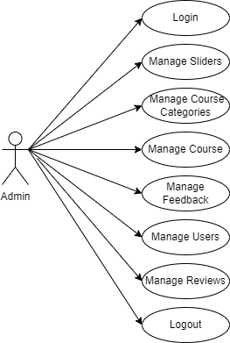

#### 

#### 

#### 

#### 

#### 

#### 

#### 

#### 

#### 

#### 

#### 

#### 

#### 

#### 

#### 

#### 

#### 

#### 

#### 

#### 

#### 

#### 

#### **Use Case Diagram of Faculty:**

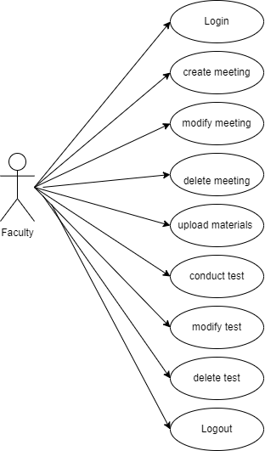

#### **Data Dictionary:**

**User:** Table name: **users**

| **Field name** | **Data type** | **Size** | **Constraints** | **Description** |
| --- | --- | --- | --- | --- |
| **id** | bigInt | 20 | Primary Key | It stores the id of user |
| **name** | varchar | 191 | Not Null | It stores the name of user |
| **lname** | varchar | 191 | Null | It stores the last name of user |
| **email** | varchar | 191 | Foreign Key | It stores the email id of user |
| **password** | varchar | 191 | Not Null | It stores the password of user |
| **phone** | varchar | 191 | Null | It stores the user's phone number |
| **gender** | varchar | 191 | Null | It stores the user’s gender |
| **dob** | date | - | Null | It stores the user’s DOB |
| **address1** | varchar | 191 | Null | It stores the user's address |
| **address2** | varchar | 191 | Null | It stores the user's address |
| **city** | varchar | 191 | Null | It stores the user's city name |
| **state** | varchar | 191 | Null | It stores the user's state name |
| **country** | varchar | 191 | Null | It stores the user's country name |
| **pincode** | int | 10 | Null | It stores the user's area pincode |
| **created_at** | timestamp | - | Null | It stores the date and time of account creation |
| **updated_at** | timestamp | - | Null | It stores the date and time of account updating |

**Categories : Table name : categories**

| **Field name** | **Data type** | **Size** | **Constraints** | **Description** |
| --- | --- | --- | --- | --- |
| **id** | bigInt | 20 | Primary Key | It stores the id of category |
| **name** | varchar | 191 | Not Null | It stores the name of category |
| **description** | longtext | - | Not Null | It stores the description of category |

| **duration** | varchaf | 4 | Default - 0 | It stores the status of duration |
| --- | --- | --- | --- | --- |
| **rating** | tinyInt | 4 | Default - 0 | It stores the popular status of category |
| **image** | varchar | 191 | Not Null | It stores the image of category |
| **created_at** | timestamp | - | Null | It stores the date and time of category creation |
| **updated_at** | timestamp | - | Null | It stores the date and time of category updating |

**Rating :**Table name: **ratings**

| **Field name** | **Data type** | **Size** | **Constraints** | **Description** |
| --- | --- | --- | --- | --- |
| **id** | bigInt | 20 | Primary Key | It stores the id of rating |
| **user_id** | bigInt | 20 | Foreign Key | It stores the id of user |
| **course_id** | bigInt | 20 | Foreign Key | It stores the id of course |
| **stars_rated** | int | 10 | Not Null | It stores the rating course |
| **created_at** | timestamp | - | Null | It stores the date and time of rating creation |
| **updated_at** | timestamp | - | Null | It stores the date and time of rating updating |

**Reviews :** Table name: **reviews**

| **Field name** | **Data type** | **Size** | **Constraints** | **Description** |
| --- | --- | --- | --- | --- |
| **id** | bigInt | 20 | Primary Key | It stores the id of review |
| **user_id** | bigInt | 20 | Foreign Key | It stores the id of user |
| **course_id** | bigInt | 20 | Foreign Key | It stores the id of course |
| **user_review** | mediumtext | - | Not Null | It stores the review of course |
| **review_status** | tinyInt | 4 | Not Null | It stores the status of review |
| **created_at** | timestamp | - | Null | It stores the date and time of rating creation |
| **updated_at** | timestamp | - | Null | It stores the date and time of rating updating |

**Sliders :**Table name: **sliders**

| **Field name** | **Data type** | **Size** | **Constraints** | **Description** |
| --- | --- | --- | --- | --- |
| **id** | bigInt | 20 | Primary Key | It stores the id of slider |
| **link** | mediumtext | - | Not Null | It stores the link of course |
| **image** | varchar | 191 | Not Null | It stores the image of carousel |
| **status** | tinyInt | 4 | Default - 0 | It stores the status of carousel image |
| **created_at** | timestamp | - | Null | It stores the date and time of slider creation |
| **updated_at** | timestamp | - | Null | It stores the date and time of slider updating |

**Faculty :**Table name:Faculty

| **Field name** | **Data type** | **Size** | **Constraints** | **Description** |
| --- | --- | --- | --- | --- |
| **id** | bigInt | 20 | Primary Key | It stores the id of slider |
| **name** | mediumtext | - | Not Null | It stores the link of course |
| **image** | varchar | 191 | Not Null | It stores the image of carousel |
| **status** | tinyInt | 4 | Default - 0 | It stores the status of carousel image |
| **created_at** | timestamp | - | Null | It stores the date and time of slider creation |
| **updated_at** | timestamp | - | Null | It stores the date and time of slider updating |

**Meeting:**Table name:Meetinh

| **Field name** | **Data type** | **Size** | **Constraints** | **Description** |
| --- | --- | --- | --- | --- |
| **id** | bigInt | 20 | Primary Key | It stores the id of meeting |
| **name** | varchar | -255 | Not Null | It stores the name of meeting |
| **duration** | datetime |  | Not Null | It stores the time duration of meeting |
| **created_at** | timestamp | - | Null | It stores the date and time of slider creation |
| **updated_at** | timestamp | - | Null | It stores the date and time of slider updating |

**Functional & Behavioral Modeling:**

#### **Data Flow Diagram (0 Level):**

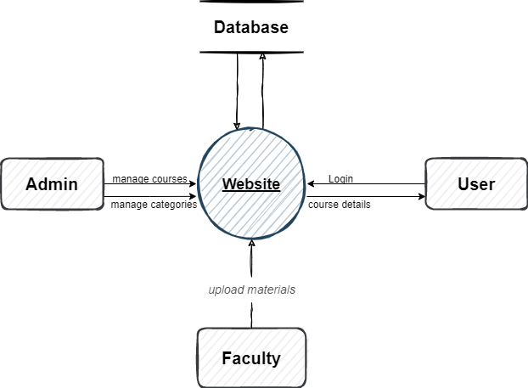

* **Admin**

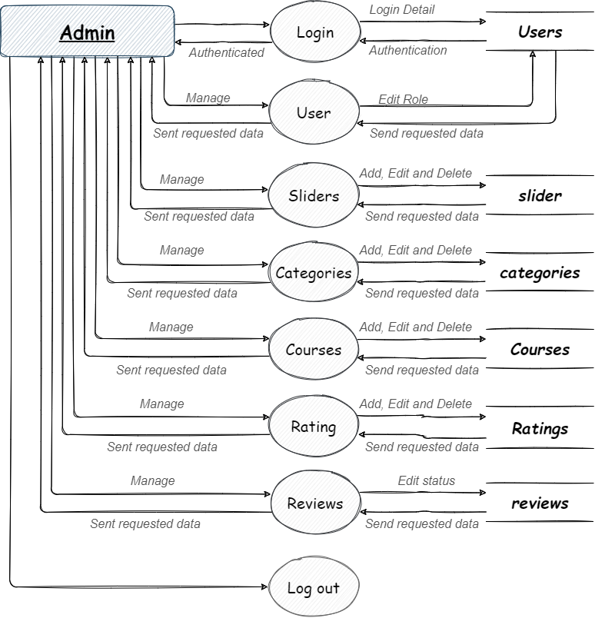

* **User**

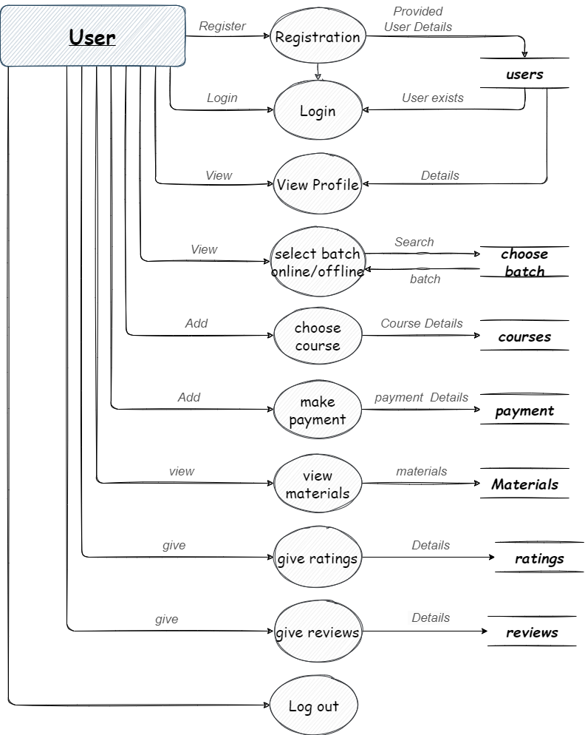

* **Faculty**

