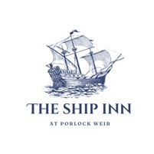
The Ship Inn Porlock Weir
CMS User Manual & Client Guide
System: Outstatic CMS & Admin Tools
This is the definitive instruction manual for managing your website, updating downloadable menus, adding gallery photos, and editing pages on theshipinnporlockweir.co.uk.

1. How to Log In
1. In your web browser, go to: https://theshipinnporlockweir.co.uk/outstatic
2. Click "Sign in with GitHub".
3. Enter Username: hello@theshipinnporlockweir.co.uk and Password: theshipinnta248pb!
4. If prompted on screen, click "Authorize".

2. Understanding the Dashboard
The left sidebar of your Outstatic dashboard gives you access to all key website sections:
- Pages — Controls core website content (Home, Food & Drink, Contact, Rooms, etc.).
- Menus — Displays and manages all downloadable food & drink PDF menus.
- Gallery — Controls all photos and categories shown on the Photo Gallery page.
- Events — Displays and schedules upcoming live music, pub events, and promotions.
- News — Controls articles and news updates.
- Media Library — Central repository for all uploaded images.

3. How to Upload and Use Images in Outstatic
Step 1: Uploading Images to the Media Library
1. In the left sidebar, click Media Library.
2. Click "Add Media" and choose the image from your computer (.webp, .jpg, .png).
3. The photo will appear immediately in your media library.
Step 2: Assigning Images to Pages
• Cover Images (Standard Pages): Click the Cover Image box in the right sidebar, pick your photo from the Media Library, and click Save.
• Hero Rotating Images (Home Page): Copy the image path from the Media Library (e.g., /images/ship-inn.webp) and paste it into Hero Image 1, 2, or 3.

4. How to Edit and Save Any Page
1. In the left sidebar, click Pages, then click the page you want to update.
2. Focus on the Right Sidebar fields. (The large center editor is for internal notes only).
3. If a field shows "+ Create", click it to open the text input box.
4. Ensure Status is set to "Published" (not Draft).
5. Click the black "Save" button in the top-right corner.
6. Wait 1–2 minutes, then refresh your live website to see changes.

5. What Each Field Changes (Page by Page)
🏠 The Homepage
- Hero Image One, Two, Three: Giant rotating background photos behind the main welcome text.
- Strapline: The italic text directly below the logo ("Historic charm meets modern comfort").
- Intro Paragraphs 1 to 5: The core welcoming text in the middle section of the home page.
- Feature Cards 1, 2, 3: The three promotional cards at the bottom (Rooms, Pub & Restaurant, Location).
🍷 Food & Drink Page
What you see on the website | Field to edit in Outstatic (Right Sidebar)
Wide banner photo at the top | Cover Image
Left column introductory text | Food & Drink Intro Para One
Lagers, Ciders, Ales beer lists | Lagers List, Ciders List, Ales List
Breakfast serving details | Breakfast Description & Times
📞 Contact Page (Global Information)
Note: Editing the Contact page automatically updates contact details across the ENTIRE site (Footer, Header, Legal):
What you see on the website | Field to edit in Outstatic (Right Sidebar)
Phone & Email everywhere | Phone Number, Email Address
Address in Footer & Header | Address Line One, Two, Town, Postcode
Daily opening hours | Opening Hours (Monday - Sunday)
Food serving times in Footer | Kitchen Close Info

6. How to Manage & Upload Menus
⚠️ Requirement: Menus must be in PDF format (.pdf). Word files or images should be exported/saved as PDF before uploading.
Method 1: One-Click Menu Manager (Recommended)
1. Go to: https://theshipinnporlockweir.co.uk/admin/menus
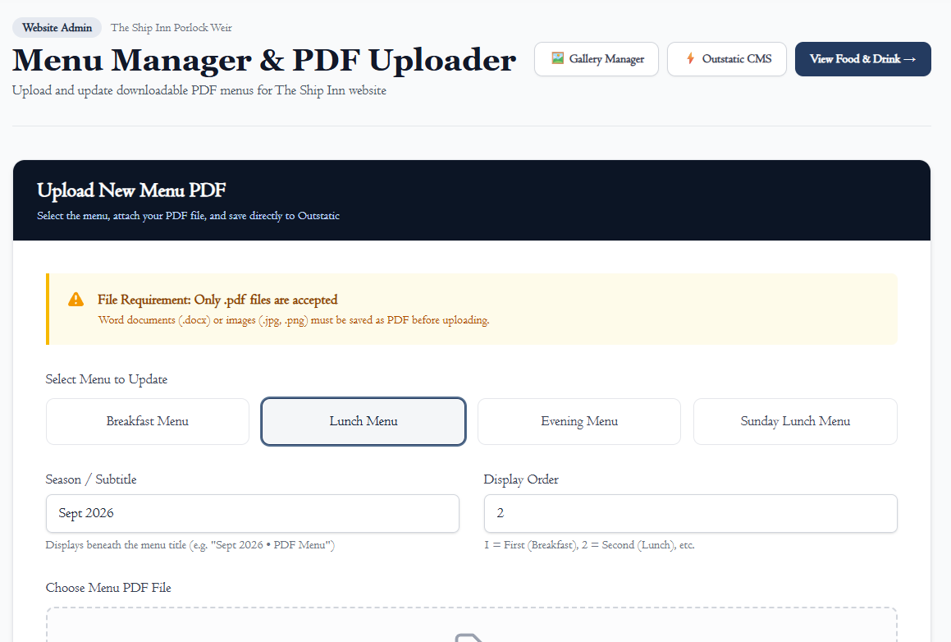 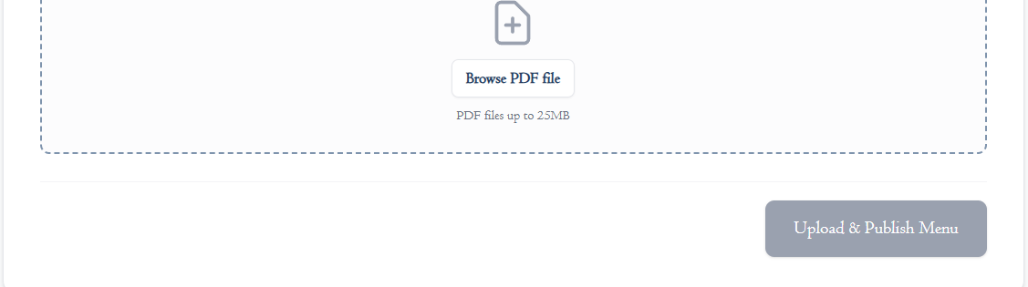
2. Select the menu (Breakfast Menu, Lunch Menu, Evening Menu, Sunday Lunch Menu, or Custom Menu).
3. Enter the Season / Subtitle (e.g. "Autumn 2026" or "Served 12:00 PM – 3:00 PM").
4. Click "Browse PDF file" and choose your .pdf file.
5. Click "Upload & Publish Menu". Live website & Outstatic update automatically in 1–2 minutes!
Method 2: Managing via Outstatic Dashboard
1. Click Menus in the left sidebar of Outstatic.
2. Click any menu to edit its subtitle, display order, or toggle Status from Published to Draft (to temporarily hide a menu).
3. Click Save.

7. How to Manage the Photo Gallery
Method 1: Dedicated Gallery Manager (Recommended)
- Go to: https://theshipinnporlockweir.co.uk/admin/gallery
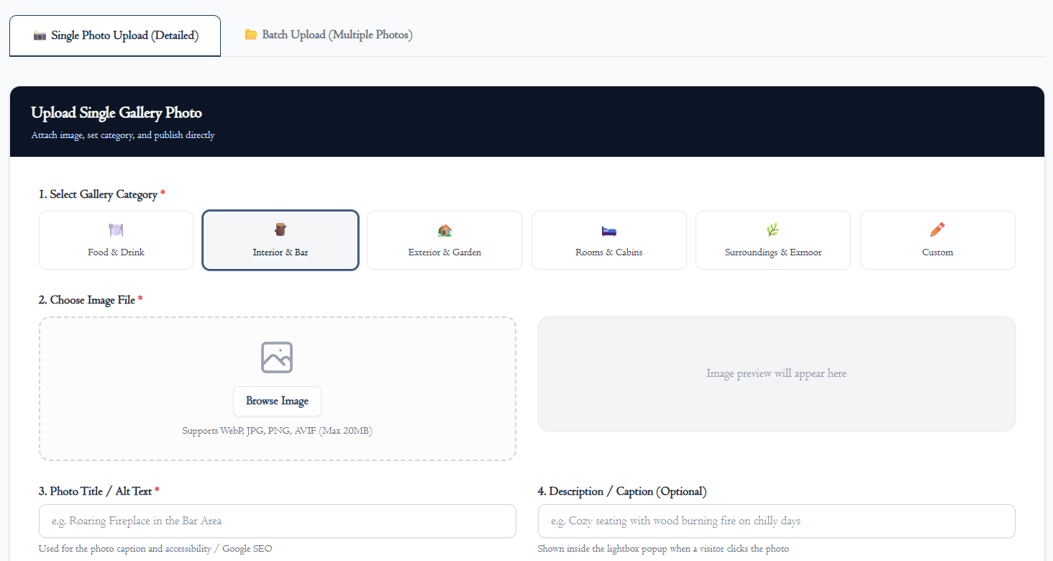
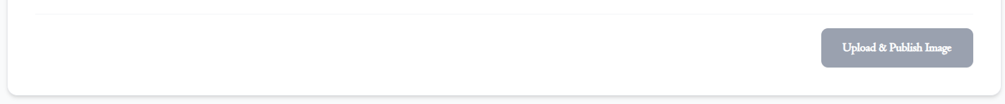
2. Choose Single Photo Upload or Batch Upload (for uploading multiple photos at once).
3. Select Category: Food & Drink, Interior & Bar, Exterior & Garden, Rooms & Cabins, Surroundings, or Custom.
4. Click "Browse Image" to pick your photo (.webp, .jpg, .png, .avif) and preview it.
5. Enter a Photo Title / Alt Text and optional Caption.
6. Click "Upload & Publish Image". The photo goes live and syncs with Outstatic!
Method 2: Managing via Outstatic Dashboard
1. Click Gallery in the left sidebar.
2. Click "New" to create a photo entry.
3. Set Title, Cover Image, and Category in the right sidebar.
4. Set Status to Published (or Draft to hide) and click Save.

8. How to Add a New Event or News Article
1. Click Events or News in the left sidebar of Outstatic.
2. Click the "New" button in the top right.
3. In the centre screen: Type your headline in the Title box and write your story/event text below it.
4. In the right sidebar: Select the Date, upload a Cover Image, and enter a short Description.
5. Set Status to "Published" and click Save.

9. Quick Summary: Which Tool Should I Use?
Task | Best Tool | Web Link
Upload a new PDF food menu | Menu Manager | https://theshipinnporlockweir.co.uk/admin/menus
Upload new photos to the gallery | Gallery Manager | https://theshipinnporlockweir.co.uk/admin/gallery
Edit phone number, address, or hours | Outstatic Pages (Contact) | https://theshipinnporlockweir.co.uk/outstatic
Add an upcoming live music event | Outstatic Events | https://theshipinnporlockweir.co.uk/outstatic
Publish a news story or announcement | Outstatic News | https://theshipinnporlockweir.co.uk/outstatic
The Ship Inn, Porlock Weir — TA24 8PB Website & CMS Managed by itsmyapp (https://itsmyapp.co.uk) Manual Version 1.5 — Updated 23 September 2026

