Answer the following questions based on the trace file named: http-wireshark-
trace1-1.

1. Is your browser running HTTP version 1.0, 1.1, or 2? What version of HTTP is
the server running?

Ans : HTTP/1.1

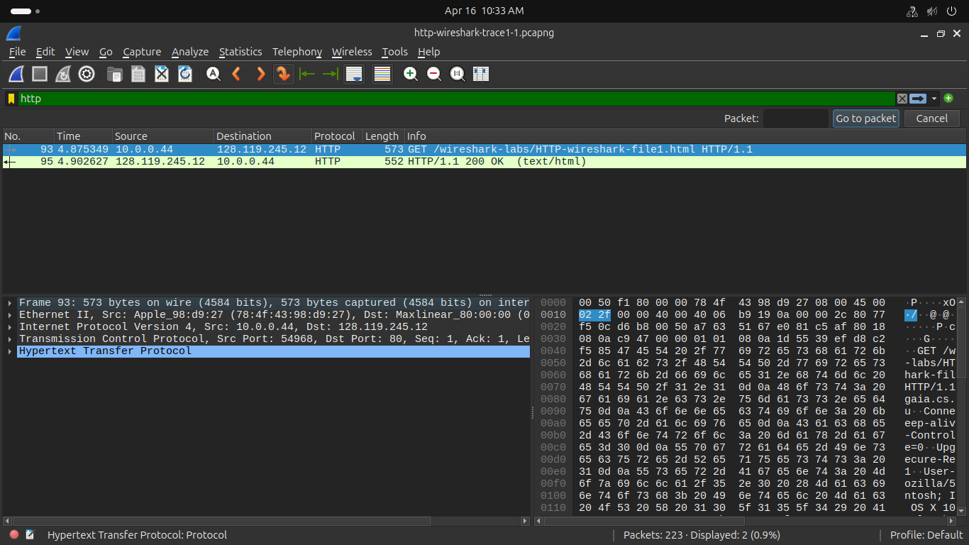

2. What languages (if any) does your browser indicate that it can accept to the server?

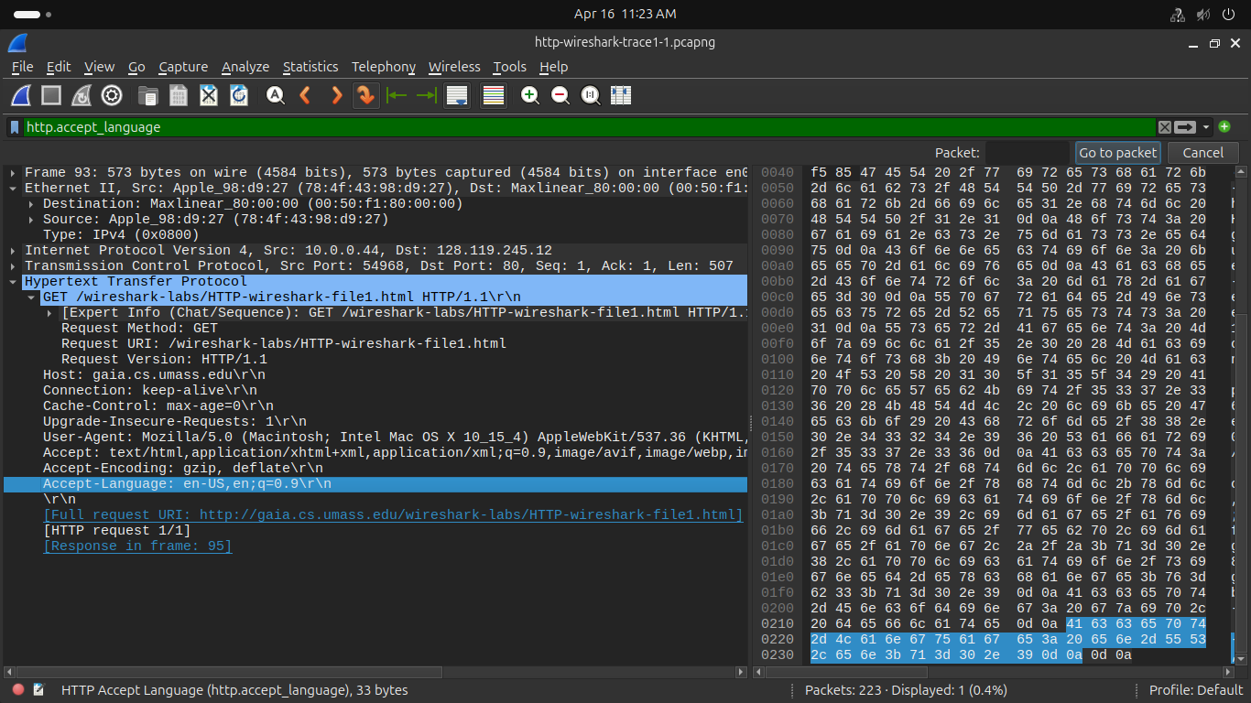

3. What is the IP address of your computer? What is the IP address of the
gaia.cs.umass.edu server?

Ans:
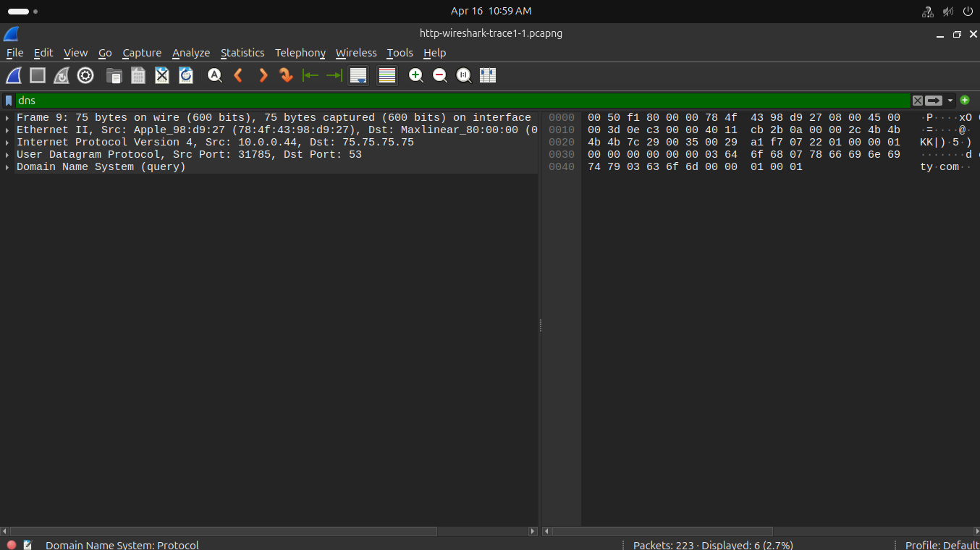

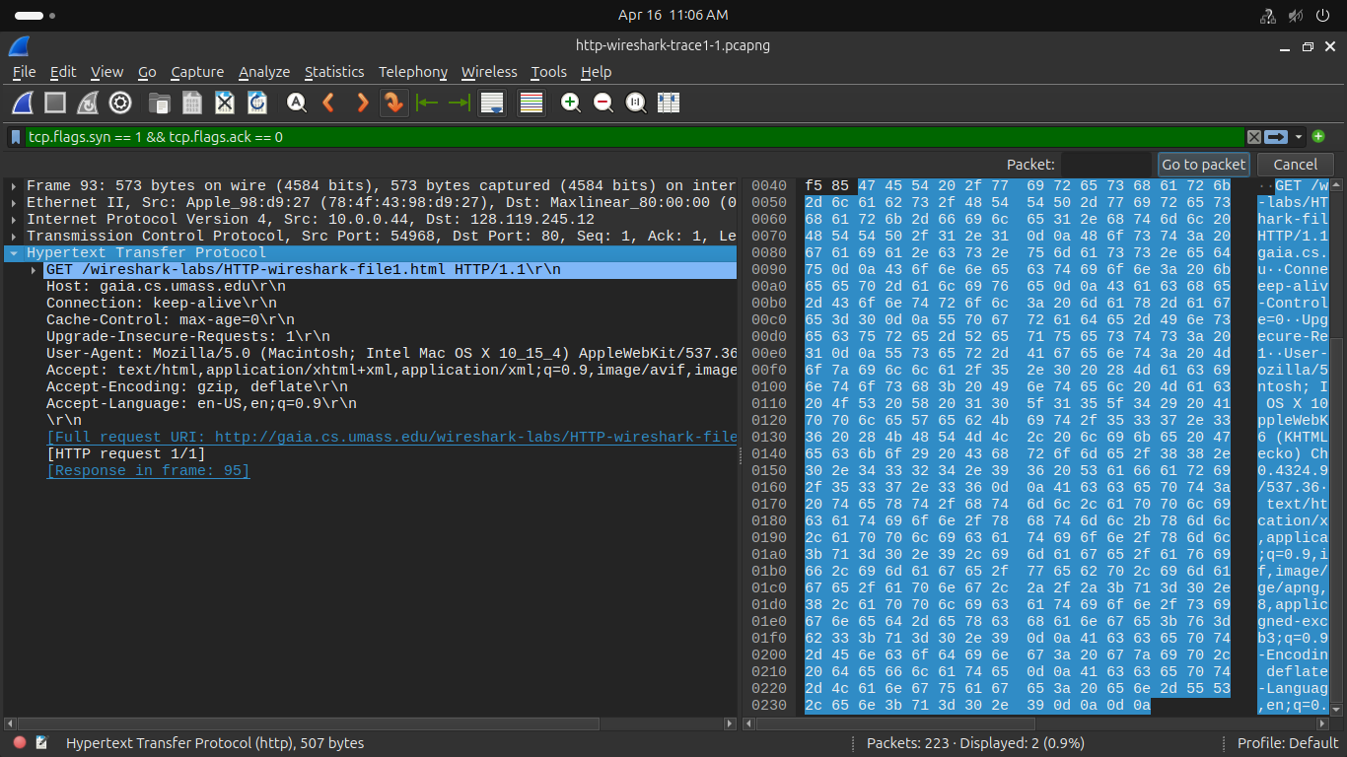

4. What is the status code returned from the server to your browser?

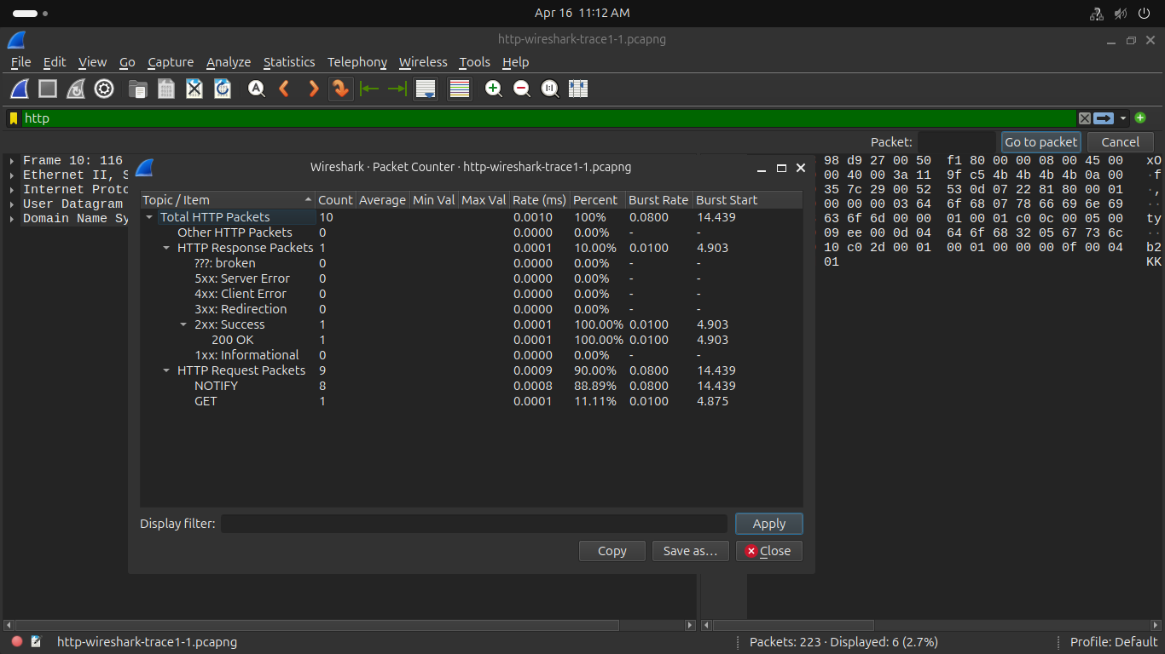

5. When was the HTML file that you are retrieving last modified at the server?
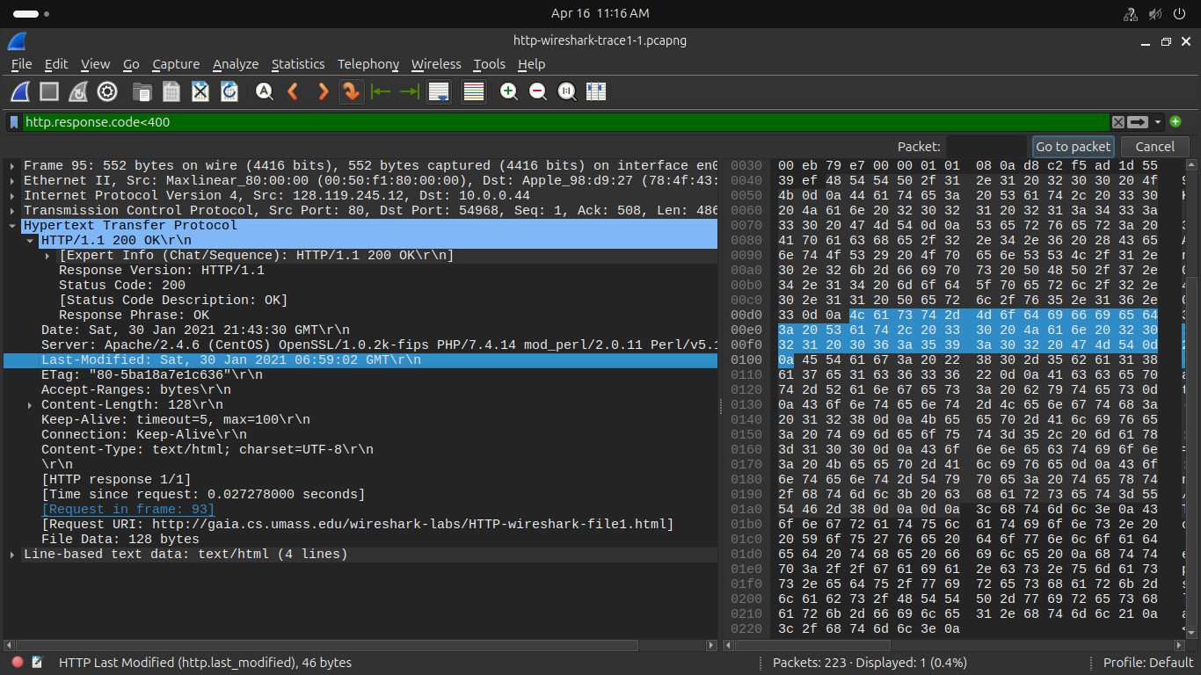

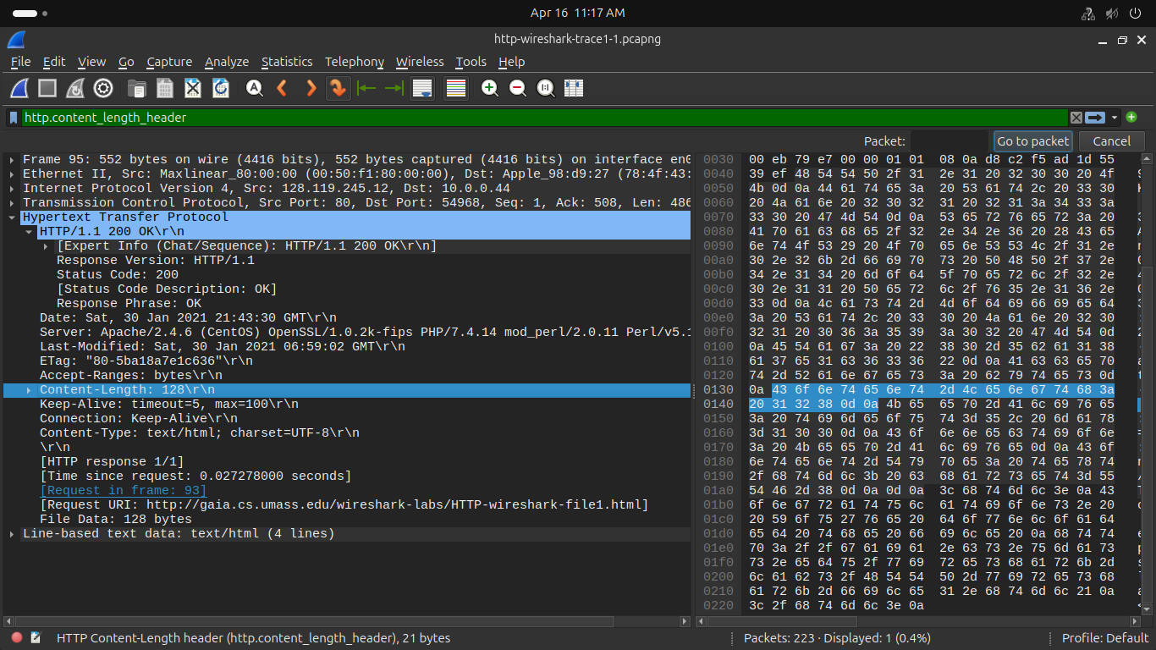
6. How many bytes of content are being returned to your browser?

HTTP CONDITIONAL GET/response interaction
Answer the following question based on the trace file: http-wireshark-trace2-1.

7. Inspect the contents of the first HTTP GET request from your browser to the
server. Do you see an “IF-MODIFIED-SINCE” line in the HTTP GET?

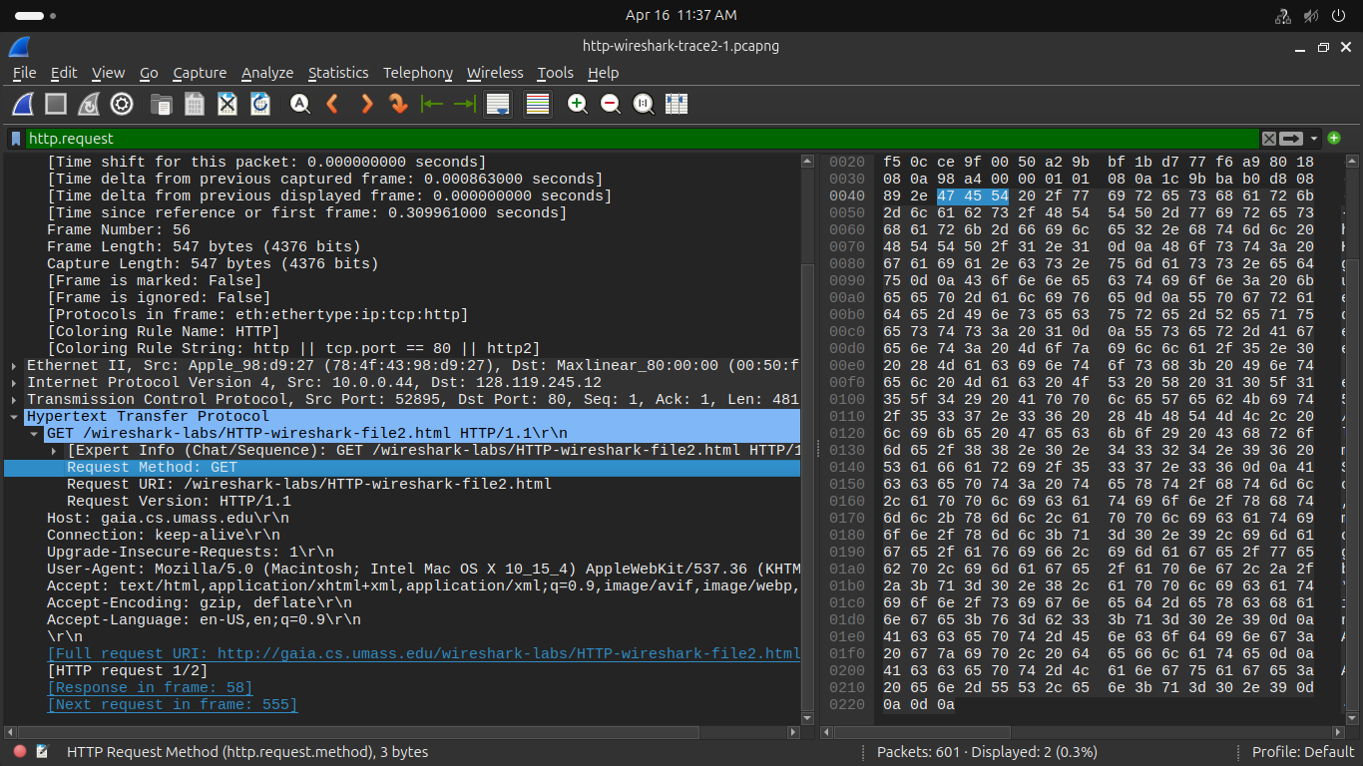

8. Inspect the contents of the server response. Did the server explicitly return thecontents of the file? How can you tell?

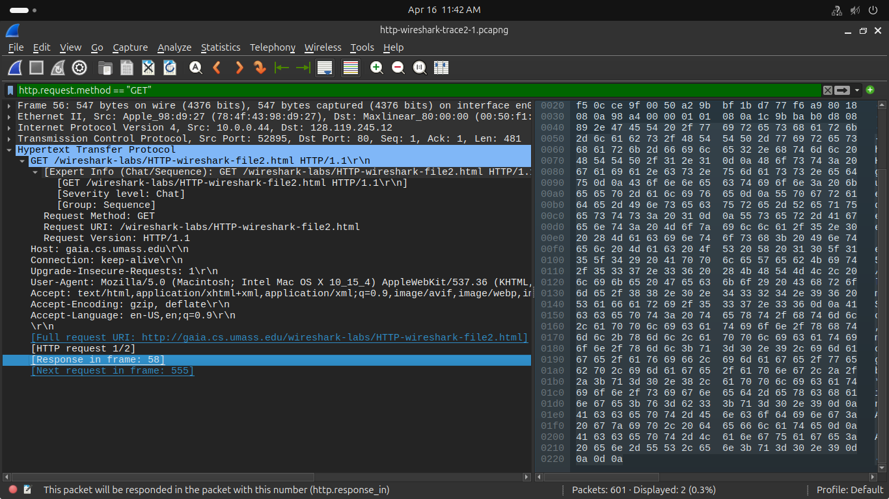

9. Now inspect the contents of the second HTTP GET request from your browser to
the server. Do you see an “IF-MODIFIED-SINCE:” line in the HTTP GET1? If
so, what information follows the “IF-MODIFIED-SINCE:” header?

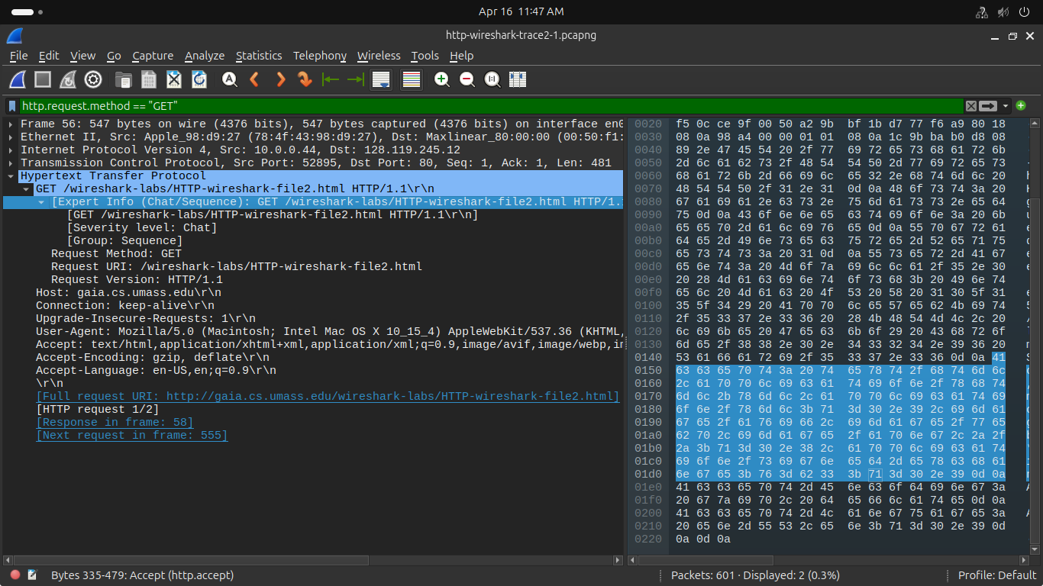

10. What is the HTTP status code and phrase returned from the server in response to
this second HTTP GET? Did the server explicitly return the contents of the file?
Explain.

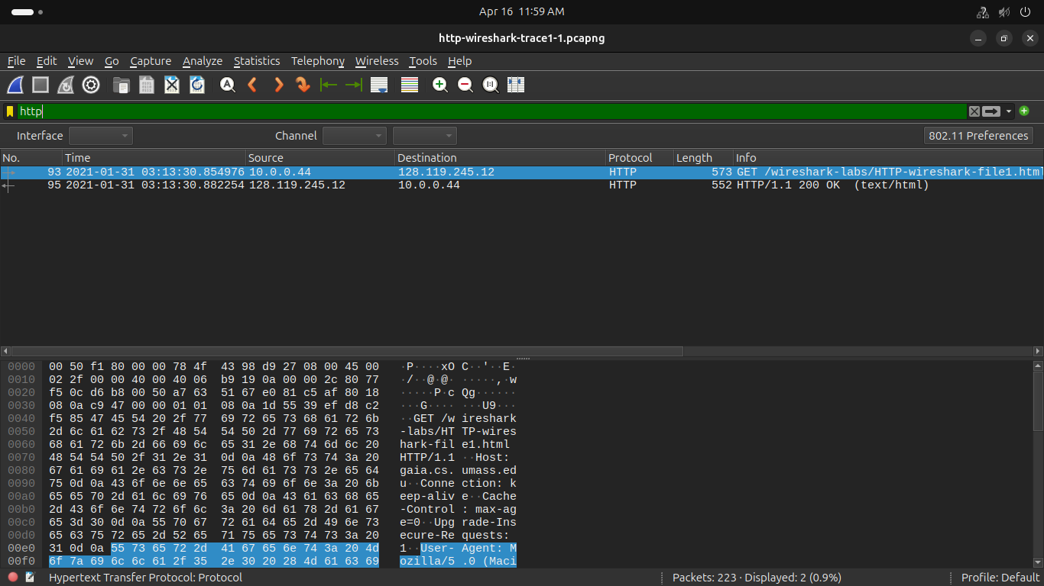

Retrieving Long Documents
Answer the following questions based on the trace file named : http-wireshark-trace3-1

11. How many HTTP GET request messages did your browser send? Which packet
number in the trace contains the GET message for the Bill or Rights ?

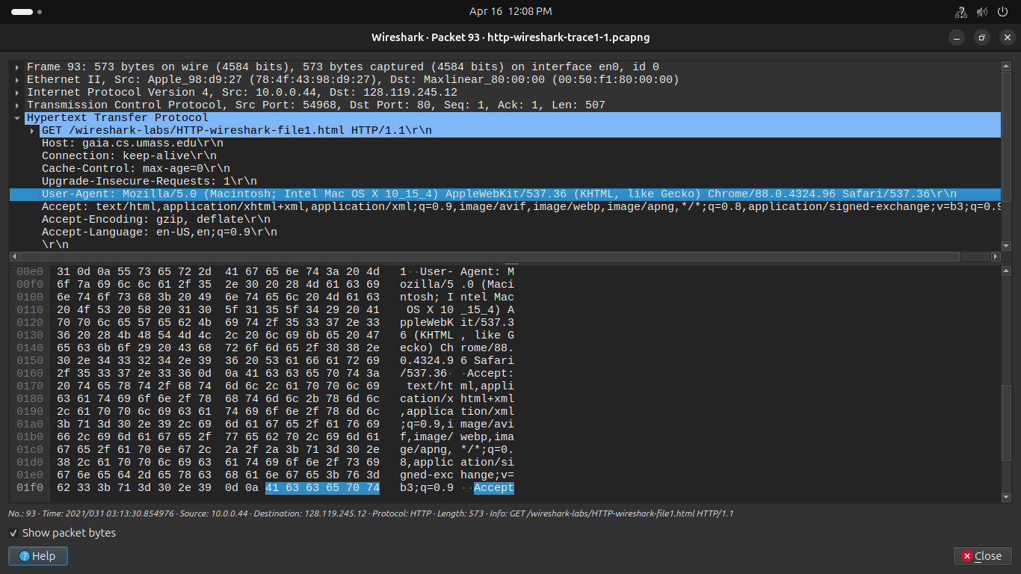

12. Which packet number in the trace contains the status code and phrase associated
with the response to the HTTP GET request?
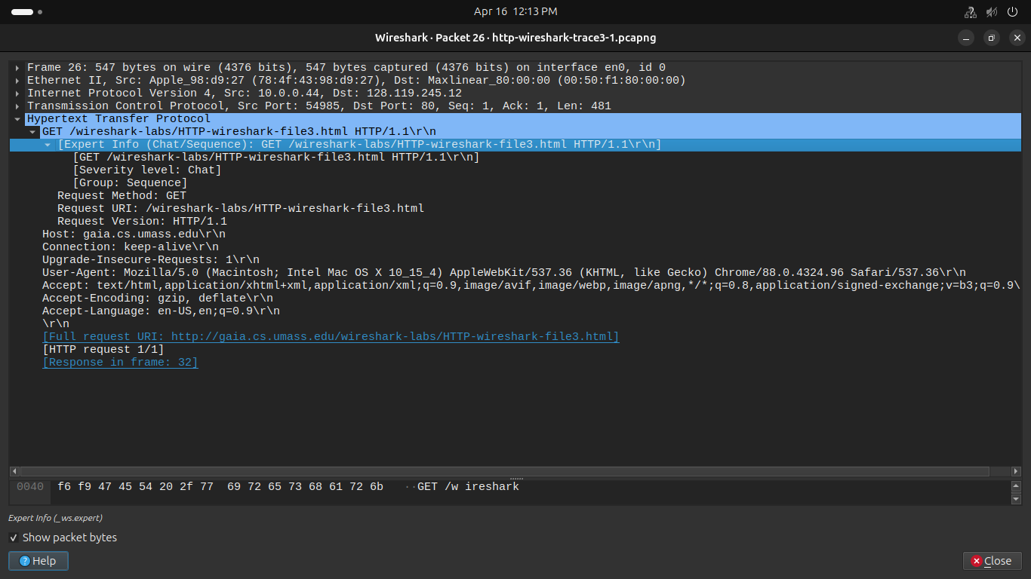

13. What is the status code and phrase in the response?

14. How many data-containing TCP segments were needed to carry the single HTTP
response and the text of the Bill of Rights?

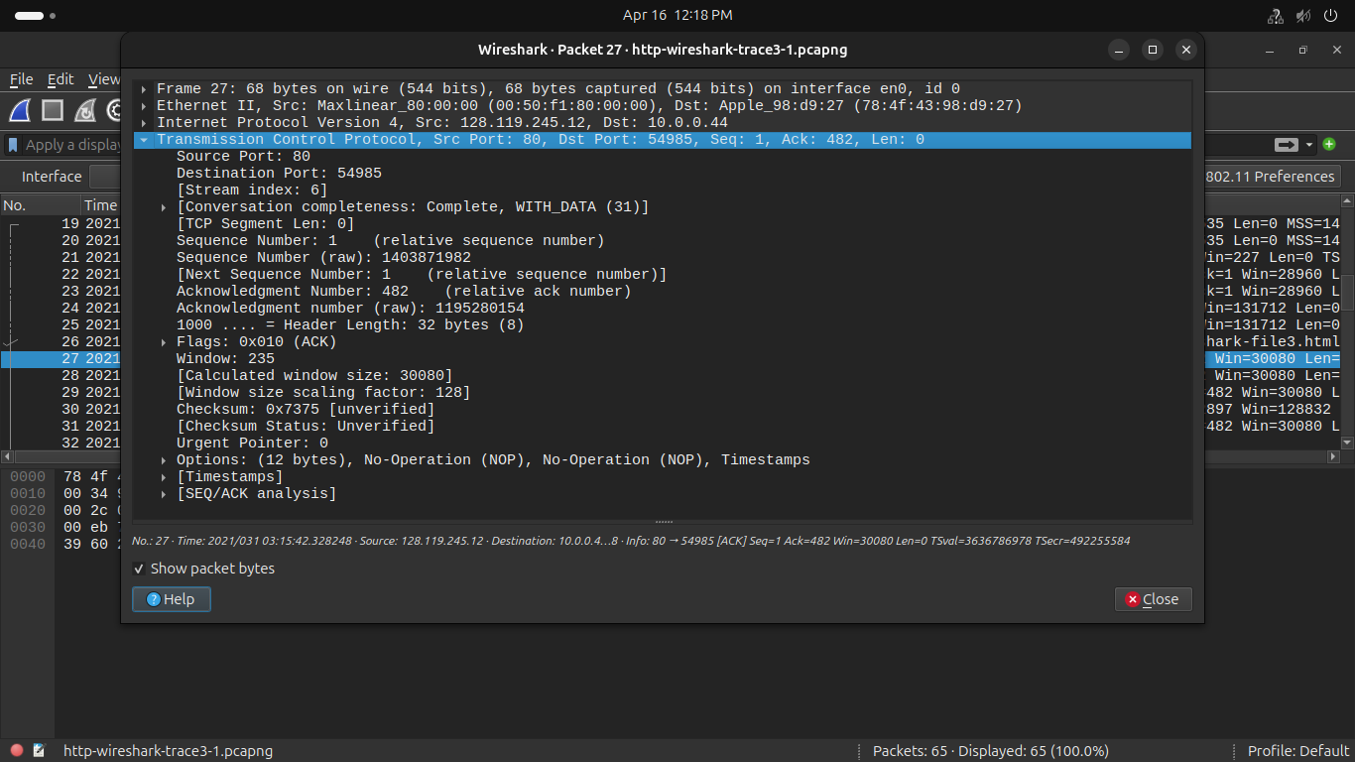
4. HTML Documents with Embedded Objects
Answer the following questions based on the trace file named : http-wireshark-trace4-

15. How many HTTP GET request messages did your browser send? To which
Internet addresses were these GET requests sent?

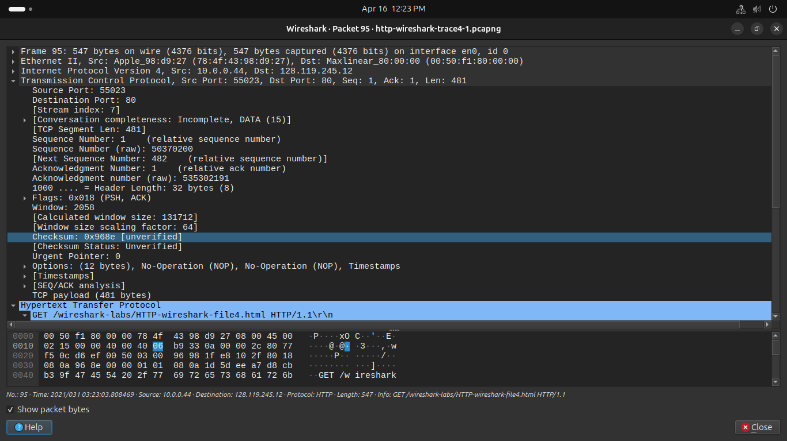

16. Can you tell whether your browser downloaded the two images serially, or
whether they were downloaded from the two web sites in parallel? Explain.

My browser sent 3 http GET message requests. One each to each for each of the following: The initial page, the Pearson logo, and the cover of the Pearson book, 5th Edition.
- Initial Page address: 128.119.245.12
- Pearson Logo: 165.193.140.14
- Pearson book, 5th Edition: 128.119.240.90
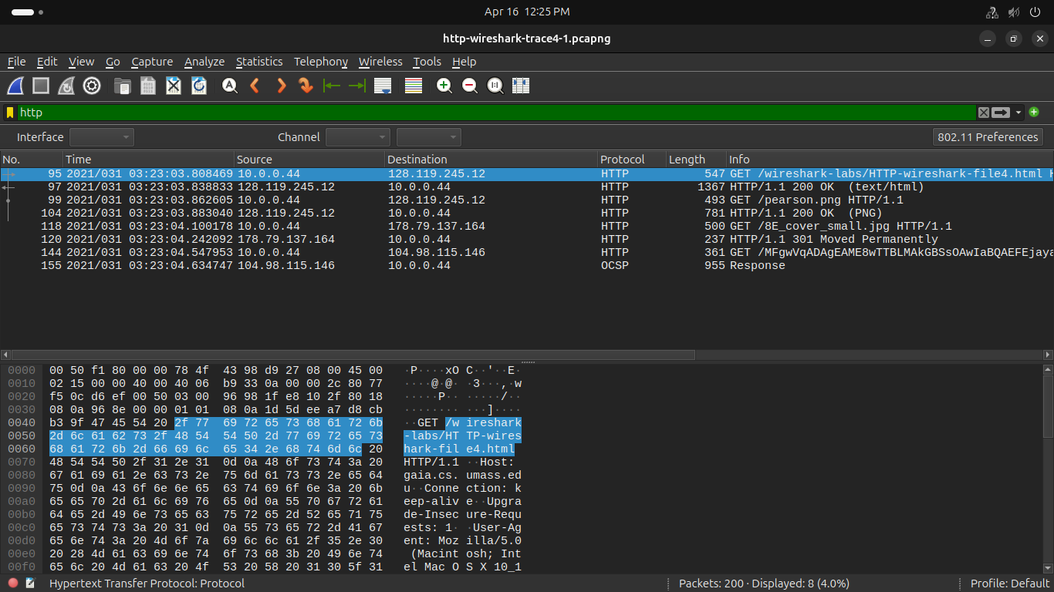
5 HTTP Authentication
Answer the following questions based on trace file named: http-wireshark-trace5-1.

17. What is the server’s response (status code and phrase) in response to the initial
HTTP GET message from your browser?
The browser downloaded the two images in serially. I believe this to be the case because the first image was requested and sent before the second image was requested by the browser. Had they been running in parallel, both files would have been requested then would have returned in the same time period. In this case however, the second image was only requested after the first image came back.
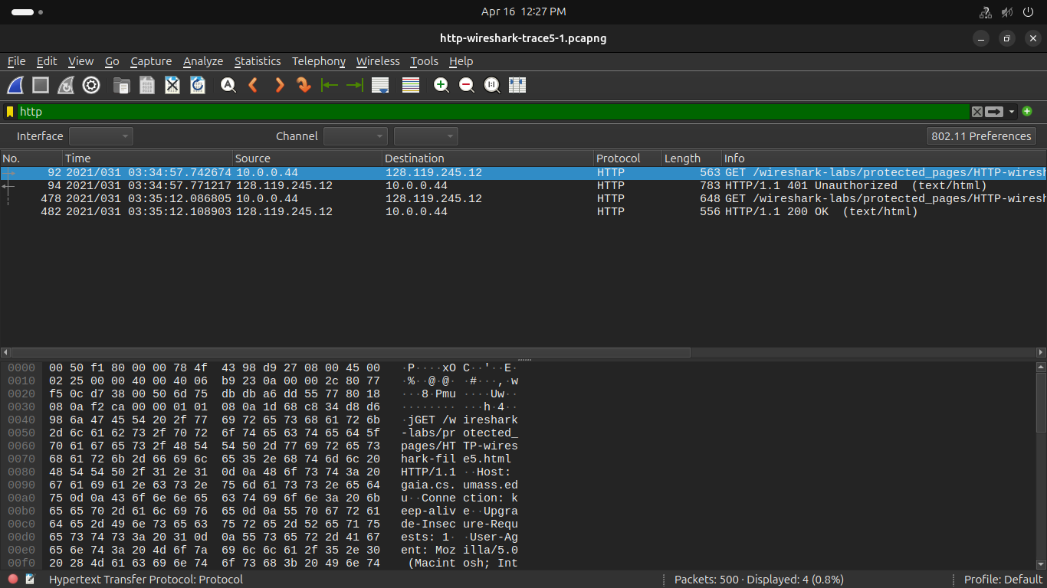
18. When your browser’s sends the HTTP GET message for the second time, what
new field is included in the HTTP GET message?

The new field that is now included is the authorization field. This is included because we sent the server a username and password along with our request stating that we were authorized to receive the page.

