**Comuter Networks Lab**

**Assignment -Week 8**

1. **Run nslookup to obtain the IP address of the web server for the Indian Institute of Technology in Mumbai, India: www.iitb.ac.in. What is the IP address of** [**www.iitb.ac.in**](http://www.iitb.ac.in/)**.**

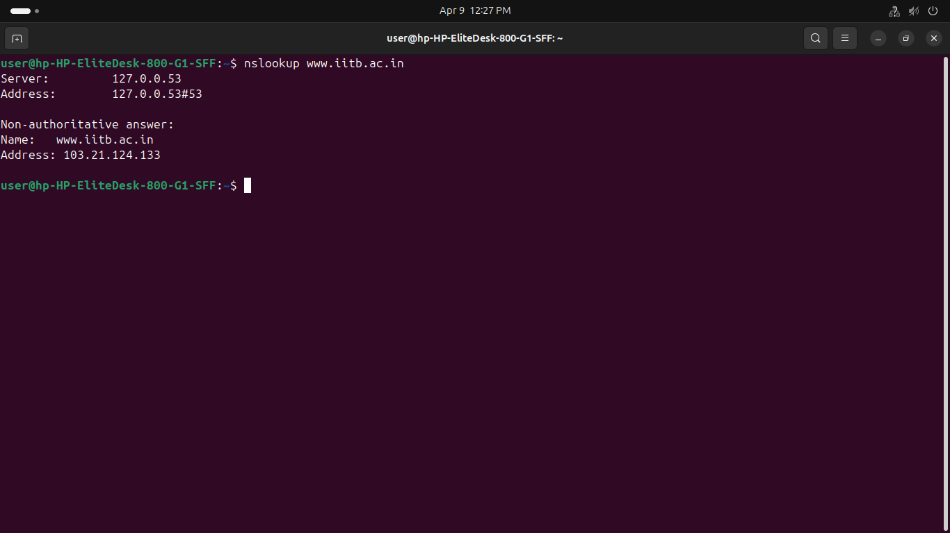

**2. What is the IP address of the DNS server that provided the answer to your nslookup command in question 1 above**

=>127.0.0.53

**3.Did the answer to your nslookup command in question 1 above come from an authoritative or non-authoritative server?**

=>Non-authoritative answer: means the DNS response **did not** come directly from an authoritative DNS server for the iitb.ac.in domain — instead, it came from a **cache**

*****4* Locate the first DNS query message resolving the name gaia.cs.umass.edu. What is the packet number**[1] **in the trace for the DNS query message? Is this query message sent over UDP or TCP?****

**=> Packet number=39**

**It is sent over UDP**

****5. Now locate the corresponding DNS response to the initial DNS query. What is the packet number in the trace for the DNS response message? Is this response message received via UDP or TCP?****

**=>Packet number= 41  
 It is also using UDP**

****6. What is the destination port for the DNS query message? What is the source port of the DNS response message****

**=> Destination : 8.8.8.8 Source :192.168.12.25**

**7. To what IP address is the DNS query message sent**

**=> 8.8.8.8  
  
**8. Examine the DNS query message. How many “questions” does this DNS message contain? How many “answers” answers does it contain?****

**=> Question : 1  
 Answer : 0**

****9. Examine the DNS response message to the initial query message. How many “questions” does this DNS message contain? How many “answers” answers does it contain?**** **=> Question: 1   
 Answer: 1**

**1**0. The web page for the base file http://gaia.cs.umass.edu/kurose_ross/ references the image object http://gaia.cs.umass.edu/kurose_ross/header_graphic_book_8E_2.jpg , which, like the base webpage, is on gaia.cs.umass.edu.****

**=> No additional DNS query is made for the image, because it's hosted on the same domain and the IP address is reused.**

****11. What is the destination port for the DNS query message? What is the source port of the DNS response message?****

**=> Destination : 8.8.8.8 Source :192.168.12.25**

**1**2. To what IP address is the DNS query message sent? Is this the IP address of your default local DNS server?****

**=> send to 8.8.8.8**

**my DNS server is : 172.31.100.7**

****13. Examine the DNS query message. What “Type” of DNS query is it? Does the query message contain any “answers”?****

**Type = A**

**It contains 0 answer**

****14. Examine the DNS response message to the query message. How many “questions” does this DNS response message contain? How many “answers”?****

**Questions=> 1   
 Answer=> 1**

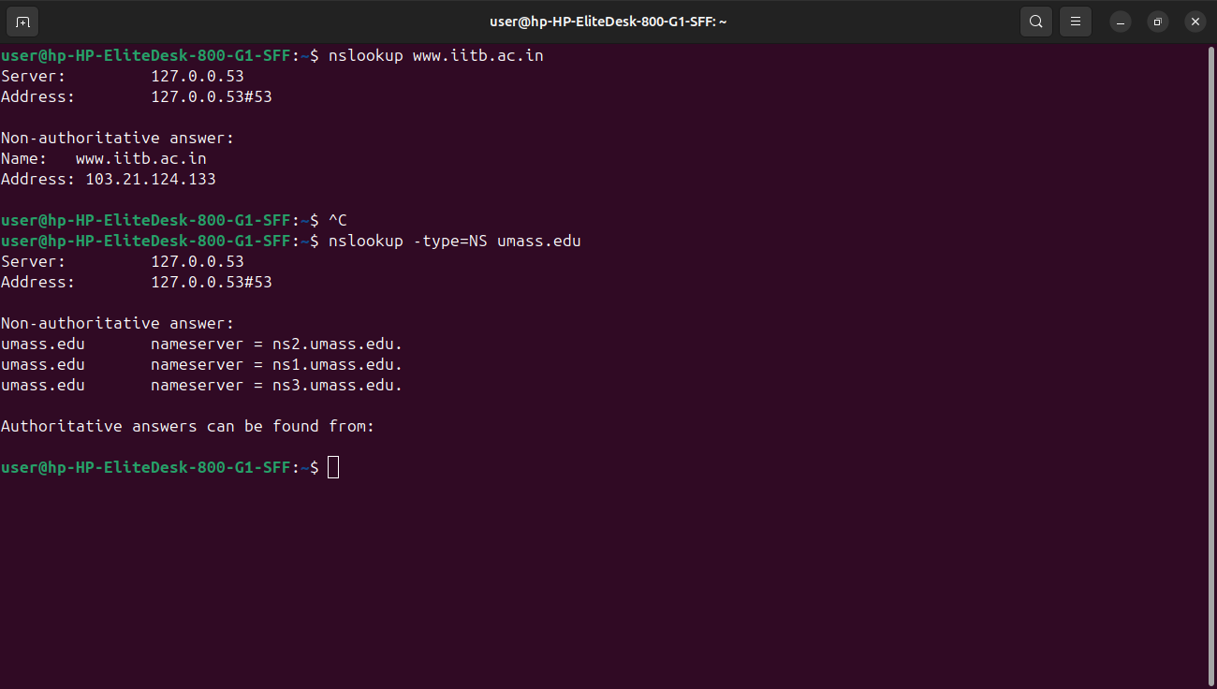

**\**

****15 .To what IP address is the DNS query message sent? Is this the IP address of your default local DNS server?****

**send to 8.8.8.8**

**my DNS server is : 172.31.100.7**

****16 . Examine the DNS query message. How many questions does the query have? Does the query message contain any “answers”?****

**Questions=> 1   
 Answer=> 0**

****17 .Examine the DNS response message (in particular the DNS response message that has type “NS”). How many answers does the response have? What information is contained in the answers? How many additional resource records are returned? What additional information is included in these additional resource records (if additional information is returned)?****

**Question : 1  
 Answer : 3  
 additional resource: 2**

**contains two name server :**

**1. Name: ns3.umass.edu**

**Type: A (1) (Host Address)**

**Class: IN (0x0001)**

**Time to live: 3412 (56 minutes, 52 seconds)**

**Data length: 4**

**Address: 128.103.38.68**

**2.**

**Name: ns2.umass.edu**

**Type: A (1) (Host Address)**

**Class: IN (0x0001)**

**Time to live: 3428 (57 minutes, 8 seconds)**

**Data length: 4**

**Address: 128.119.10.28**

1.