Date: 23 -04 -2025

Day: Wednesday

**Computer Networks Lab**

**Week 11- Assignment**

**Tracing UDP with Wireshark**

**Name: Kirtibala Verma**

**Reg: 2023ca53**

***Answer the following questions using udp-wireshark-trace file:***

1. **Select the first UDP segment in your trace. What is the packet number1 of this segment in the trace file? What type of application-layer payload or protocol message is being carried in this UDP segment? Look at the details of this packet in Wireshark. How many fields there are in the UDP header? What are the names of these fields?**

**Ans-**  The first UDP segment in a Wireshark trace would typically be identified by its UDP Protocol number (17) in the IP Protocol field and the packet number would be 1. It carries an application-layer payload or protocol message depending on the specific application using UDP. The UDP header has 4 fields: Source Port, Destination Port, Length, and Checksum.

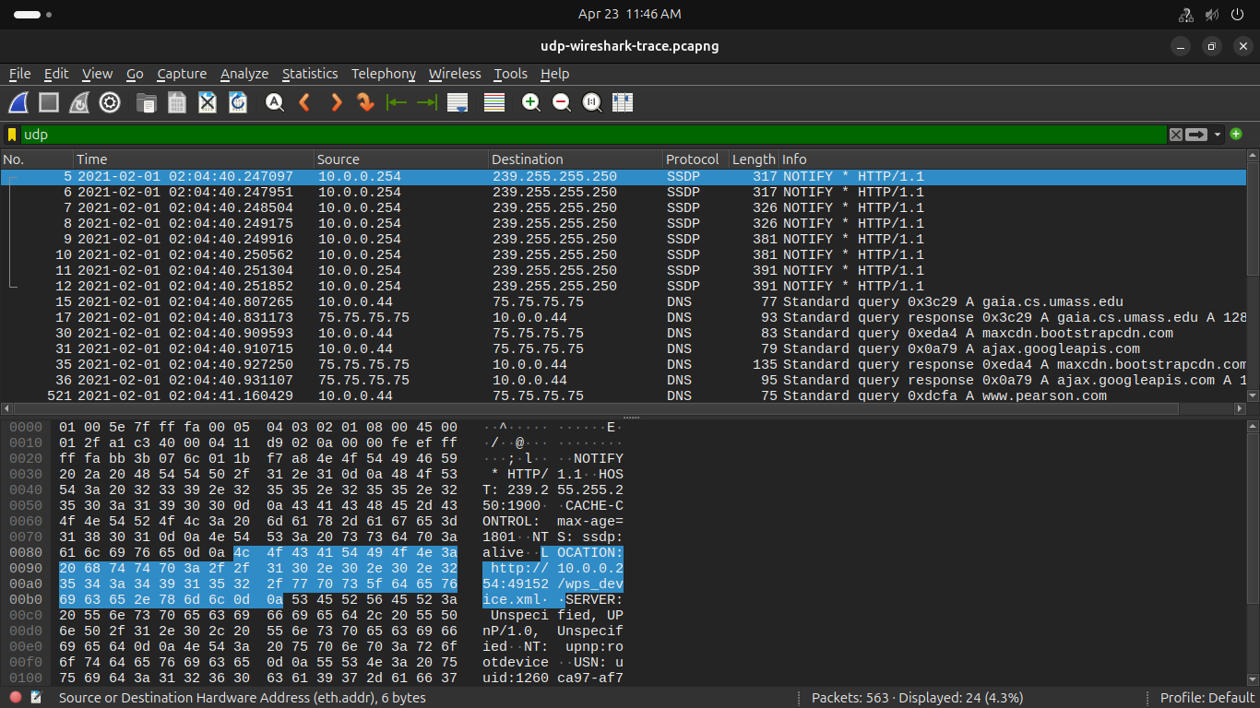

**2.By consulting the displayed information in Wireshark’s packet content field for this packet, what is the length (in bytes) of each of the UDP header fields?**

**Ans-** Each of the UDP header fields is 2 bytes long

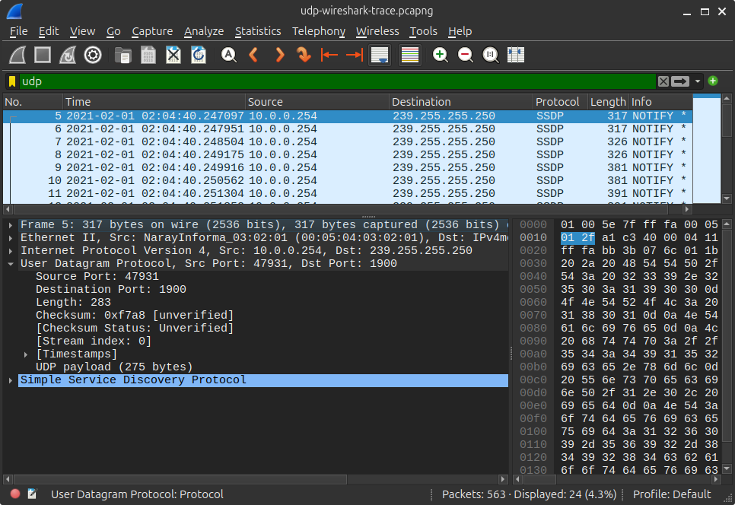

**3) The value in the Length field is the length of what? Verify your claim with your captured UDP packet.**

**Ans-** 283

**4) What is the maximum number of bytes that can be included in a UDP payload? (Hint: the answer to this question can be determined by your answer to 2. above)**

**Ans-** The maximum number of bytes that can be in the payload is 2^16- the bytes already being used by the header field (8). Therefore the maximum payload is 65535-8= 65527 bytes.

**5) What is the largest possible source port number? (Hint: see the hint in 4.)**

**Ans-** The largest possible source port number is 2^16 or 65535.

**6) What is the protocol number for UDP? Give your answer in decimal notation. To answer this question, you’ll need to look into the Protocol field of the IP datagram containing this UDP segment.**

**Ans-** 17

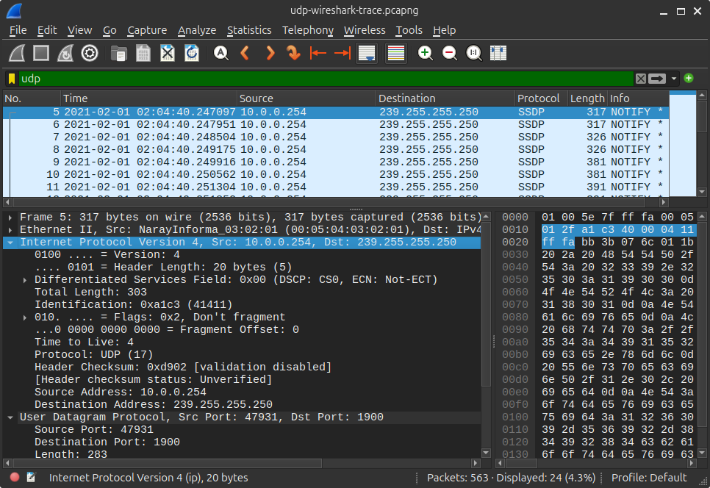

**7) Examine the pair of UDP packets in which your host sends the first UDP packet and the second UDP packet is a reply to this first UDP packet. (Hint: for a second packet to be sent in response to a first packet, the sender of the first packet should be the destination of the second packet). What is the packet number1 of the first of these two UDP segments in the trace file? What is the value in the source port field in this UDP segment? What is the value in the destination port field in this UDP segment? What is the packet number2 of the second of these two UDP segments in the trace file? What is the value in the source port field in this second UDP segment? What is the value in the destination port field in this second UDP segment? Describe the relationship between the port numbers in the two packets.**

**Ans -** The relationship between port numbers is that the source port on the send message is the destination port of the receive message. The destination port for the send message is also the source port for the receive message.