R07922141

張緣彩

19/09/2018

Computer Vision Hw1 Report

Part 1

How to run: python r07922141.py

Upside-down lena,

Using for loop to loop width, height and color channel (RGB) then reverse every height from top to bottom, color channel remains the same, the algorithm is as below.

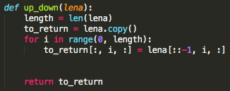 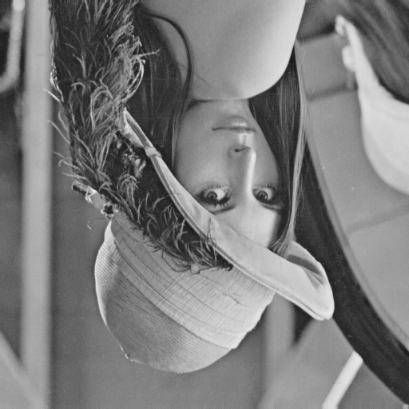

Left-side-right lena,

Using for loop to loop the width, height and color channel (RGB) then reverse every width from left to right, color channel remains the same, the algorithm is as below.

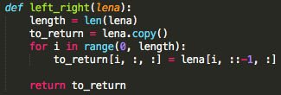 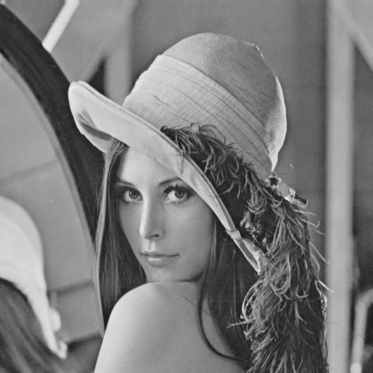

Diagonal mirrored lena,

Using for loop to loop the width, height and color channel (RGB) then find the diagonal line (i == j), every row of the bottom area of the diagonal line will copy every column of the top area of the diagonal line, color channel remains the same, the algorithm is as below.

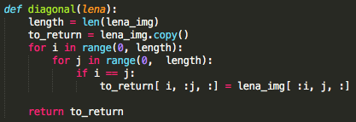 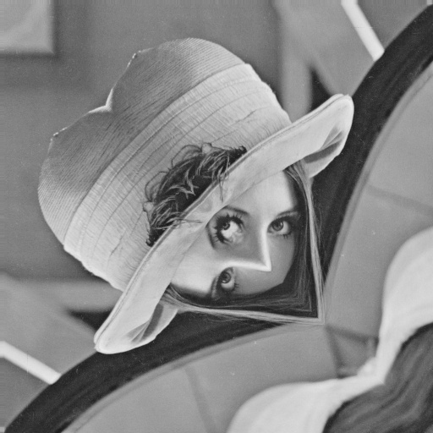

Part 2

1. Rotate lena.bmp 45 degree clockwise

 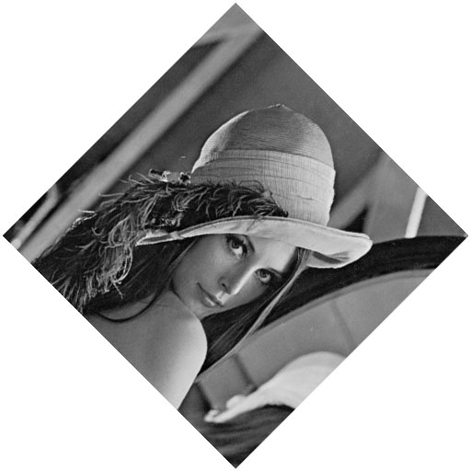

1. Shrink lena.bmp in half

 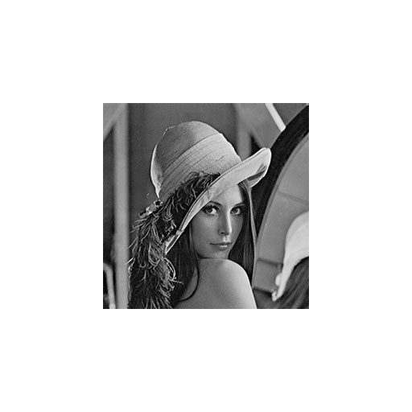

1. Binarize lena.bmp at 128 to get binarized lena

