R07922141

張緣彩

22/09/2018

Computer Vision Hw2 Report

Part I. Binarization

Using a for loop to loop through width, height and color channel of the image, then thresholding each value, the algorithm is as below.

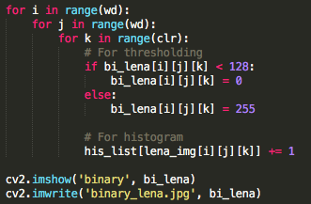 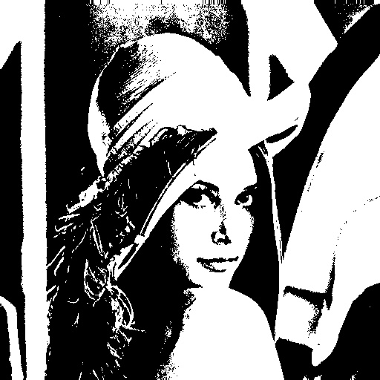

Part II. Histogram

Calculate each value (0~255) frequency in the image, then use bar chart to plot histogram of the image, the algorithm is as below.

 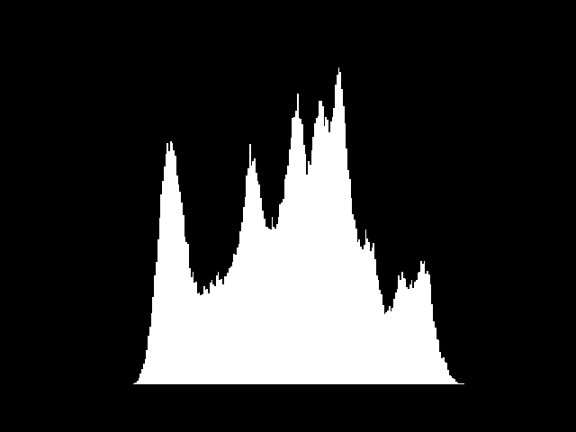

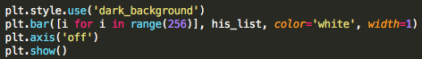

Part III. Connected Component and Bounding Box

I’m using 4-connected with iterative algorithm. In the iterative algorithm, first we need a to give each non-zero pixel an unique index. Then, we need top-down and bottom-up function to keep cycling the whole image several time. In each cycle, the function loop through every pixel and giving that pixel a smallest value among its neighbor (4 neighbors). Finally, we keep iterate it until the sum of the value of the whole image stopped decrease. By the way, I have removed the small connected component as well. As result, we need to iterate roughly 20 times with 37 seconds. The algorithm is as below.

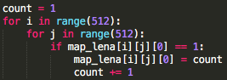 

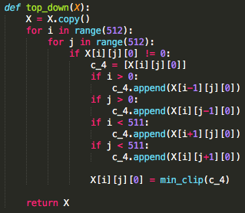 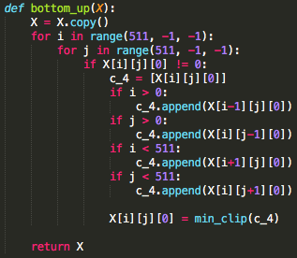

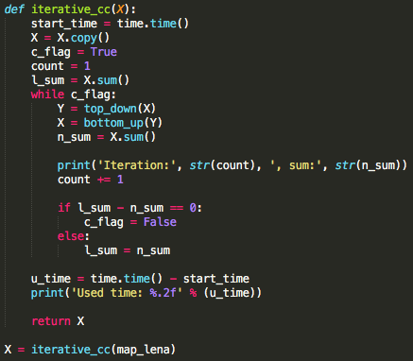 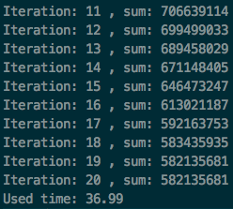

For the bounding box and centroid, we need to find the minimum and maximum position of X-coordinate and Y-coordinate. Then, use the X-coordinate and Y-coordinate to write the bounding box and centroid. For centroid, we draw a horizontal and a vertical rectangle. For the bounding box, we draw two horizontal lines and two vertical lines. The algorithm is as below.

