R07922141

張緣彩

19/10/2018

Computer Vision Hw4 Report

1. Implementation
   1. Dilation  
      As described in the lecture note, dilation actually makes a white pixel (255) wider. For given center point and a kernel, if the center point is 255 then all other neighbors point (according to kernel) will be 255 as well.  
      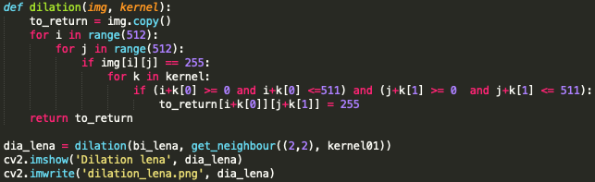
   2. Erosion  
      As described in the lecture note, erosion actually makes a black pixel (0) wider. For given center point and a kernel, the center point will be 255 if and only if all the neighbors point of the center point is 255, otherwise the center point will be 0.  
      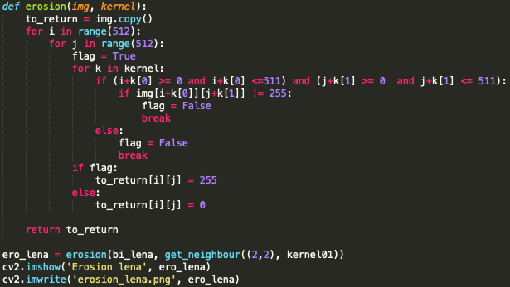
   3. Opening  
      As described in the lecture note, we just need to apply erosion to the given image and continue by dilation.  
      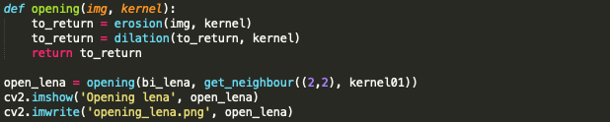
   4. Closing  
      As described in the lecture note, we just need to apply dilation to the given image and continue by erosion.  
      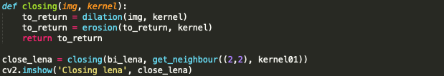
   5. Hit and Miss  
      As described in the lecture note, we need to calculate erosion of A and J kernel, and erosion of A complement and K kernel. Then intersect these two results to get the final result.  
      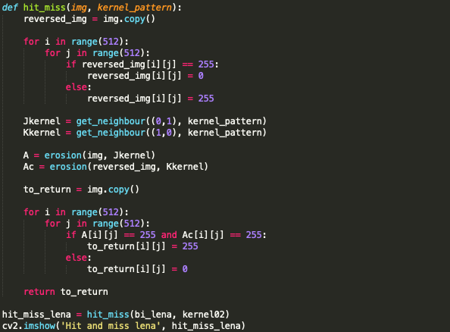
   6. Kernel  
      This function is use to get all the point in the given kernel. For given a center point and kernel pattern, it generates all the neighbors point according to the center point.  
      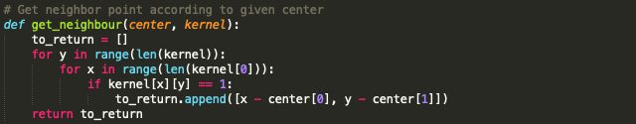
2. Result
   1. Dilation  
      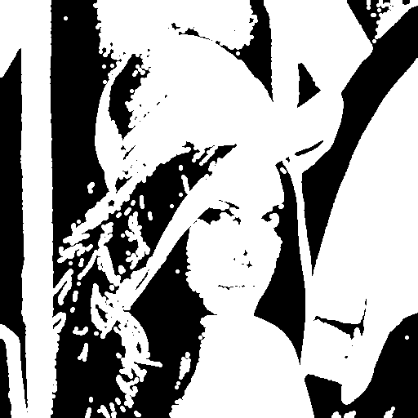
   2. Erosion  
      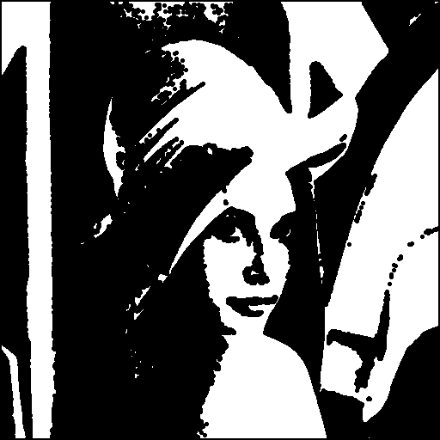
   3. Opening  
      
   4. Closing  
      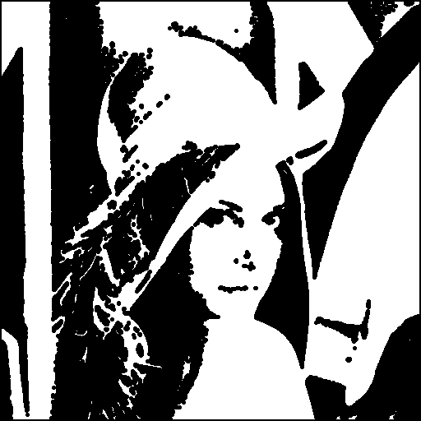
   5. Hit and Miss  
      