R07922141

張緣彩

25/10/2018

Computer Vision Hw5 Report

1. Implementation
   1. Dilation  
      As described in the lecture note, dilation actually get local maxima of the kernel.  
      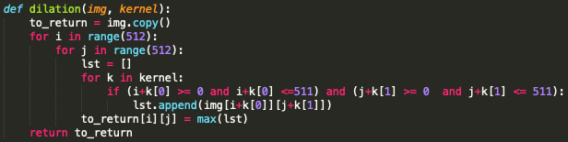
   2. Erosion  
      As described in the lecture note, erosion actually get local minima of the kernel.  
      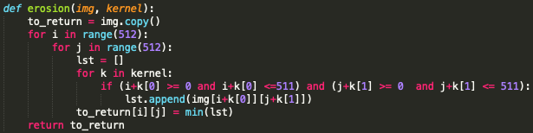
   3. Opening  
      As described in the lecture note, we just need to apply erosion to the given image and continue by dilation.  
      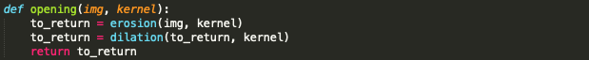
   4. Closing  
      As described in the lecture note, we just need to apply dilation to the given image and continue by erosion.   
      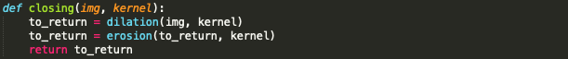
   5. Kernel  
      This function is use to get all the point in the given kernel. For given a center point and kernel pattern (value = 0), it generates all the neighbors point.  
      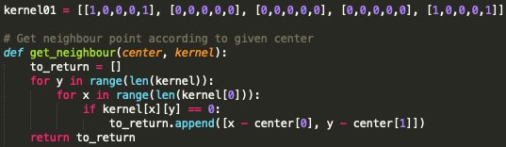
2. Result
   1. Dilation  
      
   2. Erosion  
      
   3. Opening  
      
   4. Closing  
      