R07922141

張緣彩

10/10/2018

Computer Vision Hw6 Report

1. **Implementation**

Down sampling and binarization, make 512x512 into 64x64 binarized lena. First initialized an empty 64x64 2D array. Then loop each pixel and binarize it.

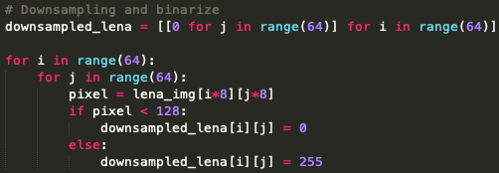 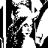

After that, for each pixel in 64x64 binarized lena that not equal to 0, find its neighbor for given center (x y) and find the yokoi connectivity. The yokoi connectivity is depend on H and F function according to lecture note.

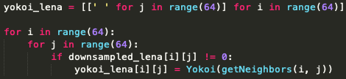

Center point will be x0 and its neighbors’ points is according lecture note x1, x2, x3, x4, x5, x6, x7 and x8. (Each point must be inside of 0 to 64)

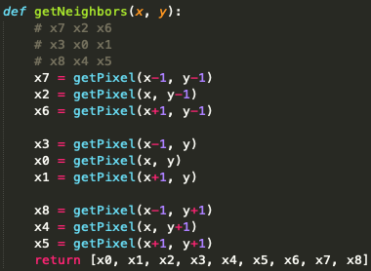 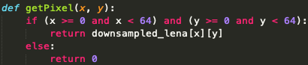

The yokoi function return f function of h function. According to lecture note, f1 will be x0, x1, x6 and x2; f2 will be x0, x2, x7 and x3; f3 will be x0, x3, x8 and x4; f4 will be x0, x4, x5 and x1.

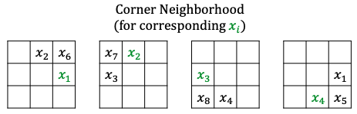

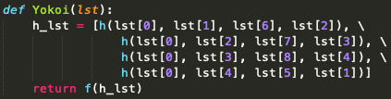

The f function is according to lecture note equation. But since that example yokoi image didn’t print 0, so I replaced 0 into space.

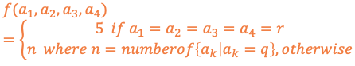 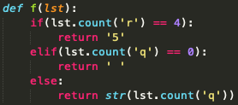

The h function is also according to lecture note equation.

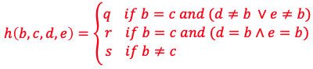

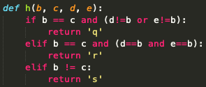

1. **Result**

