R07922141

張緣彩

10/19/2018

Computer Vision Hw7 Report

1. **Implementation**

First down sampling and binarizing lena same as homework 6.

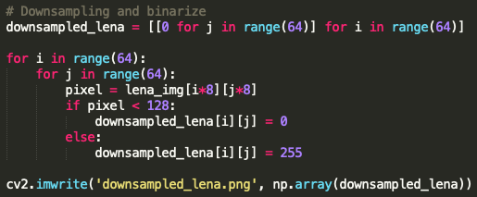

Then keep repeating step 1 (Yokoi), 2 and 3 until nothing change.

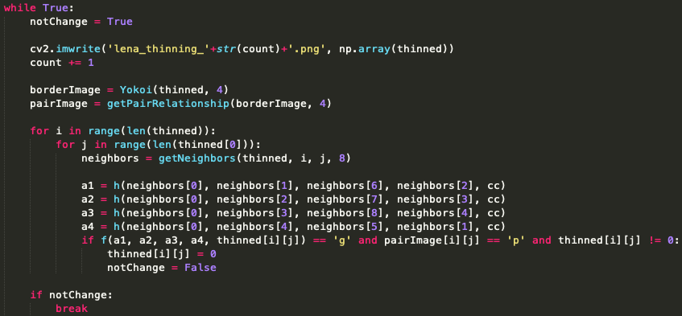

For the shrink operator, we need to find the ‘h’ and ‘f’ function according to lecture note.

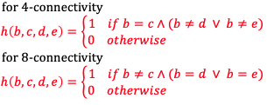

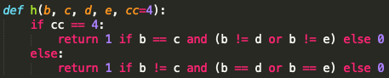





We use yokoi function as described in class. Then find the yokoi number with 1 (edge).

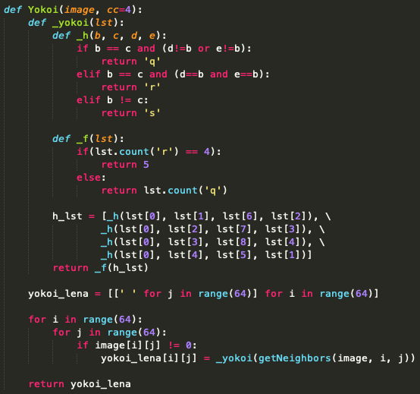

For the pair relationship function, iterate every pixel and get its neighbor points, then find ‘h’ and output p and q note according to lecture note.

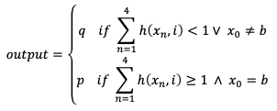

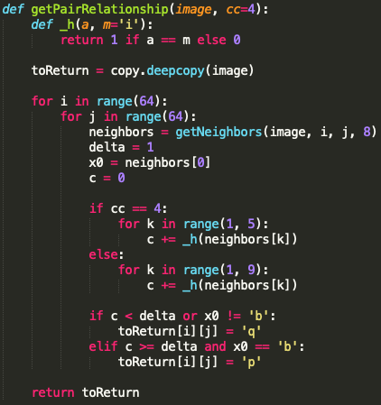

1. **Result (Total 7 iteration!)**

|  |  |  |  |  |  |  |
| --- | --- | --- | --- | --- | --- | --- |
| 1st | 2nd | 3rd | 4th | 5th | 6th | 7th |
|  |  |  |  |  |  |  |

Final Result (yokoi 4, pair relation 4, connected shrink 4)

