MANG1041_Individual_80%.doc x
by Nalie Do
Submission date: 10-May-2025 04:53PM (UTC+0100)
Submission ID: 258700672
File name: MANG1041_Individual_80_.docx (26.61K)
Word count: 1489
Character count: 7985
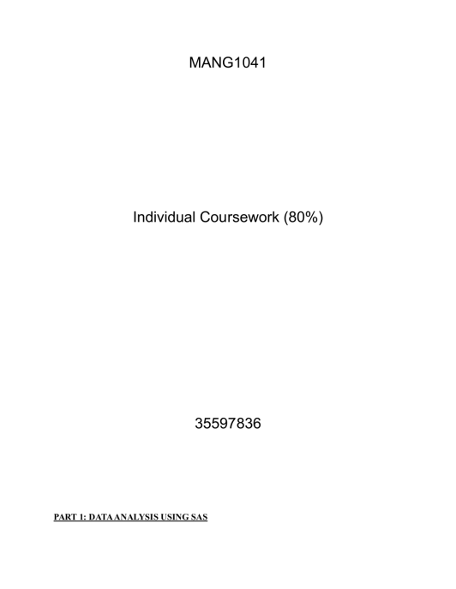
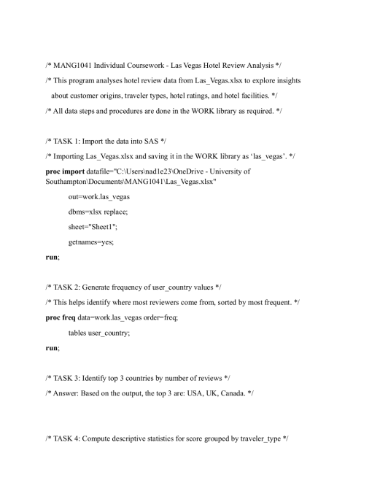
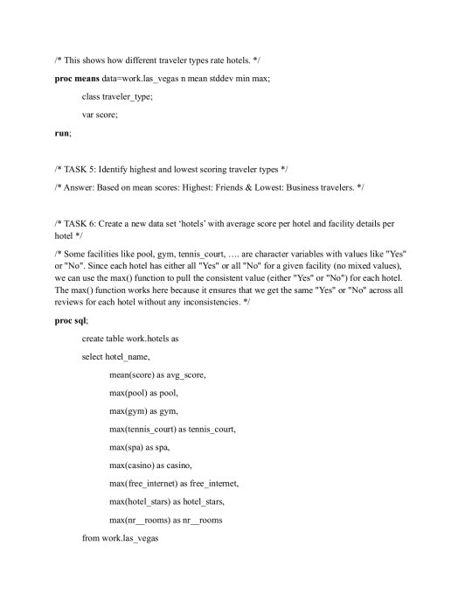
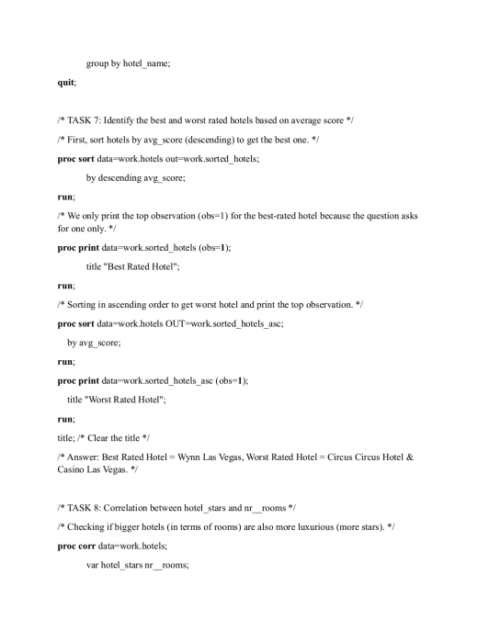
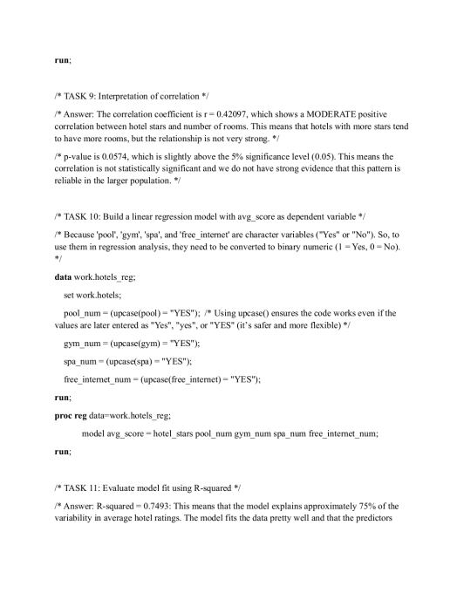1
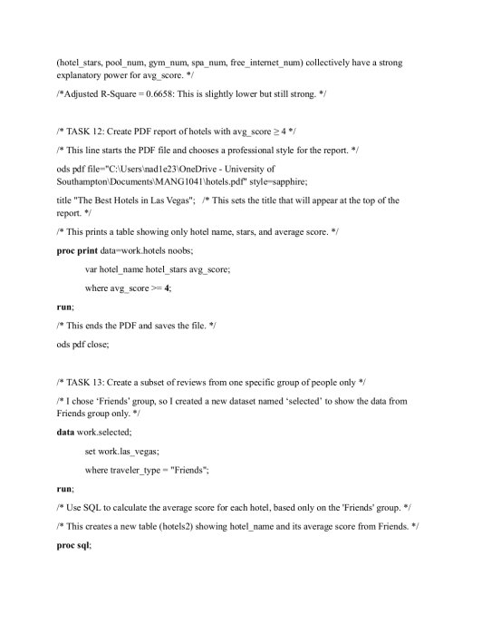
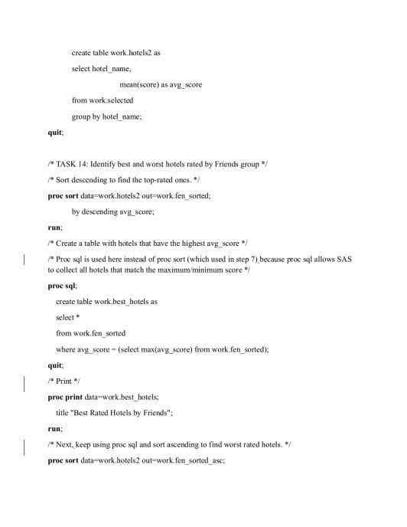
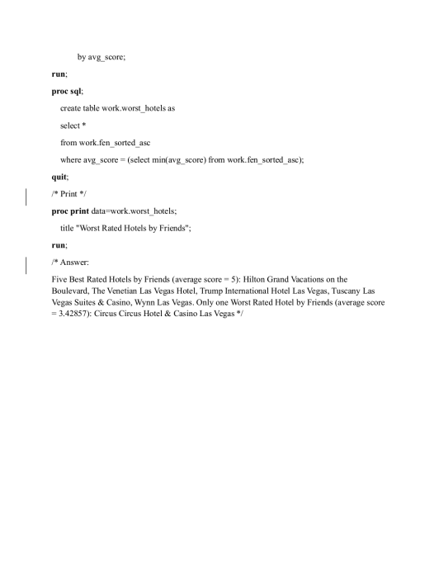
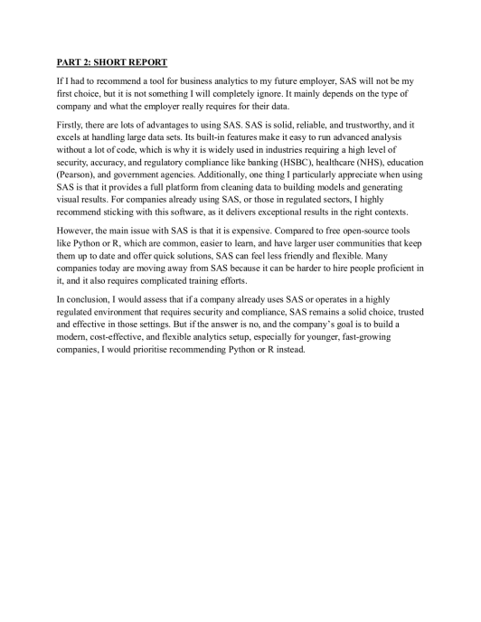
MANG1041_Individual_80%.docx GRADEMARK REPORT
FINAL GRADE
94/100
GENERAL COMMENTS
Part 1: 80/80
When using the WORK library, there is no need to use its
name in the code.
Tasks:
T1: 3/3
T2: 2/2
T3: 3/3
T4: 3/3
T5: 2/2
T6: 10/10
T7: 2/2
T8: 3/3
T9: 2/2
T10: 6/6
T11: 4/4
T12: 5/5
T13: 12/12
T14: 3/3
Addresses tasks/ question set (Performing the tasks using a
SAS program): 60/60
Structure (Comments, the structure and elegance of
the SAS
program): 20/20
Part 2: 14/20
The report is generally OK. It covers some
advantages and
disadvantages of SAS. It could include stronger/more
convincing arguments and be more in-depth. There
is a clear and thoughtful
recommendation. The presentation quality is high.
The report structure could be
improved, e.g. by dividing the contents into sections
and subsections.
Analysis (Rigorously argued and focussed analysis):
6/10
Presentation (Clearly presented report): 8/10
Very well done!
PAGE 1
PAGE 2
PAGE 3
PAGE 4
PAGE 5
Comment 1
Good comment!
PAGE 6 PAGE 7 PAGE 8 PAGE 9

