35597836_MANG1041_Individu al.docx
by Nalie Do
Submission date: 26-Mar-2025 10:13PM (UTC+0000)
Submission ID: 253851303
File name: 35597836_MANG1041_Individual.docx (18.45K)
Word count: 476
Character count: 2570
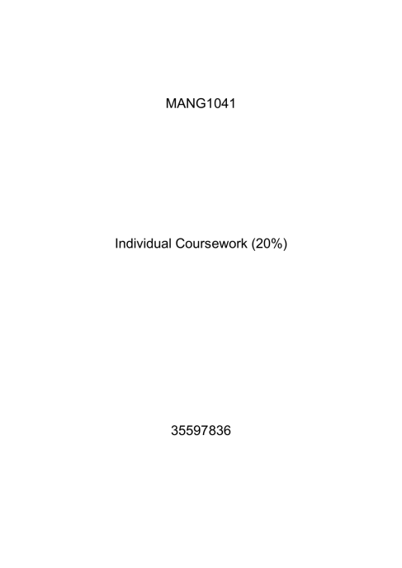
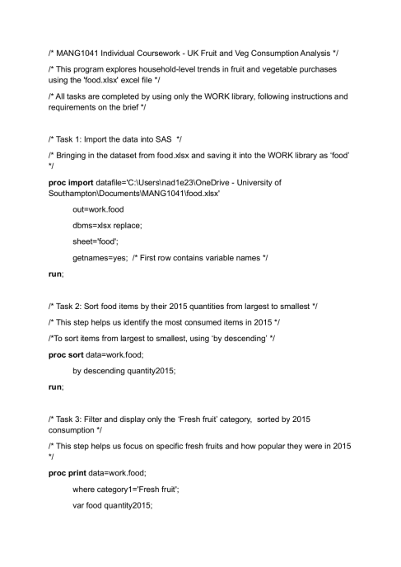
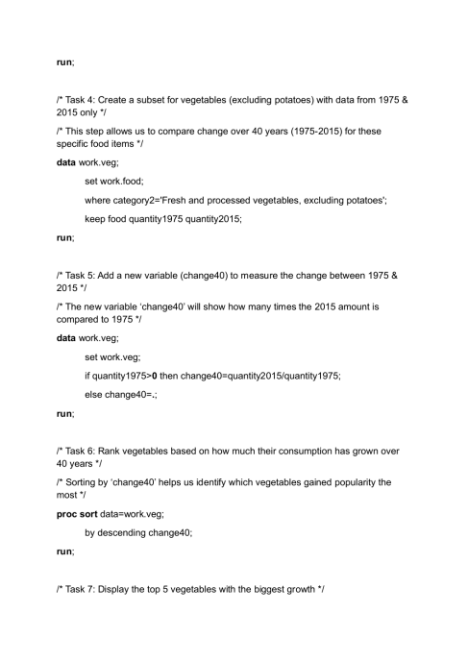
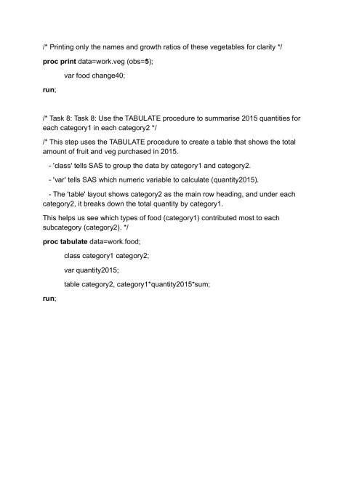table category2*category1, quantity2015;
35597836_MANG1041_Individual.docx GRADEMARK REPORT
FINAL GRADE
90/100
PAGE 1
PAGE 2
PAGE 3
GENERAL COMMENTS
The code is fine. When using the WORK library, there is no
need to use its name in the code. Very well done!
Tasks:
T1: 10/10
T2: 10/10
T3: 10/10
T4: 10/10
T5: 10/10
T6: 10/10
T7: 10/10
T8: 5/10
Addresses tasks/ question set (Performing the tasks using a
SAS program): 75/80
Structure (Comments, the structure and elegance of the SAS
program): 15/20
PAGE 4 QM
table category2*category1, quantity2015; There should be:
table category2*category1, quantity2015;

