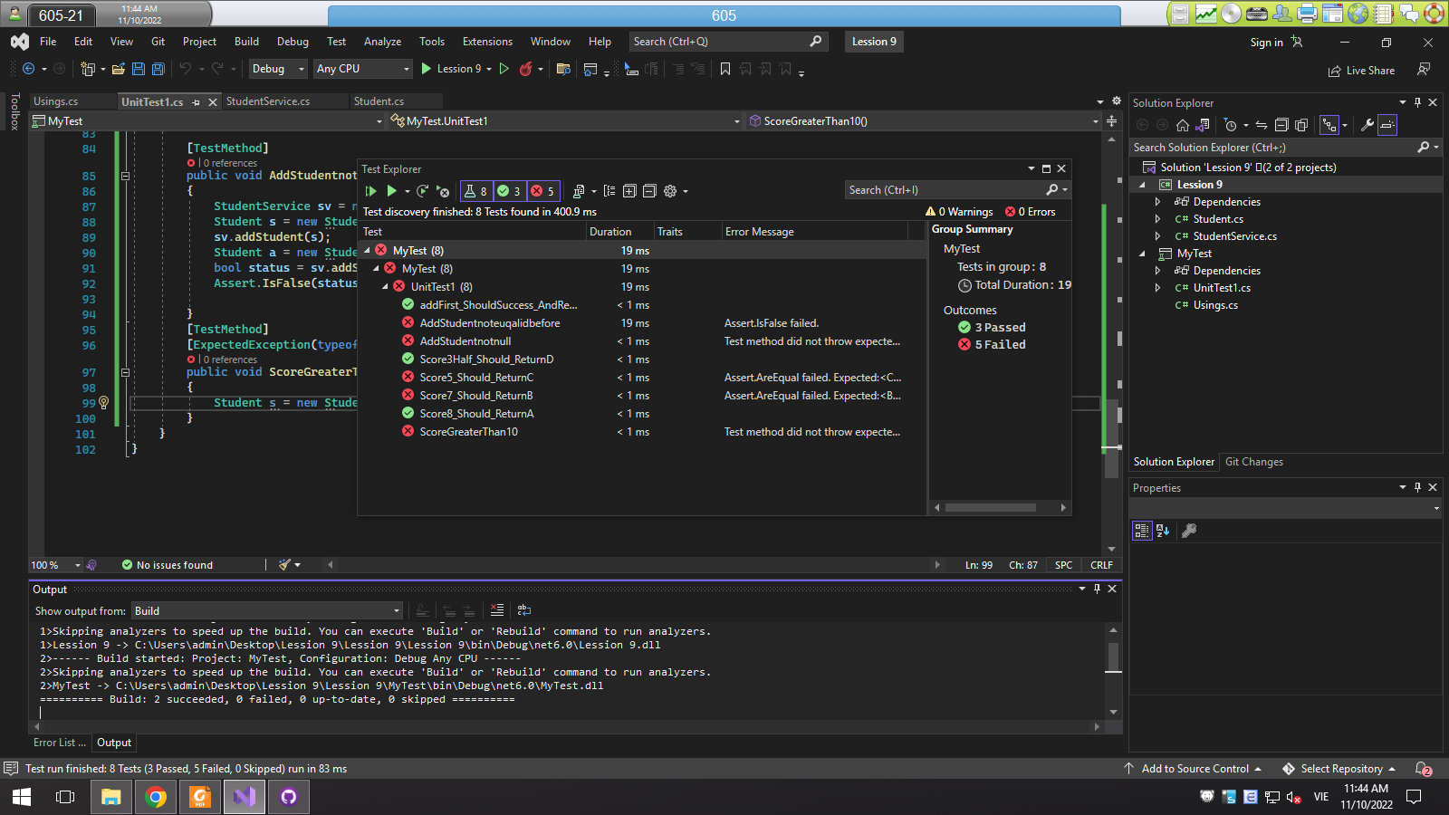

Testcase getLetterScore()

8 -> A (True)

7 -> B (False)

5 -> C (False)

3.5 -> D (True)

Testcase AddfirstStudent()

Add -> (True)

If Student = null throw NullReferenceException -> (false)

If Student has Id like Student’s Id before return false -> (false)

If Score than 10 -> Null SystemException -> (false)