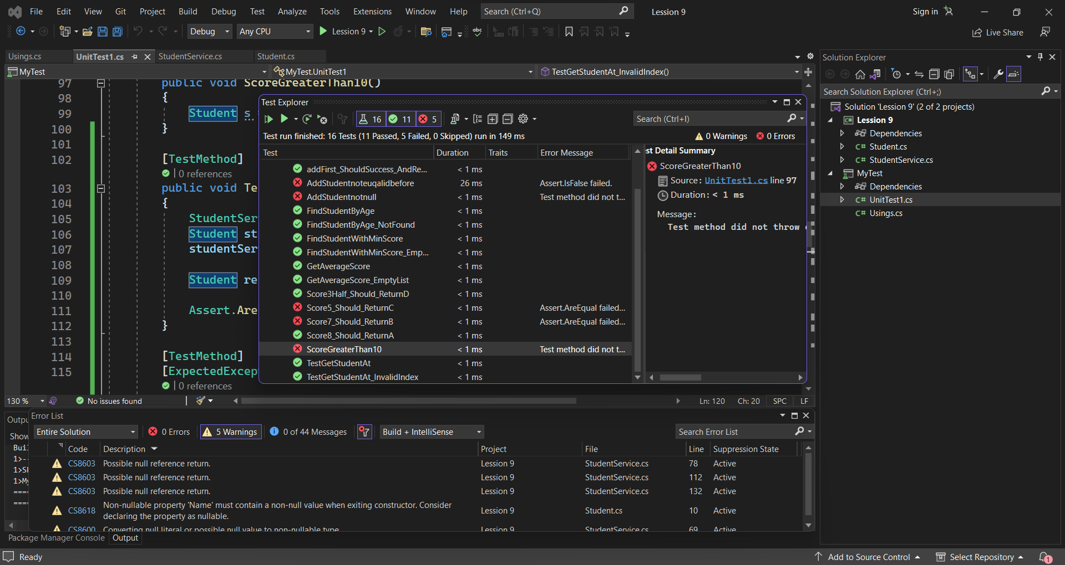

**Testcase getLetterScore()**

**Input:** 8 -> **Output:** A (Correct)

**Input:** 7 -> **Output:** B (Incorrect)

**Input:** 5 -> **Output:** C (Incorrect)

**Input:** 3.5 -> **Output:** D (Correct)

**Testcase addStudent()**

**Input:** Add -> **Output:** Add completely (Correct)

**Input:** Student = null -> **Output:** throw NullReferenceException (Incorrect)

**Input:** Student with ID like Student’s ID before -> **Output:** return false (Incorrect)

**Input:** Score than 10 -> **Output:** throw Null SystemException -> (Incorrect)

**Testcase getStudentAt(int position)**

**Input:** Student with a position greater than the list -> **Output:** throw IndexOutOfRangeException (Correct)

**Input:** Student with a position greater than the list -> **Output:** throw IndexOutOfRangeException with the message "Index {i} is not available in this array,". (Correct)

Input: Student with a valid position -> **Output:** The student at the specified position is returned (Correct)

**Testcase findStudentbyAge(int age)**

**Input:** Student with an age value to search for in the list of students -> **Output:** return the first student with the specified age (Correct)

**Input:** Student with an age value that is not on the list -> **Output:** return null (Correct)

**Testcase getAverageScore()**

**Input:** An empty list of students -> **Output:** throw SystemException (Correct)

**Input:** An empty list of students -> **Output:** throw SystemExceptionwith the message "Student list is empty (Incorrect)

**Input:** A list of students with valid scores -> **Output:** return the average score of all students(Incorrect)

**Testcase findStudentWithMinScore()**

**Input:** An empty list of students -> **Output:** return null (Correct)

**Input:** A list of students with varying scores-> **Output:** return the student with the lowest score (Correct)

**Input:** A list of students with same lowest scores-> **Output:** return the one at the end of the list (Correct)