**TASK 1: JENKINS**

**Step 1:** Create a new freestyle project named “Install_npinx”

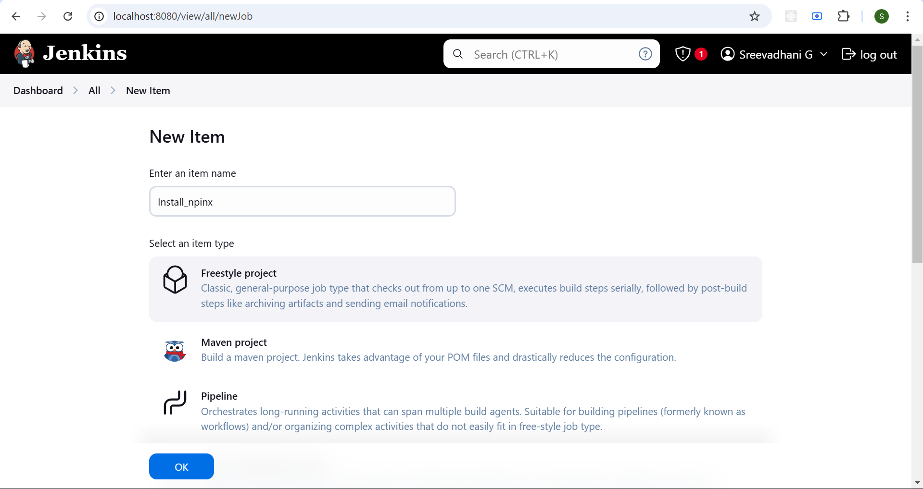

**Step 2:** Create a directory “/var/lib/jenkins/workspace/html_files” and create index.html file in it

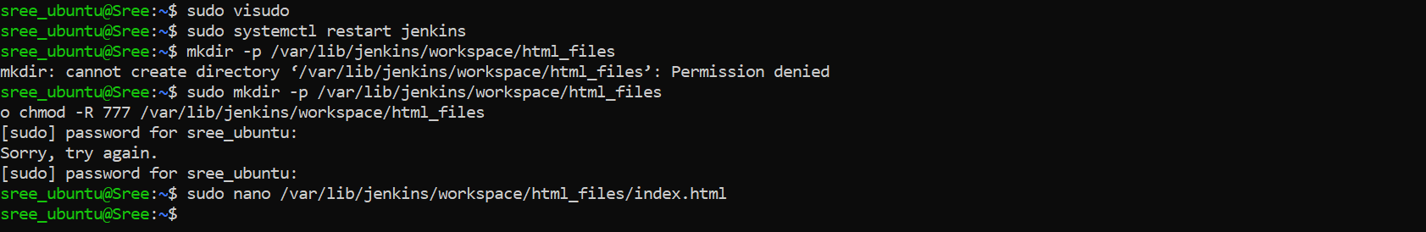

**In index.html**

<!DOCTYPE html>

<html lang="en">

<head>

<meta charset="UTF-8">

<meta name="viewport" content="width=device-width, initial-scale=1.0">

<title>Welcome to My Website</title>

<style>

body {

font-family: Arial, sans-serif;

background-color: #f4f4f4;

margin: 0;

padding: 0;

text-align: center;

}

.container {

width: 50%;

margin: 100px auto;

background: white;

padding: 20px;

border-radius: 10px;

box-shadow: 0px 0px 15px rgba(0, 0, 0, 0.2);

}

h1 {

color: #007bff;

}

p {

font-size: 18px;

color: #555;

}

</style>

</head>

<body>

<div class="container">

<h1>Welcome to My Nginx Website!</h1>

<p>This page is hosted using Nginx installed via Jenkins.</p>

</div>

</body>

</html>

**Step 3:** Open the execute shell and enter the following command

# Update and install Nginx

sudo apt update

sudo apt install -y nginx

# Start and enable Nginx service

sudo systemctl start nginx

sudo systemctl enable nginx

# Copy the manually created HTML file to Nginx root

sudo cp /var/lib/jenkins/workspace/html_files/index.html /var/www/html/

# Restart Nginx to apply changes

sudo systemctl restart nginx

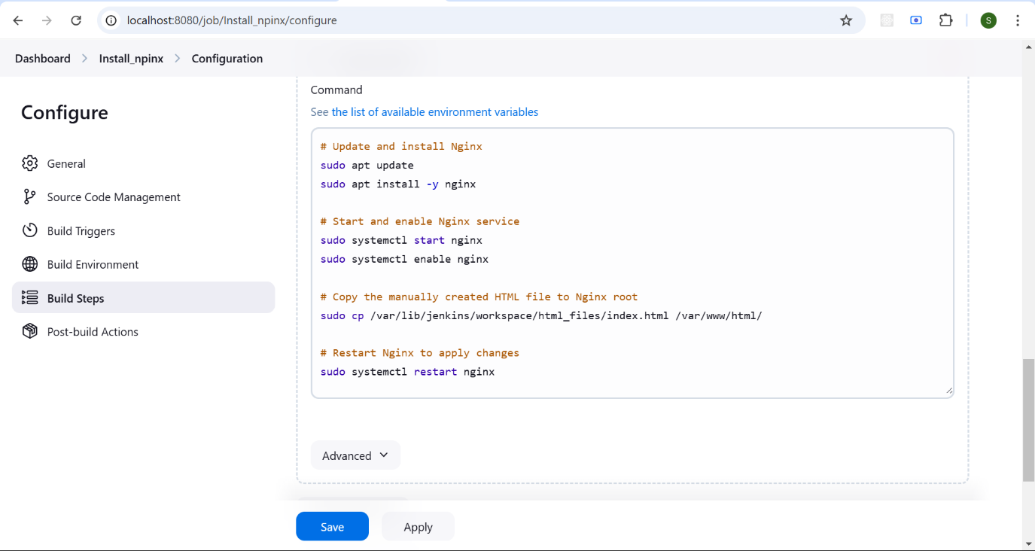

**Step 4:** Run the Jenkins Job by clicking on Build Now

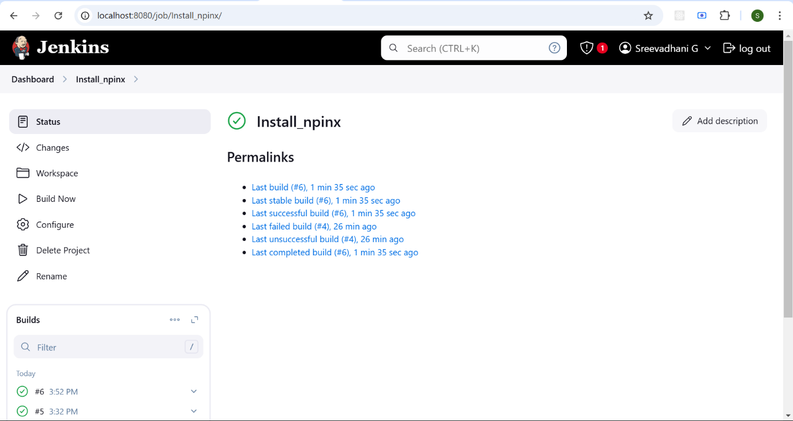

**Step 5:** Check the Console Output to verify

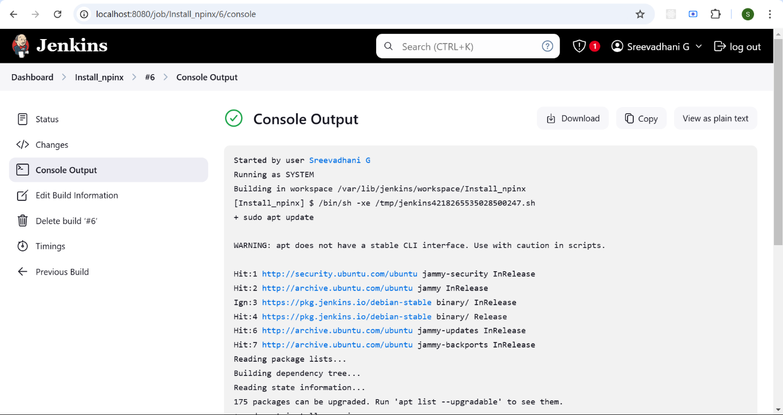

**Step 5:** Go to <http://localhost> and verify the output

