FIREBASE
To use Firebase Realtime Database in your Android project, you need to follow these Firebase Setup Prerequisites:

✅ 1. Create Firebase Project
- Go to: https://console.firebase.google.com
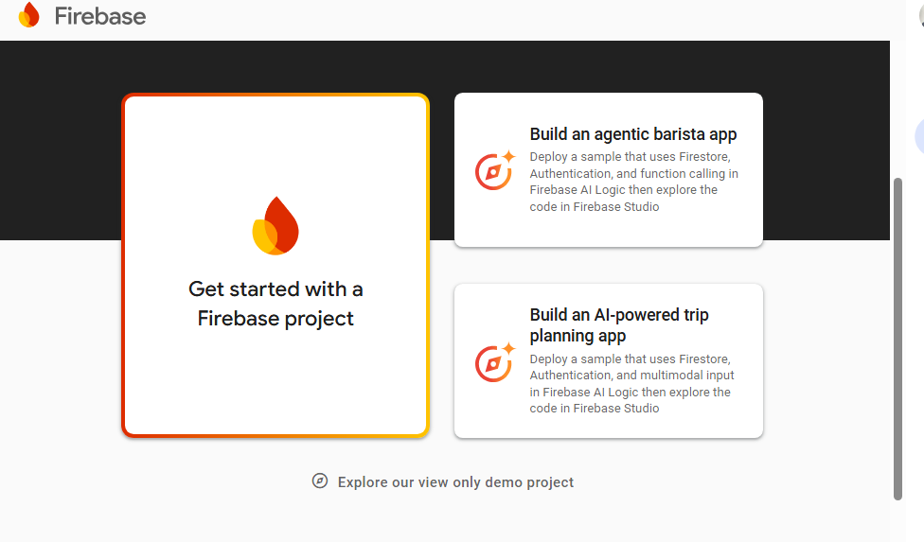
- Click "Add Project".
- Enter a Project Name, click Continue.
- Disable or enable Google Analytics (your choice), click Create Project.
- 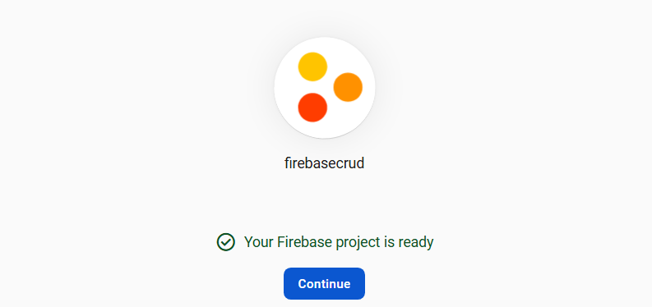

✅ 2. Register Your Android App
- After creating the project, click "Add app" → Android icon.
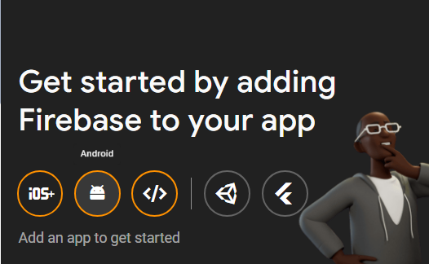
- Fill in:
  - Android package name (e.g. com.example.firebasecrud)
  - App nickname (optional)
  - SHA-1 (required for Firebase Auth, optional for Realtime DB)
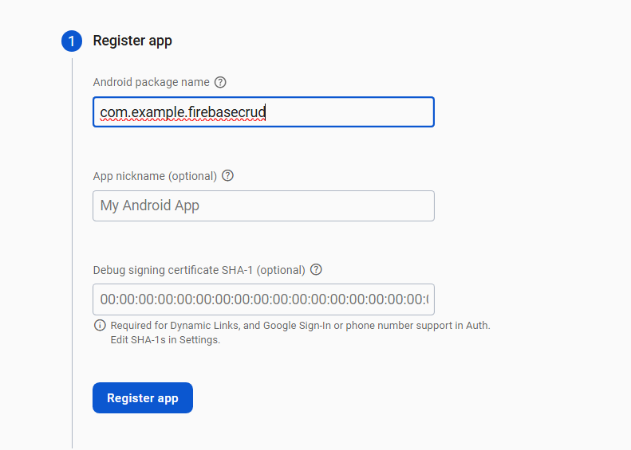
- Click Register App.

✅ 3. Download google-services.json
- After registration, click "Download google-services.json".
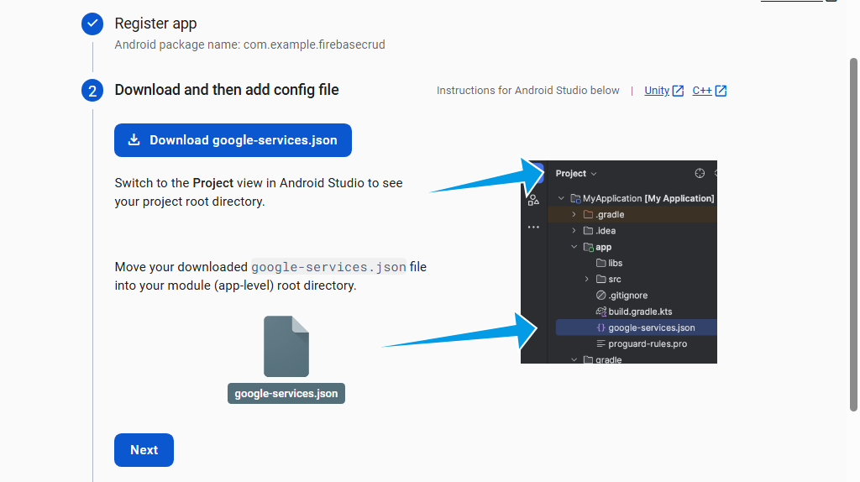
- Place this file inside your project:
- app/ --> paste here
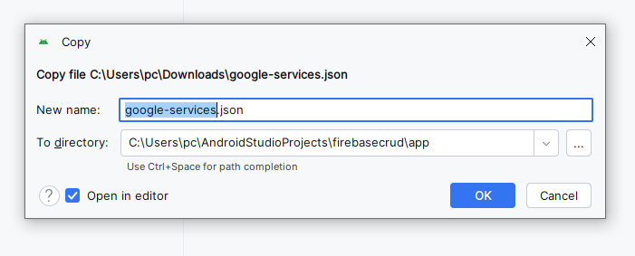

✅ 4. Add Firebase SDK to Your App

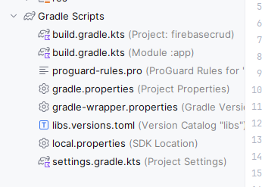

In Project-level build.gradle:
buildscript {
dependencies {
id("com.google.gms.google-services") version "4.4.3" apply false

}
}

In App-level(Add this) build.gradle:
plugins {
alias(libs.plugins.android.application)

id("com.google.gms.google-services") // Add this
}

dependencies {
// Firebase Realtime Database and Auth
implementation("com.google.firebase:firebase-database:20.3.0")
implementation("com.google.firebase:firebase-auth:22.3.0")
implementation(platform("com.google.firebase:firebase-bom:34.2.0"))
implementation("com.google.firebase:firebase-analytics")

}

✅ 5. Sync Project with Gradle
Click "Sync Now" when prompted in Android Studio.

✅ 6. Enable Realtime Database in Firebase Console
- Go to Firebase Console → Your Project
- Open Build > Realtime Database
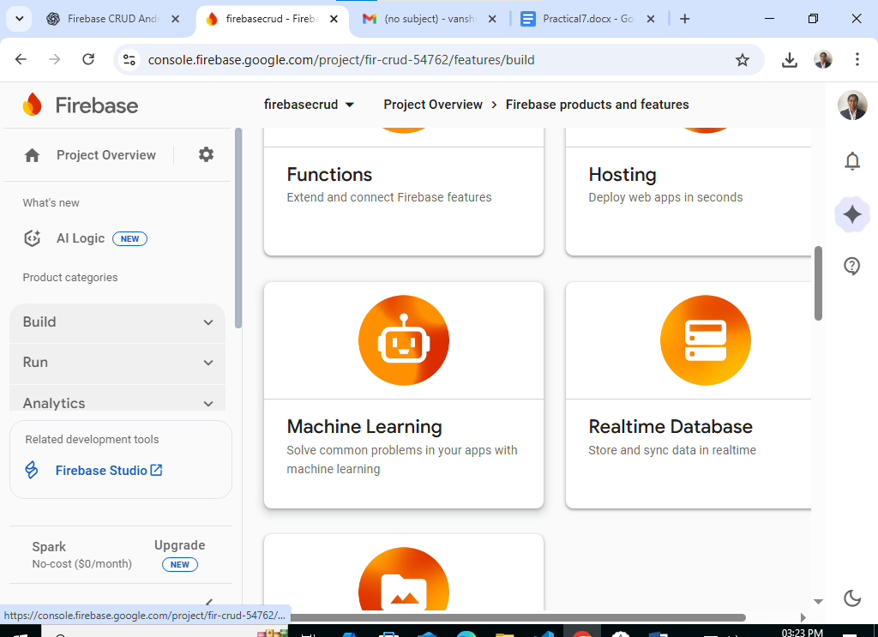
- Click "Create Database"
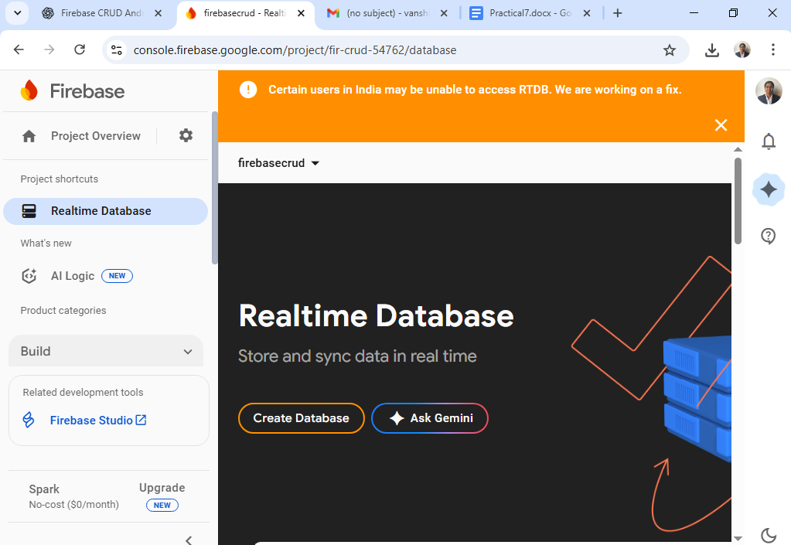
- Select your region and start in test mode (for development)
{
"rules": {
".read": true,
".write": true
}
}
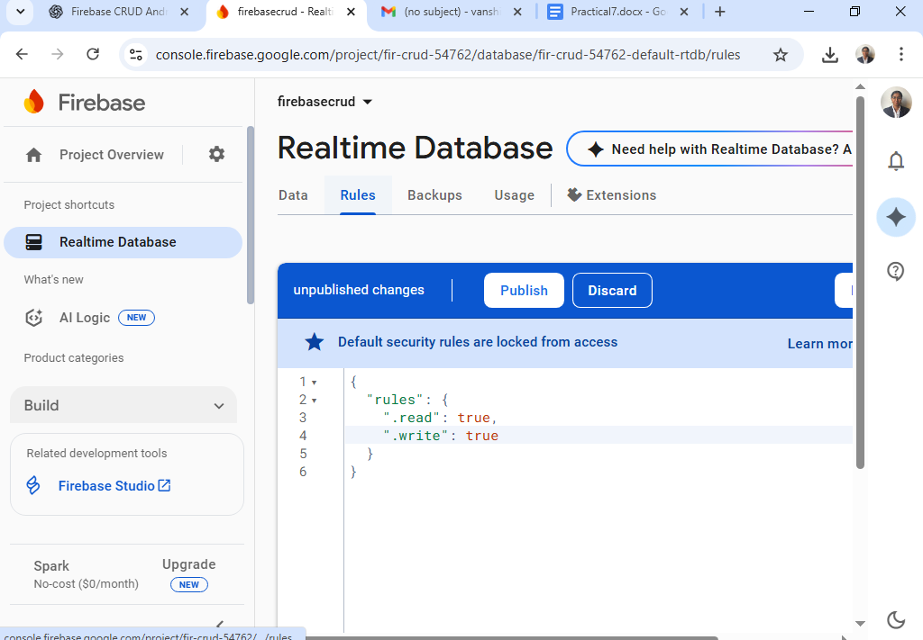

Click Publish

MainActivity.java
package com.example.firebasecrud;
import static com.example.firebasecrud.R.*;
import android.os.Bundle;
import android.view.View;
import android.widget.*;
import androidx.annotation.NonNull;
import androidx.appcompat.app.AppCompatActivity;
import com.google.firebase.analytics.FirebaseAnalytics;
import com.google.firebase.database.*;
import java.util.*;
public class MainActivity extends AppCompatActivity {
EditText etName, etEmail;
Button btnAdd, btnUpdate, btnDelete, btnViewAll;
ListView listView;
FirebaseAnalytics firebaseAnalytics;
DatabaseReference dbRef;
List<User> userList;
String selectedUserId = "";
@Override
protected void onCreate(Bundle savedInstanceState) {
super.onCreate(savedInstanceState);
setContentView(R.layout.activity_main);
firebaseAnalytics = FirebaseAnalytics.getInstance(this);
// Initialize views
etName = findViewById(R.id.etName);
etEmail = findViewById(R.id.etEmail);
btnAdd = findViewById(R.id.btnAdd);
btnUpdate = findViewById(R.id.btnUpdate);
btnDelete = findViewById(R.id.btnDelete);
btnViewAll = findViewById(R.id.btnViewAll);
listView = findViewById(R.id.listView);
dbRef = FirebaseDatabase.getInstance().getReference("users");
userList = new ArrayList<>();
// Button actions
btnAdd.setOnClickListener(view -> {
addUser();
logEvent("add_user");
});
btnUpdate.setOnClickListener(view -> {
updateUser();
logEvent("update_user");
});
btnDelete.setOnClickListener(view -> {
deleteUser();
logEvent("delete_user");
});
btnViewAll.setOnClickListener(view -> {
retrieveUsers(); // Only fetch when View All is clicked
});
listView.setOnItemClickListener((adapterView, view, i, l) -> {
User user = userList.get(i);
etName.setText(user.getName());
etEmail.setText(user.getEmail());
selectedUserId = user.getId();
});
}
private void logEvent(String action) {
Bundle bundle = new Bundle();
bundle.putString(FirebaseAnalytics.Param.METHOD, action);
firebaseAnalytics.logEvent(FirebaseAnalytics.Event.SELECT_CONTENT, bundle);
}
private void addUser() {
String name = etName.getText().toString();
String email = etEmail.getText().toString();
if (name.isEmpty() || email.isEmpty()) {
Toast.makeText(this, "Enter name and email", Toast.LENGTH_SHORT).show();
return;
}
String id = dbRef.push().getKey();
User user = new User(id, name, email);
dbRef.child(id).setValue(user);
Toast.makeText(this, "User Added", Toast.LENGTH_SHORT).show();
etName.setText("");
etEmail.setText("");
}
private void updateUser() {
if (!selectedUserId.isEmpty()) {
String name = etName.getText().toString();
String email = etEmail.getText().toString();
User user = new User(selectedUserId, name, email);
dbRef.child(selectedUserId).setValue(user);
Toast.makeText(this, "User Updated", Toast.LENGTH_SHORT).show();
} else {
Toast.makeText(this, "Select a user to update", Toast.LENGTH_SHORT).show();
}
}
private void deleteUser() {
if (!selectedUserId.isEmpty()) {
dbRef.child(selectedUserId).removeValue();
Toast.makeText(this, "User Deleted", Toast.LENGTH_SHORT).show();
etName.setText("");
etEmail.setText("");
selectedUserId = "";
} else {
Toast.makeText(this, "Select a user to delete", Toast.LENGTH_SHORT).show();
}
}
private void retrieveUsers() {
dbRef.addListenerForSingleValueEvent(new ValueEventListener() {
@Override
public void onDataChange(@NonNull DataSnapshot snapshot) {
userList.clear();
for (DataSnapshot postSnapshot : snapshot.getChildren()) {
User user = postSnapshot.getValue(User.class);
userList.add(user);
}
List<String> displayList = new ArrayList<>();
for (User user : userList) {
displayList.add("Name: " + user.getName() + "\nEmail: " + user.getEmail());
}
ArrayAdapter<String> adapter = new ArrayAdapter<>(MainActivity.this,
android.R.layout.simple_list_item_1, displayList);
listView.setAdapter(adapter);
Toast.makeText(MainActivity.this, "Data displayed on device", Toast.LENGTH_SHORT).show();
}
@Override
public void onCancelled(@NonNull DatabaseError error) {
Toast.makeText(MainActivity.this, "Error: " + error.getMessage(), Toast.LENGTH_SHORT).show();
}
});
}
}

User.java
package com.example.firebasecrud;
public class User {
private String id;
private String name;
private String email;
public User() {} // Required for Firebase
public User(String id, String name, String email) {
this.id = id;
this.name = name;
this.email = email;
}
public String getId() { return id; }
public String getName() { return name; }
public String getEmail() { return email; }
public void setId(String id) { this.id = id; }
public void setName(String name) { this.name = name; }
public void setEmail(String email) { this.email = email; }
}

activity_main.xml
<?xml version="1.0" encoding="utf-8"?>
<androidx.constraintlayout.widget.ConstraintLayout xmlns:android="http://schemas.android.com/apk/res/android"
android:layout_width="match_parent"
android:layout_height="match_parent">
<LinearLayout xmlns:android="http://schemas.android.com/apk/res/android"
android:padding="16dp"
android:orientation="vertical"
android:layout_width="match_parent"
android:layout_height="match_parent"
android:fitsSystemWindows="true">
<EditText
android:id="@+id/etName"
android:hint="Name"
android:layout_width="match_parent"
android:layout_height="wrap_content"/>
<EditText
android:id="@+id/etEmail"
android:hint="Email"
android:layout_width="match_parent"
android:layout_height="wrap_content"/>
<Button
android:id="@+id/btnAdd"
android:text="Add User"
android:layout_width="match_parent"
android:layout_height="wrap_content"/>
<Button
android:id="@+id/btnUpdate"
android:text="Update User"
android:layout_width="match_parent"
android:layout_height="wrap_content"/>
<Button
android:id="@+id/btnDelete"
android:text="Delete User"
android:layout_width="match_parent"
android:layout_height="wrap_content"/>
<Button
android:id="@+id/btnViewAll"
android:text="View All Users"
android:layout_width="match_parent"
android:layout_height="wrap_content"/>
<ListView
android:id="@+id/listView"
android:layout_width="match_parent"
android:layout_height="0dp"
android:layout_weight="1"/>
</LinearLayout></androidx.constraintlayout.widget.ConstraintLayout>

AndriodManifest.xml
<?xml version="1.0" encoding="utf-8"?>
<manifest xmlns:android="http://schemas.android.com/apk/res/android"
xmlns:tools="http://schemas.android.com/tools"
package="com.example.firebasecrud">
<!-- Required for Firebase Realtime Database & Analytics -->
<uses-permission android:name="android.permission.INTERNET" />
<application
android:allowBackup="true"
android:dataExtractionRules="@xml/data_extraction_rules"
android:fullBackupContent="@xml/backup_rules"
android:icon="@mipmap/ic_launcher"
android:label="@string/app_name"
android:roundIcon="@mipmap/ic_launcher_round"
android:supportsRtl="true"
android:theme="@style/Theme.Firebasecrud">
<activity android:name=".MainActivity"
android:exported="true">
<intent-filter>
<action android:name="android.intent.action.MAIN" />
<category android:name="android.intent.category.LAUNCHER" />
</intent-filter>
</activity>
</application>
</manifest>

