Research Title
Smart Academic Documents Appointment Scheduling Solutions Harnessing Raspberry Pi Technology for ICCT Colleges Timetable Optimization.

Application Name
DiReCT: Digital Record and Credential Transaction

Proposer’s Names
Alvarez, Reynel Pascua
Beatingo, Rodel Señoron
Catigbe, Daniel Nuico
Enriquez, Rita Carmel Uba
Marmol, John Kurt Russelle Medrano
Pandac, April Mae Jamil
Samoranos, Vincent Egarta
Ybañez, Gerlie Jane Cabia-an
Project Description
The DiReCT: Digital Record and Credential Transaction is a self-service platform designed to modernize the academic credential request process, empowering students with the ability to independently schedule appointments, select desired credential documents, process payments, and choose their preferred document retrieval method (delivery options). Conveniently located on campus, this kiosk streamlines the credential request process, reducing manual tasks and providing a more efficient and accessible service for both students and administrative staff.
Problem DiReCT Aims to Solve
The existing process for requesting academic credentials presents several limitations for students and administrative staff alike:
- Long Wait Times
- Students experience delays due to high demand and slow processing.
- Appointment Conflicts
- Fixed schedules make it hard for students to find convenient appointment times.
- Manual Processes
- Lots of paperwork and steps slow down the whole process.
- Lack of Notifications
- Without reminders, students often miss important appointments and deadlines.
- Lack of Transparency
- Provides users with real-time updates on appointment status.
Objectives
The primary objectives of the DiReCT are as follows:
- Convenient Appointment Scheduling
- Users can easily select and set their preferred appointment dates, ensuring a hassle-free experience tailored to their schedules.
- Keep Students Informed
- Ensure that students receive timely notifications about their appointment schedules, helping them stay organized and prepared.
- User-Friendly Interface
- Offers an intuitive design that makes scheduling and managing appointments simple and accessible for all users, regardless of their tech skills.

Kiosk Prototype Design
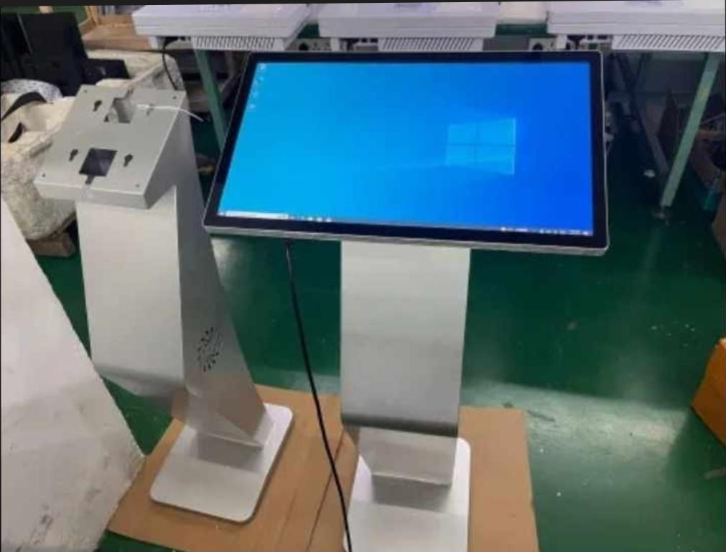
How to use?
Our DiReCT Kiosk System have only five (5) simple steps to complete the transaction.
- Enter Student No. - Enter your student number to access services. This will help you manage your appointments and access your academic documents easily.
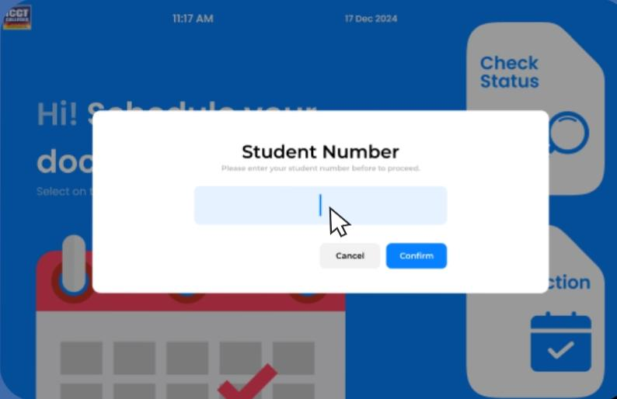
- Pick Documents – Easily select and pick the documents you need from a comprehensive list, ensuring you get exactly what you require for your academic needs.
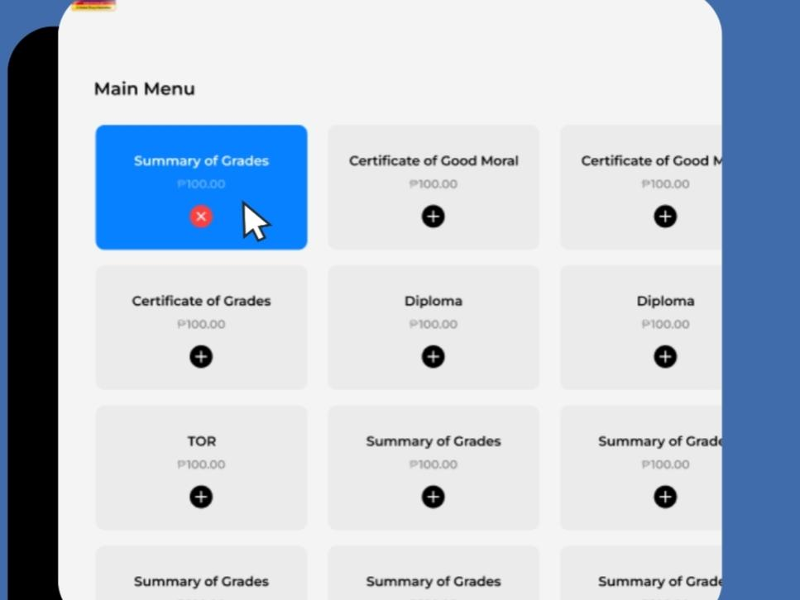
- Select Shipping Options – Choose your preferred method for document delivery, whether it’s express shipping, or in-person pickup, to ensure you receive your documents at your convenience.
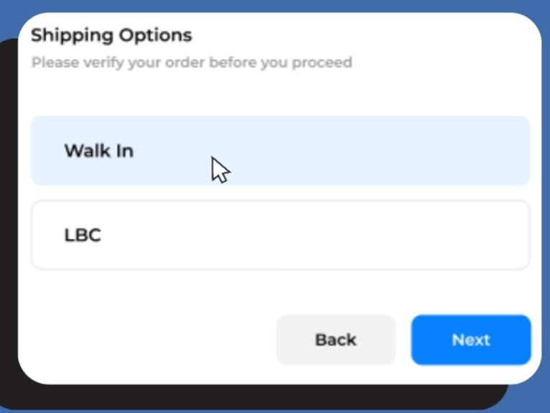
- Choose Appointment Schedule – Schedule your appointment at a time that works for you, ensuring that you can manage your academic responsibilities without any hassle.
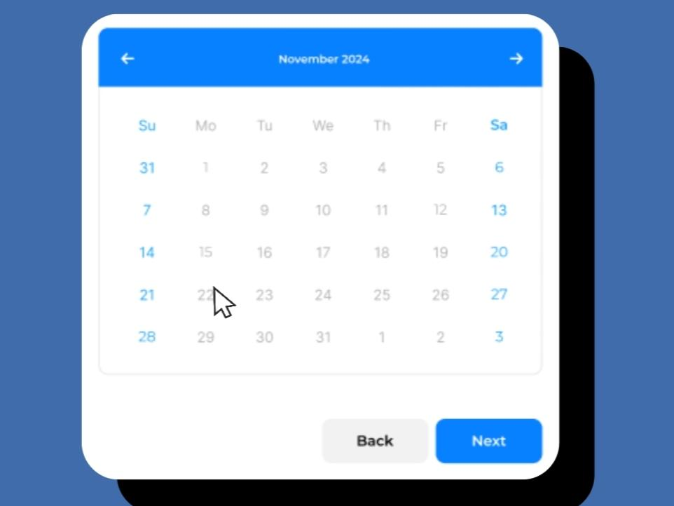
- Select Payment Methods – Choose a payment method that fits your preference, ensuring a seamless and convenient transaction process and pay it.
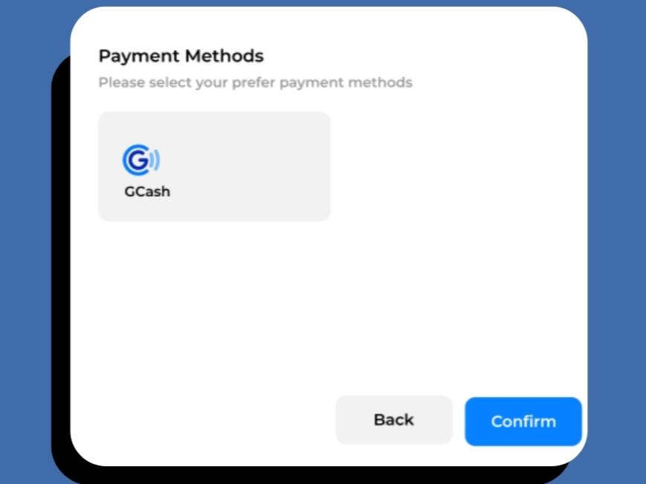
Application Features
- Kiosk & Mobile Application Features
  - Appointment Calendar
- Allows students to select a convenient appointment time, eliminating the limitations of registrar-assigned schedules and reducing the need for rescheduling.
  - Academic Credential List
- Offers a comprehensive display of all available credential documents, allowing students to easily browse and select the specific credentials they require.
  - Payment Integration
- Provides a seamless, secure payment experience, enabling students to pay transaction thru supported school payment options.
  - Reminder Alert
- Delivers timely notifications for upcoming appointments and payment deadlines, helping students stay organized and informed of key dates.
  - Delivery Integration
- Offers flexibility by allowing students to select their preferred method of document retrieval, whether through in-person pickup or via delivery.
- Registrar Features
  - Student Request Monitoring
- Track all student document requests and their payment statuses in real time.
  - Document Status Management
- This feature allows registrars to update the statuses of student document requests based on the selected delivery or pickup options. The status options include:
For Delivery Options:
- Pending: Indicates that the document request has not yet been paid.
- Processing: Indicates that the payment has been received and the document is being prepared for courier delivery to the student’s address.
- Delivered: Confirms that the document has been successfully delivered to the student's home.
For Pickup Options:
- Pending: Indicates that the document request has not yet been paid.
- Completed: Signifies that payment has been received, and the document is awaiting the scheduled appointment date for pickup.
- Released: Confirms that the document has been collected by the student at the school.
  - Academic Document Management
- Add, update, or delete academic documents. (The documents added will appear in the kiosk's academic document list.)
  - Delivery Options Management
- Manage delivery options by adding, updating, or deleting choices. (Pick-Up, LBC Express, J&T Express)
  - Payment Options Management
- Add, update, or delete available payment methods for student transactions.

Flowchart
This is the flowchart for our project, detailing each application and indicating the instructions for the system: You can also view it here.
- KIOSK
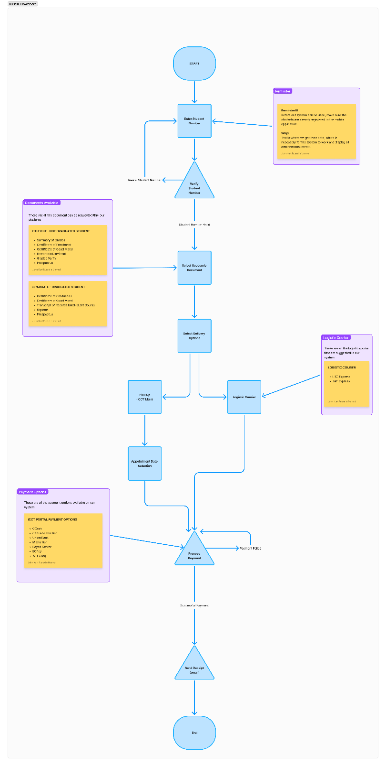
- MOBILE
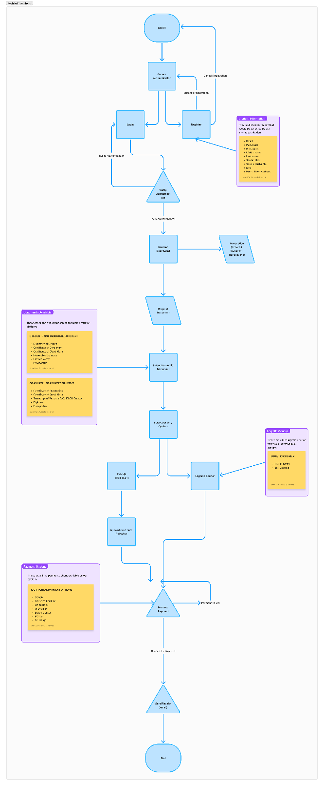
- REGISTRAR
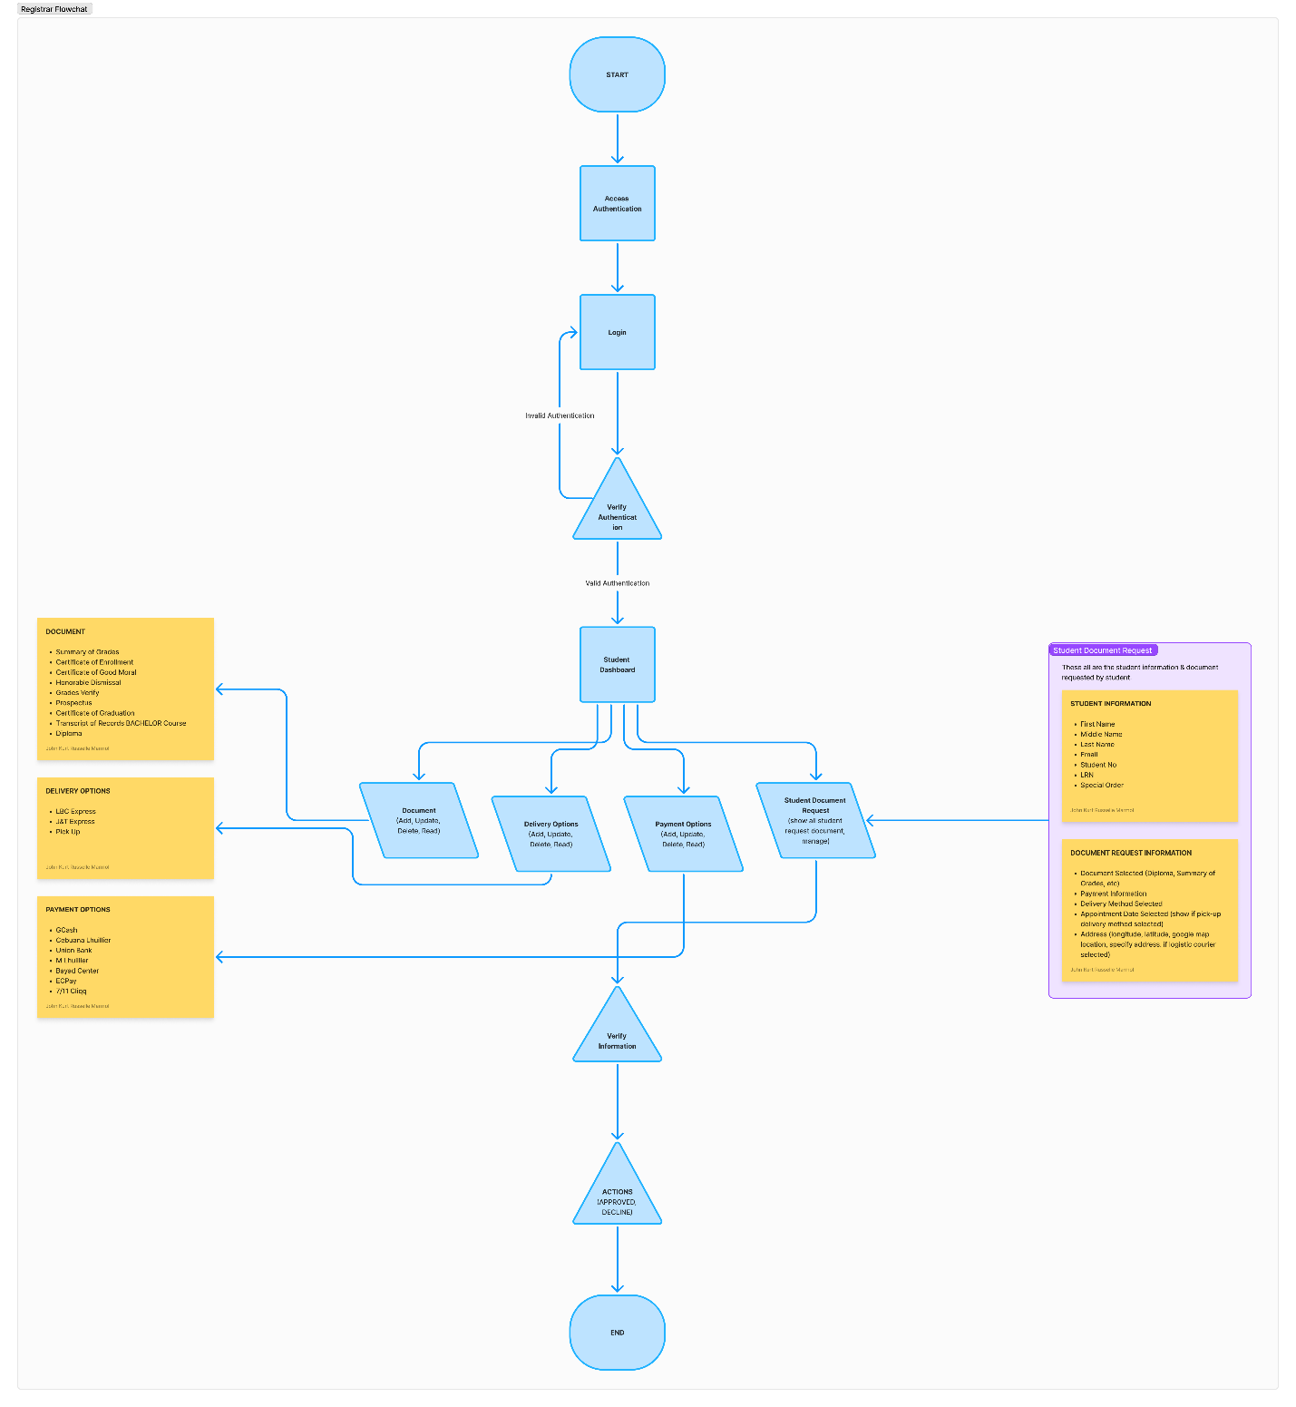
Entity Relational Diagram
This is the database schema for our project DiReCT. You can also view it here.
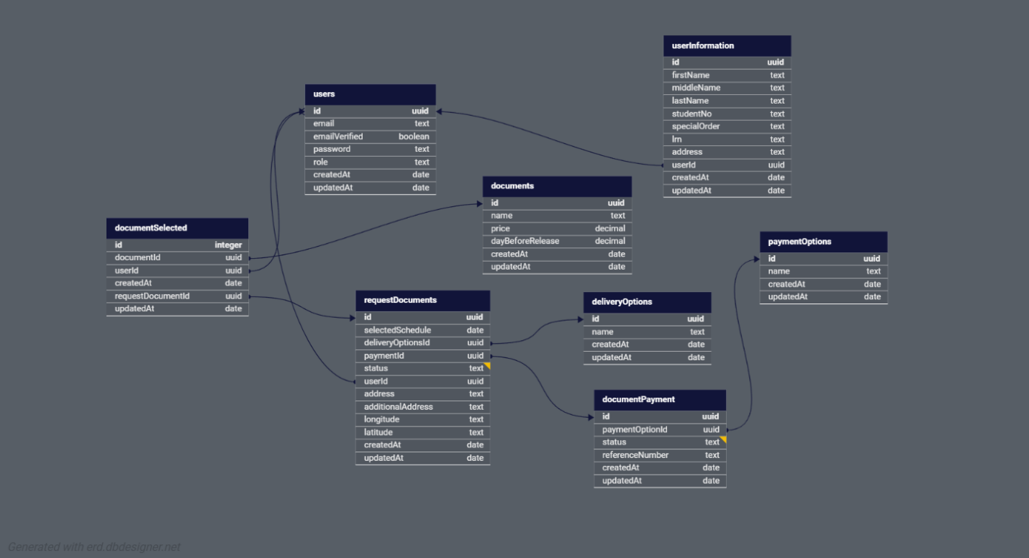
Resources Required
To successfully implement our project, we require a combination of specific hardware and software resources. Each component plays a crucial role in ensuring the system's functionality, efficiency, and reliability.
- Hardware:
  - Raspberry Pi 4 Model B
  - Kiosk Body
  - Touch Panel w/ LCD
  - Cables (micro, power adapter, HDMI)
  - Memory Card
- Software:
This is all software technology we will be using to develop our software application.
Front End | Back End
- React.js  - React Native  - Next.js  - Electron.js  - JavaScript  - TypeScript | - PostgreSQL  - Node.js  - Nest.js  - JavaScript  - TypeScript
Design Tools & Development Tools
- Figma
- Postman
- VS Code
- Postbird
- NPMJS Library

Development Timeline
This development timeline outlines the development process from initial research and planning to deployment, spanning a period of two (2) month and two (2) weeks.

- Phase 1: Oct 1 – 30
- Importing Kiosk Body & Touch Panel with LCD.
- Hardware Assembly.
- Phase 2: Oct 7 – 11
- Database Schema Design
- Database Implementation
- Phase 3: Oct 11 – 20
- Kiosk & Mobile Software UI Prototyping
- Phase 4: Oct 21 – Dec 6
- Development of Software for both Kiosk & Mobile
- Phase 5: Dec 9 – Dec 13
- QA Testing & Production Deployment

