EXERCISE DOCUMENT

FOR

INFORMATICA MDM HUB
Level - 0

Prepared By | Somdeep Bhattacharya(158752)
Create Date | April 12,2021
Reviewed By | Arnab Hazra (304029)
Review Date | April 12,2021

Overview:

This document will cover the basic configuration of Data Model in Informatica MDM Hub, and provides a real life scenario with business requirements.

Purpose:

The purpose of this document is to let a user understand the basic implementation in Informatica MDM Hub and how the configuration is done.

In-Scope:

The document will guide the user to execute the steps to build up a basic MDM data model. It will provide a simple Hands-on scenario for the beginners in Informatica MDM tool.

Out Of Scope:

The document will not provide the detail steps for configuration and implementation.

Business Requirements

- To build up a Customer MDM system.
- System will store Customer and their Address information.
- Customer can be of two types, i.e. PROFESSIONAL and ACCOUNT.
- Source data will be coming from 2 source systems, i.e. SRC1 and SRC2.
- SRC1 will provide Customer and Address data for both professionals and organizations (account data).
- SRC2 will provide Customer and Address data for professionals only.
- Both the sources will be sending Full Set of Data.
- Records from SRC1 are more reliable than records from SRC2.
- Reliability of a record from SRC1 will be maintained initially, and will be decayed rapidly for longer period of a year.
- Reliability of a record from SRC2 will be decayed with time in a linear fashion in a period of 9 months.
- If the source is sending Null values for First Name and Last Name of a Professional, then the reliability of the entire record will be downgraded.
- If the source is sending Null values for Organization Name, then the reliability of the entire record will be downgraded.
- If the Addr Line 1 for an Address record is Null, then the reliability of the entire record will be downgraded.
- If the Addr Line 2 for an Address record is Null, then the reliability of the Addr Line 2 value of that record will be downgraded.
- Full Name should be populated with First Name, first letter of Middle Name, Last Name for Professional records and with Org Name for Account records.

[* -Address String as match field consists of Address Line 1, State, City and ZIP_CD]

MDM Design Considerations

- Here, individual landing tables are created for each source providing the same type of data. But, single landing table can also be created, and a source system identifier can be added as an attribute in the landing table that can be further added in the query parameter to load data in the source specific staging tables.
- The purpose of having FULL NAME and ORG NAME in the data model is not the same. FULL NAME will be present for both Professional and Account Records, whereas ORG NAME is only for the Account records.
- For Professionals, FULL NAME= Concatenation of FIRST NAME, First letter of MIDDLE NAME, LAST NAME
- For Accounts, Full Name =Organization Name
- The Design here comprises of 2 sections:
- MDM Hub Data Model Implementation

Design Requirements

ER Diagram

The Entity Relationship Diagram for the above requirements is depicted as below:

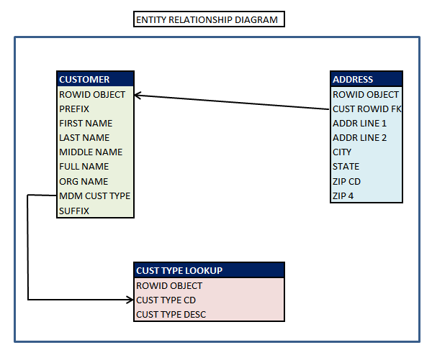

Source System

- Add two source systems SRC1 and SRC2 for CUSTOMER and ADDRESS Base Object in the Informatica MDM Hub
- LKP_ADMIN will be the source for the CUST TYPE LOOKUP Base object

Customer Entity

- Create the table structure for CUSTOMER base object and it’s corresponding attributes as per below table:

Entity | Display Name | Physical Name
CUSTOMER | CUSTOMER | C_CUSTOMER

CUSTOMER COLUMN ATTRIBUTE
COLUMN NAME | DATA TYPE | LENGTH | TRUST | VALIDATION | NULLABLE
ROWID OBJECT | CHAR | 14
PREFIX | VARCHAR | 10 | Y | Y | Y
FIRST NAME | VARCHAR | 200 | Y | Y | Y
LAST NAME | VARCHAR | 200 | Y | Y | Y
MIDDLE NAME | VARCHAR | 50 | Y |  | Y
FULL NAME | VARCHAR | 500 | Y | Y | Y
ORG NAME | VARCHAR | 200 | Y | Y | Y
MDM CUST TYPE | VARCHAR | 30 |  |  | Y
SUFFIX | VARCHAR | 10 | Y | Y | Y

- Create the staging tables of Customer as below as per below table structure. Since customer data is received from both the source systems, two Staging tables are needed.

Source | Display Name | Physical Name
SRC1 | S SRC1 CUST | C_S_SRC1_CUST
SRC2 | S SRC2 CUST | C_S_SRC2_CUST

Base Object column selection for CUSTOMER staging tables
Columns from Base Object | S SRC1 CUST | S SRC2 CUST | Lookup Configure
ROWID OBJECT | √ | √
PREFIX | √ | √
FIRST NAME | √ | √
LAST NAME | √ | √
MIDDLE NAME | √ | √
FULL NAME | √ | √
ORG NAME | √ | X
MDM CUST TYPE | √ | √ | √
SUFFIX | √ | √

- Create the Landing tables of Customer as per below table. Since customer data is received from both the source systems, two Landing tables are needed.

Source | Display Name | Physical Name
SRC1 | L SRC1 CUST | C_L_SRC1_CUST
SRC2 | L SRC2 CUST | C_L_SRC2_CUST

CUSTOMER landing table attributes
Column Name | L SRC1 CUST | L SRC2 CUST
CUST_ID | √ | √
PREFIX | √ | √
FIRST NAME | √ | √
LAST NAME | √ | √
MIDDLE NAME | √ | √
ORG NAME | √ | X
SRC CUST TYPE | √ | √
SUFFIX | √ | √

- Define the trust setting for CUSTOMER base object columns as per below table:

CUSTOMER COLUMN TRUST CONFIGURATION
COLUMN NAME | SOURCE NAME | MAX | MIN | UNITS | DECAY | GRAPH
PREFIX | SRC1 | 80 | 60 | MONTH | 12 | SLOW INITIAL RAPID LATER
 | SRC2 | 70 | 50 | MONTH | 9 | LINEAR
FIRST NAME | SRC1 | 80 | 60 | MONTH | 12 | SLOW INITIAL RAPID LATER
 | SRC2 | 70 | 50 | MONTH | 9 | LINEAR
LAST NAME | SRC1 | 80 | 60 | MONTH | 12 | SLOW INITIAL RAPID LATER
 | SRC2 | 70 | 50 | MONTH | 9 | LINEAR
MIDDLE NAME | SRC1 | 80 | 60 | MONTH | 12 | SLOW INITIAL RAPID LATER
 | SRC2 | 70 | 50 | MONTH | 9 | LINEAR
FULL NAME | SRC1 | 80 | 60 | MONTH | 12 | SLOW INITIAL RAPID LATER
 | SRC2 | 70 | 50 | MONTH | 9 | LINEAR
ORG NAME | SRC1 | 80 | 60 | MONTH | 12 | SLOW INITIAL RAPID LATER
SUFFIX | SRC1 | 80 | 60 | MONTH | 12 | SLOW INITIAL RAPID LATER
 | SRC2 | 70 | 50 | MONTH | 9 | LINEAR

- Configure the validation Rules configuration for CUSTOMER as per below table:

VALIDATION RULES FOR CUSTOMER
Rule No | Rule Description | Column to downgrade Trust | Percentage | Reserve Min Trust
1 | If FIRST NAME and LAST NAME are NULL and MDM CUST TYPE=’PROF’ | FIRST NAME | 70 | N
 |  | LAST NAME | 70 | N
 |  | MIDDLE NAME | 70 | N
 |  | PREFIX | 100 | Y
 |  | SUFFIX | 100 | Y
 |  | FULL NAME | 70 | N
2 | If ORG NAME is NULL and MDM CUST TYPE=’ACCT’ | ORG NAME | 80 | Y
 |  | FULL NAME | 80 | Y

Address Entity

- Create the table structure for ADDRESS base object and it’s columns as per below table:

Entity | Display Name | Physical Name
ADDRESS | ADDRESS | C_ADDRESS

ADDRESS COLUMN ATTRIBUTE
COLUMN NAME | DATA TYPE | LENGTH | TRUST | VALIDATION | NULLABLE
CUST ROWID FK | CHAR | 14
ADDR LINE 1 | VARCHAR | 200 | Y | Y | Y
ADDR LINE 2 | VARCHAR | 200 | Y | Y | Y
CITY | VARCHAR | 100 | Y | Y | Y
STATE | VARCHAR | 100 | Y | Y | Y
ZIP CD | VARCHAR | 5 | Y | Y | Y
ZIP 4 | VARCHAR | 4 | Y | Y | Y

- Design for staging tables of Address is defined as below: Since Address data is received from both the source systems, two Staging tables are needed.

Source | Display Name | Physical Name
SRC1 | S SRC1 ADDR | C_S_SRC1_ADDR
SRC2 | S SRC2 ADDR | C_S_SRC2_ADDR

Base Object column selection for ADDRESS staging tables
Columns from Base Object | S SRC1 ADDR | S SRC2 ADDR | Lookup Configure
ROWID OBJECT | √ | √
CUST ROWID FK | √ | √ | √
ADDR LINE 1 | √ | √
ADDR LINE 2 | √ | √
CITY | √ | √
STATE | √ | √
ZIP CD | √ | √
ZIP 4 | √ | √

- Design for Landing tables of Address is defined as below: Since customer address data is received from both the source systems, two Landing tables are needed.

Source | Display Name | Physical Name
SRC1 | L SRC1 ADDR | C_L_SRC1_ADDR
SRC2 | L SRC2 ADDR | C_L_SRC2_ADDR

ADDRESS landing table attributes
Column Name | L SRC1 ADDR | L SRC2 ADDR
CUST_ID | √ | √
ADDR LINE 1 | √ | √
ADDR LINE 2 | √ | √
CITY | √ | √
STATE | √ | √
ZIP CD | √ | √
ZIP 4 | √ | √

- Define the trust setting for ADDRESS base object is as per below table:

ADDRESS COLUMN TRUST CONFIGURATION
COLUMN NAME | SOURCE NAME | MAX | MIN | UNITS | DECAY | GRAPH
ADDR LINE 1 | SRC1 | 80 | 60 | MONTH | 12 | SLOW INITIAL RAPID LATER
 | SRC2 | 70 | 50 | MONTH | 9 | LINEAR
ADDR LINE 2 | SRC1 | 80 | 60 | MONTH | 12 | SLOW INITIAL RAPID LATER
 | SRC2 | 70 | 50 | MONTH | 9 | LINEAR
CITY | SRC1 | 80 | 60 | MONTH | 12 | SLOW INITIAL RAPID LATER
 | SRC2 | 70 | 50 | MONTH | 9 | LINEAR
STATE | SRC1 | 80 | 60 | MONTH | 12 | SLOW INITIAL RAPID LATER
 | SRC2 | 70 | 50 | MONTH | 9 | LINEAR
ZIP CD | SRC1 | 80 | 60 | MONTH | 12 | SLOW INITIAL RAPID LATER
 | SRC2 | 70 | 50 | MONTH | 9 | LINEAR
ZIP 4 | SRC1 | 80 | 60 | MONTH | 12 | SLOW INITIAL RAPID LATER
 | SRC2 | 70 | 50 | MONTH | 9 | LINEAR

- Configure the Validation Rule for ADDRESS as per below table:

VALIDATION RULE FOR ADDRESS
Rule No | Rule Description | Column to downgrade Trust | Percentage | Reserve Min Trust
1 | If ADDR LINE 1 is NULL | ADDR LINE 1 | 70 | N
 |  | ADDR LINE 2 | 70 | N
 |  | CITY | 70 | N
 |  | ZIP CD | 70 | N
 |  | STATE | 70 | N
2 | If ADDR LINE 2 is NULL | ADDR LINE 2 | 100 | Y

Customer Type Lookup Entity

- Define the Table structure for CUSTOMER TYPE LOOKUP base object and it’s column as per below table:

Entity | Display Name | Physical Name
CUSTOMER TYPE LOOKUP | LKP CUST TYPE | C_LKP_CUST_TYPE

CUSTOMER TYPE LOOKUP COLUMN ATTRIBUTE
COLUMN NAME | DATA TYPE | LENGTH | TRUST | VALIDATION | NULLABLE
ROWID OBJECT | CHAR | 14
CUST TYPE CD | VARCHAR | 30
CUST TYPE DESC | VARCHAR | 200

- Design for staging tables of Customer Type Lookup is defined as below. Since Lookup data is received from only LKP_ADMIN, one Staging tables is needed.

Source | Display Name | Physical Name
LKP_ADMIN | S LKP CUST TYPE | C_S_LKP_CUST_TYPE

Base Object column selection for CUST TYPE LOOKUP staging table
Columns from Base Object | S LKP CUST TYPE | Lookup Configure
CUST TYPE CD | √
CUST TYPE DESC | √

- Design for Landing tables of Customer Type Lookup is given below.

Source | Display Name | Physical Name
LKP_ADMIN | L CUST TYPE | C_L_CUST_TYPE

CUST TYPE LOOKUP landing table attributes
Column Name | L CUST TYPE
CUST TYPE CD | √
CUST TYPE DESC | √

Design & Build

- Creation of Source Systems

From System and Trust tool in the workbench of the Informatica MDM console, create the source systems required. Here in this assignment SRC1, SRC2 and LKP_ADMIN needs to be created.

- Creation of Base Objects

Three base objects: CUSTOMER, ADDRESS and CUSTOMER TYPE LOOKUP are to be created for this assignment, from the Schema tool in the console under Base Object category.
Please find the screenshot of CUSTOMER base object below for the reference

Create the columns required for the base objects from the COLUMNS option for the base object. Below is the screenshot of the columns of the CUSTOEMR base object

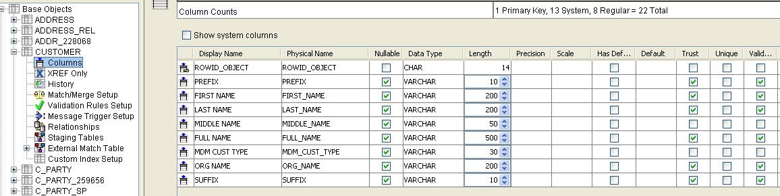

Configure the attributes of the columns of the base object according to the specification, like, assigning Datatype, Length, enable for Trust, Validation etc.

In the same way other base objects (ADDRESS and CUST TYPE LOOKUP) need to be created and configured.

- Setup Relationship between two Base Objects ( Parent – Child)

To configure the relationship between two base objects, add the relationship from the Relationships option under the Child base object. Select the foreign Key column in the Child object with the unique column of the Parent one.

Below is the screen shot of the CUSTOMER – ADDRESS relationship configured inside the ADDRESS (child) table.

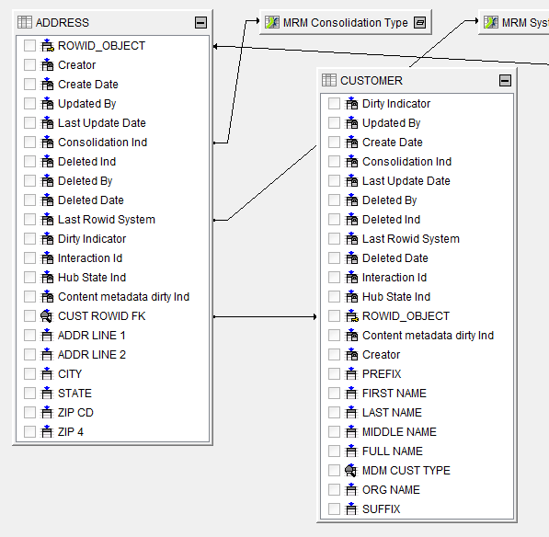

- Creation of Staging Tables

Staging tables are created from the Staging Tables option under the respective Base Object. Staging tables are source specific and hence, need to create as many Staging tables as the number of sources sending data for that particular base object.
In this assignment, CUSTOMER and ADDRESS are getting data from SRC1 and SRC2.

Columns from the base objects are available to select for each of the staging table created under it. Select the required columns which are supposed to be fed by the source specified for that staging table.

Below is the screenshot of the selection of column for staging table.

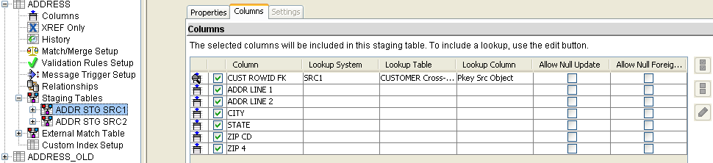

To maintain the referential integrity, one needs to configure the lookup in the staging table for the column on which Relationship has been configured in base object level.

Below is the screenshot of the lookup configured in ADDRESS staging table on the column CUST ROWID FK which is the Foreign Key in the ADDRESS base object.

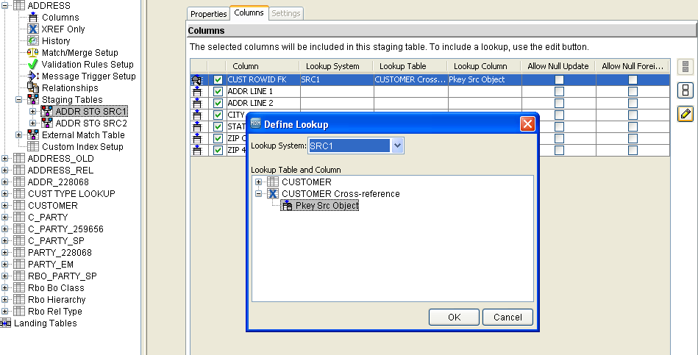

- Creation of Landing Tables

Landing tables are created from Schema under Model workbench. To load the customer attributes in the customer base object from two sources i.e. SRC1 and SRC2, two landing tables need are required. The same way two landing tables need to be created to load the address attributes and one landing table is required to load the cust type lookup table.

Create the columns that are required to load the inbound attributes in the base objects from the COLUMNS option. Below is the screenshot of the columns of the SRC1 CUSTOMER landing table.

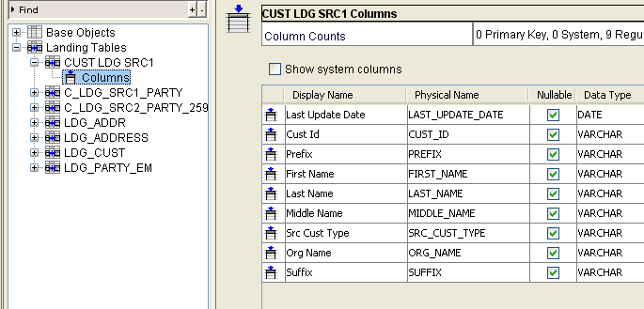

In the same way other landing tables for ADDRESS and CUST TYPE LOOKUP need to be created and configured.

- Creation of Mappings

Two mappings, one for SRC1 and another for SRC2 need to be created to stage the data from landing to staging table for customer entity. The same way two mappings need to be created for address entity and one mapping need to be created for cust type lookup table.

For customer mapping, CUST_ID is mapped to PKEY_SRC_OBJECT of staging table.

For address mapping, concatenation of CUST_ID, ADDR_LINE1, CITY, STATE (pipe-| separated) are mapped to PKEY_SRC_OBJECT of the corresponding staging table.

For customer lookup table, CUST TYPE CD is the Primary Key.

Below is the screenshot of SRC1 CUSTOMER mapping for reference.

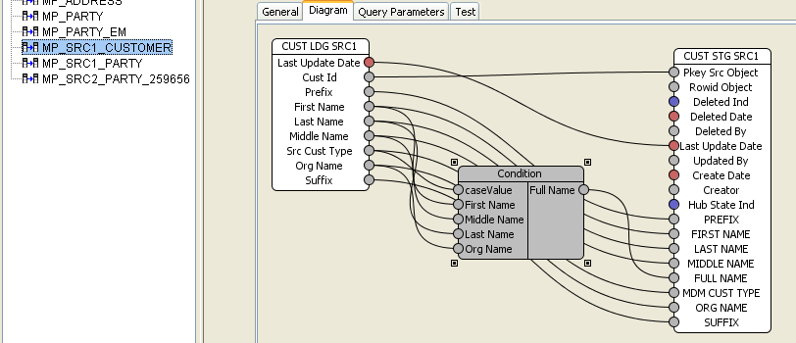

- Trust Configuration

Trust needs to be configured for Trust enabled columns of the base object which receives data from more than one source system to determine the cell level survivorship during consolidation process in Informatica MDM.

Trust configuration is done in System and Trust tool in the workbench. Trust Score, Decay Period, Decay Graph are determined for those columns of the base objects.

- Validation Rule Set up

Validation Rule is used to ensure data quality at base object level. This basically downgrades the Trust of the columns for a record if the condition defined for the rule is met by the record. Validation Rule is configured in Validation Rules Setup option inside one base object.

Below is the screenshot of one of the Validation Rules for CUSTOMER base objects as per the requirement in this assignment.

