**Name: Nikhil Sharma**

**UID: 23BCC70030**

**Class: 23BCC-1(A)**

**Experiment -1**

**Student Registration Form with HTML5 Validation**

**Aim:**

To design and implement a basic student registration form using HTML5 that collects user information and performs input validation.

**Theory:**

HTML5 provides several input types and attributes that allow validation directly in the browser without writing JavaScript. This includes:

1. required: Ensures the field must be filled before submission.
2. type="email": Checks that the input is a valid email address.
3. type="number": Accepts only numerical values.
4. min, max: Sets allowed ranges for numbers.
5. pattern: Allows custom regular expression matching.
6. placeholder: Provides user guidance inside input fields.

Using these features improves user experience and ensures data integrity before it reaches the server.

**Procedure:**

1. Create a new HTML file (e.g., student-registration.html).
2. Inside the <body>, add a <form> element with relevant fields.
3. Use HTML5 attributes like required, type, min, and placeholder to validate input.
4. Add a submit button to allow users to send the data.
5. Open the file in a browser and test the form by filling out incorrect and correct values.

**Code:**

<!DOCTYPE html>

<html lang="en">

<head>

  <meta charset="UTF-8">

  <title>Student Registration Form</title>

  <style>

    /* Reset & font */

    * {

      margin: 0;

      padding: 0;

      box-sizing: border-box;

      font-family: 'Segoe UI', Tahoma, Geneva, Verdana, sans-serif;

    }

    body {

      min-height: 100vh;

      display: flex;

      justify-content: center;

      align-items: center;

      padding: 20px;

    }

    form {

      background-color: #ffffff;

      padding: 30px 40px;

      border-radius: 12px;

      max-width: 420px;

      width: 100%;

      box-shadow: 0 10px 25px rgba(0, 0, 0, 0.1);

    }

    h2 {

      text-align: center;

      margin-bottom: 20px;

      color: #333;

      font-size: 26px;

    }

    label {

      font-weight: 500;

      margin-top: 15px;

      color: #444;

      display: block;

    }

    input {

      width: 100%;

      padding: 12px;

      margin-top: 8px;

      border: 1px solid #ccc;

      border-radius: 8px;

      font-size: 16px;

      transition: all 0.3s ease;

    }

    input:focus {

      border-color: #2575fc;

      box-shadow: 0 0 8px rgba(37, 117, 252, 0.3);

      outline: none;

    }

    button {

      margin-top: 20px;

      width: 100%;

      padding: 14px;

      background: linear-gradient(90deg, #6a11cb, #2575fc);

      color: #fff;

      border: none;

      border-radius: 8px;

      font-size: 18px;

      cursor: pointer;

      transition: background 0.3s ease;

    }

    button:hover {

      background: linear-gradient(90deg, #5a0ecb, #1e65fc);

    }

  </style>

</head>

<body>

  <form>

    <h2>Student Registration</h2>

    <label for="name">Full Name:</label>

    <input type="text" id="name" name="name" required placeholder="Enter your full name">

    <label for="email">Email Address:</label>

    <input type="email" id="email" name="email" required placeholder="example@email.com">

    <label for="age">Age:</label>

    <input type="number" id="age" name="age" required min="5" max="100" placeholder="Enter your age">

    <button type="submit">Register</button>

  </form>

</body>

</html>

**Output:**

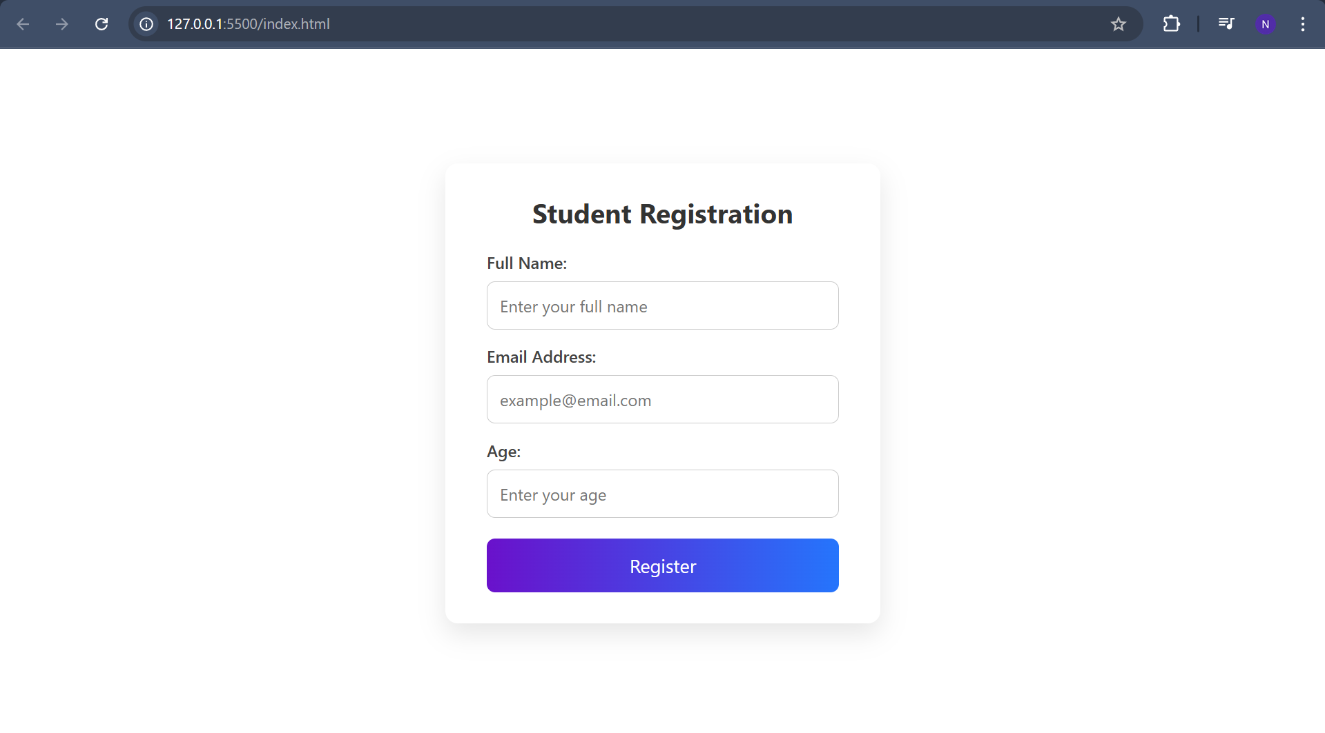

**Learning Outcomes:**

1. By completing this practical, the student will be able to:
2. Understand the importance of form validation in web development.
3. Use HTML5 input types and validation attributes effectively.
4. Design accessible and user-friendly web forms.
5. Validate user data directly in the browser without JavaScript.