**bikroy.com**

**Issue:** accepting alphanumeric letters for sign up

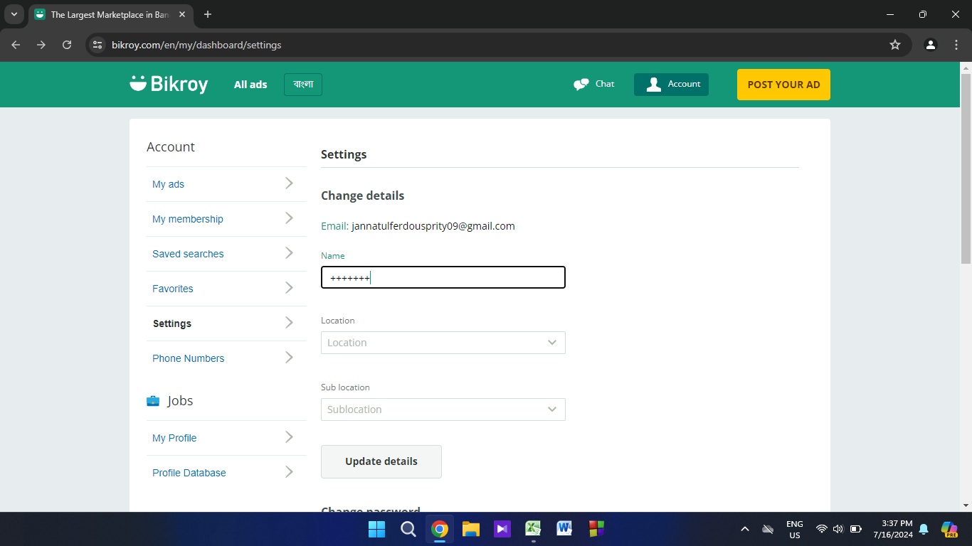

Description:

1.Go to the URL https://bikroy.com/

2.click on log in

3.click on sign up

4.in the name field entering:+++++

5.it will accept it

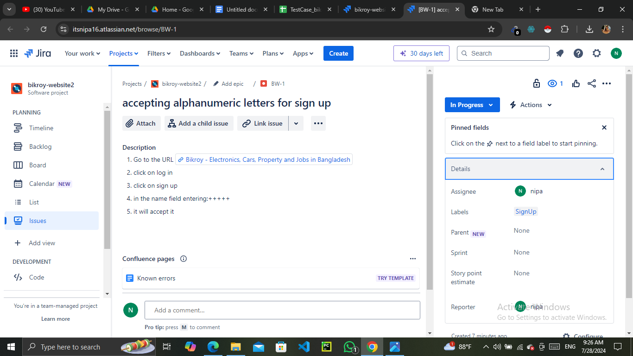

Description:This work was assigned to nipa(the user herself) to solve the issue. The developer was working and it was in the progress stage.

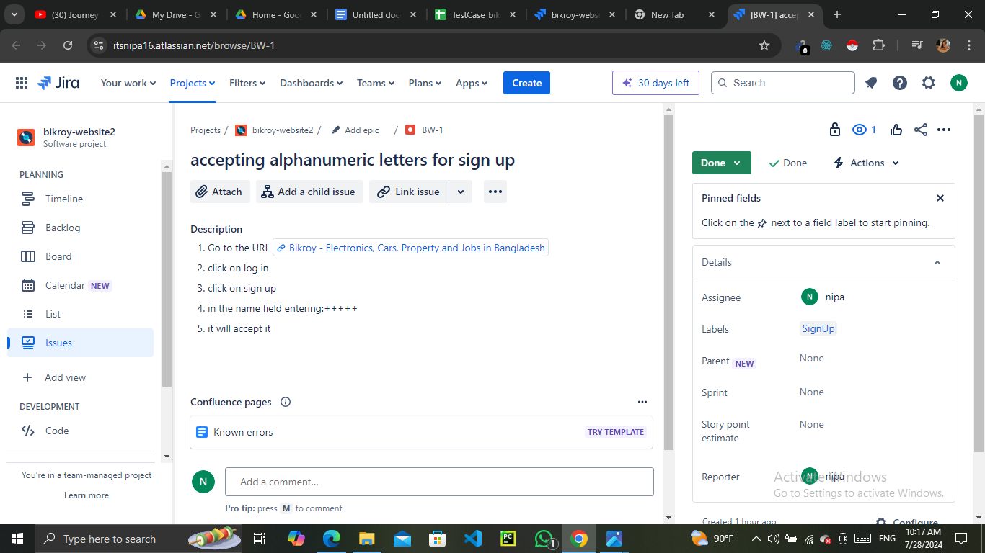

Description: Developer completed the work and the work is done.