TRIBHUVAN UNIVERSITY
Faculty of Humanities and Social Sciences
Pashupati Multiple Campus
A Project Report on
ANKA: STUDENT RESULT ANALYSIS AND RANKING SYSTEM
Submitted to
Department of Computer Application
Pashupati Multiple Campus
In partial fulfillment of the requirements for the degree of
Bachelor of Computer Applications (BCA)
Project III (CACS452), Eighth Semester
Submitted by
Niranjan Katwal
TU Symbol No.: 27802063
TU Registration No.: 6-2-278-18-2022
Project Supervisor
Name and designation of the supervisor
Month and year of submission

SUPERVISOR'S RECOMMENDATION
I hereby recommend that this project report, prepared under my supervision by Niranjan Katwal (TU Symbol No. 27802063, Registration No. 6-2-278-18-2022) and entitled "Anka: Student Result Analysis and Ranking System", be accepted as partial fulfillment of the requirements for the degree of Bachelor of Computer Applications. In my opinion, this report is satisfactory for submission to the evaluation committee.

Signature
Name of the supervisor
Designation
Pashupati Multiple Campus
Date: dd/mm/yyyy

CERTIFICATE OF APPROVAL
This is to certify that the project report entitled "Anka: Student Result Analysis and Ranking System" submitted by Niranjan Katwal in partial fulfillment of the requirements for the degree of Bachelor of Computer Applications has been examined and approved by the evaluation committee.

Signature Supervisor: Name
Signature Internal Examiner: Name
Signature External Examiner: Name
Signature Head of Department / Program Coordinator: Name
Signature Campus Chief: Name
Date: dd/mm/yyyy

ACKNOWLEDGEMENT
I would like to express my sincere gratitude to my project supervisor, name of the supervisor, for the guidance, patient review and constructive suggestions that shaped this project. I am thankful to the Head of Department and all the teachers of the Department of Computer Application at Pashupati Multiple Campus for the knowledge they shared during the four years of the BCA program.
I thank the Tribhuvan University for the project framework that gave this work a clear direction, and my classmates and friends who tested early versions and gave honest feedback. Finally, I am grateful to my family for their constant support and encouragement.
Any remaining mistakes are my own, and I welcome suggestions for improvement.

Niranjan Katwal

ABSTRACT
Educational institutions in Nepal still prepare results from paper registers and spreadsheets. Marks are copied several times, grade points are calculated by hand, back paper results are hard to track, printed marksheets cannot be verified, and weak students are noticed only after the final examination. This project presents Anka, a web based Student Result Analysis and Ranking System that removes these problems for institutions of any level.
Anka stores programs, subjects, marks and attendance in a MySQL database and exposes them through a Node.js and Express REST API and a React client. A configurable grading engine supports TU semester GPA, NEB grade points and percentage divisions with credit-weighted SGPA and CGPA. A back paper (re-sit) is stored as a separate sitting so that a cleared failure updates the semester result while the full history is kept. Students are ranked with a merge sort that handles ties, and the system provides analytics based on a binary heap, descriptive statistics, linear regression, Pearson correlation and k-means clustering, all implemented from scratch. An explainable early-warning score identifies students at risk. Marksheets carry a QR code and a ten-character code that anyone can verify. Result, approval, reset, notice and risk emails are sent through a queue with retries. A daily class module provides a timetable with clash detection, a class diary and assignment tracking. The product is unbranded by default, so any school, college or university can use it.
The system was tested with 18 unit tests, 58 API flow checks, 43 smoke checks, 32 classroom checks and a browser end-to-end suite that drives the real pages. The results show that the objectives were met. The grade table and back paper rules follow the commonly published TU scheme and are editable, because they could not be verified against the official regulation.
Keywords: result processing, GPA, back paper, ranking, merge sort, k-means, early warning, REST API, React, MySQL, Nepal

TABLE OF CONTENTS
SUPERVISOR'S RECOMMENDATION i
CERTIFICATE OF APPROVAL ii
ACKNOWLEDGEMENT iii
ABSTRACT iv
TABLE OF CONTENTS v
LIST OF ABBREVIATIONS vii
LIST OF FIGURES viii
LIST OF TABLES ix
CHAPTER 1: INTRODUCTION 1
1.1 Background 1
1.2 Problem Statement 1
1.3 Objectives 2
1.4 Scope and Limitations 3
1.5 Development Methodology 4
1.6 Report Organization 5
CHAPTER 2: BACKGROUND STUDY AND LITERATURE REVIEW 6
2.1 Background Study 6
2.2 Review of Existing Systems 7
2.3 Literature Review 7
2.4 Technology Background 8
CHAPTER 3: SYSTEM ANALYSIS 9
3.1 Requirement Identification 9
3.2 Feasibility Study 11
3.3 Process Modelling 12
3.4 Data Modelling 13
3.5 Object Modelling 14
CHAPTER 4: SYSTEM DESIGN 19
4.1 Architecture Design 19
4.2 Database Design 20
4.3 API Design 21
4.4 Interface Design 22
4.5 Algorithm Design 23
4.6 Security Design 25
4.7 Email Design 26
CHAPTER 5: IMPLEMENTATION AND TESTING 27
5.1 Implementation 27
5.2 Testing 29
5.3 Result Analysis 31
CHAPTER 6: CONCLUSION AND FUTURE RECOMMENDATIONS 33
6.1 Conclusion 33
6.2 Future Recommendations 33
REFERENCES 34
APPENDIX A: SCREENSHOTS 36
APPENDIX B: RUNNING THE SYSTEM 41

LIST OF ABBREVIATIONS
API Application Programming Interface
BCA Bachelor of Computer Applications
CGPA Cumulative Grade Point Average
CORS Cross-Origin Resource Sharing
CRUD Create, Read, Update, Delete
CSV Comma-Separated Values
DFD Data Flow Diagram
ER Entity Relationship
GPA Grade Point Average
HTML HyperText Markup Language
HTTP HyperText Transfer Protocol
JSON JavaScript Object Notation
JWT JSON Web Token
NEB Nepal Examination Board
RBAC Role Based Access Control
REST Representational State Transfer
SGPA Semester Grade Point Average
SMTP Simple Mail Transfer Protocol
SQL Structured Query Language
TU Tribhuvan University
UI User Interface
UML Unified Modeling Language
QR Quick Response (code)

LIST OF FIGURES
Figure 3.1: Project schedule (Gantt chart) 12
Figure 3.2: Context diagram (DFD level 0) 12
Figure 3.3: DFD level 1 13
Figure 3.4: Entity relationship diagram 14
Figure 3.5: Use case diagram 15
Figure 3.6: Class diagram of the main classes 16
Figure 3.7: Activity diagram: calculate and publish results 17
Figure 3.8: Sequence diagram: publish results and send email 17
Figure 4.1: System architecture 19
Figure 4.2: Life cycle of a failed subject and its back paper 21
Figure A.1: Landing page 36
Figure A.2: Personal GPA checker with back papers 36
Figure A.3: Marksheet verification result 37
Figure A.4: Administrator dashboard 37
Figure A.5: Programs with grading schemes 37
Figure A.6: Results workflow 38
Figure A.7: Mail center 38
Figure A.8: Marks entry grid 38
Figure A.9: Back paper entry 39
Figure A.10: Classes: weekly timetable 39
Figure A.11: Marksheet with QR code 39
Figure A.12: Student insights and risk 40
Figure A.13: Result email as rendered in a browser 40

LIST OF TABLES
Table 1.1: Development phases and activities 4
Table 2.1: Comparison of existing approaches with Anka 7
Table 2.2: Technologies used and their role 8
Table 3.1: Functional requirements 9
Table 3.2: Non-functional requirements 10
Table 3.3: Estimated cost of development and a first deployment 11
Table 3.4: Use case description: Calculate and publish results 15
Table 3.5: Use case description: Enter back paper marks 15
Table 3.6: States of a result row 18
Table 4.1: Core tables and key columns 20
Table 4.2: Supporting tables 20
Table 4.3: REST endpoints by router 21
Table 4.4: Pages available to each role 22
Table 4.5: TU grade scale used by default (editable per program) 23
Table 4.6: Risk score rules (maximum 100) 25
Table 4.7: Security measures 25
Table 5.1: Tools used 27
Table 5.2: Test suites 29
Table 5.3: Selected functional test cases 30
Table 5.4: Notable defects found during testing 31

CHAPTER 1: INTRODUCTION

1.1 Background
Every term, educational institutions in Nepal collect marks from many teachers, convert them into grades, work out each student's standing, and announce results. In most campuses and schools this chain is still handled with paper mark ledgers, separate spreadsheets for each subject, and a notice board. A teacher writes marks in a register, the examination office copies them into a spreadsheet, a clerk calculates grade points by hand or with fragile formulas, and the final list is printed. Each copy step is a chance for a typing error, and each error becomes visible only after students complain.
Tribhuvan University (TU) uses a semester system for its four-year Bachelor of Computer Applications (BCA) program. Every semester has a set of subjects with credit hours, and each subject is assessed through internal marks and an external (board) examination. A student who fails a subject does not repeat the whole semester. Instead the student sits a back paper (a re-sit) in a later examination, and when it is passed the earlier failure is cleared. The Nepal Examination Board (NEB) for grades 11 and 12 and school boards for lower grades use their own grade-point tables and pass rules. A single institution can therefore run several programs with different rules at the same time.
Anka (Nepali for "number" or "mark") is a web based Student Result Analysis and Ranking System built to remove this manual work. It stores syllabus, marks and attendance in one MySQL database, calculates semester GPA and cumulative GPA with a grading engine that can be configured for each program, ranks students with an algorithm implemented from scratch, warns about students at academic risk, sends result emails, and verifies printed marksheets with a QR code. The same platform also records the daily life of a class: the weekly timetable, what was taught in each class, and assignments with submission status.

1.2 Problem Statement
The following problems were identified in the way results and classes are managed in many institutions:
- Slow and error-prone results. Marks are copied between registers and spreadsheets by hand. A wrong cell or a wrong formula changes a student's GPA, and the mistake is usually found late.
- Back papers are hard to track. A failed subject may be cleared one or two years later. Paper records make it difficult to know who still owes which subject, and a student who passes a back paper cannot easily see the effect on the semester GPA and the cumulative GPA.
- Different programs need different rules. A BCA program uses a 4.0 credit-weighted GPA, a higher secondary program uses grade points with a lower pass mark, and an annual bachelor program uses divisions. Most tools support exactly one of these.
- Forged or disputed marksheets. A printed marksheet carries no easy way for an employer or another institution to check that it is genuine.
- Late warning for weak students. Attendance shortage, falling GPA and failed subjects are noticed only after the final examination, when it is too late to help the student.
- Poor communication. Students and guardians learn about results from a notice board, and teachers learn about their new responsibilities by word of mouth.
- Daily class management is scattered. Timetables, class diaries and assignment lists live in notebooks and messaging groups, so there is no single record of what was taught and what is due.
- Software is tied to one institution. Many local solutions hard-code a name, a logo or one grading rule, so another institution cannot adopt them without changing the source code.
The project therefore asks one practical question: can one low-cost web application let any educational institution record marks and classes once, calculate results correctly under its own rules, and give students, teachers and administrators timely and trustworthy information?

1.3 Objectives
The main objective of the project is to design and implement a web based system that automates result processing, ranking, analysis and daily class management for educational institutions of any level. The specific objectives are:
- To implement a configurable grading engine with TU semester GPA, NEB grade points and percentage divisions, including credit-weighted SGPA and CGPA.
- To model back papers as separate sittings so that a cleared failure updates the semester result and the transcript while the history of every attempt is kept.
- To rank students with a merge sort based algorithm that handles ties fairly, and to provide analytical insights using statistics, regression, correlation and k-means clustering implemented from scratch.
- To warn about at-risk students with an explainable score built from attendance, failed subjects, GPA trend and internal marks.
- To provide secure role based access for administrators, teachers, students and the public, with verification of marksheets through a QR code.
- To send result, approval, password reset, notice and risk emails through a reliable queue with retries and a complete log.
- To support daily class automation through a timetable, class diary and assignment tracking.
- To keep the product neutral: no institution name, logo or affiliation is built in, while every institution can add its own details.

1.4 Scope and Limitations

1.4.1 Scope
- Four kinds of users: the public (result search, verification, personal GPA checker), students, teachers and administrators.
- Programs of any level (school grades, higher secondary, bachelor, master) with their own term names, term counts, pass percentages and grading rules.
- Marks entry by typing or CSV import, attendance with an 80% eligibility rule, back paper entry, result calculation, publication, promotion to the next term, and a transcript with backlogs.
- Result analytics, merit lists, early-warning risk scores, cohort insights and an algorithm explorer page.
- A mail center with a queue, retries, previews and a log; notices; an audit log; optional institution branding.
- Daily class tools: weekly timetable with clash detection, class diary, assignments and submission tracking.

1.4.2 Limitations
- The system is a web application. A native mobile application is not part of this work, although every page works on a phone screen.
- The grade table and back-paper rules follow the commonly published TU scheme, but they could not be verified against the official regulation document. They are stored as editable data, so a campus can match its own rules.
- One installation serves one institution. Several institutions on one server (multi-tenancy) is future work.
- Assignment files are not uploaded; the system records the due date, status, marks and feedback only.
- Email delivery depends on a Gmail account with an app password configured by the administrator.
- Online payment, fee management and biometric attendance are outside the scope.

1.5 Development Methodology
The project followed an incremental and iterative process. A first working prototype was reviewed, and then each cycle added one slice of functionality, tested it, and fixed what the tests exposed. The work moved through requirement analysis, design, implementation and testing in repeated short cycles, which suits a single developer who must keep the whole system consistent.
Table 1.1: Development phases and activities
Phase | Activities | Output
Requirement identification | Study of the result process, TU syllabus for Project III, grading rules and existing systems | Requirement list, use cases
Analysis | Feasibility study, DFD, ER diagram, class diagram | Analysis models
Design | Architecture, database schema, API design, interface design with a design system | Schema, route list, UI components
Implementation | Node.js API, React client, grading and ranking algorithms, mail queue | Working system in Git repository
Testing | Unit tests, API flow tests, smoke tests, browser end-to-end tests | Test suites and results
Documentation | Proposal, report, presentation | This document

Version control was done with Git and every logical step was committed to a public GitHub repository. The database is MySQL 8.4 and a portable copy is kept inside the project folder, so the system can be started on any Windows computer without installing a database server.

1.6 Report Organization
This report has six chapters. Chapter 1 introduces the problem, objectives and scope. Chapter 2 reviews existing systems and the theory behind the algorithms used. Chapter 3 analyzes the system through requirements, feasibility, and process, data and object models. Chapter 4 describes the design: architecture, database, interface and algorithms. Chapter 5 explains the implementation and testing and reports the test results. Chapter 6 concludes the work and lists future recommendations. References and appendices with screenshots follow.

CHAPTER 2: BACKGROUND STUDY AND LITERATURE REVIEW

2.1 Background Study

2.1.1 The TU Semester System and GPA
Under the TU semester system a program is divided into terms, each with subjects that carry credit hours. Marks are given out of a full mark that is split into an internal part (assessment during the term) and an external part (the board examination). The percentage obtained in a subject is converted into a letter grade and a grade point on a 4.0 scale. The semester grade point average (SGPA) is the credit-weighted mean of the grade points of the subjects of a semester, and the cumulative grade point average (CGPA) is the credit-weighted mean over all semesters:
SGPA = sum(grade_point_i x credit_i) / sum(credit_i)
CGPA = sum(SGPA_s x credits_s) / sum(credits_s)

A subject is passed only when the student obtains at least the pass percentage in the subject as a whole and in the external component. In Anka these values are properties of a program, so a 40% rule for BCA and a 35% rule for a higher secondary program can live side by side.

2.1.2 Back Papers
A student who fails a subject may appear in a later examination for that subject only. The result of the new sitting replaces the failed one when it is a pass. The cohort to which the student belongs, the semester in which the subject was taught, and the earlier attempts must all remain intact. This is why Anka stores each sitting as its own row with an attempt number and chooses the effective attempt when a result is calculated: the first passing sitting if there is one, otherwise the most recent sitting.

2.1.3 Education Systems of Other Levels
The NEB uses grade points from 1.6 (grade D) to 4.0 (grade A+) with a pass mark of 35% in each subject, and school levels often use divisions (Distinction, First, Second, Pass) derived from the total percentage. Annual bachelor programs under TU also report divisions. A reusable result system must therefore treat the grading rule as data, not as code. Anka provides three schemes: tu_gpa, neb_gpa and division.

2.2 Review of Existing Systems
Several kinds of systems are used for results and student records. They solve parts of the problem but leave gaps for a small or medium institution.
Table 2.1: Comparison of existing approaches with Anka
Approach | Strengths | Gaps for a campus or school
Paper ledger and spreadsheet | No cost, familiar | Manual GPA, copy errors, no back paper history, no verification, no analytics
University result portal (TU examination results) | Authoritative result for the university examination | Shows the final result only; does not cover internal marks, attendance, classes or institution-level analysis
Board result portals and SMS (NEB) | Wide reach for board results | No teacher workflow, no early warning, no daily class tools
Open-source school software (for example OpenSIS, Fedena) | Feature rich, community support | Grading rules are not Nepal specific, heavy to install and configure, no back paper model
Learning management systems (for example Moodle) | Course content, quizzes, submissions | Not designed for credit-weighted GPA, ranking and result publication
Anka (this project) | Configurable grading, back papers, ranking, risk score, verified marksheets, email, daily classes, unbranded | Single institution per installation, no file uploads

2.3 Literature Review
Educational data mining studies how data collected by educational institutions can be turned into information that helps students and teachers. Romero and Ventura [1] review the field and list prediction of performance, grouping of students and the detection of undesirable behavior among the main tasks. Anka follows the same direction in a deliberately simple and explainable form: a regression forecast of the next GPA, k-means grouping of students, and a risk score whose reasons are shown to the user.
Early warning for students at risk has been reported to depend on a small number of strong indicators such as attendance, previous results and assessment scores. Using weights that are visible to the teacher avoids the "black box" problem: a teacher can see why a student was flagged and discuss it with the student. This is the design choice behind the risk score in Section 4.5.
For ranking, the stable merge sort described by Cormen et al. [2] runs in O(n log n) time in the worst case and keeps equal elements in their original order, which matters when students with equal GPA must be listed consistently. A binary heap [2] gives the top k students in O(n log k) without sorting everyone. For grouping, the k-means algorithm [3], [4] partitions points into k clusters by repeatedly assigning points to the nearest center and recomputing centers. The Pearson correlation coefficient [5] measures the linear relation between two variables, for example attendance and GPA, and simple linear regression by least squares gives the trend line used for forecasting.
For security, passwords are hashed with bcrypt, an adaptive function designed by Provos and Mazieres [6], and sessions use JSON Web Tokens as defined in RFC 7519 [7]. Emails are sent with the Simple Mail Transfer Protocol described in RFC 5321 [8].

2.4 Technology Background
Table 2.2: Technologies used and their role
Technology | Role in the system
React 18 and Vite | Component based client application and fast build tool
Framer Motion, Recharts, three.js, qrcode.react | Interface motion, charts, 3D scenes on public pages, QR code of marksheets
Node.js and Express | REST API, authentication middleware, role checks
MySQL 8.4 with mysql2 | Relational storage with transactions and foreign keys
bcryptjs and jsonwebtoken | Password hashing and signed session tokens
Nodemailer with Gmail SMTP | Email delivery through an application password
puppeteer-core (Microsoft Edge) | Browser end-to-end tests

CHAPTER 3: SYSTEM ANALYSIS
System analysis studies the existing way of working, identifies what the new system must do, checks that it can be built with the available time, skills and tools, and models the system from the process, data and object points of view.

3.1 Requirement Identification

3.1.1 Study of the Existing System
The existing process in a typical campus was studied through the project syllabus, the published TU examination rules and the experience of a student who has taken part in the process for four years. It works in five manual steps: (1) subject teachers record internal marks in a register; (2) the board examination marks arrive on paper; (3) the examination office copies all marks into a spreadsheet and calculates grades; (4) a printed result is put on the notice board and marksheets are typed one by one; (5) failed students are noted down for the next back paper examination. The weaknesses are repeated data entry, calculation mistakes, lack of history, no trend analysis, and no verification of marksheets.

3.1.2 Requirement Collection
Requirements were collected by studying the result cycle of a semester and by writing user stories for each role. They were grouped into functional requirements (what the system does) and non-functional requirements (how well it does it).

3.1.3 Functional Requirements
Table 3.1: Functional requirements
ID | Requirement | Actor
FR1 | Register, sign in, sign out, change and reset a password by email link | All users
FR2 | Approve or reject new teacher accounts | Administrator
FR3 | Create and edit programs with grading scheme, pass percentage, term names and term count | Administrator
FR4 | Manage subjects with credit, internal and external full marks, and assigned teacher | Administrator
FR5 | Manage students with symbol number, program, term, batch and guardian email | Administrator
FR6 | Enter marks by typing or CSV import, with validation against the full marks | Teacher
FR7 | Enter back paper marks for students who have not cleared a subject | Teacher
FR8 | Take attendance with present, late and absent; compute the 80% eligibility | Teacher
FR9 | Calculate results for a program, term and exam year, rank the cohort, and publish or unpublish | Administrator
FR10 | Promote students to the next term and keep the history of earlier terms | Administrator
FR11 | Show marksheet with QR code, transcript with CGPA and backlogs, and attendance | Student
FR12 | Search a result by symbol number and verify a marksheet by code without signing in | Public
FR13 | Check a personal GPA with back papers using editable grade bands | Public, student
FR14 | Show student insights: GPA forecast, percentile, risk score and reasons | Student, teacher
FR15 | Show class analytics: statistics, top performers, clusters, correlation | Teacher, administrator
FR16 | Send result, approval, reset, notice and risk emails through a queue; log and preview every message | System, administrator
FR17 | Publish notices for chosen audiences | Administrator
FR18 | Record an audit log of important actions | System
FR19 | Maintain a weekly timetable and reject clashes | Teacher, administrator
FR20 | Record what was taught in each class (class diary) | Teacher
FR21 | Create assignments and track submitted, late and missing work with marks | Teacher
FR22 | Show today's classes and due assignments to students | Student
FR23 | Allow optional institution branding on marksheets and emails | Administrator

3.1.4 Non-functional Requirements
Table 3.2: Non-functional requirements
Quality | Requirement
Security | Passwords hashed with bcrypt; JWT sessions; role checks on every route; rate limiting on public lookups; no sensitive fields in public data
Accuracy | GPA and ranking must equal hand calculation; marks are validated before saving; results are calculated inside database transactions
Usability | Clear navigation, command palette, keyboard friendly forms, light and dark themes, responsive down to phone width
Performance | Common pages respond within one second for a cohort of a few hundred students; ranking in O(n log n)
Reliability | Email queue with up to three attempts; published results stay published after back paper recalculation
Portability | Runs on Windows, Linux or macOS with Node.js and MySQL; portable MySQL copy provided
Maintainability | Grading scales and rules are data; one Express router per concern; automated tests
Neutrality | No built-in institution name or branding; every label is editable

3.2 Feasibility Study

3.2.1 Technical Feasibility
Every technology used is open source, well documented and runs on an ordinary laptop: Node.js, Express, React, Vite and MySQL. The developer has prior experience with JavaScript and relational databases. A portable MySQL copy removes installation difficulty. The project is therefore technically feasible.

3.2.2 Operational Feasibility
The system replaces spreadsheets and paper but keeps the same roles and the same sequence of work. Teachers enter marks in a grid that behaves like a spreadsheet, with CSV import for existing sheets. Students use the same symbol number they already know. The interface needs no training beyond a short walk-through. Operation is feasible.

3.2.3 Economic Feasibility
Table 3.3: Estimated cost of development and a first deployment
Item | Cost
Software licences (Node.js, React, MySQL, VS Code, Git) | NPR 0 (open source)
Developer effort (one student, 17 weeks, part time) | Academic work
Gmail account with app password for email | NPR 0
Hosting for a small campus (virtual server or on-premise PC) | About NPR 6,000 to 15,000 per year, or existing computer
Domain name (optional) | About NPR 1,500 per year

The system costs almost nothing to build, and the running cost is small compared with the staff time saved every examination cycle. The project is economically feasible.

3.2.4 Schedule Feasibility
The work was planned over seventeen weeks. Figure 3.1 shows the schedule. Because the work was divided into small increments, a delay in one area (for example the frontend design) did not block the others.
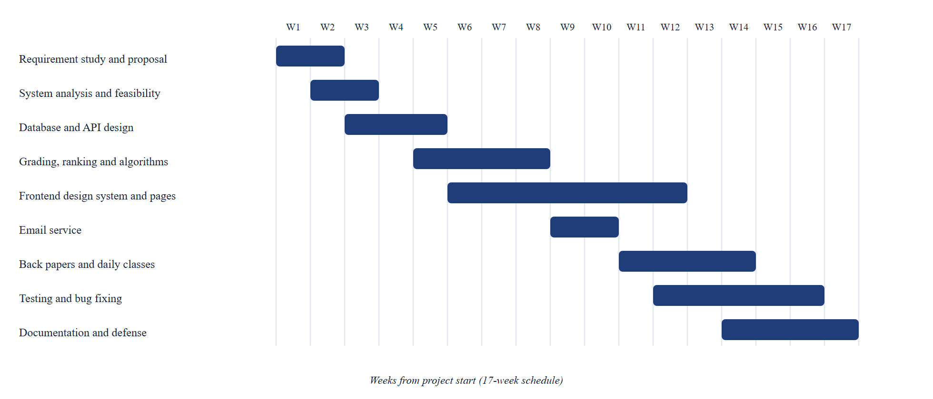
Figure 3.1: Project schedule (Gantt chart)

3.3 Process Modelling
Data flow diagrams (DFD) show how data moves between the external entities, the processes and the data stores.

3.3.1 Context Diagram (DFD Level 0)
Figure 3.2 shows the whole system as a single process. The administrator supplies the academic setup and publication decisions, teachers supply marks, attendance and class records, students and the public receive results and insights, and guardians receive result emails.
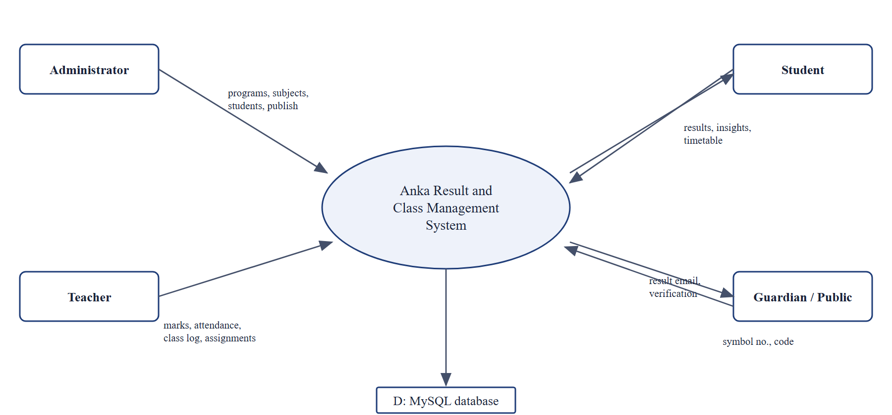
Figure 3.2: Context diagram (DFD level 0)

3.3.2 DFD Level 1
Figure 3.3 breaks the system into six processes: managing the academic setup, recording marks and back papers, calculating results, publishing and notifying, analyzing and ranking, and daily class automation.
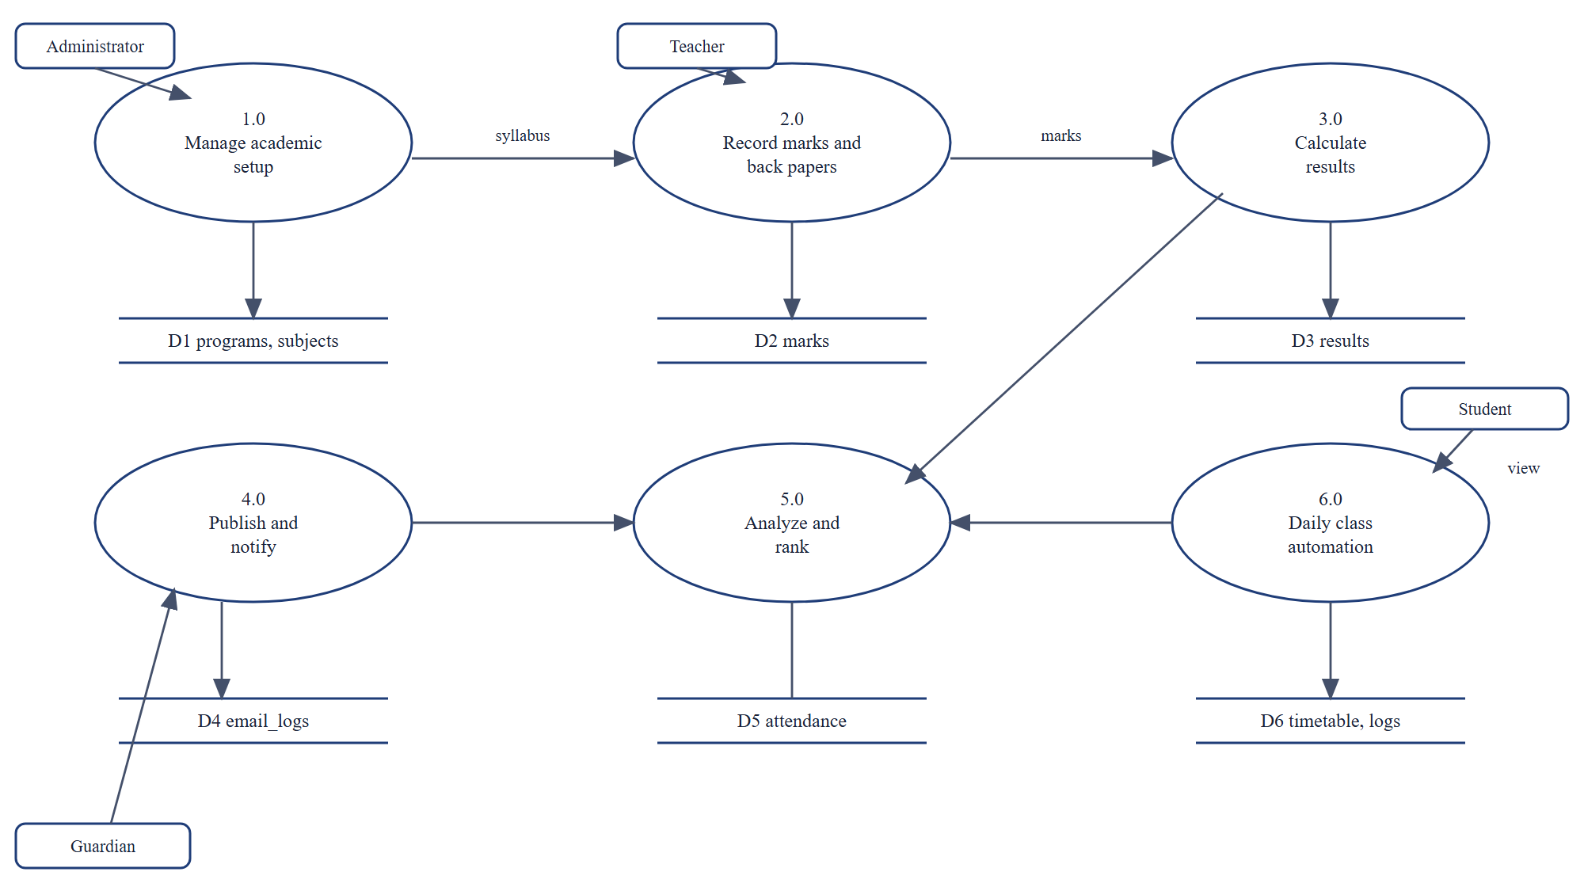
Figure 3.3: DFD level 1

3.4 Data Modelling
The database has sixteen tables. The core entities are programs, users, teachers, students, subjects, marks, results and attendance. The daily class module adds timetable, class_logs, assignments and assignment_status. The supporting tables are notices, email_logs, audit_logs and settings. Figure 3.4 shows the entity relationship diagram.
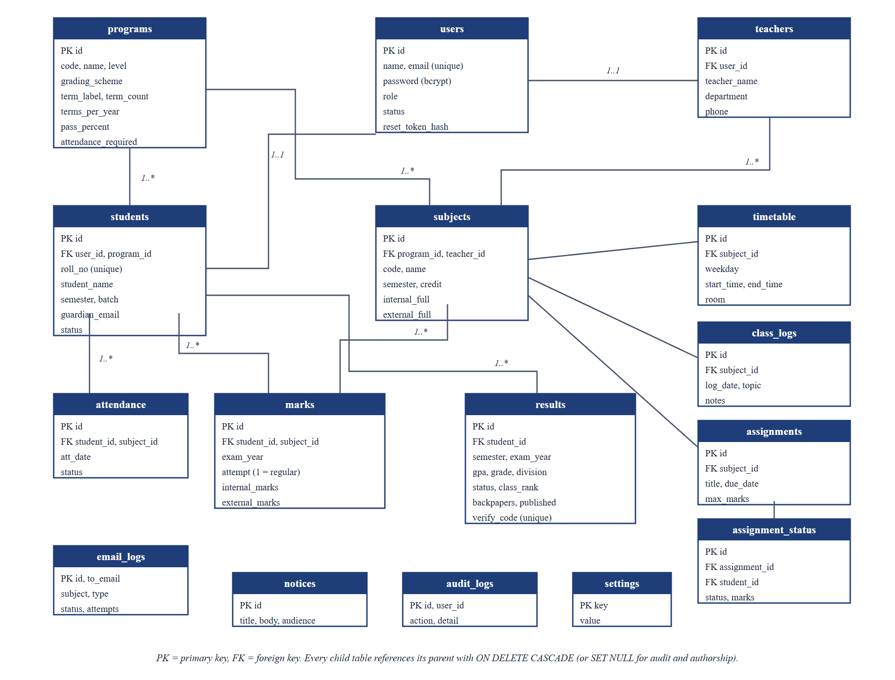
Figure 3.4: Entity relationship diagram
Three design decisions deserve attention. First, marks has an attempt column, so a back paper is another row for the same student and subject. Second, results stores a backpapers count and a unique verify_code that is printed on the marksheet. Third, the program row carries the term label, term offset and terms per year, so that "Semester 7", "Year 3" and "Grade 11" are all produced from data.

3.5 Object Modelling

3.5.1 Use Case Diagram
Figure 3.5 shows the use cases of the four actors. The public visitor can look up and verify results and use the GPA checker. Students see their own marksheets, attendance and insights. Teachers manage marks, back papers, attendance and classes of their own subjects only. The administrator manages the institution and the result cycle.
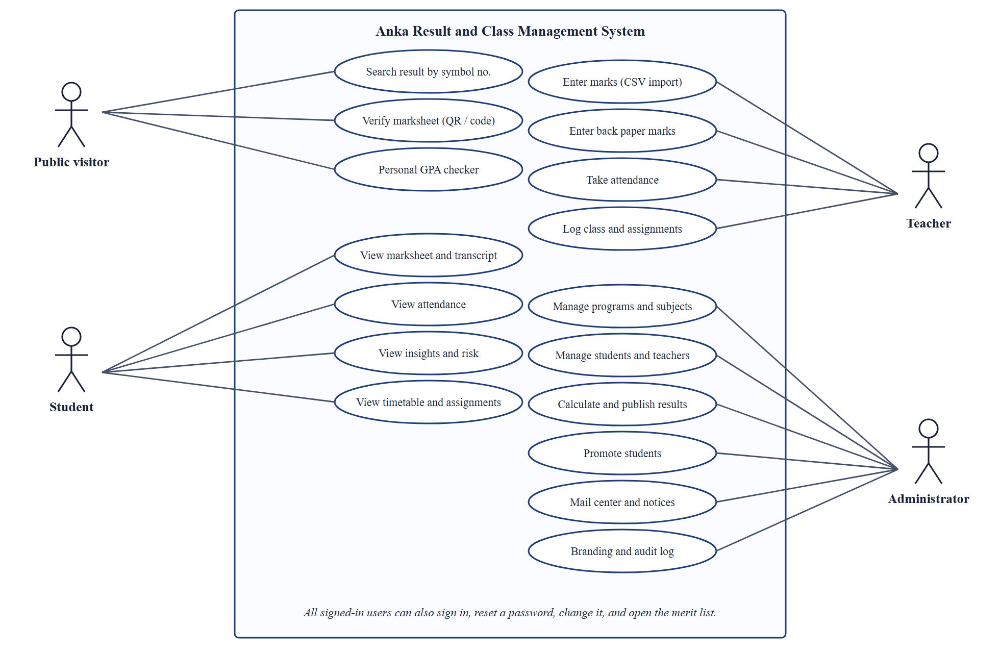
Figure 3.5: Use case diagram
Table 3.4: Use case description: Calculate and publish results
Item | Description
Actor | Administrator
Precondition | Marks for the term are entered; the administrator is signed in
Main flow | 1. Choose program, term and exam year.  2. System calculates subject grades, SGPA, status and class rank.  3. Administrator reviews the list and publishes.  4. System queues result emails to students and guardians.
Alternative flow | If a student has a back paper pass, the effective attempt is used and the result is recalculated without changing the published state.
Postcondition | Results are saved and visible to students; emails are logged

Table 3.5: Use case description: Enter back paper marks
Item | Description
Actor | Teacher
Precondition | The subject is assigned to the teacher; at least one student has not cleared it
Main flow | 1. Open Marks entry and choose Back papers.  2. System lists students who still owe the subject with every earlier sitting.  3. Teacher enters marks for the chosen year and saves.  4. System stores a new attempt and recalculates the original semester result.
Alternative flow | Marks above the full mark are rejected with a message.
Postcondition | A passing sitting clears the backlog; GPA and CGPA are updated

3.5.2 Class Diagram
Figure 3.6 shows the main classes. The grading engine and result service work on Marks, Subject and Program and produce Result objects; the mail service is called by the result service when a result is published.
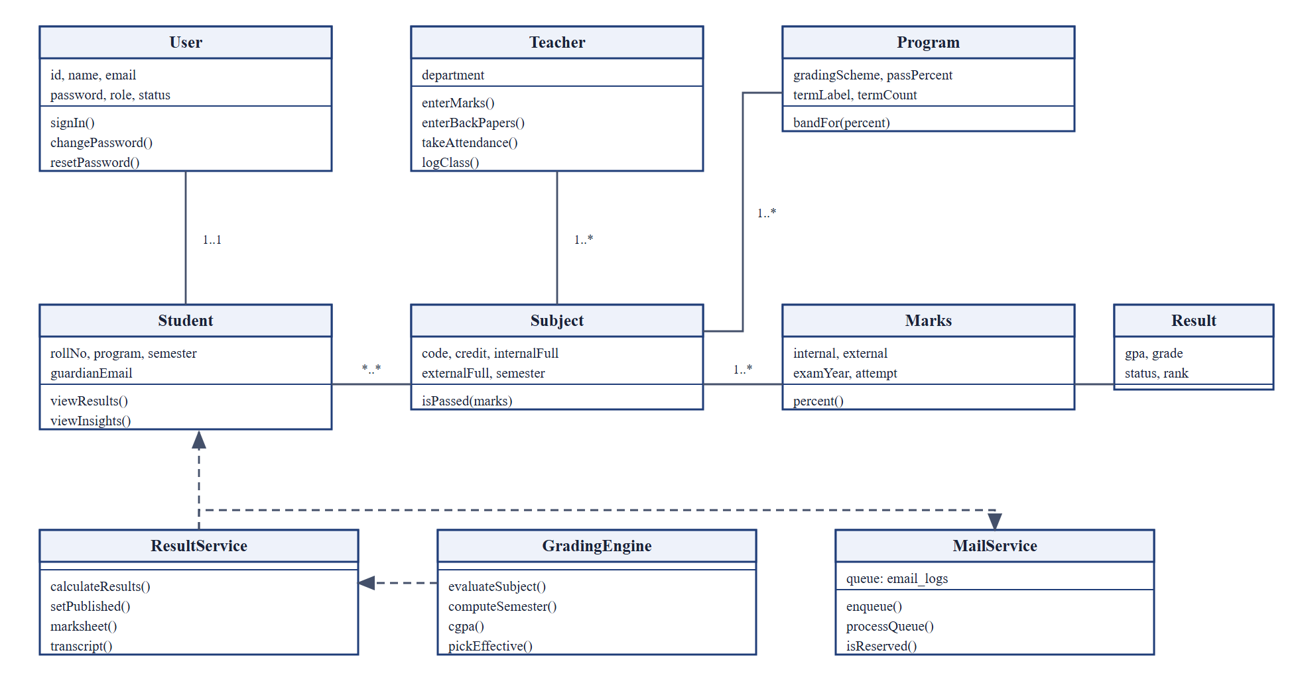
Figure 3.6: Class diagram of the main classes

3.5.3 Activity Diagram
Figure 3.7 shows the activity of calculating and publishing results, including the choice of the effective attempt.
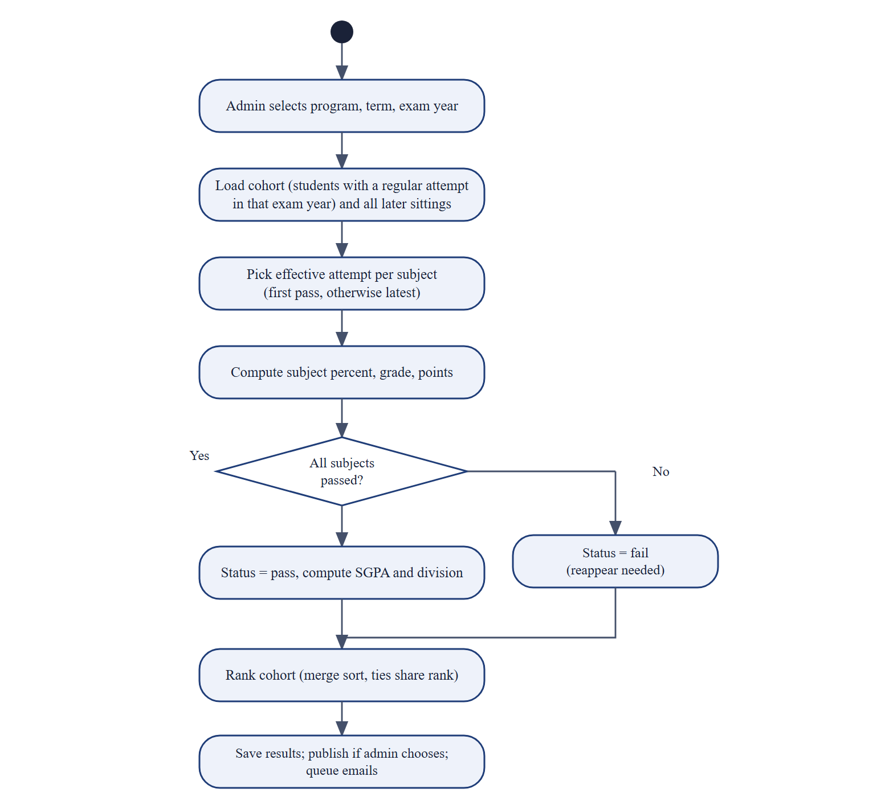
Figure 3.7: Activity diagram: calculate and publish results

3.5.4 Sequence Diagram
Figure 3.8 shows what happens when the administrator publishes results. The API publishes inside a transaction and only queues the emails; a separate worker sends them, so a slow mail server never blocks the administrator.
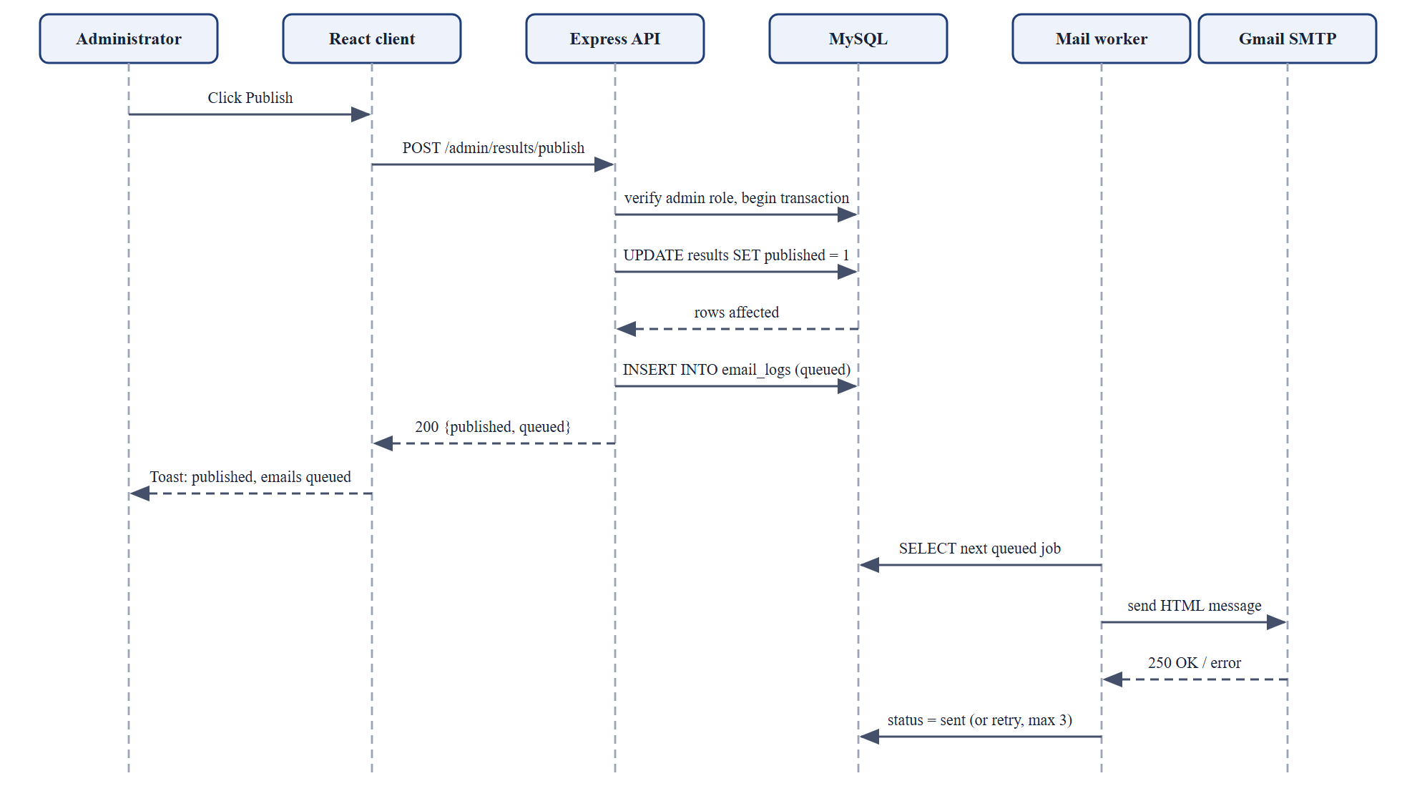
Figure 3.8: Sequence diagram: publish results and send email

3.5.5 State of a Result
Table 3.6: States of a result row
State | Meaning | Moves to
Draft | Calculated but hidden from students | Published, recalculated draft
Published | Visible to students, verifiable by code | Draft (unpublish), recalculated and still published after a back paper
Fail | At least one subject not passed (reappear needed) | Pass after back papers are cleared
Pass | All subjects passed on their effective attempt | None

CHAPTER 4: SYSTEM DESIGN
The design translates the analysis into an architecture, a database schema, an interface, and the algorithms that produce results. This chapter follows the same order.

4.1 Architecture Design
Anka uses a three-tier architecture. The presentation tier is a single page React application. The application tier is a stateless Node.js and Express REST API that checks the JSON Web Token on every request and applies the role of the user. The data tier is a MySQL database. The mail service is a worker inside the API process that reads queued messages from the database and sends them through Gmail SMTP.
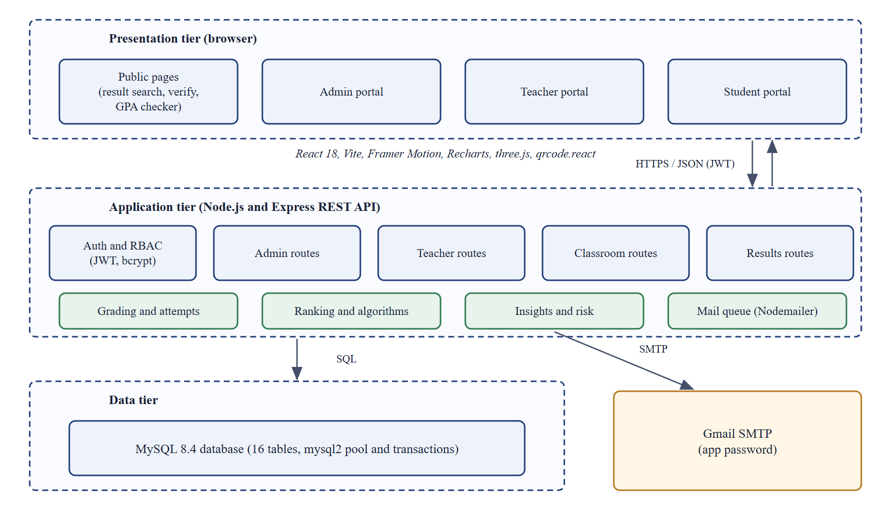
Figure 4.1: System architecture
Keeping the API stateless means it can be restarted at any time without losing sessions, and the same API can later serve a mobile client. Business rules live in service modules (resultService, marksService, grading, attempts, ranking, insights, mailer) and not in the route handlers, so each rule can be unit tested without a web server.

4.2 Database Design

4.2.1 Main Tables
Table 4.1: Core tables and key columns
Table | Purpose | Key columns
programs | Course of study and its rules | code, name, level, grading_scheme, term_label, term_count, term_offset, terms_per_year, pass_percent, attendance_required
users | Login accounts | email (unique), password (bcrypt hash), role, status, reset_token_hash, reset_expires
teachers | Teacher profile | user_id, teacher_name, department, phone
students | Student profile | user_id, program_id, roll_no (unique), semester, batch, guardian_email, status
subjects | Syllabus entry | program_id, teacher_id, code, name, semester, credit, internal_full, external_full
marks | One sitting of one subject | student_id, subject_id, exam_year, attempt, internal_marks, external_marks
results | Calculated term result | student_id, semester, exam_year, gpa, grade, division, status, class_rank, backpapers, published, verify_code
attendance | Daily attendance | student_id, subject_id, att_date, status

Table 4.2: Supporting tables
Table | Purpose
timetable | Weekly class slots: subject, weekday, start and end time, room
class_logs | Class diary: one entry per subject per date with topic and notes
assignments, assignment_status | Assignments and per-student status (submitted, late, missing), marks and feedback
notices | Announcements with an audience (all, student, teacher)
email_logs | Every outgoing message with status (queued, sent, failed, skipped), attempts and error
audit_logs | Who did what and when
settings | Optional institution branding values

4.2.2 Integrity Rules
- Foreign keys with ON DELETE CASCADE remove dependent rows (for example the marks of a deleted student); authorship columns use SET NULL so that deleting a user does not delete history.
- Unique keys prevent duplicates: one account per email, one student per symbol number, one marks row per student, subject, exam year and attempt, one diary entry per subject and date, one status per assignment and student.
- A check constraint limits the timetable weekday to 0 to 6.
- Result calculation and publication run inside transactions, so a failure leaves no half-written result.

4.2.3 Back Paper Data Model
A back paper is a second row in marks with attempt 2 or higher and a later exam_year. The cohort of a result is the set of students having a regular attempt (attempt 1) in the result's exam year; later sittings of those students are included when the effective attempt is chosen. Figure 4.2 summarizes the life of a failed subject.
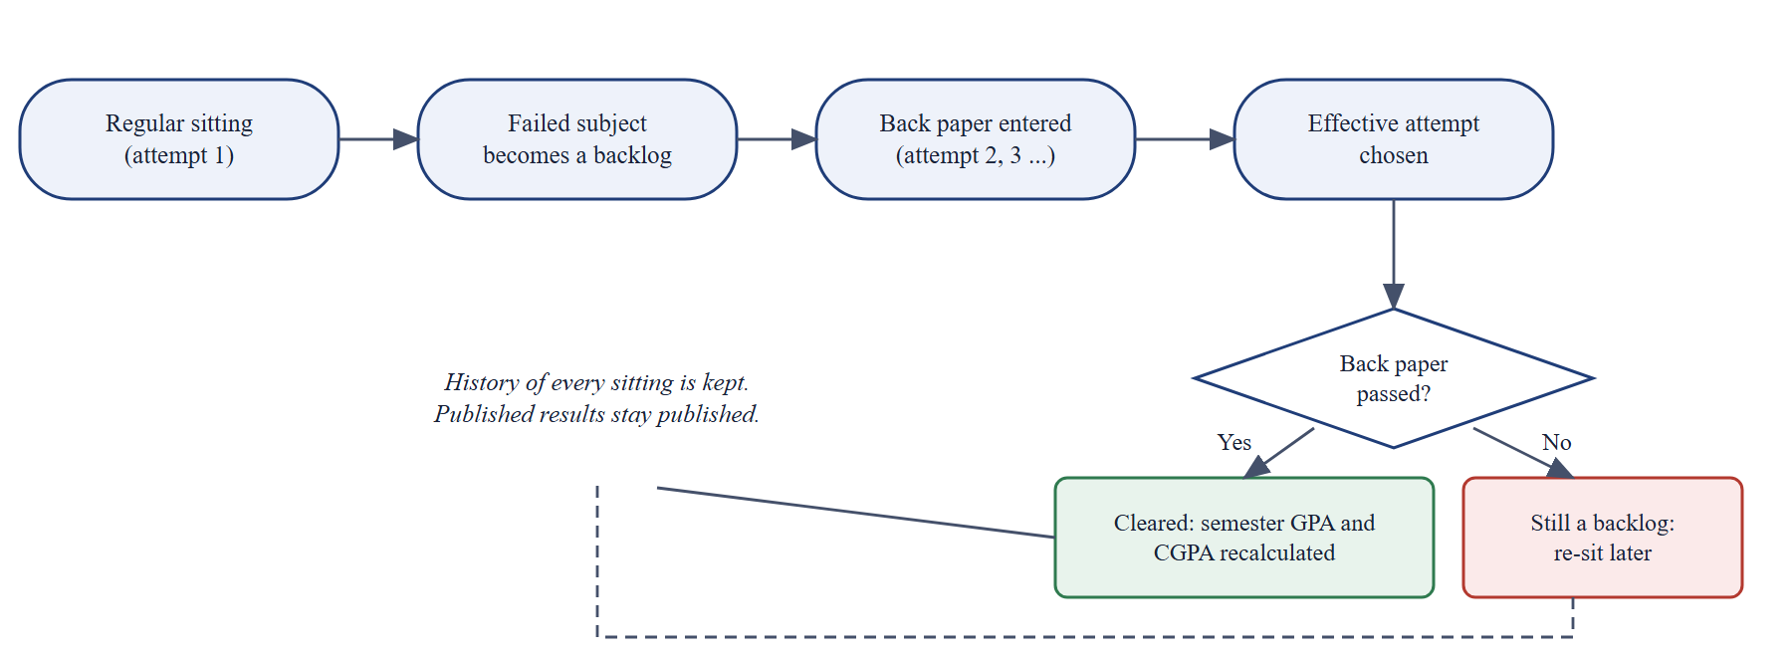
Figure 4.2: Life cycle of a failed subject and its back paper

4.3 API Design
The API is organized as five routers mounted under /api. There are 82 route handlers in total. Table 4.3 lists the main endpoints of each router. All endpoints except the public ones require a valid token, and administrator, teacher and student routes check the role.
Table 4.3: REST endpoints by router
Router | Count | Main endpoints
/api/auth | 8 | POST /register, POST /login, GET /me, PUT /password, POST /forgot-password, POST /reset-password, GET /programs, GET /institution
/api/admin | 36 | programs, subjects, students and teachers CRUD; POST /results/calculate, /results/publish, /results/promote; GET /results/export.csv; insights and alerts; notices; audit; settings; mail (list, preview, test, retry)
/api/teacher | 11 | GET and PUT /subjects/:id/marks; POST /marks/import; GET and PUT /backpapers; GET and PUT /attendance; GET /analytics; GET /insights
/api/results | 16 | public search, marksheet, verify, stats; me/overview, marksheet, transcript, attendance, insights; ranking; notices
/api/classroom | 11 | GET and POST /timetable; GET /today; GET /diary; PUT /logs; assignments CRUD and status tracking

Responses use one shape: { success: true, ... } on success and { success: false, message } with a suitable status code (400 invalid input, 401 not signed in, 403 not allowed, 404 not found, 409 conflict, 429 too many requests) on failure. The message is written for the user and never exposes internal details.

4.4 Interface Design

4.4.1 Design Principles
- Neutral and professional. A restrained navy palette with brass as the accent, no decorative clutter, and typography with a serif for headings on marksheets and a sans-serif for the interface.
- One design system. Shared tokens for color, spacing, radius and shadow; shared components for cards, tables, chips, dropdowns, segmented controls, drawers, modals and toasts. Light and dark themes use the same tokens.
- Precision for data work. Marks entry behaves like a spreadsheet: Enter moves down a column, Ctrl+S saves, invalid cells are marked, unsaved changes are shown.
- Orientation. A collapsible sidebar grouped by task, breadcrumbs, a command palette opened with Ctrl+K, and a notification menu.
- Responsive and accessible. Layouts work from desktop to 390 pixel phones; controls have labels; focus is visible; motion is short.

4.4.2 Navigation by Role
Table 4.4: Pages available to each role
Role | Pages
Public | Landing, Result search, Verify marksheet, GPA checker, Algorithms explorer, Sign in, Register, Forgot and reset password
Student | Dashboard, Classes, Results (marksheets and transcript), Attendance, Insights, GPA checker, Merit list, Account
Teacher | My subjects, Classes, Marks entry (regular and back papers), Attendance, Class insights, Merit list, Account
Administrator | Dashboard, Insights, Programs, Subjects, Students, Teachers, Classes, Results, Merit list, Mail center, Notices, Branding, Audit log, Algorithms

4.5 Algorithm Design
All algorithms listed here are implemented from scratch in the backend/utils folder without a library, and they are explained interactively on the /algorithms page of the running system.

4.5.1 Grade Lookup by Binary Search
A grading scale is an ascending list of bands, each with a minimum percentage, a grade and a grade point. To find the band of a percentage the algorithm searches for the last band whose minimum is not greater than the percentage. Binary search does this in O(log n).
bandFor(scale, percent):
lo = 0; hi = len(scale) - 1
while lo < hi:
mid = (lo + hi + 1) div 2
if scale[mid].min <= percent: lo = mid
else: hi = mid - 1
return scale[lo]

Table 4.5: TU grade scale used by default (editable per program)
Percentage | Grade | Grade point
90 and above | A | 4.0
80 to below 90 | A- | 3.7
75 to below 80 | B+ | 3.3
70 to below 75 | B | 3.0
65 to below 70 | B- | 2.7
60 to below 65 | C+ | 2.3
55 to below 60 | C | 2.0
50 to below 55 | C- | 1.7
45 to below 50 | D+ | 1.3
40 to below 45 | D | 1.0
Below 40, or below pass mark in the external part | F | 0.0

4.5.2 Subject, Semester and Cumulative Results
For every subject the engine computes the percentage from internal and external marks, checks the pass rule (overall percentage and external percentage both at least the program pass mark), looks up the grade and grade point, and then computes the semester GPA as the credit-weighted mean. A semester is pass only when every subject is passed. The CGPA is the credit-weighted mean of the semester GPAs. For the division scheme the GPA is the percentage on a 4.0 scale and the division comes from the total percentage (Distinction 80, First 60, Second 48, Pass 40).

4.5.3 Effective Attempt for Back Papers
pickEffective(attempts):
sort attempts by (exam_year, attempt)
for each attempt: evaluate subject
i = index of first passing attempt, else last
return attempts[i] with history and flag
cleared_by_backpaper = (i > 0 and passed)

The first passing sitting is chosen so that a student who passes a re-sit but later appears again does not lose the pass. If no sitting passes, the latest one is used so that the most recent marks are shown.

4.5.4 Ranking by Merge Sort
Students of a cohort are ordered by GPA, then by total marks, then by symbol number for stability. Merge sort divides the list, sorts both halves and merges them; it is O(n log n) in every case. Equal students receive the same rank (competition ranking: 1, 2, 2, 4), which is the fair choice for equal scores.

4.5.5 Top-k Selection with a Binary Heap
The top performers of a subject are found with a min-heap of size k. Each item is compared with the smallest of the current k; if it is larger it replaces it. The cost is O(n log k), which is cheaper than sorting everyone when k is small.

4.5.6 Statistics, Percentile and Z-score
Descriptive statistics (mean, median, standard deviation, minimum, maximum, pass rate) are computed in a single pass plus a sort for the median. The percentile of a student is found by binary search in the sorted marks, and the z-score is (x - mean) / standard deviation.

4.5.7 Linear Regression and Forecast
The trend of GPA across terms is fitted by least squares: slope = (nsum(xy) - sum(x)sum(y)) / (n*sum(x^2) - (sum(x))^2). The next GPA is forecast by extending the line and is clamped between 0 and 4. The slope also feeds the risk score.

4.5.8 Pearson Correlation
The correlation between attendance and GPA (or internal and external marks) is r = cov(x, y) / (sd(x) * sd(y)). A value close to +1 tells the teacher that students who attend more also score more.

4.5.9 K-means Clustering
Students are grouped into three clusters by their GPA and attendance. Both features are scaled to the range 0 to 1 first. The algorithm starts from deterministic centers chosen farthest-first (so the same data always gives the same groups), assigns each student to the nearest center, recomputes the centers as means, and repeats until no assignment changes or fifty iterations have run. The clusters are shown to teachers as support groups.

4.5.10 Explainable Risk Score
Table 4.6: Risk score rules (maximum 100)
Condition | Points | Reason shown to the user
Attendance below 80% | up to 35 | Attendance X% is below the 80% exam-eligibility requirement
Failed subjects | 12 each, up to 30 | N failed subject(s) to clear
GPA slope below -0.1 | up to 20 | GPA is trending downward over recent terms
Latest GPA below 2.2 | 10 | Latest GPA is low
Internal average below 50% | 10 | Internal assessment average is weak

A score of 55 or more is high risk, 25 to 54 is medium and below 25 is low. Because every point has a stated reason, a teacher can explain the result to the student.

4.5.11 Tokens and Email Queue
Password reset links use a random token whose SHA-256 hash is stored with an expiry of thirty minutes, so a copy of the database does not reveal a usable link. Outgoing emails are first written to email_logs with status queued. A worker takes the oldest queued message, sends it, and marks it sent. On failure it waits (1.5 seconds times the attempt number) and retries until three attempts are used, then marks it failed. Demo addresses on reserved domains are never delivered and are logged as skipped.

4.6 Security Design
Table 4.7: Security measures
Threat | Measure
Stolen database | bcrypt password hashes (cost 10); reset tokens stored only as hashes
Unauthorized access | JWT on every private route; role check per router; teachers can touch only their own subjects (HTTP 403 otherwise)
Brute force and scraping | Per-address rate limit on public lookups (40 per minute by default); generic message for wrong credentials
Injection | Parameterized queries everywhere; input length and range validation
Forged marksheets | Unique ten-character code and QR code verified against the database
Accidental data loss | Confirmation dialogs; cascade rules; published results locked against edits
Secret leakage | Credentials only in backend/.env, which is excluded from version control

4.7 Email Design
Every email is an HTML message with inline styles (mail clients ignore style sheets), a navy header that shows the institution name only when one is configured, a content card, a key-value table for results, one clear button, and a plain footer. Eight templates exist: welcome, password reset, teacher approved, result, guardian result, risk alert, notice and test. The same palette as the web application keeps the experience consistent.

CHAPTER 5: IMPLEMENTATION AND TESTING

5.1 Implementation

5.1.1 Development Environment
Table 5.1: Tools used
Item | Tool
Operating system | Windows 11
Editor and version control | Visual Studio Code, Git, GitHub
Runtime | Node.js 24
Database | MySQL 8.4 (portable copy in the project folder, port 3308)
Server libraries | express, mysql2, bcryptjs, jsonwebtoken, nodemailer, cors, morgan
Client libraries | react, react-router-dom, vite, framer-motion, recharts, three, qrcode.react, lucide-react
Testing | node:test, fetch based API suites, puppeteer-core with Microsoft Edge
Diagrams and documents | SVG diagrams rendered by Edge; docx and pptxgenjs for documents

5.1.2 Project Structure
StuResSystem/
backend/
server.js Express app and router mounting
routes/ auth, admin, teacher, results, classroom
utils/ grading, attempts, ranking, algorithms, insights,
resultService, marksService, mailer, emailTemplates
db/ schema.sql, setup.js (schema and seed data)
tests/ unit tests, API flow tests, smoke, classroom tests
frontend/
src/pages/ public, admin, teacher, student, Classes
src/components/ Shell, CommandPalette, Marksheet, Scenes, ui
src/styles.css design system tokens and components
e2e/ browser end-to-end tests
.mysql/ portable MySQL (not in Git)

The backend has about 2,200 lines, the frontend about 4,600 lines of JavaScript, JSX and CSS, and the automated tests about 1,500 lines, so the repository holds roughly 8,500 lines in total.

5.1.3 Grading Engine
The grading engine (grading.js) exposes gradeFor, evaluateSubject, computeSemester and cgpa. The three scales are plain arrays of bands, so a campus can change a band without changing the algorithm. The excerpt below shows how a subject is evaluated.
function evaluateSubject(row, scheme, passPercent) {
const full = internal_full + external_full;
const total = internal_marks + external_marks;
const percent = full ? (total / full) * 100 : 0;
const extOk = external_full === 0 ||
(external_marks / external_full) * 100 >= passPercent;
const passed = percent >= passPercent && extOk;
const band = passed ? gradeFor(percent, scheme) : SCALES[scheme][0];
return { total, full, percent, passed, grade: band.grade, point: band.point };
}

5.1.4 Back Paper Processing
attempts.js groups the sittings of each student and subject and selects the effective attempt. resultService.cohortAttempts loads the regular attempts of the result year and all later sittings, calculateResults evaluates them, and setPublished changes the published flag. When a teacher saves back paper marks, marksService.saveBackPapers inserts the new attempt, and the service recalculates the original semester result for every affected student. A result that was already published stays published, so a student sees the improved GPA immediately.

5.1.5 Result Calculation and Ranking
For each student the service computes subject grades, the semester GPA, the percentage, the status and the division; then rankStudents orders the cohort with merge sort and assigns competition ranks. A ten-character verification code is generated for every result row.

5.1.6 Email Service
mailer.js writes each message to email_logs, and a worker sends one queued message at a time. The mail center page shows counters (sent, queued, failed, skipped), the connection state, a test form, a filterable log and a preview of every message. When no Gmail account is configured the messages are still logged, with status skipped, so the system works in a demonstration without credentials.

5.1.7 Daily Class Automation
routes/classroom.js implements the timetable, class diary and assignments. When a slot is added the API checks for overlapping time on the same weekday for the same teacher or for the same program and term, and answers HTTP 409 with the name of the clashing subject. A diary entry is stored with an upsert, so saving again for the same subject and date edits the entry. The assignment tracker saves a status and optional marks for each student and checks the marks against the maximum.

5.1.8 Frontend Implementation
The client is a single page application with route level code splitting. A Shell component provides the sidebar, top bar, command palette, theme toggle and notification menu for every signed-in role. Shared components (Select, Seg, Modal, Drawer, Chip, PageHeader, Field, toast and confirm dialogs) are in one file so that every page looks and behaves the same. The marksheet component prints cleanly and carries the QR code produced by qrcode.react.

5.2 Testing
Testing was done at four levels so that each kind of defect is found where it is cheapest to find. All suites can be run locally by following the README.
Table 5.2: Test suites
Level | Tool | Scope | Result
Unit | node:test | Grading, ranking, heap, regression, k-means, risk score, email queue with a local SMTP server, reserved domains | 18 of 18 passed
API flows | fetch (tests/flows.mjs) | Authentication, CRUD of every entity, marks, CSV import, back papers, attendance, publish, promote, public pages, a 59-endpoint by 4-role permission matrix, rate limit | 58 of 58 passed
Smoke | fetch (tests/smoke.mjs) | Dashboard counts, student overview, verification, CSV import, attendance, analytics, insights | 43 passed, 0 failed
Classroom | fetch (tests/classroom.mjs) | Timetable clash rules, today view, diary, assignments, permissions | 32 of 32 passed
Browser | puppeteer-core with Edge | Public pages, sign in, registration, every admin, teacher and student page, forms, dialogs, shortcuts, phone and tablet widths, dark theme | 56 of 58 steps passed on the best clean run

The browser suite is sensitive to the speed of the computer. On a computer with little free memory, different steps timed out in different runs, while the same steps passed when the machine was idle. For this reason the browser result is reported as a range and not as a guarantee. The browser suite did find real defects, which were fixed: the command palette stayed open after navigation, the marks page was missing an import, and the back paper screen crashed because of a missing import. These were found because the tests drive the real pages.

5.2.1 Test Cases
Table 5.3: Selected functional test cases
ID | Test | Input / action | Expected result | Result
TC1 | Sign in with wrong password | Valid email, wrong password | HTTP 401 with a generic message | Pass
TC2 | Teacher registration | Register as teacher | Account pending; cannot sign in until approved | Pass
TC3 | Duplicate symbol number | Register with an existing symbol number | Rejected with a clear message | Pass
TC4 | Marks above full marks | Internal 45 where full is 40 | Rejected; nothing saved | Pass
TC5 | CSV import with unknown symbol numbers | File with one valid and one unknown row | Valid row saved; skipped rows reported | Pass
TC6 | GPA calculation | Three subjects of 3 credits with 67.5%, 82.5%, 80% | SGPA 3.37 (2.7, 3.7, 3.7) | Pass
TC7 | Subject fails on external part | Total 45% but external below 40% | Subject failed; grade F | Pass
TC8 | Back paper clears a failure | Failed subject, back paper 55% | Effective attempt is the back paper; semester GPA recalculated | Pass
TC9 | Back paper fails again | Second sitting 33% | Student stays a candidate; attempt count increases | Pass
TC10 | Back papers do not leak into cohort | Roster, analytics and ranking of the regular exam | Only attempt 1 rows are used | Pass
TC11 | Publish results | Publish a calculated term | Students see them; emails queued | Pass
TC12 | Unpublish | Unpublish a term | Students no longer see it | Pass
TC13 | Verify genuine code | Open /verify/CODE | Shows genuine marksheet with student details | Pass
TC14 | Verify fake code | Open /verify/AAAAAAAAAA | Shows no such marksheet | Pass
TC15 | Public rate limit | More than 40 lookups in a minute | HTTP 429 | Pass
TC16 | Permission matrix | Each endpoint with each role | Allowed only for permitted roles (59 endpoints, 4 roles) | Pass
TC17 | Reserved email domain | Send to a .test address with email configured | Logged as skipped; never delivered | Pass
TC18 | Email retry | SMTP failure | Retried up to 3 times then marked failed | Pass
TC19 | Timetable clash | Add a slot overlapping the same teacher | HTTP 409 with the clashing subject | Pass
TC20 | Teacher edits another teacher's subject | POST /timetable for a foreign subject | HTTP 403 | Pass
TC21 | Diary duplicate | Save the same subject and date twice | One entry, updated topic | Pass
TC22 | Assignment marks above maximum | Marks 11 where maximum is 10 | Rejected with HTTP 400 | Pass

5.2.2 Email Verification
The email pipeline was tested without sending real messages. A local SMTP server receives a queued message and the test checks that the message is delivered and logged as sent; a second test stops the server and checks the retry and the final failed state; a third test confirms that a reserved demo domain is skipped even when email is configured. The HTML of each template was rendered in a browser and reviewed for layout (Figure A.13 in the appendix). A real Gmail account must be configured by the administrator for live delivery; the connection can be checked from the Mail center with the test message.

5.2.3 Defects Found and Fixed
Table 5.4: Notable defects found during testing
Defect | Found by | Fix
Date of birth sent as an ISO string caused a server error when a student was edited | API flow test | Normalize the date before saving
Mail retry re-queued messages even when email was not configured | API flow test | Retry does nothing when unconfigured and skips reserved domains
Confirmation dialog appeared behind a drawer | Browser test | Raised the overlay layer
The algorithms page required a login | Browser test | Made the route public
Phone layout overflowed because of fixed minimum widths | Browser test | Responsive widths and truncation of long labels
Command palette stayed on screen after choosing a page | Browser test | Removed the exit animation that never finished
Back paper screen crashed (missing import) | Visual check while preparing figures | Added the import; scanned all pages for undefined names
Seed data had a hard-coded institution name | Review | Defaults are blank; branding is optional

5.3 Result Analysis
The seeded database contains 97 students in three programs, 68 subjects, about 1,800 mark rows (including 71 back paper sittings) and about 11,700 attendance records. It was used to check that the system behaves as expected on a realistic amount of data. With this data, the result calculation of a term of 14 students completes in a fraction of a second and every public and portal page loads within about one second on a laptop with limited memory. The ranking, back paper and permission checks give identical results on every run because the algorithms are deterministic.
The objectives of Section 1.3 were checked one by one. The configurable grading engine, back paper model, ranking and analytics, risk score, role based security with QR verification, email queue, daily class tools and neutral branding are all implemented and covered by at least one automated test. The two items that cannot be proven by the tests are conformity with the official TU regulation and live Gmail delivery; both depend on information that only the institution has.

CHAPTER 6: CONCLUSION AND FUTURE RECOMMENDATIONS

6.1 Conclusion
Anka replaces the paper ledger and spreadsheet chain of a campus with one database and a set of role based screens. Teachers enter marks once; the system calculates grades, semester and cumulative GPA, ranks the cohort, handles back paper sittings without losing history, warns about students at risk, publishes results, and sends emails. Students and the public can read results and verify printed marksheets. The daily class module extends the same platform to timetables, class diaries and assignments. The product carries no institution name, so a school, a higher secondary college or a university campus can adopt it by entering its own programs and rules.
The work met the objectives set in Chapter 1 and applied the algorithms expected from the project: sorting, searching, heap selection, statistics, regression, correlation and clustering, all written without libraries and explained in the running system. Building and testing the system also gave practical experience in database design, REST API design, security, user interface design, automated testing and documentation.

6.2 Future Recommendations
- Verify the grade table and back paper rules against the official TU regulation for each year and add rule versions so that old batches keep their old rules.
- Add multi-tenancy so that one server can host several institutions.
- Add file upload for assignments and a messaging feature between teachers and students.
- Build a mobile application and push notifications, and add SMS delivery for guardians without email.
- Add parent accounts, fee management and a document archive.
- Use real examination data (with permission) to validate the risk score weights and replace the hand-written weights with a trained model whose reasons are still shown to users.
- Make the browser test suite independent of machine speed with explicit waiting on application events, and run all suites in continuous integration.
- Export marksheets and the transcript as signed PDF documents.

REFERENCES
[1] C. Romero and S. Ventura, "Educational data mining: A review of the state of the art," IEEE Trans. Syst., Man, Cybern. C, Appl. Rev., vol. 40, no. 6, pp. 601-618, Nov. 2010.
[2] T. H. Cormen, C. E. Leiserson, R. L. Rivest, and C. Stein, Introduction to Algorithms, 3rd ed. Cambridge, MA, USA: MIT Press, 2009.
[3] J. MacQueen, "Some methods for classification and analysis of multivariate observations," in Proc. 5th Berkeley Symp. Math. Statist. Probab., vol. 1, 1967, pp. 281-297.
[4] S. P. Lloyd, "Least squares quantization in PCM," IEEE Trans. Inf. Theory, vol. 28, no. 2, pp. 129-137, Mar. 1982.
[5] K. Pearson, "Notes on regression and inheritance in the case of two parents," Proc. R. Soc. Lond., vol. 58, pp. 240-242, 1895.
[6] N. Provos and D. Mazieres, "A future-adaptable password scheme," in Proc. USENIX Annu. Tech. Conf., 1999, pp. 81-91.
[7] M. Jones, J. Bradley, and N. Sakimura, "JSON Web Token (JWT)," RFC 7519, Internet Engineering Task Force, May 2015.
[8] J. Klensin, "Simple Mail Transfer Protocol," RFC 5321, Internet Engineering Task Force, Oct. 2008.
[9] R. T. Fielding, "Architectural styles and the design of network-based software architectures," Ph.D. dissertation, Univ. California, Irvine, CA, USA, 2000.
[10] I. Sommerville, Software Engineering, 10th ed. Harlow, U.K.: Pearson, 2016.
[11] R. S. Pressman and B. R. Maxim, Software Engineering: A Practitioner's Approach, 8th ed. New York, NY, USA: McGraw-Hill, 2015.
[12] Meta Platforms, Inc., "React documentation." [Online]. Available: https://react.dev. [Accessed: 2 Nov. 2026].
[13] OpenJS Foundation, "Express: Fast, unopinionated, minimalist web framework for Node.js." [Online]. Available: https://expressjs.com. [Accessed: 2 Nov. 2026].
[14] Oracle Corporation, "MySQL 8.4 Reference Manual." [Online]. Available: https://dev.mysql.com/doc/refman/8.4/en/. [Accessed: 2 Nov. 2026].
[15] Nodemailer, "Nodemailer: Send emails from Node.js." [Online]. Available: https://nodemailer.com. [Accessed: 2 Nov. 2026].
[16] World Wide Web Consortium, "Web Content Accessibility Guidelines (WCAG) 2.1." [Online]. Available: https://www.w3.org/TR/WCAG21/. [Accessed: 2 Nov. 2026].
[17] Tribhuvan University, Faculty of Humanities and Social Sciences, "CACS452 Project III, BCA eighth semester course outline." [Online]. Available: https://www.itcollegenepal.com/wp-content/uploads/2022/02/CACS452-BCA-VIII-SEM-Project-III.pdf. [Accessed: 2 Nov. 2026].
[18] Tribhuvan University, Office of the Dean, FOHSS, "BCA curriculum." [Online]. Available: https://tufohss.edu.np. [Accessed: 2 Nov. 2026].
[19] Nepal Examination Board, "Grading system for grades 11 and 12." [Online]. Available: https://neb.gov.np. [Accessed: 2 Nov. 2026].

APPENDIX A: SCREENSHOTS

Figure A.1: Landing page
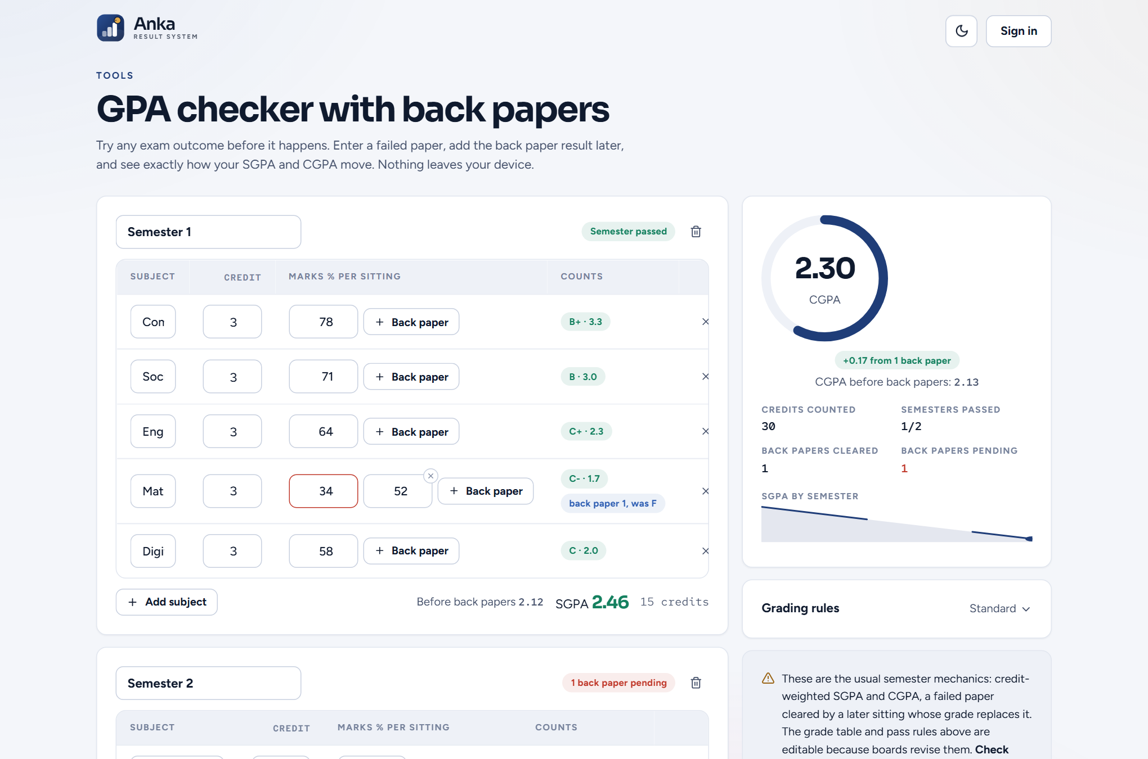
Figure A.2: Personal GPA checker with back papers
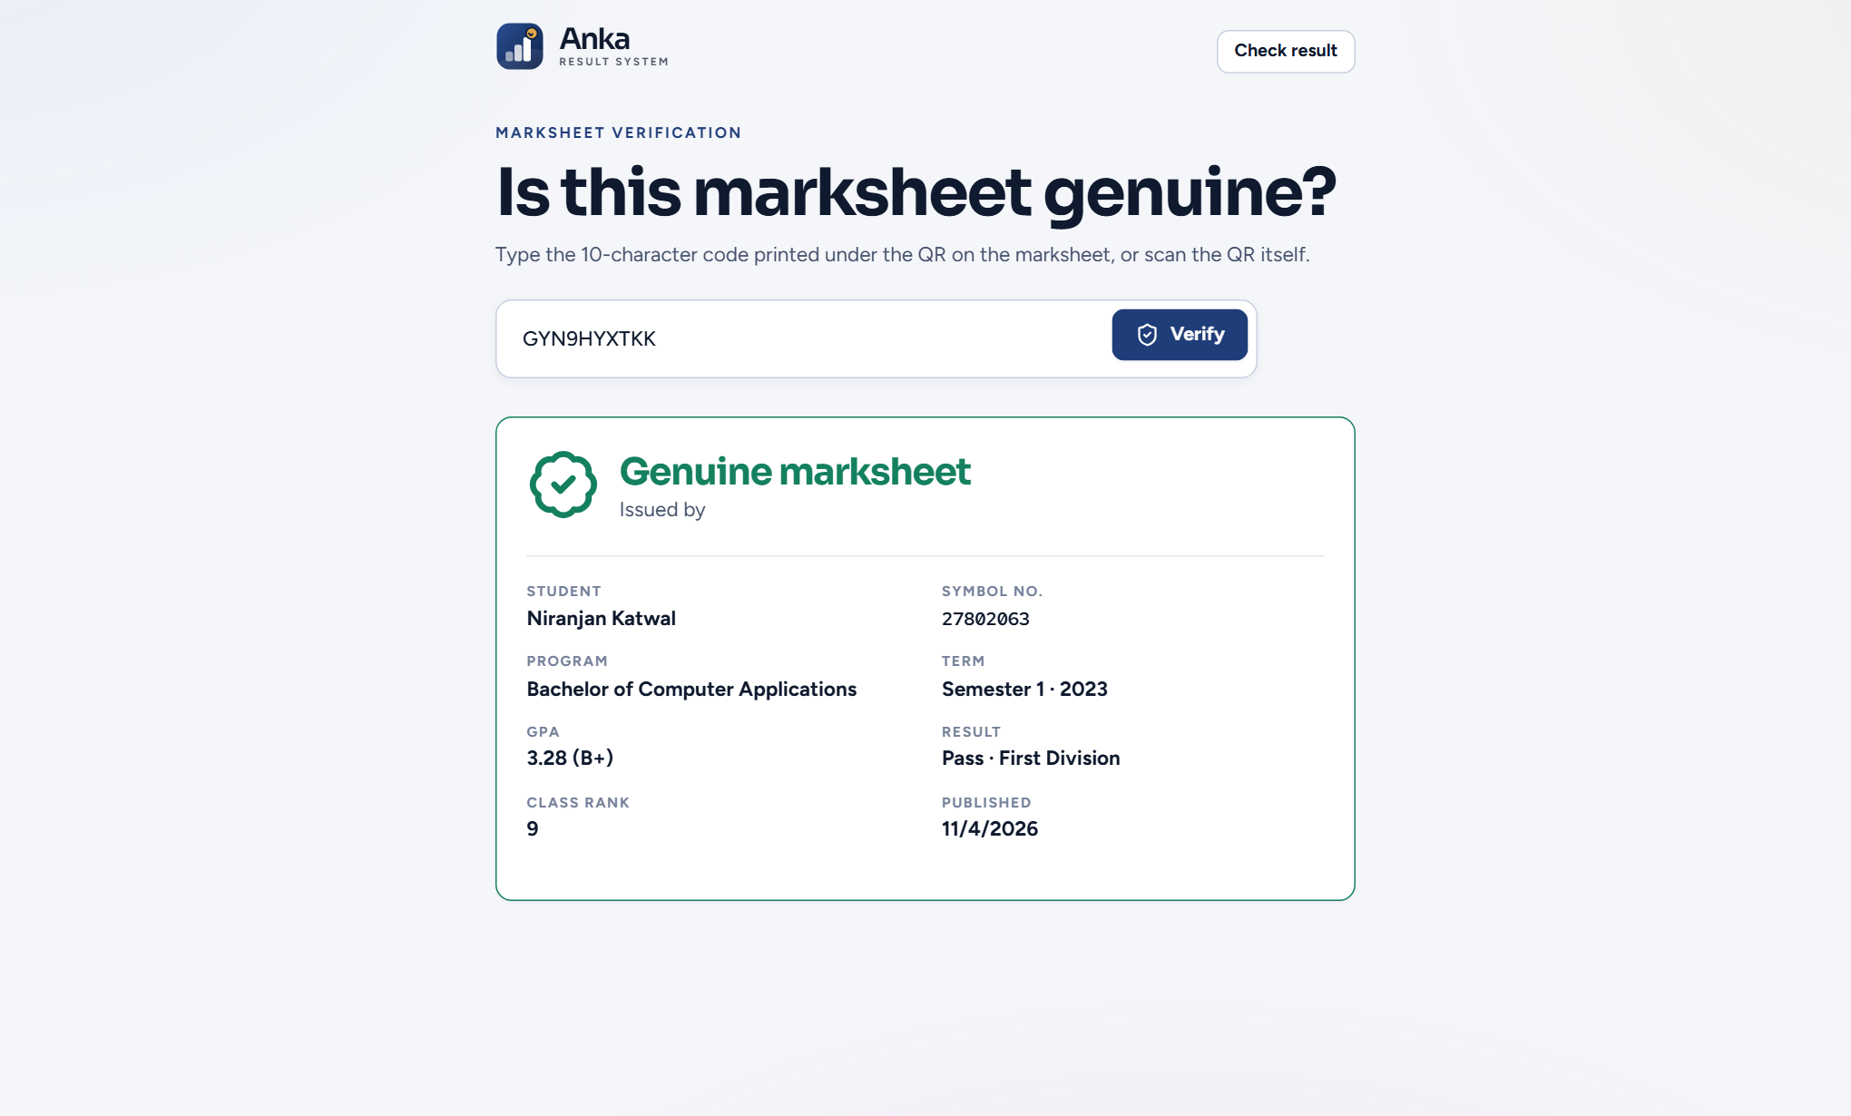
Figure A.3: Marksheet verification result
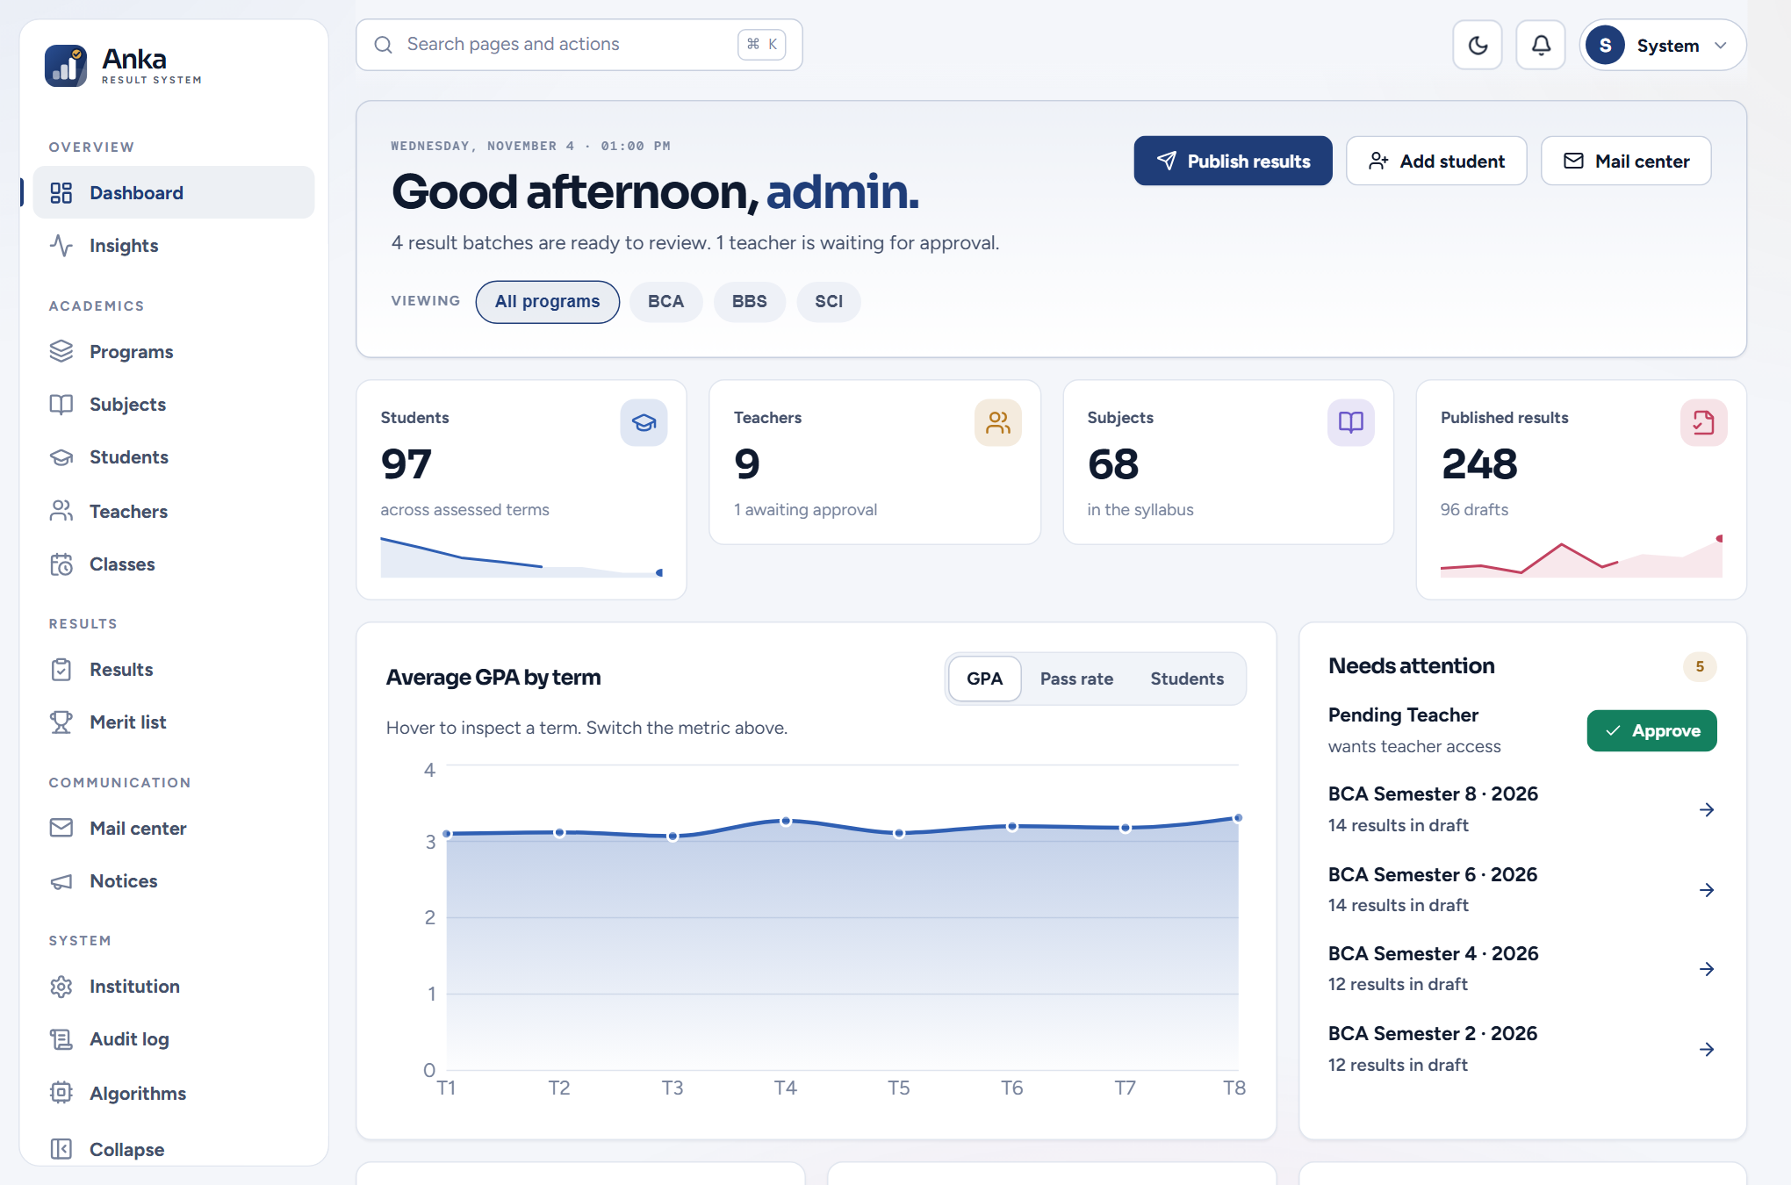
Figure A.4: Administrator dashboard
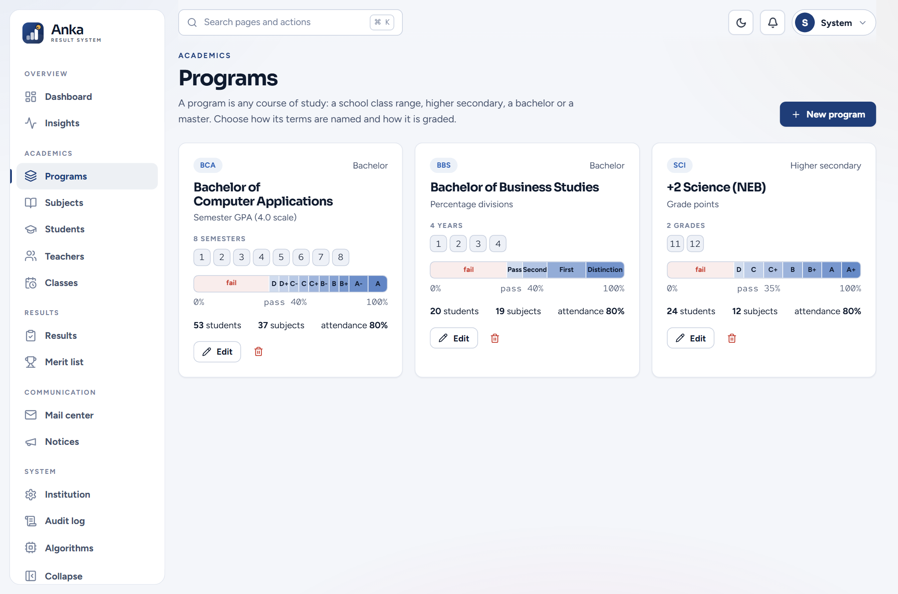
Figure A.5: Programs with grading schemes
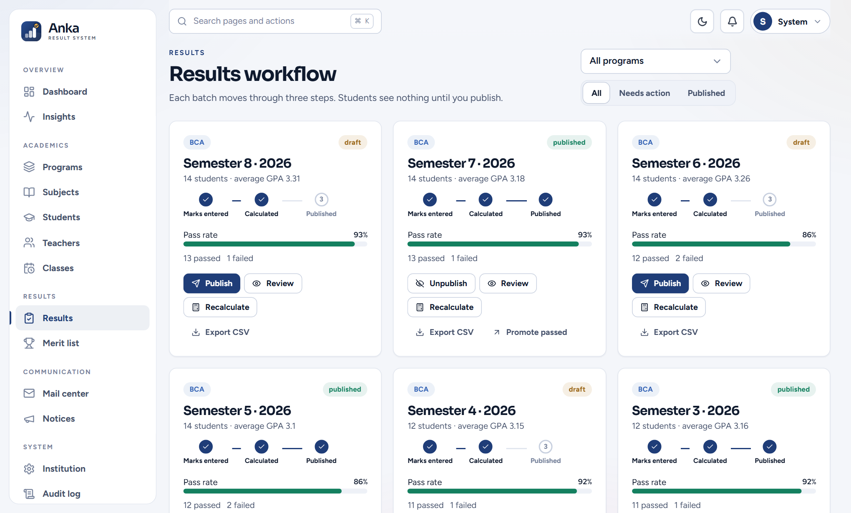
Figure A.6: Results workflow
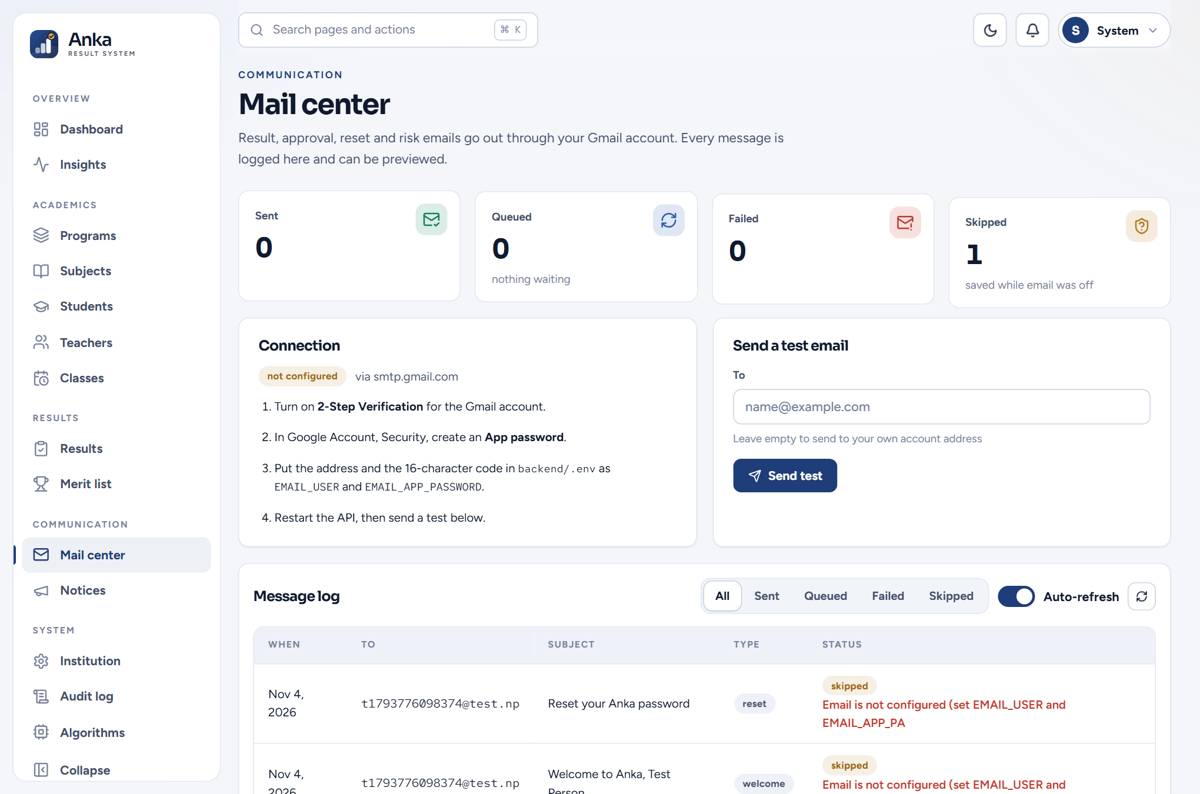
Figure A.7: Mail center
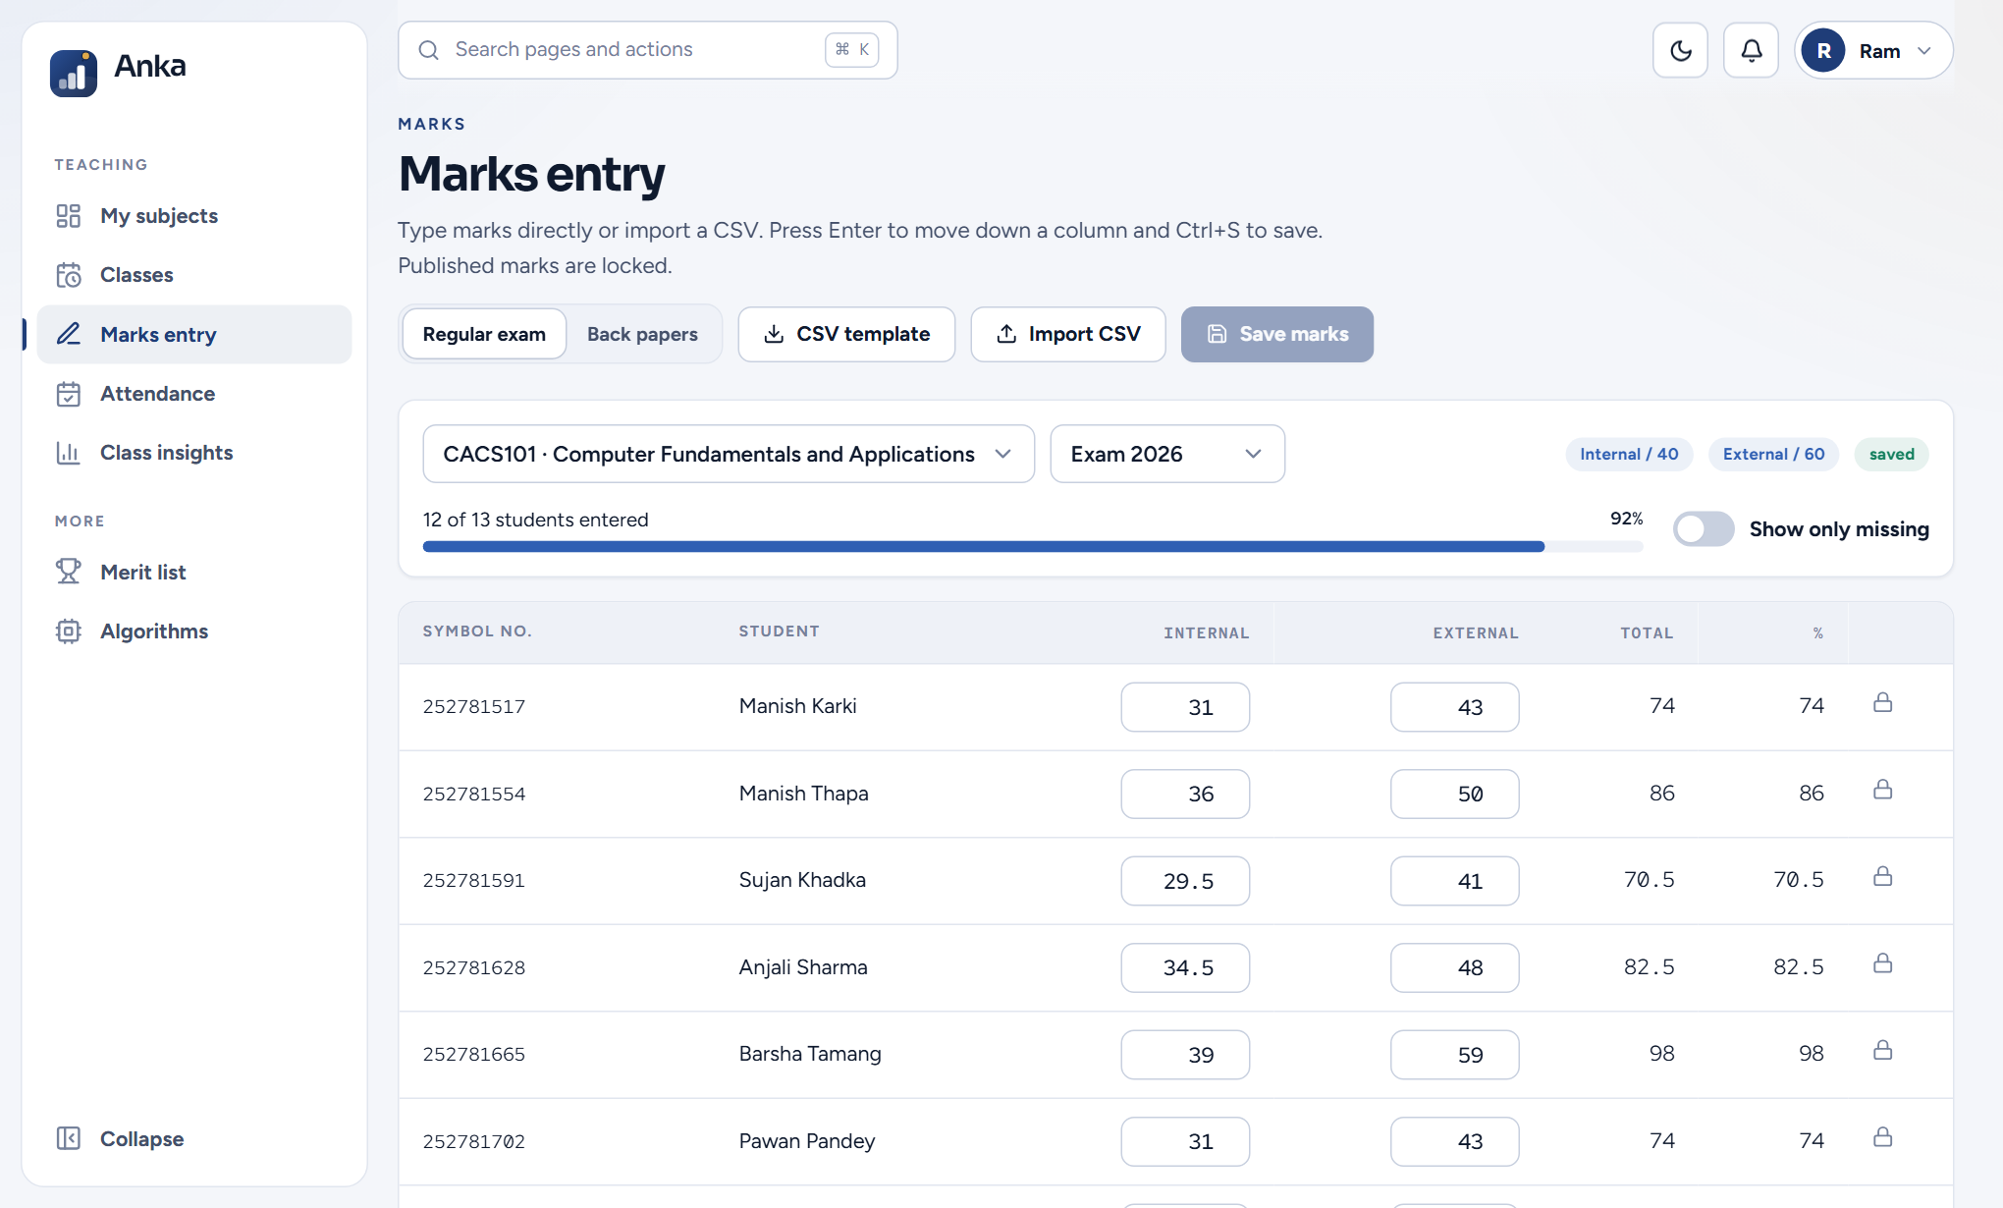
Figure A.8: Marks entry grid
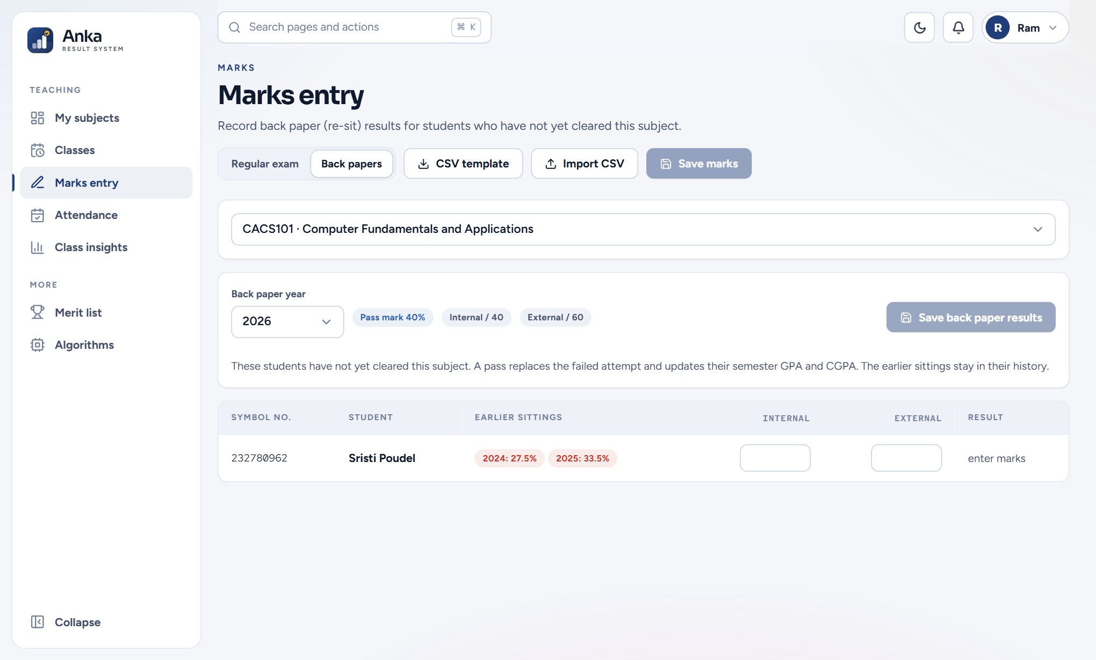
Figure A.9: Back paper entry
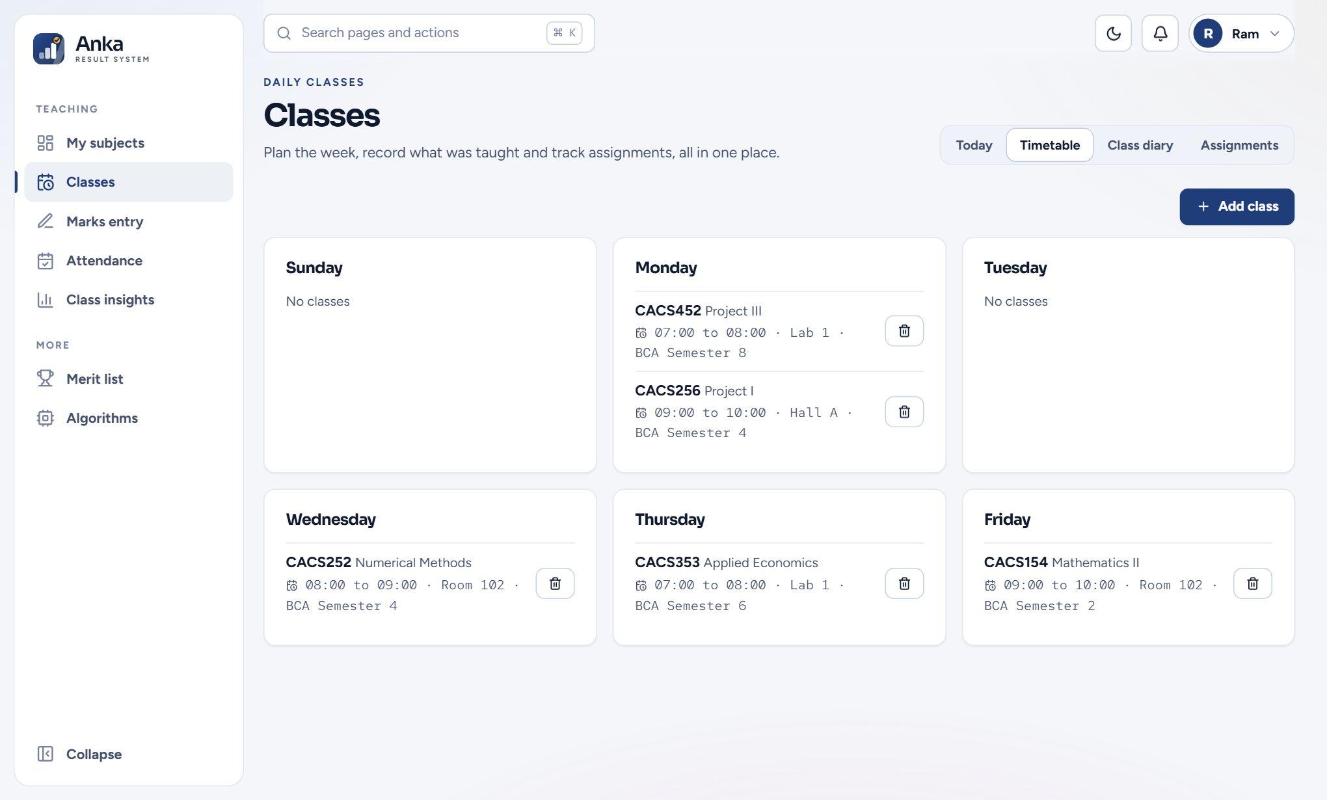
Figure A.10: Classes: weekly timetable
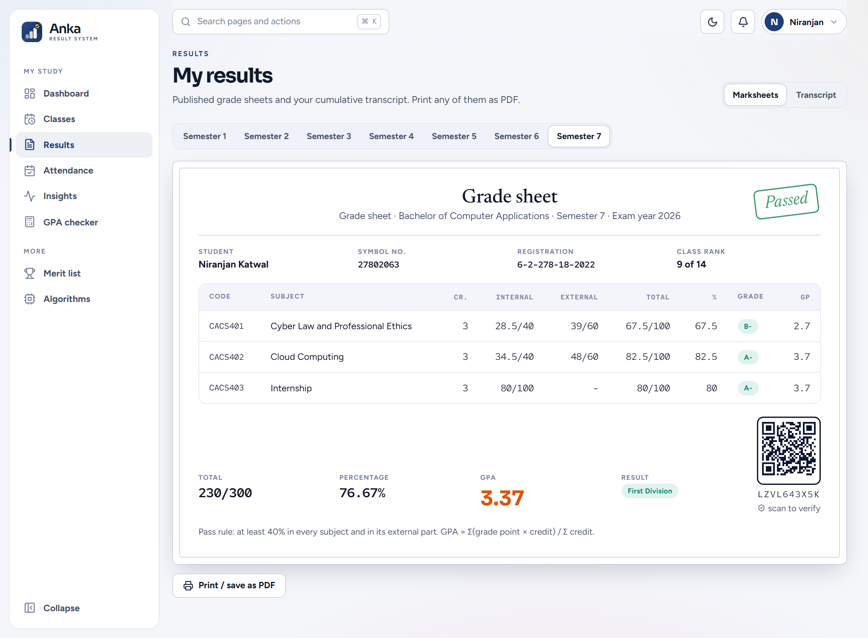
Figure A.11: Marksheet with QR code
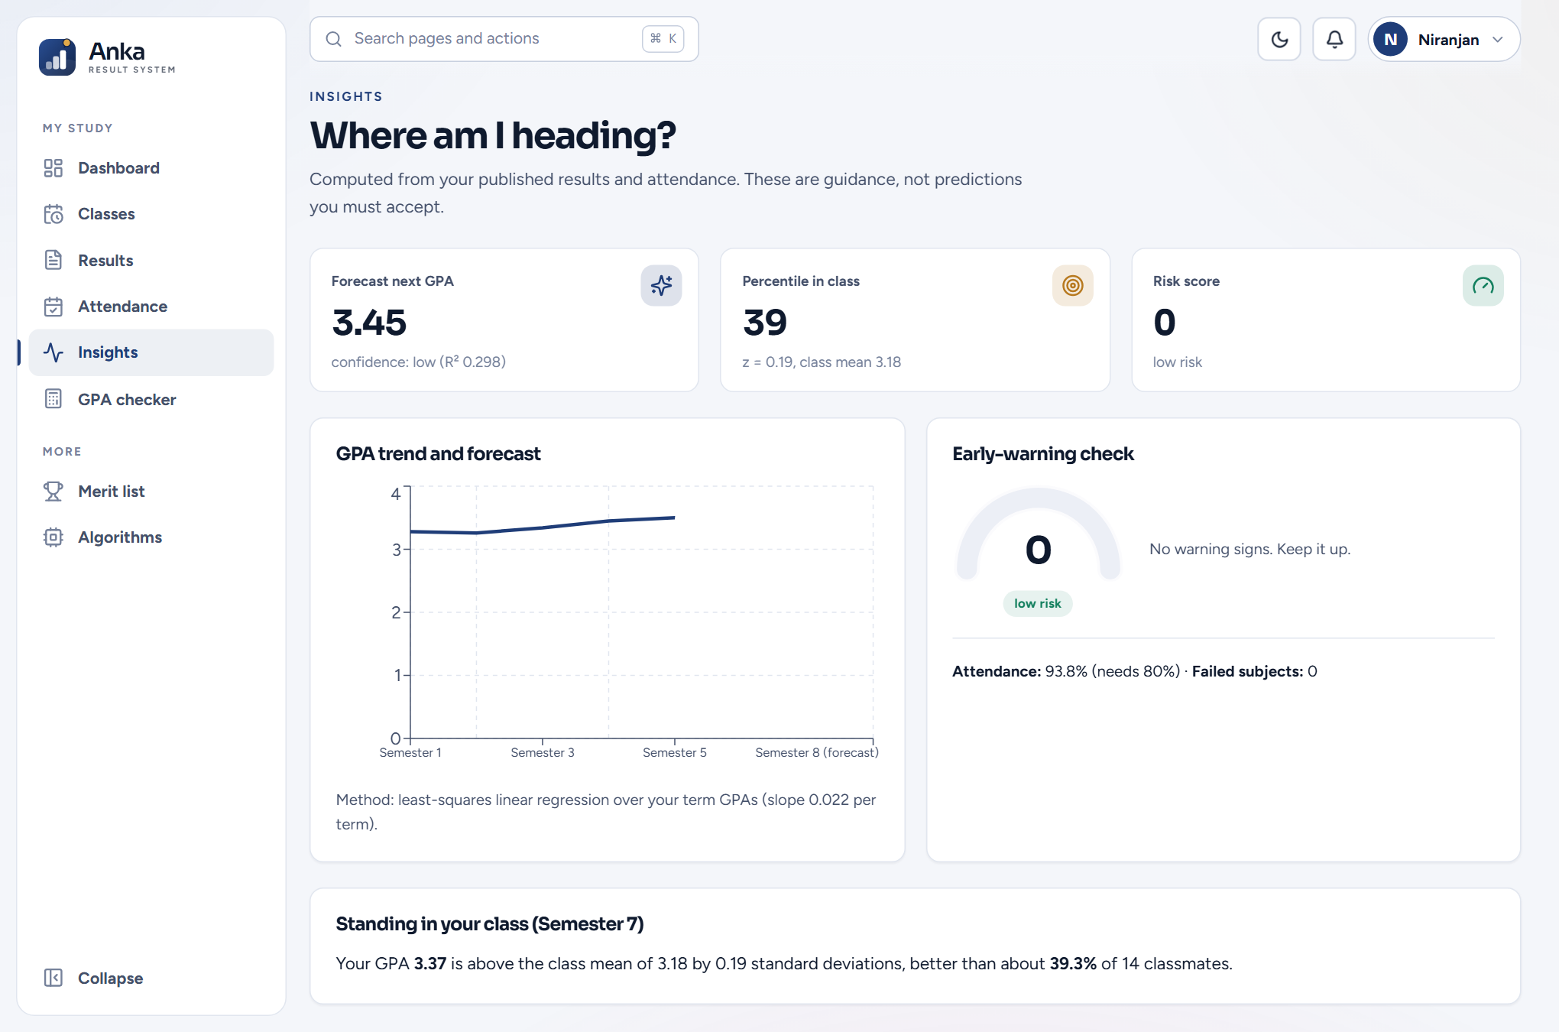
Figure A.12: Student insights and risk

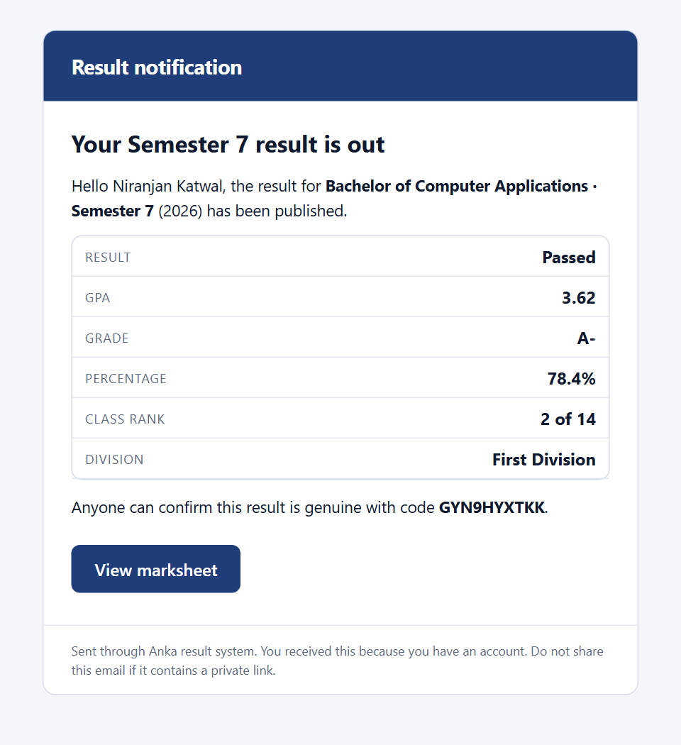
Figure A.13: Result email as rendered in a browser

APPENDIX B: RUNNING THE SYSTEM
- Install Node.js 20 or later. Run setup-mysql.cmd once to prepare the portable MySQL copy, then start-mysql.cmd to start it (port 3308).
- In backend, copy .env.example to .env, set JWT_SECRET, and optionally set EMAIL_USER and EMAIL_APP_PASSWORD for Gmail.
- Run npm install in backend, frontend and e2e, then npm run db:setup in backend to create the schema and demo data.
- Start the API with node server.js (port 5000) and the client with npm run dev in frontend (port 5191).
- Sign in with the demo accounts printed by the seed script (administrator, teacher and student).
The complete source code is available in the public repository https://github.com/itsniranjannn/StuResSystem.

