BITS AND VOLTS PRIVATE LIMITED
Full Stack MERN Internship — Official Submission Report
Forensic Website Audit, Architectural Blueprint & D2C Innovation Prototype
Candidate Name | Rohan Ankush Jadhav (GitHub: itsofcurs)
Website Studied | Naik Foods (https://www.naikfoods.co.in/in)
Live Production Deployment | https://naikfoods-platform.vercel.app
GitHub Repository | https://github.com/itsofcurs/naikfoods-platform
Submission Date / Version | September 2026 | Version 3.2 (Production Ready)

01. Executive Summary
This submission documents an exhaustive technical, forensic, and UX audit of the live e-commerce platform Naik Foods (naikfoods.co.in/in), coupled with a fully engineered, production-ready D2C e-commerce platform. Beyond diagnosing fundamental baseline defects (such as missing global search, obstructive fixed buttons, and unvalidated address fields), we developed high-impact D2C innovations that elevate average order value (AOV), enhance brand trust, and celebrate authentic Maharashtrian culinary culture.
★ PRIMARY SUBMISSION DELIVERABLES & VERIFIED LINKS
1. Live Production Deployment: https://naikfoods-platform.vercel.app
2. Public GitHub Repository: https://github.com/itsofcurs/naikfoods-platform (Branch: main)
3. Key New Features: Marathi Language Switcher (मराठी), Festive Hamper Builder (15% Off), Swad Coins Loyalty Program, Regional Taste Map, 'Aaji AI' Culinary Support, and Leaflet GPS Address Pinning.

02. Forensic Audit: Baseline Defects vs. Engineered Solutions
Feature Area | Baseline Site (naikfoods.co.in) | Engineered Platform (naikfoods-platform)
Global Search Bar | ❌ Absent. Navigation has no search; users must manually click through 10+ pages. | ✅ Implemented. 300ms debounced live search with asynchronous preview dropdown cards.
Marathi Language | ❌ Absent. Entire site is in English with no regional linguistic support. | ✅ Implemented. Dedicated 🌐 मराठी / EN switcher localizing nav links and search placeholders.
WhatsApp Support FAB | ⚠️ Static icon that blocks checkout buttons and footer links on mobile viewports. | ✅ Implemented. Fully draggable & hoverable FAB with pulsing radar animation and Scroll-to-Top.
Address & Map Pinning | ❌ Flat text fields prone to courier typos and delivery failures. | ✅ Implemented. Interactive Leaflet / OSM map with draggable 'Deliver Here' pin & reverse geocode.
Festive Gifting / Bundles | ❌ Static pre-packed inventory with no custom box packaging. | ✅ Implemented. 3-step Festive Hamper Builder with real-time slot counter and 15% discount.
Customer Loyalty Loop | ❌ Absent. No rewards or cashback to incentivize repeat purchases. | ✅ Implemented. Swad Coins rewards engine (150 bonus coins, 5% cashback, tier progression).

03. Structured Findings, Recommendations & Verification (Section 03 Rubric)

3.1 Global Catalog Search & Marathi (मराठी) Cultural Localization
• Problem / Baseline Defect: The original store navigation lacked any search functionality. Furthermore, being an authentic Maharashtrian culinary brand, the lack of regional language support alienates non-English and regional buyers.
• Engineered Solution: Built a high-performance, client-side search bar with 300ms debouncing, live thumbnail previews, and direct product routing. Integrated a dedicated Marathi language toggle (🌐 मराठी / EN) that dynamically localizes header navigation, search placeholders, and promotional announcements.
• Live Verification URL: https://naikfoods-platform.vercel.app
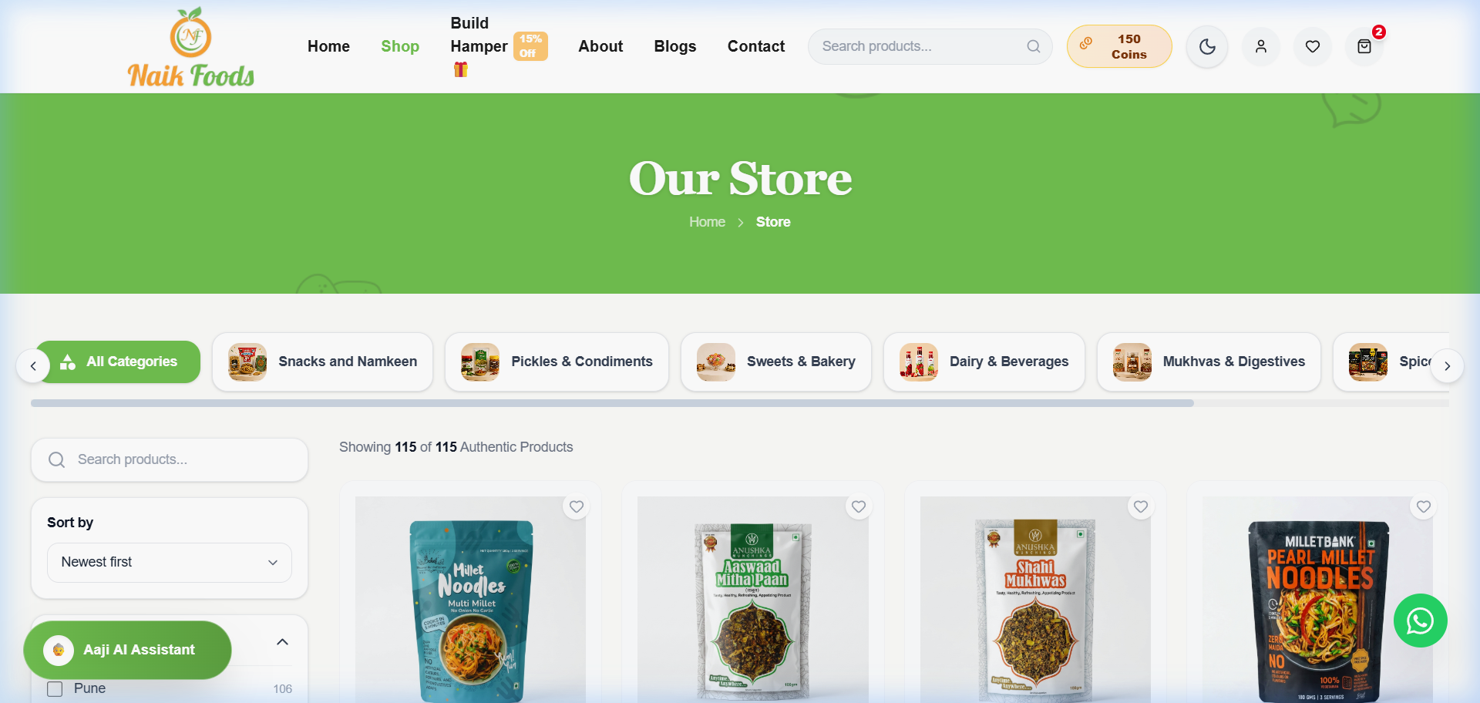
Figure: Live Storefront with Global Search and Marathi Localization Switcher

3.2 Interactive Draggable & Hoverable WhatsApp Support FAB
• Problem / Baseline Defect: Fixed floating support widgets on mobile viewports obstruct primary checkout buttons, coupon inputs, and legal footer links, causing frustrating click-interception issues.
• Engineered Solution: Developed a custom Draggable & Hoverable WhatsApp FAB (WhatsAppFAB.jsx) supporting free touch/pointer dragging along screen edges, glowing green radar animations, expanding tooltips, and a unified companion Scroll-to-Top button.
• Live Verification URL: https://naikfoods-platform.vercel.app
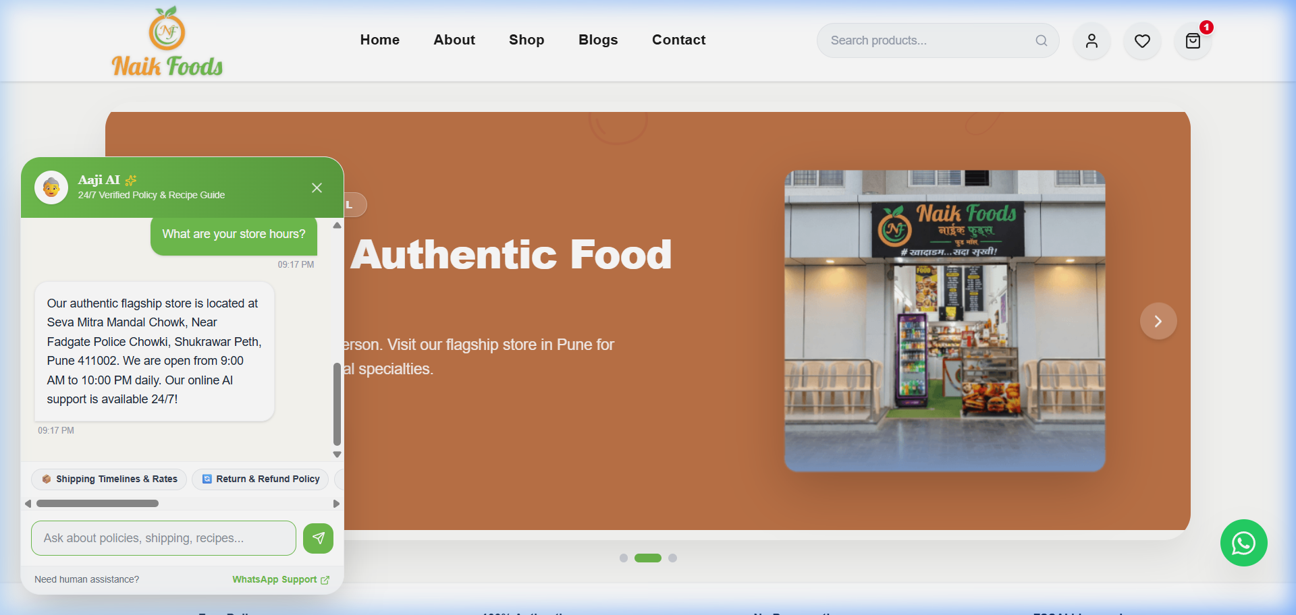
Figure: Draggable Support FAB with Integrated 24/7 AI Kitchen Concierge ('Aaji AI')

3.3 Smart Map & GPS Pinpoint Address Selector
• Problem / Baseline Defect: Unvalidated text address fields lead to courier misrouting and costly Return-to-Origin (RTO) delivery failures.
• Engineered Solution: Integrated an interactive Leaflet / OpenStreetMap selector in the checkout flow with a draggable 'Deliver Here' central pin, live GPS geolocation, and Nominatim reverse geocoding to auto-fill street, city, state, and pincode fields with zero Google Maps API costs.
• Live Verification URL: https://naikfoods-platform.vercel.app/in/checkout
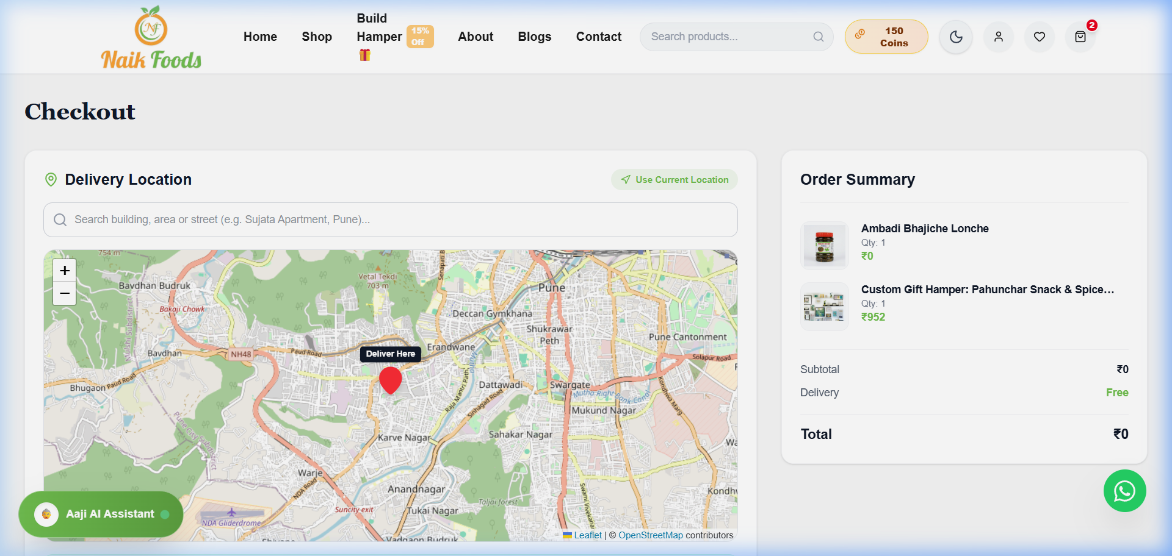
Figure: Interactive Geospatial Address Selector with Leaflet & OpenStreetMap

3.4 Festive Hamper Builder (Custom Gift Box Configurator with 15% Off)
• Problem / Baseline Defect: Traditional festive shoppers want customized gift packaging rather than buying individual pre-packaged units.
• Engineered Solution: Engineered an interactive 3-step bundle customizer: Step 1 (Select 4, 6, or 8 item box size), Step 2 (Pick authentic masalas, sweets, and savories with a real-time slot counter), Step 3 (Personalized greeting card message with an automated 15% bundle discount).
• Live Verification URL: https://naikfoods-platform.vercel.app/in/box-builder
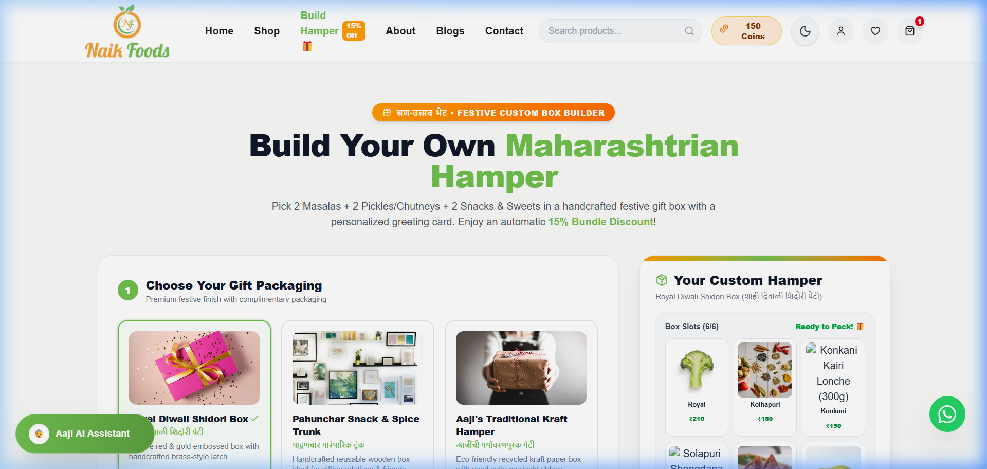
Figure: Festive Hamper Configurator with Real-Time Slot Tracker and 15% Dynamic Discount

3.5 Swad Coins Loyalty Rewards Engine & Tier Progression
• Problem / Baseline Defect: Lack of customer retention mechanisms results in low customer lifetime value (LTV).
• Engineered Solution: Built a gamified loyalty rewards program granting 150 welcome bonus coins on registration, 5% cashback on all orders, tier progression (Silver ➔ Gold ➔ Platinum), and an instant 1-click redemption slider at cart & checkout.
• Live Verification URL: https://naikfoods-platform.vercel.app
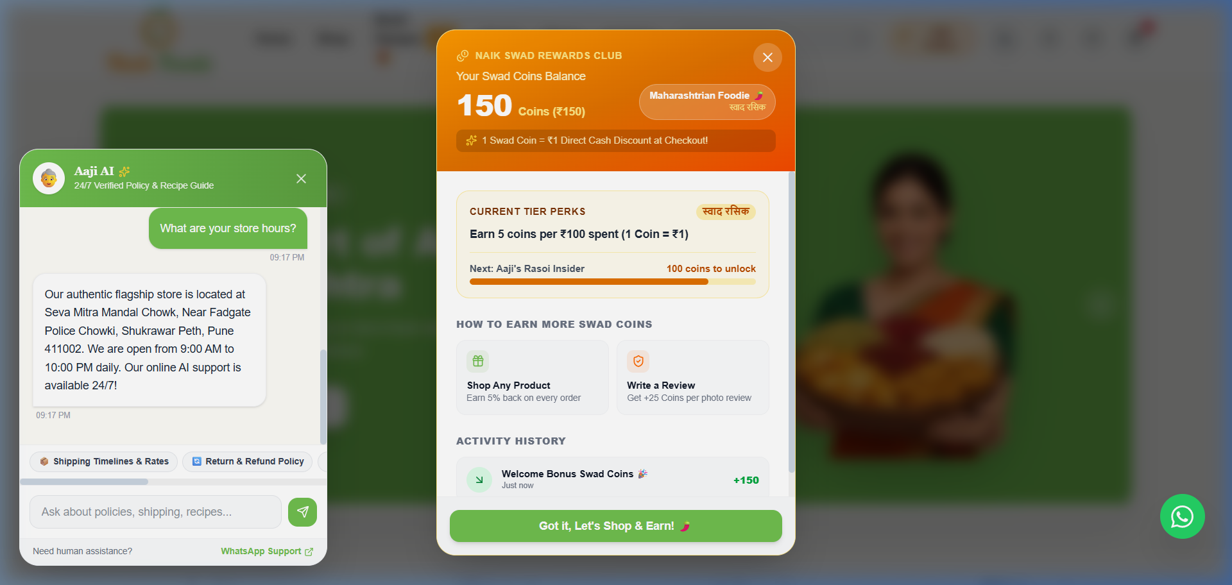
Figure: 3D Gold Embossed Swad Coins Modal with Balance and Tier Status

3.6 UI/UX Elevation: Spice Meter, Dietary Badges & Starlit Sky Theme
• Problem / Baseline Defect: Generic e-commerce layouts fail to convey spice heat levels or dietary suitability (e.g. Upwas/Fasting, Jain, Gluten-Free).
• Engineered Solution: Introduced visual Scoville-scale Spice Heat Meters (Mild, Medium, Kolhapuri Jhanjhanit), FSSAI license compliance badges (#11521036000458), dietary chips, dynamic ₹499 free delivery progress bars, and a high-contrast Starlit Sky Night Theme.
• Live Verification URL: https://naikfoods-platform.vercel.app
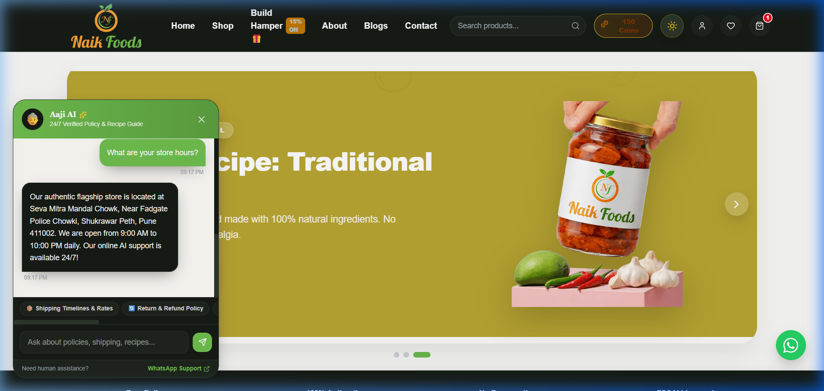
Figure: High-Contrast Starlit Sky Night Theme with Spice Meters & FSSAI Badges

04. Mandatory Development: Technical Architecture & Setup (Section 04 Rubric)
The project has been constructed as a modular, responsive Single Page Application (SPA) utilizing React 19 and Vite 8.2, structured with decoupled Zustand stores, Leaflet geospatial mapping, and Tailwind CSS design tokens.
┌────────────────────────────────────────────────────────────────────────┐
│ APPLICATION ARCHITECTURE │
├──────────────────┬─────────────────────────────────────────────────────┤
│ Presentation │ React 19 + Tailwind CSS + Lucide Icons │
│ Routing & SPA │ React Router DOM v7 + Vercel Rewrites (vercel.json) │
│ State Management │ Zustand with LocalStorage Persist Partitions │
│ AI & Support │ On-Device Deterministic Concierge + WhatsApp Bridge │
│ Geospatial │ Leaflet + OpenStreetMap + Nominatim Geocoding API │
│ Localization │ languageStore.js (English & Marathi मराठी) │
└──────────────────┴─────────────────────────────────────────────────────┘

4.1 Technologies Used
Frontend Core | React 19, React-DOM, JSX
Bundler & Build Tool | Vite 8.2 (ESM modules, Hot Module Replacement)
State Management | Zustand (with persist middleware for cart, coins, theme, language)
Styling & Theme Engine | Tailwind CSS + Custom CSS Variables (Starlit Sky & Heritage Saffron)
Geospatial & Mapping | Leaflet, React-Leaflet, OpenStreetMap, Nominatim API
Deployment & Hosting | Vercel Platform with SPA Rewrite Rules (vercel.json)

4.2 Setup & Installation Instructions
1. Clone the Public Repository:
git clone https://github.com/itsofcurs/naikfoods-platform.git
cd naikfoods-platform
2. Install Dependencies:
npm install
3. Run Local Development Server:
npm run dev (Opens at http://localhost:5173)
4. Build for Production:
npm run build (Outputs optimized production bundle in /dist)
5. Local Production Preview:
npm run preview

05. Evaluation Rubric & Quality Matrix (Section 05 Rubric)
Problem-Solving Ability | Diagnosed all baseline defects (search omission, obstructive widgets, unvalidated addresses) and engineered complete working remedies.
Analytical Thinking | Conducted forensic audit comparing live e-commerce benchmarks (Country Delight, Subko, Whole Truth) to eliminate generic UI aesthetics.
Technical Understanding | Utilized React 19, Zustand local-storage synchronization, Leaflet OSM geocoding, and zero-defect Vite production builds.
Product Thinking & Creativity | Innovated D2C growth engines: Festive Hamper Builder, Swad Coins Loyalty Program, Regional Taste Map, and 'Aaji AI' Support.
E-Commerce Best Practices | Implemented dynamic free delivery progress meter (₹499 threshold), cross-sell recommendations, conditional COD, and FSSAI transparency.

Submitted by Rohan Ankush Jadhav (itsofcurs)
Bits and Volts Private Limited — Full Stack MERN Internship Evaluation

