**Banner links copy, repeat across each page:**

Solving Long Term Debt

Sale of Land

Local Government Experts

Case Studies

About

Pricing

Contact Us

1. Home page:

Banner links

Logo

**Headline:**

Recouping outstanding debt, in difficult personal situations

*Image of Road to Recovery*

2. (About)

Banner links

**Headline:**

Modernising debt recovery in Local Government

**Subhead:**

Traditional Debt Recovery vs. Recoupa Debt Recovery

**Body:**

Local Government Councils are moving towards more sustainable approach to debt recovery. For more than 80 years Local Government Councils have relied on legal actions through the Courts to recover debts owed to them. But legal actions are slow and expensive, they cause almost as many problems as they solve. Widespread suing of Ratepayers is now considered financially and socially unsustainable

**Subhead:**  
Recoupa sustainable debt recovery

**Body:**

Recoupa has developed and proven a more sustainable debt recovery approach which:

* engages Ratepayers in compassionate and rational discussions to organise payment
* recoups debts more quickly and without legal action
* reduces the cost of debt recovery
* starts sufferers of chronic financial stress on their recuperation journeys
* helps Council to be much better informed on hardship situations
* reduces collateral damage within communities;

|  |  |  |
| --- | --- | --- |
| Recoupa triple bottom-line gives excellent results  to Ratepayers, to Councils and to Communities; | | |
| **Sustainable for Councils** | **Sustainable for Ratepayers** | **Sustainable for Communities** |
| Ratepayers pay their Rates more quickly  Council is known for its sustainable practices  Council cashflows fewer legal costs | Easier for Ratepayers to pay Rates debt in full without expensive legal costs  Less burden on Ratepayers & families | Financially struggling families are relieved of high legal costs  Social side-effects of poverty reduced, in schools, health, crime & more… |
|
|

3. (Solving Long Term Debt)

Banner links

**Subhead:**

Collaborative solutions to the problem of Long Term Debt: Late-Stage Intervention

*Image of worried man looking at a bill with Help sign*

3x Icons:

**Problem icon**

* Large debts, long outstanding
* Many stages of legal action have been taken
* Complex health and/or social issues may exist
* **Solution icon**
* Ratepayers are engaged in rational, respectful & compassionate discussions
* Solutions are negotiated & monitored to conclusion
* Detailed reporting and recommendation are provided to Council for approval
* **Benefit icon**
* Large, old debts are paid
* Outstanding Rates % are reduced
* Ratepayers take steps towards recuperating & are grateful to Council

4. (Sale of Land Triage)

Banner Links

**Subhead:**

Collaborative solutions to the problem of Long Term Debt: Sale of Land Triage

*Image of Land for Sale sign*

3x Icons

**Problem icon**

* Property is eligible for Sale of Land but is occupied
* Council exposed to risk of negative publicity
* Need for deep understanding of the situation

**Solution icon**

* Visit property and discover situation
* Professional report, with risk assessment, prior to Council resolution
* Often find viable alternative to sale of the property

**Benefits icon**

* Old debts are safely recovered from occupied properties

5. (Local Government Experts)

Banner Links

**Subhead:**

Collaborative solutions to the problem of Long Term Debt: Council Briefings

*Image of Richard*

3x Icons

**Problem icon**

* Council resolutions are delayed due to Councillor unfamiliarity with Sale of Land
* Councillors require understanding of Sale of Land and debt recovery

**Solution icon**

* Professional, informative briefing to Council prior to resolution

**Benefits icon**

* Councillors can make informed decisions to pass progressive resolutions

CASE STUDIES

The Recoupa team has been working with councils and communities to achieve sustainable results for a number of years. Detailed outcomes are documented and due to sensitive content, are available for review on request. Summary case studies are reviewable here:

Case Study 1 - Patience Works *(clickable link to the full case study)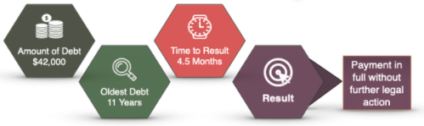*

*Make Graphic a clickable link*

Case Study 2 - Compassion Works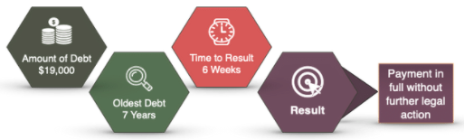

Case Study 3 - Effort Works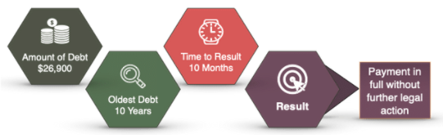

Case Study 4 - Understanding Works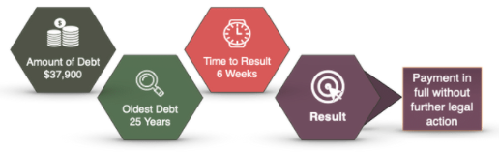

Case Study 5 - Early Intervention Works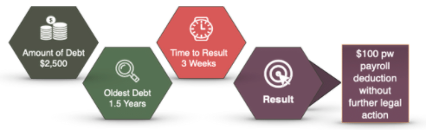

Case Study 1 - Patience Works

**Headline:**

Case Study 1 - Patience Works

**Subhead:**

Situation

**Body:**

Adult sibling Ratepayers inherited the property, but their addresses were unknown.   
Previous debt recovery agency had tried to locate the Ratepayers unsuccessfully for 7 years.  
Previous agency took legal action, served Statements of Claim by Court Post to address at which Ratepayers could not receive them.  
Judgment entered.  
Bank Garnishees had collected $800.

**Subhead:**

Resolution

**Body:**

We located Ratepayers penniless & living apart in poor conditions.  
Considerable effort to build understanding & trust.  
Engaged both Ratepayers in compassionate supportive process.   
First one, then both Ratepayers advised they wished to sell the property.

* + We located Real Estate Agent with offer acceptable to Ratepayers.
  + We intensively assisted them to voluntarily sell property.
  + Very many unforeseeable complexities/obstacles arose, we resolved all.

Each Ratepayer received $400,000 from sale proceeds.  
Ratepayers extremely grateful to Council. Real Estate & Solicitor impressed.  
Council paid in full.

Case Study 2 - Compassion Works

**Headline:**

Case Study 2 - Compassion Works

**Subhead:**

Situation

**Body:**

Many stages of legal action had been taken.  
Many payment arrangements made but defaulted.  
The property was being considered for Sale of Land but was occupied.  
Council requested an assessment of the situation as triage for Sale of Land.

**Subhead:**

Resolution

**Body:**

Enquiries led to Ratepayer c/- parents, recuperating after suicide attempt.  
Ratepayer had been diagnosed with chronic depression & bipolar disorder.  
He failed to cope with mounting financial pressures.  
We:

* + Ceased legal action
  + Established understanding & trust
  + Offered support, which was gratefully accepted

Ratepayer wished to withdraw superannuation funds.   
We offered support and he phoned us several more times for moral support.  
Ratepayer phoned us for updated amount the morning he received funds.   
He immediately visited Council & paid in full.  
Ratepayer is relieved & very grateful to Council for its compassionate help.

Case Study 3 - Effort Works

**Headline:**

Case Study 3 - Effort Works

**Subhead:**

Situation

**Body:**

The Ratepayer suffered significant emotional trauma 10 years earlier.  
She abandoned the property then, by simply driving away, with her young son.  
She left house fully furnished & supplied with food.   
A debt recovery agency had tried to locate the Ratepayer unsuccessfully.

**Subhead:**

Resolution

**Body**

We located Ratepayer living 480kms from the property.   
She was highly distressed, we invested time building understanding & trust.  
We compassionately supported delicate journey to decide to sell property.  
Ratepayer couldn’t face-up to sale process.

* + We obtained 3 Real Estate appraisals & a supportive local Solicitor.
  + We drove Solicitor & Real Estate appraisals to Ratepayer at home.
  + Solicitor was engaged.
  + Maintenance & clean-ups on the property organised.
  + We supported Real Estate Agent to manage obstructive neighbour before & during auction.

The property sold at a higher than expected price at auction. Ratepayer received ~$450,000 proceeds and bought a house at the beach. Council paid in full.

Case Study 4 - Understanding Works

**Headline:**

Case Study 4 - Understanding Works

**Subhead:**

Situation

**Body:**

Ratepayer is elderly widow pensioner with multiple health issues.  
Ratepayer abandoned property 7 years earlier.  
Retired to neighbouring Shire for health reasons.  
Property very fully furnished with possessions and memories of 30 years of living and raising family.    
Council reluctant to take legal action.  
A debt recovery agency had unsuccessfully tried to resolve situation by making Field Calls.

**Subhead:**

Resolution

**Body**

Ratepayer engaged in compassionate discussions about situation & wishes for abandoned property.   
She advised struggling financially, still paying insurance & electricity bills on property.

* + Signs of hoarding.
  + Wished to sell property but incapable of sorting out the houseful of furniture & possessions.
  + Has 3 adult children, but too embarrassed to tell them & enlist support.

Long supportive discussions, Ratepayer consented to briefing one of adult children.  
Ratepayer supported by family to sort out property.    
Family very grateful to Council. Council paid in full.  


Case Study 5 - Early Intervention Works

**Headline:**

Case Study 5 - Early Intervention Works

**Subhead:**

Situation

**Body:**

Ratepayer is an adult, employed but struggles to manage finances.  
He voluntarily disconnected the electricity nine years ago, finding it too difficult to pay the bills.  
He cooks in the dark on a fire, with the mantra, “a fire and a radio is all a bloke needs”.  
Thousands of dollars in legal fees added to his financial struggles, as Council took legal action every 2-3 years to collect the Rates debt.  
The previous two legal actions were paid in full by Wage Garnishees.  
Council is ready to start legal action again.

**Subhead:**

Resolution

**Body**

We visited the Ratepayer in the evening at his (dark) home, and proposed a voluntary wage deduction. He agreed to pay $100 pw by wage deduction.  
With his consent, we phoned employer’s Payroll Department for their specific contact details.  
The Ratepayer has no electricity, no computer and no email, so we wrote a letter to his Payroll Department from him, authorising the wages deduction.  
We delivered the letter to the Ratepayer for signing, and sent the signed letter to Payroll who phoned us to confirm it was processed.  
The $100 payments have been made consistently every week, and Council will recover full payment months earlier than by legal action.  
The Ratepayer has saved over $1,000 in legal fees.

Contact US

Logo

CONTACT US

Mailing Address

PO Box 5343, Victoria Point QLD 4165

Email

[hello@recoupa.com](mailto:hello@recoupa.com)

Phone

NSW 02 8006 6800  
QLD 07 3040 6111