# ERD And Design :

## ERD :

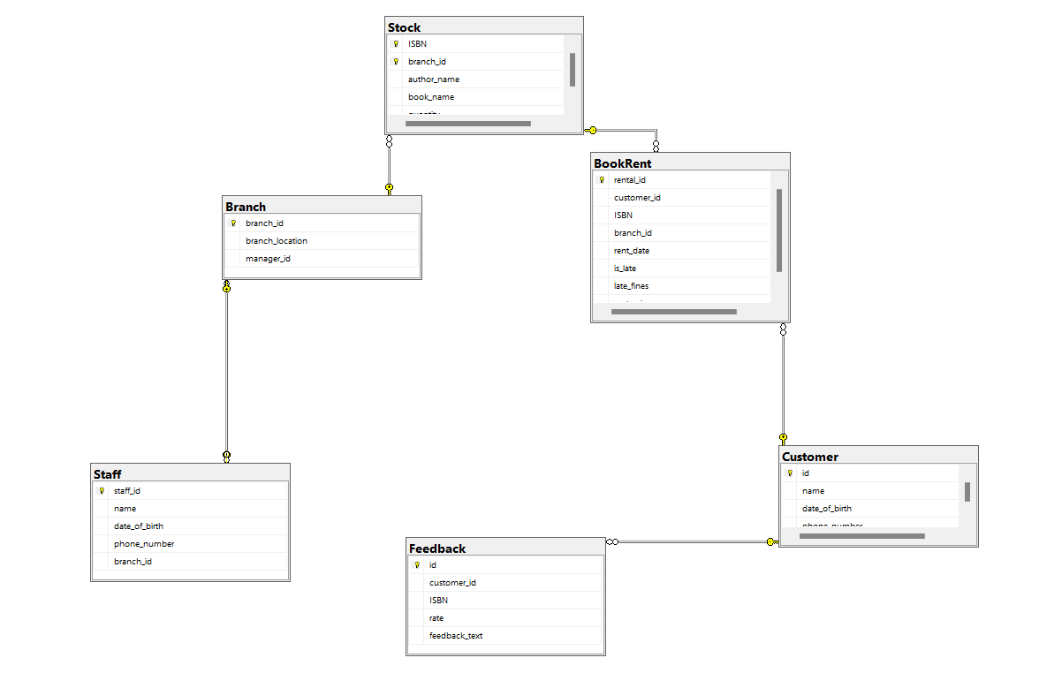

## Entities :

### Customer:

- Attributes: id (Primary Key), name, date_of_birth, phone_number

### Staff:

- Attributes: staff_id (Primary Key), name, date_of_birth, phone_number, branch_id (Foreign Key)

### Branch:

- Attributes: branch_id (Primary Key), branch_location, manager_id (Foreign Key)

### Stock:

- Attributes: ISBN, branch_id, author_name, book_name, quantity

- Primary Key: (ISBN, branch_id)

- Foreign Key: branch_id references Branch(branch_id)

### Feedback:

- Attributes: id (Primary Key), customer_id (Foreign Key), ISBN, rate, feedback_text

- Foreign Key: customer_id references Customer(id)

### BookRent:

- Attributes: rental_id (Primary Key), customer_id (Foreign Key), ISBN, branch_id, rent_date, is_late, late_fines, rent_price, is_Returned

- Foreign Key: customer_id references Customer(id), (ISBN, branch_id) references Stock(ISBN, branch_id)

## Relationships :

* Customer to Feedback: One customer can provide multiple feedback.
* Customer to BookRent: One customer can have multiple book rentals.
* Staff to Branch: One staff member can manage only one branch.
* Branch to Staff: One branch is managed by one staff member.
* Branch to Stock: One branch can have multiple stock items.
* Stock to Branch: One stock item belongs to one branch.

## Cardinality and Optionality:

* Customer to Feedback: One-to-Many (1:N), Mandatory on the "1" side (Customer), and Optional on the "N" side (Feedback).
* Customer to BookRent: One-to-Many (1:N), Mandatory on the "1" side (Customer), and Optional on the "N" side (BookRent).
* Staff to Branch: One-to-One (1:1), Mandatory on both sides (Staff and Branch).
* Branch to Staff: One-to-One (1:1), Mandatory on both sides (Branch and Staff).
* Branch to Stock: One-to-Many (1:N), Mandatory on the "1" side (Branch), and Optional on the "N" side (Stock).
* Stock to Branch: One-to-One (1:1), Mandatory on both sides (Stock and Branch).