SOLUTION DESIGN DOCUMENT
For
OPTIX (Pvt.) Ltd | Odoo 19 | SCM & Finance | End-to-End Procure-to-Stock Process & Customizations | Version 1.1 | 16 October 2026 | Draft for Business Review

TABLE OF CONTENTS
TABLE OF CONTENTS 2
1. Document Control 6
2. Introduction 6
3. Purpose 6
4. Scope 6
5. Odoo Modules 7
6. Odoo Setup & Configuration 7
7. Business Process Overview 12
8. Detailed Solution Design – Process Flow 13
9. End-to-End Process Matrix 24
10. Roles & Responsibilities 24
11. Key Business Controls 25
12. Exception & Alternate Processes 25
13. Conclusion 26
14. Sign-Off 26
OPTIX COMPLETE CUSTOMIZATION GUIDE
1. Purpose and scope 28
2. Quick access directory 28
3. Purchase Request customization 30
4. Departments, products and analytic allocation 31
5. Purchase orders, approvals and budget controls 31
6. Project approvals and Project PR budgets 32
7. Contacts and CRM customer synchronization 33
8. Inventory, serials, warranty and gate passes 33
9. Supplier payment deductions and cheque advice 34
10. Accounting kit and community budget integration 35
11. Administration and supporting modules 35
12. Module and source register 36

1. Document Control
Item | Value | Remarks
Document | Solution Design Document | Odoo SCM & Finance
Version | 1.1 | Completed setup register and customization coverage; 16 October 2026
Scope | Procurement to Inventory & Finance | End-to-end process
Platform | Odoo | Standard Odoo functionality preferred
Audience | Business, SCM, Finance, IT | For review and sign-off

2. Introduction
This Solution Design Document defines the proposed end-to-end process in Odoo covering Supply Chain Management (SCM) and Finance. The objective is to establish a controlled flow from material/service requirement through procurement, purchase order, goods receipt, inspection where applicable, inventory availability, vendor billing and accounting.
The design emphasizes segregation of duties, approval controls, traceability, inventory accuracy and automatic financial integration. Standard Odoo functionality should be used wherever possible, with configuration before customization.

3. Purpose
- Define the target business process and Odoo transaction flow.
- Identify the Odoo SCM and Finance modules involved at each stage.
- Define roles, approvals, documents and system controls.
- Ensure that physical inventory transactions are correctly reflected in accounting.
- Provide a baseline for configuration, UAT, training and implementation.

4. Scope

4.1 In Scope
- Item/product master and product categories.
- Purchase Requisition / internal material requirement (where implemented).
- RFQ and vendor quotation evaluation.
- Purchase Order creation and approval.
- Receipt scheduling and warehouse operations.
- Goods receipt and quality/inspection control where required.
- Lot/serial number capture where applicable.
- Inventory update and stock valuation.
- Vendor bill creation and three-way matching.
- Accounts Payable and payment processing.
- Accounting entries generated from procurement and inventory transactions.
- Operational and financial reporting.

4.2 Out of Scope / To Be Confirmed
- Manufacturing/MRP processes.
- Advanced landed-cost allocation beyond the agreed design.
- Payroll and HR.
- Customer sales/order-to-cash processes.
- Country-specific tax configuration not explicitly approved in the project scope.

5. Odoo Modules
Module | Purpose | Key Process Coverage
Purchase | Procurement management | RFQ, quotation, PO, approvals, vendor terms
Inventory | Warehouse and stock control | Receipts, putaway, lots/serials, stock moves
Quality | Inspection and quality control | Incoming inspection, pass/fail, quality checks
Accounting | Financial accounting | Vendor bills, journal entries, AP, payments
Contacts | Business partner master | Vendor master and financial details
Products | Item/product master | UOM, category, routes, tracking, valuation

6. Odoo Setup & Configuration
The following setup register records repository-supported behavior and required configuration. Pending values require the named business owner because no approved company master-data export or live database was supplied. Proposed controls are not evidence of deployed enforcement.

6.1 Company Setup
Field | Value / completion responsibility
Company Name | Optix Pakistan Private Limited
Registered address | 1D - 27, Sector 30 Korangi Industrial Area Karachi, Pakistan
NTN / tax registration | 7146772-7
Operating address / branches | 1D - 27, Sector 30 Korangi Industrial Area Karachi, Pakistan
Point of contact | Ali Afraz

6.2 Warehouse
Setup item | Configuration / status
Warehouse master | WH:Optix Pakistan Private Limited  Short codes: WH  Locations: WH/Karachi and WH/Lahore
Receipt operation | Configure incoming operation and vendor/source and receiving/destination locations for each warehouse
Receipt steps | SCM to approve one-, two- or three-step receiving; inspection requires an agreed controlled route
Ownership / access | Scm.wh@optix.pk

6.3 Sub-Inventory
Setup item | Configuration / status
Sub-inventory mapping | Represent storage areas as internal stock locations under the relevant warehouse; actual names pending SCM
Department stores | Department Location (hr.department.location_id) supplies the destination for custom Internal Requests
Quarantine / rejected area | Proposed controlled locations; SCM/Quality to approve disposition and access before use
Availability | Location usage and routes determine availability; a location name alone does not enforce inspection holds

6.4 Locations
Location / usage | Design and outstanding decision
Vendor / customer | Use appropriate external location usage; verify operation defaults
Receiving / stock | Internal locations under each warehouse; actual hierarchy and codes pending SCM
Department destination | Link each requesting department to its authorized internal destination
Inspection / scrap / transit | Configure relevant usage and routes; approve quarantine release, scrap and inter-warehouse handling

6.5 Product Categories
Category / field | Required definition
Goods / services | SCM to provide category hierarchy; goods tracking and services procurement differ
Costing / valuation | Finance to approve methods and Odoo 19 accounting treatment per category; repository does not establish production values
Accounting mapping | Finance to supply expense, valuation and applicable clearing accounts; product analytic GL is a separate analytic dimension
Tracking / warranty | Product-level serial tracking where required; custom warranty duration is in days

6.6 UOM
UoM setup | Rule / owner
Base / purchase UoM | SCM to confirm unit names for each item and its purchase unit
Conversions | Configure conversions within the same UoM category; verify vendor pack sizes
Quantity precision | Approve rounding for indivisible goods, lengths and services
Serial-tracked goods | Verify individual serial assignments and quantities before transfer validation

6.7 Sequencing / Numbering
Sequence | Repository definition / decision
Contact code | res.partner.code: PART/ + five digits; supplied default, live next number unverified
Product reference | product.template.sequence: PROD/ + five digits when internal reference is absent
RFQ number | purchase.rfq: RFQ + five digits; confirmation can assign standard purchase.order sequence
Other document numbering | PR, project, receipt, bill and payment sequences: verify installed application/company setup; prefixes not established here

6.8 Transaction Type
Transaction | Implemented flow / setup
Purchase Request / Project PR | Approvals-based request; approved eligible lines generate vendor purchasing documents
Internal Request | Approved eligible goods lines create department internal transfers; configure destinations
Revenue Share Request | Type and flag exist; confirm live purchasing entry point because current button visibility excludes this type
Receipt / delivery / return | Use configured Inventory operations and standard return links; warehouse routes and tolerances require SCM approval

6.9 Payment Terms
Payment-term item | Configuration / status
Supplier defaults | Finance to provide approved terms per supplier; no production terms supplied
Due dates / installments | Configure actual days, percentages and installment rules in Accounting
PO and bill review | Review carried terms and maturity dates before confirmation/posting
Settlement | Custom gross payment less WHT/STSP determines net payment; early-payment-discount write-offs are outside this custom flow

6.10 Taxes
Tax setup | Configuration / status
Bill taxes | Finance to approve rates, applicability, price inclusion, fiscal positions and accounts; no statutory rates inferred
Payment WHT / STSP | Set Payment Deduction Category and Payment Deduction Account on eligible deduction taxes
Report classification | Set Accounting Report Tax Category on corresponding ledger accounts; complete partner/bill/payment metadata
Validation | Prevent double deduction of bill taxes; 5.5% in the guide is an illustration and is not an approved tax rate

6.11 Vendor / Supplier Master
• Maintain approved vendor records in Contacts with legal name, address, tax registration, payment terms, bank details and procurement status.
• Define vendor approval/activation ownership and ensure inactive or blocked vendors cannot be selected for new procurement transactions.
• Required setup fields should include vendor category, payment terms, fiscal/tax information, currency where applicable, and supplier reference.

6.12 Product Routes & Procurement Rules
• Define procurement routes and replenishment rules for each relevant product/category, including Buy, stockable/service behavior and any make-to-order or replenishment logic used by the business.
• Confirm lead times, minimum order quantities, purchase UOM and vendor-specific purchase information.
• Document which products require manual procurement versus automated replenishment.

6.13 Inventory Valuation & Costing
• Finalize the inventory valuation method and costing approach for each applicable product category.
• Define automated versus manual inventory valuation behavior and the accounting accounts used for stock valuation, stock input/output and clearing.
• Confirm treatment of inventory adjustments, returns, scrap and valuation corrections.

6.14 Quality & Inspection Setup
• Identify products/categories requiring incoming inspection and define the applicable Quality Control Points and inspection types.
• Define pass/fail criteria, quarantine/rejection locations, disposition ownership and evidence requirements.
• Confirm whether failed material may be reworked, returned to vendor, or released after approved disposition.

6.15 Accounting Configuration
• Finalize chart of accounts, account mappings by product/category, journals, payable accounts, inventory valuation accounts and GR/IR clearing accounts.
• Confirm fiscal positions, tax accounts, vendor bill sequence, credit note treatment and posting rules.
• Finance must approve the accounting configuration before production transactions begin.

6.16 Approval Matrix & Delegation
• Define approval levels by amount, department, business unit, purchase category and transaction type.
• Document approver roles, escalation path, delegation/substitution rules, rejection/resubmission behavior and approval audit requirements.
• The approval matrix should be approved by Business/SCM and Finance before workflow configuration.

6.17 Users, Roles & Access Control
• Define Odoo users and security groups for Requester, Buyer, Warehouse Receiver, Quality Inspector, Finance AP, Treasury, SCM Manager and System Administrator.
• Apply segregation of duties so that requesting, purchasing, receiving, invoice approval and payment activities are appropriately separated.
• Define access for create, edit, approve, validate, cancel, return and accounting actions.

6.18 Payment Methods & Bank Setup
• Configure bank journals/accounts, payment methods, payment terms and payment approval controls.
• Define payment batches or individual payment processing, supporting-document requirements and bank reconciliation rules.
• Confirm who can prepare, approve, execute and reconcile vendor payments.

6.19 Procurement & Receiving Control Parameters
• Finalize receipt tolerances, partial receipt rules, over-receipt handling, backorder behavior and cancellation controls.
• Define whether bills are created from ordered quantities or received quantities and document the three-way matching tolerance policy.
• Confirm purchase return, debit/credit note and vendor claim procedures.

7. Business Process Overview
The proposed end-to-end flow is:

1. Requirement Identified

2. Purchase Requisition / Internal Request

3. Approval

4. RFQ / Vendor Sourcing

5. Vendor Quotation Evaluation

6. Purchase Order Creation

7. PO Approval

8. Supplier Dispatch

9. Goods Receipt

10. Quality / Inspection (if applicable)

11. Putaway / Stock Update

12. Vendor Bill

13. Three-Way Match

14. Accounting Posting

15. Payment to Vendor

16. Closure & Reporting

8. Detailed Solution Design – Process Flow

8.1 Product & Master Data Setup
- The Product Master centralizes all product details, including vendor info and purchase prices, helping automate orders, compare supplier offers, and manage stock replenishment efficiently.
- Create products/items with appropriate product type, UOM, purchase UOM, inventory routes and tracking.
- Define product categories and inventory valuation behavior.
- For controlled materials, configure lot or serial tracking.
- Maintain vendor-specific purchase information such as vendor, lead time, price and minimum quantity where required.
- Finance should define the applicable accounts/category accounting configuration.

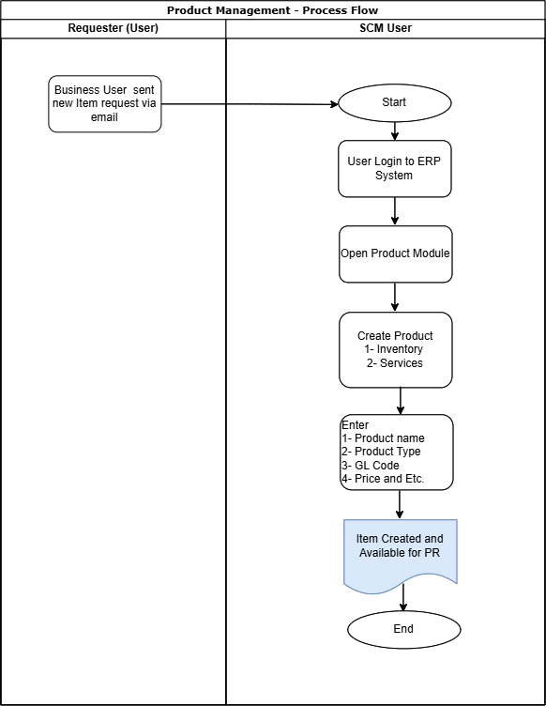

Process Summary:

- Business User sends a new product request to the SCM User via email.
- SCM User logs in to the Odoo ERP system.
- SCM User opens the Product module.
- SCM User selects the option to create a new product.
- SCM User selects the product type, such as Goods/Product or Service.
- SCM User enters the required product information, including:
- Product Name
- Product Type
- Product Category
- Sales/Purchase Price
- Other required product attributes
- SCM User saves the product record in Odoo.
- Odoo creates the product successfully and makes it available for use in Purchase Requisitions (PRs) and other relevant transactions.

8.2 Purchase Requisition (PR) Process
- Business user raises a requirement for material/service.
- Request should contain product/service, quantity, required date, destination warehouse and business justification.
- Approval is performed according to department, amount and/or category.
- Approved requirements become the basis for procurement action.
- Optix implements requisitions through Approvals renamed Purchase Request, extended by purchase_inherit and project_pr_budget. Department managers are added on submission; eligible non-refused lines can proceed after full or partial approval.

Requester → System → Manager / Approver: requirement creation, submission, approval and transfer to SCM.
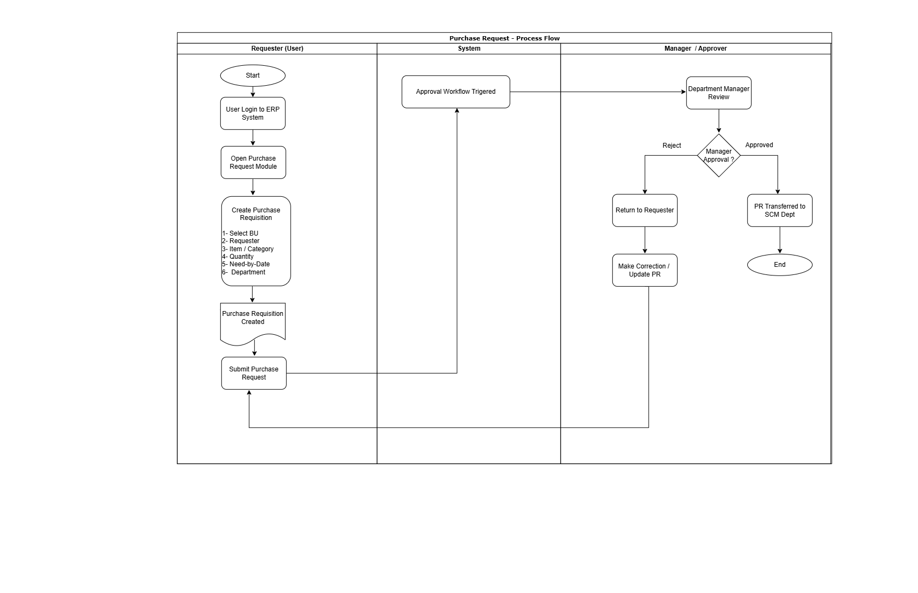
Process Summary:

- The Requester logs in to the ERP system.
- The requester opens the Purchase Request module.
- The requester creates a new Purchase Request (PR) by entering:
- Business Unit (BU)
- Requester
- Item / Category
- Quantity
- Need-by Date
- Department
- The system creates the Purchase Requisition in draft status.
- The requester submits the Purchase Request.
- The system triggers the Approval Workflow.
- The Department Manager reviews the Purchase Request.
- The manager makes an approval decision:
- If refused, departmental lines retain refusal user/date and the request may be partially approved. Use the permitted withdrawal/reset and resubmission process for corrections; refusal does not itself establish an automatic return-to-draft workflow.
- If Approved: The Purchase Request is transferred to the SCM (Supply Chain Management) Department for further procurement processing.
- The Purchase Request approval process is completed.

8.2.1 Project Purchase Requisition (PR) Process
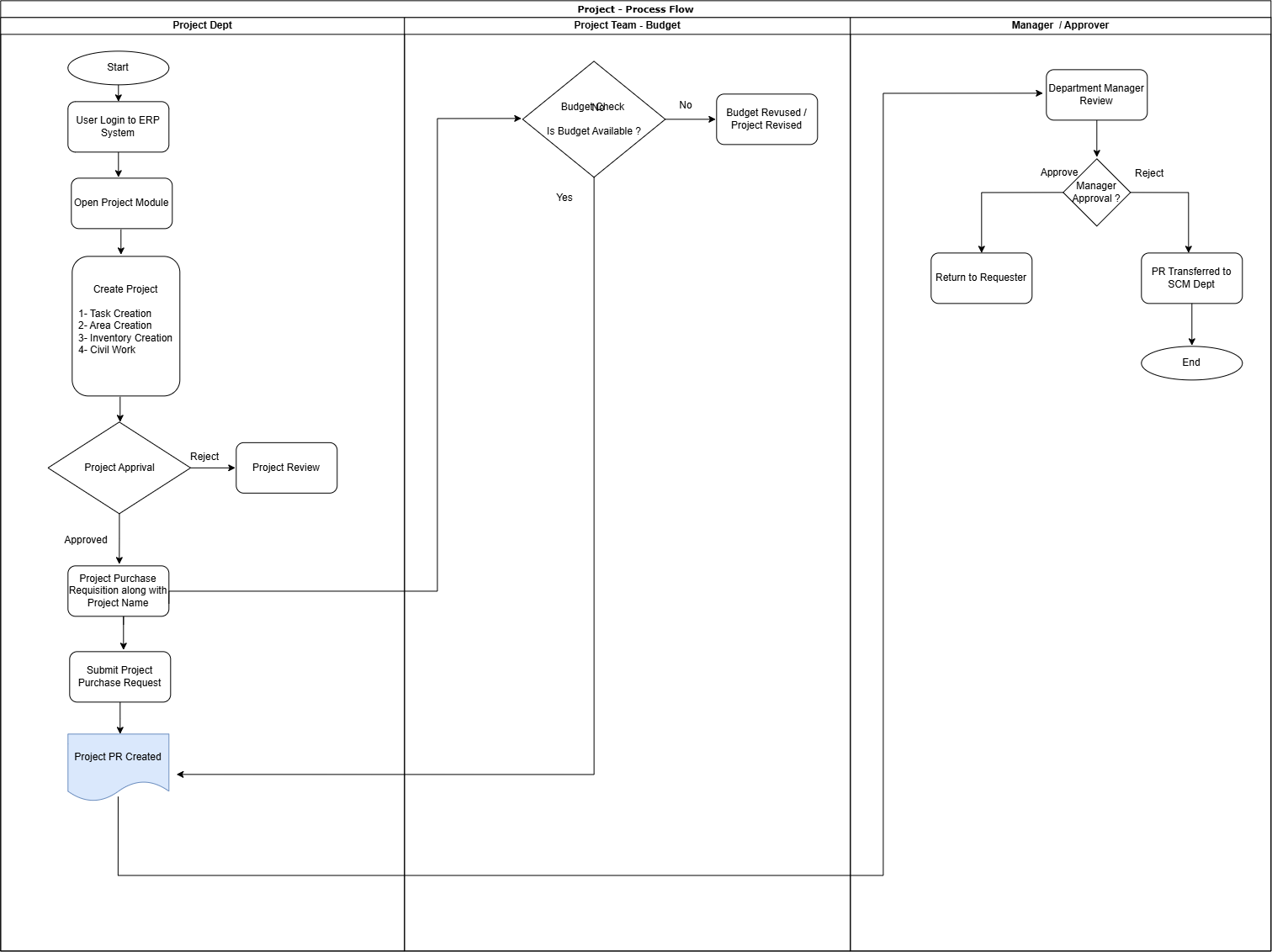

Process Summary:
- The requester logs into the ERP System and opens the Project Module.
- Create a project and enter Project Products with planned quantity, UoM and estimated unit cost. Task Creation, Area Creation, Inventory Creation and Civil Work are business examples; a dedicated project-type selector is not established by this repository.
- The created project is submitted for Project Approval. If rejected, the project is sent for review and necessary revisions before resubmission.
- Once the project is approved, the requester creates a Project Purchase Requisition (PR) against the approved project and enters the relevant Project Name.
- The requester submits the Project Purchase Request, after which the Project PR is created in the system.
- Project PR validation checks the approved project, company, planned products, committed quantity and remaining amount. No separate Project Team/Budget workflow queue is established by this extension.
- The available budget is verified against the project requirement. If sufficient budget is not available, the project/PR is sent for Budget or Project Revision and subsequently re-submitted for validation.
- If the required budget is available, the PR is forwarded to the Department Manager for review.
- The Department Manager reviews the PR and makes the approval decision. If rejected, the PR is returned to the requester for necessary corrections and resubmission.
- If the Department Manager approves the PR, it is transferred to the SCM Department for further procurement processing.
- The Project PR approval workflow is completed once the approved PR is successfully transferred to the SCM Department.

8.3 Purchase Order (PO) Process
- Buyer reviews approved requirements and creates RFQ(s).
- RFQ is sent to one or more approved vendors.
- Vendor quotations are evaluated based on price, lead time, quality, payment terms and commercial conditions.
- Selected quotation is confirmed for PO creation.
- Buyer creates the Purchase Order from the approved requirement/RFQ.
- PO includes vendor, products, quantities, prices, taxes, expected delivery date, warehouse and payment terms.
- PO is submitted for approval according to configured approval limits.
- Approved PO becomes the authorized purchasing document and creates the expected incoming shipment in Inventory.

Requesting Department → Procurement / Buyer → Supplier → Finance → System → Manager / Approval.

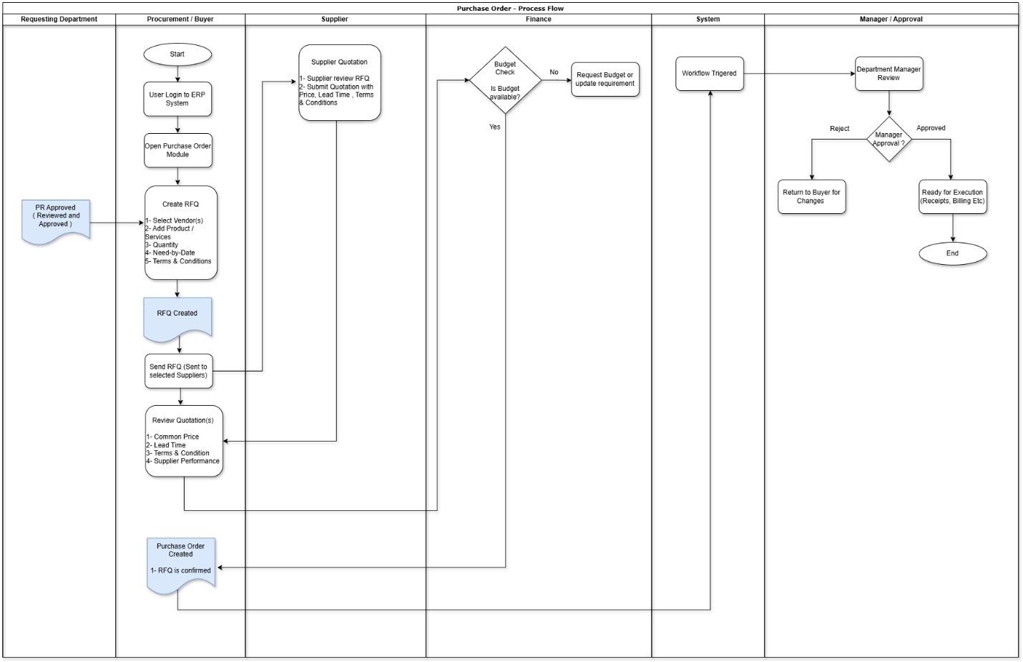

Process Summary
- The approved Purchase Requisition (PR) is received by the Procurement / Buyer team.
- The Procurement / Buyer logs in to the Odoo ERP system.
- The Procurement / Buyer opens the Purchase Order module.
- The Procurement / Buyer creates a new Request for Quotation (RFQ) by entering:

4.1 Supplier (Vendor)

4.2 Products / Services

4.3 Quantity

4.4 Unit of Measure (UoM)

4.5 Need-by Date / Expected Delivery Date

4.6 Unit Price (if applicable)

4.7 Payment Terms

4.8 Delivery Terms

4.9 Other Purchase Conditions (if applicable)
- The system creates the RFQ in Draft status.
- The Procurement / Buyer sends the RFQ to the selected supplier(s).
- The Supplier reviews the RFQ and submits a quotation containing:

7.1 Unit Price

7.2 Lead Time

7.3 Delivery Terms

7.4 Payment Terms

7.5 Any additional commercial conditions
- The Procurement / Buyer reviews and evaluates the supplier quotation(s) based on:

8.1 Price

8.2 Delivery Lead Time

8.3 Terms & Conditions

8.4 Supplier Performance

8.5 Business Requirements
- At PO confirmation, the customization checks analytic city/GL setup and a matching confirmed analytic budget. Finance configures Restrict, Allow or Show only warning.
- The Finance Department makes a budget decision:
- Restrict blocks a line exceeding its matching budget amount. Show only warning provides Proceed/Cancel; Allow permits exceeding that amount after required setup checks. This check compares individual line subtotals and does not aggregate overall PO or historical spend.
- Project PR separately checks committed request quantity and amount against the approved project plan. Community budgets are a third, separate budget model.
- The Purchase Manager / Authorized Approver reviews the Purchase Order.
- The Purchase Manager makes an approval decision:
- If Rejected: The Purchase Order is returned to the Procurement / Buyer for correction, negotiation, or amendment. After the required changes, the Purchase Order is resubmitted for approval.
- If Approved: The RFQ is confirmed, and the system automatically converts it into a Purchase Order (PO).
- The Purchase Order is approved and becomes ready for downstream procurement activities, including Goods Receipt, Vendor Billing, and Payment.
- The Purchase Order approval process is completed.

8.4 Goods Receipt
- Warehouse receives material against the approved PO.
- Receiver verifies quantity, packaging and supporting delivery documents.
- Received quantities are entered in the incoming shipment.
- Lot/serial numbers are captured where product tracking is enabled.
- Over-receipt or partial receipt is controlled according to business policy.
- Receipt is validated only after physical verification.

8.5 Quality / Inspection
- For inspection-controlled products, the incoming receipt triggers a Quality Check or Quality Control Point.
- Inspector records inspection results against the received quantity.
- Passed material proceeds to available stock/putaway.
- Failed material is placed in an appropriate quarantine/rejection location and handled through return, rework or disposition process.
- Inspection evidence should remain traceable to the receipt and PO.

8.6 Putaway & Inventory Update
- After successful receipt/inspection, warehouse performs putaway into the designated internal location.
- The inventory transaction updates on-hand quantity.
- For tracked items, lot/serial traceability is retained.
- Inventory valuation is updated according to the configured costing method and product/category accounting setup.
- Stock is then available for downstream warehouse consumption according to business rules.

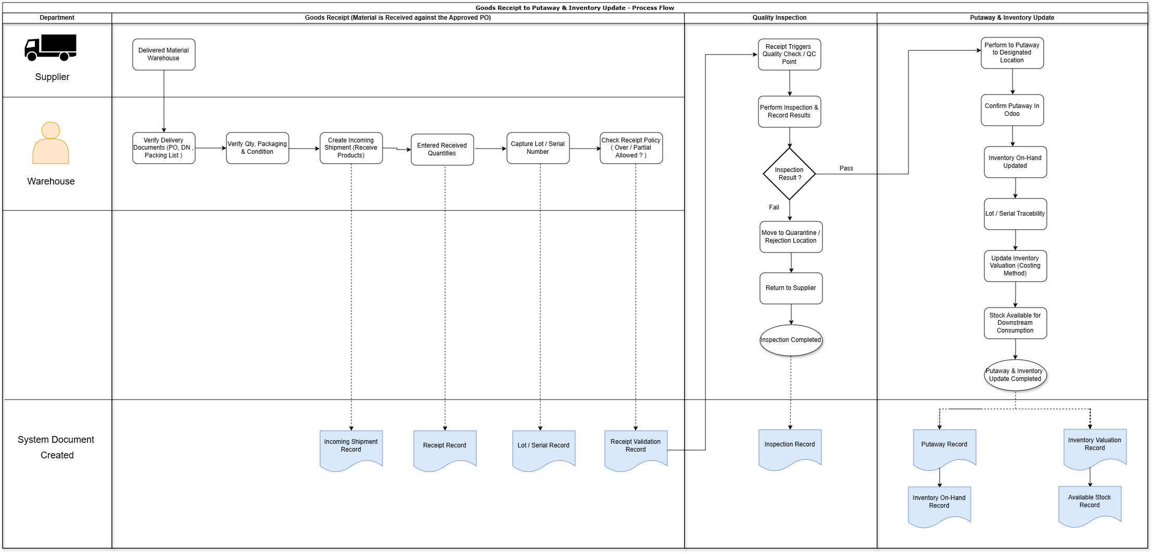

Process Summary:

- Supplier delivers material to the warehouse against the approved Purchase Order (PO).
- Warehouse verifies the PO, Delivery Note, Packing List, and other supporting documents.
- Warehouse checks the received quantity, packaging, and physical condition of the material.
- Warehouse user processes the Incoming Shipment/Receipt in Odoo against the approved PO.
- Actual received quantities are entered in the Odoo receipt.
- Lot or Serial Numbers are captured where applicable for inventory traceability.
- Enter actual quantities and handle backorders under the configured operation. Receipt tolerances and over-receipt blocking must be verified in the deployed system; no custom tolerance engine is established by the reviewed addons.
- If Quality Control is configured, Odoo triggers the required quality inspection.
- Quality/Warehouse team performs the inspection and records the inspection results in Odoo.
- If the material passes inspection, it proceeds to the putaway process.
- If the material fails inspection, it is moved to a Quarantine/Rejected Location and may be returned to the supplier.
- Odoo applies the configured Putaway Rules and directs the material to the designated storage location.
- Warehouse confirms and validates the putaway transaction in Odoo.
- Odoo updates the Inventory On-Hand Quantity after successful receipt and putaway.
- Lot/Serial information remains linked with the inventory for future tracking and transactions.
- Odoo updates inventory valuation based on the configured costing method.
- The received and putaway stock becomes available for consumption, transfer, picking, or other downstream inventory transactions.

8.7 Vendor Bill & Three-Way Matching
- Vendor bill is recorded in Accounting, preferably from the PO/receipt where applicable.
- Finance verifies supplier, quantity, price, taxes and invoice references.
- Three-way matching compares PO, receipt and vendor bill.
- Differences are routed for resolution before final posting/payment where controls are enabled.
- Approved bill is posted to Accounts Payable.

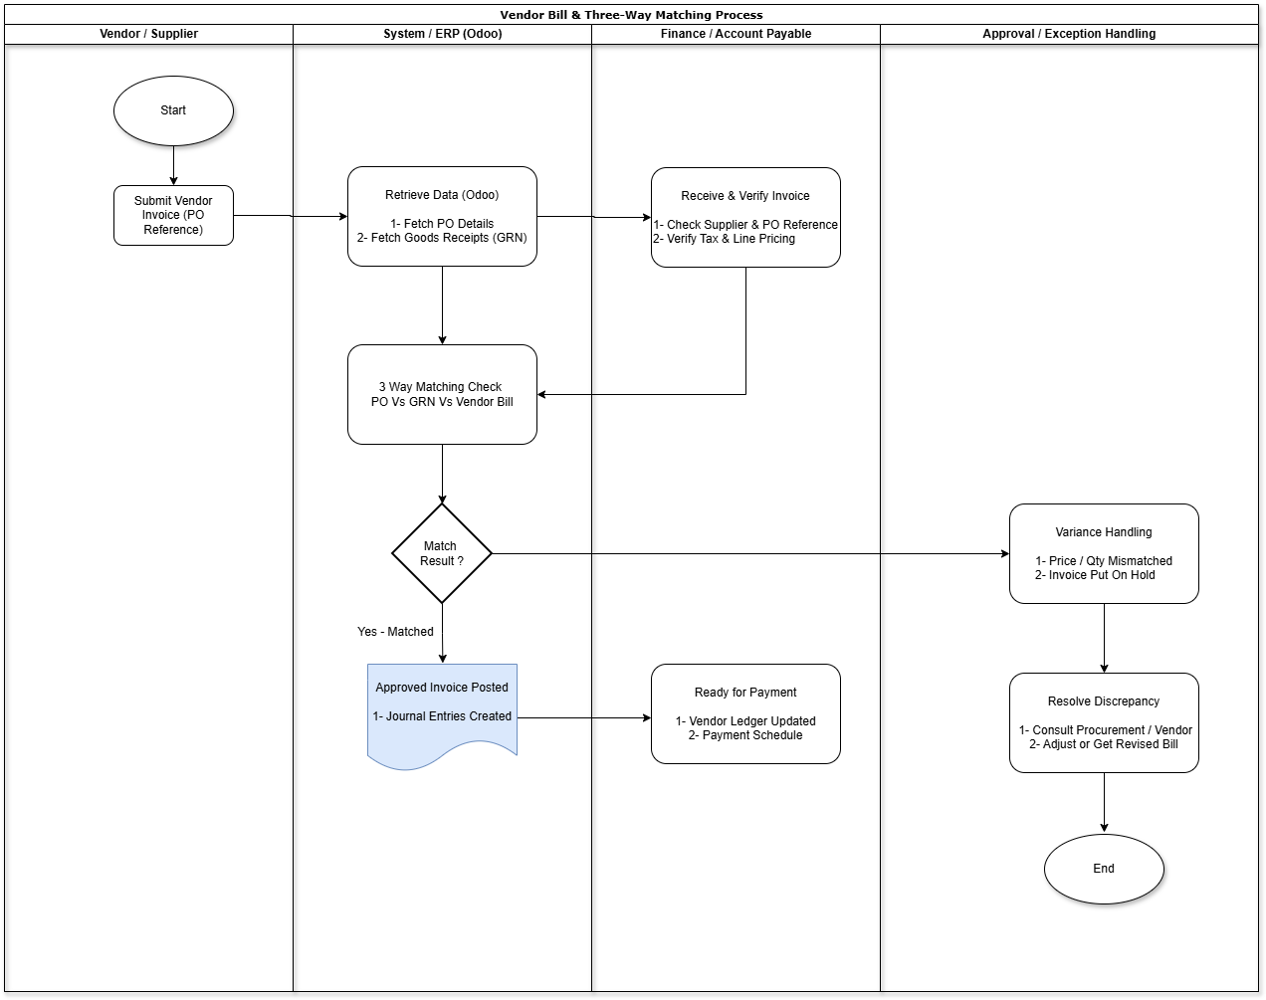

Process Summary:

- Vendor submits the invoice against the approved Purchase Order (PO).
- Finance/Accounts Payable receives and verifies the supplier, invoice details, quantity, price, taxes, and references.
- System retrieves the relevant PO and Goods Receipt (GR) details.
- Finance performs three-way matching between PO, Goods Receipt, and Vendor Invoice.
- If the invoice matches, it proceeds for approval and validation.
- Finance records and resolves mismatches before posting/payment under an approved operating procedure. Automatic invoice holds, routing and tolerance enforcement require confirmation in the deployed system.
- Relevant teams coordinate with the vendor to clarify the discrepancy, obtain a corrected invoice, or make the required adjustment.
- Once the discrepancy is resolved, the invoice is revalidated/re-matched.
- The approved invoice is posted to Accounts Payable (AP) and becomes available for payment processing.

8.8 Accounting & Payment
- Accounting entries are generated based on configured product/category valuation and accounting rules.
- Vendor liability is recognized through the vendor bill.
- Finance reviews payable balances and due dates.
- Payment is created through the approved payment process.
- Bank reconciliation is performed after payment/bank statement processing.
- Transaction is considered financially closed once payable and reconciliation activities are complete.

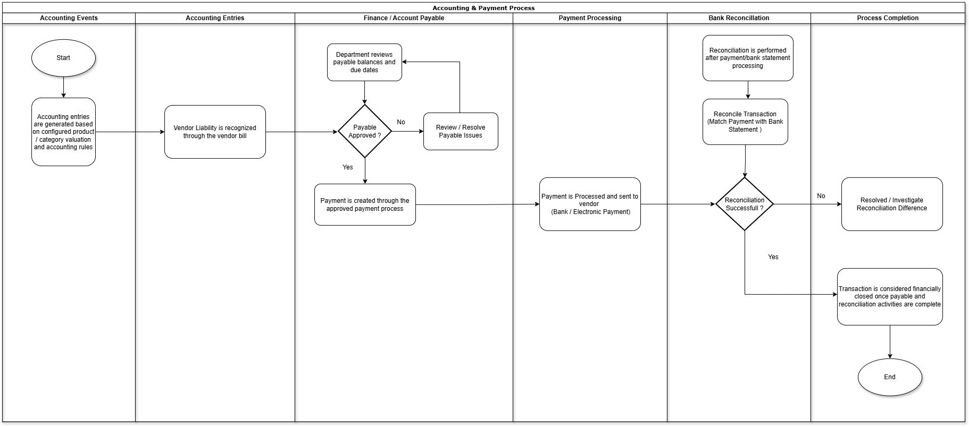

Process Summary:
- Accounting entries are generated based on the configured product/category valuation and accounting rules.
- Vendor liability is recognized through the posted vendor bill.
- Finance reviews the payable balance and due date.
- If the payable is approved, the payment is created through the approved payment process; otherwise, it is reviewed and resolved.
- The payment is processed and sent to the vendor through the configured payment method.
- The bank transaction is matched with the payment during bank reconciliation.
- If reconciliation is unsuccessful, the discrepancy is investigated and resolved.
- Once the payment is successfully reconciled, the payable is cleared and the transaction is considered financially closed.

8.9 Accounting Entries

8.9.1-Goods Receipt / Warehouse Delivery

8.9.2-Invoice Receipt (IR) & Three-Way Match

8.9.3-Payment Processing

8.10 Reports & Dashboard
The reporting functionality provides users with the ability to view, generate, and analyze relevant business data based on defined criteria. Reports will present information in a clear and structured format to support monitoring, operational activities, and business decision-making.
The report will include appropriate filters and selection criteria, allowing users to retrieve the required information for a specific period, status, category, or other relevant parameters. Where applicable, users will be able to export the report in commonly used formats such as PDF.
ID | Report / reference sample
R01 | Age Analysis ACP
R02 | Cost Centre-wise Income
R03 | List of Payments (All)
R04 | List of Payments (Taxes)
R05 | Sales Tax Annexure Report
R06 | Supplier Balances
R07 | Transaction List

9. End-to-End Process Matrix
Step | Process | Odoo Module | Responsible | Key Output | Finance Impact
1 | Requirement | Purchase / custom requisition | Requester | Approved requirement | None
2 | RFQ | Purchase | Buyer | RFQ / quotations | None
3 | PO Creation | Purchase | Buyer | Draft PO | None
4 | PO Approval | Purchase | Approver | Approved PO | Commitment/control only
5 | Receipt | Inventory | Warehouse | Validated receipt | Inventory/valuation impact as configured
6 | Inspection | Quality | Quality/SCM | Pass/Fail result | Possible hold until accepted
7 | Putaway | Inventory | Warehouse | Available stock | Inventory valuation maintained
8 | Vendor Bill | Accounting | Finance | Posted vendor bill | AP liability
9 | Match & Approval | Accounting/Purchase | Finance | Approved payable | Control
10 | Payment | Accounting | Finance/Treasury | Vendor payment | Cash/bank + AP

10.Roles & Responsibilities
Role | Responsibility / access
Requester | Enter requests and departmental lines; submit and follow approval status
Department manager | Review departmental lines and assigned approval activities; linked employee/user required
Raise PR Request for all Departments | Broader department selection than the ordinary requester domain
SCM User / SCM Manager | Purchasing processing; non-revenue-share PO access rules; SCM User has Return PR
CEO | Approval Groups menu and broad purchase-order access through custom group rules
HR Revenue Share | Visibility of the CRM-opportunity Project field on requests
Project Manager | Project planning and permitted changes/reset of approved project information
Assigned project/PO approver | Act at the configured current approval level
Inventory user | Transfers, delivery customer sync and stock operations subject to normal access
Accounting reader / Finance | Reports; accounting users manage permitted payments and deduction details
System administrator | Users, CRM key, module installation, schedules, backup and session parameters

11. Key Business Controls
- PO should not be receivable against unless it has reached the required approval status.
- Receipt quantity should be based on actual physical receipt and authorized tolerances.
- Lot/serial-controlled products must have tracking information before receipt validation.
- Inspection-controlled materials should not become freely available stock before successful inspection.
- Vendor bills should be matched against PO and receipt to prevent duplicate/incorrect payments.
- Access should be segregated between requester, buyer, warehouse receiver and finance approver.
- Changes to approved commercial terms should be controlled and re-approved where applicable.
- All inventory adjustments, returns and cancellations should be traceable to an authorized transaction.

12. Exception & Alternate Processes

12.1 Partial Receipt
- Allow receipt for the quantity physically delivered.
- Keep remaining quantity open for subsequent delivery.

12.2 Short / Excess Receipt
- Record actual quantity and apply approved tolerance rules.
- Escalate exceptions to Procurement/SCM.

12.3 Rejected Material
- Move to quarantine/rejection location.
- Process supplier return or approved disposition.

12.4 Purchase Return
- Create return against the received goods where applicable.
- Ensure inventory and financial treatment is aligned with the vendor credit/debit process.

12.5 Invoice Mismatch
- Hold or route the invoice for exception approval.
- Resolve price/quantity/tax differences before payment.

12.6 Cancelled PO
- Cancellation must be restricted to authorized users.
- Open receipts and financial documents must be checked before cancellation.

Risk | Impact | Mitigation
Incorrect master/accounting setup | Incorrect stock or financial posting | Controlled master-data validation and Finance sign-off
Unclear approval limits | Procurement delays or unauthorized purchases | Define approval matrix before configuration
Poor receiving discipline | Inventory mismatch | Warehouse SOP and mandatory receipt controls
Invoice mismatch | Payment delays | Three-way matching and exception workflow
Over-customization | Upgrade/support complexity | Prefer standard Odoo configuration and documented exceptions

13. Conclusion
The proposed Odoo solution provides an integrated SCM and Finance process from business requirement through procurement, receipt, inspection, inventory update, vendor billing and payment. The design provides transaction traceability across Purchase, Inventory, Quality and Accounting while maintaining appropriate approval and financial controls.
Before implementation, the organization should finalize the approval matrix, warehouse operating model, inspection rules, inventory valuation method, tax/accounting configuration and any required deviations from standard Odoo functionality. These decisions should be captured during the fit-gap and configuration workshops.

14. Sign-Off
Function | Name | Signature | Date
Business / SCM
Finance
IT / ERP
Project Manager

PART II: OPTIX COMPLETE CUSTOMIZATION GUIDE
Supplementary Customization, Workflow, Reporting and Access Reference
This revised reference restores the complete customization coverage, including seven Optix accounting reports, cost centre expenses and role/setup responsibilities. Descriptions are based on repository source and existing technical documentation; installation and live configuration remain to be verified.
Customization reference | Revision 1.1 | 16 October 2026 | Repository review; live configuration unverified

1. Purpose and scope
This document describes the functionality present in the Optix custom-addons repository, explains where a person can use it in Odoo, and records the setup needed for each workflow. It covers all 12 addon directories in this workspace, including local modifications currently present in the working tree.
The descriptions are based on module manifests, models, views, security definitions and existing implementation documents. Repository presence establishes that code exists; it does not prove that every module is installed, configured or active in the production database. Production installation status and current user permissions were not checked for this document. Menu labels can vary with Odoo edition, language and installed applications. Where a standard parent menu is supplied by Odoo, the path below identifies the relevant application and record.
Custom Optix business functionality is distinguished from adapted or integrated third-party addons. Existing third-party author and license declarations remain applicable. No business transactions or application code were changed while preparing this guide.

2. Quick access directory
Customization | Where a user accesses it | Primary user
Purchase, internal and revenue share requests | Purchase Request app → open or create a request → Request Type and Products | Requesters and approvers
Project approval and planned products | Project app → open a project → Project Products and Approvals | Project managers and assigned approvers
Project PR | Purchase Request app → Request Type: Project PR → Project | Project requesters
Department-based analytic allocation | Request or purchase order → product lines → Departments / Analytic Distribution | Requesters and SCM
Department master setup | Employees → Departments → open department | HR / administrators
Product GL, asset tag and warranty duration | Inventory or Purchase → Products → product form | Product administrators
Purchase budget controls | Accounting → analytic budgets → Configuration; Purchase → RFQ → Confirm | Finance and SCM
Filter budget lines | Open a budget → Filter Lines | Finance
PO approval and recommendation | Purchase → Orders → RFQs / Purchase Orders → open order | SCM and assigned approvers
Approval group configuration | Purchase → Configuration → Approval Groups | CEO group
Return a PO to its source PR | Purchase → open order → Return PR | SCM User
Customized purchase order print | Purchase → open order → Print → Purchase Order | SCM
Customer code and CNIC | Contacts → open a contact | Contact users
CRM customer synchronization | Inventory → Operations → Deliveries → open delivery → Sync CRM Customers | Inventory users
CRM access-key setup | Inventory → Configuration → Settings → Optix CRM | System administrators
Delivery customer CNIC and product tags | Inventory → open transfer / delivery | Inventory users
Serial spreadsheet import | Inventory → transfer → product move / serial detail → Import Serials XLSX, when shown | Inventory users
Lot warranty and repair warranty | Inventory → Products → Lots/Serial Numbers; Repairs → repair form | Inventory and repair users
Gate pass / issuance receipt | Inventory → transfer → Consume/Issuance Receipt tab; Print → Gate Pass | Warehouse users
Payment deductions and cheque advice | Accounting → Vendors → Payments, or bill → Pay / Register Payment | Finance
Seven Optix accounting reports | Accounting → Reporting → select report | Accounting readers and Finance
Cost Centre-wise Expenses | Accounting → Reporting → Cost Centre-wise Expenses | Accounting readers and Finance
Dynamic accounting reports | Accounting → Reporting → Dynamic Financial Reports | Finance
Accounting kit reports and tools | Accounting → Reporting, Accounting, Configuration, Customers and Payments | Finance
Automatic backup configuration | Settings → Technical → Automatic Database Backup → Backup Configuration | Administrators
Inactive session timeout | Settings → Technical → Parameters → System Parameters | Administrators
Inventory column search | Supported Inventory list views → column-header filter row | Inventory users

3. Purchase Request customization
Implemented primarily in Purchase Control Hub (purchase_inherit).
The standard Approvals application is renamed Purchase Request. Requests support Purchase Request, Internal Request and Revenue Share Request; the Project PR extension adds another request type. The request shows calculated amount and status, departmental product lines, analytic allocation and links to resulting purchase orders or internal transfers.

Purchase Request workflow
1. Open Purchase Request and create a request using the configured purchase approval category.
2. Select Purchase Request as the request type. Enter the reason, required attachments and product lines.
3. Choose each line's department, product, quantity and unit. Review the description, price and analytic allocation. Non-service prices are derived from product cost; service prices can be entered manually.
4. Submit the request. The customization adds required department managers as approvers where they are not already listed. Each manager must be an employee with a linked Odoo user. Newly added department managers share an approval sequence so they can act in parallel.
5. Assigned approvers review the request. Department-manager refusal affects that manager's departmental lines and records the refusing user and date. A request can become Partial Approved.
6. Once eligible, use the Purchase Request action on the approved request to generate RFQs / purchase orders. This button creates purchasing documents; it is separate from submitting the request.
7. Open the resulting orders through the purchase-order smart button and complete the PO approval process.
Only eligible, non-refused lines without an existing purchase-order-line link are generated. Lines are grouped by supplier and company; a draft or sent order for the same request and supplier can receive additional eligible lines. Department, analytics, request price and reason pass to the order, and request attachments are copied when a new order is created. Supplier setup on products is required for order generation.
The request includes cancellation, withdrawal and reset behavior. Resetting clears the manager-refusal metadata. Approval activities are tied to the relevant request/approver, with customized activity completion behavior.

Internal Request workflow
Use Request Type: Internal Request, add departmental product lines and submit for approval. After full or partial approval, use Create IR. Eligible consumable-type product lines are grouped by department and create internal stock transfers. Configure the departmental destination location before use. The request's Internal Transfer smart button opens its linked transfer, and generated transfers retain the source request reference. Repeated creation for the same request is checked to avoid duplicate transfers. Service lines do not generate stock transfers.

Revenue Share Request
The request model includes Revenue Share Request and a Project field linked to won CRM opportunities, visible to the HR Revenue Share group. The PO-generation code carries a revenue-share flag for this type. However, the current request view exposes the order-generation button only for Purchase Request and Project PR. Treat revenue-share order generation as requiring a confirmed live entry point before training users on an end-to-end process. The revenue-share Project field is a CRM opportunity, separate from the Project app project used by Project PR.

4. Departments, products and analytic allocation
Open Employees → Departments and configure Cost Center, City and Department Location. Cost Center and City selectors use analytic plans whose names contain the corresponding text. Assign a department manager with a linked user and link requesting employees to their Odoo users.
Open a product through Inventory or Purchase. The product Accounting area adds an analytic GL selector using plans whose names contain GL. General Information adds Asset Tag No. and the warranty duration field, currently labelled Warrent and shown for serial-tracked products. Duration is interpreted as days. New products without an internal reference receive a reference from the product sequence.
Request and PO lines use department cost centre, department city and product GL to populate analytic distribution. The custom analytic widget supports the purchasing workflow. On PO lines, Amount to Change adjusts the non-service unit price relative to product standard cost; service lines remain manually editable. Changing the department can refresh the analytic allocation, so review it before approval.

5. Purchase orders, approvals and budget controls
Purchase orders add Department, Revenue Share, Reason, source Approval Request, department-manager approval tracking and a Sent Back flag. New RFQs use a custom RFQ sequence; confirmation can replace an RFQ-prefixed number with a purchase-order sequence number. Company currency is supplied when missing.

Multi-level PO approval
1. A CEO-group user opens Purchase → Configuration → Approval Groups.
2. Define the group, ordered active levels, assigned users, recommendation/approval flags and amount limits.
3. On the RFQ, choose the approval group and confirm when ready.
4. Where approval is required, the order enters To Approve and shows the Current Approval Level and Pending At information.
5. Assigned users use Recommend or Returned as applicable and enter comments in the wizard. The final approval follows the available approval action.
6. Review Approval Comments for the history of requests, recommendations, returns and approvals.
Routing follows active level sequence. Maximum amount influences approval-button eligibility. Do not assume the configured minimum amount independently selects a routing band: the current level-routing implementation advances by sequence.

Analytic budget control at confirmation
Purchase Control Hub extends Odoo's analytic budget models, budget.analytic and budget.line. Finance configures a confirmed budget for the cost centre / city / analytic GL combination and chooses Configuration: Restrict, Allow or Show only warning.
At PO confirmation, missing department city, product GL, analytic city or matching confirmed budget prevents confirmation. Restrict blocks an over-budget line; Show only warning opens a Budget Warning dialog with Proceed/Cancel; Allow permits exceeding the configured amount after the required setup checks.
The current comparison uses each PO line subtotal against the matching budget line's budget_amount. It is not a cumulative project-spend calculation. The city and GL lookups use database-specific analytic fields x_plan6_id and x_plan8_id. Preserve the corresponding analytic-plan structure when deploying elsewhere.
Open an analytic budget and choose Filter Lines to filter by cost centre, city, GL, product, exact start/end dates and budget amount using equals, greater-than-or-equal or less-than-or-equal. The date fields match exact line dates rather than filtering an overlapping period.

Return and manager review
SCM User can use Return PR on a PO with a valid source request reference. It cancels the order, withdraws/cancels/resets the source PR and schedules an activity for the requester. The requester revises and resubmits the request. Orders with no identifiable source PR cannot use this process.
Manager Approval records the current department manager's approval on the order. The approval code includes a check for all department managers on returned orders with Amount to Change lines. Availability depends on the record's workflow and the user's role.

Purchase order print
Use the standard Purchase Order print action. The customized layout includes requester, origin under PROJ/CUSTOMER Name & Code, delivery/payment terms, quote reference, delivery date, business unit, internal department and delivery location. Lines show item code, description, quantity, unit, unit price and extended price. Totals, amount in words and fixed Optix terms are added. Discount and Other Charges currently print as fixed 0.00 values; the project/customer label displays origin rather than a separate customer lookup.

6. Project approvals and Project PR budgets
Implemented in Project PR Budget Control (project_pr_budget).
1. Open a project in the Project app. Add Project Products with planned product, quantity, UoM and estimated unit cost.
2. Select an Approval Group and use Submit for Approval.
3. Assigned users approve sequentially. The Approvals tab records level status, acting user and action date. Authorized users can reject; Project Managers have the Reset to Draft action.
4. After approval, open the project's Purchase Requisitions smart button or create a Purchase Request with Request Type: Project PR and select the approved project.
5. Choose products from the project's planned items and review planned, requested and remaining quantity plus estimated unit cost.
6. Submit and approve the Project PR, then use the purchase-generation action to create purchasing documents.
The extension checks that the project is approved, the company matches where specified, products belong to the plan, and quantity and amount remain within the project limits. It checks committed requests during submission/approval and document creation. Committed states include approved, partially approved and purchasing/transfer-created requests; refused lines are excluded from active line consumption.
Project Total Cost is planned quantity × estimated cost. Utilized Amount is based on committed Project PR request amounts; Remaining Amount is planned cost less utilization. These figures represent request commitments, not posted expenses or payments. Submitted requests alone are not included in the committed-state total.
Tasks can only be created or moved into approved projects under this extension. Approved project budget information is protected from ordinary users; Project Managers can modify it. Changing the selected project on a draft Project PR clears its product lines, so choose the project before entering products.

7. Contacts and CRM customer synchronization
Contacts add an automatically sequenced Code and CNIC Number. CRM customer identity is stored separately from this internal code.
An administrator enters the CRM access key at Inventory → Configuration → Settings → Optix CRM and saves. Inventory users open an outgoing delivery and click Sync CRM Customers. A progress screen shows the import status and Return to receipt reopens the saved delivery with the updated customer selector. Leaving the screen does not stop the job.
The integration reads the Optix CRM customer endpoint in batches of 200. It creates or updates customers by unique CRM CustomerId and maps name, address, city, CNIC, email, phone, customer code, area, subarea, MRC and status. Imported blank contact values clear previous imported values. Customers absent from the response are not deleted, and CRM status does not automatically archive contacts.
The supplied schedule starts nightly at 02:00 Asia/Karachi; a worker scheduled every minute processes pending work. Actual timings can be edited in Settings → Technical → Automation → Scheduled Actions. Cron workers must be enabled. A failed run resumes from the first uncommitted page; clicking again after completion starts a full scan. One shared job prevents overlapping imports.
Existing contacts without CRM IDs are not automatically matched by name, phone or CNIC. Link existing records to their CRM identities before the first scan where necessary to prevent duplicate business contacts. Users do not enter credentials on the delivery form.

8. Inventory, serials, warranty and gate passes
Transfers display aggregated product internal references, asset tags and the selected customer's CNIC. Outgoing delivery customer selection is limited to contacts marked as customers.

Serial spreadsheet import
Open the product move / serial-detail area of a transfer and use Import Serials XLSX when available. Upload an .xlsx workbook whose first row is a header. Accepted headers are serial, serial number and serial_no; otherwise the first column is used. The active sheet is read and the first row is skipped.
Import fills existing movement-detail rows in order and creates additional detail rows for extra serials. Values populate the custom Serial Number field (serial_no); they do not automatically create Odoo lot records or populate the standard lot/serial linkage. Check movement quantities and standard lot assignment before validation. The import requires openpyxl. Additional-row creation uses qty_done in the current code, so verify that branch on the deployed Odoo 19 database before relying on bulk creation.

Warranty and repairs
Products store warranty duration in days. On creation of a lot for a product with a duration, missing warranty start defaults to today and missing end becomes start plus duration. Open Inventory → Products → Lots/Serial Numbers to review Warrenty Start, Warrenty End and Warrenty Status (current spelling in the interface).
Repairs displays the selected lot's warranty status and updates the repair's under-warranty choice when the lot is selected. Warranty status is stored and recomputes when its date fields change; the code does not contain a daily expiry-refresh job, so stored status should not be assumed to update solely because midnight passes.

Gate pass / Consume/Issuance Receipt
Open a transfer's Consume/Issuance Receipt tab and enter vehicle number, driver name, driver contact and corresponding company. Created By records the originating user and Include Product Details controls whether product details are printed. Use Print → Gate Pass to generate the receipt. The interface tab is renamed; the print action remains Gate Pass. This addon retains Cybrosys attribution and includes local receipt presentation changes.

9. Supplier payment deductions and cheque advice
Implemented in Purchase Control Hub, with account classifications and reporting supplied by fw_account_reports.
Finance configures Accounting → Configuration → Taxes with Payment Deduction Category (WHT or Sales Tax / STSP) and Payment Deduction Account. Configure Accounting Report Tax Category on the corresponding ledger accounts. Supplier payable and journal outgoing payment/outstanding accounts must be present. Normal bill sales tax stays on the bill; only designated withholding taxes are selectable for payment deductions.

Payment against bills
1. Open a posted vendor bill or select bills for one supplier and currency, then choose Pay / Register Payment.
2. Select journal, payment method and date; enable Payment Tax Deductions.
3. Review Gross Settlement. For a partial settlement, enter the gross portion being paid.
4. Add WHT/STSP taxes. Keep Use Gross as Base or disable it and enter Custom Tax Base.
5. Keep Payment Difference Handling: Keep Open. For multiple bills use Group Payments; register incompatible supplier, currency or payable-account batches separately.
6. Create the payment, review its journal entry, then choose Print → Payment / Cheque Advice.

Standalone payment
Open Accounting → Vendors → Payments → New. Choose an outgoing supplier payment, enable Payment Tax Deductions and enter Gross Amount. Review deductions and Net Payable. Add payee/cheque details and optional Invoice / P.O. / PR References. Multiple reference rows are supported and their allocated gross amounts must total the payment gross. Confirm and print Payment / Cheque Advice.
Net bank payment = gross settlement − deductions. For example, gross 100,000 with 5.5% WHT produces supplier payable debit 100,000, WHT credit 5,500 and bank/outstanding payment credit 94,500. The original bill is preserved. A standalone payment can later be reconciled through standard accounting tools; selecting a bill in an advice-reference row only documents that reference.
Persistent deduction lines retain tax, account, category, base, rate, formula and amount snapshots. Linked payments copy invoice/PO/PR references when available. Accounting Entries displays actual journal amounts. The advice shows supplier/bank details, references, gross, WHT, STSP, net and actual debits/credits. Validation checks duplicate taxes, invalid accounts, excessive deductions, reference totals and posted changes. Draft/reset/repost behavior synchronizes deduction entries.
Early-payment-discount write-offs are not combined with this workflow. Avoid deducting a tax already deducted on the bill. Existing historical deductions are not reconstructed. Database-specific tax corrections and account mappings are recorded in docs/payment_tax; those IDs must not be applied blindly to another database.

10. Optix accounting reports

Seven reports in fw_account_reports
Open Accounting → Reporting, choose a report, set company and date filters, then use View Report, Print PDF or Export CSV. Access requires Accounting read-only privileges or a role that inherits them; company and record access rules still apply.
Report menu | What it provides
Age Analysis ACP | Payables outstanding at an as-of date, historical reconciliation effects and maturity buckets; advances separately
Cost Centre-wise Income | Posted income analytic allocations by cost centre, optional city and account, with same-period prior-year comparison
List of Payments (All) | Posted outbound supplier payments grouped by bank, gross/net, WHT/STSP, other differences and knock-off/balance
List of Payments (Taxes) | Payments with WHT/STSP, taxable amount, rates, payment nature and report-specific balance
Sales Tax Annexure Report | Posted vendor bills/refunds, taxable base and tax classifications, invoice/supplier and deduction metadata
Supplier Balances | Opening payable balance, period debits/credits and closing balance; optional zero balances
Transaction List | Journal items by month, journal, date and voucher, with subtotals and optional draft entries
Set tax categories on ledger accounts, partner Tax ID/Report CNIC/Annexure Supplier Type and location details, bill AP Report Details, and payment Payment Tax Report Details where needed. Reports display money in selected company currency. Bill-only deductions are not automatically attributed in full to partial payments.

Cost Centre-wise Expenses
Open Accounting → Reporting → Cost Centre-wise Expenses. Set dates, company, cost centre plan, optional city plan/cities, code bounds and printed site heading. Use View Report, Print PDF or Export Excel for a native .xlsx workbook.
The report includes posted journal-linked analytic allocations for expense, depreciation and cost-of-revenue accounts. Credits reduce expense; the same calendar dates one year earlier provide Last Year. Unallocated journal items and manual analytic items without a posted journal entry are excluded. Prior-year-only accounts remain visible.
Cost centre/city analytic Reference values form combined codes; names form headings. Inclusive code bounds filter those codes. Site Heading changes printed text; Company and Cities filter data. Excel contains numeric amounts, groups, subtotals and grand totals. Sum account detail rather than detail plus subtotal rows to avoid double counting.

Dynamic Financial Reports
The integrated Cybrosys dynamic_accounts_report addon exposes Accounting → Reporting → Dynamic Financial Reports: General Ledger, Trial Balance, Partner Ledger, Balance Sheet, Profit and Loss, Cash Book, Bank Book, Aged Receivable, Aged Payable and Tax Report. It supplies interactive report screens and export/print controls according to each screen. This family is separate from the seven Optix-format reports above.

11. Accounting kit and community budget integration
base_accounting_kit is a Cybrosys Community accounting addon included in the repository. It supplies:
- Accounting → Reporting → Generic Statements: Profit and Loss, Balance Sheet and Cash Flow Statement.
- Accounting → Reporting → Daily Reports: Cash Book and Bank Book.
- Accounting → Reporting → Partner Reports: Partner Ledger and Aged Partner Balance.
- Accounting → Reporting → Audit Reports: General Ledger, Trial Balance, Journals Audit and Tax Report.
- Accounting → Accounting → Management: asset records and depreciation operations.
- Accounting → Configuration: asset categories, account groups, financial report definitions and follow-up levels.
- Customer follow-up reports and contact Customer Statement information.
- Recurring Templates under the payment menu; recurring-entry automation.
- Bank-statement import/reconciliation, credit-limit settings, post-dated cheque support, invoice copy-layout configuration and accounting lock-date tools, where enabled.
These are integrated package capabilities, not all original Optix developments. Availability depends on installed dependencies, roles and accounting configuration.
base_account_budget adds the separate Community budget workflow. Open Accounting → Accounting → Budgets, enter budget lines and use Confirm, Approve and Done as appropriate. Configuration includes budgetary positions/accounts, analytic accounts show Budget Items, and Filter Lines opens the added filtering wizard.
Community budgets use crossovered.budget models. They are separate from Purchase Control Hub's account_budget analytic budget models and from Project PR commitments. Configuring one does not automatically configure the others.

12. Administration and supporting modules

Automatic database backup
The integrated auto_database_backup addon provides Settings → Technical → Automatic Database Backup → Backup Configuration (enable developer mode to access Technical). Configure database, format, destination, credentials, retention and notifications. Destination choices include local storage, FTP/SFTP, Google Drive, Dropbox, OneDrive, Nextcloud and Amazon S3. Connection-test buttons are available for supported destinations. Scheduled Actions controls the job execution.
The existing backup documentation includes configuration and operational evidence, logs and a staging listing from 6 October 2026. It records SFTP authentication and backup startup and an archive visible in the supplied listing; it does not establish a current restore test. See docs/auto_database_backup/Auto_Database_Backup_Configuration.pdf for the operational record.

Inactive session timeout
auth_session_timeout is an OCA addon that expires inactive sessions. Configure Settings → Technical → Parameters → System Parameters: inactive_session_time_out_delay (seconds) and inactive_session_time_out_ignored_url (excluded technical URLs). The supplied default delay is two hours. Ordinary users experience this through session expiry rather than a separate menu.

Advanced inventory list search
jl_list_advance_search_inventory adapts supported Inventory list renderers for the separate jl_list_advance_search base module. Install the base dependency and enable advanced search in user preferences where required. Use the filter row beneath column headings, combining text/relation filters or numeric/date ranges with native search and grouping. The base module is not in this workspace; this inventory addon alone does not provide the complete search feature.

13. Roles and setup responsibilities
Role | Responsibility / access
Requester | Enter requests and departmental lines; submit and follow approval status
Department manager | Review departmental lines and assigned approval activities; linked employee/user required
Raise PR Request for all Departments | Broader department selection than the ordinary requester domain
SCM User / SCM Manager | Purchasing processing; non-revenue-share PO access rules; SCM User has Return PR
CEO | Approval Groups menu and broad purchase-order access through custom group rules
HR Revenue Share | Visibility of the CRM-opportunity Project field on requests
Project Manager | Project planning and permitted changes/reset of approved project information
Assigned project/PO approver | Act at the configured current approval level
Inventory user | Transfers, delivery customer sync and stock operations subject to normal access
Accounting reader / Finance | Reports; accounting users manage permitted payments and deduction details
System administrator | Users, CRM key, module installation, schedules, backup and session parameters
Assign roles in Settings → Users & Companies → Users. Custom PO rules cover employee ownership/assignment, department-manager association, SCM non-revenue-share visibility and CEO full domain. Odoo combines applicable group rules and inherited groups; validate actual visibility with the intended user's account instead of treating a single rule as an exclusive restriction.
Before rollout, verify module installation, department managers/users, analytic plans and budget combinations, product supplier/cost/GL data, project plans, approval levels, supplier/bank accounts, deduction categories and report metadata. Users should refresh their browsers after backend asset upgrades.

14. Module and source register
Technical addon | Coverage / attribution
purchase_inherit | Purchase Control Hub; Osama Nadeem / Zalino Tech; requests, purchasing, analytics, master data, CRM sync, warranty, serial import and payment deductions
project_pr_budget | Project PR Budget Control; Zalino Tech; project planning/approval and request commitment limits
ml_purchase_approval | Multi-level PO approval groups, levels, actions and history; integrated with Purchase Control Hub
fw_account_reports | Seven Optix-format accounting reports and supporting metadata
cost_center_expense_report | Expense reporting with prior-year comparison and PDF/Excel output
gatepass_slip | Cybrosys gate pass addon with local receipt/interface customization
base_account_budget | Cybrosys Community budgets with filtering extension
base_accounting_kit | Cybrosys Community accounting package
dynamic_accounts_report | Cybrosys interactive accounting reports
auto_database_backup | Cybrosys automated backup integration
auth_session_timeout | OCA inactive-session expiration
jl_list_advance_search_inventory | Third-party inventory compatibility extension for advanced list search
Primary implementation sources: each addon's __manifest__.py, models, views, wizards, reports and security files. Detailed references: docs/crm_customer_sync.md; docs/payment_tax/README.md and deployment.md; fw_account_reports/README.md; cost_center_expense_report/README.md; docs/uat/Optix_Accounting_Reports_UAT_v1.0.pdf; docs/auto_database_backup/README.md; auth_session_timeout/readme/CONFIGURE.md; jl_list_advance_search_inventory/README.md.
Existing test sources cover the seven accounting reports, expense reports and CRM sync; the payment-tax documentation contains an isolated Odoo-shell validation suite. Those tests were not rerun for this documentation-only task. The access paths and behavioral descriptions were checked against repository definitions; live installation, screen visibility and transaction behavior remain deployment checks.

15. Outstanding decisions and acceptance evidence
The following items require business data or deployment evidence. They are not confirmed custom implementations.
Item / owner | Required completion or acceptance evidence
Company and sites / Finance, SCM | Legal address, NTN, named contacts, warehouse/location hierarchy, product categories and approved UoM list
Approvals / SCM, Finance | Named level users and limits; confirm sequence behavior and test unauthorized actions, refusal, partial approval and Return PR
Receiving and quality / SCM, Quality | Approve receipt steps, tolerances and quarantine release; verify Quality availability, control points and blocking behavior
Vendor restrictions / SCM | Approve activation policy and verify enforcement; no custom approved/blocked supplier workflow is demonstrated here
Invoice matching / Finance | Approve tolerance and hold procedure; demonstrate enforcement before describing automatic holds as implemented
Valuation / Finance | Approve category accounts and costing; retain actual Odoo 19 receipt, bill, return and payment journal evidence
Budget controls / Finance | Test missing analytic setup and all three confirmation modes; verify project quantity/amount limits separately
Payments and reports / Finance | Test full/partial/grouped payments, deductions, advice references and all report exports against ledger totals
Inventory extensions / SCM, IT | Validate extra-row XLSX import compatibility, standard lot assignment and warranty expiry refresh requirement
Deployment / IT | Confirm installed modules, analytic fields x_plan6_id/x_plan8_id, user visibility, CRM schedule and backup restore evidence
Final sign-off / process owners | Record actual names, dates, decisions and UAT evidence; signatures cannot be completed from repository data

16. Revision record and source traceability
Revision 1.1 fills ten setup tables, corrects duplicated section numbering, integrates current request/project/budget behavior, qualifies unverified controls and accounting assumptions, and restores full report/access documentation. Original images and package relationships are retained. Source document remains unchanged.
Evidence: purchase_inherit/data/*sequence.xml; purchase_inherit/models/hr_department.py, purchase_order.py, approval_request.py, account_payment.py; purchase_inherit/wizard/stock_serial_import_wizard.py; project_pr_budget/models/approval_request.py and project_project.py; fw_account_reports/README.md; cost_center_expense_report/README.md; docs/customization/Optix_Complete_Customization_Guide.md. Existing guide source references identify the remaining addon definitions. No application behavior or production data was changed.

